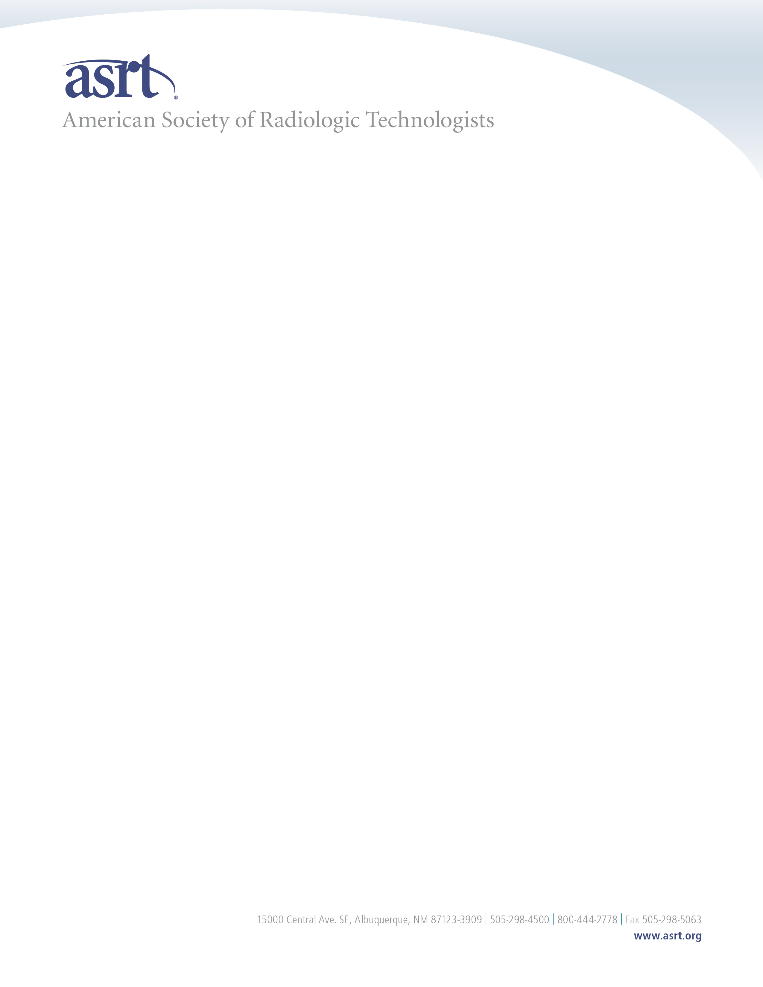

William Anderson

Office of the General Counsel

250 Washington Street

Boston, MA 02108

[Reg.Testimony@mass.gov](mailto:Reg.Testimony@mass.gov)

March 21, 2025

Dear Mr. Anderson,

The American Society of Radiologic Technologists represents more than 156,000 medical imaging and radiation therapy professionals across the nation, including 5,265 in Massachusetts. Our main mission as an organization is to advance and elevate the medical imaging and radiation therapy profession and to enhance the quality and safety of patient care. With that mission in mind, ASRT provides the following comments on proposed amendments to 105 CMR 125.000- *Licensing of Radiologic Technologists.*

ASRT understands the need to address workforce shortages through utilization of limited radiographers; however, patient safety must take priority. By requiring limited-scope radiographers to meet initial educational requirements and pass a standardized competency exam under the proposed amendments, Massachusetts is taking a critical step to ensure Bay Stater’s receive safe, high-quality care from qualified medical imaging paraprofessionals in urgent care settings.

 Additionally, limiting the procedures a limited-scope radiographer can perform and requiring limited-scope radiographers to pass a national competency exam, the proposed amendments to 105 CMR 125.000 appropriately balances workforce shortage and patient safety issues while ensuring patients receive high quality care.

ASRT appreciates your commitment to providing patients’ access to quality health care services that only individuals that meet national education and clinical standards can provide and looks forward to working with you in the future to achieve this goal. Please feel free to contact me at [mcheck@asrt.org](mailto:mcheck@asrt.org) or 800-444-2778; Ext 1314 if you have any questions.

Sincerely ,

Meredith A. Check, MPP

Director of Government Relations and Public Policy

American Society of Radiologic Technologists