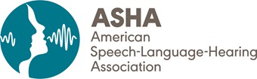

Submitted via email: [Reg.Testimony@mass.gov](mailto:Reg.Testimony@mass.gov)

October 28, 2024 William Anderson

Office of the General Counsel

Department of Public Health 250 Washington Street

Boston, MA 02108

RE: SLP/AUD Board Regulations Dear Mr. Anderson:

On behalf of the American Speech-Language-Hearing Association (ASHA), I write to express support for proposed amendments to 260 CMR 1.00: Standards, Complaint and Grievance Procedure and 260 CMR 2.00: Application and Licensing Requirements.

ASHA is the national professional, scientific, and credentialing association for 234,000 members, certificate holders, and affiliates who are audiologists; speech-language pathologists (SLPs); speech, language, and hearing scientists; audiology and speech- language pathology assistants; and students. Over 5,900 ASHA members reside in Massachusetts.1

The proposed regulations will adopt a provisional license for SLPs engaging in their clinical fellowship period. This proposal will allow clinical fellows to fulfill Medicare licensing requirements to practice in skilled nursing facilities, thereby allowing more positions to be filled in Massachusetts. We also appreciate the updated reference to ASHA’s 2020 certification standards.

Thank you for your consideration of ASHA’s position. If you or your staff have any

questions, please contact Susan Adams, ASHA’s director of state legislative and regulatory affairs, at [sadams@asha.org](mailto:sadams@asha.org).

Sincerely,

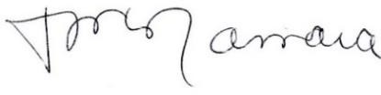

Tena L. McNamara, AuD, CCC-A/SLP 2024 ASHA President

1 American Speech-Language-Hearing Association. (2023). *Massachusetts* [Quick Facts]. <https://www.asha.org/siteassets/advocacy/state-fliers/massachusetts-state-flyer.pdf>