INDOOR AIR QUALITY ASSESSMENT

Amesbury Middle School
220 Main Street
Amesbury, MA

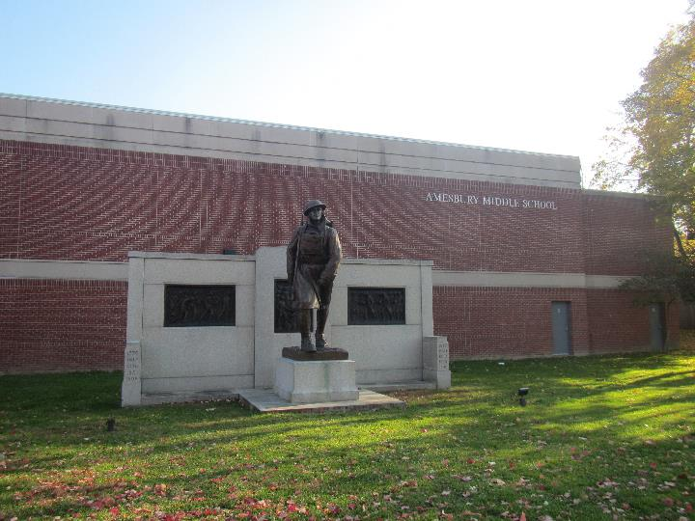

Prepared by:
Massachusetts Department of Public Health
Bureau of Climate and Environmental Health
Indoor Air Quality Program
December 2023

BACKGROUND
Building: | Amesbury Middle School
Address: | 220 Main Street, Amesbury
Assessment Requested by: | Jim McCarthy, Director of Facilities,  Amesbury Public Schools
Reason for Request: | General IAQ assessment following occupant complaints
Dates of Assessment: | October 20, 2023, and November 14, 2023
Massachusetts Department of Public Health/Bureau of Environmental Health (MDPH/BEH) Staff Conducting Assessment: | Mike Feeney, Director, IAQ Program on October 20, and Jen Lajoie, Environmental Analyst/Inspector and Ruth Alfasso, Environmental  Engineer/Inspector, IAQ Program, on November 14.
Building Description: | The Amesbury Middle School is a sprawling brick and concrete building with original sections built in the 1800s with additions in the 1950s and 1990s. It has numerous segments of flat roofs, some skylights, courtyards, and other architectural features. The school contains classrooms, offices, and accessory areas like a gym, library, cafeteria, and auditorium.
Windows: | Windows are openable in most areas of the school

METHODS
Please refer to the IAQ Manual for methods, sampling procedures, and interpretation of results (MDPH, 2015).

RESULTS AND DISCUSSION
The following is a summary of testing results on October 20, 2023 (Table 1). Only temperature and relative humidity testing was conducted, and only in the 200 series rooms, the auditorium, and the library area:
- Temperature was within or very close to the recommended comfort range of 70°F to 78°F in all areas tested.
- Relative humidity was almost all above the recommended range of 40% to 60% in the areas assessed. This is reflective of outdoor conditions on the day of the visit.
The following is a summary of testing results on November 14, 2023 (Table 2):

- Carbon dioxide was above the MDPH guideline of 800 parts per million (ppm) in about one fourth of the areas visited indicating adequate fresh air in most spaces. Levels above 800 ppm were found in the more highly occupied classrooms.
- Temperature was within or close to the recommended comfort range of 70°F to 78°F in all areas tested. Some occupants reported rooms that were frequently too hot or too cold.
- Relative humidity was mostly below the recommended range of 40% to 60% in all areas assessed. This is typical of the heating season in New England.
- Carbon monoxide levels were non-detectable (ND) in all areas assessed.
- Fine particulate matter (PM2.5) concentrations were below the National Ambient Air Quality Standard (NAAQS) level of 35 μg/m³.

Ventilation
A Heating, Ventilating, and Air Conditioning (HVAC) system has several functions. First it provides heating and, if equipped, cooling. Second, it is a source of fresh air. Finally, an HVAC system will dilute and remove normally occurring indoor environmental pollutants by not only introducing fresh air, but by filtering the airstream and ejecting stale air to the outdoors via exhaust ventilation.
Fresh air in the majority of classrooms is supplied by unit ventilators (univents). (Picture 1). Univents draw air from the outdoors through a fresh air intake located on the exterior wall of the building (Picture 2) and return air through an air intake located at the base of the unit. Fresh and return air are mixed, filtered, heated, or cooled and provided to rooms through an air diffuser located in the top of the unit (Figure 1). In some classrooms, univents were blocked with items or furniture on top or in front (Picture 3). This limits the amount of fresh air that can be circulated into the room. The area on top and in front of univents should be kept free of obstructions. Most univents were operating at the time of the assessment.
Mechanical exhaust ventilation in most classrooms is provided by either wall-mounted (Picture 4) or ceiling-mounted exhaust vents, connected to rooftop motors. In some classrooms, exhaust ventilation appears to be provided by unit exhaust equipment. These units look like univents, but do not have the air diffuser on top. Because both the univent and the unit exhaust are located on the exterior wall of the classroom, fresh air may be drawn from the univent into the exhaust vent without circulating to the rest of the room (this is also known as “short circuiting”) which may limit the effectiveness of ventilation. Note that many of the wall-mounted exhaust vents were also blocked by furniture or items (Picture 4). Exhaust vents that could be accessed were tested for draw of air and most of them were working, however some appeared to be off or drawing weakly (Table 1). Vents should be checked for draw on a regular basis and repaired as needed.
It is also important to note that despite ongoing maintenance and replacement of parts/components by facilities staff and contractors, many of the HVAC units throughout the building are at the end of their life cycle. According to the American Society of Heating, Refrigeration, and Air-Conditioning Engineering (ASHRAE), the service life of this type of unit is 15-20 years, assuming routine maintenance of the equipment (ASHRAE, 1991).
Fresh air for some classrooms and common areas is provided by air handling units (AHU) through ducted supply vents in ceilings (Picture 5). The AHU were examined during the October 20, 2023, visit.

The MDPH IAQ Program recommends that supply and exhaust ventilation operate continuously during occupied periods to provide air exchange and filtration. Without sufficient supply and exhaust ventilation, normally occurring environmental pollutants can build up and lead to indoor air quality/comfort complaints.

To have proper ventilation with a mechanical ventilation system, the systems must be balanced after installation to provide an adequate amount of fresh air to the interior of a room while removing stale air from the room. It is recommended that HVAC systems be re-balanced every five years to ensure adequate air systems function (SMACNA, 1994).

Note that AMS has no means to provide chilled air/air conditioning from univents. Univents operating during warm weather directly introduce unconditioned outdoor air into classrooms.

The AMS has openable windows in most classrooms and offices which can be an additional source of fresh air. Windows should not be opened during heavy rain, or when air conditioning is operating in the room to prevent water damage.

Microbial/Moisture Concerns

Water-Damaged Ceiling Tiles
All areas visited were assessed for the presence of visible water damage. Water-damaged ceiling tiles were noted in many areas during both the October 20th and the November 14th visit (Pictures 6 - 8; Table 1). Most of these appear to be from historic roof leaks in areas where the roof has since been repaired. Other leaks appear to be from the sprinkler system, and a few may be due to leaks through the side of the building envelope including the window systems. During the October 20th visit, it was noted that water from the gymnasium peaked roof emptied onto a flat roof section (Picture 9). Water, ice and snow from this peaked roof impacting on the flat roof can damage the roof membrane, resulting in leaks.
Water-damaged ceiling tiles should be replaced. During replacement of tiles, the area above the removed tiles should be checked for additional water damage and clean/repairs made as needed. In some areas, ceiling plaster and paint were also water-damaged. This material should be repaired (e.g., scraped and replaced) once the water leaks are repaired.
In one area, the windowsill was covered with fabric/toweling, apparently to absorb water that leaked through the window. This material can readily become mold colonized as toweling material may not dry quickly.
In several areas, ceiling tiles have been covered with plastic designed to catch leaks and direct them to buckets through a tube (Pictures 10 and 11). These buckets need to be emptied daily (or as needed) and kept clean to prevent stagnant water and associated odors. In the boys’ locker room some of the tubing was filled with what appeared to be leaf debris (Picture 12). This not only indicates that the gaps in the roof are large enough to admit debris, but they may clog the tubing and are likely to become moldy and produce odors when moistened.
It was reported by facility staff that some parts of the roof have been repaired in the short term and no longer leak. Water-damaged ceiling tiles should be replaced, and water catchment plastic should be removed from these areas. A full roof replacement project is in process for the school. Once the roof is fully replaced, all plastic coverings, water-damaged ceiling tiles, and associated materials should be removed, and replaced with clean tiles.
Note that the material of ceiling tiles stains easily when exposed to water leaks, but also dries quickly due to the large air space on both sides. No dark stains were noted on any ceiling tiles that would indicate mold growth.

Auditorium Issues
The original reason for assessing this school concerned conditions in the auditorium where occupants had reported musty odors. During the October 20, 2023, visit, a thorough investigation was made of the auditorium and accessory spaces. Prior to the October 20, 2023 visit, the auditorium was closed for remediation with access restricted. Doors from hallways into the auditorium were sealed with plastic and tape on the inside of the auditorium (Picture 13), providing a barrier to any pollutants in the auditorium from migrating into the hallway and other adjacent space. Note that the auditorium has its own HVAC system, which also provides cooling. Where an area with chilled air meets areas without air conditioning, condensation may occur leading to water damage. It is likely that water damage to the auditorium is in part due to condensation on chilled building components when in contact with unconditioned hot, moist air.
The auditorium has fresh air diffusers that are installed in sound-attenuation panels that hang from the ceiling (Picture 14). The sound-attenuation panels show water damage around the fresh air supplies. The area next to the fresh air supplies would be chilled by the operation of the air conditioning, which may bring surfaces below the dew point when an excess of moist unconditioned air is brought into the auditorium. Sources may include:
- Space under hallway doors (Picture 13),
- Space around exterior wall access doors, and/or
- Auditorium doors if propped open when the HVAC system is operating in cooling mode, particularly during extended periods of hot, humid weather.

The way in which the HVAC system operates may contribute to condensation on and near the fresh air supplies. When the auditorium HVAC system is not in use, the air temperature and relative humidity will match the conditions in adjacent, unconditioned space in the AMS. If the air temperature and relative humidity have a dewpoint that is above the set point temperature of the HVAC coils, the chilled air will lower the temperature of the fresh air diffusers to a temperature that will cause water vapor to condense on the diffusers. Note that the design, location, and height of the fresh air diffusers also play a role in this occurrence. The fresh air supplies do not appear to be routinely cleaned, likely because they are hard to access. As these devices direct air, dust/debris may be drawn upwards and can then adhere to the louver fins and adjacent ceiling materials by static electricity. Dust/debris, when moistened for long enough, can become a mold growth medium even on the otherwise non-porous surfaces of the vents. In general, vent surfaces should be cleaned at least twice a year when the HVAC system shifts from heating to cooling mode and back.
There are numerous porous materials in the auditorium including carpeting, upholstery on seating, and acoustic ceiling panels. Any of these materials could grow mold or emit odors when exposed to moisture, including from roof leaks, condensation, or exposure to excess humidity. Porous materials such as carpeting, or ceiling tiles should be dried with fans and heating within 24 to 48 hours of becoming wet (US EPA, 2008). If porous materials are not dried within this time frame, mold growth may occur. Water-damaged porous materials cannot be adequately cleaned to remove mold growth and should be discarded.
During the October 20, 2023 visit, IAQ staff recommended that an additional layer of plastic and tape be placed on the exterior of the doors to the auditorium and media room, as well as the interior. This would not only provide an additional layer of protection from odors and particulates from the affected area, but also serves as a visual indication that the area is closed and therefore not an exposure concern in the rest of the school. By the time of the November 14, 2023 visit, this had been done.

Extreme weather conditions
Hot humid summers are becoming more frequent due to climate change. Massachusetts has experienced hot, humid, and rainy summers in 2018, 2021, and 2023. Extended periods of hot, humid weather were experienced in the summer of 2021. July of 2021 was the wettest ever recorded in Massachusetts, and the three-month period from June through August, known as the meteorological summer, was the fourth wettest on record, according to the National Oceanic and Atmospheric Administration’s (NOAA) Centers for Environmental Information (HG, 2021, NOAA, 2021). The summer of 2023 was also hot, and wet, being measured as the second rainiest on record (WBUR, 2023). These conditions are challenging for buildings, particularly those without air conditioning.

During the summers of 2018, 2021 and 2023, extended periods of outdoor relative humidity above 70% occurred. Under these excessively moist weather periods, public buildings experienced extended periods of water vapor exposure from high relative humidity. When exposed to these conditions, porous materials such as gypsum wallboard, cardboard, and other materials may become prone to developing mold colonization, particularly if located in areas that are prone to developing condensation on floors and walls (e.g., below grade space). According to the American Society of Heating, Refrigerating and Air-Conditioning Engineers (ASHRAE); if relative humidity exceeds 70%, mold growth may occur due to wetting of building materials (ASHRAE, 2022) even in the absence of liquid water.

Building materials subject to excess humidity

In some classrooms and hallways of the school, the ceiling tiles were sagging slightly or bowed in the ceiling tile grid (Picture 5; Table 1). As ceiling tiles become moistened by high relative humidity, the wetting can cause ceiling tiles to distend (bow) while sitting in the suspended ceiling rails. Unstained, bowed tiles are not a source of mold, however this is an indication that high relative humidity has occurred for a significant period. Therefore, other materials that remain in classrooms during hot humid weather, particularly when the school is unoccupied, may be subject to moistening and water damage. This includes carpeting/area rugs, furniture, and stored items such as boxes, paper, and clothing.

Building exterior
IAQ staff examined the building envelope to identify possible sources of water outside, breaches, and/or other conditions that could provide a source of moisture that can adversely affect indoor air quality.
Plants were observed in contact with and near the foundation. Plants near the building can cause water damage to brickwork and mortar. In addition, plants shading exterior walls can slow drying. Water can eventually penetrate the brick, subsequently freezing and thawing during the winter. This freezing/thawing action can weaken and damage bricks and mortar. Plants near air intakes (Picture 15) can also be a source of pollen and odors to the interior.
The building is also surrounded by many large trees (Picture 17). The presence of large trees is likely enhancing water retention and affecting drainage as well as overhanging the roof. These trees pose several hazards to the AMS:
- Leaves and other debris accumulate around roof drains, which inhibits rainwater drainage from the roof. Ineffective drains can lead to water running off the roof to moisten exterior walls.
- The roof appears to have a number of issues with drainage. Areas where pooled water had occurred and then dried were noted. Pooling water can be attributed to settling of the roof membrane as well as blockage of roof drains by leaves and other debris from trees that overhang the roof (Picture 16) Without adequate drainage, pooling water on the roof can also freeze during cold weather to cause degradation of the roof membrane.
- Trees prevent sunlight from drying courtyard walls and soil.
- The trees are a possible danger to the AMS due to the closeness to exterior walls (Picture 17):
  - The recommended safe distance that any tree should be planted is the minimum of the expected maximum growth height of the species from the exterior of a building (BI, 2015).
- Soil subsidence may also be caused by tree roots (Picture 18), which can undermine the structure of a building to cause wall and floor cracking and related damage. To prevent subsidence, a sufficient distance appropriate for the tree species is recommended (Williams, 2006).
- Severe weather may result in the tree falling onto the AMS or the tree roots damaging the foundation. Due to the height of the trees, each is likely located closer than recommended distances.
- In general, a tree root system will spread out in all directions from its trunk. In some cases, tree roots can extend for over 100 feet from its trunk. Any structure disrupting the root structure may make the tree unstable if subjected to high winds from a certain direction. Based on the location, the foundation walls likely disrupt the roots of several trees.
- The Department of Homeland Security’s (DHS’s) READY.GOV website provides several recommendations in order to prepare for severe thunderstorms. Of note DHS recommends “Cut down or trim trees that may be in danger of falling on your [building]” (DHS, 2023). Given the proximity to exterior walls, removal of trees from the exterior of the building including the courtyard should be strongly considered.
Some exterior doors had light visible beneath them indicating that the weatherstripping was missing or worn out. Doors to the exterior should be made weather tight.

Other moisture issue
Sinks were noted in some classrooms (Table 1). Sinks should be well maintained to avoid leaks and odors. The area under sinks is a moist environment so porous items should not be stored there. Unused sinks and other fixtures, such as in the mostly unoccupied 400-wing, and in the locker rooms, may be subject to dry drain traps. If the U- or P-trap seals on plumbing become dry, sewer gases can enter occupied spaces. Unused sinks and other plumbing fixtures should be wetted periodically to prevent dry traps, or, if no longer needed, should be properly removed.
Aquariums were noted in some areas (Picture 19; Table 1). Aquariums, terrariums, and similar items should be kept clean to prevent odors and microbial growth. Plants were also noted in some classrooms and offices (Picture 20; Table 1). Indoor plants should be well maintained and not overwatered to prevent water damage and pests. This includes plants used for science experiments. Plants, aquariums, terrariums, and other sources of odors should be kept away from the airstream of univents and other ventilation equipment.

Other issues
Tennis balls were used as chair glides in a few classrooms (Picture 21; Table 1). Tennis balls are made of materials that may be a source of respiratory irritants. Constant wearing of tennis balls can produce fibers and off-gas VOCs. Tennis balls are made with a natural rubber latex bladder, which becomes abraded when used as a chair leg pad. Use of tennis balls in this manner may introduce latex dust into the school environment. Some individuals are highly allergic to latex (e.g., spina bifida patients) (SBAA, 2001). It is recommended that the use of materials containing latex be limited to reduce the potential for symptoms in sensitive individuals (NIOSH, 1997). Latex-free glides should be used for this purpose.
A wood shop with saws and drills was present in the school (Picture 22). The shop equipment is not connected to a centralized wood dust collection system to remove dust from the source and contain it for disposal. A manual collection system is reported to be present. The dust collection systems need to be operated every time cutting/drilling occurs, and the collection vessel needs to be emptied regularly. Regular thorough cleaning using a method that does not aerosolize dust should also be used to remove wood dust and debris from surfaces (e.g., Picture 23) Wood dust can be irritating to the skin, eyes, and respiratory tract, and collected wood dust or shavings can become mold colonized if moistened, or pest food/harborage if left unattended for long periods of time.
One of the Life Skills rooms is equipped with several stoves, including a few that are gas-fired (Picture 24). Gas-fired ovens may also be present. Gas appliances can produce products of combustion including carbon monoxide and nitrogen dioxides. They should only be used when there is adequate exhaust ventilation, such as from a vent hood that exhausts outside. The demonstration gas stove in the middle of the room has no vent hood, and facility staff report that the other hoods only recirculate air. Given this, the gas stoves and ovens should be used sparingly, if at all, to avoid exposure to products of combustion.
An electric kiln was present in a prep room next to the art room (Picture 25). It appears as if the kiln had formerly been in a different location where a large overhead exhaust vent is still present (Picture 26). The kiln is currently equipped with a vent to exhaust heat and gases from the interior of the unit; however the kiln will become hot on the outside while in use and some gases and odors may escape from the unit. Relocating the large exhaust vent to serve the current location of the kiln would help remove these. The kiln area should also be kept free of any items that could be damaged or emit odors when heated, and the area should be kept clean and free from dust. Students and staff should avoid spending excess time in the kiln room when it is operating.
Four 3-D printers were noted in an otherwise unused room (Picture 27). They appeared new/unused. 3-D printers were also found in a classroom (Picture 14). These 3-D printers may produce a variety of emissions, depending on brand and use. These may include both VOCs, and fine and ultrafine particles with a variety of chemical compositions. Levels of pollutants produced may exceed health-based limits under some conditions (NIOSH 2023). 3-D printers should be used away from occupants and preferably be equipped with a direct-vented exhaust.
A vent hood is present in one of the science classrooms. It appears as if this hood has been repurposed as a display cabinet (Picture 28). If the hood is to be used in the future for science experiments, it will need to be tested and calibrated to ensure it is functioning correctly to remove fumes from the inside.
Several areas of the school, including Life Skills and the maintenance area, have washing machines and dryers. Washing machine connections should be checked periodically for tightness so they do not become a source of leaks. Front-loading washers need to be left open after a cycle so the interior can dry. Clothes dryers should be vented to the outside to remove the heat and moisture from the unit. Dryer vents should be inspected periodically for gaps and to remove a build-up of lint which can reduce the dryers effectiveness and may be a fire hazard.
Air purifiers and fans were noted in many classrooms (Table 1). Some of the fans had visibly dusty blades. Fans should be cleaned periodically to remove dust that can become airborne when they are used. Air purifiers should be cleaned and maintained in accordance with manufacturers’ instructions.
Items were found hanging from the ceiling in some areas. Hanging items can collect dust. In addition, the process of hanging items from the ceiling can expose occupants to dust and debris from above the ceiling tile system.

Some offices, the library, and other areas were carpeted. Area rugs were also found in some classrooms (Table 1). Carpets should be vacuumed regularly using a high-efficiency particulate arrestance (HEPA)-equipped vacuum cleaner to prevent aerosolization of dusts. Area rugs should also be cleaned regularly and should be stored off the floor during the summer months to prevent water damage. Used area rugs should not be brought into the school from outside, as these may be contaminated with allergens such as pet dander.

Radon
The Environmental Protection Agency (EPA) conducted a National School Radon Survey in which it discovered nearly one in five schools had “…at least one frequently occupied ground contact room with short-term radon levels above 4 [picocuries per liter] pCi/L” (US EPA, 1993). The BCEH/IAQ Program therefore recommends that every school be tested for radon, and that this testing be conducted during the heating season while school is in session in a manner consistent with USEPA radon testing guidelines. Radon measurement specialists and other information can be found at www.nrsb.org and http://aarst-nrpp.com/wp, with additional information at: http://www.mass.gov/eohhs/gov/departments/dph/programs/environmental-health/exposure-topics/iaq/radon.

CONCLUSIONS AND RECOMMENDATIONS
The following documents can provide guidance that can be used to reduce the impact of hot, humid weather in buildings.
- Mold Growth Prevention During Hot, Humid Weather https://www.mass.gov/service-details/preventing-mold-growth-in-massachusetts-schools-during-hot-humid-weather
- Remediation and Prevention of Mold Growth and Water Damage in Public Schools https://www.mass.gov/service-details/remediation-and-prevention-of-mold-growth-and-water-damage-in-public-schools-and
- Methods for Increasing Comfort in Non-air-conditioned Schools https://www.mass.gov/doc/methods-for-increasing-comfort-in-non-air-conditioned-schools/download
To remedy building problems, two sets of recommendations are made: short-term measures that may be implemented as soon as practicable and long-term measures that will require planning and resources to address overall IAQ concerns:

Short-term recommendations

Ventilation Recommendations
- Run supply and exhaust systems continuously when the school is occupied.
- Avoid blocking supply and exhaust system vents with furniture and items.
- Periodically check exhaust vents for draw of air and repair when needed.
- Continue with regular filter changes for HVAC equipment using a minimum efficiency rating value (MERV) 8 or the best quality/highest MERV-rated filter that can be used without effecting airflow. During filter changes, vacuum debris from univent and AHU cabinets.
- Use openable windows for additional fresh air during temperate weather. Tightly close windows at the end of the day and avoid opening windows during freezing temperatures or when air conditioning is in use.
- Have the HVAC system balanced if it has been more than 5 years since the last balancing.

Water damage recommendations
- Replace water-damaged ceiling tiles once leaks from plumbing, HVAC or building envelope have been resolved. Repair water-damaged plaster and paint as well.
- In areas where the roof no longer leaks, remove catchment plastic and tubing.
- Where catchment plastic and tubing is still needed, empty collection vessels daily (or as needed) and clean them periodically to prevent odors. Assess the condition of the plastic and tubing periodically as well.
- It is recommended that porous material be dried with fans and heating within 24 to 48 hours of becoming wet (US EPA, 2008, ACGIH, 1989). If porous materials are not dried within this time frame, mold growth may occur. Water-damaged porous materials cannot be adequately cleaned to remove mold growth. If porous materials are not dried within this time frame, they should be removed and discarded.
- Continue with plans to remediate water-damaged materials in the auditorium. Remove materials in accordance with the EPA Guidance “Mold Remediation in Schools and Commercial Buildings” (US EPA, 2008).
- Consider replacing the acoustic panels with non-porous material, as they will be hard to clean, or avoid using acoustic panels.
- Investigate methods to clean fresh air diffusers and ceiling tiles in the auditorium that can be performed on a regular basis without being too disruptive. Clean them during the auditorium remediation and twice a year afterwards.
- Monitor the supply air temperature coming into the auditorium when the air conditioning is running. Ideally, this temperature would be higher than the dew point temperature of the air in the room.
- Take steps to reduce the amount of hot, humid air entering the auditorium when the air conditioning is on, including keeping the doors to the rest of the school closed as much as possible, and ensuring that all exhaust vents are on and functioning to remove moisture generated by occupancy.
- Ensure that all sink and floor drains have sufficiently wetted traps. Pour water into each drain a minimum of once a week to maintain trap integrity. Consider sealing or properly abandoning any sinks and drains that are no longer needed.
- Keep aquariums and terrariums clean to prevent odors.
- Keep indoor plants in good condition, avoid overwatering, and keep them away from univents and other sources of airflow.
- Because classrooms may have high humidity in the summer months, particularly when the school is closed, the following steps should be taken:
  - avoid storage of large amounts of porous materials over the summer. Take all porous items, such as area rugs, boxes, and decorative items, off the floors before the end of the school year.
  - Put other porous items in water resistant totes or store in a climate-controlled area until the following autumn.
  - Move furniture away from walls (1 to 2-inches) to allow for airflow behind items.
  - Remove any impermeable materials such as laminated posters off walls.
- Regularly remove debris from in and around roof drains and inspect the condition of the roof. Repair roof membrane as needed.
- Trim plants and tree branches at least 5 feet away from the building, including in the courtyard.
- Add or repair weatherstripping on exterior doors to maintain weathertightness.

Other recommendations
- Avoid using latex-containing tennis balls as chair or table glides. Replace with latex-free glides or other materials.
- Use local/direct exhaust ventilation and dust collection systems for workshop equipment and ensure the dust collection system is regularly emptied. Clean surfaces in the wood shop regularly using methods that don’t aerosolize dusts (e.g., wet wiping or a HEPA-equipped vacuum).
- Use gas-fired stoves and ovens sparingly if at all, due to a lack of local exhaust ventilation.
- Consider moving the large exhaust vent shown in Picture 26 to over the current location of the kiln. Keep the kiln area clean, free of items, and keep students and staff away when the kiln is in operation.
- Use 3-D printers in accordance with manufacturer’s instructions and keep them away from occupants when operating. Where possible, use with local exhaust ventilation or an open window to remove odors, VOCs and particulates from operation.
- If the vent hood shown in Picture 28 is to be used for science purposes in the future, have the vent inspected and calibrated for proper function.
- Maintain washing machines and connections to prevent leaks, and keep front-loading washers open after each cycle to allow the units to dry.
- Ensure every clothes dryer vents to the outside. Inspect the vent connections periodically and remove the buildup of lint.
- Maintain air purifiers in accordance with manufacturer's instructions. Keep air purifiers and fans clean and free from dust.
- Avoid hanging items from the ceiling.
- Clean area rugs and carpets in accordance with IIRC recommendations. Store area rugs rolled up and off the floor in a dry area during summer break.
- The school should be tested for radon by a certified radon measurement specialist during the heating season when school is in session. Radon measurement specialists and other information can be found at: www.nrsb.org, and http://aarst-nrpp.com/wp.
- To learn more about radon, review the MDPH’s Radon in Schools and Child Care Programs factsheet, with additional information at: https://www.mass.gov/radon.
- Include an IAQ component in the school’s Wellness Advisory Committee program. An IAQ plan should have an IAQ liaison/teacher representative, a member of maintenance/facilities and administration that conduct regular walk-throughs to identify on-going and/or potential environmental issues.
- Utilize the US EPA’s (2000), “Tools for Schools”, as an instrument for maintaining a good IAQ environment in the building available at: https://www.epa.gov/iaq-schools.
- For guidance on maintaining an asthma-friendly healthy school environment, please consult the MDPH Asthma Prevention and Control Program’s Clearing the Air: An Asthma Toolkit for Healthy Schools.
- Refer to resource manual and other related IAQ documents located on the MDPH’s website for further building-wide evaluations and advice on maintaining public buildings. These documents are available at: http://mass.gov/dph/iaq.

Long Term Recommendations
- Continue with the roof replacement process. Ensure that the new roof segments are equipped with sufficient drainage to remove water including any water that may flow from peaked sections of the roof.
- If the future Life Skills curriculum is likely to require stoves and ovens, replace the gas units with electric ones.
- Consider removing trees from the courtyard and trim them away from the outside of the building.
- Since the HVAC system is likely beyond its service life contact a building engineering firm for advice regarding conditions noted at the AMS, including a building-wide HVAC equipment assessment to determine:
  - Whether the existing HVAC system can be balanced as recommended;
  - The operability and feasibility repairing the existing equipment.
  - If the equipment should be replaced due to age, physical deterioration and availability of parts for ventilation components.

REFERENCES
ACGIH. 1989. Guidelines for the Assessment of Bioaerosols in the Indoor Environment. American Conference of Governmental Industrial Hygienists, Cincinnati, OH.
ASHRAE. 1991. ASHRAE Applications Handbook, Chapter 33 “Owning and Operating Costs”. American Society of Heating, Refrigeration and Air Conditioning Engineers, Atlanta, GA.
ASHRAE, 2022. American Society of Heating, Refrigeration and Air Conditioning Engineers (ASHRAE) Ventilation for Acceptable Indoor Air Quality. ANSI/ASHRAE Standard 62.1-2022. Atlanta, GA.
BI. 2015. A List of Trees and the Recommended Safe Distance from Buildings. Bickers Insurance, Littlehampton, West Sussex, UK. https://www.bickersinsurance.co.uk/about-us/latest-news/property-owners-news/a-list-of-trees-and-the-recommended-safe-distance-from-buildings/
DHS. 2023. Thunderstorms & Lightning. Department of Homeland Security, READY.GOV. August 8. 2023. https://www.ready.gov/thunderstorms-lightning.
HG. 2021. Mold keeps South Hadley High School shuttered. Hampshire Gazette. https://www.gazettenet.com/South-Hadley-High-School-still-closed-amid-mold-remediation-42413519.
MDPH. 2015. Massachusetts Department of Public Health. “Indoor Air Quality Manual: Chapters I-III”. Available at: https://www.mass.gov/lists/indoor-air-quality-manual-and-appendices.
NOAA. 2021. Summer 2021 neck and neck with Dust Bowl summer for hottest on record. National Oceanic and Atmospheric Administration, 1401 Constitution Avenue NW, Room 5128, Washington, DC 20230 https://www.noaa.gov/news/summer-2021-neck-and-neck-with-dust-bowl-summer-for-hottest-on-record
NIOSH. 1997. NIOSH Alert Preventing Allergic Reactions to Natural Rubber latex in the Workplace. National Institute for Occupational Safety and Health, Atlanta, GA.
NIOSH. 2023. Approaches to safe 3D printing: a guide for makerspace users, schools, libraries, and small businesses. DHHS (NIOSH) PUBLICATION NUMBER 2024-103 (NOVEMBER 2023). https://www.cdc.gov/niosh/docs/2024-103/default.html

SBAA. 2001. Latex In the Home And Community Updated Spring 2001. Spina Bifida Association of America, Washington, DC.

SMACNA. 1994. HVAC Systems Commissioning Manual. 1st ed. Sheet Metal and Air Conditioning Contractors’ National Association, Inc., Chantilly, VA.
US EPA. 1993. Radon Measurement in Schools, Revised Edition. Office of Air and Radiation, Office of Radiation and Indoor Air, Indoor Environments Division (6609J). EPA 402-R-92-014
US EPA. 2000. Tools for Schools. Office of Air and Radiation, Office of Radiation and Indoor Air, Indoor Environments Division (6609J). EPA 402-K-95-001, Second Edition. http://www.epa.gov/iaq/schools/index.html.
US EPA. 2008. “Mold Remediation in Schools and Commercial Buildings”. Office of Air and Radiation, Indoor Environments Division, Washington, DC. EPA 402-K-01-001. September 2008. Available at: http://www.epa.gov/mold/mold-remediation-schools-and-commercial-buildings-guide
WBUR. 2023. “It's been a summer of rain and flooding misery in Mass.” WBUR local news. September 12, 2023. https://www.wbur.org/news/2023/09/12/summer-flooding-rain-massachusetts.
Williams, A. 2006. The Distance at Which Trees Can Affect a Building is Quite Significant. The Architects’ Journal. https://www.architectsjournal.co.uk/home/the-distance-at-which-trees-can-affect-a-building-is-quite-significant/130858.article.
Figure 1

Unit Ventilator (Univent)

Mixed Air

Air Diffuser

Outdoors Indoors

Fan

Heating/Cooling Coil

Air Mixing Plenum

Filter

Outdoor Return
Air Air

Air
Flow
Control
Louvers

Air Flow

= Fresh Air/Return Air

= Mixed Air

Picture 1
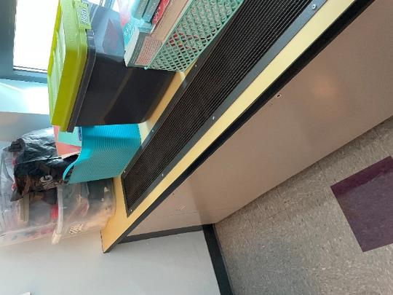
Unit ventilator
Picture 2
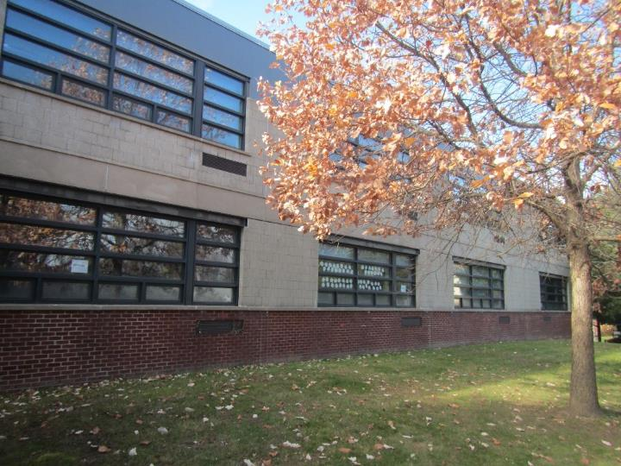
Unit ventilator intake vents

Picture 3
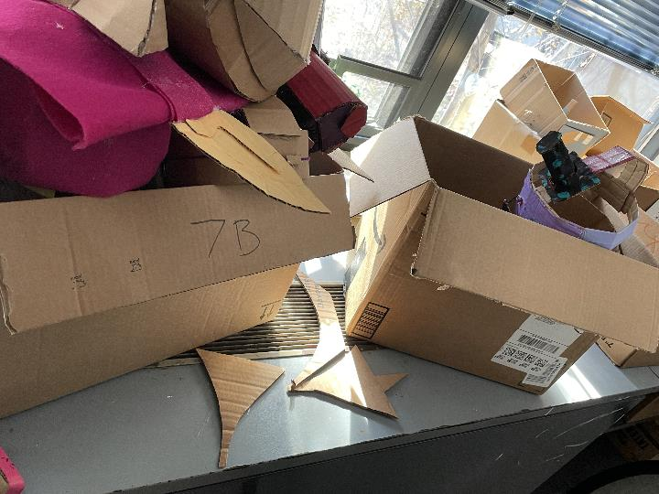
Univent blocked with boxes
Picture 4
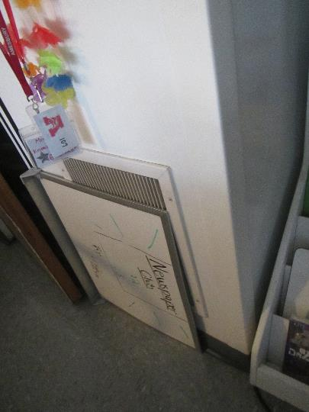
Wall-mounted exhaust vent, note items in front

Picture 5
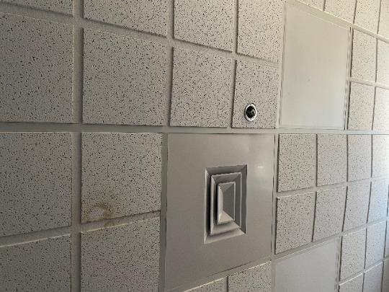
One style of ceiling-mounted supply vent, note sagging/bowed ceiling tiles
Picture 6
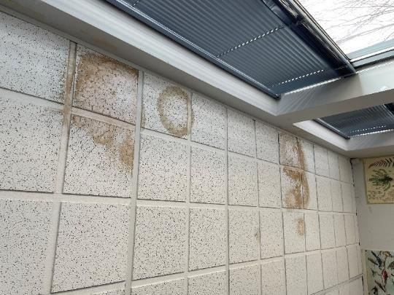
Water-damaged ceiling tiles

Picture 7
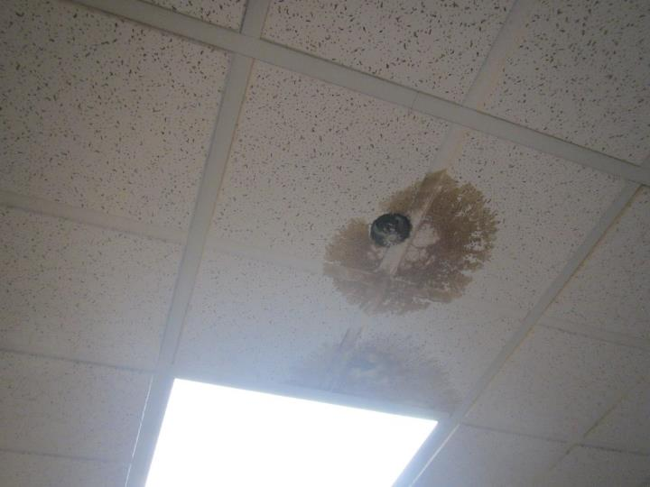
Water-damaged ceiling tiles
Picture 8
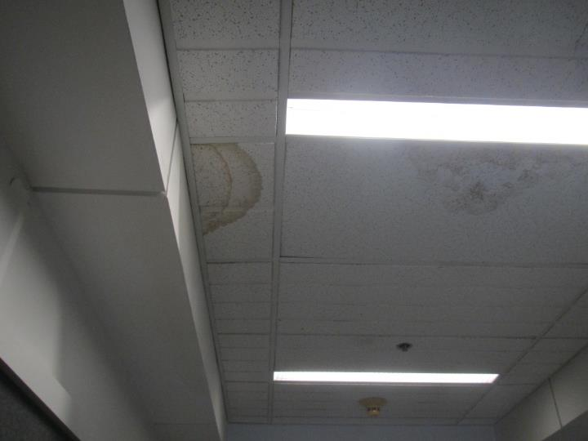
Water-damaged ceiling tiles

Picture 9
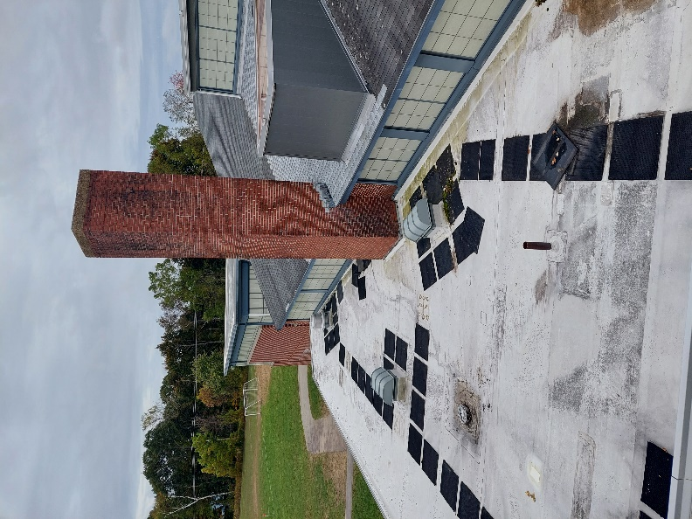
Peaked roof which can drop water and ice onto flat roof
Picture 10
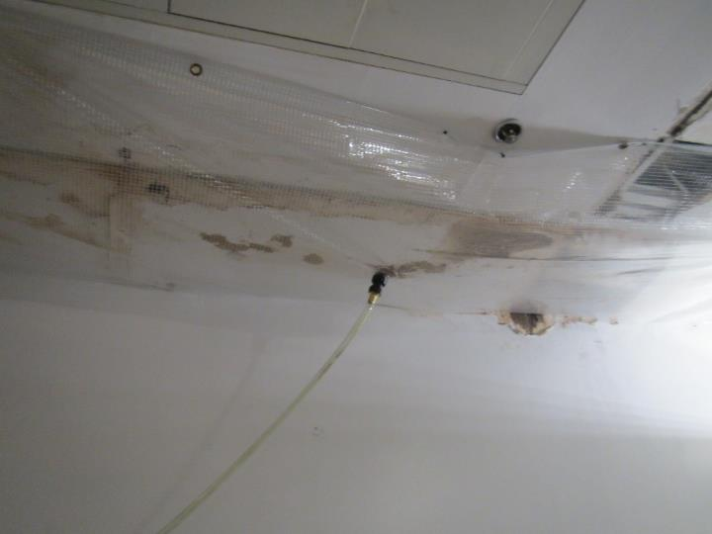
Water collection plastic with tube to direct water to bucket/barrel

Picture 11
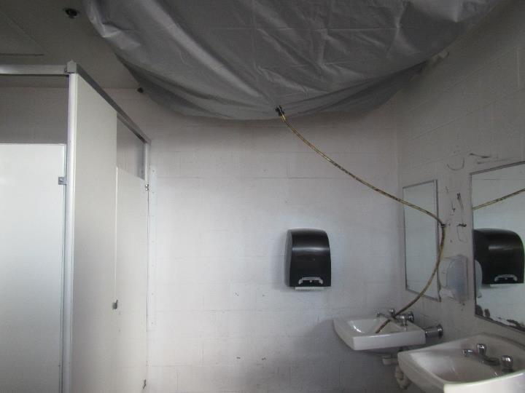
Water collection plastic emptying into a sink in the boy’s locker room
Picture 12
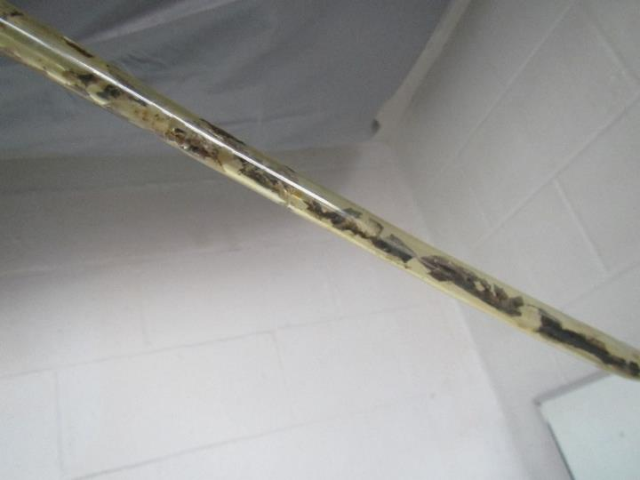
Leaf debris inside a plastic collection tube

Picture 13
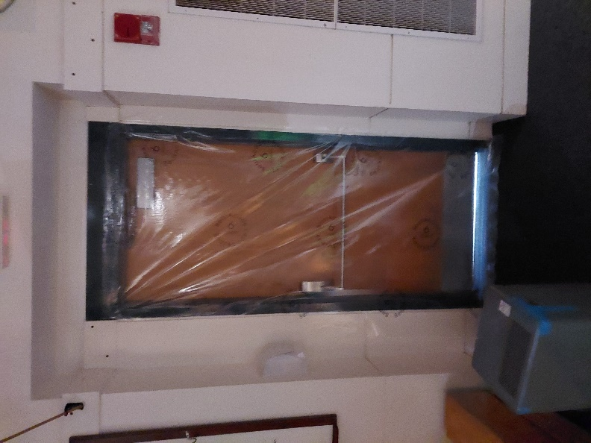
Plastic sealing the auditorium door, note light under door showing gap
Picture 14
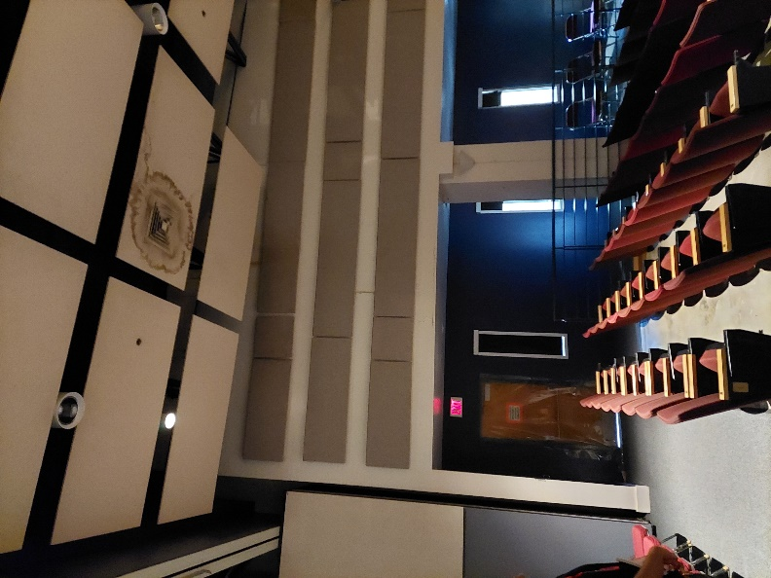
Water-damaged ceiling panels next to air supply in the auditorium

Picture 15
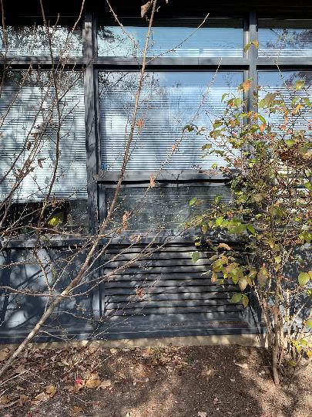
Plant next to univent air intake
Picture 16
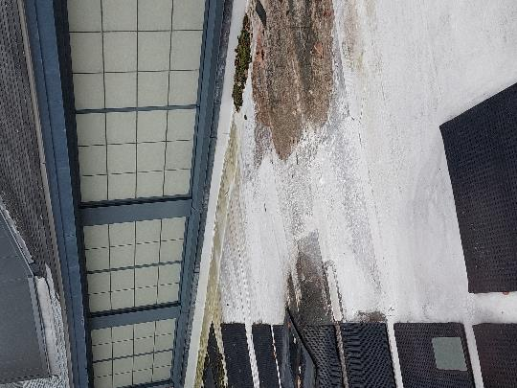
Pooling water, leaves, debris and moss on the roof

Picture 17
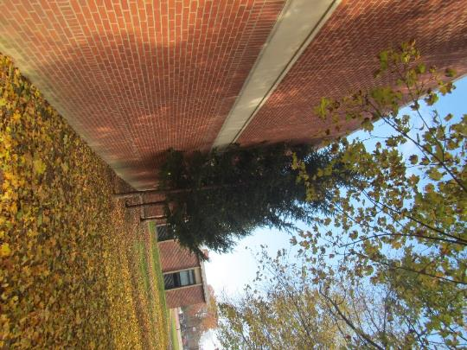
Large trees next to the building
Picture 18
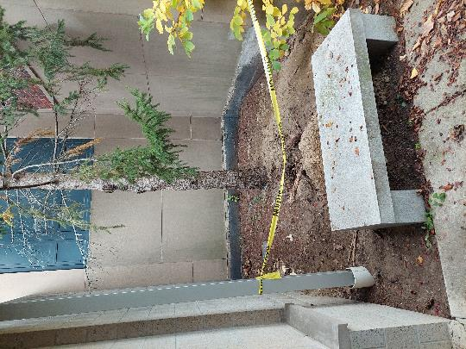
Soil disturbance caused by tree roots

Picture 19

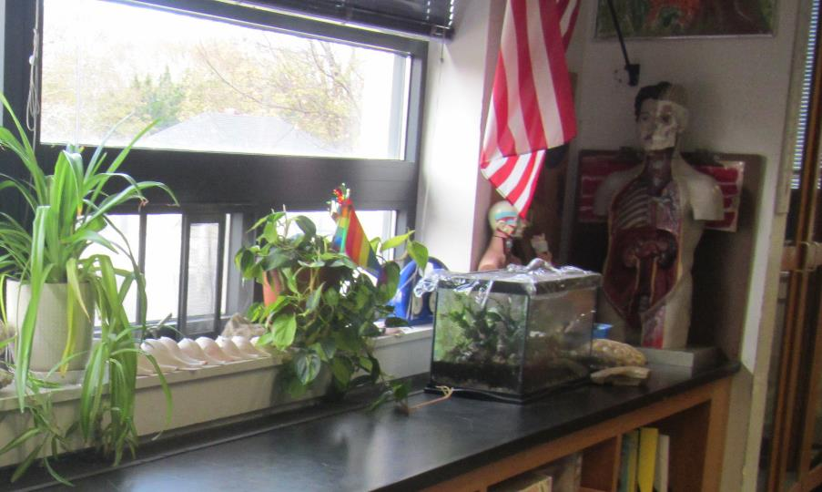
Aquarium in a classroom
Picture 20
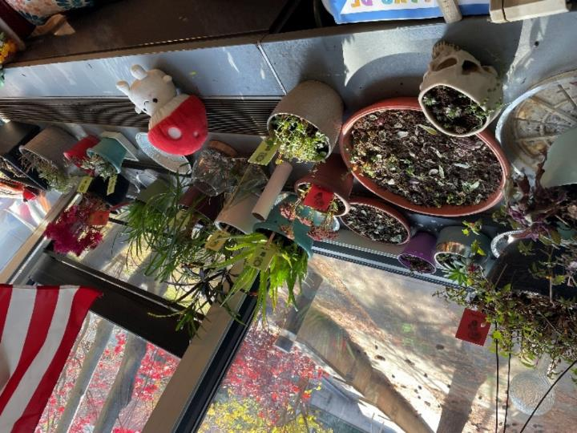
Plants in a classroom, including on the univent
Picture 21
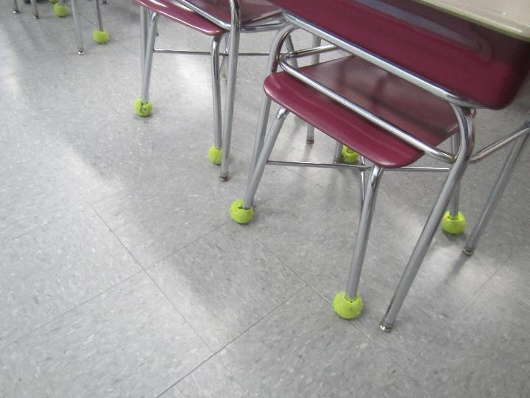
Tennis balls used as chair glides

Picture 22
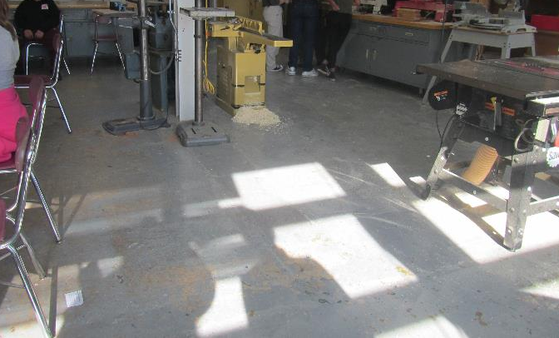
Wood shop
Picture 23
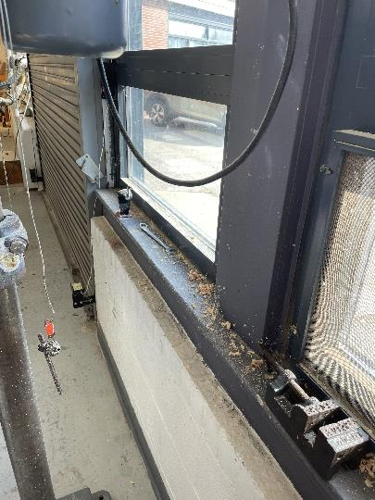
Dust and debris on surfaces in the wood shop
Picture 24
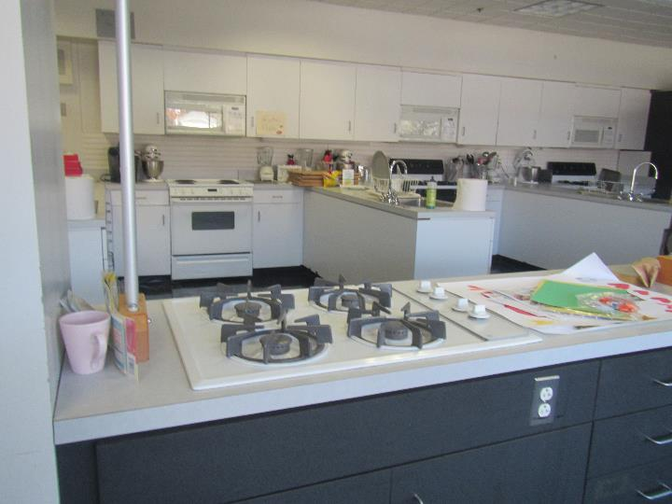
Gas stove without vent, note other electric and gas stoves in the background

Picture 25
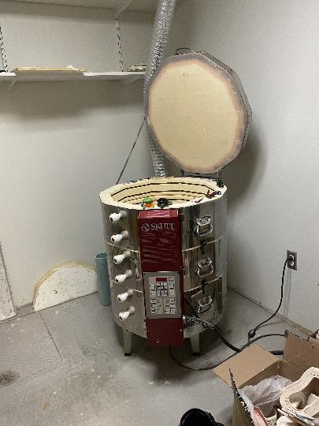
Pottery kiln
Picture 26
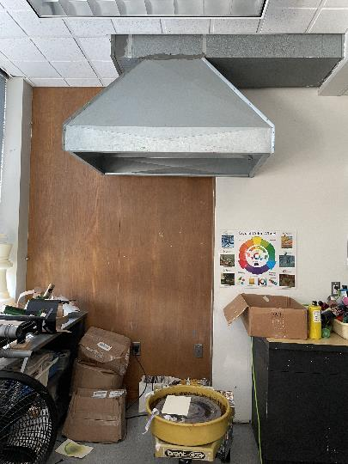
Exhaust vent, likely previous location of kiln

Picture 27
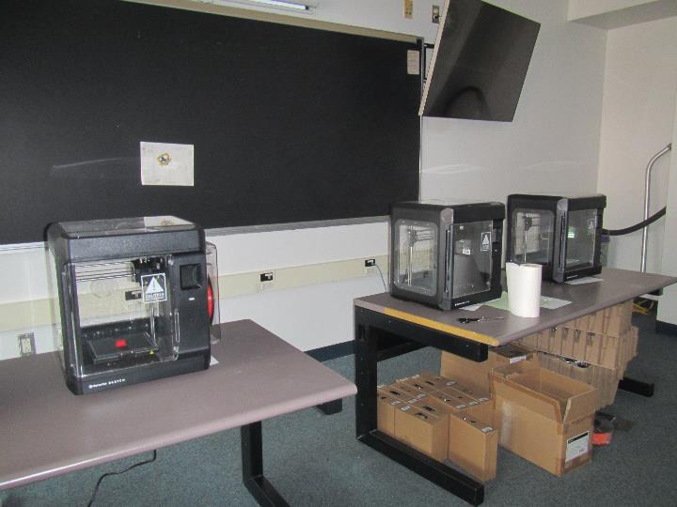
3-D printers
Picture 28
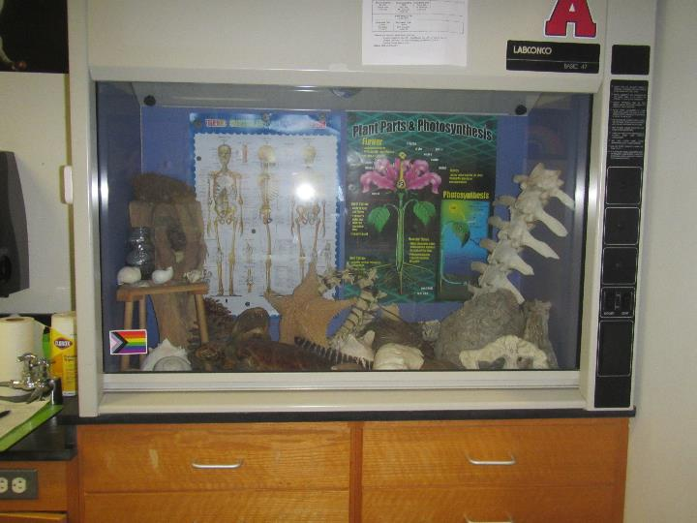
Vent hood used as display cabinet
Location/ Room | Temp  (°F) | Relative  Humidity  (%)
Background (outside) | 67 | 73
200 | 72 | 64
200 | 71 | 66
200 | 71 | 66
201 | 70 | 65
201 | 70 | 65
202 | 71 | 63
202 | 71 | 63
203 | 71 | 66
203 | 71 | 66
203 | 71 | 66
204 | 72 | 63
204 | 72 | 64
205 | 72 | 64
205 | 72 | 64
206 | 72 | 62
206 | 71 | 62
208 | 71 | 61
209 | 72 | 59
210 | 71 | 62
210 | 71 | 62
212 | 71 | 61
213 | 71 | 61
214 | 71 | 63
215 | 71 | 64
216 | 70 | 64
218 | 71 | 63
220 | 72 | 62
222 | 71 | 61
Auditorium | 69 | 57
Auditorium spotlight room | 69 | 57
Library | 70 | 61
Library hall | 71 | 62
Library lotus room | 71 | 61
Professional library | 71 | 62

Location/ Room | Carbon  Dioxide  (ppm) | Carbon Monoxide  (ppm) | Temp  (°F) | Relative  Humidity  (%) | PM2.5  (µg/m³) | Occupants  in Room | Windows  Openable | Ventilation |  | Remarks
 |  |  |  |  |  |  |  | Supply | Exhaust
Background (outside) | 370 | ND | 43 | 58 | 8 |  |  |  |  | Clear and cold
100 series rooms
100 | 1274 | ND | 72 | 46 | ND | 23 | Y | Y | Y | Bowed CTs, aquarium, sink
100 block girls restroom |  |  |  |  |  |  |  |  | Y | Signs of humidity, no WD
101 science | 757 | ND | 69 | 36 | 3 | 14 | Y | Y | Y | Exhaust part blocked, DEM, science sinks, PFs
102 | 1122 | ND | 72 | 43 | ND | 19 | Y | Y | Y | Bowed CTs, sanitizers
103 | 717 | ND | 72 | 34 | 4 | 14 | Y | Y | Y | Plant, TBs
104 | 952 | ND | 72 | 40 | ND | 14 | Y | Y | Y | Bowed CTs
105 | 697 | ND | 73 | 33 | 4 | 12 | Y | Y | Y | Chalk, fan/AP
106 | 946 | ND | 72 | 43 | ND | 15 | Y | Y | Y | Bowed CTs, area rug
107 | 870 | ND | 75 | 33 | 4 | 16 | Y open | Y | Y | Exhaust blocked, DEM, HS, plants
109 | 615 | ND | 75 | 30 | 2 | 10 | Y | Y | Y
111 | 636 | ND | 74 | 31 | 3 | 0 | Y | Y | Y | Connected to 109 by open partly divider, DEM, exhaust off
112 | 733 | ND | 73 | 47 | 2 | 5 | Y | Y | Y | Sink, PF
113- art room | 728 | ND | 73 | 42 | ND | 0 | Y | Y | Y | Clutter, blocked univents, kiln
114 | 509 | ND | 72 | 42 | 1 | 0 | Y | Y | y
115-art room | 694 | ND | 73 | 43 | ND | 0 | Y | Y | Y | Sink, plants
116 | 434 | ND | 73 | 31 | 3 | 0 | Y | Y | Y | DEM
118 | 480 | ND | 73 | 31 | 2 | 2 | Y | Y | Y | DEM
200 series rooms
200 | 1355 | ND | 71 | 47 | ND | 14 | Y | Y | Y | Plant garden tower, sinks
200 block student restrooms (boys and girls) |  |  |  |  |  |  | N | N | Y | Cleaner odor in both rooms
201 | 665 | ND | 69 | 35 | 2 | 0 | Y, 1 open | Y | Y | DEM, eyewash, sinks
202 | 1302 | ND | 71 | 46 | ND | 6 | Y | Y | Y | WD around windows
203 | 1121 | ND | 70 | 38 | 3 | 1 | Y | Y | Y
203 prep room | 1103 | ND | 70 | 38 | ND | 0 | Y | Y | Y | WD ceiling plaster, microwave, skylight, sink, fridge
204 | 1079 | ND | 72 | 43 | ND | 5 | Y | Y | Y | Buckets collecting water coming off windows
205 | 776 | ND | 71 | 35 | ND | 0 | Y | Y | Y | Connected to 203 with mostly closed divider, DEM, exhaust weak or off, univent half blocked
206 | 1388 | ND | 72 | 46 | ND | 9 | Y | Y | Y | WD CTs, carpet
207 | 945 | ND | 71 | 37 | ND | 16 | Y | Y | Y | DEM, 3 WD CT, PF
208 | 1100 | ND | 71 | 42 | ND | 14 | Y | Y | Y | Bowed CTs, carpet, WD CTs
209 adjacent to library | 576 | ND | 72 | 31 | ND | 0 | Y | Y off | Y on | 4 3D printers, carpet, 4 WD CT
210 | 890 | ND | 70 | 41 | ND | 2 | Y | Y | Y | WD CTs, bowed CTs, carpet
211 | 603 | ND | 73 | 34 | 4 | 10 | Y | Y | Y | PF, plants, DEM
212 | 545 | ND | 75 | 36 | ND | 1 | Y | Y | Y | Bowed CTs
213 | 820 | ND | 73 | 34 | 2 | 23 | Y | Y | Y | Sinks, WD ceiling, eyewash, PF, water capture plastic on ceiling
214 | 617 | ND | 75 | 36 | ND | 4 | Y | Y | Y | Bowed CTs, soft furnishings
215 | 769 | ND | 73 | 35 | 3 | 20 | Y | Y | Y | Univent blocked, Eyewash, WD CT, PF
216 | 712 | ND | 74 | 38 | ND | 0 | Y | Y | Y | Soft furnishings
218 | 667 | ND | 74 | 38 | ND | 2 | Y | Y | Y | WD around windows
220 | 882 | ND | 74 | 33 | 3 | 4 | Y | Y | Y | DEM and chalk, unit exhausts
222 | 859 | ND | 74 | 34 | 3 | 13 | Y | Y | Y | DEM and chalk, unit exhausts
Hallway outside library |  |  |  |  |  |  |  |  |  | Many WD CT and a collection tile
Librarian office | 762 | ND | 69 | 38 | ND | 0 | Y | Y | N | WD CT, carpet
Librarian workroom | 732 | ND | 69 | 38 | ND | 0 | N | N | Y | Open to the librarian’s office as one room, sink over carpet, WD CT
Library main area | 801 | ND | 70 | 37 | ND | 25 | Y | Y | Y | Carpet, books, aquarium
Library table area | 750 | ND | 71 | 36 | ND | 0 | Y | Y | Y | Carpet, books
Professional library | 592 | ND | 71 | 34 | 2 | 1 | Y | Y | Y | Carpet, several WD CT
Staff restroom |  |  |  |  |  |  |  |  | Y | Cleaner odor
300 series rooms
300 | 580 | ND | 71 | 35 | 3 | 0 | Y | Y | Y | Exhaust blocked, aquarium, lab hood used as display cabinet, class left 1 hour ago
300 block girls restroom |  |  |  |  |  |  |  |  | Y | WD plaster
301 | 599 | ND | 71 | 34 | 3 | 2 | Y | Y | Y | Class left 1 hour ago, DEM, many aquariums, and plants
302 | 750 | ND | 71 | 41 | ND | 1 | Y | Y | Y | WD CTs
303 | 631 | ND | 73 | 34 | 2 | 1 | Y | Y | Y | Class left 1 hour ago, DEM
304 | 877 | ND | 72 | 43 | ND | 0 | Y | Y | Y | Bowed CTs, blocked univents
305 | 634 | ND | 71 | 34 | 1 | 1 | Y | Y | Y | exhaust weak, class left 1 hour ago, DEM
306 | 970 | ND | 71 | 42 | ND | 0 | Y | Y | Y | Bowed CTs, blocked univents
307 | 566 | ND | 71 | 34 | 2 | 0 | Y | Y | Y | DEM
308 | 720 | ND | 72 | 41 | ND | 2 | Y | Y | Y | Bowed CTs
400s
400 | 661 | ND | 70 | 43 | ND | 0 | Y | Y | Y | WD CTs, WD around windows
401 |  |  |  |  |  | 0 | Y | Y | Y | Most of this wing is empty
402 | 673 | ND | 70 | 43 | ND | 0 | Y | Y | Y | WD CTs, roof leak collection system
403 |  |  |  |  |  | 0 | Y | Y | Y | Many WD CTs
404 | 805 | ND | 70 | 43 | ND | 0 | Y | Y | Y | WD around windows
405 | 651 | ND | 71 | 37 | 1 | 3 | Y | Y | Y | Chalk, DEM, dusty PF
406 | 655 | ND | 70 | 42 | ND | 0 | Y | Y | Y
407 | 655 | ND | 71 | 35 | 2 | 0 | Y | Y | Y
408 | 549 | ND | 73 | 34 | 1 | 0 | Y | Y | Y | Exhaust off, room feels hot, plants
Gym
Gym | 639 | ND | 72 | 36 | 3 | 14 | N (doors) | Y | Y | WD CT and collection
PE Storage |  |  |  |  |  |  |  | N | N | WD and damaged tiles
PE office, boys side | 583 | ND | 73 | 236 | 2 | 0 | Y |  | N | Food, shower
Locker rooms  (boys and girls) |  |  |  |  |  |  |  |  |  | Multiple WD CT and plaster, water catchers, likely unused drains
Tech/utility hallway
Life skills | 602 | ND | 72 | 34 | 2 | 8 | Y | Y | Y | DEM, flowers
Life skills | 530 | ND | 72 | 32 | 3 | 1 | Y | Y | Y | Gas stoves and electric stoves, some gas stoves have no hood, others have recirculating hoods, dryer is vented to outdoors
Cafeteria | 667 | ND | 68 | 38 | 4 | 0 | N |  |  | Dusty CTs, bowed CT
Tech A | 557 | ND | 68 | 36 | 4 | 0 | Y | N | N | Empty
Tech office | 498 | ND | 69 | 34 | 3 | 0 | N | N | Y
Special Education | 448 | ND | 71 | 31 | 1 | 0 | N | Y |  | Ceiling-mounted univent, mats, sinks
Tech Education B | 615 | ND | 72 | 41 | ND | 0 | N/A | Y | Y | Sink
Wood shop | 689 | ND | 72 | 41 | ND | 12 | Y | Y | Y | Wood dust/wood chips
Main office area
Nurse | 568 | ND | 72 | 33 | 3 | 2 | Y | Y | Y | Sink, fridges
Asst. Principal | 536 | ND | 77 | 30 | 3 | 0 | Y | Y | Y | Hot, plant, DEM, bowed CT
Counselor | 487 | ND | 76 | 27 | 1 | 0 | Y 1 open | Y | Y | DEM
108 office | 467 | ND | 75 | 33 | 3 | 0 | Y | Y | N
Calm room | 558 | ND | 74 | 36 | 4 | 0 | N | ? | ? | No vents located
Main office | 536 | ND | 71 | 32 | 2 | 2 | Y | Y | Y
Principal’s office | 506 | ND | 70 | 32 | 1 | 1 | Y | Y | Y
Counselor | 603 | ND | 69 | 42 | ND | 0 | Y | Y | Y | WD CTs, Bowed CTs, WD around window

The service life is the median time during which a particular system or component of …[an HVAC]… system remains in its original service application and then is replaced. Replacement may occur for any reason, including, but not limited to, failure, general obsolescence, reduced reliability, excessive maintenance cost, and changed system requirements due to such influences as building characteristics or energy prices (ASHRAE, 1991).

