INDOOR AIR QUALITY ASSESSMENT

Amesbury Public Library
139 Main Street
Amesbury, Massachusetts

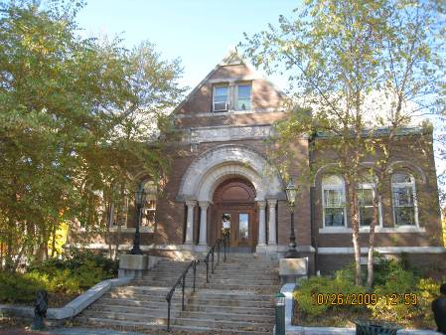

Prepared by:
Massachusetts Department of Public Health
Bureau of Environmental Health
Indoor Air Quality Program
March 2010

Background/Introduction
At the request of the Amesbury Board of Health and Amesbury Public Library Trustees, the Massachusetts Department of Public Health (MDPH), Bureau of Environmental Health (BEH) provided assistance and consultation regarding indoor air quality (IAQ) at the Amesbury Public Library (APL), located at 149 Main Street, Amesbury, Massachusetts. Concerns about mold growth subsequent to flooding of the building prompted the assessment. Heavy rain had reportedly penetrated the building, creating a flood in a converted office area in the lowest level of the library addition (Picture 1). Following the flooding incident, carpeting was reportedly replaced and other water-damaged materials removed. On October 26, 2009, a visit was made to this building by Michael Feeney, Director of the BEH’s IAQ Program and Sharon Lee, an Environmental Analyst/Inspector for BEH’s IAQ Program.
The APL is a two-story, brown brick building constructed in 1901 (Picture 2). The basement of the original building previously housed the mechanical ventilation room, boiler room and a common area. The area has since been remodeled and the mechanical room was converted into carpeted office space. In addition to office space and the boiler room, the basement of the original building also includes a reading room, staff kitchen and restrooms. A three level book stack wing (the stacks) was added to the north wall of the building in the 1950s (Picture 3). When the basement/lower level of the stacks was remodeled, wood paneling was installed over the original cement foundation walls (Picture 4). A large environmentally controlled document storage vault is also located in the lower level of the stacks (Picture 5). The purpose of the vault is to provide a controlled environment with optimal temperature and humidity to store delicate historical documents. The control system for the document storage vault was not operating at the time of the assessment, and reportedly has not functioned for some time. Windows are openable throughout the building.

Methods
Air tests for carbon monoxide, carbon dioxide, temperature and relative humidity were conducted with the TSI, Q-Trak, IAQ Monitor, Model 8554. Air tests for airborne particle matter with a diameter less than 2.5 micrometers were taken with the TSI, DUSTTRAK™ Aerosol Monitor Model 8520. BEH staff also performed visual inspection of building materials for water damage and/or microbial growth.

Results
The APL is staffed by approximately 6 employees, and can be visited up to 200 individuals on a daily basis. Tests were taken under normal operating conditions, and results appear in Table 1.

Discussion

Ventilation
It can be seen from Table 1 that carbon dioxide levels were below 800 parts per million (ppm) in all areas indicating adequate air exchange at the time of the assessment. It is important to note that although air exchange appeared adequate, the APL does not have a functioning mechanical ventilation system. The APL’s original natural/gravity feed ventilation system has been abandoned, thus the sole source of ventilation in the building is openable windows. In addition, a number of areas were empty/sparsely populated, which can greatly reduce carbon dioxide levels. Carbon dioxide levels would be expected to increase with higher occupancy and windows closed.
Ventilation in the original building was provided by grated, louvered wall vents (Picture 6). The vents are connected by a ventilation shaft to vault-like “air-mixing” rooms in the basement. The draw of air into these vents is controlled by a draw chain pulley system. The chains of the pulley system were designed to set the flue in the ventilation shaft at a desired angle to adjust fresh air intake.
Air movement is provided by the stack effect. Heating elements located in the base of the ventilation shaft warm the air, which rises up the ventilation shaft. As heated air rises, negative pressure is created, drawing cold air from the enclosed air-mixing rooms in the basement into the heating elements/ventilation shaft. This system was designed to draw outside air into the air-mixing rooms through windows. The percentage of fresh air is controlled by a sash window in the air mixing rooms.
As mentioned previously, the ventilation system has been abandoned, and the air-mixing rooms have been converted to office space. Without a functioning ventilation system, normally occurring environmental pollutants can build up. If this system remains abandoned, care should be taken to ensure ventilation shafts are rendered airtight in the library, in the basement air-mixing rooms and at the top of abandoned chimney/ventilation stacks to prevent the egress/movement of particulates, pests and drafts into occupied areas. Relative to the flooding incident, moisture and other odors could also migrate to occupied areas via this abandoned vent system.
Currently, ventilation in both the original APL and the addition is controlled by the use of openable windows. Rooms were originally configured in a manner to use cross-ventilation to provide comfort for building occupants. The building is equipped with windows on opposing exterior walls. This design allows for airflow to enter an open window, pass through a room and subsequently pass through the open window on the opposite side of the room on the leeward side (opposite the windward side) (Figure 1). This system fails if the windows are closed (Figure 2).
Of note was the presence of ceiling-mounted air diffusers in the suspended ceiling of the original building (Picture 7). This type of air diffuser is typically used to supply air from a mechanical ventilation system. BEH staff traced the flexible ductwork (Picture 8) back to vents opening in the boiler room (Picture 9). The flexible ducts are not connected to a mechanical system. It appears that this combination of flexible ductwork and diffusers may be a method to passively provide heated air to the basement area. However, this duct system appears to breach the fire integrity of the boiler room wall, providing a ready pathway for fire to spread into the ceiling plenum of the lowest level of the APL.
Restrooms in the lowest level appear to vent directly outdoors. The restroom in the uppermost floor of the original building, vents into the attic space (Picture 10). Exhaust ventilation is necessary in restrooms to remove excess moisture and prevent restroom odors from penetrating into adjacent areas. Bathroom exhausts should be vented to the outdoors.
The Massachusetts Building Code requires that each room have a minimum ventilation rate of 15 cubic feet per minute (cfm) per occupant of fresh outside air or openable windows (SBBRS, 1997; BOCA, 1993). The ventilation must be on at all times that the room is occupied. Providing adequate fresh air ventilation with open windows and maintaining the temperature in the comfort range during the cold weather season is impractical. Mechanical ventilation is usually required to provide adequate fresh air ventilation.
Carbon dioxide is not a problem in and of itself. It is used as an indicator of the adequacy of the fresh air ventilation. As carbon dioxide levels rise, it indicates that the ventilating system is malfunctioning or the design occupancy of the room is being exceeded. When this happens, a buildup of common indoor air pollutants can occur, leading to discomfort or health complaints. The Occupational Safety and Health Administration (OSHA) standard for carbon dioxide is 5,000 parts per million parts of air (ppm). Workers may be exposed to this level for 40 hours/week, based on a time-weighted average (OSHA, 1997).
The MDPH uses a guideline of 800 ppm for publicly occupied buildings. A guideline of 600 ppm or less is preferred in classrooms due to the fact that the majority of occupants are young and considered to be a more sensitive population in the evaluation of environmental health status. Inadequate ventilation and/or elevated temperatures are major causes of complaints such as respiratory, eye, nose and throat irritation, lethargy and headaches. For more information concerning carbon dioxide, consult Appendix A.
Temperature measurements ranged from 68° F to 72° F, which were within or close to the lower end of the MDPH recommended range (Table 1). The MDPH recommends that indoor air temperatures be maintained in a range of 70o F to 78o F in order to provide for the comfort of building occupants. In many cases concerning indoor air quality, fluctuations of temperature in occupied spaces are typically experienced, even in a building with an adequate fresh air supply. In addition, it is difficult to control temperature and maintain comfort without a functioning ventilation system.
The relative humidity measured in the building ranged from 31 to 41 percent at the time of the assessment, which was below the MDPH recommended comfort range in a number of areas (Table 1). The MDPH recommends a comfort range of 40 to 60 percent for indoor air relative humidity. Relative humidity levels in the building would be expected to drop during the winter months due to heating. The sensation of dryness and irritation is common in a low relative humidity environment. Low relative humidity is a very common problem during the heating season in the northeast part of the United States.

Microbial/Moisture Concerns
As discussed, a heavy rain event resulted in flooding/water damage to building materials (i.e., carpeting) and paper materials (i.e., books, files). Prior to the assessment, water-damaged building materials were reportedly removed and replaced in the basement/lower level of the building. At the time of the assessment, new carpeting had been installed in the converted office space. It is important to note that since the floor of the lowest level is likely constructed without a vapor barrier and the area seems to be prone to flooding, the use of carpeting is not recommended. Consideration should be given to replacing carpeting with a non-porous flooring material (i.e., tile) in the future.
Water-damaged wall plaster, peeling paint and other moisture indicators were observed in a number of areas throughout the building. In the uppermost level, such damage to plaster is likely associated to roof leaks (Picture 11). While plaster is not likely to grow mold, repeated water damage can lead to its deterioration. Most notable was efflorescence observed on the foundation brick wall in the lower level (Pictures 12). Efflorescence is a characteristic sign of water damage to brick and mortar, but it is not mold growth. As moisture penetrates and works its way through mortar, brick or plaster, water-soluble compounds dissolve, creating a solution. As the solution moves to the surface of the material, the water evaporates, leaving behind white, powdery mineral deposits. Water damage in this area is most likely the result of water penetration through the building envelope (foundation and exterior brick). The most obvious source of the moisture appears to be downspouts from the roof emptying at the base of the building.
It appears that at one point a sloped cement apron lined the edge of the building to aid in the drainage of rainwater away from the foundation (Picture 13). Over the years, the surrounding lawn has grown over the building’s cement apron (Picture 14). The grassy surface can both hold water against the foundation and form a natural trough for rain to puddle against the building. These conditions present potential moisture penetration sources. Over time, these conditions can undermine the integrity of the building envelope and provide a means of water entry into the building via capillary action through foundation concrete and masonry (Lstiburek & Brennan, 2001). The freezing and thawing of water during winter months can lead to further damage and subsequent water penetration into the interior of the building. In addition, these breaches may provide a means for pests/rodents into the building.
With water readily travelling through the foundation walls, it is also likely that moisture is affecting various building materials in the basement. Upon entering the lowest level of the stack wing, a distinct musty odor was noted. The source of the odor was tracked to a utility room, which is formed by a wall of wood paneling and the foundation of the original building. The interior wall space appears to be one that is chronically moistened (Picture 4), which can lead to mold growth in the wood paneling and gypsum wallboard (Picture 15). Since the utility room had such a distinct musty odor, it is likely that these materials have become mold colonized and should be removed.
The US Environmental Protection Agency (US EPA) and the American Conference of Governmental Industrial Hygienists (ACGIH) recommend that porous materials be dried with fans and heating within 24 to 48 hours of becoming wet (US EPA, 2001; ACGIH, 1989). If not dried within this time frame, mold growth may occur. Once mold has colonized porous materials, they are difficult to clean and should be removed/discarded.

Other IAQ Evaluations
Indoor air quality can be negatively influenced by the presence of respiratory irritants, such as products of combustion. The process of combustion produces a number of pollutants. Common combustion emissions include carbon monoxide, carbon dioxide, water vapor and smoke (fine airborne particle material). Of these materials, exposure to carbon monoxide and particulate matter with a diameter of 2.5 micrometers (μm) or less (PM2.5) can produce immediate, acute health effects upon exposure. To determine whether combustion products were present indoors, BEH staff obtained measurements for carbon monoxide and PM2.5.

Carbon Monoxide
Carbon monoxide is a by-product of incomplete combustion of organic matter (e.g., gasoline, wood and tobacco). Exposure to carbon monoxide can produce immediate and acute health affects. Several air quality standards have been established to address carbon monoxide and prevent symptoms from exposure to these substances. The MDPH established a corrective action level concerning carbon monoxide in ice skating rinks that use fossil-fueled ice resurfacing equipment. If an operator of an indoor ice rink measures a carbon monoxide level over 30 ppm, taken 20 minutes after resurfacing within a rink, that operator must take actions to reduce carbon monoxide levels (MDPH, 1997).
The American Society of Heating Refrigeration and Air-Conditioning Engineers (ASHRAE) has adopted the National Ambient Air Quality Standards (NAAQS) as one set of criteria for assessing indoor air quality and monitoring of fresh air introduced by HVAC systems (ASHRAE, 1989). The NAAQS are standards established by the US EPA to protect the public health from six criteria pollutants, including carbon monoxide and particulate matter (US EPA, 2006). As recommended by ASHRAE, pollutant levels of fresh air introduced to a building should not exceed the NAAQS levels (ASHRAE, 1989). The NAAQS were adopted by reference in the Building Officials & Code Administrators (BOCA) National Mechanical Code of 1993 (BOCA, 1993), which is now an HVAC standard included in the Massachusetts State Building Code (SBBRS, 1997). According to the NAAQS, carbon monoxide levels in outdoor air should not exceed 9 ppm in an eight-hour average (US EPA, 2006).
Carbon monoxide should not be present in a typical, indoor environment. If it is present, indoor carbon monoxide levels should be less than or equal to outdoor levels. On the day of the assessment, outdoor carbon monoxide concentrations were non-detect (ND). No levels of carbon monoxide were detected inside the building during the assessment (Table 1).

Particulate Matter (PM2.5)
The US EPA has established NAAQS limits for exposure to particulate matter. Particulate matter is airborne solids that can be irritating to the eyes, nose and throat. The NAAQS originally established exposure limits to particulate matter with a diameter of 10 μm or less (PM10). According to the NAAQS, PM10 levels should not exceed 150 microgram per cubic meter (μg/m³) in a 24-hour average (US EPA, 2006). These standards were adopted by both ASHRAE and BOCA. Since the issuance of the ASHRAE standard and BOCA Code, US EPA established a more protective standard for fine airborne particles. This more stringent PM2.5 standard requires outdoor air particle levels be maintained below 35 μg/m³ over a 24-hour average (US EPA, 2006). Although both the ASHRAE standard and BOCA Code adopted the PM10 standard for evaluating air quality, MDPH uses the more protective PM2.5 standard for evaluating airborne particulate matter concentrations in the indoor environment.
Outdoor PM2.5 concentrations were measured at 3 μg/m³ (Table 1). Indoor PM2.5 levels ranged from 4 to 6 μg/m³ (Table 1), which were below the NAAQS PM2.5 level of 35 μg/m³. Frequently, indoor air levels of particulates (including PM2.5) can be at higher levels than those measured outdoors. A number of mechanical devices and/or activities that occur indoors can generate particulate during normal operations. Sources of indoor airborne particulates may include but are not limited to particles generated during the operation of fan belts in the HVAC system, cooking in the cafeteria stoves and microwave ovens; use of photocopiers, fax machines and computer printing devices; operation of an ordinary vacuum cleaner and heavy foot traffic indoors. Although no measurable levels of carbon monoxide or elevated PM2.5 were detected, the potential for combustion products to migrate into occupied areas from the boiler room was observed via the flexible ducts connecting the lowest level of the APL to the boiler room.

Other Conditions
Building occupants reported problems with birds entering the attic crawlspace. During the evaluation, BEH staff observed a flying bird inside the attic a window while facing the rear of the building outdoors. BEH staff observed light penetrating into the closet when inspecting the attic, indicating a breach in the roof, which is the likely route for birds to access the interior of the building (Picture 16). Birds can be a source of disease, and bird wastes and feathers can contain mold and mildew, which can be irritating to the respiratory system. No obvious signs of bird roosting materials were seeing in closets on the second floor by BEH staff or reported by occupants.
Other conditions that can affect indoor air quality were observed during the assessment. Window-mounted air conditioners (ACs) were observed in a few areas. These units are normally equipped with filters, which should be cleaned or changed as per manufacturer’s instructions to avoid the build-up and re-aerosolization of dirt, dust and particulate matter.
It appears that insulation on a pipe in the utility room of the lowest level stacks had been removed, leaving behind a friable material (Picture 4). The pipe should be examined to determine if this material contains asbestos. Where asbestos-containing materials are found damaged, these materials should be removed or remediated in a manner consistent with Massachusetts asbestos remediation laws (MDLI, 1993).

Conclusions/Recommendations
Measures to remediate the water damage in the lower level appeared to be effective. However, the design and conditions created by converting the lowest level of the original building into occupied space has resulted in the installation of materials (e.g., wall-to-wall carpeting) that if chronically moistened will result in mold colonization. Since areas that have been carpeted are also areas that contain components for the original HVAC system, the existing ductwork serves as a possible pathway for odors to migrate from the areas that sustained water damage. The general building conditions, maintenance, work hygiene practices and the condition/abandonment of HVAC equipment, if considered individually, present conditions that could negatively impact indoor air quality. When combined, these conditions can serve to further degrade indoor air quality. For these reasons, a two-phase approach is required for remediation. The first consists of short-term measures to improve air quality and the second consists of long-term measures that will require planning and resources to adequately address the overall indoor air quality concerns.

Short-term Recommendations
- Remove water damaged/mold colonized GW in the utility room in a manner consistent with recommendations in “Mold Remediation in Schools and Commercial Buildings” published by the US Environmental Protection Agency (US EPA, 2001). This document can be downloaded from the US EPA website: http://www.epa.gov/iaq/molds/mold_remediation.html.
  - Use local exhaust ventilation and isolation/containment techniques, if possible, to control remediation pollutants. Precautions should be taken to avoid the migration of these materials into adjacent/occupied areas of the building.
  - Seal discarded mold-colonized materials in plastic trash bags for transport to prevent cross-contamination during removal from building.
  - Clean non-porous surfaces (e.g., chairs, desks, tables) with a mild detergent, soap and water or an appropriate antimicrobial agent.
  - Vacuum carpets (and other surfaces) with a high efficiency particulate arrestance (HEPA) filter equipped vacuum cleaner.
- Disconnect the flexible ductwork from the boiler room and seal breaches in the boiler room wall with a fire-rated material.
- Seal the gravity duct vents in a manner to permanently render all openings air-tight.
- Seal the breach in the roof to prevent bird entry.
- Ensure that the second floor restroom vent is ducted to the outdoors.
- For buildings in New England, periods of low relative humidity during the winter are often unavoidable. Therefore, scrupulous cleaning practices should be adopted to minimize common indoor air contaminants whose irritant effects can be enhanced when the relative humidity is low. To control for dusts, a high efficiency particulate arrestance (HEPA) filter equipped vacuum cleaner in conjunction with wet wiping of all surfaces is recommended. Avoid the use of feather dusters. If used store them away from occupied areas. Drinking water during the day can help ease some symptoms associated with a dry environment (throat and sinus irritations).
- Discard water-damaged porous materials (e.g., boxes, papers, files) that are deemed unworthy of preservation/restoration. Damaged materials that need to be recovered can be transferred to another media (e.g., microfiche or computer scanning). Where stored materials such as medical records are to be preserved, restored or otherwise handled, an evaluation should be conducted by a professional book/records conservator. The preservation/restoration process can be rather expensive and may be considered for conservation of irreplaceable documents that are colonized with mold. Due to cost of conservation, disposal or replacement of moldy materials may be the most economically feasible option.
- Consider having exterior brick foundation re-pointed and waterproofed to prevent further water intrusion. Repair/replace water-damaged interior plaster. Examine surrounding non-porous areas for mold growth and disinfect with an appropriate antimicrobial if necessary.
- Repair/replace missing/damaged sections of gutter/downspout system to direct water away from the foundation of the building.
- Remove grass and repair cement apron around the building to direct rainwater away from the foundation.
- Clean/change filters for ACs as per the manufacturer’s instructions or more frequently if needed.
- Install weather-stripping underneath boiler room/hallway doors to prevent the migration of odors and particulates.
- Contact a licensed asbestos inspector to examine the pipe in the in the utility room (Picture 4). If asbestos, take measures the remediate the condition of this pipe in a manner consistent with federal and Massachusetts laws and regulations.
- Refer to resource manuals and other related indoor air quality documents for further building-wide evaluations and advice on maintaining public buildings. These materials are located on the MDPH’s website: http://mass.gov/dph/iaq.

Long-term Recommendations
- Consider removing the wood paneling that exists in close proximity to the foundation walls.
- Consider consulting with an architect, masonry firm or general contractor regarding the integrity of the building envelope, primarily concerning water penetration through the roof/exterior walls.
- Consider replacing carpeting in lower level with a non-porous material (e.g., tile).
- Replace or make repairs to the original slate roof.

References
ACGIH. 1989. Guidelines for the Assessment of Bioaerosols in the Indoor Environment. American Conference of Governmental Industrial Hygienists, Cincinnati, OH.
ASHRAE. 1989. Ventilation for Acceptable Indoor Air Quality. American Society of Heating, Refrigeration and Air Conditioning Engineers. ANSI/ASHRAE 62-1989
BOCA. 1993. The BOCA National Mechanical Code/1993. 8th ed. Building Officials and Code Administrators International, Inc., Country Club Hill, IL.
Lstiburek, J. & Brennan, T. 2001. Read This Before You Design, Build or Renovate. Building Science Corporation, Westford, MA. U.S. Department of Housing and Urban Development, Region I, Boston, MA
MDPH. 1997. Requirements to Maintain Air Quality in Indoor Skating Rinks (State Sanitary Code, Chapter XI). 105 CMR 675.000. Massachusetts Department of Public Health, Boston, MA.
MDLI. 1993. Regulation of the Removal, Containment or Encapsulation of Asbestos, Appendix 2. 453 CMR 6,92(I)(i).
OSHA. 1997. Limits for Air Contaminants. Occupational Safety and Health Administration. Code of Federal Regulations. 29 C.F.R 1910.1000 Table Z-1-A.
SBBRS. 1997. Mechanical Ventilation. State Board of Building Regulations and Standards. Code of Massachusetts Regulations. 780 CMR 1209.0
US EPA. 2001. “Mold Remediation in Schools and Commercial Buildings”. Office of Air and Radiation, Indoor Environments Division, Washington, DC. EPA 402-K-01-001. March 2001. Available at: http://www.epa.gov/iaq/molds/mold_remediation.html
US EPA. 2006. National Ambient Air Quality Standards (NAAQS). US Environmental Protection Agency, Office of Air Quality Planning and Standards, Washington, DC. http://www.epa.gov/air/criteria.html.
Picture 1

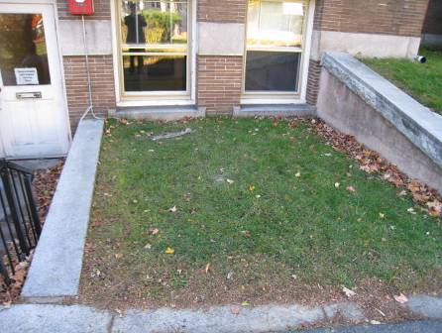

Exterior Wall of Flooded Area

Picture 2

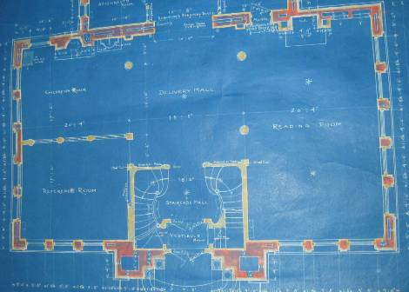

Blueprint of Original Building

Picture 3

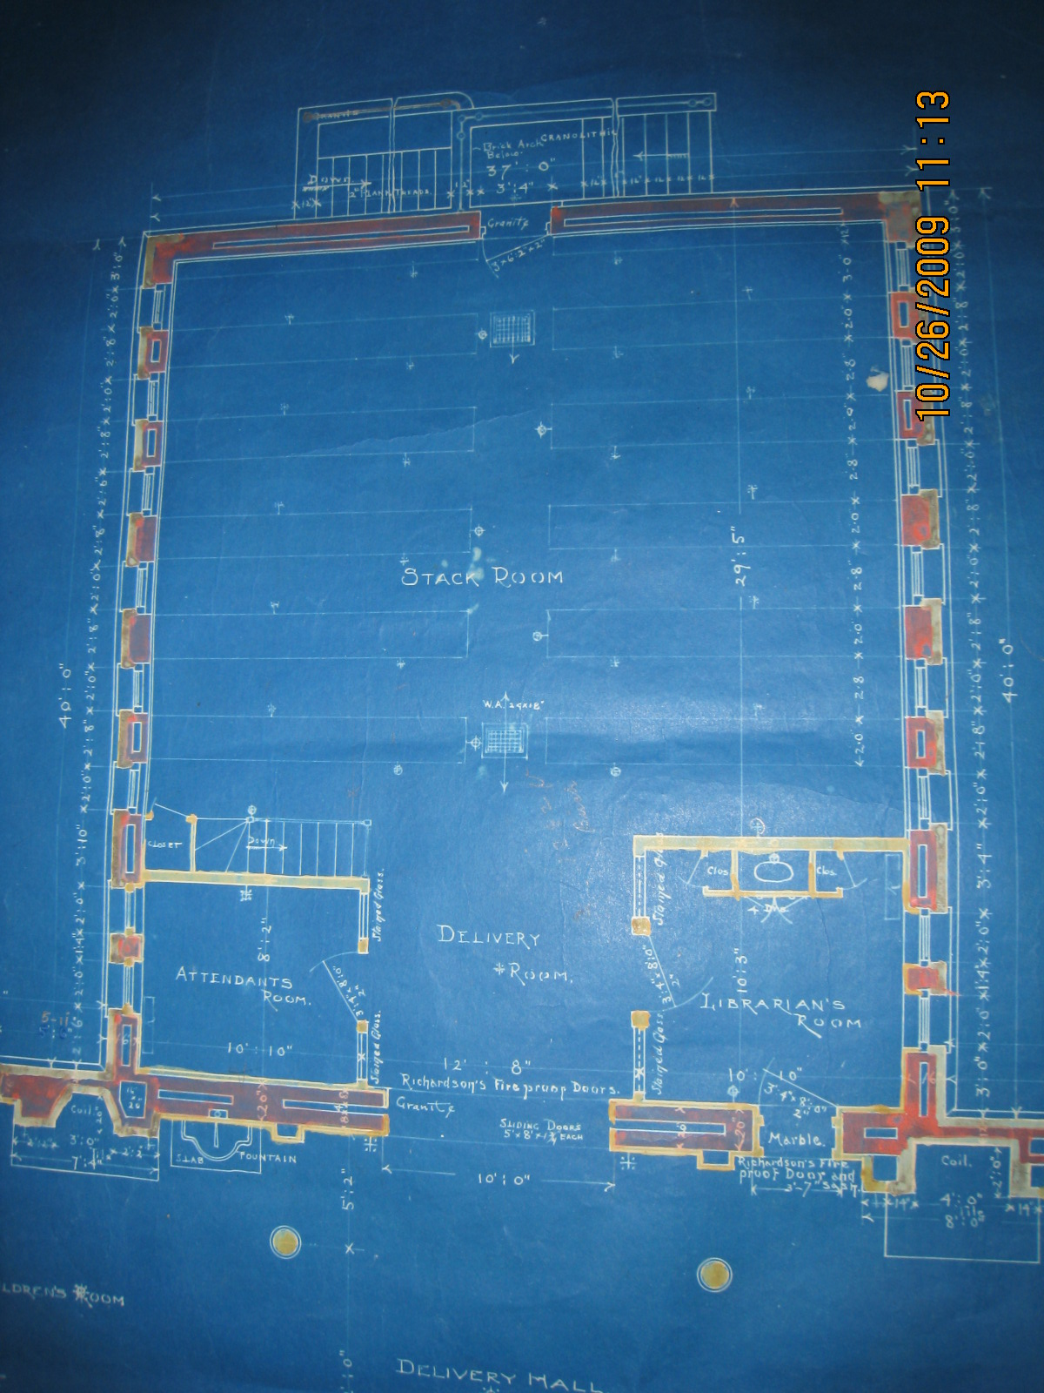

Blueprint of 1950s Addition (The Stack Wing)

Picture 4

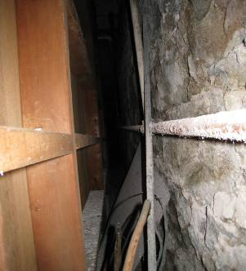

Paneling Installed Over Foundation Walls in Lowest Level of the Stack Wing,
[Note White Powdery Material on Foundation (Efflorescence) and Condition of Pipe on Right-hand Side]
Picture 5

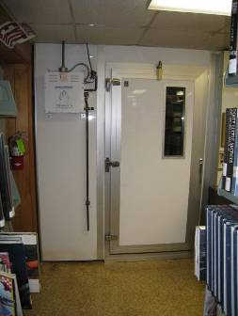

Environmentally Controlled Document Storage Vault

Picture 6

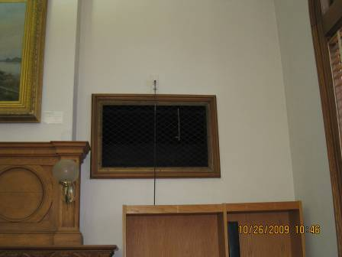

Fresh Air Supply Vent of Original System

Picture 7

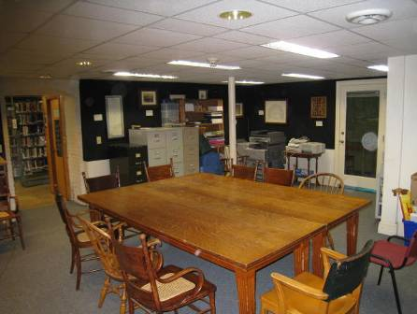

Fresh Air Diffuser on Lower Level Suspended Ceiling

Picture 8

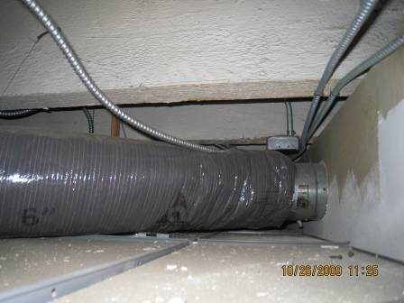

Flexible Duct in Ceiling

Picture 9

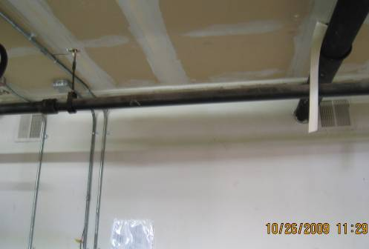

Vent in Furnace Room Connected To Ceiling Vent via the Flexible Ductwork in Picture 8

Picture 10

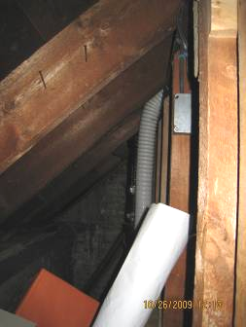

Top Floor Restroom Vent Open to Attic Space

Picture 11

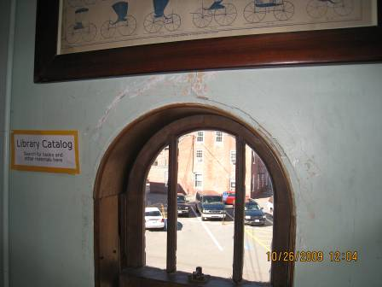

Water-Damaged Plaster

Picture 12

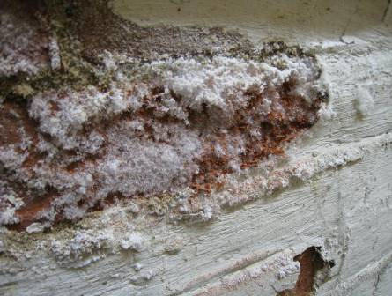

Efflorescence on brick wall

Picture 13

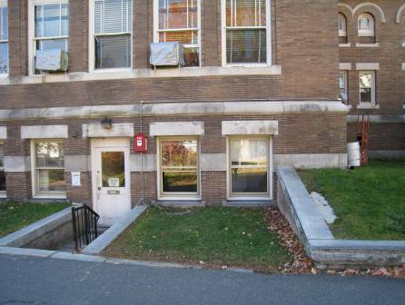

Cement Sloped Apron Overgrown With Grass

Picture 14

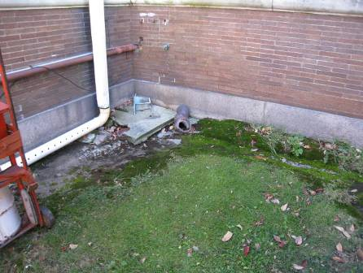

Corner of Building Overgrown With Moss

Picture 15

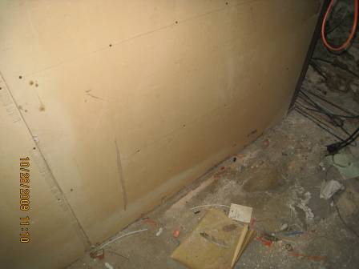

Water Damage to Paneling Wall, Note Stains and Mold Colonies

Picture 16

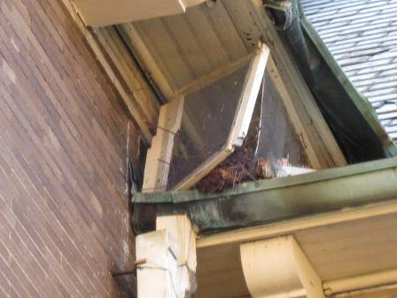

Likely Route for Birds to Access the Interior of the Building
Location | Occupants  in Room | Carbon  Dioxide  (ppm) | Temp  (°F) | Relative  Humidity  (%) | Carbon Monoxide  (ppm) | PM2.5  (µg/m3) | Windows  Openable | Ventilation |  | Remarks
 |  |  |  |  |  |  |  | Supply | Exhaust | Remarks
Background |  | 64 | 20 | 383 | ND | 3 |  |  |  | Sunny
First Floor
A/V area | 2 | 72 | 36 | 630 | ND | 4 | Y | N | N | AC
Checkout/computer area | 5 | 72 | 36 | 620 | ND | 4 | Y | N | Y  Gravity | ACs
Director’s office | 0 | 72 | 36 | 610 | ND | 4 | Y | N | N | DO, ACs
Fiction stack | 1 | 69 | 39 | 598 | ND | 5 | Y | N | N
Front hallway | 0 | 71 | 38 | 635 | ND | 4 | N | N | N | Water bubbler on carpet
Hall to fiction area | 0 | 72 | 36 | 671 | ND | 5 | N | N | N
Staff office | 0 | 72 | 36 | 620 | ND | 5 | Y | N | N | DO, ACs
Teen Scene | 0 | 72 | 36 | 647 | ND | 4 | Y | N | N | AC

Ground Floor
800-900 stacks | 0 | 69 | 34 | 584 | ND | 6 | Y | N | N | WD storage closet: moldy GW
Assistant director’s office | 0 | 68 | 35 | 603 | ND | 4 | Y | N | N
Downstairs office | 2 | 70 | 35 | 707 | ND | 6 | Y | N | N | DO, plant
Friends bookshop | 0 | 70 | 35 | 624 | ND | 5 | Y | N | N | musty
Quiet reading room | 4 | 70 | 35 | 707 | ND | 6 | N | Passive | N | Heated air supplied from boiler room
Staff room (kitchen) | 3 | 70 | 31 | 746 | ND | 5 | N | Passive | N | DO, exhaust in bathroom
Top Floor
000-700 stacks | 1 | 69 | 41 | 544 | ND | 4 | Y | N | N | Fan
Children’s room | 3 | 70 | 40 | 654 | ND | 4 | N | N | N | ACs, exhaust in bathroom, birds in closet
YA fiction | 0 | 69 | 41 | 531 | ND | 4 | Y | N | N

