INDOOR AIR QUALITY ASSESSMENT

Amherst Department of Public Works
586 South Pleasant Street
Amherst, MA

October 2025

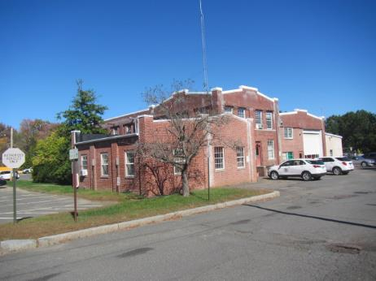

Prepared by:
Massachusetts Department of Public Health
Bureau of Climate and Environmental Health
Division of Environmental Health Regulations and Standards

Contents

EXECUTIVE SUMMARY 3
BACKGROUND 4
RESULTS AND DISCUSSION 5
Ventilation 6
Water Damage and Moisture Concerns 7
Water Damage Issues 8
Sources of Respiratory Irritants/Possible Asthma Triggers 9
CONCLUSIONS AND RECOMMENDATIONS 12
REFERENCES 17
PICTURES 18
Table 1 50
Table 2A 54
Table 2B 55
Table 2C 56
Table 3 57
Table 4 59

R an EXECUTIVE SUMMARY

The Massachusetts Department of Public Health’s Division of Environmental Health Regulations and Standards (MDPH/EHRS) conducted an indoor air quality (IAQ) assessment of the Amherst Department of Public Works (ADPW) building. This assessment was requested by Amherst DPW staff for the purpose of investigating mold concerns and general IAQ complaints reported in the building. It should also be noted that concurrent to the MDPH investigation, the Division of Labor Standards, WorkPlace Safety & Health Program for Public Employees conducted their own inspection and will be issuing an independent report.
The building is reported to have chronic issues with water damage and mold growth. Water damage was occurring from both exterior/building envelope issues, as well as internal sources (leaks and condensation) which has resulted in visible mold growth on interior surfaces/items and damage to building materials. It is also important to note the heating, ventilation, and air conditioning (HVAC) system as well as local exhaust components are not well-maintained, in disrepair, or well past their service life. These conditions make it difficult to control outside airflow, temperature, and relative humidity, particularly during hot, humid, summer conditions that can lead to condensation and water damage issues. Further, the lack of proper functioning local exhaust ventilation will prevent the efficient removal of airborne pollutants typically generated in a DPW/industrial-type setting (e.g., exhaust emissions, oil & gasoline fumes, particulates, and volatile organic compounds from chemical use, plasma cutting, and welding operations).
Other building materials (e.g., carpeting, floor tiles, roof, and windows) are mostly original to the building’s construction and are also past their service life and in need of replacement. As climate change and global warming intensifies, the urgent need for modern, energy-efficient solutions becomes clear. Without significant upgrades of HVAC equipment and other interior components, building conditions and indoor air quality will continue to degrade.
Finally, the building, particularly the office and kitchen/break areas, are in severe need of cleaning. Throughout the facility surfaces were damaged, which make them difficult to clean, and/or were covered in accumulated dust and debris creating unsanitary conditions.
Based on the results of the assessment, the following primary recommendations are made:
- Work with a professional flooding/restoration firm to identify and remediate areas of water damage and mold growth.
- Remediate water-damaged/mold-colonized items and building materials using the US EPA’s “Mold Remediation in Schools and Commercial Buildings”. Available at: http://www.epa.gov/mold/mold-remediation-schools-and-commercial-buildings-guide
- Due to the age/condition of the HVAC system, consult with an HVAC engineering firm to evaluate the system for repair or replacement, particularly local exhaust components in garage and work areas.
- Make repairs to the building exterior to prevent water damage and temperature/comfort control issues.
- Operate supply and exhaust ventilation equipment continuously for air exchange and filtration during occupied hours.
- Change filters for HVAC system.
- Reduce clutter and improve cleaning and dust control, particularly in offices, breakrooms, and dining areas.
- Keep interior doors shut to create barriers within the building to prevent the free migration of work-related pollutants.
- Conduct a thorough top to bottom cleaning of all items and flat surfaces throughout the facility, with particular attention to office/work areas and kitchen, breakroom, and dining areas. Surfaces, particularly floors should be clean, dry, and smooth/waxed to ensure proper cleaning and sanitation. Due to the scope of cleaning, consider bringing in outside/professional cleaning company.
(Conclusions and Recommendations)

R an BACKGROUND
Building: | Amherst Department of Public Works (ADPW)
Address: | 586 South Pleasant Street, Amherst, Massachusetts
Assessment Requested by: | ADPW staff
Reason for Request: | Mold concerns, work-related pollutants, and general indoor air quality (IAQ)
Date of Assessment: | October 1, 2025
Massachusetts Department of Public Health/Bureau of Climate and Environmental Health/Division of Environmental Health Regulations and Standards (MDPH/BCEH/EHRS) Staff Conducting Assessment: | Cory Holmes, Senior Advisor for Indoor Air Quality Inspections, Audits, Outreach, and Training, and Thomas Murphy, Environmental Analyst, Indoor Air Quality Outreach and Education Unit
Building Description: | The ADPW is a brick, concrete, and wooden structure that was originally built as a trolly maintenance barn in the early 1900’s. Several additions and modifications have been conducted over the years, most recently in the early 2000s.
Windows: | Windows are original and are openable throughout the building.

R an RESULTS AND DISCUSSION
The following is a summary of indoor air testing results (Table 1)
- Carbon dioxide (CO₂) | a measure of the adequacy of ventilation | Levels were below the MDPH guideline of 800 parts per million (ppm) in areas surveyed. However, most areas were empty/sparsely populated at the time of inspection, which can reduce carbon dioxide levels. Carbon dioxide levels would be expected to increase with higher occupancy.
- Temperature | a measure of comfort | Was within or slightly below the MDPH recommended range of 70°F to 78°F in the areas at the time of assessment that had the exterior doors closed. Areas with the doors open to the outside such as the Mechanic Shop area were below the recommended range of 70°F to 78°F.
- Relative humidity | a measure of comfort and, when in excess for an extended period, a way to reflect the potential for mold and fungal growth | Was within the MDPH recommended range of 40 to 60% in all areas tested.
- Carbon monoxide  (CO) | a product of combustion that can result in acute and long term cardiovascular, respiratory, and neurological symptoms | Levels ranging from ND (non-detectable) to 15 ppm were measured inside the building. The level of 15 ppm was measured in the mechanic shop, where plasma cutting was occurring. Exposure to elevated levels of carbon monoxide can produce immediate and acute health effects.
- Particulate matter (PM2.5) | a way to measure inhalable particle distribution in the air | Concentrations were below the National Ambient Air Quality Standard (NAAQS) of 35 micrograms per cubic meter (μg/m³) in all areas tested except for the Mechanic Shop, Mechanic Shop Office, and Mechanic Shop Parts Room. These levels were measured during plasma cutting.
- Total Volatile Organic Compounds (TVOCs) | VOCs are carbon-containing substances that can evaporate at room temperature. Frequently, exposure to low levels of total VOCs (TVOCs) may produce eye, nose, throat and/or respiratory irritation in some sensitive individuals. | Levels ranging from ND to 4 were measured in the building. The level of 4 was measured in the mechanic shop, where plasma cutting was occurring. It is important to note that measurable levels of TVOCs may occur in an industrial work setting, however, good depressurization/ventilation techniques should be employed to minimize/reduce exposure.

Ventilation
Ventilation refers to both the supply of fresh air and the removal of stale air from a room. The introduction of fresh air into an occupied space will dilute normally occurring pollutants that are generated by occupancy and other activities. In addition, a heating, ventilation, and air conditioning (HVAC) system will remove pollutants from a building if operating appropriately.

The HVAC system consists of air handling units (AHUs) located above the ceiling tile system in the main office (Picture 1) equipped with pleated air filters (Picture 2 and 3). Conditioned outside air is provided through ceiling or wall-mounted vents (Pictures 4 and 5) and is returned to the AHUs by ducted ceiling or wall-mounted return vents (Picture 6). Also noted above the ceiling tiles was failing insulation around ductwork (Picture 7), which can compromise temperature control and lead to condensation issues and mold as evidenced by numerous water-damaged ceiling tiles, which will be discussed further in the Water Damage and Moisture Concerns section of this report. It was not clear if the AHU for the main office or other office areas had the capability to introduce fresh, outside air. The AHUs in other areas of the building were in complete disrepair (Pictures 8 through 12) and appeared to have not operated in some time.

In the basement there was also an oddly contrived, makeshift mechanical ventilation system rigged up, consisting of a floor model drying-type exhaust fan that was mounted onto a cut-out sheet metal duct (Picture 13). The system was reportedly designed to pull warmer air from the basement using byproduct heat generated by the boiler plants and pushing it into the first floor/occupied area of the building. Although this is a clever use of waste heat, there is also the opportunity for oil/fuel odors, particulates, and byproducts of combustion such as carbon monoxide, to infiltrate the building, creating exposure opportunities which can result in odors, discomfort, respiratory symptoms, and adverse health conditions particularly for asthmatics and/or sensitive individuals. In addition, even when not in use the open duct can serve as a pathway for these pollutants to migrate into occupied areas of the building through naturally occurring drafts and the stack effect (heated air rising).

The various types of ventilation components as well as devices that can move/redirect airflow are listed in Table 2A, Table 2B and Table 2C.

HVAC System Maintenance
Balancing
To have proper ventilation with a mechanical supply and exhaust system, a system must be balanced to provide an adequate amount of fresh air to the interior of a room while also removing stale air from the room. It is recommended that HVAC systems be re-balanced every five years to ensure adequate air systems function (SMACNA, 1994).

Additional HVAC Conditions:
Please note, the equipment in this building has exceeded its service life. According to the American Society of Heating, Refrigeration, and Air-Conditioning Engineers (ASHRAE), the service life of this type of unit is 15-20 years, assuming routine maintenance of the equipment (ASHRAE, 1991).

- Please note that with the age and condition of the HVAC components, balancing of fresh air supply and return/exhaust vents may not be possible.
- To maximize air exchange, the IAQ Outreach and Education Unit recommends that both supply and exhaust ventilation operate continuously during periods of occupancy. To have proper ventilation with a mechanical ventilation system, the systems must be balanced after installation to provide an adequate amount of fresh air to the interior of a room while removing stale air from the room. It is recommended that HVAC systems be re-balanced every five years to ensure adequate air systems function (SMACNA, 1994). The last date of balancing of the systems was not known at the time of assessment.

Water Damage and Moisture Concerns
Please note that the IAQ Outreach and Education Unit does not recommend conducting mold testing in a typical water damage remediation. For details, please consult Guidance Regarding Testing for Mold in Water-Damaged Public Buildings | Mass.gov
The application of a mildewcide to moldy porous materials is not recommended.

Molds are found naturally in our environment both indoors and outdoors. Inside, mold growth may occur when items, particularly porous products such as paper or gypsum wallboard, are exposed to moisture. Typical water sources include leaks, floods, and condensation. To avoid mold growth, dry all water-damaged items and affected areas within 24-48 hours and reduce indoor humidity. Some people with chronic respiratory conditions, such as asthma, are more likely to experience health symptoms associated with molds, including allergic reactions and respiratory irritation. Controlling moisture is the key to preventing mold growth and potential health symptoms.

Hot humid summers are becoming more frequent due to climate change. Massachusetts has experienced hot, humid, and rainy summers in 2018, 2021, and 2023. July of 2021 was the wettest ever recorded in Massachusetts, and the three-month period from June through August, known as the meteorological summer, was the fourth wettest on record, according to the National Oceanic and Atmospheric Administration’s (NOAA) Centers for Environmental Information (NOAA, 2021). The summer of 2023 was also hot, and wet, being measured as the second rainiest on record (WBUR, 2023). The summers of 2024 and 2025 have also had significant stretches of hot, humid weather.

During these hot and wet summers, extended periods of outdoor relative humidity above 70% occurred. Under these weather periods, public buildings experienced extended periods of water vapor exposure from high relative humidity. When exposed to these conditions, porous materials such as gypsum wallboard, cardboard, and other materials may become prone to developing mold colonization, particularly if located in areas that are prone to developing condensation on floors and walls (e.g., below grade space).

Water Damage Issues
(see Water Damage and Moisture Concern Pictures)

- Water damage from leaks and condensation was observed in the form of water-damaged/mold-colonized ceiling tiles in several areas (Table 1, Pictures 14 through 16).
- Water infiltration and leaks were noted in several areas where water was being collected in a plastic catch basins/tubing (Pictures 17 through 20).
- Mold growth on fiberglass insulation (Picture 21).
- Water-damaged gypsum wallboard was observed in the breakroom and conference room (Pictures 22 and 23). Both areas were tested with a moisture meter and the water-damaged gypsum wallboard ceiling in the breakroom was found to be saturated/wet at the time of assessment and recommended to be removed.
- Other signs of water infiltration and mold growth on items were seen in several areas throughout the building, of concern was severely water-damaged wooden ceiling and insulation materials that were failing, which could also provide a safety issue (Pictures 24 through 33).
- Visible mold was observed on the gaskets of the refrigerator/freezer in the breakroom (Picture 34).
Several other conditions on the outside of the building were identified that can contribute to water infiltration issues, which are specified in Table 3 and are listed below.
Mold Growth
Porous materials (e.g., gypsum wallboard, ceiling tiles and carpeting) can be dried with fans and heating within 24 to 48 hours of becoming wet (US EPA, 2008).
If porous materials are not dried within this time frame, mold growth may occur.

- Rotted wood and lack of paint around windows, which can accelerate water damage and wood rot (Pictures 35 and 36).
- Corroded metal doors and doorframes (Picture 37).
- Drainage issues including missing/damaged gutters and downspouts and missing/damaged mortar around brick (Pictures 38 through 42). Many areas showed signs of efflorescence. Efflorescence is a characteristic sign of water damage to brick and mortar, but it is not mold growth. As moisture penetrates and works its way through mortar and brick, water-soluble compounds in mortar and brick dissolve, creating a solution. As the solution moves to the surface of the mortar or brick, the water evaporates, leaving behind white, powdery mineral deposits.
- Holes and breaches in exterior walls (Picture 43 and 44). These breaches can provide a pathway for drafts, odors, particulates, and pests into the building.
- Light penetrating through the spaces around exterior doors, which can provide a means of egress for uncontrolled drafts, moisture and pest entry into the building.
- Trees/shrubbery against exterior walls (Picture 45). The presence of trees is likely enhancing water retention, preventing drying of the exterior, and affecting drainage as well as overhanging the roof. These trees pose several hazards:
  - Leaves and other debris accumulate around gutters, and roof drains where present, which inhibits rainwater drainage. Clogged gutters and/or ineffective drains can lead to water running off the roof to moisten exterior walls.
  - Trees prevent sunlight from drying walls and soil.
  - The trees are a possible danger due to the distance from exterior walls.
The recommended safe distance that any tree should be planted is the
minimum of the expected maximum growth height of the species from the
exterior of a building (BI, 2015).
  - Soil subsidence may also be caused by tree roots, which can undermine the structure of a building to cause wall and floor cracking and related damage. To prevent subsidence, a sufficient distance appropriate for the tree species is recommended (Williams, 2006).
  - Severe weather may result in the tree falling onto the building or the tree roots damaging the foundation. Due to the height of the trees, each is likely located closer than recommended distances.
  - In general, a tree root system will spread out in all directions from its trunk. In some cases, tree roots can extend for over 100 feet from its trunk. Any structure disrupting the root structure may make the tree unstable if subjected to high winds from a certain direction. Based on the location, the foundation walls likely disrupt the roots of several trees.
  - The Federal Emergency Management Agency (FEMA) provides several recommendations to prepare for severe thunderstorms. Of note FEMA recommends “Cut down or trim trees that may be in danger of falling on your [building]” (FEMA, 2018). Given the proximity to exterior walls, removal of trees near the building should be considered.

Sources of Respiratory Irritants/Possible Asthma Triggers

Asthma is a lung disease that can make breathing difficult. Without careful management of asthma, some people can have symptoms, like a tight feeling in the chest, shortness of breath, coughing, or wheezing. Although there is no cure for asthma, people with asthma can live healthy, active lives. A safe and healthy environment helps to reduce asthma symptoms.

Possible asthma triggers and/or airborne pollutants exist in the building. These are listed below as well as in (Table 4).
(see Sources of Respiratory Irritant Pictures)

- As mentioned previously, the building is in severe need of cleaning. In a number of areas floor surfaces were damaged, scuffed and dull, which makes them difficult to clean and results in unsanitary conditions (Pictures 46 through 48).
- Some areas are covered with wall-to-wall carpet that is worn, soiled, and past its service life (Pictures 49 and 50). Carpeting has a service life of approximately 10-11 years (IICRC, 2002). Carpeting that is beyond its service life becomes increasingly difficult to clean and may release fibers which can be irritating if airborne. Carpets should be vacuumed regularly with a high efficiency particulate arrestance (HEPA) filter equipped vacuum cleaner and cleaned annually (or semi-annually in soiled/high traffic areas) in accordance with Institute of Inspection, Cleaning and Restoration Certification (IICRC) recommendations (IICRC, 2012).
- Determine if carpeting is adhered to asbestos-containing floor tile prior to any carpet removal. If asbestos present in flooring, comply with all state and federal asbestos handling and disposal laws and regulations.
- Flat surfaces and items throughout the facility were dirty and covered in accumulated dust and debris (Pictures 51 and 52). Although some form of general janitorial and maintenance cleaning is conducted, they may not be able to clean as effectively if items are not picked up or surfaces are cluttered.
- Dirty filters occluded with dust and debris were noted in the main office and in window-mounted ACs (Pictures 53 and 54).
- In some areas, ceiling/wall vents, personal fans, and other items had accumulated dust and debris (Picture 55 through 57). This dust/debris can be re-aerosolized when units are activated and be a source of eye and respiratory irritation.
- Compounding the cleaning issue was the presence of open doors in vehicle bays and work areas throughout the building allowing free migration for vehicle exhaust, soot, dirt, and dust to enter occupied areas of the ADPW (Picture 58). However, in some cases there were no doors installed to close.

Finally, it is important to note that this building is a functioning vehicle maintenance and repair facility. Employees must work with various products that likely contain hazardous materials that are related to maintenance and repair of vehicles. For this reason, in order to properly train staff, documents for products containing hazardous materials [called Safety Data Sheets (SDS)] should be obtained from the manufacturer. The SDS lists exposure limits to chemicals; proper protective equipment; proper ventilation recommendations for use of the product as well as emergency response information. Staff should be trained in the safe handling of materials that have SDS. As noted previously, the IAQ Outreach and Education Unit staff conducted air sampling for TVOCs using a photo ionization detector (PID). The PID will identify the presence of detectable volatile organic compounds (VOCs) but does not differentiate between specific VOCs that may be present. Therefore, the air sampling for TVOCs only indicates that there may be a source of exposure in the workplace and should not be used to determine compliance of US Occupational Safety and Health Administration (OSHA) regulations regarding hazardous materials Permissible Exposure Limits (PELs).

During the course of the assessment, a number of sources of pollutants were noted:

- Vehicle exhaust from vehicles that consists of carbon monoxide, particulates, and soot (Pictures 59 and 60).
- Unventilated welding/plasma cutting stations (Pictures 61 and 62).
- Spills on the floor likely fluid related to vehicle operations and maintenance, including diesel fuel, motor oil, and other vehicle liquids which contain volatile organic compounds (VOCs).
- Rubber/petroleum odors from tire storage.
- Odors/VOCs from degreasers, parts washer, and maintenance/cleaning chemicals (Pictures 63 through 65).
- Oil and gasoline usage and storage (Pictures 65 and 66).

R an CONCLUSIONS AND RECOMMENDATIONS

Short-term Recommendations

HVAC System Helpful Links
 | Operate supply and exhaust ventilation equipment continuously for air exchange and filtration during occupied hours.
 | Periodically check the function of all exhaust vents and repair as needed.
 | Use openable windows for additional fresh air during temperate weather. However, care should be taken to avoid opening windows when air conditioning is in use to prevent condensation and mold growth, and during extreme cold to prevent freezing of pipes. | https://www.airnow.gov/
 | Conduct regular filter changes (2-4 times per year) for HVAC equipment using minimum efficiency rating value (MERV rating) of 8 or the best quality/highest MERV rating the ventilation system can accommodate to improve air filtration as much as possible without significantly reducing airflow. | ANSI/ASHRAE Standard 52.2-2017
 | During filter cleaning examine cooling fins for dust/debris and clean/vacuum as needed to ensure efficient operation and to prevent mold growth and associated odors.
 | During filter changes vacuum out dust and debris from HVAC cabinets.
 | Keep interior doors shut to maintain comfort/set temperatures.
 | Have the HVAC system balanced every 5 years in accordance with SMACNA recommendations (SMACNA, 1994).
 | Seal open duct in basement to prevent the migration of odors, particulates and exhaust emissions into occupied areas. Consider alternate method of providing heat/ventilation.
Water Damage Sources
 | Remove or clean water-damaged/mold-contaminated materials in accordance with US EPA Guidance “Mold Remediation in Schools and Commercial Buildings” (e.g., gypsum wallboard ceiling in breakroom).  Work with a professional flooding/restoration firm to identify and remediate areas of water damage and mold growth. | http://www.epa.gov/mold/mold-remediation-schools-and-commercial-buildings-guide
 | During remediation, remove or cover items to prevent dust accumulation and conduct thorough cleaning after using HEPA vacuum and wet-wiping techniques of items, flat surfaces, floors, and walls.
 | Replace water-damaged ceiling tiles and other building materials such as insulation (e.g., 2nd floor/Picture 21). Repeated water damage to ceiling tiles indicates leaks from the roof or plumbing/HVAC system which should be repaired. | US EPA. 2008. “Mold Remediation in Schools and Commercial Buildings”. EPA 402-K-01-001. United States Environmental Protection Agency, Office of Air and Radiation, Indoor Environments Division, Washington, DC. September 2008. http://www.epa.gov/mold/mold-remediation-schools-and-commercial-buildings-guide
 | Conduct a thorough building envelope evaluation to make repairs/repointing efforts to eliminate leaks.
 | Make repairs to gutters and downspouts to ensure proper drainage away from the building.
 | Continue to monitor areas of active leaks until repairs to building envelope are complete. Any buckets or hoses used to capture water should be emptied and cleaned as needed to prevent mold/odors.
 | Seal holes/breaches in exterior walls and spaces around utilities with a fire-rated insulation or foam.
 | Thoroughly clean the inside and outside of window and portable air conditioners, if units cannot be cleaned adequately, replace. Clean/change filters in accordance with manufacturer’s instructions. Keep windows closed in rooms where air conditioners are operating to avoid condensation.
 | Refinish or remove stained/water-damaged building materials on ceilings, floors, and walls. Monitor for additional damage and make repairs as needed.
 | Remove trees and plants away from exterior walls and windows to allow for better drying of building materials and prevent pollen and odors from being drawn into the building such as the Water Department Office.
 | Repair/refinish rotted wood/delaminated wooden window frames/sills to prevent water damage and wood rot.
 | Seal/repair broken windows to prevent drafts, moisture, and pest entry.
 | Trim branches overhanging roof and clean out gutters.
 | Make repairs to damaged/corroded metal doors and door frames.
 | Install/replace weather-stripping around exterior doors to prevent pest entry, drafts, and water infiltration.
 | Avoid storing porous materials (carboard boxes, paper, etc.) in contact with floors, particularly during periods of high humidity.
 | Use dehumidifiers in combination with fans and ACs during summer months/periods of elevated relative humidity. Clean and maintain portable dehumidifying units in accordance with manufacturers’ recommendations or drain into sinks/floor drains to reduce daily maintenance.
 | Clean mold from refrigerator and freezer gaskets. If they cannot be adequately cleaned, replace.
 | Reduce clutter. Periodically remove unwanted items. Store remaining items neatly and off the floor. Where rooms have a history of moisture issues, consider storing items in waterproof totes.

Respiratory Irritants/Possible Asthma Triggers
 | Install indoor air sensors, particularly for carbon monoxide due to the nature of work in a DPW/garage setting to prevent exposure to vehicle exhaust and welding pollutants.
 | Provide local exhaust for fume/VOC-generating activities such as welding and parts washing and in-particular vehicle exhaust.
 | Keep interior doors shut to create barriers within the building to prevent the free migration of work-related pollutants. Install doors or a temporary barrier between work areas, where there are none.
 | Conduct a thorough top to bottom cleaning of all items and flat surfaces throughout the facility, with particular attention to office/work areas and kitchen, breakroom and dining areas. Surfaces, particularly floors should be clean, dry, and smooth/waxed to ensure proper cleaning and sanitation. Due to the scope of cleaning, consider bringing in outside/professional cleaning company.
 | Make repairs or replace damaged, broken, and uneven floor surfaces to ensure proper cleaning and prevent tripping/fall hazards.
 | To control for dusts, use a HEPA filter-equipped vacuum cleaner and wet wiping on all surfaces on a regular basis.
 | Determine if carpeting is adhered to asbestos-containing floor tile prior to any carpet removal. If asbestos present in flooring, comply with all state and federal asbestos handling and disposal laws and regulations.
 | Replace worn, soiled, and damaged carpeting beyond its useful life. Until carpet can be replaced, clean in accordance with IICRC recommendations (IICRC, 2012); annually (or semi-annually in soiled/high traffic areas). Be sure to have any suspect floor tiles and mastic evaluated/remediated in accordance with state and federal regulations for asbestos-containing materials.
 | Supplement mechanical ventilation with portable air purifiers equipped with HEPA filters. While these do not supply fresh air, they can remove particles including mold spores and microbes. If used, ensure filters are changed and equipment is cleaned in accordance with manufacturers’ instructions. Avoid the use of air purifiers that may product ozone. | https://www.epa.gov/indoor-air-quality-iaq/ozone-generators-are-sold-air-cleaners
 | Clean supply, return/exhaust vents and personal fans to regularly to remove accumulated dust/debris.
Ensure the principles of integrated pest management (IPM) are followed in accordance with state regulations. Continue with district-wide plans to work with a professional pest contractor to address rodent infestation issues, including:
• reducing harborages inside (i.e., library) and outside the building,
• sealing breaches and pathways of entry,
• centralizing food prep appliances to central location,
• reducing/eliminating eating in offices/work areas, and improving cleaning protocols

Long-term Recommendations
Contact an HVAC engineering firm for a building-wide evaluation to provide local exhaust solutions for vehicle maintenance areas, as well as individual work stations/functions (e.g., welding, plasma cutting, parts washer, oil/fueling stations).
Consult a HVAC engineering firm to conduct a building-wide ventilation systems assessment. Based on issues with air exchange/indoor air quality complaints, age, physical deterioration, and availability of parts for ventilation components, such an evaluation is necessary to determine the feasibility of repair or replacement of the equipment. In addition, have them determine whether the existing HVAC system can be balanced in its current condition should be considered.
Replace carpeting beyond its service life. Determine if carpeting is adhered to asbestos-containing floor tile prior to any carpet removal. If asbestos present in flooring, comply with all state and federal asbestos handling and disposal laws and regulations.
Remove trees from close proximity to the building.
Replace original single-paned windows with modern energy efficient windows.
Evaluate exterior doors for proper closure, repair/replace as necessary.
Replace roof.

REFERENCES
ASHRAE. 1991. ASHRAE Applications Handbook, Chapter 33 “Owning and Operating Costs”. American Society of Heating, Refrigeration and Air Conditioning Engineers, Atlanta, GA.
BI. 2015. A List of Trees and the Recommended Safe Distance from Buildings. Bickers Insurance, Littlehampton, West Sussex, UK. https://www.bickersinsurance.co.uk/about-us/latest-news/property-owners-news/a-list-of-trees-and-the-recommended-safe-distance-from-buildings/
FEMA. 2018. How to Stay Safe When a Thunderstorm Threatens. Federal Emergency Management Agency, Washington, DC. FEMA V-1009/May 2018.
IICRC. 2002. Institute of Inspection, Cleaning and Restoration Certification. A Life-Cycle Cost Analysis for Floor Coverings in School Facilities.
IICRC. 2012. Institute of Inspection, Cleaning and Restoration Certification. Carpet Cleaning: FAQ.
MDPH. 2015. Massachusetts Department of Public Health. Indoor Air Quality Manual: Chapters I-III. Available at: Indoor Air Quality Manual.
NOAA. 2021. Summer 2021 neck and neck with Dust Bowl summer for hottest on record. National Oceanic and Atmospheric Administration, 1401 Constitution Avenue NW, Room 5128, Washington, DC 20230 https://www.noaa.gov/news/summer-2021-neck-and-neck-with-dust-bowl-summer-for-hottest-on-record.
SMACNA. 1994. HVAC Systems Commissioning Manual. 1st ed. Sheet Metal and Air Conditioning Contractors’ National Association, Inc., Chantilly, VA.
US EPA. 2003. “Ozone Generators that are Sold as Air Cleaners: An Assessment of Effectiveness and Health Consequences”. United States Environmental Protection Agency, Office of Air and Radiation, Indoor Environments Division, Washington, DC. Last updated September, 2018. https://www.epa.gov/indoor-air-quality-iaq/ozone-generators-are-sold-air-cleaners.
US EPA. 2008. Mold Remediation in Schools and Commercial Buildings. US Environmental Protection Agency, Office of Air and Radiation, Indoor Environments Division, Washington, D.C. EPA 402-K-01-001. http://www.epa.gov/mold/mold-remediation-schools-and-commercial-buildings-guide.
WBUR. 2023. “It's been a summer of rain and flooding misery in Mass.” WBUR local news. September 12, 2023. https://www.wbur.org/news/2023/09/12/summer-flooding-rain-massachusetts.
Williams. 2006. The Distance at Which Trees Can Affect a Building is Quite Significant. The Architects’ Journal. https://www.architectsjournal.co.uk/home/the-distance-at-which-trees-can-affect-a-building-is-quite-significant/130858.article

R an PICTURES
(Click to link back to report)
HVAC pictures
Picture 1
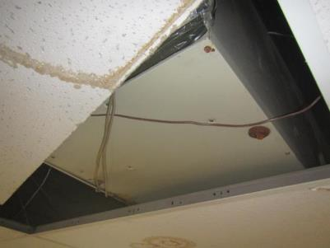
Air handling unit above ceiling in main office
Picture 2
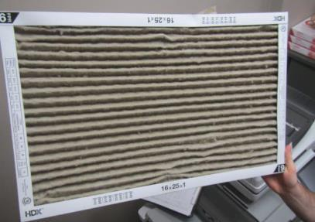
Clogged filter in ceiling return vent in main office
Picture 3
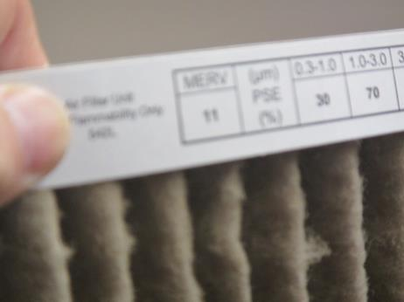
Close-up of pleated MERV 11 filter for main office air handling unit
Picture 4
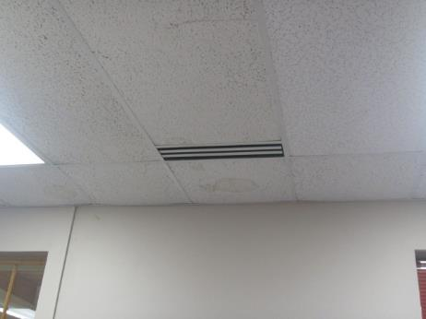
Slotted supply diffuser in main office, also note water-damaged ceiling tile
Picture 5
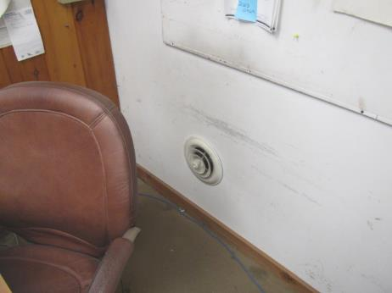
Wall-mounted supply vent in upstairs office
Picture 6
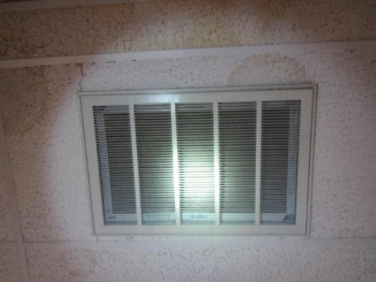
Ceiling-mounted return vent in main office
Picture 7
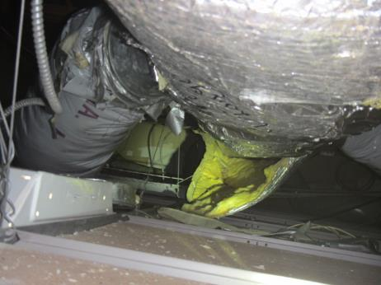
Failing insulation around ductwork above ceiling tiles in main office
Picture 8
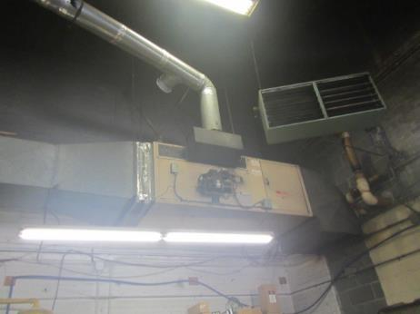
Abandoned AHU in garage area
Picture 9
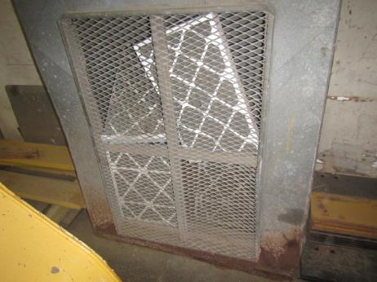
Abandoned HVAC system/damaged filters in vehicle maintenance area
Picture 10
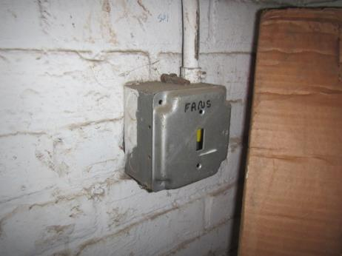
Abandoned fan controls
Picture 11
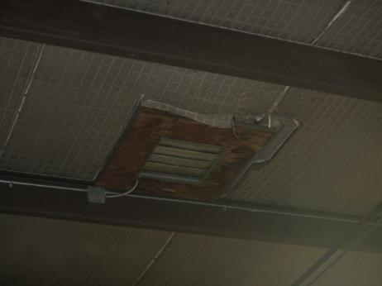
Abandoned ceiling vent
Picture 12
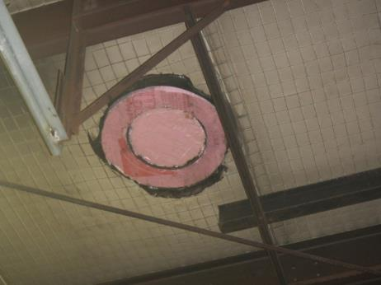
Abandoned ceiling vent sealed with insulation
Picture 13
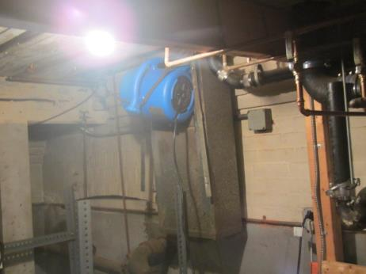
Makeshift ventilation system in basement
Water Damage and Moisture Concern Pictures
(click to link back to report)
Picture 14
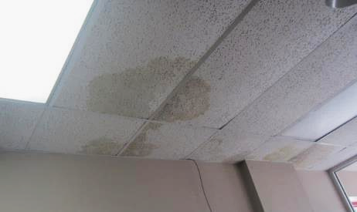
Water-damaged ceiling tiles in main office
Picture 15
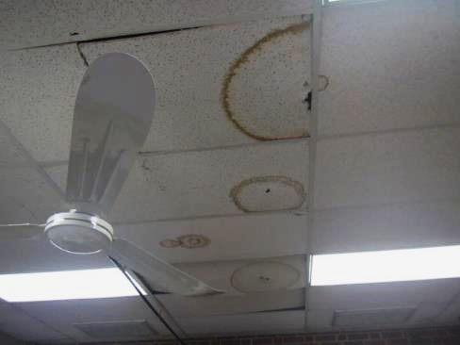
Water-damaged ceiling tiles in main office
Picture 16
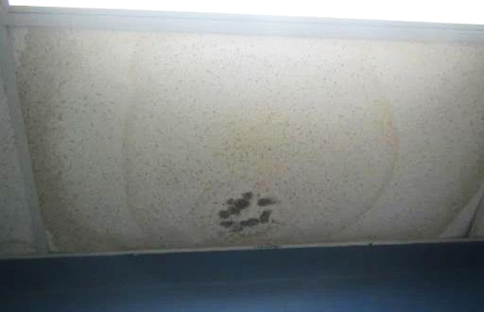
Water-damaged ceiling tiles, dark staining indicates likely mold growth
Picture 17
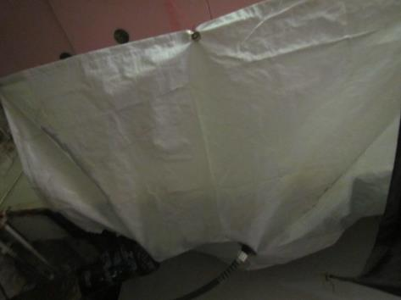
Chronic leaks collected in plastic catch basin
Picture 18
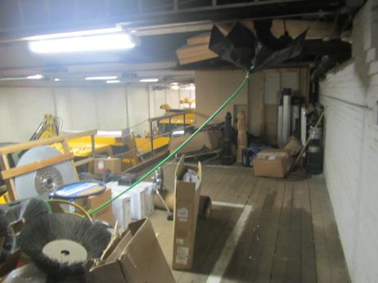
Chronic leaks collected in plastic catch basin
Picture 19
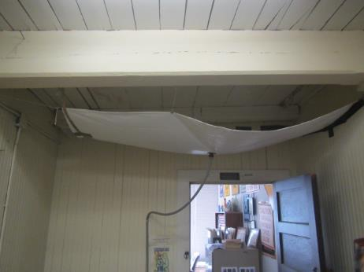
Chronic leaks collected in plastic catch basin
Picture 20
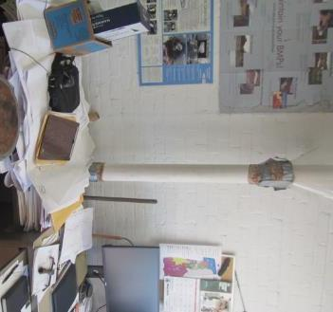
Leaks collected and diverted using a plastic dog collar (arrow)
Picture 21
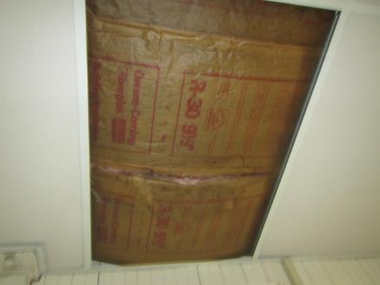
Visible mold (dark staining) on paper of water-damaged insulation on 2nd floor
Picture 22
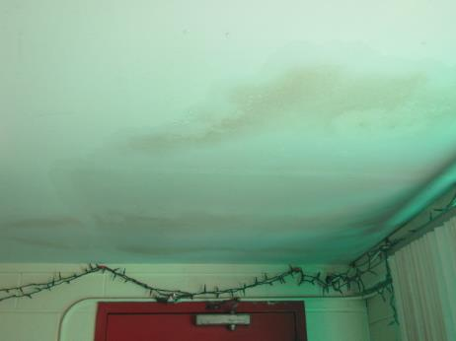
Water-damaged gypsum wallboard in breakroom that was wet at the time of assessment
Picture 23
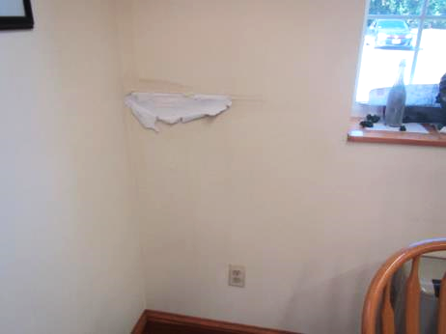
Water-damaged gypsum wallboard in conference room
Picture 24
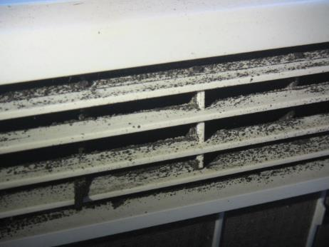
Visible mold growth on air conditioner
Picture 25
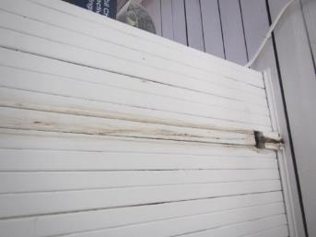
Water-stained wood from leak
Picture 26
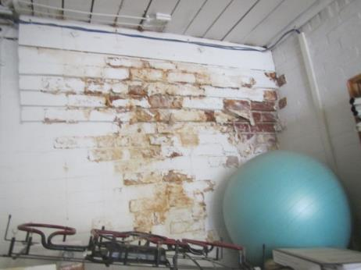
Peeling paint and efflorescence from water penetration through brick and mortar
Picture 27
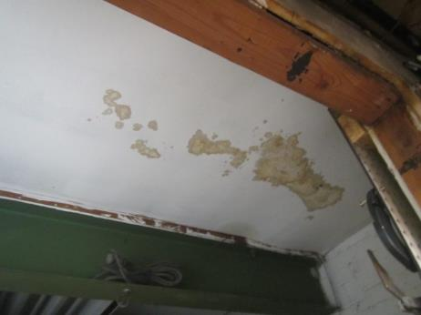
Water-damaged ceiling in oil room
Picture 28
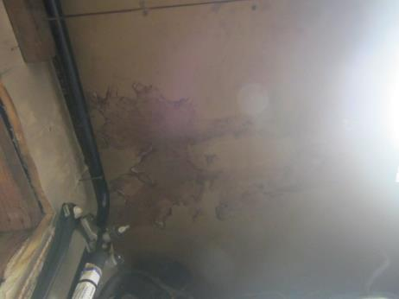
Water-damaged ceiling
Picture 29
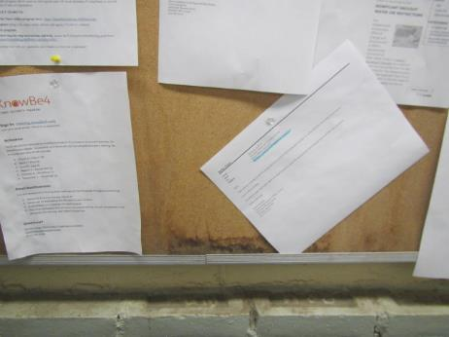
Water-damaged corkboard, dark-staining likely indicates mold growth
Picture 30
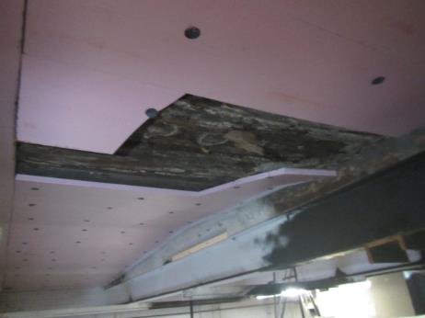
Water-damaged ceiling, note failing insulation material and rotted wood
Picture 31
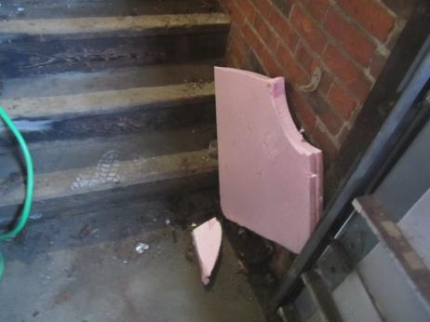
Failing insulation
Picture 32
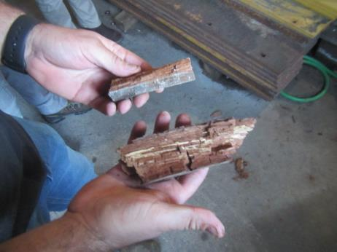
Wood debris from failing/water-damaged ceiling
Picture 33
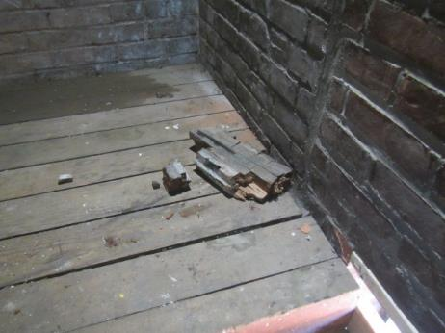
Wood debris from failing/water-damaged ceiling
Picture 34
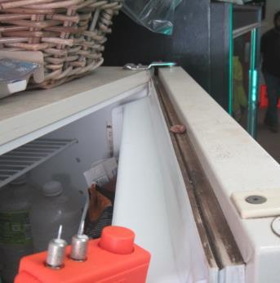
Dust, debris, and mold growth on refrigerator gasket
Picture 35
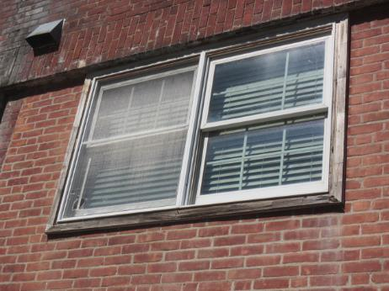
Rotted exposed wood around windows
Picture 36
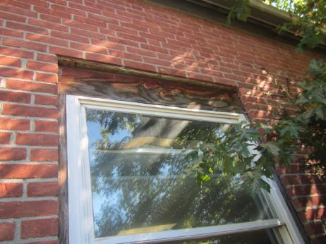
Exposed wood around windows
Picture 37
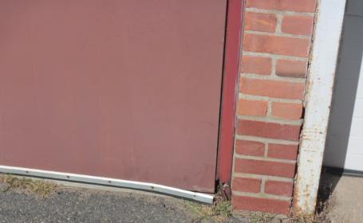
Corroded/damaged metal door and doorframe
Picture 38
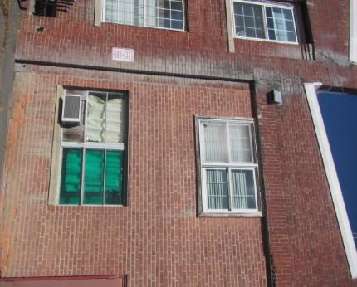
Drainage issues note efflorescence and characteristic staining down exterior brickwork
Picture 39
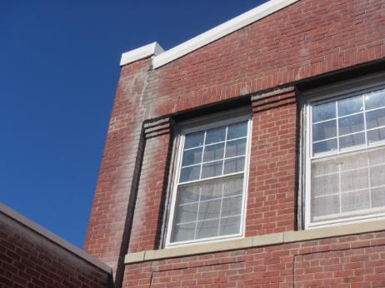
Drainage issues note efflorescence and characteristic staining down exterior brickwork
Picture 40
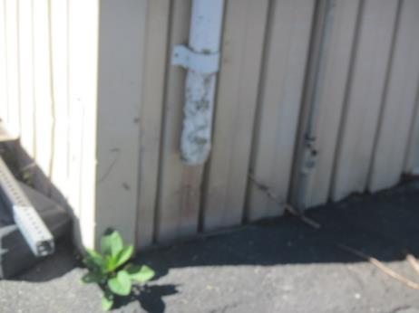
Damaged downspout/missing elbow extension
Picture 41
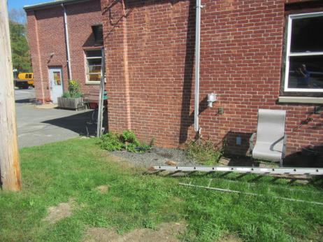
Damaged downspout/missing elbow extension
Picture 42
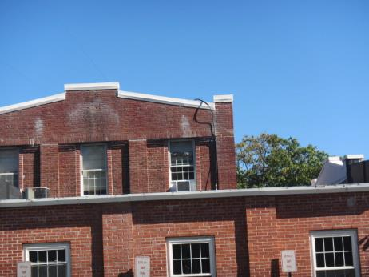
Efflorescence and missing/damaged mortar around brickwork
Picture 43
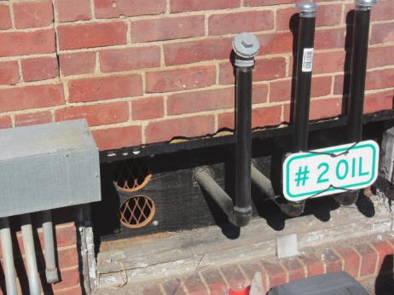
Open holes (with large-sized mesh)
Picture 44
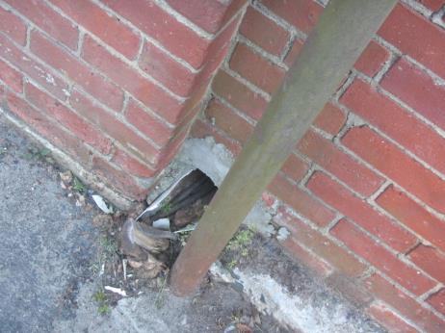
Breach in exterior wall
Picture 45
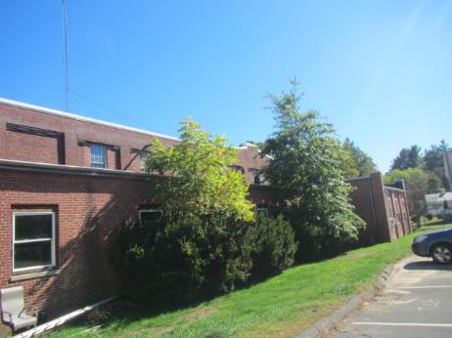
Trees/shrubbery against exterior wall
Sources of Respiratory Irritant Pictures
(Click to link back to report)
Picture 46
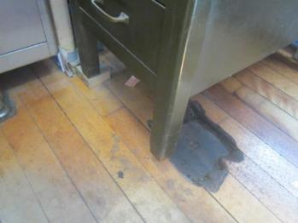
Damaged/dull, uneven wooden flooring
Picture 47
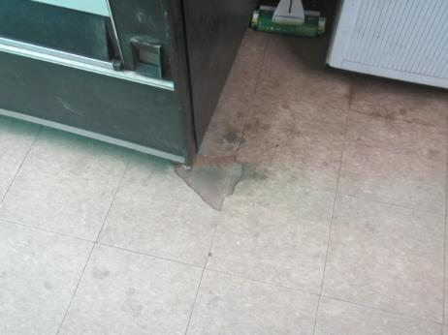
Damaged/dirty tile flooring
Picture 48
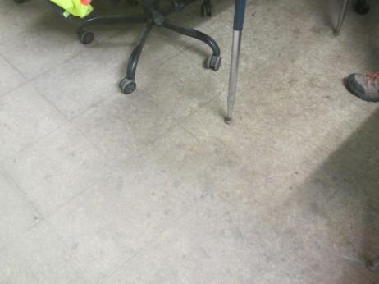
Dirty/dull tile flooring in breakroom/kitchen area
Picture 49
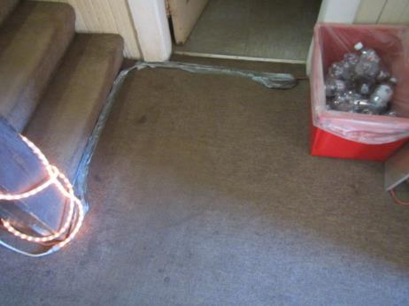
Dingy, soiled, threadbare carpeting
Picture 50
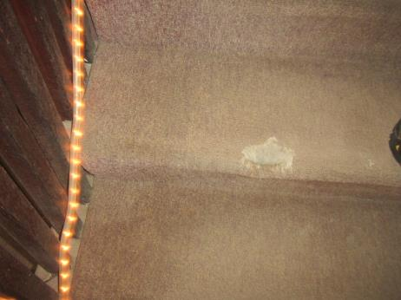
Damaged/dirty, threadbare carpeting on stairs
Picture 51
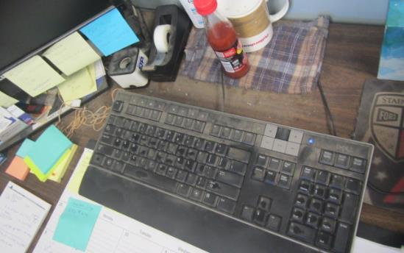
Dirt, dust, and debris on flat surfaces and office items
Picture 52
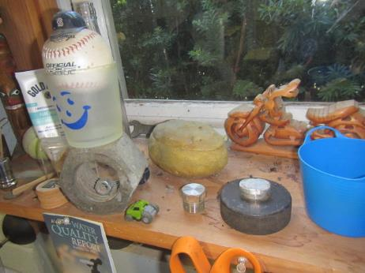
Dirt, dust and debris on flat surface and office items
Picture 53
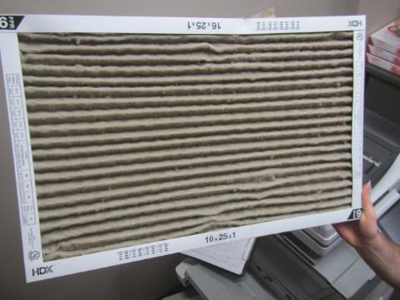
Dirty filter in main office area
Picture 54
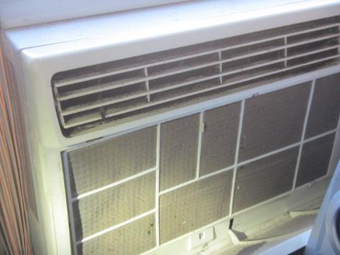
Dirty filter in window-mounted AC
Picture 55
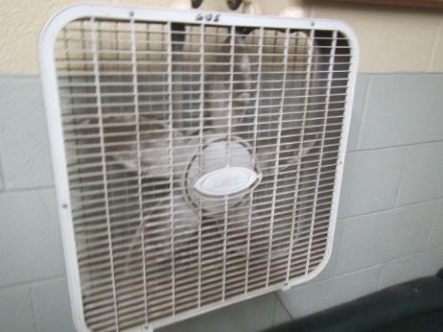
Portable fan occluded with dust and debris
Picture 56
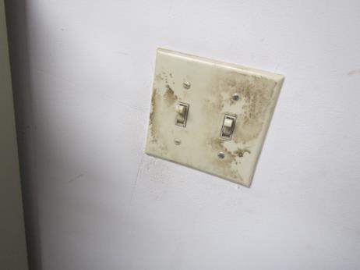
Dirty wall switch
Picture 57
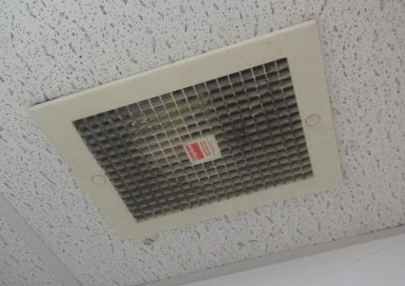
Dirty ceiling vent
Picture 58
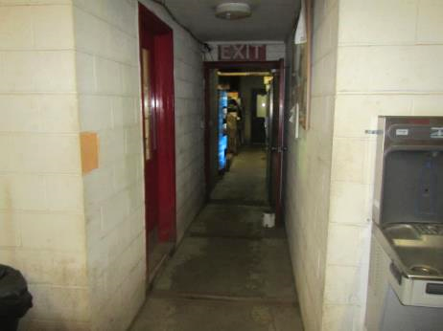
Open doors throughout the facility
Picture 59
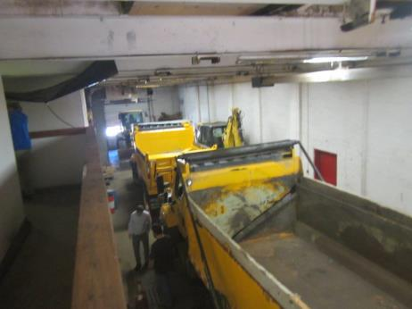
DPW vehicles in bay
Picture 60
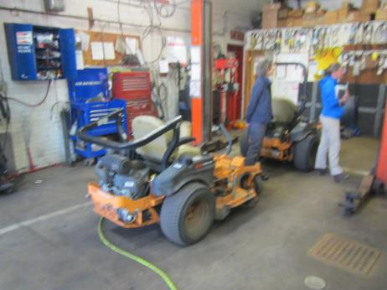
Landscaping vehicles
Picture 61
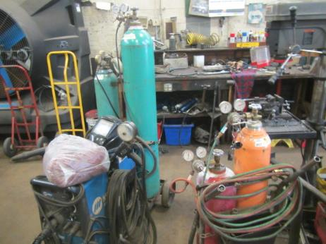
Welding station
Picture 62
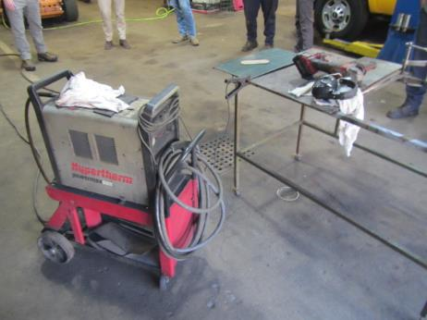
Plasma cutting operations
Picture 63
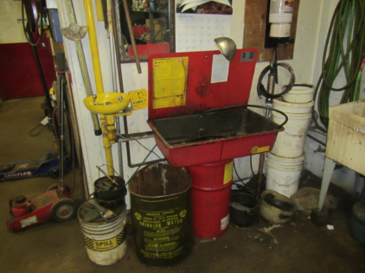
Chemical parts washer
Picture 64
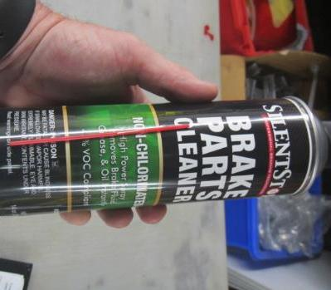
VOC-containing parts cleaner
Picture 65
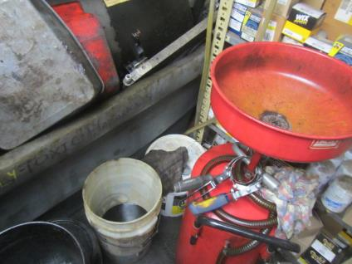
Oil and chemical parts washer
Picture 66
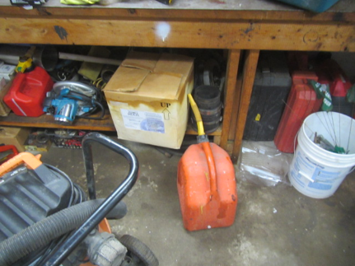
Gasoline containers

Table 1 Location | Carbon  Dioxide  (ppm) | Carbon Monoxide  (ppm) | Temp  (°F) | Relative  Humidity  (%) | PM2.5  (µg/m³) | TVOC | Occupants  in Room | Windows  Openable | Ventilation |  | Remarks
 |  |  |  |  |  |  |  |  | Supply | Exhaust | Remarks
Background (outside) | 416 | ND | 67 | 66 | ND | ND |  |  |  |  | Sunny, slight breeze
Mechanic Shop | 682 | 15* | 65 | 47 | 161* | 5* | 4 | N | N | Y  Off | *Plasma cutting occurring, Air handling unit not operating, ceiling fans only blow air down, wall louver fan off, bay door open, ventilation fan is on a timer hand dial, side wall exhaust malfunctions/overheats
Mechanic Shop Office | 469 | 5 | 62 | 51 | 49 | ND | 0 | N | N | N | Refrigerator, microwave, toaster oven, dusty personal fan
Parts Room | 495 | 3 | 64 | 50 | 35 | ND | 0 | N | N | N | WD ceiling, leak stopped by temporary measures
Oil Room | 537 | 2 | 64 | 49 | 18 | ND | 0 | N | N | N | Oil containers, no mechanical ventilation, evidence of previous leak down ceiling/wall
2nd Floor Stairway Area | 777 | 1 | 72 | 48 | 9 | ND | 0 | N | N | N | Worn out carpeting, gap near ceiling support beam, WD ceiling, apparatus set up to catch water from ceiling leak
Town Engineer Office | 731 | 1 | 75 | 44 | 7 | ND | 0 | Y | N | N | Window air conditioner, area carpet, hole near radiator in floor, efflorescence on wall, paper files, chemical sprays, leaks collected and diverted using a plastic dog collar
Engineer Staff Office | 612 | 2 | 77 | 43 | 7 | ND | 2 | Y | N | N | Window air conditioner, missing CT, plant, windows don’t close, efflorescence on wall, pooling water on roof
Sign Shop | 751 | 2 | 77 | 43 | 15 | ND | 0 | Y | N | N | Dirty box fan, evidence of mold on window air conditioner, cleaning spray, adhesive
Main Office | 759 | ND | 74 | 45 | ND | ND | 0 | Y | Y | Y  dusty | WDCTs, plants, mini fridge, carpeted, exhaust vent filter clogged
Conference Room | 762 | ND | 75 | 45 | ND | ND | 0 | Y | N | N | WD wall
Assistant Superintendent Office | 718 | ND | 74 | 44 | ND | ND | 0 | Y | N | N | Carpeted, window air conditioner
Water Department Offices | 666 | ND | 71 | 42 | ND | ND | 0 | Y | N | N | Window air conditioner filter light on, dusty computer keyboards, shrubbery directly outside window, damaged upholstered chair, non-HEPA filter vacuum, microwave, area carpet
Water Department Garage | 504 | ND | 67 | 43 | ND | ND | 0 | Y | N | N | Opening under garage door
Water Department Break Room | 544 | ND | 68 | 47 | 1 | ND | 0 | N | N | N | Dusty personal fan, refrigerator, microwave, toaster, coffee maker, couch
Water Department Records Room | 582 | ND | 69 | 46 | 1 | 1 | 0 | N | N | N | Area carpet, microwave
Men’s Locker Room | 624 | 1 | 72 | 47 | 17 | ND | 0 | N | Y | Y | Weak exhaust vent, wall exhaust vent near urinals
Highway Department Breakroom | 637 | ND | 73 | 45 | 6 | ND | 0 | N | N | N | WD ceiling, hole in ceiling, toaster, microwave, cooking stove (no exhaust vent), air freshener, floor not easily cleanable
Main Bay | 517 | 1 | 75 | 40 | 15 | ND | 0 | N | N | N | Bay doors closed, damaged/opening under exterior door, tires, gas cans, landscaping equipment, tailpipe/rear of trucks are parked/idle in bay outside doors leading to offices, no mechanical ventilation, periodic ceiling leaks above drinking fountain
Union Office | 598 | 1 | 75 | 50 | 7 | ND | 0 | N | N | N | Hole in CT, WDCT, possible mold growth on CT
Highway Supervisor Office | 616 | 1 | 73 | 48 | 9 | ND | 0 | N | Y | Y  dusty | Wheel and tire cleaner, WD and mold on cardboard
Middle Highway Office | 554 | 1 | 73 | 47 | 8 | ND | 0 | N | Y | N | Not used due to remediation, drywall torn out
Division Director Highway Department Office | 539 | 1 | 73 | 45 | 11 | ND | 0 | Y | Y | Y  dusty | Floors not easily cleanable, dusty floor, dusty computer keyboard
Main Bay Extension | 537 | 1 | 72 | 43 | 10 | ND | 0 | N | N | N | Painting truck parked, liquid spill on floor, corroded doors, bay doors closed
Superintendent Office | 561 | ND | 77 | 42 | ND | ND | 0 | Y | N | Y | Mini fridge, cardboard boxes on floor, carpeted
Office Manager’s Space | 625 | ND | 76 | 44 | 2 | ND | 0 | N | N | Y | Dusty personal fan, carpet stains, WD CT, carpeted
Basement | 554 | ND | 73 | 47 | 3 | ND | 0 | N | N | N | Dehumidifier, openings in window, pile of swept up debris, makeshift ventilation system
Ladies Room Left |  |  |  |  |  |  |  |  |  | N | No exhaust vent for shower, air freshener spray
Ladies Room Right |  |  |  |  |  |  |  |  | N | Y | Holes in floor not sealed
Men’s Room |  |  |  |  |  |  |  |  | N | N | Efflorescence

(Click to link back to report)

Table 2A
Equipment Present in Building  (X = Yes) | Type of Heating/Cooling Ventilation  Equipment | Fresh  Air  Supply  (X = Yes) | Type of Location(s) | Air Filters Installed  MERV Rating  (1-15, U*)  (X = Yes) | Comments
 | Univents
X | Rooftop Air Handling Units | X
 | Outdoor, Ground-Installed Air Handling Units
 | Attic/Crawlspace Air Handling Units
X | Ceiling-Mounted Air Handling Units (including inside plenum)
X | Basement/Crawlspace-Installed Air Handling Units |  |  |  | Makeshift unit, duct cut out w/exhaust fan
X | Mechanical Room-installed Air Handling Units | X
 | Fan Coil Units
X | Window-Mounted Air Conditioners |  |  |  | Evidence of mold in sign shop
 | Wall Louver-Controlled Gravity Air Supply
X | Windows
 | Fan in window (blowing in)
X | Built in wall fan (switched) | X | Garage/  Vehicle bay |  | Reported issue with operation
 | Heat recovery ventilator unit
 | Energy recovery ventilator unit
 | Chilled Beam
 | Passive combustion supply vent in basement/boiler room

*U = Filter Rating underdetermined due to inaccessibility during building visit

(Click to link back to report)

Table 2B
Equipment Present in Building  (X = Yes) | Type of Exhaust Ventilation  Equipment | Ducted  To Outdoors  (X = Yes) | Type of Location(s) | Comments
 | Rooftop Motors/Fans
 | Unit Exhaust
X | Ceiling Return Vent
 | Ceiling Return Vent, Plenum
X | Wall Return Vent
 | Kitchen Stove Hood
X | Restroom Exhaust Vent
 | Photocopier Exhaust Vent
X | Garage |  |  | Reported issues with operation
 | Chemical Hood(s)
 | Locker Rooms
 | Showers
 | Lock up Cells
 | Clothes Dryers
 | Gas Water Heaters
 | Furnace-Flue to Chimney
 | Furnace/Boiler direct vent or power vent (no combustion air supply)
 | Kiln, Pottery
 | Dark Room
 | Generator Room
 | Wood Shop Dust Collector
 | Spray Paint Booths
 | Fan in window (blowing out)

Table 2C
Equipment Present in Building  (X = Yes) | Type of Equipment | Type of Location(s) | Comments
 | Floor Fans, pedestal
X | Portable fans | Various areas | Some dirty and dusty
 | Air Purifier (HEPA, other)
 | Floor heaters, portable
 | Refrigerators, Cold Beverage Vending Machines
 | Radiator, wall-mounted
X | Radiator, floor-mounted
X | Passive vents (Wall/Door) | Various offices | Openings in floor due to not being properly sealed

(Click to link back to report)

Table 3
Found in Building  X = Yes | Water-Damaged Materials, Building Components or Stored Materials | Location | Visible Microbial Growth?  X = Yes | Musty odor detected?  X = Yes | Comments
 | Books-other bound materials
X | Brick walls – broken, missing mortar | Exterior
 | Brick walls – blocked weep holes
X | Cardboard boxes | Offices/  storage areas | X |  | Discard
 | Carpet tiles
X | Carpet - Area rugs | Various
X | Carpet wall-to-wall
 | Ceiling tiles - affixed directly to ceiling surface
 | Ceiling tiles - bowing-in suspended ceiling
 | Ceiling tiles - water-stained in splined ceiling
X | Ceiling tiles - water-stained in suspended ceiling | Various | X |  | Fuzzy substance
 | Chairs - laminated
 | Cloth
 | Countertops (around sinks)
 | Curtains
X | Dust/debris within AHU, uninvent, HVAC, chilled beam units, etc. (WD through condensation, humidity, or leaks) | Various
X | Efflorescence (i.e., mineral deposits) | Interior and exterior of building
 | Engineered woods - particleboard, plywood, Masonite
 | Flooring – loosened tiles
 | Flooring - wooden
 | Furniture - laminated
 | Furniture - upholstered
X | Gypsum wallboard - ceiling | Various
 | Gypsum wallboard - restroom wall
X | Gypsum wallboard - interior wall | Various
X | Gypsum wallboard – located on exterior wall | Various
 | HVAC drain pan – lack of draining
 | HVAC filters
 | Insulation- attic (paper-backed)
 | Insulation - inside air handling unit
 | Insulation - on pipe(s) fiberglass
 | Insulation - on pipe(s) other/plaster-like material
 | Insulation - wall cavity
 | Insulation – ceiling plenum
 | Modular furniture – walls/cloth partitions
 | Musical instrument cases
 | Plaster ceilings
 | Plaster walls
 | Records/files
X | Refrigerator - door gasket
 | Refrigerator - drip pan
 | Refrigerator - Interior surfaces
 | Room divider - ceiling-mounted, sliding
 | Sink backsplash
 | Tables – laminated
 | Wallpaper
X | Wood - attic/roof materials | Exterior
 | Wood - floor joists in basement ceiling
 | Wood - wall framing
X | Wood - window sills | various
 | Wood - window-mounted air conditioner framing
 | OTHER: Wooden baseboard

WHAT ARE ENVIRONMENTAL ASTHMA TRIGGERS?
Asthma triggers are any chemical, pollutant, or allergen that can make your asthma worse. Asthma triggers can also be strong chemical smells, dust, or pets. Your asthma triggers may be different from those of other people. Not all asthma triggers affect people the same way. Environmental asthma triggers are found both indoors and outdoors. DPH link: Asthma and Your Environment (mass.gov)

(click to link back to report)

Table 4
Condition Present  X = Yes | Possible asthma symptom-inducing environmental pollutant | Recommendation to reduce or eliminate the pollutant
X | Water Damage and/or Mold  (allergen) | Identify water source and repair to eliminate.  Clean non-porous materials.  Remove and replace porous materials susceptible to mold growth.  Perform regular water damage assessments as a tool to ensure timely mitigation as needed.  Use NIOSH water damage assessment protocol as a guide: NIOSH water damage assessment guideline.
X | Moistening of building components during hot, humid weather (>2 days in length) (mold, allergen) | Remove materials not dried in <2 days in a manner consistent with US EPA Mold Removal in Commercial Buildings guideline.  Use dehumidification in occupied basement areas and other areas with chronic dampness.
X | Vegetation against exterior of building (water damage-mold) | Remove all vegetation preventing building exterior drying.  Remove all vegetation capable of falling onto a building or depositing debris onto the roof.
 | Personal humidifiers (lack of proper maintenance)  (pollutant and allergen) | Clean and maintain properly.  Use distilled water to eliminate metal and water treatment odors.  Maintain hydration by increasing water consumption.
 | Drains: Floor drains, Sink drains (abandoned use)  Water bubblers (abandoned use) | If in use, pour water into drain at least twice a week.  If not in use, seal the drain with an appropriate material in accordance with Massachusetts Plumbing Code (248 CMR 10.00).
 | Live Animals (turtles, gerbils, birds, rabbits, etc.) | Ensure cleanliness or remove animals from the location.
 | Improperly maintained aquariums and terrariums (allergen) | Maintain such equipment properly to eliminate odor.  Discontinue use.
X | Plants and flowers  (allergen and mold) | Keep indoor plants well maintained and not overwatered. Monitor for signs of mold and pests.  Ensure water for cut flowers does not become stagnant.  Ensure dried plant material is free of odors, mold, and pests and handled carefully  If asthma risks are high, eliminate plants and flowers.
 | HVAC system moisture issues  (mold, allergen) | Consult ASHRAE’s minimum standards for HVAC maintenance and inspection of commercial HVAC systems (https://www.ashrae.org/technical-resources/bookstore/standards-180-and-211).
 | HVAC system contaminant issues (allergen) | Consult ASHRAE’s minimum standards for HVAC maintenance and inspection of commercial HVAC systems (https://www.ashrae.org/technical-resources/bookstore/standards-180-and-211).
 | Indoor swimming pool odors outside of swimming pool (mold, chemical) | Maintain and operate pool HVAC systems to vent odors from building.  Ensure locker room exhaust vents are operating during building hours.  All doors leading to pool should be rendered airtight and be closed.
X | Pollen (allergen) | Recommend installation of MERV 8 or better filters if HVAC engineer confirms HVAC system can be so equipped without adversely affecting function.  Cut grass after hours.  Cut grass in a pattern to direct clippings away from exterior wall.  Remove trees and shrubs from in front of windows and air intakes.
 | Dry air | Maintain hydration.  Avoid overheating of air.
 | Dust mites  (allergen) | Recommendation to remove non-official upholstered furniture, area rugs, pillows, cushions, etc.  Cleaning with use of HEPA-filtered vacuum cleaner.  Eliminating clutter, storing items in dust and moisture-proof containers, and regularly removing dust through wet wiping.
X | Pests, including rodents and cockroaches  (allergen) | Use of integrated pest management guidelines, including:  - Proper disposal of food containers  - Proper storage of food products in airtight containers  - Elimination of use of food as art projects  - Remove pest harborages/clutter  - Regular monitoring for pests  EPA IPM guideline link
 | Latex-containing materials | Remove tennis balls from furniture legs.
X | Fragrances  (chemical) | Eliminate point sources, such as:  - Plug-in air fresheners  - Aroma/oil reed diffusers  - Scented sprays  - Discontinue use of other scented materials  - Consult DPH fragrance guideline: Clean air is odor-free
X | Strong smells from /use of Chemicals (such as cleaning products)  (chemical) | Use building-issued cleaning products.  Use products in accordance with manufacturer’s instructions including dilution, application, and ventilation.  Avoid using products that are stronger than needed for the situation.
 | Strong odors from new building materials (carpeting/furniture)  (chemical) | Use low VOC-emitting materials.  Air out materials (outside or in unoccupied area) prior to installation.
 | Tobacco smoke  Secondhand Smoke  (pollutant) | Eliminate tobacco smoking.  Seal all shared wall penetrations.
X | Products with a strong odor such as paint, perfume, hairspray, air fresheners, bug-spray, laminators, candles, wax melters, dry erase markers and other VOC-containing products  (chemical) | If essential:  - Provide proper exhaust ventilation to eject aerosolized product directly outdoors.  - Avoid/reduce use during occupied hours.  If not necessary, remove and eliminate.
X | Vehicle exhaust  (pollutant) | Enforce anti-idling regulations and post signs to give notice.  Relocate vehicles away from fresh air intakes.  Require vehicles to park face-in at building walls.  Close doors to prevent vehicle exhaust from entering occupied spaces  idling-faq
 | Vapors and or fumes from gas, oil, or kerosene stoves  (pollutant) | Operate stove hood when stove in use.  Install stove hood if not present.  Ensure equipment is in good working order.
 | Ozone (pollutant) | Eliminate use of ozone generating equipment.
X | Window Air Conditioners (if not properly maintained) (allergen) | Equip with proper filter and clean periodically.  Clean drip pans.  Install in window with weathertight, non-mold-growth sustaining material.
 | Pottery (pollutant) | Do not operate kiln during occupied hours.  Operate kiln with exhaust system activated.  Seal all seams and holes in kiln vent.  Ensure kiln exhaust discharge terminates outdoors.
X | Carpeting (allergen) | Clean carpeting in a manner consistent with IICRC standards, including regular vacuuming with a high efficiency particulate air (HEPA) filtered vacuum in combination with annual cleaning or semi-annual cleaning in soiled high traffic areas.
X | Sweeping/dusting vs HEPA vacuuming/wet wiping  (allergen or pollutant) | Refrain from using feather dusters or brooms.  Utilize HEPA vacuums and wet wiping to minimize aerosolizing particulate matter.
X | Lack of adequate air exchange/mechanical ventilation | Make repairs as necessary and ensure all HVAC system components are operating continuously when building is occupied.
X | Lack of local exhaust at source of pollution (vocational shop activities, kitchen exhaust hood) (all) | Recommend installation of exhaust ventilation to direct pollutants directly outdoors.
 | Renovating buildings while occupied  (chemical) | Use all SMACNA guidelines for Renovation While Buildings Are Occupied. For information, visit https://www.mass.gov/service-details/construction-and-renovation-generated-pollutants-in-occupied-buildings.
 | Chemistry program chemical storage  (chemical) | Repair (if needed) and operate chemical storeroom vents appropriately.  Reduce or eliminate unneeded or overstocked chemicals.  Store all chemicals in a manner to separate incompatible chemicals.  Keep chemical storerooms clean.
 | Photocopiers/duplicating machines | All machines should have dedicated exhaust vents or be used in a well-ventilated area.

