**PELHAM AND AMHERST REGIONALIZATION OF ASSESSMENT SERVICES**

**Community Innovation Challenge Grant Final Report**

**Town of Amherst and Pelham**

**April 1, 2014**

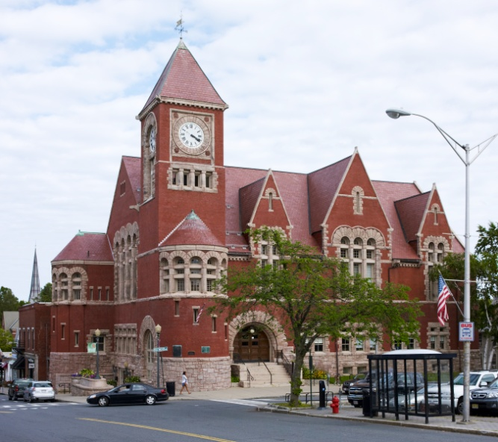 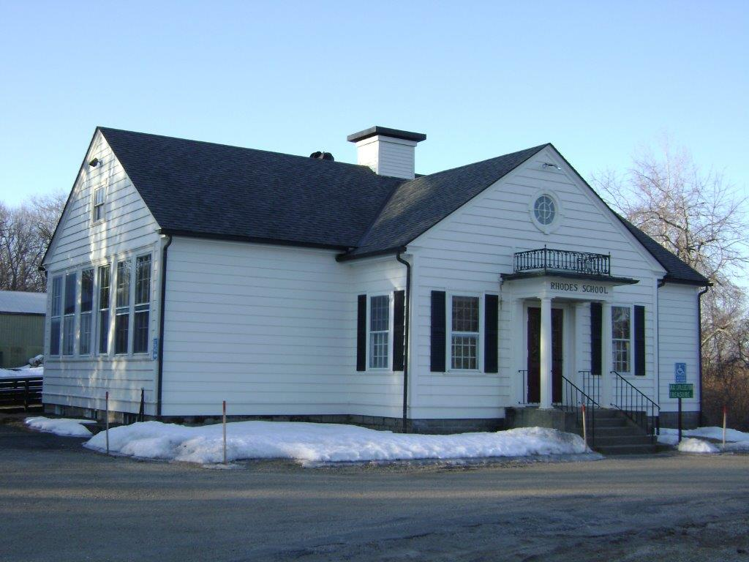

**Table of Contents**

Introductory Letter 3 & 4

Executive Summary 4

Partner Communities 4

Goal 4

Implementation Plan 4, 5 & 6

Budget 6

Challenges and Solutions 7

Outcomes 8

Contacts 9

References 9

Resources 9, 10 & 11

# Introductory Letter

April 1, 2014

Secretary Glen Shor

Executive Office for Administration and Finance

State House Room 373

Boston, Ma 02133

Re: Towns of Pelham and Amherst, Community Innovative Challenge Grant FY 2013.

Dear Secretary Shor,

In Western Massachusetts most communities are small towns and rely greatly on part time employees or volunteers to staff their offices. The Town of Pelham is a small community of 1,400 adjacent to The Town of Amherst in Hampshire County. In 2012 Pelham lost its part time assessment staffer and approached the Town of Amherst to explore a regional agreement for assessment services. Although Amherst provides the professional assessment services, Pelham retains an elected Board of Assessors that meets bi-monthly, and makes the final decisions. This agreement has Amherst staffing the Pelham office two half days a week and also has a full time availability in Amherst for Pelham residents. One major problem was accessibility from Amherst to Pelham records.

In 2013 the two communities applied for a CIC Grant to allow for the updating of the Pelham web page with assessment record history files back to 1960. Creation of a self-service kiosk in Pelham Town Hall; and the execution of an agreement to allow the Amherst personnel to work from Amherst on Pelham records.

Through the use of the CIC Grant Amherst personnel scanned all the Pelham assessment records back to 1960 and then added those records to the Pelham web page. These records are used actively by real estate professionals, appraisers, banks and residents so by putting them on the web they are available at all hours of the day. We also purchased and installed a kiosk in Pelham for those people that prefer to visit town hall. With assessing staff available only two half days a week, electronic access to the records is important. A major part of the grant funding allowed us to upgrade the appraisal software in both communities so that both utilized the same platform.

The new link on the Town of Pelham’s website is now fully operational and Amherst assessing personnel have been able to successfully maintain the ownership and legal information create reports for the Department of Revenue to set the tax rate and have the tax bills mailed out timely from Amherst. The residents of Pelham can now access all of their assessment information online at either the Town of Pelham’s website or the Town of Amherst’s website as well as have assessment staff available to answer questions during normal business hours.

As you are aware, assessing services that are essential to all communities and the first link in generating the tax bills every year as well as equalizing values every third year. The CIC funded project has created a very good model showing how two communities can work together to provide an enhanced service to the public. We believe that this is a good model for other communities to follow.

The Town of Amherst Assessing Department, served as the lead applicant for the grant application, and appreciates being a part of this endeavor. This is another opportunity for two longtime partner communities to work together to serve the public.

Sincerely

Signature of David Burgess, the Principal Assessor for the Town of Amherst

David W. Burgess

Principal Assessor

Town of Amherst.

# Executive Summary

The project is up and running as of late December.

To date we have had 469 online inquiries using the new data base for Pelham. Our goal is to have a ratio of approximately one inquiry a year for each parcel. Pelham has 750 improved parcels so we feel we are well on the way to accomplishing that goal.

To see the results of the project visit the [Town of Pelham web page](http://www.townofpelham.org)

# Partner Communities

The two communities involved in this cooperative grant are the Town of Pelham and the Town of Amherst in Hampshire County. Pelham is a small “hill town” with a population of about 1400 and relies greatly on volunteerism and a small professional staff. Amherst has a year round population of approximately 20000 and grows to 38000 during the academic year. The two communities have a history of cooperation as part of a regional school system and with Amherst providing ambulance coverage for Pelham.

# Goal

The goal was to achieve better access to assessment records for public and professional needs. Amherst has been providing assessment services, under contract with Pelham, since 2012 and the grant was used to enhance these services and provide similar access to Pelham records as is already available in Amherst. The goal was to achieve this using the experienced assessment and information technology (IT) departments in Amherst.

# Implementation Plan

The plan had several steps:

1. Locate documents to be displayed on the web page; Pelham assessment records back fifty years.
2. Sort and put in order by location and fiscal year.
3. Hire a document scanning company, in this case New England Archives
4. Purchase and set up a computer and a printer for a self service kiosk in Pelham.
5. Work with the common assessment software vendor VGSI to update both communities and ensure compatibility from both communities.
6. Town of Amherst IT Department upload scanned documents; and
7. Town of Amherst IT Department set up the network to run off the servers in Amherst and give access on both the Town of [Pelham website](http://www.townofpelham.org), and the [Town of Amherst website](http://www.amherstma.gov).

The Towns of Amherst and Pelham determined that, to optimize the user experience for residents and businesses in both towns, all assessment record from Pelham from the early 1960’s on should be provided through the electronic format. Previously, Pelham stored these records in the basement of its town hall. It was decided to take all of the Pelham records offsite to Amherst and go through the process of sorting and ordering the documents. Although this was a labor intensive, time consuming effort, it allowed us to correctly format and collate the records for scanning and produced the desired results with control of the project being kept in-house.

We selected New England Archives to scan the documents as they are a company we have worked with before and are on the State Bid List. Once we completed the sorting New England Archives took the documents and scanned them into a digital format that allowed the Amherst IT department to take the files and set them up on our GIS for display. Anyone searching for information is able to search by owner name, property address, or assessors’ property record information.

As part of the grant we installed a self service kiosk in the Town of Pelham offices. The administrative offices are open Monday through Thursday, however, the assessing office is only staffed on Tuesday and Thursday mornings so a kiosk was needed. Visitors to Pelham Town Hall are able to access the assessment records and print copies when no one is in the office. This part of the grant implementation alone is a great benefit to many professional users of the system. It is not uncommon for appraisers to travel long distances to carry out work in Pelham and then visit the assessing office to get information. They are now able to either print in the office or go online and get the information from their own office. It does not eliminate their need to physically view the property but it may save them a trip back to get information when the office is staffed.

Both communities share a common software provider for assessment use, Vision Appraisal Software, and it was decided that the best way to proceed was to purchase the most recent release as Pelham was on an earlier version than Amherst. Common software made sense for assessing and compatibility on the web.

Achieving the project relied heavily on the Town of Amherst IT Department for both the hardware and the software. Indeed the largest part of the project turned out to be for information technology hardware and support.

When we applied for the grant our intent was to use the professional services of the Town of Amherst Information Technology Department to carry out most of the work on web access and updating the web pages. The assessing office took on the job of correlating the old Pelham records and preparing them for scanning. We also relied on Vision Appraisal and New England Archives for software and scanning estimates. The original budget is outlined below:

# Budget

**Budget Item Amount**

Kiosk $ 2,000

Scanning $ 7,500

Setup and Configuration $ 6,000

Appraisal Software Upgrade $ 6,000

Record Correlation $14,000

**Total Budget $35,500**

As the project progressed it became increasingly obvious that the labor costs we had estimated for records sorting were too high, as well as the eventual cost of scanning. It also became obvious that we needed to increase our server capacity and that the cost of updating the software as well as the maintenance of the software was too low. We determined that more server capacity and the upgrade to Vision Appraisal Version 7.0 was needed.

# Challenges and Solutions

The Vision Appraisal Systems 6.5 Software cannot be installed on Windows running a 64-bit operating system, which is Amherst’s standard for virtual machines. Because the use of Vision Appraisal Systems software from Pelham is via a remote connection to an Amherst virtual machine that runs at the Amherst Town Hall computing center, it was necessary to set up a custom connection for use by staff from Pelham.  The custom connection consists of an external connection to a 64-bit virtual machine, which upon login, automatically connects to an internal 32 bit virtual machine on which the Vision Appraisal Systems 6.5 software is installed.  This approach has been successful and will no longer be necessary upon the release of Vision Appraisal 7.0 software, which is 64-bit.

# Outcomes

|  |  |  |  |  |  |  |  |  |  |
| --- | --- | --- | --- | --- | --- | --- | --- | --- | --- |
| **PROJECT GOAL** | **MEASURE** | | **CURRENT YEAR** | **PRIOR YEAR** | **TREND** | **TARGET** | **STATUS** | **COMMENTS** | |
| To develop a regionalized assessment program for the Towns of Amherst and Pelham | # of online enquiries | | 469 | NA | Increasing | 750 | Yellow triangle, showing that this measure is close to meeting the associated target | Based on the number of visits to the Amherst web site in a year we estimated 750 visits, or 1 per parcel. We have not yet reached that but considering the program is less than a year old this is a good start. | |
| # of office visits in Pelham | | 50 | NA | NA | NA | Straight line, showing that this measure is not applicable at this time | No prior year data was available for comparison | |
| # of Pelham inquiries dealt with in Amherst | | 47 | NA | Increasing | To eventually have more visits in Amherst than Pelham. | Green circle, showing that this target has been met | This is a good trend in as much as we now have as many office visits in Amherst as in Pelham. | |
| % of Pelham tax bills mailed on time | | 100% | 100% | Steady | 100% | Green circle, showing that this target has been met | A positive result as we maintain the 100% level of tax billing for Pelham. | |
| **STATUS LEGEND** | **OFF TARGET:** | Red square, showing that a particular measure is off track | **CLOSE TO TARGET** | Yellow triangle, showing that a particular measure is close to being achieved | **ON TARGET:** | **Green circle, showing that a particular measure has been achieved** | **NOT APPLICABLE:** | | Straight line, showing that a particular measure is not applicable |

**CONTACT INFORMATION**

**Town of Amherst**

David Burgess

Principal Assessor

4 Boltwood Avenue

Amherst 01002

[Burgessd@amherstma.gov](mailto:Burgessd@amherstma.gov)

Kristopher Pacunas

Information Technology Director

4 Boltwood Avenue

Amherst 01002

[Pacunask@amherstma.gov](mailto:Pacunask@amherstma.gov)

**Town of Pelham**

Robert Rowell, Assessor

351 Amherst Rd

Pelham 01002

[assessors@townofpelham.org](mailto:assessors@townofpelham.org)

**REFERENCES**

We contracted with [New England Archives](http://www.neac.com/) to do the paper scanning and we use [App Geo](http://www.appgeo.com/) for the GIS Viewer tool serving up the Town’s GIS page. Lastly we consolidated the software solutions of both Town’s [Vision Government](http://www.vgsi.com/) systems. We used in-house staff to coordinate and technically configure the implementation.

Town of Amherst GIS website

[Town of Amherst GIS website (with data for the Town of Pelham)](http://gis.amherstma.gov/apps/pelham/)

**RESOURCES**

SERVICE CONTRACT FOR THE PROVISIONS OF ASSESSMENT SERVICES TO THE

TOWN OF PELHAM

This Agreement is hereby entered into this 29th day of October, 2012 by and between the TOWN OF AMHERST ("Amherst") and the TOWN OF PELHAM ("Pelham") to enable the Principal Assessor and Staff of the TOWN OF AMHERST ("Assessment Staff") to perform the duties of such office for the Town of Pelham.

1. Purpose: The purpose of this contract is to permit the Assessing Department of Amherst to provide assessment described herein, to Pelham through its Assessing Department. This agreement is authorized by General Laws Chapter 40, Section 4A, for the provision of assessing services .

1. Term: This contract is for the period 29th October, 2012 through June 30,2015 and may be renewed, on a triennial basis by March 1of each 3rd year by the mutual written agreement of both parties, provided, however, that the total term of this Agreement shall not exceed twenty-five (25) years). Either party may terminate this Agreement by providing the other with ninety (90) days written notice.
2. Scope of Services: Amherst will provide assessment services to Pelham as described in the Job description attached hereto as Appendix A, which is incorporated herein. The Assessment Staff will work under the supervision and direction of the Principal Assessor and shall provide assessing services, as directed by said Department. The hours to be mutually agreed to by the Principal Assessor of Amherst and the Board of Assessors of Pelham at the onset of this agreement.
3. Reporting Requirements: Pelham shall keep accurate and comprehensive records of services performed, and any costs incurred. Such information shall be provided to the Chair Person of the Pelham Assessors or the Town Manager of Amherst upon their request.
4. Payment Provisions: Pelham shall pay to Amherst the sum of $13,300 for the period 29th October, 2012 -June 30,2013 and at the rate of $20,000 each year for Fiscal Years 2014 and 2015. Said sum represents an hourly wage, plus a charge for overhead and fringe benefits. Pelham shall reimburse Amherst for such services on a quarterly basis, said payments being made to the Town of Amherst .
5. Each party hereto shall indemnify, defend, and hold the other harmless from and against any and all claims, demands, liabilities, actions, causes of actions, costs and expenses, including attorney's fees, arising out of the indemnifying party's breach of this Agreement or the negligence or misconduct of the indemnifying party or its agents or employees.
6. Pursuant to the provisions of General Laws, Chapter 40,Section 4A, both parties agree that the Assessment Staff will remain, and for all purposes be considered throughout the duration of this contract for services (or any extension thereof), full-time regular employees of the Town of Amherst .
7. This Agreement contains the entire agreement of the parties and supersedes any prior agreements or understandings, whether era! or in writing, between them. This Agreement may not be changed or modified except by a written instrument in accordance with the provisions herein. This Agreement shall be governed by the laws of the Commonwealth of Massachusetts and the parties hereto submit to the jurisdiction of any of its appropriate courts for the adjudication of disputes arising out of this Agreement. The provisions of those laws shall not be deemed waived by any provision of this Agreement.
8. If any provision of this Agreement is declared to be illegal,unenforceable,or void, then both parties shall be relieved of all obligations under that provision provided, however, that the remainder of the Agreement shall be enforced to the fullest extent permitted by law.

IN WITNESS WHEREOF,the parties hereunto set their hands and seals this 22"d day of October,

2012.

TOWN OF AMHERST TOWN OF PELHAM

*w· =L'-o-:::....:....:';:J [* (_

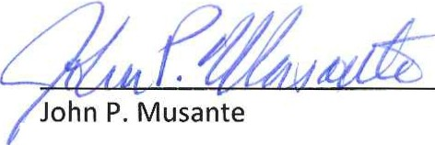

Town Manager

William Martell

Chair,Pelham Selectboard