INDOOR AIR QUALITY ASSESSMENT

Amherst Regional Middle School
170 Chestnut Street
Amherst, Massachusetts

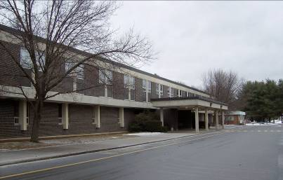

Prepared by:
Massachusetts Department of Public Health
Bureau of Environmental Health
Indoor Air Quality Program
April 2008

Background/Introduction
At the request of Ellen Bokina, Environmental Health Coordinator/Sanitarian for the Amherst Health Department, the Massachusetts Department of Public Health (MDPH), Bureau of Environmental Health (BEH) provided assistance and consultation regarding indoor air quality issues at Amherst Regional Middle School’s swimming pool. The assessment was requested after several children became ill after swimming in the pool. Although it had been previously determined by the BEH’s Community Sanitation Program’s personnel that the chlorine levels in the pool exceeded state regulations and had since been remedied, BEH was requested to determine whether the ventilation system in the pool area could have been a contributing factor to the illnesses.
On February 1, 2008, a visit was made to this school by Michael Feeney, Director of BEH’s Indoor Air Quality (IAQ) Program, Lisa Hébert, a Regional IAQ Inspector for BEH’s IAQ Program, and Peter Wheeler, an Environmental Health Inspector within BEH’s Division of Community Sanitation. The school is a two story brick building that was constructed in 1969. Portions of the school were substantially renovated in 2001-2002. The renovation included but was not limited to the addition of a new boiler room as well as new emergency lighting. The building was built on a slab.
As the building containing the pool was physically separated from the rest of the school, the pool/gym building was the only building assessed during this visit. Mr. Feeney and Ms. Hébert were accompanied on the assessment by Ronald J. Bohonowicz, Director of Facilities and Transportation for the Amherst Pelham Regional School, and Ms. Bokina from the Amherst Health Department.

Methods
Air tests for carbon dioxide, temperature, relative humidity and carbon monoxide were taken with the TSI, Q-Trak ™, IAQ Monitor Model 8551.

Results
This school has a student population of over 575 and a staff of 101. The tests were taken during normal operations at the school. Test results appear in Table 1.

Discussion
Ventilation
It can be seen from Table 1 that carbon dioxide levels did not exceed 800 parts per million (ppm) in any of the areas surveyed. Carbon dioxide levels above 800 ppm are indicative of a ventilation problem within a building. The carbon dioxide levels documented on this visit ranged from 475 ppm to 735 ppm, indicating adequate air exchange in the pool/gym building.
Air is supplied to the swimming pool area by means of air supply diffusers located in the ceiling tiles above the pool and at the ceiling/wall juncture over the pool’s deck (Pictures 1 and 2). Air exhausts the pool area through vents located in the walls at each of the four corners of the pool (Pictures 3 and 4). One exhaust vent in particular exhibited heavy oxidation on the grates as well as on the louvers. The oxidation may be caused due to concentrated airflow into that vent in comparison to the three other exhaust vents in the room. The air in the pool area contains chlorine that may cause metal to corrode. If one exhaust vent is receiving an inordinate amount of air, the system may not be properly balanced; therefore, air circulation in the pool area would not be at its optimum. The oxidation observed on the louvers may also prevent the louvers from being adjusted in order to balance the system. In that event, the louvers would be required to be repaired or replaced in order to properly balance the system.
The air-handling units (AHUs) are located in a mechanical room adjacent to the pool. One AHU had a hole cut into the sheet metal (Picture 5). The opening should be properly sealed. In the same photo, boxes of fluorescent light bulbs are shown being stored on the floor adjacent to and below a portion of one of the AHUs. Breakage of these glass bulbs can cause injuries and, if broken, may release mercury and/or other hazardous compounds. Therefore, the bulbs must be stored, transported and disposed of in a manner which will not cause a hazard. Additionally, insulation on a portion of the AHU was not in good repair (Picture 6).
The Facilities Transportation Offices utilize univents for air supply (Picture 7). From the exterior of the building, the particulate matter being drawn into the system is easily visible on the brick wall below the air intake (Picture 8). With the air intakes so close to the ground, the filters must be changed on a regular basis due to excessive exposure to debris and moisture. It was reported that filters are changed twice a year, June/July and February. Filter changes done twice a year are usually sufficient under most circumstances. All belts are serviced during the summer. The Facilities and Transportation Department has the ability to monitor and adjust AHUs and univents in all areas of every school in the Amherst-Pelham Regional School District through a computerized monitoring system. The temperature of every classroom in any building can be monitored and adjusted utilizing this system. Functioning fresh air supply and exhaust ventilation is necessary to provide for the comfort of the occupants in this building.
To maximize air exchange, the MDPH recommends that both supply and exhaust ventilation operate continuously during periods of school occupancy. In order to have proper ventilation with a mechanical supply and exhaust system, the systems must be balanced to provide an adequate amount of fresh air to the interior of a room while removing stale air from the room. It is recommended that HVAC systems be re-balanced every five years to ensure adequate air systems function (SMACNA, 1994). The mechanical ventilation systems were reportedly balanced in 1996-1997 following renovations.
The Massachusetts Building Code requires that each room have a minimum ventilation rate of 15 cubic feet per minute (cfm) per occupant of fresh outside air or openable windows (SBBRS, 1997; BOCA, 1993). The ventilation must be on at all times that the room is occupied. Providing adequate fresh air ventilation with open windows and maintaining the temperature in the comfort range during the cold weather season is impractical. Mechanical ventilation is usually required to provide adequate fresh air ventilation.
Carbon dioxide is not a problem in and of itself. It is used as an indicator of the adequacy of the fresh air ventilation. As carbon dioxide levels rise, it indicates that the ventilating system is malfunctioning or the design occupancy of the room is being exceeded. When this happens, a buildup of common indoor air pollutants can occur, leading to discomfort or health complaints. The Occupational Safety and Health Administration (OSHA) standard for carbon dioxide is 5,000 parts per million parts of air (ppm). Workers may be exposed to this level for 40 hours/week, based on a time-weighted average (OSHA, 1997).
The MDPH uses a guideline of 800 ppm for publicly occupied buildings. A guideline of 600 ppm or less is preferred in schools due to the fact that the majority of occupants are young and considered to be a more sensitive population in the evaluation of environmental health status. Inadequate ventilation and/or elevated temperatures are major causes of complaints such as respiratory, eye, nose and throat irritation, lethargy and headaches. For more information concerning carbon dioxide, consult Appendix A.
Temperature readings were within a range of 70°F to 78°F, which were within the BEH recommended guidelines. The BEH recommends that indoor air temperatures be maintained in a range between 70°F to 78°F in order to provide for the comfort of building occupants. In many cases concerning indoor air quality, fluctuations of temperature in occupied spaces are typically experienced, even in a building with an adequate fresh air supply. No temperature related complaints had been reported to school officials prior to this visit.
The relative humidity in this building was below the BEH recommended comfort range in most areas sampled. Relative humidity measurements ranged from 16 to 89 percent during the inspection. The highest reading (89%) was taken in the pool area while numerous children were utilizing the pool. The BEH recommends that indoor air relative humidity is comfortable in a range of 40 to 60 percent. Higher humidity levels would be expected in an indoor pool environment.

Microbial/Moisture Concerns
The hall outside the pool area exhibited water damaged ceiling tiles. Ceiling tiles are made of materials that can serve as a medium for mold growth when wetted. Mold growth can be a respiratory irritant to certain sensitive individuals. Tiles should be removed and the source of water damage must be identified and remedied prior to replacement with new tiles.

Other Concerns
The wood shop is not used by students at this time. It is utilized by maintenance personnel for projects during the day as well as by woodworking students taking adult evening classes. It was noted that the odor of the wood shop was noticeable outside of the shop. The interior of the wood shop was clean and dust-free. The sawdust collection system appeared to be in very good condition (Picture 9). The ventilation system was operational at the time of the BEH/IAQ visit. The noticeable wood odor in the hall was more than likely due to the fact that the door to the shop was open at the time of the visit.

Conclusions/Recommendations
In view of the findings at the time of the visit, the following recommendations are provided:
- Consider consulting an HVAC engineer to examine and balance the ventilation system in the pool area. Balancing should occur every five years. Consideration could also be given to the cleaning of heating coils on AHUs.
- Consider storing fluorescent bulbs away from the AHU in a secure area where the bulbs would not be subject to accidental breakage. Additionally, spent bulbs should be stored in a secure area, until such time that the bulbs can be properly disposed of to minimize the potential for the release of mercury into the environment. Refer to EPA’s Mercury Storage and Transportation Guidance for such procedures (Appendix B). If a fluorescent bulb does break despite these efforts, utilize Massachusetts Department of Environmental Protection’s cleanup guidelines for mercury bulbs (Appendix C). Additional guidance concerning mercury spill clean up is provided by BEH’s IAQ Program (Appendix D).
- Remove water damaged ceiling tiles in hallway outside of pool area to investigate and remedy water damage. Replace with new ceiling tiles.
- Seal hole in the AHU.
- Consider replacing/repairing insulation on AHU.
- Consider adopting scrupulous cleaning practices. For buildings in New England, periods of low relative humidity during the winter are often unavoidable. Therefore, scrupulous cleaning practices should be adopted to minimize common indoor air contaminants whose irritant effects can be enhanced when the relative humidity is low. To control for dusts, a HEPA filter equipped vacuum cleaner in conjunction with wet wiping of all surfaces is recommended. Drinking water during the day can help ease some symptoms associated with a dry environment (throat and sinus irritations).

References
BOCA. 1993. The BOCA National Mechanical Code/1993. 8th ed. Building Officials and Code Administrators International, Inc., Country Club Hill, IL.
OSHA. 1997. Limits for Air Contaminants. Occupational Safety and Health Administration. Code of Federal Regulations. 29 C.F.R 1910.1000 Table Z-1-A.
EPA. 2008. Packaging Mercury for Storage and Transportation. Retrieved on February 20, 2008 from: http://www.epa.gov/mercury/spills/index.htm#packaging.
SBBRS. 1997. Mechanical Ventilation. State Board of Building Regulations and Standards. Code of Massachusetts Regulations. 780 CMR 1209.0.
SMACNA. 1994. HVAC Systems Commissioning Manual. 1st ed. Sheet Metal and Air Conditioning Contractors’ National Association, Inc., Chantilly, VA.
Picture 1

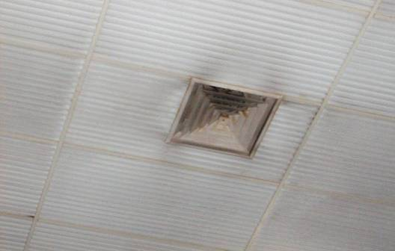

Air Supply Diffuser Located In Ceiling Tile above Pool

Picture 2

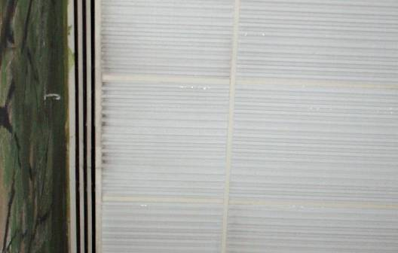

Air Supply Diffuser Located At Ceiling/Wall Juncture Above Pool Deck
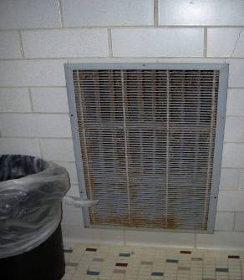
Picture 3

Exhaust Vent in Pool Area

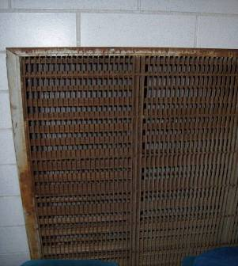
Picture 4

Exhaust Vent in Pool – Note Heavy Oxidation

Picture 5

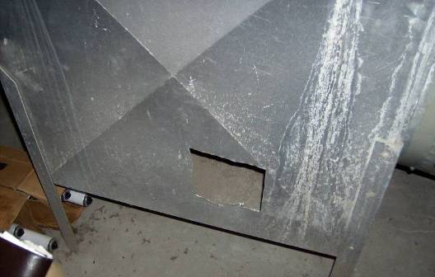
Whole Cut Into AHU
Also Note Boxes of Fluorescent Bulbs Stored On Floor

Picture 6

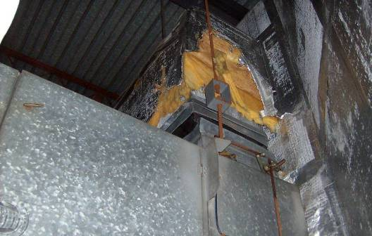

Insulation Is In Disrepair
Picture 7

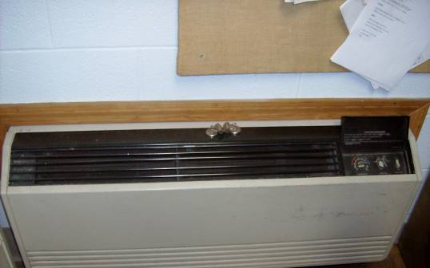

Univent in Facilities Transportation Office

Picture 8

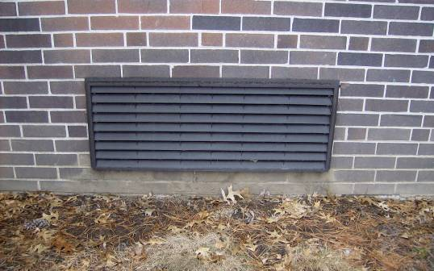

Univent Fresh Air Intake (UFAI),
Note Particulate/Debris Being Pulled Into System
Picture 9

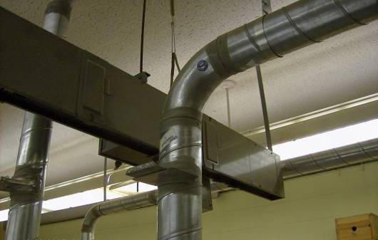

Wood Shop Dust Collection System
Location | Carbon  Dioxide  (*ppm) | Carbon  Monoxide  (*ppm) | Temp  °(F) | Relative  Humidity  (%) | Occupants  in Room | Windows  Openable | Ventilation |  | Remarks
 |  |  |  |  |  |  | Supply | Exhaust | Remarks
Background/Outdoors | 404 | ND | 43 | 20
Pool | 630 | ND | 72 | 89 | 32 | N | Y | Y | DO, Many children in pool
Pool | 605 | ND | 78 | 52 | 0 | N | Y | Y | Corrosion noted on exhaust vents, louvers are corroded as well
Boy’s Locker Room | 600 | ND | 73 | 30 | 1 | Y | Y | Y | DC
Girl’s Locker Room | 653 | ND | 72 | 30 | 0 | Y | Y | Y | DO
Gymnasium | 685 | ND | 72 | 27 | 25 | N | Y | Y | DO, Ceiling fans are not in clean condition
Wood Shop | 619 | ND | 70 | 18 | 2 | N | Y | Y | DO
Tech. Ed | 505 | ND | 71 | 16 | 0 | N | Y | Y | DO
Theatre Room | 735 | ND | 72 | 17 | 1 | N | Y | Y | New AHU; latex paint
Storage Room (Old Metal Shop) | 475 | ND | 70 | 16 | 0 | N | Y | N | DO
Facilities Transportation Office | 510 | ND | 71 | 19 | 2 | N | Y | Y | DO
Dir. of Facilities and Transportation Office | 522 | ND | 71 | 19 | 0 | Y | Y | Y | DO
Old Boiler Room | 537 | ND | 73 | 20 | 0 | Y | N | Y | DO, Room now used by maintenance dept.

BUREAU OF ENVIRONMENTAL HEALTH

Indoor Air Quality Program

Mercury Spill Clean Up Procedure

February 2008

The Indoor Air Quality (IAQ) Program routinely receives inquiries concerning the accidental spill and clean up of small amounts of elemental mercury. Such spills are usually associated with mercury containing devices, such as thermometers, thermostats, barometers and medical equipment, such as older sphygmomanometer (blood pressure cuffs).

For cleaning, handling and disposal of broken fluorescent lights, including compact fluorescent lights, please refer to the Massachusetts Department of Environmental Protection’s (MDEP) guidelines. The MDEP has posted compact fluorescent light (CFL) information for consumers and cleanup guidance at http://mass.gov/dep/toxics/stypes/cflinfo.htm (Consumer Information CFL Bulbs) and http://mass.gov/dep/toxics/stypes/brkncfls.htm (Guidance for Cleaning up Broken CFL Bulbs) and info about recycling options at http://mass.gov/dep/toxics/stypes/cflrlocs.xls and (Municipal & Commercial Drop-Off Locations for Mercury-Added Product Recycling).

The IAQ Program recommends the following procedures to assess potential health impacts and to clean up small amounts of mercury from spills that occur in homes or other buildings.

Ventilation and Isolation

- Do Not Walk either on broken mercury-containing materials or on visible mercury.
- Do Not Use a vacuum cleaner or broom to remove or gather broken mercury-containing materials or on visible mercury.
- Close interior doors of spill areas.

How to Ventilate the Mercury Spill Location
Fan in Window
Door Closed
Spill
Airflow of Fan
Hallway

- Place a fan in the window operating in a manner to blow air directly outdoors.
- Interior doors should stay closed to prevent mercury contamination in other areas of house/building.
- Operate the fan in the spill areas for at least a day whether mercury is visible or not to ensure optimal ventilation (weather permitting).

Spill Clean up

If mercury was spilled on a hard, non-porous surface (e.g., metal, tile, plastic, etc.):

- Do not use a vacuum cleaner or broom to clean the area. Use of a vacuum cleaner can both contaminate the vacuum cleaner and spread the mercury contamination.
- Gather visible mercury together using a rigid material (e.g. squeegee, cardboard, thick paper).
- Work to gather spilled mercury beads toward a central location to form a large bead.
- Push the mercury beads into a plastic dustpan or use an eyedropper to pick up the beads.
- Tape can also pick up small mercury beads, but use caution due to problems associated with mercury adhering to tape.
- Collect all mercury into a used, wide-mouthed, plastic container with a screw-on lid.
- Optional step: Sprinkle sulfur powder (available at some lawn and garden stores) on the spill area after cleaning up the beads of mercury; a color change from yellow to brown indicates that mercury is still present and more cleanup is needed. If the sulfur powder stays yellow, this indicates clean up efforts were successful.
- After mercury is removed, clean area with soap and water. Discard bucket, sponge and rubber gloves as if mercury contaminated.

If the mercury was spilled on hardwood or other surfaces that may have crevices:

- If mercury accumulates in cracks in flooring or below floorboards, it cannot be completely removed using the methods described previously.
- Contacting an environmental remediation firm that possesses a mercury spill clean up kit may be necessary.

If the mercury was spilled on carpet or other cloth material:
- Cloth materials cannot be cleaned completely of mercury contamination and should be discarded.
- If the contaminated item is removable and disposable (throw rug, furniture cover, sheet, clothing, paper, cardboard, etc.), carefully place the contaminated material into a sealable plastic bag.
- Place the disposable container into a plastic bag that you can tie off at the top (to keep the contents inside) and transport to an outdoor trash bin right away.

Anything that has come in contact with mercury, including all clean up materials must be taken to a recycling facility or household hazardous waste program for proper disposal.

Once mercury clean up is completed, wash your hands and other parts of your body that may have come in contact with mercury.

Questions

If you have any questions concerning these guidelines, please contact:

Massachusetts Department of Public Health
Bureau of Environmental Health
Indoor Air Quality Program
250 Washington Street, 7th Floor
Boston, MA 02108

Phone: (617) 624-5757, Fax: (617) 624-5777

