Among Massachusetts workers, who is more likely to work outdoors?
Occupational Health Surveillance Program, Spring 2025

Introduction
Working outdoors can increase the risk of exposure to climate-related health hazards like extreme heat, poor air quality (e.g., wildfire smoke), and vector-borne disease (e.g., Lyme disease). Understanding which subgroups of workers are more likely to work outdoors allows for tailored interventions and outreach.

Methods
We first developed an approach to identify outdoor workers based on occupation. We then used data from the 2018-2022 American Community Survey 5-year Public Use Microdata Sample to estimate the percent of employed Massachusetts residents aged 16 years and older (i.e., workers) in occupations that involve outdoor work.
In this data brief, we present findings on who is more likely to work outdoors in Massachusetts by select demographics, including industry.
Additional findings and information on the approach developed to identify workers in the analysis are available upon request at mdph.ohsp@mass.gov.

[Text Box]
Key takeaways
- Nearly 1 in 5 workers in Massachusetts works outdoors, putting them at increased risk of exposure to climate-related health hazards.
- The likelihood of working outdoors is not equal across the workforce.
- It is important to disaggregate data by detailed race/ethnicity where possible since subgroups within racial or ethnic groups may have different cultures, perspectives, and experiences.
- These findings could be used by government or community partners for climate-related efforts, such as research, policy development and outreach campaigns.

[Images: There are three images next to each other. Image 1 shows a person outside unloading boxes from the back of a van; image 2 shows a person in a hat trimming a shrub in front of a house; image 3 shows a person holding a fishing net on a boat.]
[Caption]
Examples of occupations that involve outdoor work include landscapers, fishing workers, roofers, paramedics, and delivery drivers.

Findings

Overall

There were an estimated 3.67 million workers in Massachusetts on average from 2018–2022. While the majority (82.5%) were likely to work primarily indoors, an estimated 17.5% or 641,000 worked outdoors. Approximately 460,000 outdoor workers worked in the private sector and 68,000 worked in state and local government.

Figure 1. Percent of Massachusetts workers who worked outdoors, 2018-2022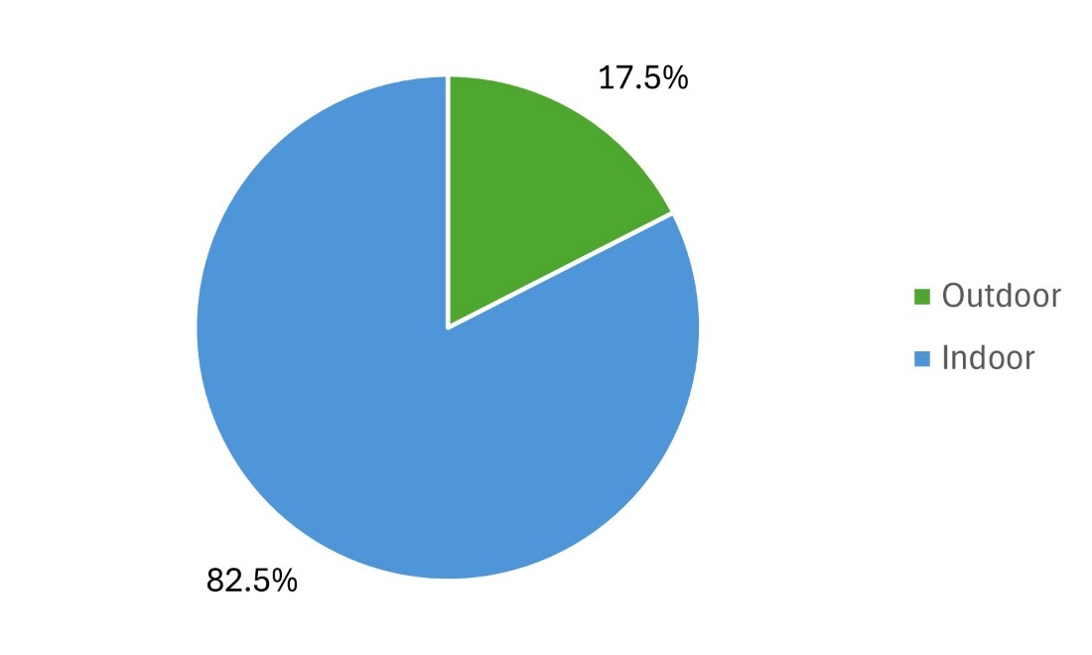

Data source: 2018-2022 American Community Survey 5-year Public Use Microdata Sample

[Image: A person in a yellow hard hat climbing on a construction site.]
Select demographics

Figure 2 shows the percent of Massachusetts workers who worked outdoors by:
- Sex: The percent was higher among male (28.1%) than female (6.4%) workers.
- Age: The percent ranged from 16.5% among 25–34 year-old workers to 18.5% among workers aged 65 and older.
- Race and Hispanic/Latino (nH/nL) ethnicity: The percent ranged from 7.7% among Asian/Native Hawaiian/Pacific Islander, nH/nL workers to 29.2% among American Indian/Alaska Native, nH/nL workers. Additional findings by detailed Hispanic/Latino ethnicity are included on the next page.
- Nativity and Language spoken at home: The percent was slightly higher among workers born outside the US compared to those born in the US (18.4% vs. 17.2%), and among those who spoke a language other than English at home compared to those who spoke English only (18.8% vs. 17.0%).

Figure 2. Percent of Massachusetts workers who worked outdoors by select demographics, 2018-2022
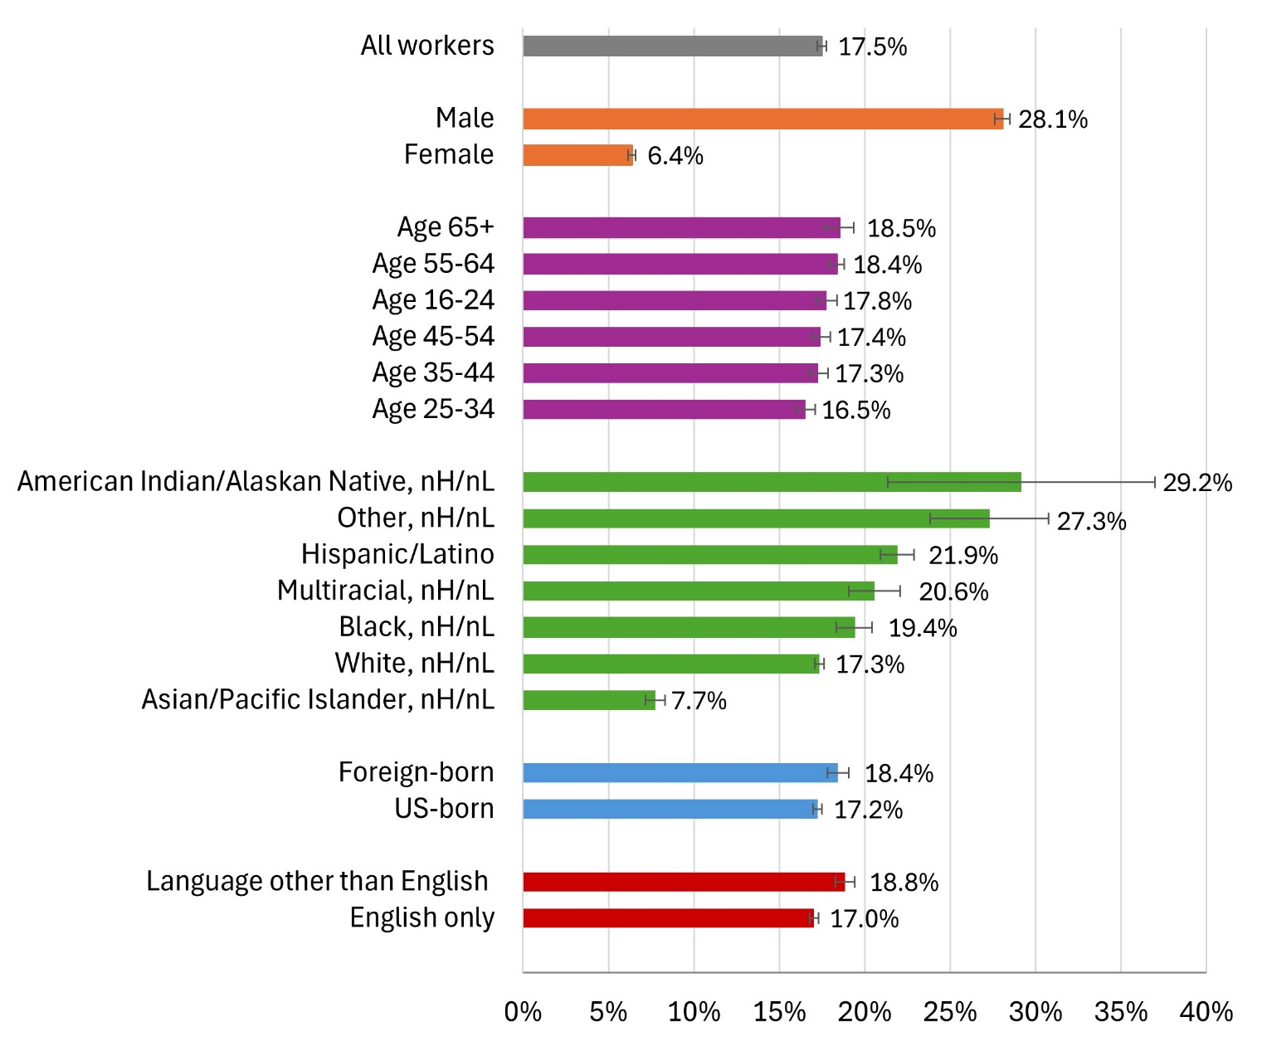

Data source: 2018-2022 American Community Survey 5-year Public-use Microdata Sample
Notes: 1) “Hispanic/Latino” includes respondents who self-identified as having Hispanic, Latino or Spanish origins;
2) nH/nL = non-Hispanic/non-Latino; 3) Native Hawaiian workers are included in Asian/Pacific Islander, nH/nL; 4) Language is language spoken at home; 5) Error bars are 95% confidence intervals.
Detailed race and ethnicity: Hispanic/Latino workers

Disaggregating data by detailed race and/or ethnicity often reveals differences in estimates across subgroups that are masked when the subgroups are combined. To examine these differences, we looked at select racial and ethnic subgroups of workers and identified the percent among each subgroup who worked outdoors.

Figure 3 highlights these findings for subgroups of Hispanic/Latino workers:*
- Among all Hispanic/Latino workers, an estimated 21.9% or 89,000 worked outdoors. By detailed Hispanic/Latino ethnicity, the percent who worked outdoors ranged from 15.6% among Colombian workers to 40.9% among Ecuadorian workers. Worth noting, an estimated 95.8% of all Hispanic/Latino outdoor workers spoke Spanish at home.
- Among Brazilian workers, an estimated 36.2% or 18,000 worked outdoors; 98.7% of Brazilian outdoor workers spoke Portuguese at home.

Note: Brazilian workers are included in this section based on Latin American ancestry or origin, but most self-identified using a non-Hispanic/non-Latino racial category (e.g., White or other) rather than as Hispanic/Latino.

Figure 3. Percent of Massachusetts workers who worked outdoors by detailed Hispanic/Latino ethnicity, 2018-2022

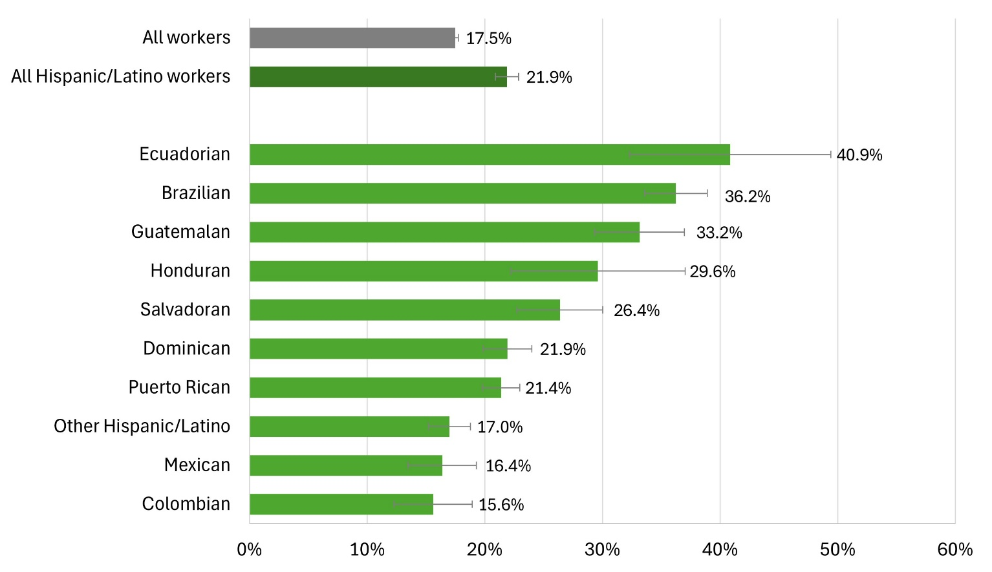
Data source: 2018-2022 American Community Survey 5-year Public Use Microdata Sample
Notes: 1) “All Hispanic/Latino workers” includes respondents who self-identified as having Hispanic, Latino or Spanish origins; 2)“Other Hispanic/Latino” includes Cuban, Costa Rican, Nicaraguan, Panamanian, Other Central American, Argentinean, Bolivian, Chilean, Paraguayan, Peruvian, Uruguayan, Venezuelan, Other South American, Spaniard, and all other Spanish, Hispanic, Latino. These groups were combined due to individual estimates being unstable (i.e., Relative Standard Error >15%); 3) “Brazilian” includes those who reported Brazilian as primary or secondary ancestry/ethnic origin; most identified as non-Hispanic/non-Latino racial category and are not included in the estimate for “All Hispanic/Latino workers”. Some are also included in “Other Hispanic/Latino”; 4) Error bars are 95% confidence intervals.
* Additional findings and information on the approach developed to identify workers in the analysis are available upon request at mdph.ohsp@mass.gov.
Industry

Figure 4 shows the percent of Massachusetts workers who worked outdoors by industry, or the type of business in which a person works (i.e., what the employer does). The ten industry groups in Figure 4 accounted for an estimated 447,000 or 70% of all outdoor workers in Massachusetts.
- There were four industry groups where over half of the workers worked outdoors: Construction with 80.2% (an estimated 177,000 workers); Agriculture, Forestry, Fishing and Hunting with 76.8% (11,000 workers); Transportation with 67.8% (82,000 workers); and Real Estate, Rental and Leasing with 64.2% (39,000 workers).

Figure 4. Percent of Massachusetts workers who worked outdoors: Top 10 industries, 2018-2022

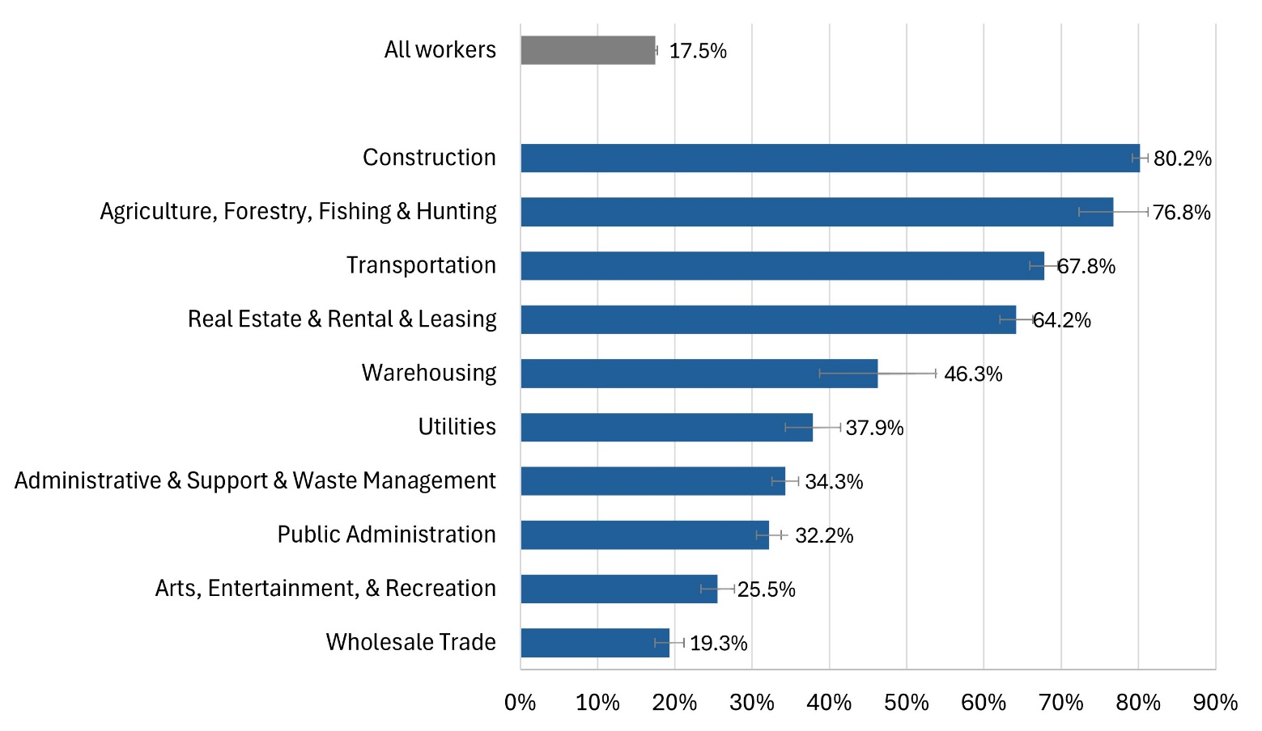

Data source: 2018-2022 American Community Survey 5-year Public Use Microdata Sample
Note: Error bars are 95% confidence intervals.

[Image: A person in a red hat working in a field.]

Additional Resources

Massachusetts Department of Labor Standards
- Heat Illness - For employers
- Heat Illness - For employees
- Heat Illness Prevention and Management for Outdoor Workers
- Protect Outdoor Workers Exposed to Wildfire Smoke Polluted Air
Massachusetts Department of Public Health, Bureau of Climate and Environmental Health
- Climate and Health
National Institute for Occupational Safety and Health
- Working Safely Outdoors
- Heat Stress and Workers
Occupational Safety and Health Administration
- Heat Illness Prevention
AirNow
- Air Quality Index

[Image: Two sanitation workers outside standing next to a green garbage truck.]

