INDOOR AIR QUALITY ASSESSMENT

Amvet Boulevard Elementary School
70 Amvet Boulevard
North Attleboro, Massachusetts

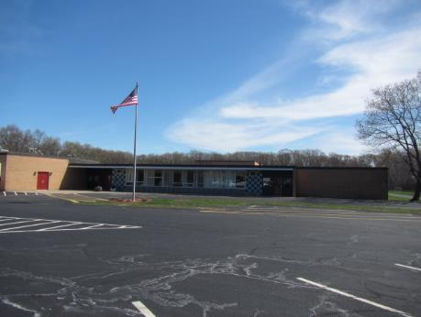

Prepared by:
Massachusetts Department of Public Health
Bureau of Environmental Health
Indoor Air Quality Program
May 2019

Background

Building: | Amvet Boulevard Elementary School (ABES)
Address: | 70 Amvet Boulevard, North Attleborough, MA
Reason for Request: | General indoor air quality (IAQ) and water damage/mold concerns
Date(s) of Assessment: | April 25 & 30, 2019
Assessment Requested by: | Scott Holcomb, Superintendent, North Attleborough Public Schools (NAPS)
Massachusetts Department of Public Health/Bureau of Environmental Health (MDPH/BEH) Staff Conducting Assessment: | Cory Holmes, Environmental Analyst, IAQ Program
Date of Building Construction: | The ABES is a one-story yellow brick building constructed in 196. A modular classroom was added in the early 1990s.
Building Description: | Brick and concrete construction; ceilings are concrete, walls are cinderblock and floors are tile. All ventilation components are original equipment dating back to the early 1960s (1990s for Modular).
Building Population: | Approximately 380 students in grades K through 5 with a staff of approximately 60
Windows: | Openable, although some in disrepair due to age (original metal framed, single-paned windows).

Background
The school is experiencing chronic water leaks through the roof and primarily around abandoned skylights that have been sealed with wood. As a result of water damage and other concerns regarding air quality, the NAPS hired VERTEX® an environmental consultant, to conduct a limited IAQ assessment. The VERTEX report recommended:
- Retain a reputable roofing contractor to identify and repair roof leaks.
- Restrict access to Room 1 until elevated spore counts have been addressed and to prevent migration of airborne particulates.
- Retain a reputable mold remediation contractor to clean Room 1 and dispose of water-damaged building materials (i.e., plywood, area rug, etc.).
- Routine cleaning and general housekeeping of classrooms should include the particulate removal from the HVAC return and supply registers, as well as clearing off the univents to improve air circulation.
- Remove and replace water-damaged ceiling tiles in Room 27 (VERTEX, 2019).

During the week of April 15-19, J Brian Day, a fire/flooding remediation specialist completed mold remediation of Room 1. J Brian Day’s scope of work included:
- Thoroughly cleaning all contents of classroom with an anti-microbial agent.
- Treating the ceiling with Fiber-Lok mold and stain remover and allowing it to dry with dehumidification and then re-treating with an anti-microbial agent.
- Encapsulating the ceiling with Fiber-Lok 600 encapsulating paint.
- Treating all the walls and wall hangings with an anti-microbial agent.
- Conducting work with classroom under negative air pressure.
- After completion of work/visual inspection, follow-up tests were conducted and determined that the room was “cleared for a return of normal use” (Appendix A).

IAQ Testing Results
Please refer to the IAQ Manual for methods, sampling procedures, and interpretation of results (MDPH, 2015). The following is a summary of indoor air testing results (Table 1).
- Carbon dioxide levels were above the MDPH guideline of 800 parts per million (ppm) in 32 of 38 locations assessed, indicating a lack of air exchange, mainly due to deactivated/outdated ventilation components. This is explained further in the Ventilation section of this report.
- Temperature was within or close to the recommended range of 70°F to 78°F, with a number of complaints of poor comfort/lack of temperature control.
- Relative humidity was within or close to the recommended range of 40 to 60% the day of assessment.
- Carbon monoxide levels were non-detectable (ND) in all indoor areas tested.
- Fine particulate matter (PM2.5) concentrations measured were below the National Ambient Air Quality Standard (NAAQS) limit of 35 μg/m³ in all areas tested.
- TVOCs (total volatile organic compounds) levels were ND in room 1, which had a lingering odor of paint.

Ventilation
A heating, ventilating and air conditioning (HVAC) system has several functions. First it provides heating and, if equipped, cooling. Second, it is a source of fresh air. Finally, an HVAC system will dilute and remove normally occurring indoor environmental pollutants by not only introducing fresh air, but by filtering the airstream and ejecting stale air to the outdoors via exhaust ventilation. Even if an HVAC system is operating as designed, point sources of respiratory irritation may exist and cause symptoms in sensitive individuals.
Mechanical ventilation equipment was deactivated in almost every area throughout the building in both classrooms and common areas (e.g., cafeteria, gym, library) (Table 1). It is also important to note that several classrooms with carbon dioxide levels below 800 ppm were unoccupied or sparsely populated, which can greatly reduce carbon dioxide levels. Therefore during full occupancy the carbon dioxide levels would be expected to be higher.
Fresh air in classrooms is supplied by a unit ventilator (univent) system (Figure 1). These units are not just “heaters” but “ventilators” when heat is not called for (e.g., comfortable spring day). Univents draw air from outdoors through a fresh air intake located on the exterior walls of the building (Picture 1) and return air through an intake located at the base of each unit. Fresh and return air are mixed, filtered, heated and provided to classrooms through an air diffuser located in the top of the unit. Univents have local controls for “low” and “high” fan speed (Picture 2). As stated, the majority of univents were deactivated during the assessment, preventing a mechanical means to introduce air into the building (Table 1). Obstructions to airflow, such as items on and/or in front of univents were seen in a number of classrooms (Picture 3; Table 1). In order for univents to provide fresh air as designed, these units must remain “on” and allowed to operate while rooms are occupied. Importantly, intakes, diffusers and returns must remain free of obstructions.
Mechanical exhaust ventilation in classrooms is provided by unit exhaust ventilators (Picture 4). A unit exhaust ventilator appears similar to a univent, but removes air from the classroom and ejects it out of the building (Picture 1). Unit exhaust ventilators were not operating at the time of the assessment and appeared not to have been operating for some time. BEH/IAQ and school maintenance staff examined the interior of one of these units and found the unit was unplugged. The unit was plugged to observe function and it reactivated. Without proper supply and exhaust ventilation, normally occurring environmental pollutants can build up and lead to indoor air quality/comfort complaints.
Ventilation for many interior rooms (without windows) is supplied by ceiling/rooftop mounted equipment and distributed/returned by a combination of wall, ceiling and passive door vents (Pictures 5 through 7). However if supply/exhaust units/motors are not operating, no air exchange is provided to these areas.
Ventilation for the modular classroom is provided by a rooftop air handling unit (AHU) (Picture 8). Fresh air is distributed to the classroom via ductwork connected to ceiling-mounted air diffusers (Picture 9). Return vents draw air back to the AHUs through ceiling-mounted grilles (Picture 10). A thermostat controls the HVAC system and has fan settings of “on” and “automatic”. The thermostat was set to the fan “auto” setting (Picture 11) during the assessment. The “automatic” fan setting on the thermostat activates the HVAC system at a preset temperature. Once the preset temperature is reached, the HVAC system is deactivated. Therefore, no mechanical ventilation is provided until the thermostat re-activates the system. The BEH/IAQ Program recommends that the thermostat be set to fan “on” to provide a continuous source of air exchange and filtration.
In order to have proper ventilation with a mechanical supply and exhaust system, these systems must be balanced to provide an adequate amount of fresh air to the interior of a room while removing stale air from the room. It is recommended that existing ventilation systems be re-balanced every five years to ensure adequate air systems function (SMACNA, 1994).
According to the American Society of Heating, Refrigeration and Air-Conditioning Engineers (ASHRAE), the service life for a unit heater, hot water or steam is 20 years, assuming routine maintenance of the equipment (ASHRAE, 1991). Despite attempts to maintain the univents (e.g., oiling bearings, changing filters regularly), the operational lifespan of this equipment has been exceeded. Maintaining the balance of fresh to exhaust air will become more difficult as the equipment ages and as replacement parts become increasingly difficult to obtain.

Microbial/Moisture Concerns
In order for building materials to support mold growth, a source of water exposure is necessary. The US Environmental Protection Agency (US EPA) and the American Conference of Governmental Industrial Hygienists (ACGIH) recommends that porous materials (e.g., wallboard, carpeting) be dried with fans and heating within 24 to 48 hours of becoming wet (US EPA, 2008; ACGIH, 1989). If porous materials are not dried within this time frame, mold growth may occur. It is important to note that the majority of building materials observed were non-porous surfaces (i.e., cinder block, concrete, floor tiles), which are not conducive to mold growth as opposed to porous materials such as gypsum wallboard, carpet and fibrous ceiling tiles).
Water-damaged ceiling tiles were observed in the modular classroom (Pictures 12 and 13) where an active leak was reported, and a few in hallways (Table 1); these indicate leaks from the building envelope and/or plumbing system. These tiles should be replaced after a leak is found and repaired. NAPS representatives reported that a roofing contractor has been hired and roof repairs were on-going. Active leaks were observed in Room 25, where buckets were positioned to catch dripping water (Picture 14). In many areas, dark staining was observed on concrete ceilings (Pictures 15 through 17) indicating historic leaks. No visible mold was observed on building materials during the assessment. BEH/IAQ staff physically tried to clean the stain in one area but the stain was embedded into the concrete.
Visible mold growth was observed in one area, the Faculty Lounge. A refrigerator had mold on the gaskets (Pictures 18 and 19). Refrigerators should be cleaned out regularly to prevent odors and microbial growth. Gaskets should be cleaned with a mild antimicrobial solution; if they are too heavily stained to be cleaned, they should be replaced.
Plants were observed in a number of areas (Table 1). Plants can be a source of pollen and mold, which can be respiratory irritants to some individuals. Plants should be properly maintained and equipped with drip pans and should be located away from air diffusers to prevent the aerosolization of dirt, pollen and mold.
Since the school was built as a former junior high in the early 1960s, it contains former shower/locker rooms that are used as storage areas (Pictures 20 and 21). Leaking plumbing and or condensation on cool surfaces (i.e., cool floors/walls) can be a source of moisture to porous materials (like paper, cloth and cardboard) and the indoor environment, particularly when outdoor humidity is high. It is also important to note that drains are usually designed with traps in order to prevent the back up of sewer odors/gases from penetrating into occupied spaces. When water enters a drain, the trap fills and forms a watertight seal. Without a watertight seal, odors and sewer gas can enter occupied space.
A variety of air conditioning (AC) units are used in classrooms, including window units, wall-mounted units, and portable air conditioners (Table 1). Air conditioning units collect condensation that should be drained to prevent water damage and microbial growth. Condensation collection pans/vessels and drains should be inspected for leaks and clogs and cleaned periodically to prevent stagnant water and debris that can lead to odors and microbial growth.
Trees overhang the roof in some areas (Picture 22), which can lead to deterioration of the building envelope due to root infiltration and dampness against the exterior surface. Plants can also be a source of debris and pollen to air intakes and drains. Plants and trees should be trimmed away from the building and from overhanging the roof.

Other IAQ Evaluations
Exposure to low levels of total VOCs (TVOCs) may produce eye, nose, throat, and/or respiratory irritation in some sensitive individuals. To determine if VOCs were present, BEH/IAQ staff examined rooms for products containing VOCs. BEH/IAQ staff noted hand sanitizers, cleaners, air fresheners and dry erase materials in use within the building (Table 1). All of these products have the potential to be irritants to the eyes, nose, throat, and respiratory system of sensitive individuals and should be kept out of reach of children. In one case, a product with the warning label: “Harmful or Fatal if Swallowed” was observed on a countertop (Picture 23). This was removed by NAPS maintenance staff.
Photocopiers and laminators were located in the Faculty Lounge, Main Office and a few other areas. Photocopiers can emit ozone and TVOCs, especially when they are older or heavily used and laminators give off waste heat and plastic odors. It is recommended that this equipment be used in a well-ventilated area, preferably with local exhaust ventilation.
In a few classrooms, tennis balls were found sliced open and placed around chair legs to reduce noise (Picture 24). Tennis balls are made of a number of materials that are a source of respiratory irritants. Constant wearing of tennis balls can produce fibers and off-gas VOCs. Tennis balls are made with a natural rubber latex bladder, which becomes abraded when used as a chair leg pad. Use of tennis balls in this manner may introduce latex dust into the school environment. Some individuals are highly allergic to latex (e.g., spina bifida patients) (SBAA, 2001). It is recommended that the use of materials containing latex be limited to reduce the potential for symptoms in sensitive individuals (NIOSH, 1997). Latex-free glides should be used for this purpose. Note that in some classrooms, pieces of cloth were tied around chair legs instead of tennis balls; these should be changed out when they get worn or soiled.
A univent was opened and the filter examined. It was determined to be a type that provides minimal filtration (Picture 25). The BEH/IAQ Program recommends pleated filters with a Minimum Efficiency Reporting Value (MERV) of 8 which are adequate in filtering out pollen and mold spores (ASHRAE, 2012). Note, that an increase in filtration can cause stress on equipment, which needs to be evaluated to determine if the higher-rated filters will allow adequate function. AHUs for the modular classroom and common areas should also be equipped with MERV 8 or higher filters. ACs in use also have filters that need to be cleaned or changed regularly in accordance with manufacturer’s instructions to prevent the build-up of dust and debris.
Many classrooms had personal fans. Some of these had dusty blades (Table 1). Some supply and exhaust vents were also observed to be dusty (Pictures 9, 10, 12, and 26, Table 1). This dust/debris can be reaerosolized when the equipment is activated. In many areas, items, including books, papers, toys and decorative items were observed on floors, windowsills, tabletops, counters, bookcases, and desks (Pictures 27; Table 1), which can make it more difficult for custodial staff to clean as evidence by accumulation of dust/debris on flat surfaces such as windowsills (Picture 28).
Most classrooms had carpeting that appeared to be several decades old. In many areas, this carpeting was visibly very worn, frayed, wrinkled and stained (Picture 29; Table 1). The service life of carpeting in schools is approximately 10-11 years (IICRC, 2002). Aging carpet can produce fibers that can be irritating to the respiratory system. In addition, tears or lifting carpet can create tripping hazards. Carpeting should be cleaned annually or semi-annually in soiled high traffic areas as per the recommendations of the Institute of Inspection, Cleaning and Restoration Certification (IICRC, 2012). Non-carpeted surfaces are recommended for most areas of schools.
Many classrooms had area rugs, which should also be cleaned regularly and discarded when too worn out or soiled to be cleaned (e.g., Picture 30). Plush and upholstered items such as chairs, pillows/cushions, and toys were also found (Table 1, Pictures 31 and 32) and should also be cleaned regularly to remove the build-up of oils and debris.
Missing light covers were seen in the OT/PT area (Picture 33). Fixtures should be equipped with access covers installed with bulbs fully secured in their sockets. Breakage of glass can cause injuries and may release mercury and/or other hazardous compounds.
Classroom 10 had a missing panel, exposing a hot water pipe (Picture 34). This panel should be replaced/space be covered to prevent a burning/fire hazard.

Conclusions/Recommendations
The conditions related to IAQ problems at the ABES raise a number of issues. The general building conditions, maintenance, work hygiene practices, and the condition of HVAC equipment, if considered individually, present conditions that could degrade IAQ. When combined, these conditions can serve to further degrade IAQ. Some of these conditions can be remedied by actions of building occupants. Other remediation efforts will require alteration to the building structure and equipment. For these reasons, a two-phase approach is required for remediation. The first consists of short-term measures to improve air quality and the second consists of long-term measures that will require planning and resources to adequately address overall IAQ concerns.

Short-term measures:
- Operate all ventilation systems throughout the building (e.g., gym, cafeteria, classrooms) continuously during periods of school occupancy and independent of thermostat control.
- To increase airflow in classrooms, set univent controls to “high.”
- Program the thermostat for the Modular classroom to operate continuously (fan “on”) during occupied periods (if possible).
- Examine each univent for function. Survey classrooms for univent function to ascertain if an adequate air supply exists for each room. Consider consulting an HVAC engineer concerning the calibration of univent fresh air control dampers throughout the school.
- Operate all exhaust vents in classrooms, common areas, restrooms and internal rooms. Check exhaust vents for air draw periodically. Inspect unit exhaust motors and belts for proper function. Repair and replace as necessary.
- Remove all blockages from univents (top and front) and exhaust vents to ensure adequate airflow.
- Use openable windows in conjunction with classroom univents and exhaust vents to increase air exchange. Care should be taken to ensure windows are properly closed at night and weekends.
- Consider adopting a balancing schedule of every 5 years for all mechanical ventilation systems, as recommended by ventilation industrial standards (SMACNA, 1994).
- Continue with on-going roof repairs. Once leaks are repaired replace water-damaged ceiling tiles and paint/refinish areas with water stains, etc.
- Until full roof replacement can occur, monitor leaks/condition of wood in former skylights. If further water damage occurs:
  - Patch area(s) of leaks;
  - Remove any visible mold growth using US EPA Guidelines (US EPA, 2008);
  - Clean/treat surface of wood with an antimicrobial/sealing agent.
- Make repairs to building envelope (e.g., siding, soffits) of Modular Room 27 to prevent further water penetration.
- Avoid storage of any porous materials in areas of known leaks or in unconditioned spaces (e.g., former locker/shower areas).
- Ensure all refrigerators are kept clean to prevent microbial growth and odors. Clean gaskets and other surfaces with a mild antimicrobial solution to remove debris and mold.
- Properly maintain plants, including drip pans, to prevent water damage to porous materials. Plants should also be located away from air diffusers to prevent the aerosolization of dirt, pollen, and mold.
- If floor drains in former locker/shower areas are unused, pour water down drains periodically to maintain the trap seal. Consider sealing permanently (plumbing cut and capped) to prevent odors/pests.
- Ensure that condensation from AC equipment is draining properly. Check collector pans, piping and any associated pumps for clogs and leaks and clean periodically to prevent stagnant water build-up and remove debris that may provide a medium for microbial growth.
- Trim back trees from overhanging the roof and ensure all plants/shrubs are located at least five feet away from air intakes (e.g., courtyard).
- Reduce use of products and equipment that emit VOCs. Avoid the use of air freshening products including plug-ins and sprays.
- Use photocopiers and laminators in well-ventilated areas.
- Replace tennis balls on chair footings with latex-free glides.
- Consider upgrading to a pleated filter of MERV 8 in univents and AHUs, if these can be used with the current equipment. Change filters 2-4 times a year or as per the manufacture’s recommendations.
- Regularly clean/vacuum univent/AHU cabinets, supply/return vents, fans and air conditioner filters to avoid aerosolizing accumulated particulate matter.
- For buildings in New England, periods of low relative humidity during the winter are often unavoidable. Therefore, scrupulous cleaning practices should be adopted to minimize common indoor air contaminants whose irritant effects can be enhanced when the relative humidity is low. To control for dusts, a high efficiency particulate arrestance (HEPA) filter-equipped vacuum cleaner in conjunction with wet wiping of all surfaces is recommended. Avoid the use of feather dusters. Drinking water during the day can help ease some symptoms associated with a dry environment (throat and sinus irritation).
- Replace outdated carpeting past its useful life. Consider using non-carpet flooring in classroom areas.
- Note due to the age of the building, flooring may include asbestos-containing materials (ACM). Ensure it is known prior to carpet removal if ACM is present. Continue to follow AHERA regulations including 3-year inspections and updates/availability of the school’s asbestos management plan.
- Clean carpeting and area rugs annually or more often in high-traffic locations in accordance with IICRC recommendations (IICRC, 2012) and discard those that are worn out or too soiled to be cleaned.
- Clean upholstered and plush items regularly to remove oils, dust and debris.
- Remove/replace worn/soiled/stained chairs/furniture (e.g., chairs in Faculty Lounge).
- Consider reducing the amount of items stored in classrooms/offices to make cleaning easier. Periodically move items to clean flat surfaces.
- Replace/repair fluorescent light covers (OT/PT) and ensure fluorescent lights are fully secured to prevent breakage.
- Repair panels in classroom 10 that expose hot water piping.
- Encourage faculty to report classroom/building related issues via a tracking program.
- Consider adopting the US EPA (2000) document, “Tools for Schools”, as an instrument for maintaining a good IAQ environment in the building available at: http://www.epa.gov/iaq/schools/index.html.
- For more information on mold refer to “Mold Remediation in Schools and Commercial Buildings” published by the US Environmental Protection Agency (US EPA, 2008). http://www.epa.gov/mold/mold-remediation-schools-and-commercial-buildings-guide.
- Refer to resource manual and other related IAQ documents located on the MDPH’s website for further building-wide evaluations and advice on maintaining public buildings. These documents are available at: http://mass.gov/dph/iaq.

Long-term Recommendations:
- Contact an HVAC engineering firm for an assessment of the ventilation system’s components and control systems (e.g., controls, air intake louvers, thermostats). Based on the age, physical deterioration, and availability of parts for ventilation components, such an evaluation is necessary to determine the operability and feasibility of repairing/replacing the equipment.
- Examine the feasibility of initiating capital improvement plans for major roof repairs/replacement.
- Consider replacement of wood sealing abandoned skylights with an appropriate fire-rated non-porous material.
- Install local exhaust ventilation for areas with photocopiers and lamination machines.

References
ACGIH. 1989. Guidelines for the Assessment of Bioaerosols in the Indoor Environment. American Conference of Governmental Industrial Hygienists, Cincinnati, OH.
ASHRAE. 1991. ASHRAE Applications Handbook, Chapter 33 “Owning and Operating Costs”. American Society of Heating, Refrigeration and Air Conditioning Engineers, Atlanta, GA.
ASHRAE. 2012. American Society of Heating, Refrigeration and Air Conditioning Engineers (ASHRAE) Standard 52.2-2012 -- Method of Testing General Ventilation Air-Cleaning Devices for Removal Efficiency by Particle Size (ANSI Approved). 2012.
IICRC. 2002. Institute of Inspection, Cleaning and Restoration Certification. A Life-Cycle Cost Analysis for Floor Coverings in School Facilities.
IICRC. 2012. Institute of Inspection, Cleaning and Restoration Certification. Carpet Cleaning: FAQ.
MDPH. 2015. Massachusetts Department of Public Health. “Indoor Air Quality Manual: Chapters I-III”. Available at: http://www.mass.gov/eohhs/gov/departments/dph/programs/environmental-health/exposure-topics/iaq/iaq-manual/.
NIOSH. 1997. NIOSH Alert Preventing Allergic Reactions to Natural Rubber latex in the Workplace. National Institute for Occupational Safety and Health, Atlanta, GA.
SBAA. 2001. Latex In the Home And Community Updated Spring 2001. Spina Bifida Association of America, Washington, DC.
SMACNA. 1994. HVAC Systems Commissioning Manual. 1st ed. Sheet Metal and Air Conditioning Contractors’ National Association, Inc., Chantilly, VA.
US EPA. 2000. Tools for Schools. Office of Air and Radiation, Office of Radiation and Indoor Air, Indoor Environments Division (6609J). EPA 402-K-95-001, Second Edition. http://www.epa.gov/iaq/schools/index.html.
US EPA. 2008. Mold Remediation in Schools and Commercial Buildings. US Environmental Protection Agency, Office of Air and Radiation, Indoor Environments Division, Washington, D.C. EPA 402-K-01-001. http://www.epa.gov/mold/mold-remediation-schools-and-commercial-buildings-guide.
VERTEX®. 2018. Short-Term Radon Testing, North Attleborough Public Schools, VERTEX Project No. 51595. July 23, 2018.
VERTEX®. 2019. Limited IAQ Assessment, Amvet Boulevard Elementary School. VERTEX Project No. 56182. April 8, 2019.
Picture 1
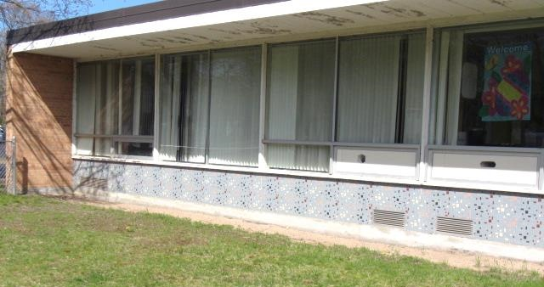
fresh air intake exhaust vent
Air intakes and exhaust vents (arrows) for classroom univents and unit exhaust ventilators

Picture 2

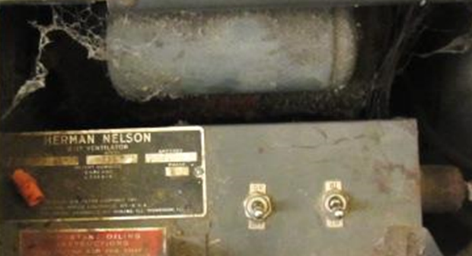

Toggle switches for activation of univents (left) and fan speed control (right),
note dust/debris/cobwebs in unit
Picture 3

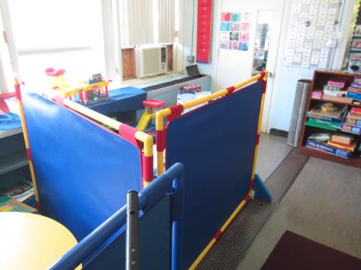
Classroom items obstructing airflow around univent (arrow)
Picture 4
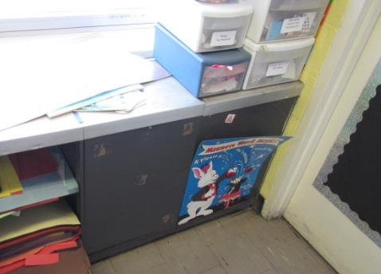
Typical unit exhaust ventilator in classroom
Picture 5
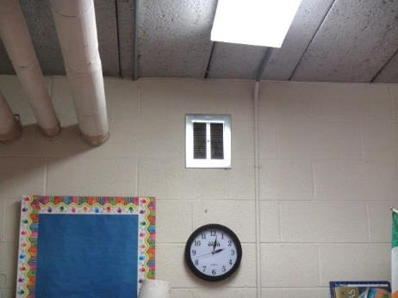
Switch-activated local exhaust vent in ESL room
Picture 6
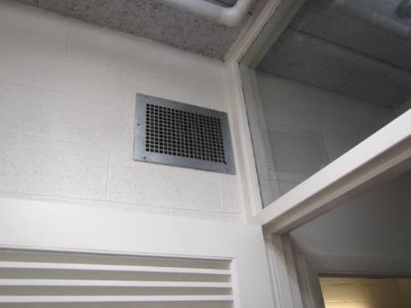
Wall-mounted vent, note passive door vents/louvers below
Picture 7
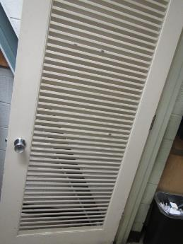
Example of passive door vents allowing airflow in/out of interior rooms
Picture 8
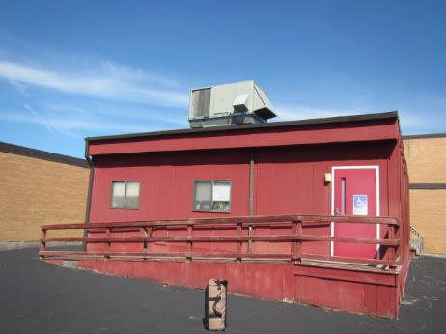
Rooftop air handling unit for modular classroom
Picture 9
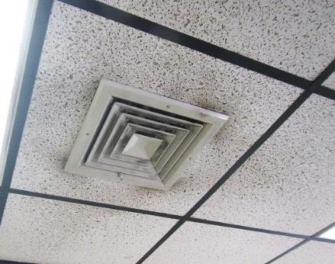
Supply diffuser for modular classroom, note dust/debris on vent/surrounding ceiling tiles
Picture 10
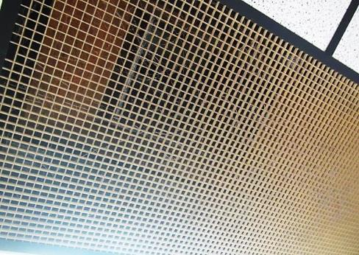
Return grill for modular classroom HVAC system, note dust/debris/cobwebs
Picture 11
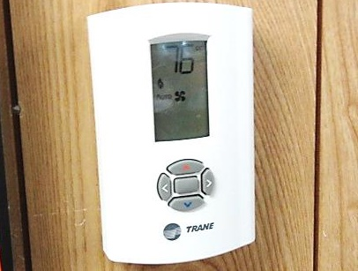
Digital thermostat for modular HVAC system, note fan in”Auto” setting
Picture 12
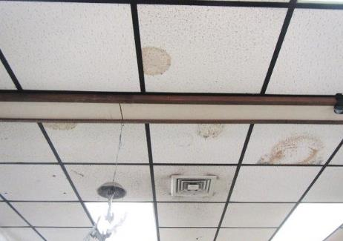
Water-damaged ceiling tiles in Modular Room 27, also note dust/debris on vent and surrounding ceiling tiles
Picture 13
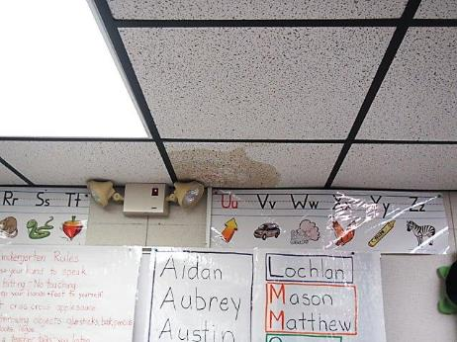
Stained ceiling tile in Modular Room 27, where active leak reported
Picture 14
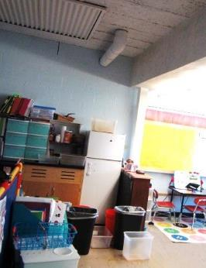
Buckets stationed on floor and countertop to catch roof leaks in Room 25
Picture 15
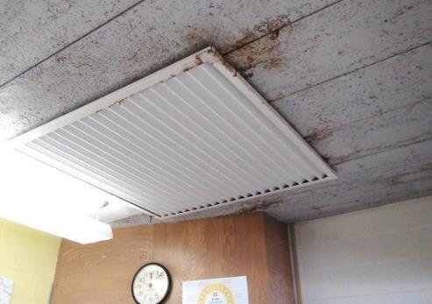
Staining on concrete ceiling and metal frame of ceiling panel
Picture 16
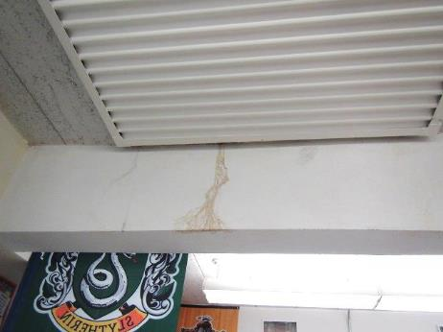
Stain from roof leak on concrete beam
Picture 17
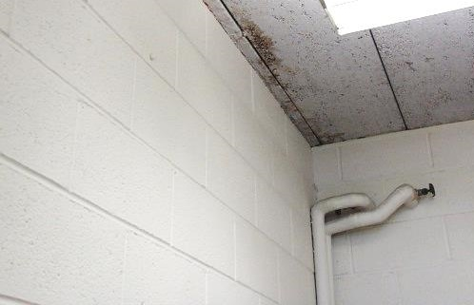
Staining of concrete ceiling
Picture 18
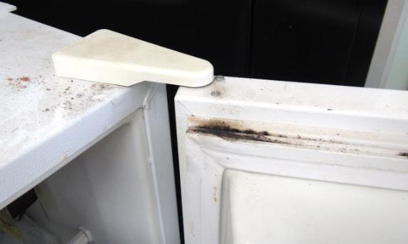
Mold growth/dark staining in Faculty Lounge refrigerator
Picture 19
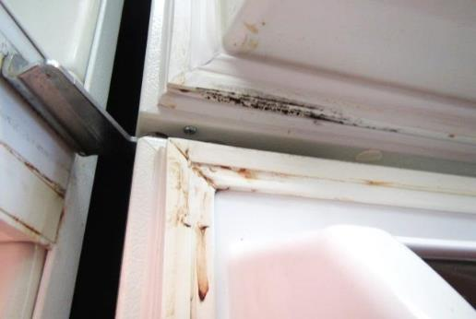
Mold growth/dark staining in Faculty Lounge refrigerator
Picture 20
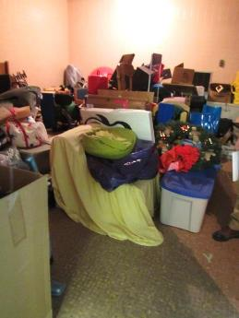
Former locker room/shower area being used for storage
Picture 21
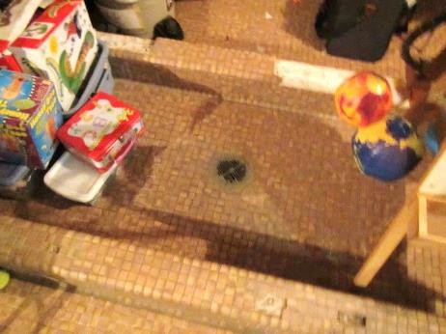
Former locker room/shower area being used for storage, note floor drain
Picture 22
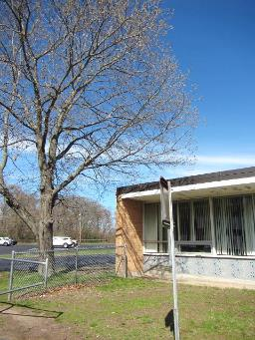
Tree overhanging roof
Picture 23
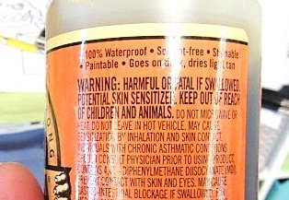
Product in classroom, note Warning label: H ARMFUL OR FATAL IF SWALLOWED
Picture 24
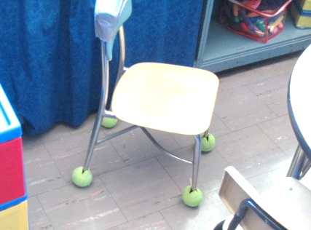
Tennis balls on chair legs
Picture 25
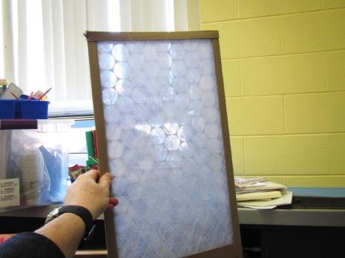
Classroom univent filter
Picture 26
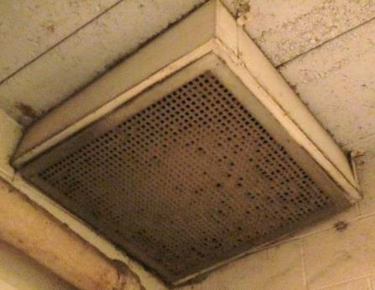
Exhaust vent for gym occluded with dust/debris
Picture 27
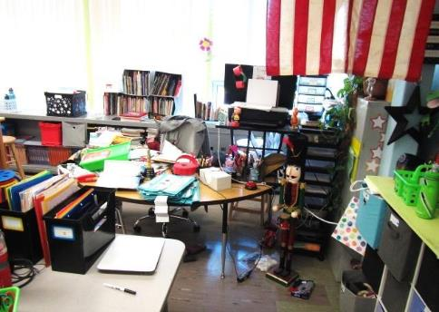
Accumulated items in classroom
Picture 28
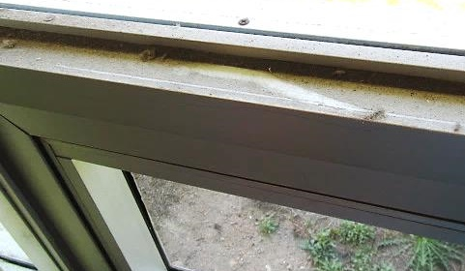
Accumulated dust/debris on windows in classroom
Picture 29
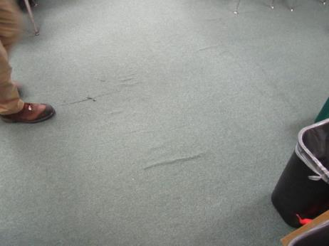
Wrinkled, worn/damaged carpeting in Modular Room 27
Picture 30
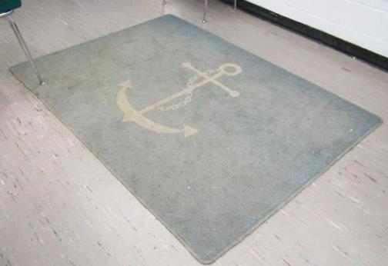
Dirty/worn area rug in classroom
Picture 31
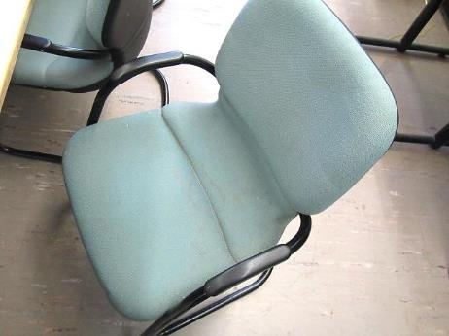
Soiled/stained chair in Faculty Lounge
Picture 32
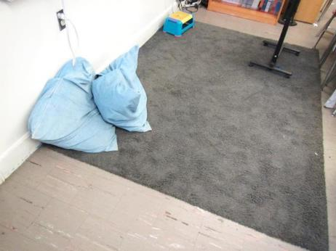
Pillows/cushions on area rug on floor
Picture 33
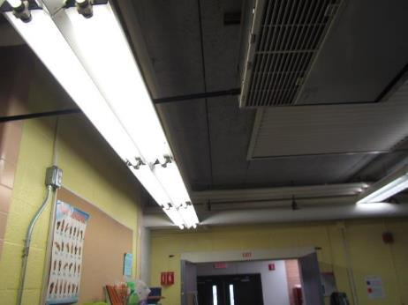
Missing fluorescent light covers in OT/PT area
Picture 34
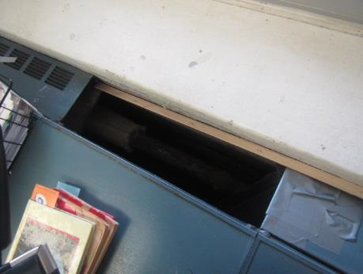
Missing radiator panel in Room 10 exposing hot water pipe

Location | Carbon  Dioxide  (ppm) | Carbon Monoxide  (ppm) | Temp  (°F) | Relative  Humidity  (%) | PM2.5  (µg/m³) | Occupants  in Room | Windows  Openable | Ventilation |  | Remarks
 |  |  |  |  |  |  |  | Supply | Exhaust
Background (outside) | 396 | ND | 63 | 36 | 12 |  |  |  |  | Clear, sunny, day after heavy extended rainfall two days prior, winds: SSE 15mph
Library | 862 | ND | 71 | 45 | 1 | 8 | Y  Open | Y  Off | Y  Off | Large area carpet, AI flat surfaces
Room 1 | 750 | ND | 69 | 44 | 3 | 0 | Y | Y  Off | Y  Off | Area carpet, leaking skylight wood, cleaned/treated/sealed-leak fixed, no current evidence of roof leaks, wood-stain bleed through, dust/debris/cobwebs in UV, latex paint odors-walls, no measureable TVOCS, hole in wall (utility), stains in closet on block wall-will be cleaned/painted over weekend
Room 2 | 1242 | ND | 71 | 48 | 5 | 23 | Y | Y | Y  Off | Area carpets, stained ceiling concrete/skylight panel, wall AC
Room 3 | 1461 | ND | 73 | 47 | 3 | 24 | Y | Y  Off | Y  Off | HS, area carpets, AI, plant, portable AC
Room 4 | 1225 | ND | 72 | 43 | 8 | 1 | Y | Y  Off | Y  Off | 18 occupants gone ~ 8 mins, DO, PF, plants, stained concrete ceiling around skylight panels, AI, AC
Nurse | 1212 | ND | 72 | 46 | 3 | 2 | N | Y  Off | Y  Off
Room 5 | 2334 | ND | 73 | 50 | 10 | 23 | Y | Y  Off | Y  Off | PF, plants
Room 6 | 2079 | ND | 73 | 51 | 5 | 1 | Y | Y  Off | Y  Off | HS, 23 occupants gone ~ 28 mins, DO, PF, portable AC
Room 7 | 1462 | ND | 73 | 44 | 4 | 0 | Y | Y | Y  Off | 24 occupants at lunch, pillows, area carpets, plants, dust/debris on flat surfaces (window sills), staining/drips ceiling concrete, glue/product: “Fatal/Harmful if Swallowed” (removed by Sch Rep)
Room 8 | 960 | ND | 72 | 41 | 7 | 0 | Y  Open | Y | Y  Off | ~ 24 occupants at lunch, DO, HS
Mrs. Dailey | 1337 | ND | 72 | 45 | 8 | 3 | Y | N | N | Stained ceiling concrete, PF, AI
Storage closet |  |  |  |  |  |  | N | N | N | Leak fixed, tarp on ceiling to catch leaks
Room 11 | 780 | ND | 72 | 38 | 6 | 21 | Y  Open | Y | Y  Off | Area rug, stained concrete ceiling
Room 13 | 1440 | ND | 73 | 46 | 9 | 23 | Y | Y  Off | Y  Off | Wall AC, DO, area rugs
Room 14 | 2348 | ND | 74 | 47 | 9 | 24 | Y | Y  Off |  | Exhaust could not be identified, wall to wall carpet, wall AC, plants
Room 15 | 2847 | ND | 73 | 51 | 13 | 24 | Y | Y  Off | Y  Off | TB, area rugs, pillow, PF
Room 17 | 1231 | ND | 73 | 42 | 8 | 25 | Y | Y | N | Ceiling mounted UV, DO, wall to wall carpet, hole in ceiling
25 | 1265 | ND | 73 | 44 | 5 | 5 | Y  Open | Y  Off | Y  Off | Area carpets, TB, active leaks-buckets
26 | 712 | ND | 70 | 39 | 11 | 3 | Y  Open | Y  Off | Y  Off | TB, AI, area carpets, items in front of UV
OT/PT | 1051 | ND | 73 | 42 | 6 | 5 | N | Y  Off | Y  Off | Ceiling mounted UV (2), exhaust in restroom off, wall to wall carpet, PF, fluorescent lights missing covers
OT/PT Storage (former girl’s locker room) |  |  |  |  |  |  | N | Y  Off | Y  Off | Abandoned shower/floor drains, cardboard/cloth items
Modular Classroom 27 | 1460 | ND | 75 | 46 | 12 | 23 | Y | Y | Y  Off | Reports of active leaks, near emergency light, plants, old/wrinkled wall to wall carpet, dust/debris on vents/surrounding ceiling tiles, DO, WD CTs, thermostat fan “Auto”
Modular Storage Closet |  |  |  |  |  |  | N | N | N | Built out/wooden frame/paneled, no ventilation, storage of paper/cardboard
Gym | 1113 | ND | 70 | 51 | 5 | 23 | N | Y  Off | Y | Exhaust grills occluded with dust/debris, 2 AHUs, WD ceiling panels
Phys Ed Office | 1055 | ND | 72 | 46 | 7 | 0 | N | Y  Passive door vent | Y  Off
Computer Room | 1218 | ND | 73 | 43 | 8 | 0 | N | Y  Off |  | Wall AC
Resource Room | 909 | ND | 73 | 39 | 4 | 3 | N | N | Y  Off | Wall to wall carpet, hole in wall-vent to adjacent computer room, PF
Teacher’s Lounge | 1032 | ND | 74 | 41 | 5 | 0 | Y  Not operable | Y  Off | N* | *Abandoned vent in wall, laminator, photocopier, portable AC, soiled/stained upholstered chairs
Art Room | 499 | ND | 72 | 32 | 5 | 1 | Y  Open | Y | N | CPs, TB, old stains ceiling/pipe
ELL | 1207 | ND | 75 | 42 | 6 | 2 | N | Y  Passive | Y | Local exhaust vent, switch activated
Ms. Reed | 726 | ND | 73 | 41 | 20 | 0 | Y | N | N | Area rug
ESL | 708 | ND | 71 | 48 | 7 | 0 | Y | N | N | Plants, area rug
Book Storage |  |  |  |  |  |  | Y | N | N | Plants
Auditorium/Stage (temporary classroom) | 939 | ND | 70 | 46 | 7 | 23 | N | Y | Y
Cafeteria | 1012 | ND | 72 | 48 | 4 | 2 | Y | Y  Off | Y  Off | Fans mounted on wall
Main Office | 899 | ND | 73 | 39 | 11 | 3 | Y | N | N | Wall to wall carpet, stained ceiling, AC, PC
Mrs. Curtis | 1253 | ND | 73 | 43 | 15 | 1 | Y | N | N | DO, wall to wall carpet
Principal’s Office | 911 | ND | 73 | 40 | 6 | 0 | Y | N | N | AC, wall to wall carpet
Behavioral Specialist | 1456 | ND | 73 | 45 | 15 | 0 | N | Y  Passive door vent | Y | Wall to wall carpet, DEM
Speech and Language | 1379 | ND | 73 | 45 | 6 | 3 | N | Y  Passive door vent | N | DEM, recommend tapping into Nurse exhaust, installing passive vent on door to library for make up air

Location | Carbon  Dioxide  (ppm) | Carbon Monoxide  (ppm) | Temp  (°F) | Relative  Humidity  (%) | PM2.5  (µg/m³) | Occupants  in Room | Windows  Openable | Ventilation |  | Remarks
 |  |  |  |  |  |  |  | Supply | Exhaust
Background (outside) | 395 | ND | 58 | 100 | 2 |  |  |  |  | Cloudy, light rain, cool
9 | 1680 | ND | 70 | 49 | 4 | 25 | Y | Y  Off | Y  Off | Stained concrete ceiling, DEM, DO, PF, HS, active leak reported/dripping from skylight
10 | 1526 | ND | 71 | 47 | 3 | 25 | Y | Y  Off | Y  Off | HS, Stained concrete ceiling, missing radiator panel-exposed hot water pipe (safety/burn hazard)

Appendix A

