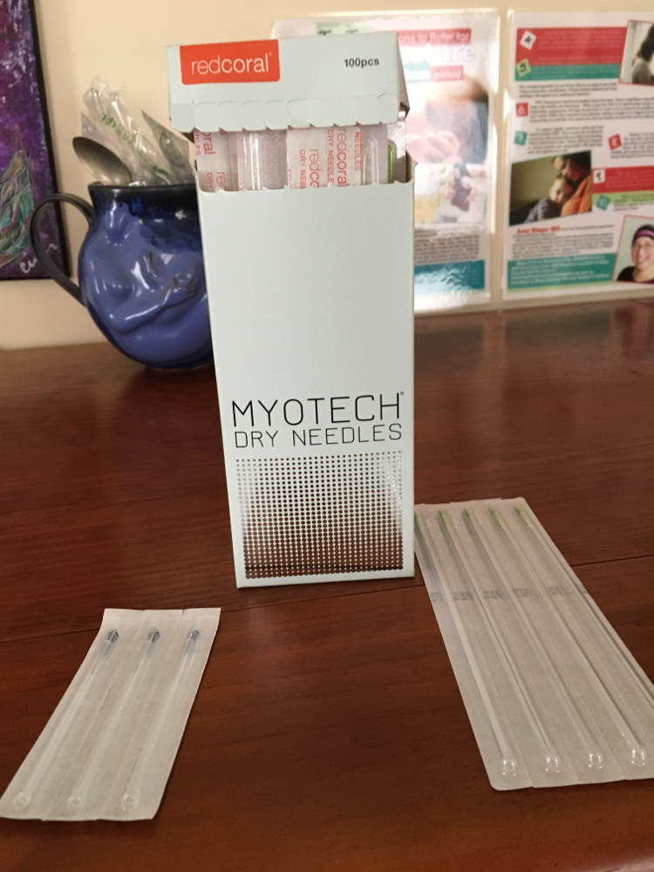
Photo dry needling box-
First, I want to thank the COA and the BOR I am for their diligence in working so hard to both assess the current language and make changes that are most productive for the profession and provide appropriate patient safety measures.

To that end, I am very concerned that we have appropriate language that reflects any insertion of any solid needle unless we say dry, acupuncture, filiform needle for therapeutic purpose is by definition and practice in the scope of acupuncture.

Below is a picture of needles and the needles from the box, that look an awful lot like acupuncture needles and are marketed currently as dry needles.

Thank you for your help, time, due diligence, and for the privilege about testifying and commenting.

Respectfully,
Amy

