An Assessment of Severe Maternal Morbidity in Massachusetts: 2011-2020
Released: JULY 2023
DATA BRIEF
DATA BRIEF
An Assessment of Severe Maternal Morbidity in Massachusetts: 2011-2020
Released: JULY 2023
Background
Globally, public health and medical professionals focus on maternal mortality as an indicator of maternal health and the quality of reproductive health care. It is considered the “tip of the iceberg” in terms of adverse maternal outcomes and while accounts for just a small proportion of the overall burden of poor maternal health, is a significant and tragic outcome. For every maternal death, there are about 100 episodes of severe maternal morbidity (SMM), affecting more than 50,000 birthing people in the United States and about 400 of birthing people in MA every year. Experts define SMM as unexpected complications of labor and delivery that result in significant short- or long-term consequences to the birthing person’s health. SMM includes life-threatening conditions (such as heart attacks, acute kidney failure, amniotic fluid embolism, disseminated intravascular coagulation, eclampsia, and sepsis), and life-saving procedures used to manage serious conditions (such as the use of a machine to help with breathing, or the removal of the uterus).
Figure 1. The Spectrum of Maternal Morbidity in Massachusetts

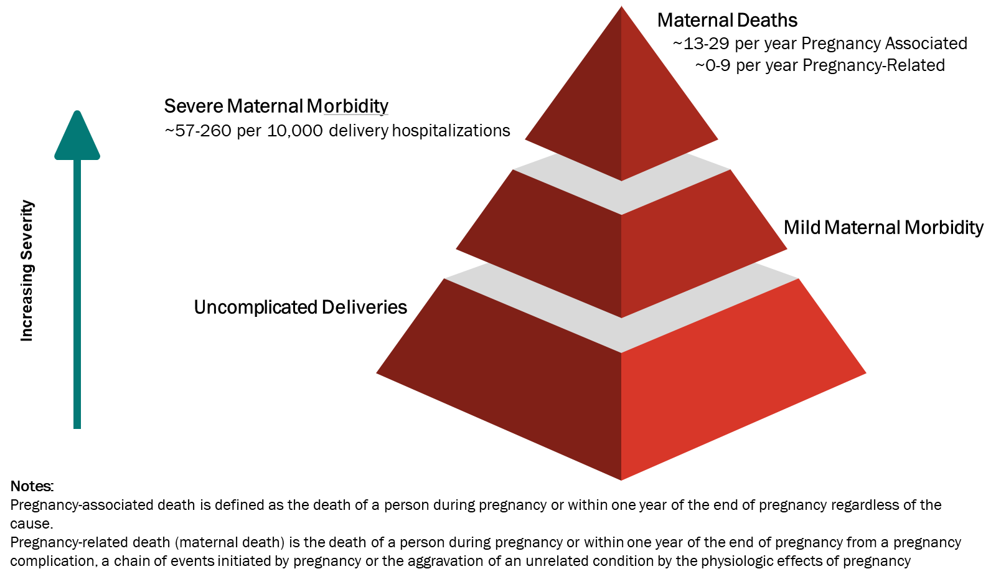
Reducing maternal death and SMM was a Healthy People (HP) 2010 and 2020 goal, and remains one of the goals for HP 2030, however limited progress has been made in achieving these goals. While the rates of SMM for all racial/ethnic groups have continued to rise over the last two decades, Black birthing people have persistently experienced the highest rates of any racial/ethnic group. Understanding how SMM has affected different racial/ethnic groups and priority populations is key to improving maternal health and preventing morbidity and mortality, particularly among pregnant people of color. Both public health and medical practitioners need to address SMM as a challenge heavily influenced by the social determinants of health. This data brief describes SMM trends and rates overall and by priority populations in Massachusetts from 2011 through 2020 using data from the public health data warehouse (PHD). PHD draws upon linked data from a broad array of health, social, and demographic sources enabling unique insights into SMM in MA.
Results
From 2011 to 2020, there were 678,382 deliveries including live births and fetal deaths among 483,699 Massachusetts residents. Among these deliveries, we linked 537,386 (79%) to hospital discharge records, and 4,092 (0.9%) met the criteria for SMM. Over this time, SMM rates increased significantly, nearly doubling from 52.3 per 10,000 deliveries in 2011 to 100.4 per 10,000 deliveries in 2020, with an annual percentage change (APC) of 8.9% per year (Figure 2).
Figure 2. SMM in Massachusetts: 2011-2020
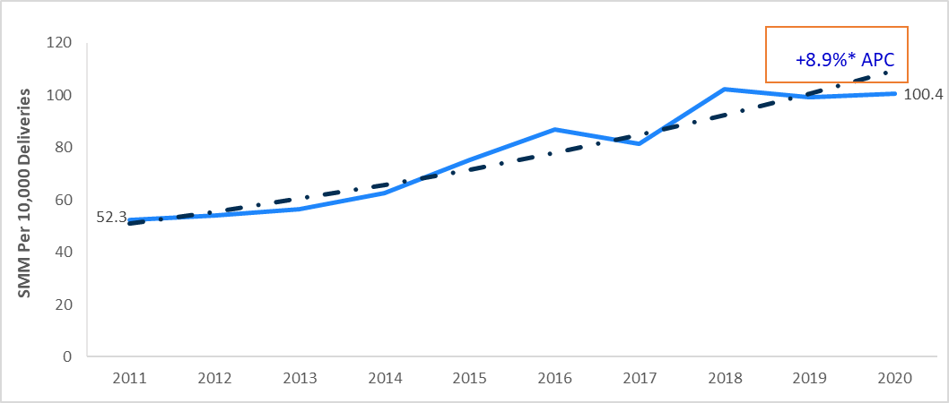

1. * Denotes statistical significance.
2. Annual Percent Change
Large disparities in SMM rates among population subgroups, defined by race and Hispanic ethnicity, exist and have persisted. These persistent disparities arise from inequities in care and access, social and economic factors, and the enduring effects of structural racism. SMM rates are statistically significantly higher among people of color. Rates among Black non-Hispanic birthing people were 2.3 times higher and rates among Asian/Pacific Islander non-Hispanic and Hispanic birthing people were 1.2 times higher than rates among White non-Hispanic birthing people (Figure 3).

Figure 3. SMM in Massachusetts by Race and Hispanic Ethnicity: 2011-2020

From 2011 to 2020, SMM rates increased by 7.8% per year on average for White non-Hispanic, 8.2% for Hispanic, 10.1% for Black non-Hispanic, and 10.5% for Asian/Pacific Islander non-Hispanic birthing people (Figure 4). Black non-Hispanic birthing people have consistently had the highest SMM rates over the 10-year period, and the inequities are increasing. In 2011, the gap between SMM rates for Black non-Hispanic and White non-Hispanic birthing people was two-fold. By 2020, the SMM rate for Black non-Hispanic birthing people was 2.5 times higher than that of White non-Hispanic birthing people, indicating a 25% increase in the gap over that time.
Figure 4. SMM in Massachusetts by Race and Hispanic Ethnicity: 2011-2020

SMM rates increase with advancing age (Figure 5). While SMM rates were highest among birthing people aged 40 and older (153.1 per 10,000 deliveries, overall), Black non-Hispanic birthing people had the highest SMM rates for every age group. Among those aged 40 and older, Black non-Hispanic birthing people experienced the highest rate of SMM, at 238.6 per 10,000 deliveries.
Figure 5. SMM in Massachusetts by Maternal Age and Race and Hispanic Ethnicity: 2011-2020
NA
SMM rates also varied by pre-pregnancy body mass index (BMI). We classified pre-pregnancy BMI as: underweight (12.0-<18.5), normal (18.5-24.9), overweight (25.0-29.9) and obese (≥30); SMM rates rose with increasing pre-pregnancy BMI (Figure 6). Overall, birthing people who were underweight or normal weight at the time they became pregnant had the lowest SMM rates (69.2 and 69.6 per 10,000 deliveries, respectively). Birthing people who were obese had the highest rate of SMM (102.3 per 10,000 deliveries, overall). We see this trend among white non-Hispanic birthing people and Black non-Hispanic birthing people, but rates across BMI groups were equivocal among Hispanic birthing people and among Asian/PI non-Hispanic birthing people. Figure 6 shows that Black non-Hispanic birthing people had the highest rates of SMM for all BMI categories. Black non-Hispanic birthing people with normal pre-pregnancy BMI had higher rates of SMM (125.6 per 10,000 deliveries) than any other race/ethnicity who were obese, suggesting that other factors may be contributing to the higher rates of SMM and the widening inequity in rates.

Figure 6. SMM in Massachusetts by BMI Category of Birthing Parent and Race and Hispanic Ethnicity: 2011-2020
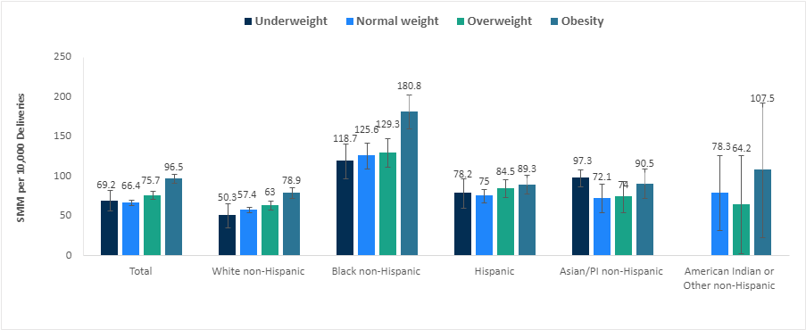

For every 10,000 deliveries, there were 113.1 deliveries with SMM among people with opioid use disorder (OUD), 105.7 deliveries among people with a mental health disorder,
101.7 deliveries among people ever experiencing homelessness, 100.3 deliveries with SMM among foreign-born birthing parents, 96.7 among people who had a history of incarceration, 89.8 deliveries with SMM among those with any disability, and 86.3 deliveries with SMM among veterans (Figure 7). However, these groupings are not mutually exclusive.
Figure 7. SMM in Massachusetts by Priority Populations: 2011-2020
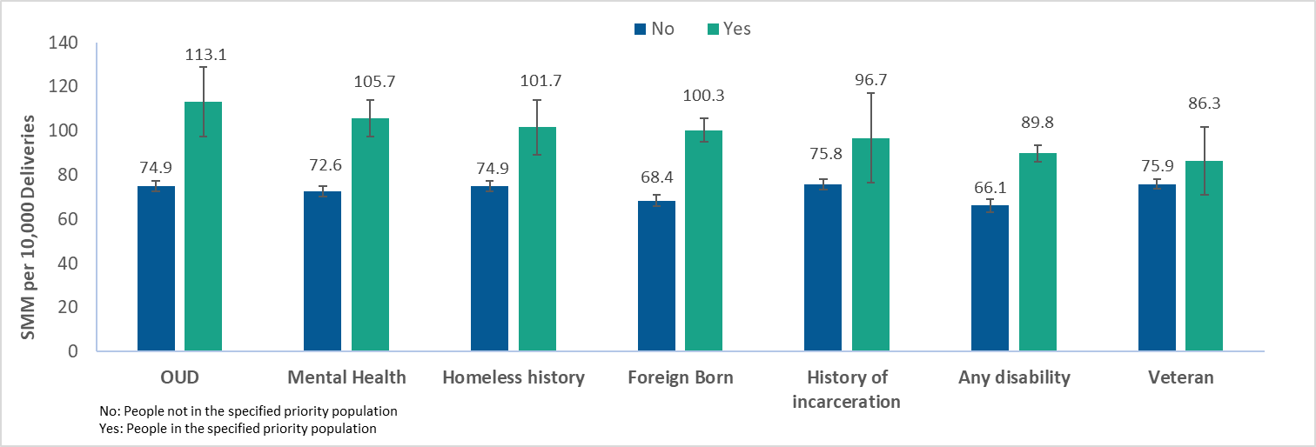
Note: See page 8 for definitions of Mental Health and Any Disability.
Some specific disabilities may increase the medical risks of pregnancy. People with disabilities should be supported in evaluating these risks when deciding whether and how to become pregnant and how to give birth. However, it is also critical to acknowledge the role of social factors in driving high rates of SMM among birthing people with disabilities. These factors include active and passive denial of medical care, inequitable access to social determinants of health such as housing and proper nutrition, and higher rates of other risk factors such as smoking, stress, and clinically unwarranted obstetric intervention.,, For every 10,000 deliveries, there were 131.6 deliveries with SMM among people with intellectual disabilities, 108.4 among people with a vision disability, and 94.6 among people with a mobility disability, which were significantly higher than the rates among people without these disabilities (75.5, 72.8 and 67.5 per 10,000 deliveries, respectively) (Figure 8). Differences among those with and without developmental and hearing disability were not significant.

Figure 8. SMM in Massachusetts by Disability Status: 2011-2020
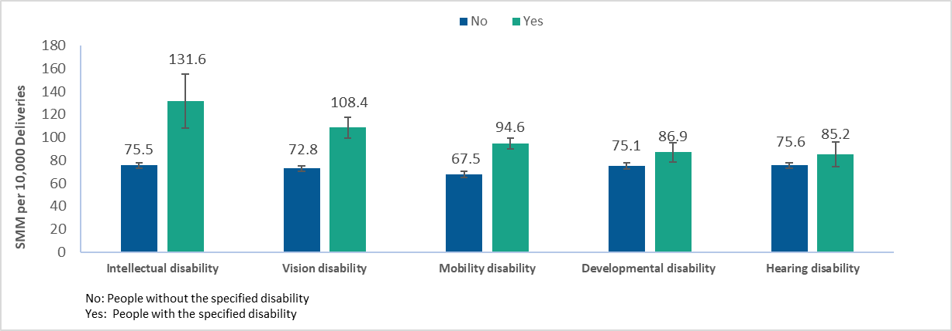

Conclusions
The prevalence of severe maternal morbidity nearly doubled in Massachusetts from 2011 to 2020. Black non-Hispanic birthing people have consistently experienced the highest SMM rates among all race/ethnicity groups, and those rates more than doubled in this time-period, widening an already large racial inequity gap. In addition, these findings reveal significant inequities experienced by birthing people with disabilities - particularly intellectual, vision, and mobility -related disabilities - which have not been previously addressed in statewide SMM reporting and which require ongoing attention. Finally, these data underscore the need for enhanced monitoring and support of the needs of all birthing people. To improve peripartum health outcomes, state policy efforts must continue to target structural racism and ableism, as well as other socioeconomic and community drivers of adverse maternal outcomes, including access to and quality of primary and prenatal care.
Related Initiatives
The Massachusetts Department of Public Health (DPH) is committed to ending health inequities. Innovative efforts at DPH to address SMM are currently underway:
- In 2022, DPH established a multi-disciplinary Maternal Health Task Force (MHTF) that will create and implement a maternal health strategic plan informed by the data in this brief as well as recommendations from the Massachusetts Racial Inequities in Maternal Health Legislative Report (2022), and guidance from the Massachusetts Maternal Mortality and Morbidity Review Committee.
- The Massachusetts Perinatal Neonatal Quality Improvement Network (PNQIN), a quality improvement network of providers and stakeholders dedicated to improving health outcomes of birthing people, newborns, and families, launched the Maternal Equity Bundle to reduce overall SMM and to close the Black-White gap in SMM. PNQIN has trained over 400 providers across 34 birthing hospitals to dismantle racism, provide respectful care that is equitable and high-quality, and eliminate perinatal health disparities.
- DPH is addressing critical gaps in direct clinical care by exploring use of the CDC’s Levels of Care Assessment Tool (LOCATeSM) to ensure that birthing people are cared for at hospitals with the resources and personnel to manage their unique needs and by implementing innovative maternal health interventions such as remote blood pressure monitoring for medically underserved communities.
Of course, there are additional opportunities to address SMM in Massachusetts. The findings of this report align with the recommendations from the Massachusetts Special Commission on Racial Inequities in Maternal Health Report (May 2022). Recommendations from this Commission are available on the General Court of the Commonwealth of Massachusetts website. Among its conclusions this report noted that:
“Racial inequities are present at multiple levels (i.e. within communities, public health, and in healthcare settings); thus, the achievement in reducing SMM and maternal mortality will be dependent upon the redesigning of health delivery infrastructures and the standardization of collaboration within and across community settings, education, mental health assistance, housing, support of doulas and certified nurse midwives, improved competency among providers, improved access for birthing moms, and enactment of laws pertaining to maternal health delivery.”

Methods
We used Massachusetts Department of Public Health’s Public Health Data Warehouse data (PHD) to conduct a retrospective analysis of SMM among people who delivery between 2011 and 2020. These data were made available through special legislation, M.G.L c. 111 s. 237 of 2017. The identification of SMM is based on the algorithm developed by the Health Resources and Services Administration (HRSA), the Centers for Disease Control and Prevention (CDC), the Agency for Healthcare Research and Quality (AHRQ), and the Alliance for Innovation on Maternal Health (AIM) (Version 07-01-2021). We found SMM cases by linking delivery records to hospital discharge records. The outcome measure was SMM during the delivery hospitalization, based on the algorithm developed by CDC. This definition relies on 21 conditions or procedures including transfusion (SMM 21) or excluding transfusion (SMM20) found through ICD-9 and ICD-10 and procedure codes. We restricted our analysis to SMM20 to focus on specific SMM conditions, thus excluding transfusion. We calculated rates and 95% confidence intervals (CI) per 10,000 deliveries. Bivariate relationships assessed through χ2 statistics to describe characteristics of birthing people who experienced a SMM hospitalization at time of delivery.
Detailed definitions:
Mental health is a composite based on diagnosis codes, Department of Mental Health admission, or those who had severe mental illness flags in either the Bureau of Substance Addiction Services (BSAS) or the Department of Corrections (DOC). The DOC's definition of Severe Mental Illness (SMI) expanded in 2019 to include anxiety and depression, based on the criminal justice reform act passed by the legislature in 2018.
The composite includes any of the following:
- Diagnosis includes any mental illness such as dementia, schizophrenic disorders, mood disorders, delusional disorders, pervasive developmental disorders, anxiety, dissociative and somatoform disorders, personality disorders, physiological malfunction arising from mental factors, acute reaction to stress, adjustment reaction, specific nonpsychotic mental disorders due to brain damage, depressive disorder not elsewhere classified, disturbance of conduct not elsewhere classified, disturbance of emotions specific to childhood and adolescence, psychic factors associated with diseases classified elsewhere.
- Severe Mental Illness (SMI) flags reported on Bureau of Substance Addiction Services (BSAS) or Department of Correction (DOC).
- Received services by DMH.
Disability definitions:
- Developmental disabilities are a group of conditions, beginning before age 22 (but often at birth/in early childhood), which delay or alter the typical course of development in the areas of bodily function, learning, language, sensation, or behavior.
- Hearing disability: The category of hearing disability includes anyone with a total or partial inability to perceive and/or process sounds at the same volume or frequency as someone with typical hearing. This includes people whose hearing is augmented by various technologies, including hearing aids and cochlear implants. This variable does not distinguish between people who primarily use ASL (or another signed language or manual communication system) and those who primarily use spoken or written English.
- Intellectual disability: Intellectual disability is a subcategory of developmental disability, characterized by significant difficulty understanding new or complex information and learning and applying new skills. People with intellectual disabilities may require more than the typical amount of support with self-care and daily activities. Intellectual disabilities begin before adulthood and affect a person throughout the life course.
- Mobility disability: A mobility disability is one that affects movement, particularly ambulation (though many mobility disabilities also affect other types of bodily movement). The presence of a mobility disability does not denote complete inability to move, or even to walk; a mobility disability may, for example, affect a person's breathing or balance in such a way as to make walking difficult, without affecting the legs at all.
- Vision disability: Vision disability includes eyesight which cannot be corrected to a “normal” level. This may present as an impairment in visual acuity (where the eye does not perceive objects with typical clarity at standard distances), or in visual field (where the eye cannot see as wide an area as usual without moving the eyes or turning the head). This category does not include minor differences in visual sense (e.g., minor myopia or presbyopia) that are easily corrected with eyeglasses or contact lenses.

SMM-20 Discharge diagnoses or procedural codes used:

- Acute myocardial infarction
- Aneurysm
- Acute renal failure
- Adult respiratory distress syndrome
- Amniotic fluid embolism
- Cardiac arrest/ventricular fibrillation
- Conversion of cardiac rhythm
- Disseminated intravascular coagulation
- Eclampsia
- Heart failure/arrest during surgery or procedure
- Puerperal cerebrovascular disorders
- Pulmonary edema/acute heart failure
- Severe anesthesia complications
- Sepsis
- Shock
- Sickle cell disease with crisis
- Air and thrombotic embolism
- Hysterectomy
- Temporary tracheostomy
- Ventilation

Data from the Population Health Information Tool, Population Data Stories: Maternal and Child Health. Modified figure from New York City Department of Health and Mental Hygiene (2016). Severe Maternal Morbidity in New York City, 2008–2012. New York, NY.
Gómez CA, Kleinman DV, Pronk N, et al. Addressing Health Equity and Social Determinants of Health Through Healthy People 2030. J Public Health Manag Pract. 2021;27(Suppl 6):S249-S257. doi:10.1097/PHH.0000000000001297
Bharel M., Bernson D, Averbach, A (2020). Using Data to Guide Action in Response to the Public Health Crisis of Opioid Overdoses NEJM Catalyst
Resident data include all events that occur to residents of the Commonwealth, including resident births that occur in other U.S. States and territories.
Bailey, Z. D., Krieger, N., Agénor, M., Graves, J., Linos, N., & Bassett, M. T. (2017). Structural racism and health inequities in the USA: Evidence and interventions. The Lancet. 389(10077),1453–1463.
For more information on the calculation of the average annual percent change, please see: https://surveillance.cancer.gov/joinpoint/
Mitra M, Parish SL, Clements KM, Cui X, Diop H. Pregnancy outcomes among women with intellectual and developmental disabilities. Am J Prev Med. 2015;48(3):300-308. doi: 10.1016/j.amepre.2014.09.032
Chen X, Lu E, Stone SL, Thu Bui OT, Warsett K, Diop H. Stressful Life Events, Postpartum Depressive Symptoms, and Partner and Social Support Among Pregnant People with Disabilities. Womens Health Issues. 2023;33(2):167-174. doi: 10.1016/j.whi.2022.10.006
Gleason JL, Grewal J, Chen Z, Cernich AN, Grantz KL. Risk of Adverse Maternal Outcomes in Pregnant Women with Disabilities. JAMA Netw Open. 2021 Dec 1;4(12): e2138414. doi: 10.1001/jamanetworkopen.2021.38414. PMID: 34910153; PMCID: PMC8674748

