­

**An Assessment of Severe Maternal Morbidity in Massachusetts: 2011-2022**

**Released: October 2024**

**DATA BRIEF**

**An Assessment of Severe Maternal Morbidity in Massachusetts: 2011-2022**

**Released: JULY 2024**

**DATA BRIEF**

**DATA BRIEF**

**An Assessment of Severe Maternal Morbidity in Massachusetts: 2011-2020**

**Released: JULY 2023**

**Background**

Severe maternal morbidity (SMM) is defined as unexpected complications of labor and delivery that result in significant short—or long-term consequences to a birthing person’s health. This is an update to the report the Massachusetts Department of Public Health (DPH) released in July 2023 examining SMM in Massachusetts, which covered data through 2020.[1] SMM includes life-threatening conditions (such as heart attacks, acute kidney failure, amniotic fluid embolism, disseminated intravascular coagulation, eclampsia, and sepsis) and life-saving procedures used to manage serious conditions (such as the use of a machine to help with breathing, or the removal of the uterus). This data brief updates SMM trends and rates overall and by priority populations in Massachusetts from 2011 through 2022 using public health data warehouse (PHD) data. PHD draws upon linked data from a broad array of health, social, and demographic sources, enabling unique insights into SMM in MA.[2]

**Results**

From 2011 to 2022, there were 811,622 deliveries, including live births and fetal deaths among 555,229 Massachusetts residents.[3] Among these deliveries, we linked 633,482 (78%) to hospital discharge records, and 5,163 (0.8%) met the criteria for SMM. From 2011 to 2018 there was a steady and significant increase in SMM with an annual percent change (APC) of 10.1% per year over that time period (Figure 1). From 2019 to 2022, the rate of SMM increased by 4.4% per year, though this increase is not statistically significant and suggests that the annual rate has leveled off.

Large disparities in SMM rates among population subgroups, defined by race and Hispanic ethnicity, exist and continue to persist. These persistent disparities arise from inequities in care and access, social and economic factors, and the enduring effects of structural racism.[4] SMM rates are statistically significantly higher among people of color. Rates among Black non-Hispanic birthing people were 2.3 times higher, rates among Hispanic were 1.3, and rates among Asian/Pacific Islander non-Hispanic and American Indian and Other non-Hispanic birthing people were 1.2 and 1.1 times higher than rates among White non-Hispanic birthing people (Figure 2). The rate for American Indian and Other non-Hispanic birthing people was not statistically different than the rate for White non-Hispanic birthing people. This lack of statistical significance is likely due to the small number of events among American Indian and Other non-Hispanic birthing people, which leads to a wider confidence interval around the rate.

From 2011 to 2022, SMM rates increased by 7.4% per year on average for White non-Hispanic, 8.1% for Hispanic, 8.8% for Black non-Hispanic, and 9.0% for Asian/Pacific Islander non-Hispanic birthing people (Figure 3)[5]. Black non-Hispanic birthing people have consistently had the highest SMM rates over the 12 years. The difference between the rate for Black non-Hispanic birthing people and White non-Hispanic birthing people has been variable over time. It was 2.1 times higher in 2011, peaked at 2.8 times higher in 2016, and has been declining since 2019 down to 2.2 times higher in 2022.

SMM rates increase with advancing age (Figure 4). While SMM rates were highest among birthing people aged 40 and older (155.8 per 10,000 deliveries overall), Black non-Hispanic birthing people had the highest SMM rates for every age group. Among those aged 40 and older, Black non-Hispanic birthing people experienced the highest rate of SMM, at 258.5 per 10,000 deliveries.

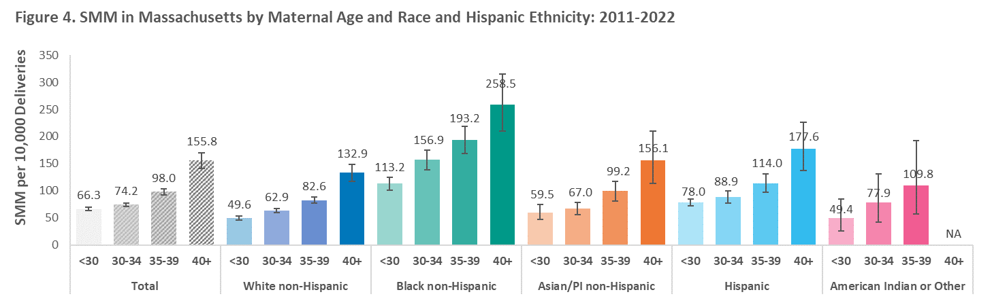

SMM rates also varied by pre-pregnancy body mass index (BMI). We classified pre-pregnancy BMI as, underweight (12.0-<18.5), normal (18.5-24.9), overweight (25.0-29.9), and obese (≥30); SMM rates rose with increasing pre-pregnancy BMI (Figure 5). Overall, birthing people who were underweight or normal weight at the time they became pregnant had the lowest SMM rates (69.0 and 70.8 per 10,000 deliveries, respectively). Birthing people who were obese had the highest rate of SMM (104.8 per 10,000 deliveries overall). We see this trend among White non-Hispanic birthing people and Black non-Hispanic birthing people. Rates across BMI groups were similar among Hispanic birthing people and Asian/PI non-Hispanic birthing people. Black non-Hispanic birthing people had the highest rates of SMM for all BMI categories. Black non-Hispanic birthing people with normal pre-pregnancy BMI had higher rates of SMM (136.7 per 10,000 deliveries) than any other race and Hispanic ethnicity who were obese, suggesting that other factors may be contributing to the higher rates of SMM and the widening inequity in rates.

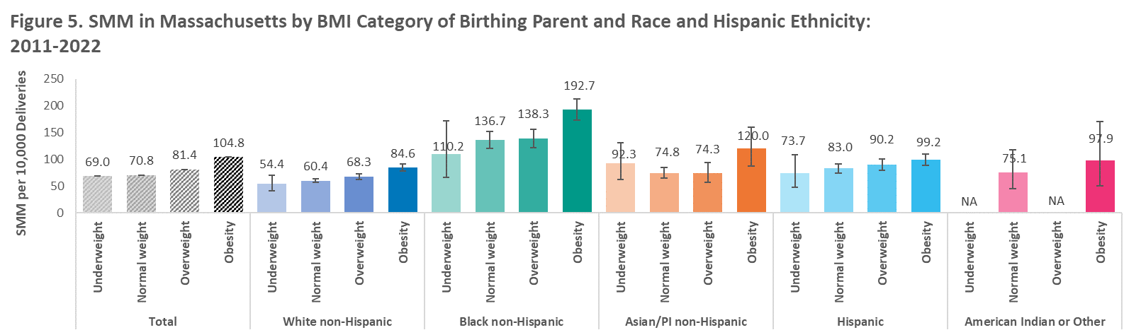

For every 10,000 deliveries, there were 127.6 deliveries with SMM among people with opioid use disorder (OUD), 112.1 deliveries among people with a mental health disorder, 112.7 deliveries among people ever experiencing homelessness, 104.6 deliveries with SMM among foreign-born birthing parents, 109.8 among people who had a history of incarceration, 92.5 deliveries with SMM among those with any disability, and 96.6 deliveries with SMM among veterans (Figure 6). These rates are all significantly higher than the comparison group without the condition/status. However, these groupings are not mutually exclusive.

Some specific disabilities may increase the medical risks of pregnancy. People with disabilities should be supported in evaluating these risks when deciding whether and how to become pregnant and how to give birth. However, it is also critical to acknowledge the role of social factors in driving high rates of SMM among birthing people with disabilities. These factors include active and passive denial of medical care, inequitable access to social determinants of health such as housing and proper nutrition, and higher rates of other risk factors such as smoking, stress, and clinically unwarranted obstetric intervention.[6],[7] Figure 7 shows that for every 10,000 deliveries, there were 135.3 deliveries with SMM among people with intellectual disabilities, 116.6 among people with a vision disability, 98.7 among people with a mobility disability, 93.0 among people with a developmental disability, and 97.0 among people with a hearing disability, which were significantly higher than the rates among people without these disabilities (81.0, 78.0, 72.3, 80.3 and 54.4 per 10,000 deliveries, respectively). These groupings are not mutually exclusive.

**Conclusions**

The prevalence of severe maternal morbidity doubled in Massachusetts from 2011 to 2022. Black non-Hispanic birthing people have consistently experienced the highest SMM rates among all race and Hispanic ethnicity groups, and those rates more than doubled in this time period. In addition, these findings reveal significant inequities experienced by birthing people with disabilities - particularly developmental and hearing-related disabilities, which had not been statistically significant in our earlier statewide SMM reporting and which require ongoing attention. Finally, these data underscore the need for enhanced monitoring and support of the needs of all birthing people. To improve peripartum health outcomes, state policy efforts must continue to target structural racism and ableism, as well as other socioeconomic and community drivers of adverse maternal outcomes, including access to and quality of primary and prenatal care.

**Related Initiatives**

The Massachusetts Department of Public Health (DPH) is committed to ending health inequities. Innovative efforts at DPH to address SMM are currently underway:

* DPH is a part of the Advancing Health Equity in Massachusetts (AHEM) initiative aimed at eliminating racial, economic, and regional disparities in health outcomes. In the Maternal and Perinatal focus, AHEM aims to improve equity in pregnancy, labor and delivery, and early motherhood.
* In 2022, DPH established a multi-disciplinary Maternal Health Task Force (MHTF) that will create and implement a maternal health strategic action plan informed by the data in this brief as well as recommendations from the Massachusetts Racial Inequities in Maternal Health Legislative Report (2022), and guidance from the Massachusetts Maternal Mortality and Morbidity Review Committee.
* The Massachusetts Perinatal Neonatal Quality Improvement Network (PNQIN), a quality improvement network of providers and stakeholders dedicated to improving health outcomes of birthing people, newborns, and families, launched the Maternal Equity Bundle to reduce overall SMM and to close the Black-White gap in SMM. PNQIN has trained over 400 providers across 34 birthing hospitals to dismantle racism, provide respectful care that is equitable and high-quality, and eliminate perinatal health disparities.
* DPH is addressing critical gaps in direct clinical care by integrating the Levels of Maternal Care (LoMC) into DPH’s hospital licensure regulation’s perinatal section 105 CMR 130.600. DPH will partner with the Joint Commission to verify levels of maternal care once the regulations are updated.
* DPH is also implementing innovative maternal health interventions such as remote blood pressure monitoring for medically underserved communities.

The findings of this report support with the recommendations from the Review of Maternal Health Services, which was conducted at the request of Governor Healey, to provide a comprehensive review of prenatal, postpartum, and birthing services across the state, through a lens of health equity and health outcomes, with a focus on the availability of quality services in rural and other underserved communities and to produce a set of recommendations for ensuring that high-quality services are reasonably available to all Massachusetts (MA) communities. The report, which details additional opportunities to address SMM in Massachusetts, was released in November 2023 and can be accessed here: [Review of Maternal Health Services.](https://www.mass.gov/doc/maternal-health-report/download)

The findings also align with the Massachusetts Special Commission on Racial Inequities in Maternal Health Report (May 2022). Recommendations from this Commission are available on the [General Court of the Commonwealth of Massachusetts website](https://malegislature.gov/Commissions/Detail/539). Among its conclusions, this report noted that:

*“Racial inequities are present at multiple levels (i.e., within communities, public health, and in healthcare settings); thus, the achievement in reducing SMM and maternal mortality will be dependent upon the redesigning of health delivery infrastructures and the standardization of collaboration within and across community settings, education, mental health assistance, housing, support of doulas and certified nurse midwives, improved competency among providers, improved access for birthing moms, and enactment of laws pertaining to maternal health delivery.”*

**Methods**

We used the Massachusetts Department of Public Health’s Public Health Data Warehouse data (PHD) to conduct a retrospective analysis of SMM among people who delivery between 2011 and 2022. These data were made available through special legislation, [M.G.L c. 111 s. 237](http://budget.digital.mass.gov/bb/gaa/fy2018/os_18/h48.htm) of 2017. The identification of SMM is based on the algorithm developed by the Health Resources and Services Administration (HRSA), the Centers for Disease Control and Prevention (CDC), the Agency for Healthcare Research and Quality (AHRQ), and the Alliance for Innovation on Maternal Health (AIM) (Version 07-01-2021). The outcome measure was SMM during the delivery hospitalization, based on the algorithm developed by the CDC. This definition relies on 21 conditions or procedures, including transfusion (SMM 21) or excluding transfusion (SMM20) found through ICD-9 and ICD-10 and procedure codes. We restricted our analysis to SMM20 to focus on specific SMM conditions, thus excluding transfusion. We found SMM cases by linking live births and fetal deaths to hospital discharge records. All the diagnoses and procedures for the delivery hospitalization are included for the identification of SMM20 conditions. The unit of analysis is the delivery for which the infant's date of birth is indexed with the mother’s delivery hospitalization.   We calculated rates and 95% confidence intervals (CI) per 10,000 deliveries. We used Byar’s approximation of the exact Poisson distribution to calculate the 95% confidence intervals.

**Detailed definitions:**

The mental health diagnosis flag is a composite based on diagnosis codes, Department of Mental Health admission, or those who had severe mental illness flags in either the Bureau of Substance Addiction Services (BSAS) or the Department of Corrections (DOC). The DOC's definition of severe mental illness (SMI) expanded in 2019 to include anxiety and depression, based on the criminal justice reform act passed by the legislature in 2018.

The composite includes any of the following:

1. Diagnosis includes any mental illness such as dementia, schizophrenic disorders, mood disorders, delusional disorders, pervasive developmental disorders, anxiety, dissociative and somatoform disorders, personality disorders, physiological malfunction arising from mental factors, acute reaction to stress, adjustment reaction, specific nonpsychotic mental disorders due to brain damage, depressive disorder not elsewhere classified, disturbance of conduct not elsewhere classified, disturbance of emotions specific to childhood and adolescence, psychic factors associated with diseases classified elsewhere.
2. Severe Mental Illness (SMI) flags reported the by the Bureau of Substance Addiction Services (BSAS) or the Department of Correction (DOC).
3. Received services by DMH.

Disability definitions:

* Developmental disabilities are a group of conditions, beginning before age 22 (but often at birth/in early childhood), which delay or alter the typical course of development in the areas of bodily function, learning, language, sensation, or behavior.
* Hearing disability: The category of hearing disability includes anyone with a total or partial inability to perceive and/or process sounds at the same volume or frequency as someone with typical hearing. This includes people whose hearing is augmented by various technologies, including hearing aids and cochlear implants. This variable does not distinguish between people primarily using ASL (or another signed language or manual communication system) and those primarily using spoken or written English.
* Intellectual disability: Intellectual disability is a subcategory of developmental disability, characterized by significant difficulty understanding new or complex information and learning and applying new skills. People with intellectual disabilities may require more than the typical amount of support with self-care and daily activities. Intellectual disabilities begin before adulthood and affect a person throughout the life course.
* Mobility disability: A mobility disability affects movement, particularly ambulation (though many mobility disabilities also affect other types of bodily movement). A mobility disability does not denote a complete inability to move or even to walk; a mobility disability may, for example, affect a person's breathing or balance in such a way as to make walking difficult without affecting the legs at all.
* Vision disability: Vision disability includes eyesight, which cannot be corrected to a “normal” level. This may present as an impairment in visual acuity (where the eye does not perceive objects with typical clarity at standard distances) or in the visual field (where the eye cannot see as wide an area as usual without moving the eyes or turning the head). This category does not include minor differences in visual sense (e.g., minor myopia or presbyopia) that are easily corrected with eyeglasses or contact lenses.

SMM-20 Discharge diagnoses or procedural codes used:

1. Acute myocardial infarction
2. Aneurysm
3. Acute renal failure
4. Adult respiratory distress syndrome
5. Amniotic fluid embolism
6. Cardiac arrest/ventricular fibrillation
7. Conversion of cardiac rhythm
8. Disseminated intravascular coagulation
9. Eclampsia
10. Heart failure/arrest during surgery or procedure
11. Puerperal cerebrovascular disorders
12. Pulmonary edema/acute heart failure
13. Severe anesthesia complications
14. Sepsis
15. Shock
16. Sickle cell disease with crisis
17. Air and thrombotic embolism
18. Hysterectomy
19. Temporary tracheostomy
20. Ventilation

1. Data brief - an assessment of severe maternal in Massachusetts: 2011-2020. 2021 Jul. https://www.mass.gov/doc/an-assessment-of-severe-maternal-morbidity-in-massachusetts-2011-2020/download.
2. Bharel M., Bernson D, Averbach, A (2020). Using Data to Guide Action in Response to the Public Health Crisis of Opioid Overdoses NEJM Catalyst  
3. Resident data include all events that occur to residents of the Commonwealth, including resident births that occur in other U.S. States and territories. 
4. Bailey, Z. D., Krieger, N., Agénor, M., Graves, J., Linos, N., & Bassett, M. T. (2017). Structural racism and health inequities in the USA: Evidence and interventions. The Lancet. 389(10077),1453–1463.
5. For more information on the calculation of the average annual percent change, please see: https://surveillance.cancer.gov/joinpoint/.
6. Mitra M, Parish SL, Clements KM, Cui X, Diop H. Pregnancy outcomes among women with intellectual and developmental disabilities. *Am J Prev Med*. 2015;48(3):300-308. doi: 10.1016/j.amepre.2014.09.032
7. Gleason JL, Grewal J, Chen Z, Cernich AN, Grantz KL. Risk of Adverse Maternal Outcomes in Pregnant Women with Disabilities. JAMA Netw Open. 2021 Dec 1;4(12): e2138414. doi: 10.1001/jamanetworkopen.2021.38414. PMID: 34910153; PMCID: PMC8674748