**Opioid Overdose Response**

**Strategies in Massachusetts**

**April 2014**

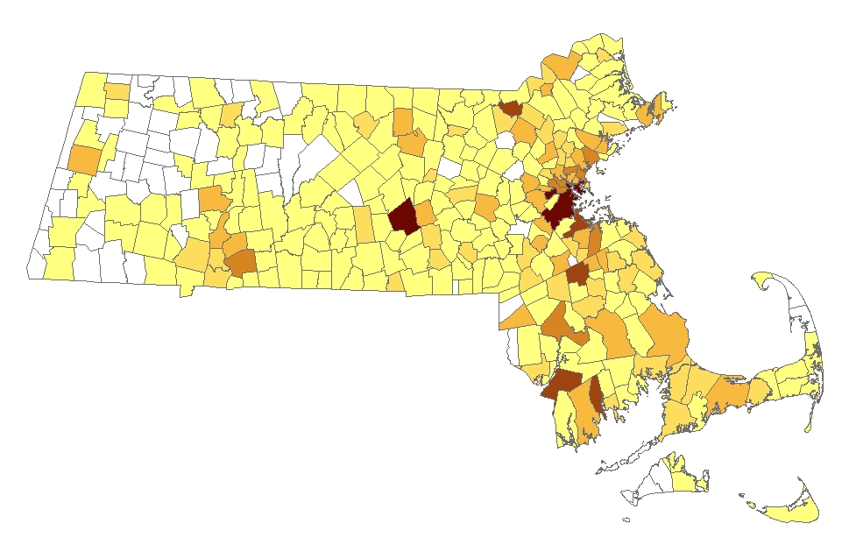

**Massachusetts Department of Public Health**

**Bureau of Substance Abuse Services**

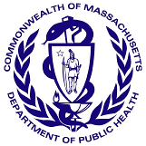 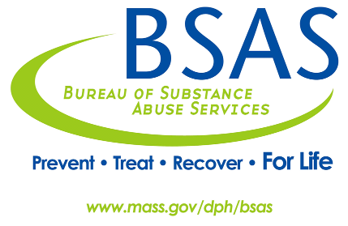

***\*Cover image:***

*2012 Total Non-Fatal Opioid-related Overdoses*

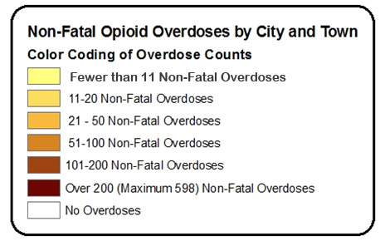

|  |
| --- |
| Sources: MA Inpatient Hospital Discharge Database, MA Outpatient Emergency Department Discharge Database, and MA Observation Stay Database, Center for Health Information and Analysis (CHIA). Counts represent acute-care hospital episodes which include hospital and emergency department discharges, and observation stays. Deaths are excluded; transfers from one acute care hospital to another are excluded. Counts do not include self-inflicted injury or assault-related cases. Counts are based on fiscal year 2012 (October 1, 2011 – September 30, 2012) |

|  |
| --- |
| **TABLE OF CONTENTS** |

BACKGROUND AND EPIDEMIOLOGY 3

DECLARATION OF PUBLIC HEALTH EMERGENCY 5

MASSACHUSETTS OVERDOSE RESPONSE STRATEGIES 6

Objectives and Strategy 6

Massachusetts Department of Public Health Initiatives 7

CONTACT INFORMATION 11

SELECTED KEY REFERENCES 11

|  |
| --- |
| BACKGROUND AND EPIDEMIOLOGY |

**Opioid**

The term *opioid* designates a class of drugs derived naturally from the opium poppy (opium, morphine, codeine), synthesized or derived from a natural opiate (heroin, oxycodone, hydrocodone), or manufactured synthetically with a chemical structure similar to opium (fentanyl, methadone). Among their many effects, opioids depress breathing by changing neurochemical activity in the brainstem where automatic bodily functions are controlled.

**Overdose**

An overdose occurs when opioid concentrations are so high in the body that they begin to cause respiratory depression. Overdoses can be further characterized as being either non-fatal (loss of consciousness and depressed breathing) or fatal (respiration ceases and/or cardiac arrest ensues) (Warner-Smith, et al, 2001).

Overdose is a common experience among opioid users. In a review of the literature on overdoses, Darke and Hall (2003) found that at least half of opioid users in cross-sectional studies report a history of non-fatal overdose, many of whom report overdosing multiple times. Additionally, Darke and Zador (1996) report that opioid users have mortality rates that are between six and twenty times those of their peers. These authors go on to report that deaths attributable to overdose are the most common cause of death among opioid users.

In a report released by the U.S. Centers for Disease Control and Prevention (CDC) in December 2011, drug overdose was identified as the cause of death for over 41,000 people in 2008 (Warner, et al, 2011). With the rate nearly tripling in the past three decades, drug overdose is now the leading cause of accidental death nationally, exceeding motor vehicle accidents; in 2008, there were 38,000 motor vehicle deaths.

While the CDC report identifies overdose as a national issue, the northeast region is disproportionately affected. In its 2011 New England High Intensity Drug Trafficking Area (NE HIDTA) Drug Market Analysis, the National Drug Intelligence Center (NDIC) noted, “opioid abuse remains the most significant drug threat to the NE HIDTA – (NDIC, 2011). The authors identify pharmaceutical opioid abuse as the driving factor behind this increase. Evidence suggests that pharmaceutical opioid abusers often switch from prescription medications to heroin due to its lower cost and greater purity.

**Massachusetts**

Data from the Massachusetts Department of Public Health’s Bureau of Health Information, Statistics, Research, and Evaluation corroborate this assessment. One-third of all injury deaths among Massachusetts residents are poisonings. Among these poisoning deaths, 69% are unintentional[1] opioid overdoses (Figure 1). In 2012, unintentional opioid overdoses (n=668) increased ten percent over the previous year (n=603). Based on the first six months of preliminary data[2], unintentional overdose deaths for 2013 are at least as high as 2012.

Figure 1: All Poisoning and Unintentional Opioid-Related Overdose Deaths,

MA Residents, 2000-2012



Source: Registry of Vital Records and Statistics, MDPH

The rate of unintentional opioid overdose deaths per 100,000 residents had an average annual increase of 8% between 2000 and 2006 and remained relatively constant from 2006 to 2011 (data not shown). The 2012 rate reached a level previously unseen in Massachusetts. The rate rose to 10.1 deaths per 100,000 residents for 2012, which represents a 90% increase from the rate of 5.3 deaths per 100,000 residents in 2000 (data not shown).

**Figure 2: Unintentional Opioid-Related Overdose Deaths vs. Motor Vehicle-Related Injury Deaths, MA Residents, 1997-2012**



Source: Registry of Vital Records and Statistics, MDPH

More people die of opioid overdoses than are killed in motor vehicle crashes. Figure 2 illustrates that since 2005 the number of deaths due to unintentional opioid overdoses surpassed those due to motor vehicles. Unintentional opioid overdoses continue to increase while motor vehicle-related injury deaths have declined.

|  |
| --- |
| DECLARATION OF PUBLIC HEALTH EMERGENCY |

On Thursday, March 27, 2014, Governor Deval Patrick declared a public health emergency in Massachusetts in response to the growing opioid addiction epidemic. The Governor directed the Department of Public Health (DPH) to take several action steps that will combat overdoses, stop the epidemic from getting worse, help those already addicted to recover and map a long-term solution to ending widespread opioid abuse in the Commonwealth.

The Governor’s Public Health Emergency declaration provides emergency powers to DPH Commissioner Cheryl Bartlett, RN. The Public Health Council convened an emergency session March 27, 2014, and granted Commissioner Bartlett the authority to work with the Public Health Council to take the following actions:

* Universally permit first responders to carry and administer naloxone (Narcan), a safe and effective opioid antagonist that, when timely administered, can reverse an overdose and save a life.  Naloxone will also be made widely available through standing order prescription in pharmacies in order to provide greater access to family and friends who fear a loved one might overdose.
* Accelerate the mandatory use of prescription monitoring by physicians and pharmacies to better safeguard against abuse or misuse. This was historically a voluntary program.
* Re-task the Commonwealth’s Interagency Council on Substance Abuse and Prevention with added members from public health, provider organizations, law enforcement, municipalities and families impacted by the opioid epidemic, to make recommendations in 60 days on further actions that can be taken, including, but not limited to: how to better coordinate services, ensure a full range of treatment regardless of insurance, and how to divert non-violent criminal defendants struggling with addiction into treatment programs.

The Administration will also dedicate an additional $20 million to increase substance abuse treatment and recovery services to the general public, to the Department of Corrections, and to Sheriffs’ Departments.

In conjunction with this public health emergency declaration, Commissioner Bartlett issued a public health advisory to help educate and raise awareness about treatment options currently available to combat and prevent the spread of opioid addiction.

|  |
| --- |
| MASSACHUSETTS OVERDOSE RESPONSE STRATEGIES |

To address the public health burden faced by its citizens, the Massachusetts Department of Public Health (MDPH) has developed a comprehensive opioid overdose response, which includes the following objectives and strategy:

## Objectives and Strategy

MDPH has **four objectives:**

1. Prevent and reduce the incidence of opioid abuse and overdoses.
2. Improve the management of overdoses.
3. Reduce the misuse of prescription opioids, which leads to overdoses.
4. Increase the number of people who access treatment.

To meet these objectives, the department is applying a **four-part strategy**:

1. Promote safe opioid prescribing and prescribing guidelines, including the use of the Massachusetts Prescription Monitoring Program (PMP).
2. Provide help if someone becomes addicted to prevent sickness, injury, or death.
3. Treat people's addiction to alcohol and other drugs.
4. Provide recovery support for individuals and their families.

## Massachusetts Department of Public Health Initiatives

The following pages describe programs that highlight BSAS’ opioid overdose response work with its DPH and community partners.

**BSAS Overdose Prevention Materials**

The Bureau of Substance Abuse Services (BSAS) has developed a collection of educational materials about opioid overdose prevention that are distributed free of charge within Massachusetts. The materials were developed with community partners and with focus groups within the target populations. The following are three of the items that are available from the Massachusetts Health Promotion Clearinghouse ([www.mass.gov/](http://www.mass.gov/)maclearinghouse):

* *"Know the Signs of Overdose"* fold out wallet card (see Figure 3)
* *"An Overdose is a Medical Emergency"* magnet (see Figure 4)

[Figure 3: “Know the Signs of an Overdose” – Fold-Out Wallet Card](http://massclearinghouse.ehs.state.ma.us/ALCH/SA1067kit.html)

**[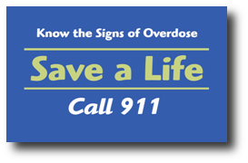 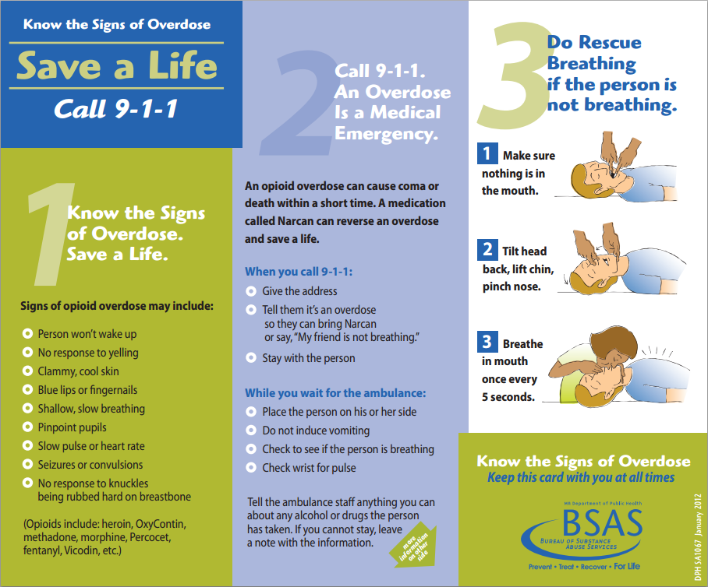](http://massclearinghouse.ehs.state.ma.us/ALCH/SA1067kit.html)**

[Figure 4: “An Overdose is a Medical Emergency” – Magnet](http://massclearinghouse.ehs.state.ma.us/ALCH/SA1068.html)

**[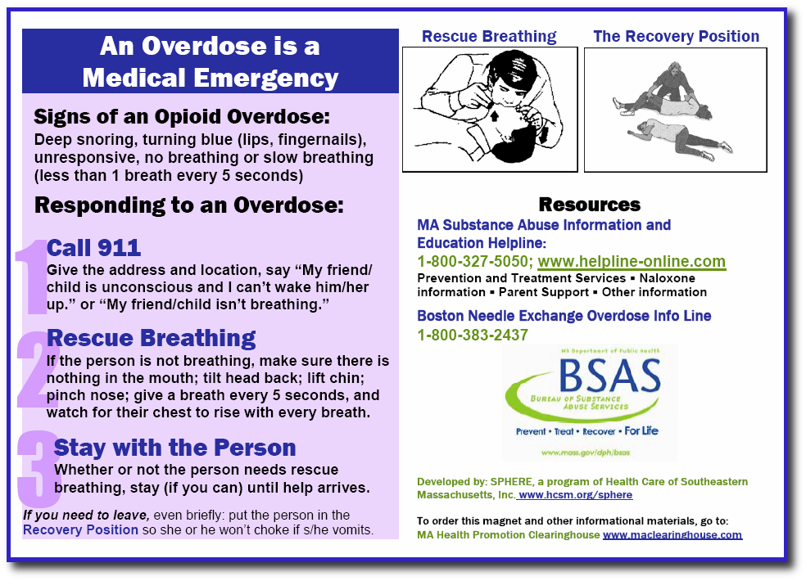](http://massclearinghouse.ehs.state.ma.us/ALCH/SA1068.html)**

**Strategic Prevention Framework - Partnerships for Success II (SPF-PFS II) Grant**

The Substance Abuse and Mental Health Services Administration (SAMHSA) awarded BSAS with the Strategic Prevention Framework - Partnerships for Success II (SPF-PFS II) grant to address prescription drug misuse and abuse among persons aged 12 to 25 in high-need Massachusetts communities. The choice of prescription drug abuse reflects the results of priority-setting by the Massachusetts Epidemiological Workgroup (MEW) and the Governor’s Interagency Council on Substance Abuse and Prevention (ICSAP). Both groups identified it as a new and emerging issue based on data showing that a growing proportion of the population are misusing and abusing prescription drugs.  Among some individuals, the misuse or abuse of prescription drugs can lead to a cross-over into other opioids such as heroin. The goal of the project is to support these high-need communities in using evidence-based prevention programs and practices to reduce prescription drug abuse in the targeted age group.

**Massachusetts Opioid Abuse Prevention Collaborative (MOAPC) Grant**

The purpose of the Massachusetts Opioid Abuse Prevention Collaborative Grant is to implement local policy, practice, systems, and environmental change(s) to prevent the use/abuse of opioids, prevent/reduce fatal and non-fatal opioid overdoses, and increase both the number and capacity of municipalities addressing these issues. Additionally, this program seeks to provide financial support for groups of municipalities to enter into formal, long term agreements to share resources and coordinate activities in order to increase the scope of this work and their capacity to address these issues among their populations. This program also emphasizes the integration of SAMHSA’s Strategic Prevention Framework (SPF) model into overall prevention systems, to ensure a consistent data-driven planning process across the Commonwealth focused on implementing effective and sustainable strategies and interventions.

**Massachusetts Technical Assistance Partnership for Prevention (MassTAPP)**

The Massachusetts Technical Assistance Partnership for Prevention (MassTAPP) is funded by BSAS to provide statewide substance abuse prevention support. MassTAPP staff offers technical assistance, capacity building, and other resources to BSAS-funded Underage Drinking Programs, MOAPC grantees, SPF-PFS II grantees, and other communities across the state. In addition, MassTAPP resources are available to all communities and coalitions seeking technical assistance to support their substance abuse prevention efforts, regardless of their funding sources. BSAS-funded communities are prioritized based on available individualized technical assistance resources; however, unfunded communities are always welcome to attend any in-person or online learning events.

**Office Based Opioid Treatment Programs (OBOT)**

The Bureau of Substance Abuse Services (BSAS) at the Massachusetts Department of Public Health currently funds 14 Office Based Opioid Treatment Programs (OBOT) located in health centers across the Commonwealth. Office based opioid treatment with Buprenorphine (OBOT-B) is a primary care model that provides evidence-based treatment for patients with opioid addiction. OBOT programs provide detoxification and maintenance treatment to opioid addicted individuals in an office based setting, often within community health centers. Patients receive treatment with prescribed buprenorphine/naloxone (Suboxone), self-administer the medication on a daily basis as prescribed with supports and education as needed. OBOT patients are also provided with integrated medical and addiction care that includes medical visits with a Primary Care Physician (PCP), visits with a Registered Nurse skilled in the care of addictive disorders, and counseling sessions with qualified clinicians. Patients are also evaluated for other opioid treatment needs including: methadone, naltrexone, and injectable naltrexone; with some sites offering these services, treatments or referrals, and coordination of services.

**Overdose Education and Naloxone Distribution (OEND)**

Since December of 2007, the Massachusetts Department of Public Health has implemented overdose education and intra-nasal naloxone (Narcan) distribution in various community-based settings. These programs have trained potential bystanders to an overdose (drug users, friends, family members) on how to reduce overdose risk, recognize signs of an overdose, access emergency medical services, and administer intra-nasal naloxone. Programs instruct potential bystanders to deliver naloxone when opioid overdose occurs; in addition to taking other actions (e.g. rescue breathing, contacting the emergency medical system). After being trained, each participant is eligible to receive an overdose prevention kit which includes instructions, two syringes pre-filled with Naloxone Hydrochloride, and a nasal atomization delivery device. Between December 2007 and March 2014, OEND programs have trained over 22,500 potential bystanders and documented over 2,655 opioid overdose reversals. The emergency declaration by Governor Deval Patrick, followed by the action of DPH Commissioner Cheryl Bartlett and the Public Health Council, will universally permit first responders to carry and administer naloxone (Narcan).

For more information about the OEND program visit the [BSAS web site](http://www.mass.gov/eohhs/gov/departments/dph/programs/substance-abuse/prevention/opioid-overdose-prevention.html#naloxone).

**Screening, Brief Intervention, and Referral to Treatment (SBIRT) Programs**

Screening, Brief Intervention, and Referral to Treatment (SBIRT) as part of routine healthcare practice has been shown to reduce unhealthy substance use, and to save lives and money.

Universal screening identifies risky alcohol and drug behaviors, such as opioid misuse. Brief interventions can encourage patients to reduce or stop unhealthy use, and, when needed, referral to treatment may get help for patients who might never have sought it on their own. Trained health care providers, including community health workers, can engage patients in discussions about change and, if needed, engage them in a discussion about treatment, including medication assisted treatment.

BSAS-funded MASBIRT TTA (Massachusetts Screening, Brief Intervention, and Referral to Treatment Training & Technical Assistance) provides training, coaching, and consultations on implementation for healthcare and public health professionals statewide; equips providers to identify and address patients’ unhealthy substance use, including prescription drug misuse; and helps organizations build linkages with specialty substance abuse treatment.

MASBIRT TTA strongly encourages all prescribers to routinely screen all patients before prescribing opioids or other medications with the potential for abuse.

Between 2007 and 2012, BSAS funded an SBIRT initiative in six Massachusetts hospitals’ emergency departments. Five of the six hospitals continue this effort, though funding has ended. Some of these programs have been able to distribute take-home intra-nasal naloxone kits to individuals at risk of opioid overdose and their friends or family members as part of the OEND program. BSAS continues to support the adoption of SBIRT at a wide variety of settings, including community hospitals, large hospital systems, and school-based health centers.

For more information about MASBIRT TTA visit [www.masbirt.org](http://www.masbirt.org).

|  |
| --- |
| CONTACT INFORMATION |

For more information on the Massachusetts Overdose Response Strategy or on any of the material provided in this document, please contact: **Hilary Jacobs**, Director, Massachusetts Department of Public Health Bureau of Substance Abuse Services.

E-mail: [hilary.jacobs@state.ma.us](mailto:hilary.jacobs@state.ma.us).

|  |
| --- |
| SELECTED KEY REFERENCES |

**National Reports**

* Warner, M., et al (2011). Drug Poisoning Deaths in the United States, 1980-2008. NCHS Brief No. 81, December 2011. Centers for Disease Control and Prevention, National Center for Health Statistics.
* New England High Intensity Drug Trafficking Area, Drug Market Analysis 2011. September 2011. U.S. Department of Justice, National Drug Intelligence Center (NDIC).

**MOAPC, SPF-PFSII, and SPHERE**

* Darke, S., & Hall, W. (2003). Heroin overdose: Research and evidence-based intervention. *Journal of Urban Health*, 80: 189-200.
* Darke, S. & Zador, D. (1996). Fatal heroin ‘overdose’: A review. *Addiction*, 91: 1765-1772.
* Pollini RA, McCall L, Mehta SH, Celentano DD, Vlahov D, Strathdee SA. (2006) Response to overdose among injection drug users. *American Journal of Preventive Medicine*; 31:261-264.
* Sporer, K.A. (1999). Acute heroin overdose. (1999). *Annals of Internal Medicine*, 130: 584-590.
* Tracy, M., Piper. T.M., Ompad, D., Bucciarelli, A., Coffin, P.O., Vlahov, D., & Galea, S. (2005). Circumstances of witnessed drug overdose in New York City: implications for intervention. *Drug and Alcohol Dependence*, 79: 181-190.
* Warner-Smith, M., Darke, S., Lynskey, M., & Hall, W. (2001). Heroin overdose: Causes and consequences. *Addiction*, 96: 1113-1125.

**OBOT**

* Center for Substance Abuse Treatment (CSAT). (2004). Clinical guidelines for the use of buprenorphine in the treatment of opioid addiction. Treatment Improvement Protocol (TIP) Series 40. DHHS Publication No. (SMA) 04-3939. Rockville, MD: Substance Abuse and Mental Health Services Administration.
* Colameco, S., Armando, J., & Trotz, C. (2005). Opiate dependence treatment with buprenorphine: One year’s experience in a family practice residency setting. *Journal of Addictive Diseases*, 24(2): 25-32.
* Fiellin, D.A., & O’Connor, P.G. (2002). Office-based treatment of opioid dependent patients. *New England Journal of Medicine*, 347(11): 817-823.
* Magura, S., Lee, S.J., Salsitz, E.A., Kolodny,A., Whitley, S.D., Taubes, T., Seewald, R., Joseph, H., Kayman, D.J., Fong, C., Marsch, L.A., & Rosenblum, A. (2007). Outcomes of buprenorphine maintenance in office-based practice. *Journal of Addictive Diseases*, 26(2), 13-23.

**Narcan**

* Baca, C.T., & Grant, K.J. (2005). Take-home Naloxone to reduce heroin death. *Addiction*, 100: 1823-1831.
* Galea, S., Worthington, N., Piper, T.M., Nandi, V.V., Curtis, M. & Rosenthal, D.M. (2006). Provision of Naloxone to injection drug users as an overdose prevention strategy: Early evidence from a pilot study in New York City. *Addictive Behaviors*, 31: 907-12.
* Maxwell, S., Bigg, D., Stanczykiewicz, K., & Carlberg-Racich, S. (2006). Prescribing naloxone to actively injecting heroin users: a program to reduce heroin overdose deaths. *Journal of Addictive Diseases*, 25: 89-96.
* Seal, K. H., Thawley, R., Gee, L., Bamberger, J., Kral, A.H., Ciccarone, D., Downing, M., & Edlin, B.R. (2005). Naloxone distribution and cardiopulmonary resuscitation training for injection drug users to prevent heroin overdose death: A pilot intervention study. *Journal of Urban Health*, 82: 303-311.
* Strang, J., Manning, et al. (2008). "Overdose training and take-home naloxone for opiate users: prospective cohort study of impact on knowledge and attitudes and subsequent management of overdoses." *Addiction*, 103: 1648-1657.
* Tobin, K., Sherman, S.G., Latkin, C.A., Welsch, C., Bielenson, P. (in press). Evaluation of the Staying Alive Program: Training Injection Drug Users to Properly Administer Naloxone and Save Lives. *International Journal of Drug Policy*.

**SBIRT**

* Babor TF, McRee BG, Kassebaum PA, Grimaldi PL, Ahmed K, Bray J. Screening, Brief Intervention, and Referral to Treatment (SBIRT): Toward a Public Health Approach to the Management of Substance Abuse. Co-published simultaneously in *Substance Abuse.* 2007; 28 (3): 7-30; and: *Alcohol/Drug Screening and Brief Intervention: Advances in Evidence-Based Practice* (ed: Richard Saitz, and Marc Galanter)
* Bernstein E, Bernstein J, & Levenson S. Project ASSERT: An ED-based intervention to increase access to primary care, preventive services, and the substance abuse treatment system. *Annals of Emergency Medicine.* 1997: 30: 181-189.
* Brown RL. Configuring Health Care for Systematic Behavioral Screening and Intervention. *Population Health Management.* 2011; 14 (6): 299-305
* Smith PC, et al. A single-Question Screening Test for Drug Use in Primary Care. *Arch Intern Med*. 2010; 170 (13): 1155-1160.

1. Unintentional combines unintentional *and undetermined* intents to account for a change in coding during the time period.
2. The 2013 RVRS death file is preliminary and subject to updates.  
   