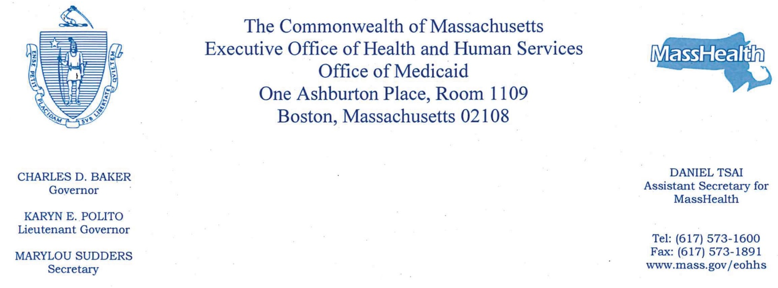

January 14, 2019

Senate Committee on Ways and Means State House, Room 212
Boston, MA 02133

House Committee on Ways and Means State House, Room 243
Boston, MA 02133

Dear members of the House and Senate Committee on Ways and Means,

Enclosed is the final compliance legislative report on the Analysis of the Impact of Wages for Direct Care Workers at Nursing Homes. As you know, nursing facility providers must use direct care add-on revenue to increase wages, benefits, and related employee costs for direct care workers in fiscal year (FY) 2018.

The FY18 budget, Chapter 47 of the Acts of 2017, requires the Executive Office of Health and Human Services (EOHHS) to repmt to the House and Senate Committees on Ways and Means an Analysis of the Impact of Wages for Direct Care Workers at Nursing Homes. The Direct Care Add-On for FY18 was implemented effective October 1, 2017 and nursing facilities are required to come into full compliance by June 30, 2018. On March 2, 2018, nursing facilities were required to file interim compliance reports with EOHHS. As a result of the interim information provided on July 16, 2018, EOHHS is submitting this final report as an update.

Thank you for your continuing commitment to the MassHealth program. If you have any questions about this repo1t, please contact Camille Pearson at Camille.pearson@state.ma.us.

cc: Marylou Sudders

