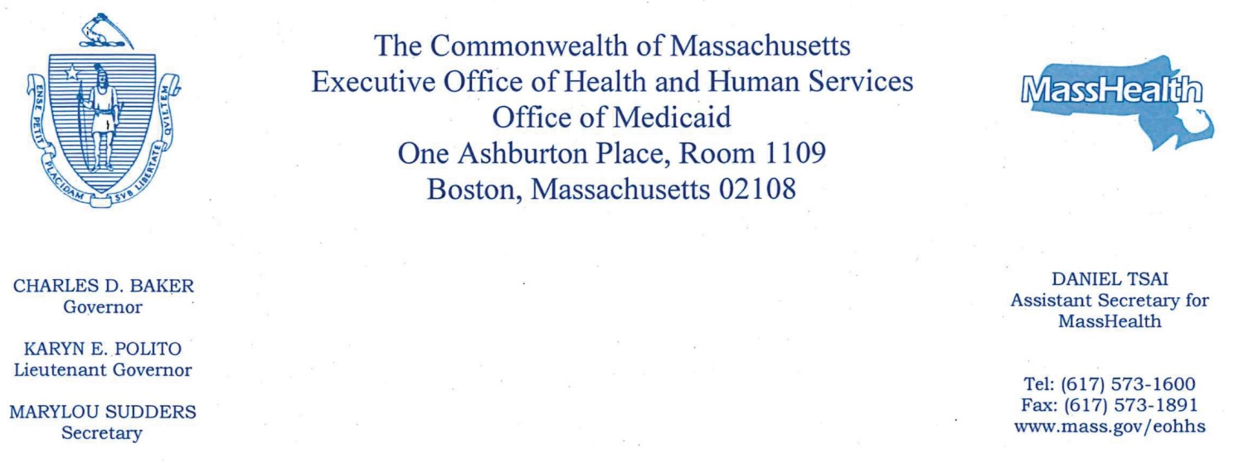

July 16, 2018
The Honorable Karen Spilka
Chair, Senate Committee on Ways and Means
State House, Room 212
Boston, MA 02133
The Honorable Jeffrey Sánchez
Chairman, House Committee on Ways and Means
State House, Room 243
Boston, MA 02133

Dear Chairs Spilka and Sánchez,

Enclosed is an interim legislative report on the Analysis of the Impact of Wages for Direct Care Workers at Nursing Homes. As you know, nursing facility providers must use direct care add-on revenue to increase wages, benefits, and related employee costs for direct care workers in fiscal year (FY) 2018.

The FY18 budget, Chapter 47 of the Acts of 2017, requires the Executive Office of Health and Human Services (EOHHS) to report to the House and Senate Committees on Ways and Means an Analysis of the Impact of Wages for Direct Care Workers at Nursing Homes. The Direct Care Add-On for FY18 was implemented effective October 1, 2017 and nursing facilities are required to come into full compliance by June 30, 2018. On March 2, 2018, nursing facilities were required to file interim compliance reports with EOHHS. As a result of the preliminary information submitted, EOHHS is submitting this interim report as an update.

Thank you for your continuing commitment to the MassHealth program. If you have any questions about this report, please contact Monica Sawhney at monica.sawhney@state.ma.us.

Sincerely,

Daniel Tsai

cc: Marylou Sudders

