Professional Identity in Nursing

The International Society for Professional Identity in Nursing
E-News December 2019
Welcome!
In this quarterly newsletter you’ll about the Professional Identity in Nursing initiative: how it started, progress since the first Think Tank in 2018 and how you could be part of this important change in language for the discipline of nursing.

What is it? Professional Identity in Nursing is an initiative to:
- Scientifically develop new language about professional identity in nursing.
- B. Widely share this deeper understanding of professional identity in nursing so that students, nurses, health care colleagues and society in general better understands what it means to think, act and feel like a professional nurse.

Beginnings
In 2018 a group of international nursing and health care leaders from regulation, practice and education assembled for a 1.5 day Think Tank on Professional Identity in Nursing. More than half of the 2018 participants returned in September 2019 for the next phase of work on definitions, domains, key elements, competencies and exemplars about this recognized but poorly understood construct.
A second outcome of the 2019 Think Tank was the charge from the participants to actively disseminate these findings within education, practice and regulation, and within society as a whole.

2018 Think Tank Outcomes:
Participants affirmed the definition, determined the need for four domains, named and defined those domains and determined key elements and competencies for each.

Domains:

2019 Think Tank Outcomes:
Work at the 2019 Think Tank yielded the WHY statement for Professional Identity in Nursing, refinement of definitions and key elements of each of the four domains, exemplars, and draft work on the conceptual model.

Domains and Definitions of Professional Identity in Nursing:
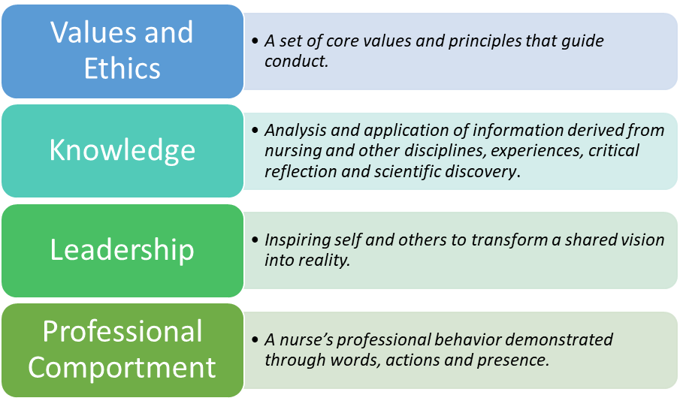

Scientific Work to Date:

Next Steps in Scientific Work:

Communicating Think Tank Findings:
Blogs:
- Kennedy, M. S. Blog Post. American Journal of Nursing. https://ajnoffthecharts.com/being-a-nurse-or-when-did-you-grok-nursing/
- Kennedy, M. S. To Be a Nurse. The American Journal of Nursing: November 2018 - Volume 118 - Issue 11 - p 7 doi: 10.1097/01.NAJ.0000547640.70037.f6. https://journals.lww.com/ajnonline/pages/articleviewer.aspx?year=2018&issue=11000&article=00001&type=Fulltext
Presentations:
- Young, E. & Phillips, P. (2019). Incorporating Professional Identity Formation in Nursing Education. Kansas Nurse Educators Conference, Wichita, KS, May 2019. (peer reviewed)
- Weybrew, K. (2019). Professional Identity in Nursing. Oregon Board of Nursing. June 2019. (invited)
- Weybrew, K. & Priddy, K. (2019). Professional Identity in Nursing: Forming and Fostering. Texas Board of Nursing. Austin, TX, September. (nvited)
- Weybrew, K. & Priddy, K. (2019) Professional Nursing Identity. October 12, 2019. California Vocational Nursing Educators Conference, Ontario, CA. (invited)
- Priddy, K. (2019) Professional Identity in Nursing in the U.S. and the Developing World. August 17th, 2019. National Association of Nigerian Nurses in North America, Dallas Fort Worth Chapter, Dallas, TX. (invited)
- Hite, A. (2019). Professional Identity in Nursing: Naming, Forming, Fostering. Advanced Practice Nurses of the Ozarks Conference. 2019 APN's: Caring Cradle to Grave. Poster presentation. Branson, MO. November (peer reviewed)
- Hite, A. & Godfrey, N. (2019). Professional Identity in Nursing: Naming, Forming, Fostering. 12th Evidence Based Practice on the Frontline: Building a Culture of Quality, Safety, and Nursing Professionalism. Poster presentation. University of Missouri-Columbia, Columbia, MO. April (peer reviewed)
- Godfrey, N., Zorek, J., Price, S., Ballard, J. (2019). Exploring Interprofessional Identity Development: A Conversation Café. Organizing Interprofessional Clinical Learning Environments, National Center for Interprofessional Practice and Education—The NEXUS Summit. Minneapolis August (invited)
- Godfrey, N. Naming and Fostering Professional Identity in Nursing: An Evidence-Based Approach. (2019). Poster presentation. INARC conference, Association of Leadership Studies in Nursing, Los Angeles, CA November (peer reviewed)
- Godfrey, N. (2019). Professional Identity in Nursing: Strategies You Can Use. ATI Nurse Educator Conference, Savannah, GA (invited)
- Godfrey, N. (2019). Professional Identity in Nursing: Leading for Broader Impact. Professional Nursing and Education Group conference (PNEG). Cleveland, OH, October (peer reviewed)
- Godfrey, N. (2019). Professional Identity in Nursing. Webinar, AMN Healthcare, October. (invited)
- Godfrey, N. & Dickow, M. (2019). Building a Sense of Professional Identity: Growing Nursing Leaders. Organization of Associate Degree Nursing conference (OADN), Lexington, KY, November (peer reviewed)
Publications
- Hite, A. & Godfrey, N. (2019). Professional Identity in Nursing: Why does it matter? Kansas Nurse, 94, (3), 14-16.
Publications (upcoming)
- Godfrey, N. [in press]. Putting away your moral beliefs? Ethics Mailbox. American Nurse Today.
- Godfrey, N. & Young, E. [in press]. Professional Identity. In Giddens, J. Concepts of Nursing Practice, 3rd edition. St. Louis: Elsevier Publishing.

Research (in process)

- Godfrey, N. & Poague, C. (2019) Professional Identity in Nursing: Transitioning from Direct Patient Care to Leadership. STUDY00144512, University of Kansas Medical Center (in process)

Next Steps in Communicating the Work:

- We will be working with a social media specialist in 2020 to further dissemination of the Think Tank work.
- There will be a Professional Identity in Nursing Forum (combination Think Tank and conference) September 15-16, 2020 in Kansas City.
- Three work groups are active now: Dissemination, Demonstration Project, and Competencies.
- A Research interest group will activate in 2020. If you are interested in participating in any of these areas, please contact Nelda Godfrey at ngodfrey@kumc.edu.

Structural Changes:

Dear colleagues, the steering group met following the Think Tank and determined that we needed a more global approach to our work. To that end, we now have a new name: The International Society for Professional Identity in Nursing. Further, the steering group has been renamed to become the Professional Identity in Nursing Advisory Council, with members listed below:

Professional Identity in Nursing Advisory Council Members:

Amy Hite
Beth Philips
Caryl Goodyear
Cole Edmonson
Janice Brewington
Judy Hodgson
Kary Weybrew
Kristen Priddy
Kristi Frisbee
Lindell Joseph
Sheryl Sommer
Susan Luparell

Just a snapshot:
Lastly, this is just a snapshot of the work to date. Any input or suggestions you have would be welcomed by your colleagues who are shepherding this intiative. Let us hear from you! For more information, you can contact for Nelda Godfrey ngodfrey@kumc.edu.
Website: http://nursing.kumc.edu/innovative-partnerships-and-practice/professional-identity-in-nursing.html

