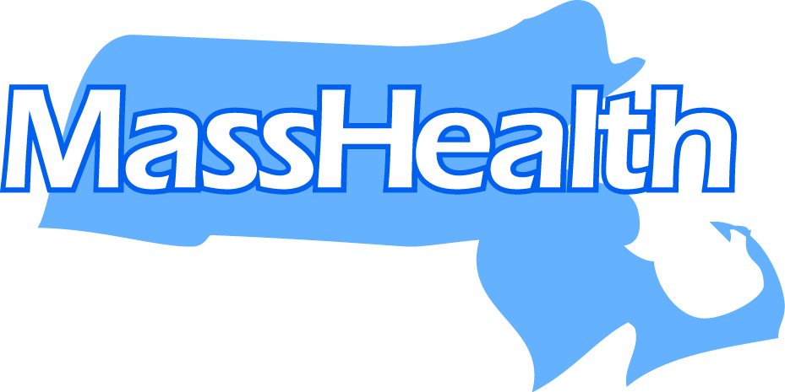
The Commonwealth of Massachusetts
Executive Office of Health and Human Services

Office of Medicaid

One Ashburton Place

Boston, Massachusetts 02108

AMANDA CASSEL KRAFT
Assistant Secretary for MassHealth

www.mass.gov/eohhs
August 26, 2021

CHARLES D. BAKER
Governor

KARYN E. POLITO
Lieutenant Governor

MARYLOU SUDDERS
Secretary
Dear School-Based Medicaid Program (SBMP) Providers,
MassHealth is very happy to announce that we have received approval from the Centers for Medicare and Medicaid Services (CMS) to expand our Medicaid Administrative Reimbursement to include work activities pursuant to state and federal public health initiatives and guidelines. This expansion will provide reimbursement for a portion of the work LEA staff have done in response to the COVID-19 pandemic, including infection control, contact tracing, and time spent planning and collaborating on how to effectively adapt the delivery of Medicaid-covered services in response to public health guidance. Activities related to other, non-COVID-19 public health guidance will also be reimbursable administrative time.
This approval is retroactive to October 1, 2020. In anticipation of CMS’s approval, MassHealth, in collaboration with UMass Medical School (UMMS), our program administrator, adapted the Random Moment Time Study to capture these work activities. Therefore, the RMTS percentages from FY21 Q2, 3, and 4 will be positively adjusted to include reimbursement for these additional work activities.
What do LEAs need to do? If your LEA has already filed Administrative Activity Claims (AAC) for Q2 or Q3 FY21, those claims need to be amended and re-calculated to add the additional reimbursable work activities. UMMS is currently working on re-coding appropriate moment responses to reflect the additional reimbursable work activities and will notify designated claim preparers as soon as the claiming system is ready to process the amendments. This will be a quick and simple process, with the primary task being to execute the Certified Public Expenditure letter for the amendments and submit those to UMMS by October 20, 2021. AAC claims for Q4 will be calculated using RMTS percentages that will already include reimbursement for the additional work activities (no amendments required). Q4 FY21 AAC claims must be submitted by October 15 and certified by October 20, 2021, as usual.
Thank you and, as always, please let us know how we can be of further assistance.
Sincerely,

Caitlin N. Carney
Senior Manager, Cross Agency & School-Based Medicaid Programs
Executive Office of Health and Human Services | MassHealth
One Ashburton Place | Boston MA 02108

