**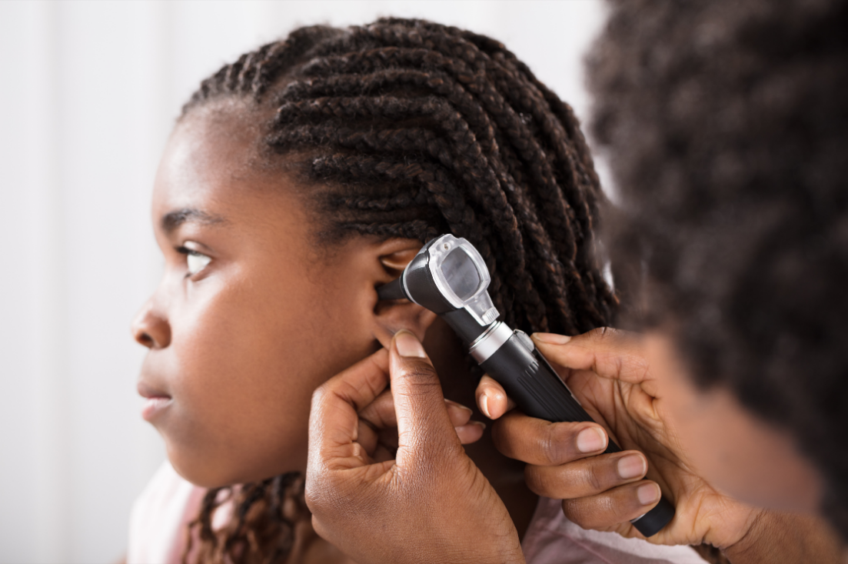****

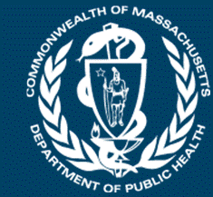

Commonwealth of Massachusetts

School-Based Health Center Program

2022-2023 Annual Report

**For more information on MDPH-funded SBHCs, including a directory of sites and their sponsoring agencies, go to** [**www.mass.gov/school-based-health-centers-here-for-the-kids**](https://www.mass.gov/school-based-health-centers-here-for-the-kids)

**About School-Based Health Centers**

**School-Based Health Centers in Massachusetts**

**S**chool-**B**ased **H**ealth **C**enters (SBHCs) are health centers that offer a variety of health care services, including primary and behavioral health care, where children and adolescents can most easily access them—school.

The **M**assachusetts **D**epartment of **P**ublic **H**ealth (MDPH)’s SBHC Program has evolved since its beginning in 1989 to provide children and adolescents with comprehensive health care in selected communities.

**MDPH-Funded SBHCs**

Every child and adolescent needs access to health care and other resources to succeed; yet, where they live, grow, and learn impacts their ability to access such resources.

The 42 SBHCs funded by MDPH’s SBHC Program in the 2022-2023 school year are strategically located where they can make the greatest impact on the lives of the youth they serve. These centers develop nurturing, stable, therapeutic relationships with students from communities that have historically experienced structural and physical barriers to comprehensive health care.

**SBHCs Funded in the 2022-2023 School Year**

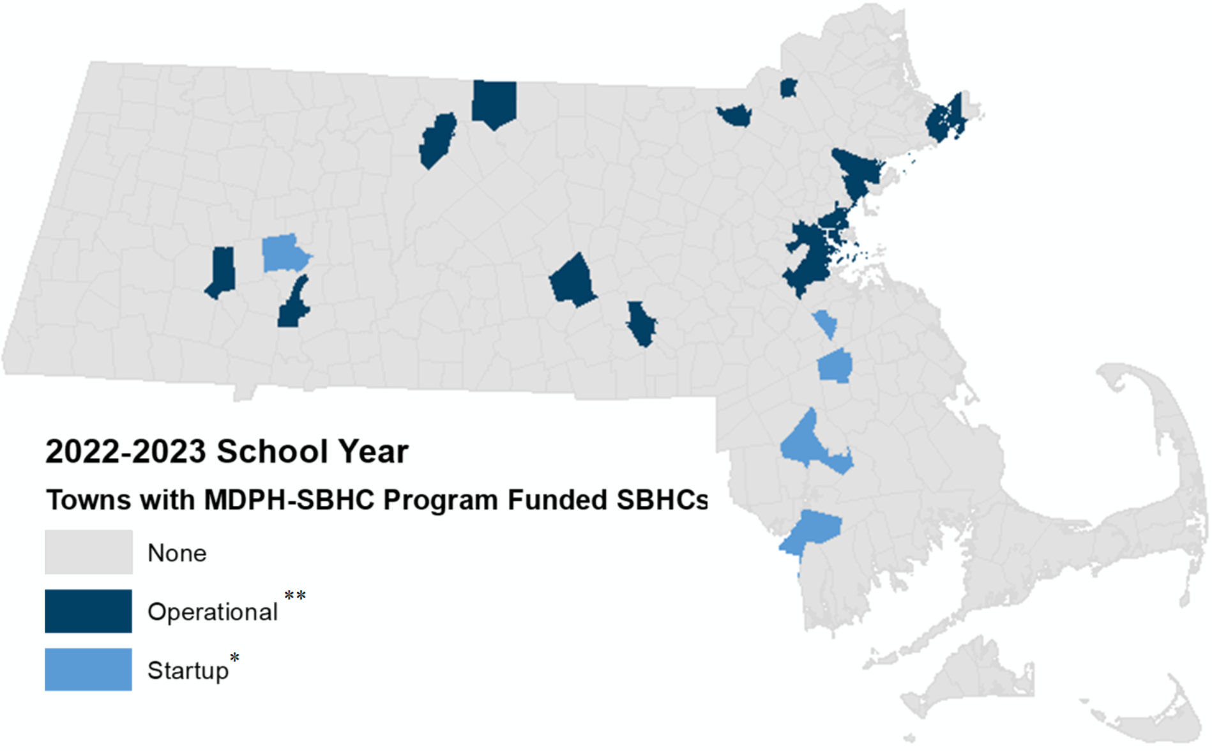

*Startup indicates that a sponsoring agency is in the process of establishing a new SBHC in partnership with a school district.

**Towns noted here as** **startups only have a startup**.

**\*\***Towns noted as **operational have at least one operational** SBHC though might also have a startup SBHC.

The full list of SBHCs, some of which support multiple schools, and their sponsoring agencies is in Appendix I.

**SBHC Program Partners**

SBHCs are run by community health centers, hospitals, behavioral health agencies, and local public health agencies. The 20 sponsoring agencies the MDPH SBHC Program funded in the 2022-2023 school year share the belief that all kids deserve the resources that they need to be healthy and demonstrated an ability to bring community organizations together to build hope and health.

**For more information on MDPH-funded SBHCs, including a directory of sites and their sponsoring agencies, go to** [**www.mass.gov/school-based-health-centers-here-for-the-kids**](https://www.mass.gov/school-based-health-centers-here-for-the-kids)

**SBHC Services and Programming**

In School-Based Health Centers (SBHCs), a collaborative team offers an extensive range of services to support students' well-being. Medical providers deliver comprehensive health assessments, physical exams, screenings, sexual and reproductive care, immunizations, nutrition counseling, treatment for health issues, prescription management, lab tests, emergency triage, and respond to public health emergencies. Behavioral health providers offer critical services including assessment, treatment, crisis intervention, prevention, therapy, medication management, advocacy, and communication with parents. Community health workers facilitate insurance enrollment, address social needs, promote SBHC services, coordinate care plans, connect families to resources, conduct home visits, and educate students on health management. These combined efforts represent a portion of the support provided by SBHC teams to enhance students' well-being in the school setting.

The SBHC Program requires all funded SBHCs to continuously work towards attaining our [quality standards](https://www.mass.gov/doc/school-based-health-center-quality-standards-0/download), which include required service offerings and a staffing framework mandating a full-time medical provider, a full-time behavioral health provider, and a full-time community health worker In the 2022-2023 school year, services provided by SBHCs included behavioral health care, primary care, vaccinations, dental care, community engagement, collaborative care planning/case management, and sexual and reproductive health care.

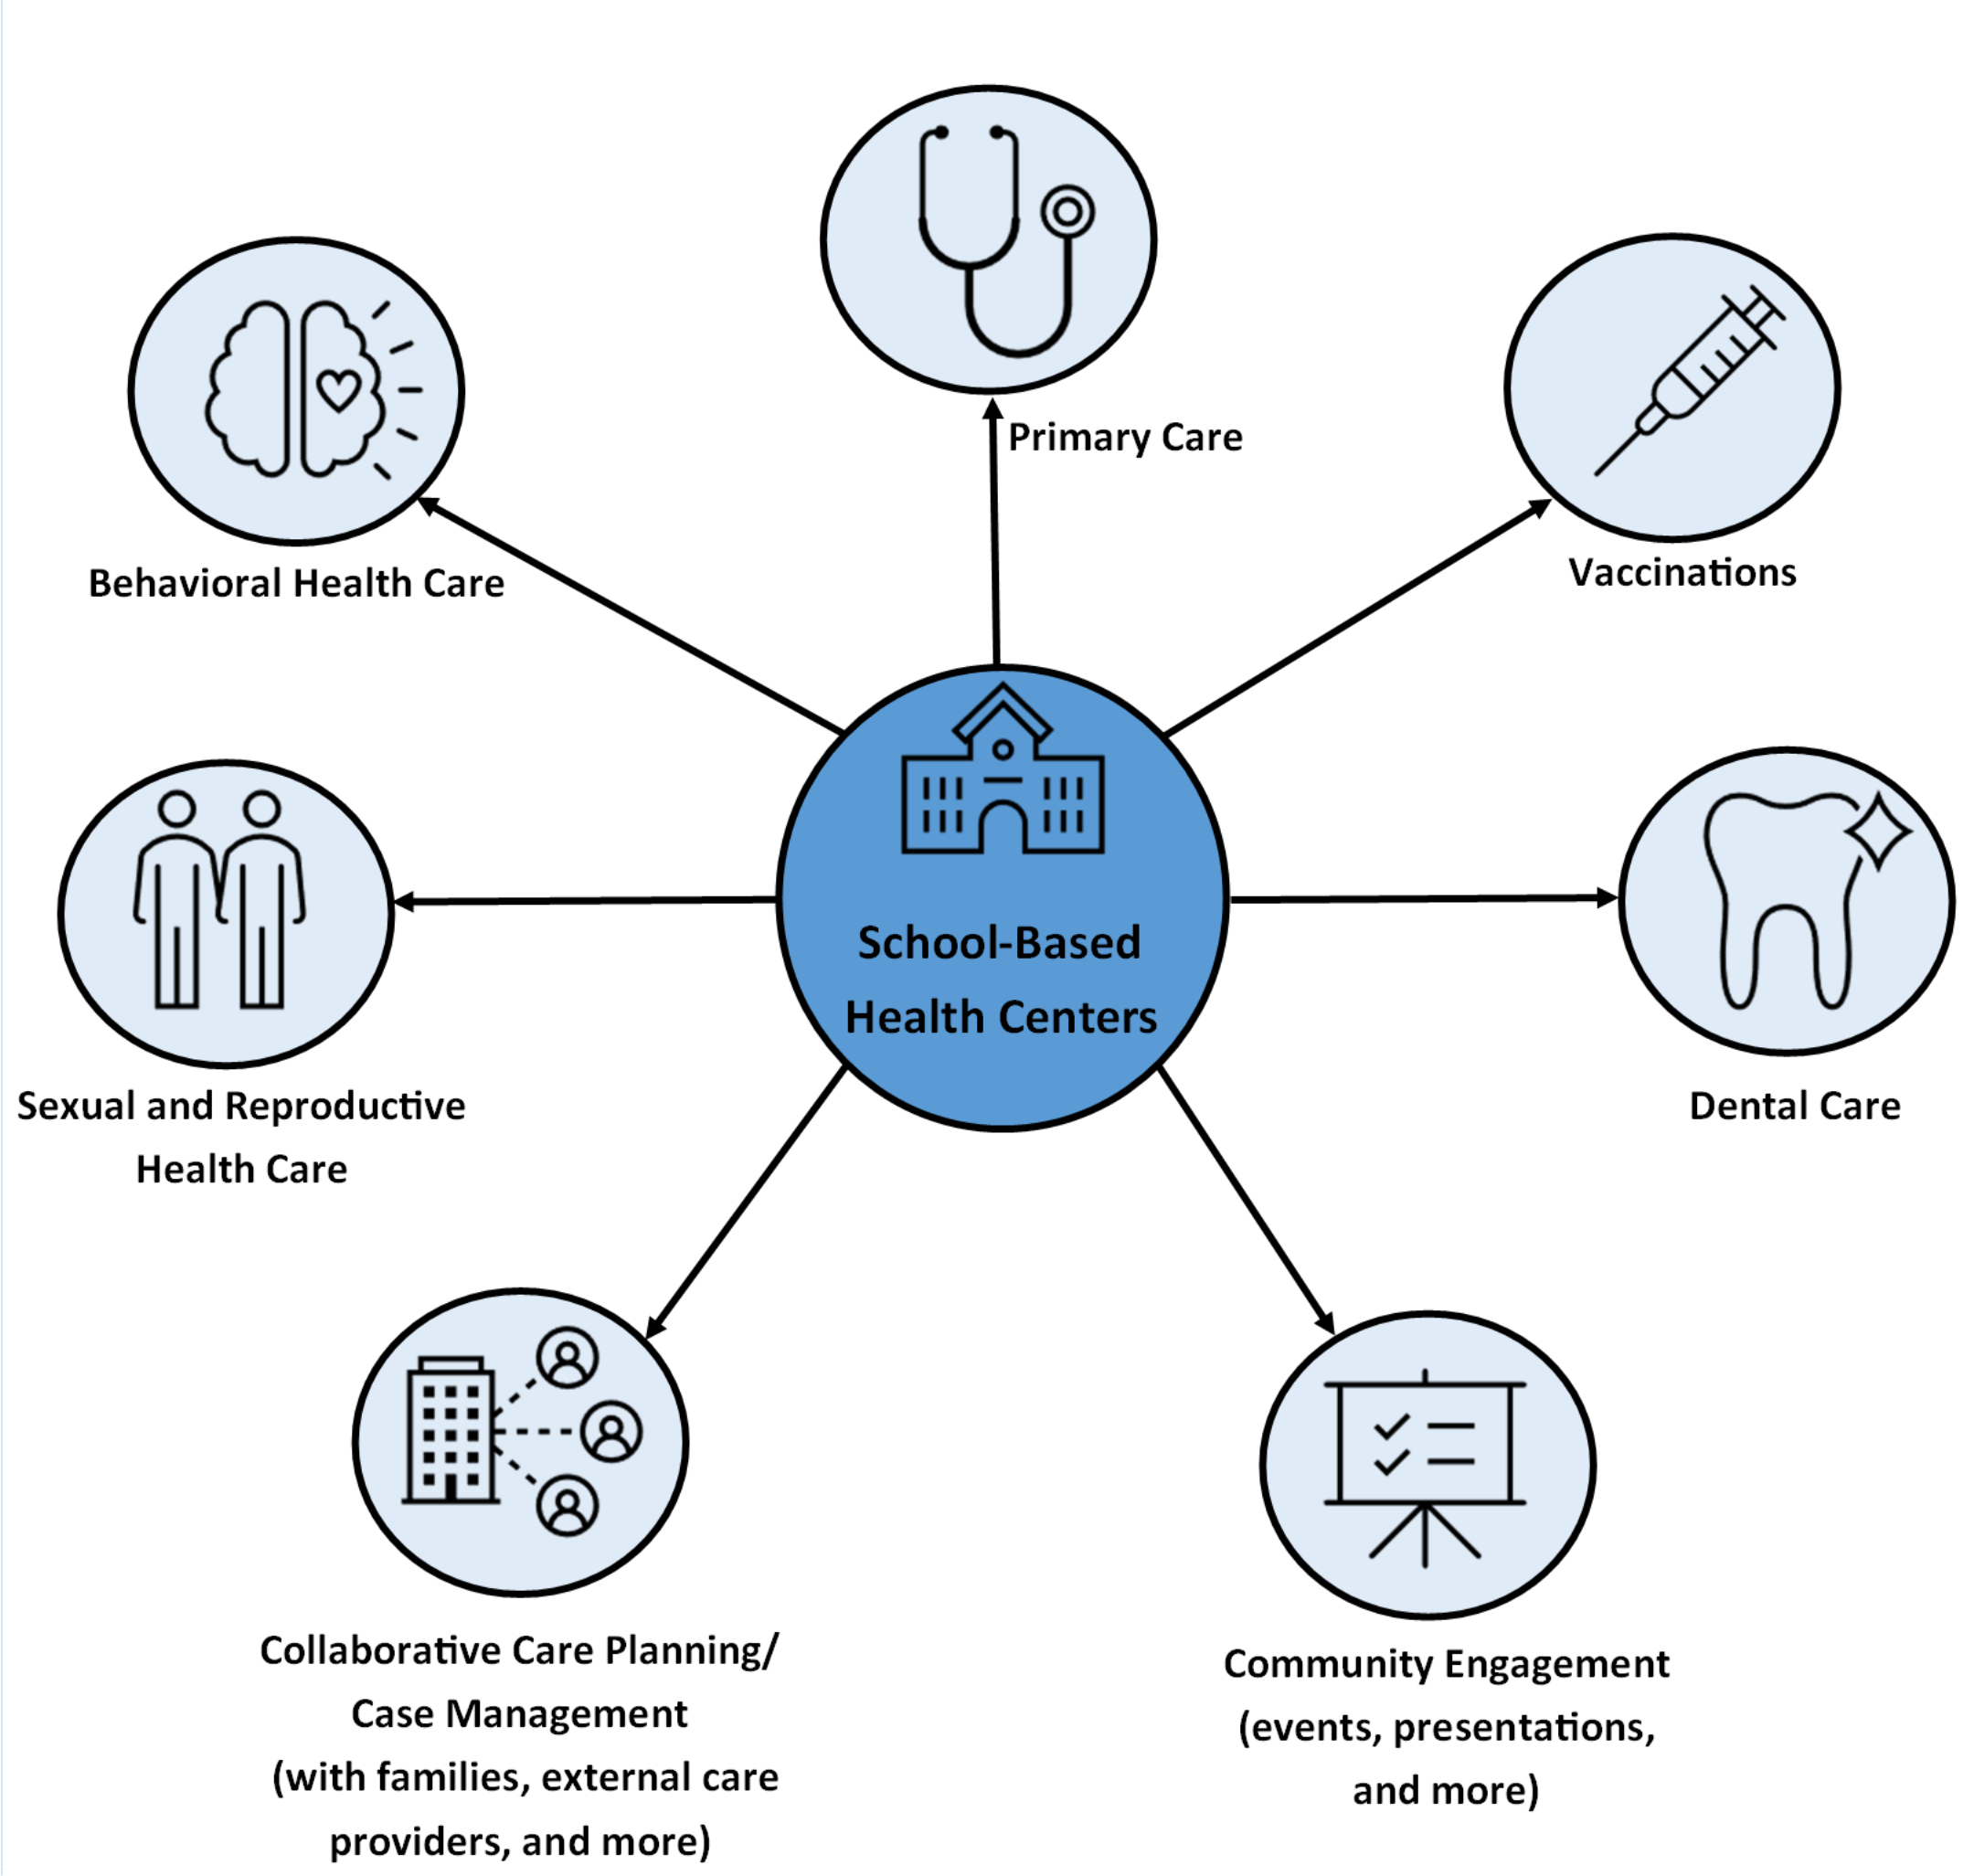

**For more information on MDPH-funded SBHCs, including a directory of sites and their sponsoring agencies, go to** [**www.mass.gov/school-based-health-centers-here-for-the-kids**](https://www.mass.gov/school-based-health-centers-here-for-the-kids)

**SBHC Impact in 2022-2023**

**School-Based Health Centers: Impact by Numbers**

In the 2022-2023 school year, MDPH Program-funded SBHCs had:

Image with clip art icons accompanying the following information:
55,164 SBHC visits, 
12,203 clients, 
26,355 Primary Care Visits, 
6,265 Reproductive Health Visits, 
and 28,005 Behavioral Health Visits.

**For more information on MDPH-funded SBHCs, including a directory of sites and their sponsoring agencies, go to** [**www.mass.gov/school-based-health-centers-here-for-the-kids**](https://www.mass.gov/school-based-health-centers-here-for-the-kids)

The visits above include all clients who were seen at the SBHC, regardless of age or enrollment status. While most clients are K-12 students, some are community members.

* Visit count categories are based on the Primary International Classification of Diseases (ICD) Code assigned to the visit by the SBHC.

1 Primary Care Visits include Reproductive Health Visits.

**Centering Racial Equity**

The American Academy of Pediatrics states that “Racism…has a profound impact on the health status of children, adolescents, emerging adults, and their families. Although progress has been made toward racial equality and equity, the evidence to support the continued negative impact of racism on health and well-being through implicit and explicit biases, institutional structures, and interpersonal relationships is clear. Failure to address racism will continue to undermine health equity for all children, adolescents, emerging adults, and their families.”2 Equitable access to health care services across all racial/ethnic groups is a first step in centering racial equity for SBHCs.

Youth in the United States face significant racial and ethnic disparities in access to medical care.4 MDPH's SBHC Program deliberately emphasizes improving access to health care for youth and children in communities profoundly impacted by health inequities, particularly those deeply affected by racism and poverty. To identify areas with the greatest need for SBHCs, various factors such as chronic absenteeism, dropout rates, the proportion of English language learners, the percentage of children living below the federal poverty level, and localities where housing costs surpass 30% of income were considered.5 SBHCs intentionally serve communities whose racial makeup differs significantly from the broader Massachusetts demographic. This is a success given our program's goals.

The pie charts below show the racial/ethnic demographic characteristics of all students in public schools in Massachusetts and those of students in schools with MDPH SBHC Program-funded SBHCs. The pie charts demonstrate that we are effectively reaching communities most likely to experience racial inequities in access to health care. By improving health care access to those who are less likely to have it, we help ensure that every child in the Commonwealth has equitable access to health care.

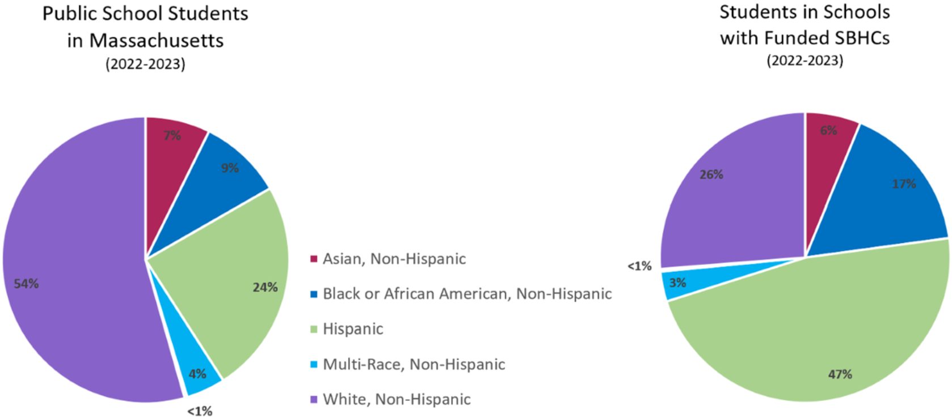

*Source: Massachusetts Department of Elementary and Secondary Education (DESE) K-12 public school data*

*“Students in Schools with Funded SBHCs” refers to all students in schools that have SBHCs that are funded by MDPH’s SBHC Program in FY23. Totals are not equal to 100% due to rounding.*

*The percent of students DESE identified as Native American (0.2% in both public schools and SBHC schools) and as Native Hawaiian/Pacific Islander (0.1% in both public schools and SBHC schools) are not visible wedges in these pie charts because of the scale. They are represented as <1%.3*

**For more information on MDPH-funded SBHCs, including a directory of sites and their sponsoring agencies, go to** [**www.mass.gov/school-based-health-centers-here-for-the-kids**](https://www.mass.gov/school-based-health-centers-here-for-the-kids)

**A Meaningful Impact**

These two stories come from MDPH’s SBHC partners that used their unique position to meet the needs of students and their families. Identifying details have been changed to protect patient privacy. Additional edits have been made to improve clarity.

SBHCs provide a healthcare access point for not only students, but also their families. A middle school student was referred to the SBHC by the school nurse after realizing they were due for required school immunizations since they recently relocated to the state. The student’s parent already completed the consent for treatment at the SBHC, so immunizations were able to be administered that day. After the student received their immunizations, the SBHC **n**urse **p**ractitioner (NP) reached out to the student’s mother to discuss the visit and to offer further assistance. During the conversation, the mother asked for help finding a primary care provider. She shared that she also had a toddler at home who hadn't seen a health professional for several years. Mom voiced concerns about this child's development noting a speech delay and destructive behaviors. Responding promptly, the SBHC NP scheduled a telehealth session to address these worries. The NP then connected the family to the SBHC behavioral health team. The psychiatrist was able to conduct a neuropsychiatric evaluation within the same week, diagnosing the child with autism spectrum disorder and most importantly, connecting the child to therapeutic supports.   
  
Through consistent and comprehensive case management, the SBHC team established trust with the mother, creating a safe space for her to eventually share about the family's experience with domestic violence, which prompted their move to Massachusetts. Through further conversation, the mom also confided in the team that she had several chronic diseases that were left untreated while she was focusing on securing her family's safety. The SBHC went on to successfully support the mom in becoming a patient of the health center, too, and she now has access to treatments to improve her physical quality of life. **This story highlights our steadfast commitment to providing not just medical treatment to our students, but holistic, wraparound support to their families.**

**For more information on MDPH-funded SBHCs, including a directory of sites and their sponsoring agencies, go to** [**www.mass.gov/school-based-health-centers-here-for-the-kids**](https://www.mass.gov/school-based-health-centers-here-for-the-kids)

**A Meaningful Impact (continued)**

A high school student initially stopped by the SBHC to schedule a physical exam. During this encounter, he spoke with our office coordinator and learned that he also needed required school immunizations. During the student’s physical exam and immunization visit with the nurse practitioner, he shared that every day after school he went to work. He was responsible for paying for his own food, daily needs, rent for a room in an apartment and transportation all on his own. He shared that his mother would be migrating to the United States soon and he was eager to support her financially.

The student was then connected to the SBHC **c**ommunity **h**ealth **w**orker (CHW) who helped him apply for financial supports and other benefits he was eligible for. The CHW connected the student to a community organization that helps teens with housing insecurity. The student now is a well-established patient of the SBHC and continues to receive ongoing healthcare and additional support connecting to resources. **This story underscores the pivotal role of the SBHC in assisting students managing substantial personal and financial responsibilities. Through providing essential healthcare services, facilitating access to crucial resources, and nurturing relationships with trusted adults, the SBHC contributes to improving students’ well-being and fostering future opportunities in a professional and supportive manner.**

**For more information on MDPH-funded SBHCs, including a directory of sites and their sponsoring agencies, go to** [**www.mass.gov/school-based-health-centers-here-for-the-kids**](https://www.mass.gov/school-based-health-centers-here-for-the-kids)

**Appendix I**

|  |  |
| --- | --- |
| **The 42 SBHCs funded by MDPH during the 2022-2023 School Year** | |
| **Sponsoring Agencies** and their SBHCs | **Address** |
|  | |
| **ADDISON GILBERT HOSPITAL** | |
| Gloucester High School | 32 Leslie O Johnson Road, Gloucester, MA |
|  | |
| **BOSTON PUBLIC HEALTH COMMISSION** | |
| Boston Latin Academy | 205 Townsend Street, Dorchester, MA |
| Brighton High School | 25 Warren Street, Brighton, MA |
| Jeremiah E. Burke High School | 60 Washington Street, Dorchester, MA |
| Madison Park High School | 75 Malcolm X Boulevard, Roxbury, MA |
|  | |
| **BROCKTON NEIGHBORHOOD HEALTH CENTER** | |
| Brockton High School (Startup) | 470 Forest Avenue, Brockton, MA |
|  | |
| **CAMBRIDGE HEALTH ALLIANCE** | |
| Cambridge Rindge & Latin High School | 459 Broadway, Cambridge, MA |
| Somerville High School | 81 Highland Avenue, Somerville, MA |
| Everett High School | 100 Elm Street, Everett, MA |
|  | |
| **CODMAN SQUARE HEALTH CENTER** | |
| Randolph High School (Startup) | 70 Memorial Parkway, Randolph, MA |
| TechBoston Academy | 9 Peacevale Road, Dorchester, MA |
|  | |
| **EDWARD M. KENNEDY COMMUNITY HEALTH CENTER** | |
| Burncoat Middle/High School | 135 Burncoat Street, Worcester, MA |
|  | |
| **FAMILY HEALTH CENTER OF WORCESTER** | |
| Claremont Academy/Woodland Academy | 15 Claremont Street, Worcester, MA |
| Doherty Memorial High School | 299 Highland Street, Worcester, MA |
| Elm Park Community School | 23 North Ashland Street, Worcester, MA |
| Goddard School of Science & Technology | 14 Richards Street, Worcester, MA |
| South High Community School | 170 Apricot Street, Worcester, MA |
| Sullivan Middle School | 140 Apricot Street, Worcester, MA |
| Worcester East Middle School | 420 Grafton Street, Worcester, MA |

**For more information on MDPH-funded SBHCs, including a directory of sites and their sponsoring agencies, go to** [**www.mass.gov/school-based-health-centers-here-for-the-kids**](https://www.mass.gov/school-based-health-centers-here-for-the-kids)

**Appendix I (continued)**

|  |  |
| --- | --- |
|  | |
| **GREATER LAWRENCE FAMILY HEALTH CENTER** | |
| Lawrence High School | 70-71 North Parish Road, Lawrence, MA |
|  | |
| **HEALTHFIRST FAMILY CARE CENTER** | |
| B.M.C Durfee High School (Startup) | 460 Elsbree Street, Fall River, MA |
|  | |
| **HEYWOOD HOSPITAL** | |
| Athol Community Elementary School | 1064 Pleasant Street, Athol, MA |
| Murdock Middle High School | 3 Memorial Drive, Winchendon, MA |
|  | |
| **HILLTOWN COMMUNITY HEALTH CENTERS** | |
| Gateway Regional Middle/High School | 12 Littleville Road, Huntington, MA |
| Smith Vocational and Agricultural High School (Startup) | 80 Locust Street, Northampton, MA |
|  | |
| **HOLYOKE MEDICAL CENTER** | |
| Holyoke High School – Dean Campus and Holyoke STEM Academy | 1045 Main Street, Holyoke, MA |
| Holyoke High School – North Campus | 500 Beech Street, Holyoke, MA |
| William R. Peck School | 1916 Northampton Street, Holyoke, MA |
|  | |
| **LOWELL COMMUNITY HEALTH CENTER** | |
| Lowell High School | 50 Father Morissette Boulevard, Lowell, MA |
|  | |
| **LYNN COMMUNITY HEALTH CENTER** | |
| Breed Middle School | 90 O'Callaghan Way, Lynn, MA |
| Ingalls School | 1 Collins Street Terrace, Lynn, MA |
| Lynn English High School | 50 Goodridge Street, Lynn, MA |
| Lynn Vocational Technical Institute | 80 Neptune Boulevard, Lynn, MA |
| Thurgood Marshall Middle School | 100 Brookline Street, Lynn, MA |
|  | |
| **MANET COMMUNITY HEALTH CENTER** | |
| Taunton Public Schools (Startup) | 60 Williams Street, Suite P101, Taunton, MA |
|  | |
| **MILFORD REGIONAL MEDICAL CENTER** | |
| Blackstone Valley Regional Vocational Technical High School | 65 Pleasant Street, Upton, MA |
|  | |
| **NEW HEALTH CHARLESTOWN** | |
| Charlestown High School | 240 Medford Street, Charlestown, MA |

**For more information on MDPH-funded SBHCs, including a directory of sites and their sponsoring agencies, go to** [**www.mass.gov/school-based-health-centers-here-for-the-kids**](https://www.mass.gov/school-based-health-centers-here-for-the-kids)

**Appendix I (continued)**

|  |  |
| --- | --- |
|  | |
| **NORTH SHORE COMMUNITY HEALTH** | |
| Peabody Veterans Memorial High School | 485 Lowell Street, Peabody, MA |
| Salem High School | 77 Willson Street, Salem, MA |
|  | |
| **MGH CHELSEA & REVERE HEALTH CENTERS** | |
| Chelsea High School | 299 Everett Avenue, Chelsea, MA |
| Revere High School | 101 School Street, Revere, MA |
|  | |
| **WHITTIER STREET HEALTH CENTER** | |
| Boston Day and Evening Academy (Startup) | 20 Kearsarge Avenue, Roxbury, MA |

**For more information on MDPH-funded SBHCs, including a directory of sites and their sponsoring agencies, go to** [**www.mass.gov/school-based-health-centers-here-for-the-kids**](https://www.mass.gov/school-based-health-centers-here-for-the-kids)

**Appendix II**

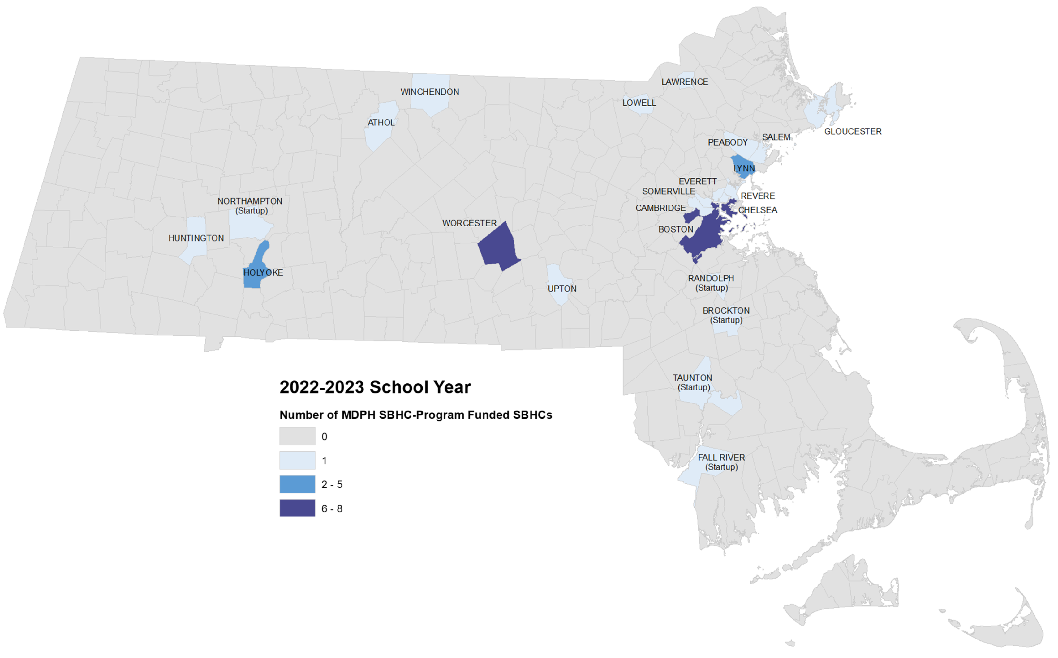

**References**

1. (2022, September 10). *Interim Guidance on Supporting the Emotional and Behavioral Health Needs of Children, Adolescents, and Families During the COVID-19 Pandemic*. American Academy of Pediatrics. Retrieved December 21, 2022, from <https://www.aap.org/en/pages/2019-novel-coronavirus-covid-19-infections/clinical-guidance/interim-guidance-on-supporting-the-emotional-and-behavioral-health-needs-of-children-adolescents-and-families-during-the-covid-19-pandemic/>

2. Trent M, Dooley DG, Dougé J, AAP SECTION ON ADOLESCENT HEALTH, AAP COUNCIL ON COMMUNITY PEDIATRICS, AAP COMMITTEE ON ADOLESCENCE. The Impact of Racism on Child and Adolescent Health. Pediatrics. 2019;144(2):e20191765 [The Impact of Racism on Child and Adolescent Health | Pediatrics | American Academy of Pediatrics (aap.org)](https://publications.aap.org/pediatrics/article/144/2/e20191765/38466/The-Impact-of-Racism-on-Child-and-Adolescent?autologincheck=redirected)

3. (2023). *Massachusetts Department of Elementary and Secondary Education*. DESE.

4. Weller, B. E., Faubert, S. J., & Ault, A. K. (2020). Youth Access to Medical Homes and Medical Home Components by Race and Ethnicity. *Maternal and child health journal*, *24*(2), 241–249.

5. (2022). *Bid Solicitation: BD-22-1031-BCHAP-BCH01-69440*. Commbuys Operational Services Division. Retrieved December 21, 2022, from <https://www.commbuys.com/bso/external/bidDetail.sdo?docId=BD-22-1031-BCHAP-BCH01-69440&external=true&parentUrl=close>

**For more information on MDPH-funded SBHCs, including a directory of sites and their sponsoring agencies, go to** [**www.mass.gov/school-based-health-centers-here-for-the-kids**](https://www.mass.gov/school-based-health-centers-here-for-the-kids)