
The Commonwealth of Massachusetts
Executive Office of Health and Human Services
Department of Public Health
250 Washington Street, Boston, MA 02108-4619

CHARLES D. BAKER
Governor
KARYN E. POLITO
Lieutenant Governor

MARYLOU SUDDERS
Secretary
MONICA BHAREL, MD, MPH Commissioner

Tel: 617-624-6000
www.mass.gov/dph

August 6, 2015

Steven T. James, Clerk
Massachusetts House of Representatives
Room 145, State House
Boston, MA 02133

William F. Welch, Clerk
Massachusetts Senate
Room 335, State House
Boston, MA 02133

Dear Mr. Clerk,

Pursuant to Chapter 313 of the Acts of 2010, the Massachusetts Department of Public Health is pleased to issue an annual summary of the state Fiscal Year 2015 activities related to screening for postpartum depression.

Sincerely,

Monica Bharel, MD, MPH
Commissioner
Department of Public Health

Cc: Representative Ellen Story (PPD Legislative Commission Co-Chair)
Senator Joan Lovely (PPD Legislative Commission Co-Chair)
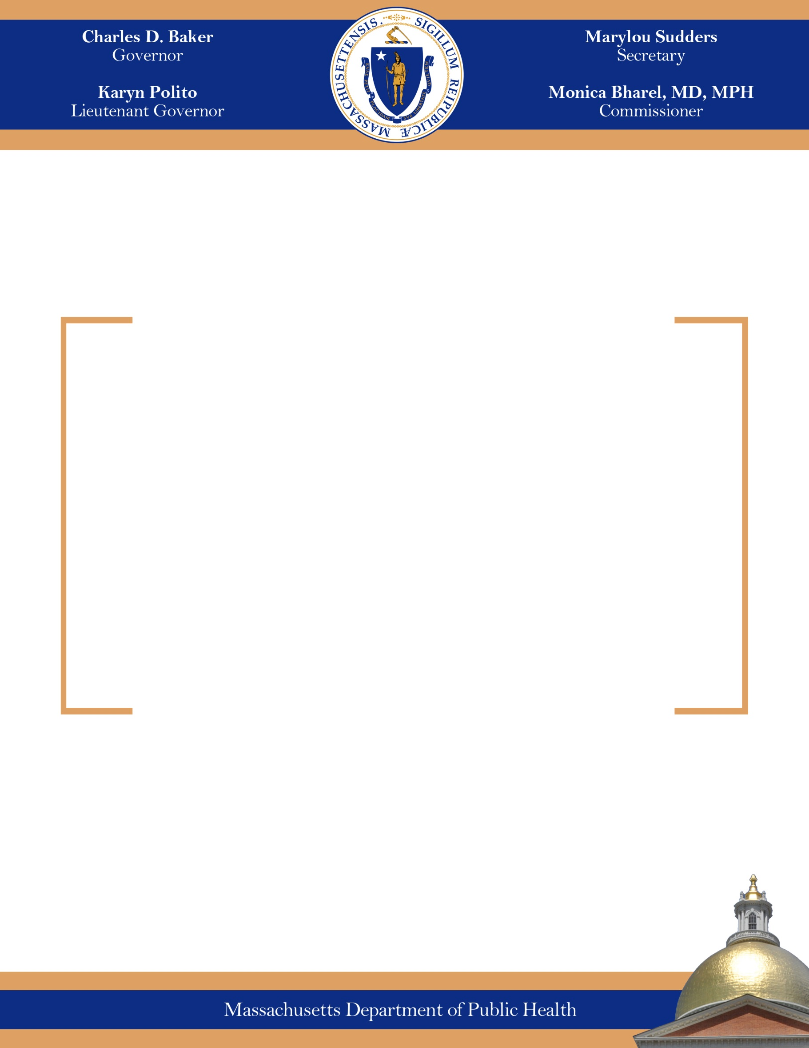
Annual Summary of Activities Related to Screening for
Postpartum Depression

August 2015

ANNUAL SUMMARY OF ACTIVITIES RELATED TO SCREENING FOR POST PARTUM DEPRESSION
Massachusetts Department of Public Health
Fiscal Year 2015

Introduction

On August 19, 2010, An Act Relative to Postpartum Depression, Chapter 313 of the Acts of 2010, was signed into law. This legislation has two primary components: the establishment of a postpartum depression (PPD) Legislative Commission and a requirement that the Massachusetts Department of Public Health (DPH) promote a culture of awareness, de-stigmatization, and screening for perinatal depression.

Specifically, DPH is charged with:

- Developing standards for effective PPD screening;
- Making recommendations to health plans and health care providers for PPD screening data reporting;
- Issuing regulations that require health plans and health care providers to annually submit data on screening for postpartum depression; and
- Issuing an annual summary of the activities related to screening for postpartum depression including best practices and effective screening tools.

This report provides a summary of activities for state Fiscal Year 2015.
PPD Pilot Programs

The FY15 budget included language requiring DPH to continue the PPD pilot programs at Community Health Centers (CHCs) in four sites across the Commonwealth. A procurement waiver was granted and the contracts were reestablished in the second quarter of state FY15. Funding for these contracts totaled $200,000, distributed evenly across all sites. This funding allowed the CHCs to continue to employ part time Community Health Workers (CHWs) to assist with PPD screening and referral activities. The four CHCs included the Family Health Center in Worcester, Holyoke Health Center, Lynn Community Health Center, and Southern Jamaica Plain Health Center.

Due to revenue shortfalls, DPH was required to terminate the contracts on November 18, 2014 as part of administrative 9C budget cuts for FY15. Funding for each PPD Pilot Program was reduced by $31,597.50. DPH provided support and technical assistance to the programs as services were terminated.

The CHCs were required to submit PPD screening data to DPH for the time period services were provided. The following is a summary of the data received for state FY15 before the programs closed.

- CHCs reported 612 face-to-face encounters with pregnant women with 290 (47%) receiving a PPD screen.
- CHCs reported 1,015 face-to-face encounters with postpartum women with 677 (67%) receiving a PPD screen.
- Of the 677 postpartum women who received a PPD screen, 116 (17%) scored either a 10, 11 or 12 on the Edinburgh Postnatal Depression Scale (EPDS) or 1 – 9 on the Patient Health Questionnaire (PHQ-9) indicating mild depressive symptoms
- Of the 677 postpartum women who received a PPD screen, 43 (6%) scored either a 13 or above on the EPDS or 10 or above on the PHQ-9 indicating moderate to severe depressive symptoms
- CHCs reported 452 face-to-face encounters by a CHW with a mother
- CHCs reported 273 indirect/collateral contacts, including phone calls, were made on behalf of the mothers serviced by the program
- CHCs reported 174 referrals being made
- CHCs reported 100 completed referrals where the mother was connected to resources
PPD Regulations - 105 CMR 271.000

An Act Relative to Postpartum Depression, Chapter 313 of the Acts of 2010 charged DPH to issue regulations that require carriers and health care providers to annually submit data on screening for postpartum depression (PPD). Understanding statewide PPD screening patterns and outcomes through relevant data reporting to DPH is intended to improve the detection of this prevalent condition and facilitate treatment for mothers in need of help.

The PPD Regulations (105 CMR 271.000) were promulgated in December 2014 and require annual reporting by a provider that conducts or oversees screening for PPD, using a validated screening tool, during a routine clinical appointment in which medical services are provided to a woman who has given birth within the previous six months. The regulations also apply to a carrier that receives a claim for this PPD screening.

The providers responsible for adhering to these regulations are OB-GYNs, Family Medicine Practitioners, Advanced Practice Nurses including Nurse Midwives and Nurse Practitioners, and Physician Assistants, who practice in a family medicine/OBGYN setting.

Providers can report their PPD Screening data to DPH through an annual written report or through claims codes. Data collection has begun in CY2015. Providers are able to submit an annual written report to DPH by March 1 for the previous calendar year using the “Annual PPD Data Reporting Form” available on the DPH webpage dedicated to PPD at: http://www.mass.gov/eohhs/gov/departments/dph/programs/family-health/postpartum-depression/

Alternatively, Providers are able to use the HCPCS code of S3005 (Performance Measurement, Evaluation of Patient Self-Assessment, Depression) with a diagnostic range V24 (Screening for Postpartum Depression) and with a modifier as a mechanism for reporting PPD screening.

Servicing Provider | Modifier for use with a positive PPD screen | Modifier for use with a negative PPD screen
OB-GYNs, Family Medicine Practitioners, Advanced Practice Nurses including Nurse Midwifes and Nurse Practitioners, & Physician Assistants | U1 | U2

The service code is set to pay at zero, or at $0.01 for carriers that are unable to process a service code without an associated payment. Carriers will be accepting this service code from the servicing providers identified above, and will be reporting it directly to DPH and/or the All Payer Claims Database (APCD) at the Center for Health Information and Analysis (CHIA) as required by the PPD Regulations. DPH recognizes that it may take a few months for health care providers and carriers to reconfigure their systems to process and accept this service code and DPH has been available to provide training and technical assistance throughout this process.
Early Intervention Partnerships Program (EIPP) – PPD Screening

The Massachusetts Early Intervention Partnerships Program (EIPP) is a high-risk maternal and newborn screening, assessment, and service system. Implemented in 2003 after a one year planning process by an Expert Working Group, EIPP provides services to women with an identified maternal or infant risk factor and links them to services to improve health and developmental outcomes. Through a variety of interventions and strategies to foster continuity of care, EIPP works to address the complex physical, emotional, and environmental health needs of pregnant and postpartum women.

EIPP provides home visiting and group services to over 550 families annually by a maternal child health (MCH) team that includes a MCH nurse, a mental health clinical professional, and a community health worker (CHW). EIPP provides maternal and infant health assessment and monitoring; health education and guidance; screening and appropriate referrals; and linkage with WIC and other resources. Programmatic performance measures and maternal and infant outcomes range from improved management of alcohol, tobacco, and other drugs, improved parenting skills, improved emotional health, increased rates of exclusive breastfeeding, increased attendance at postpartum visits, and improved nutrition.

Program eligibility data collected during the first face-to-face encounter for all 557 EIPP participants enrolled during state FY15 indicates a high need population (note: mothers may meet more than one of the following eligibility criteria):

Percent | Eligibility Criteria
85% | High level of stress
58% | History of depression including postpartum depression
54% | Inadequate food or clothing
38% | Homelessness or housing instability
20% | Tobacco use
20% | Current high risk pregnancy
10% | Substance abuse in the home
6% | Pregnant woman with a previous poor birth outcomes (still birth or neonatal death; baby less than 1000 grams)
4% | Violence in the home
3% | Maternal age 20 years or younger with at least two children, including the current pregnancy or infant
2% | Maternal age 21 or 22 years old with at least three children including the current pregnancy or infant
1% | Pregnant woman beginning prenatal care in the third trimester
1% | Postpartum woman who had inadequate or no prenatal care (Kotelchuck Adequacy of Prenatal Care utilization Index)
1% | Hepatitis B positive

At intake, and at key stages of program engagement, all EIPP participants receive a Comprehensive Health Assessment (CHA) that assesses the social, emotional, and physical well-being of the pregnant woman, mother, and infant in the context of their family. This CHA includes a PPD screen. Mothers who screen positive for depression are then supported in accessing mental health services including counseling and support groups. In FY15, 382 women were identified with depression and/or a mental health issue. 303 of these women (79.32%) received a completed referral to mental health services. Barriers to accessing mental health services included language, transportation, and lack of insurance for undocumented women.

Massachusetts Home Visiting Initiative (MHVI)

On March 23, 2010, President Obama signed into law the Patient Protection and Affordable Care Act of 2010. A provision within the Act called the Maternal, Infant, and Early Childhood Home Visiting Program provides $1.5 billion nationally over five years to states, tribes, and territories to develop and implement one or more evidence-based maternal, infant, and early childhood home visiting model(s). This provision is an unprecedented opportunity for states, tribes, and territories to improve the health and development of high need children and families. In the spring of 2010, DPH was appointed by the Administration to be the lead agency on the Maternal, Infant, and Early Childhood Home Visiting Program, now known in Massachusetts as the MA Home Visiting Initiative (MHVI).

DPH and state partners developed and submitted a state plan to the federal government in accordance with the specifications required by the legislation. Massachusetts was awarded both formula and competitive funding, providing the MHVI approximately $9.05 million-$10.66 million annually for five years.

MHVI is currently entering its final year of implementing the grant and DPH plans to apply for continuation of funding in the fall 2015. MHVI funds evidenced-based home visiting programs including Parents as Teachers (PAT), Early Head Start, Healthy Steps, Healthy Families America, and Healthy Families Massachusetts. Depression screening is conducted with all program participants at key stages of program involvement and data is currently being analyzed by the MHVI Evaluation Team. Screens should be conducted within two months of enrollment, within two months of delivery, and at 6-month intervals. In the first two quarters of federal FY15, 75% of expected screenings for depressive symptoms were completed within the appropriate time frame.

In addition to funding evidence-based home visiting programs, MHVI is also providing enhancements to home visiting programs such as Welcome Family and Moving Beyond Depression (MBD) to bolster program delivery and enhance statewide systems of care for children and families. Through April of 2015, 212 referrals were made to MBD as a result of screening for depressive symptoms conducted in MHVI home visiting program

Welcome Family – Universal PPD Screening

Welcome Family is a program that offers a universal, one-time nurse visit to mothers with newborns and their families, and serves as an entry point for families into the larger system of care for women, infants, and their families. The visit is held within 8 weeks postpartum, lasts approximately 90 minutes, and is conducted by a nurse with maternal and child health experience. All services are provided at no cost to those served by the program.

The primary focus of Welcome Family is the mother and her newborn. The father of the baby, partners, family, and friends are encouraged to participate in Welcome Family services with the permission of the mother. During the visit, the Welcome Family nurse assesses key focus areas including:

- maternal emotional health, including a PPD screen
- maternal and infant nutrition, including breastfeeding
- unmet health needs
- interpersonal violence
- substance use, including tobacco
- maternal and infant clinical assessment

Following the assessment, the nurse answers any questions and provides additional support and referrals as needed. All families participating in the program are given a Welcome Family bag that contains a swaddling blanket, water bottle, picture frame magnet, infant book, developmental toy, and nutrition guide. All mothers who have received a Welcome Family visit also receive a follow-up phone call to inquire about the outcome of the referrals made during the visit and ask if there are any additional needs or referrals required.

Marketing and outreach activities are conducted at the community level to identify and recruit mothers with newborns who are eligible for Welcome Family services. Relationships are fostered with potential referral sources in the community including OB-GYNs, midwives, birth hospitals, pediatricians, WIC, and others as appropriate.

Beginning in September 2013, two Welcome Family pilot sites began providing services to mothers of newborns in the communities of Boston and Fall River. Between 9/1/13 and 6/30/15, the Boston Public Health Commission and People Incorporated in Fall River conducted 525 and 406 visits, respectively, in which a postpartum depression screen was offered. In FY14, two additional communities (Lowell and Lawrence) were awarded Welcome Family contracts with a service provision start date of July 1, 2014. Between 7/1/14 and 6/30/15, the Anne Sullivan Center in Lowell and Home Health Visiting Nurse Association in Lawrence conducted 249 and 194 Welcome Family visits, respectively, in which a postpartum depression screen was offered.
Moving Beyond Depression (MBD) – PPD Treatment Services

Moving Beyond Depression/In-Home Cognitive Behavioral™ (MBD) is an evidence-based program that provides 15 In-Home Cognitive Behavioral Therapy™ (IH-CBT; Ammerman et al., 2007) sessions to women with clinical depression, delivered by a clinical masters-level social worker or equivalent mental health professional. The MBD team is augmented by doctoral-level clinicians with experience in CBT and perinatal depression who serve as supervisors.

MBD is uniquely and specifically adapted to meet the needs of mothers in home visiting, and addresses issues common to this population including trauma, relationship problems, and poverty. In MBD, therapists and home visitors work together to help mothers recover from depression and optimally benefit from home visiting. As demonstrated in a clinical trial, MBD has been found to be highly effective in reducing depressive symptoms and their associated clinical complications.

In October of 2013, MHVI began implementing the Moving Beyond Depression program to pregnant women and mothers who are 1) experiencing clinical depression, and 2) who are also participants in the already contracted MHVI home visiting programs in the 17 identified communities: Boston, Brockton, Chelsea, Everett, Fall River, Fitchburg, Holyoke, Lawrence, Lowell, Lynn, New Bedford, North Adams, Pittsfield, Revere, Southbridge, Springfield, and Worcester and their surrounding towns. As of April 2015, a total of 212 referrals had been made to MBD with 155 assessments completed. One hundred and one women were enrolled in MBD with twenty-five women successfully completing treatment to-date.

MHVI currently has contracts in place with four mental health agencies that are collectively providing MBD to mothers in home visiting programs in the greater Springfield, Holyoke, Fitchburg, Leominster, Worcester, Revere, Chelsea, Brockton, Fall River, and New Bedford communities. MHVI will continue working to expand MBD to ensure statewide coverage.

The program is delivered through a close partnership between home visiting programs and the agency providing the MBD/IH-CBT services. The fundamental steps of the program include:

- Home visitors administer a self-report validated depression screen (Edinburgh, CES-D, or equivalent) to identify mothers who may be eligible for treatment;
- The home visiting program refers the mother to the MBD therapist;
- MBD/IH-CBT clinical masters-level therapist meets with the mother in her home, conducts a thorough clinical assessment to determine eligibility (diagnosis of major depressive disorder), and officially enrolls her in MBD;
- Therapist provides 15 in-home IH-CBT sessions and a one-month booster to the mother; and
- Therapist and home visitor are in close communication during the course of treatment, conducting the 15th session as a joint session between the therapist and the home visitor.

Moving Beyond Depression™ was developed by Dr. Robert Ammerman and Dr. Frank Putnam at Every Child Succeeds, a regional home visiting program operated by the Cincinnati Children’s Hospital Medical Center and University of Cincinnati College of Medicine in Cincinnati, Ohio.

Additional Activities and Products

In FY15, additional activities were conducted and products were developed with the goal of supporting health care providers and health plans as DPH collaboratively implements the PPD Legislation.

- The web page dedicated to postpartum depression on the DPH website continues to be updated with resources as they become available. It can be viewed at: http://www.mass.gov/eohhs/gov/departments/dph/programs/family-health/postpartum-depression

- At the request of the Massachusetts Behavioral Health Partnership, DPH continued participation in an advisory workgroup to the Massachusetts Child Psychiatry Access Project (MCPAP) for Moms program that provides psychiatric consultation and care coordination services to health care providers treating women with PPD.

- At the request of the Massachusetts Department of Mental Health, DPH continued to participate in a quarterly statewide MCPAP for Moms Coordination Meeting.

- DPH participated in the quarterly PPD Legislative Commission Meetings.

- DPH began an ongoing evaluation process to assess the program effectiveness of the programs funded under MHVI including Welcome Family and Moving Beyond Depression.

Planned Next Steps

In the next fiscal year, DPH plans to:

- Continue to provide training and technical assistance to providers and carriers on the PPD Regulations which require annual reporting of PPD screening data.

- Continue to work with the All Payers Claim Database (APCD) at Center for Health Information and Analysis (CHIA) to collect the specific data elements from insurance claims with the service code S3005 attached, and once collected, establish a mechanism for CHIA to share this PPD Screening data with DPH who can then analyze and report to the Legislature as required by the PPD Legislation.

- At the request of the Massachusetts Behavioral Health Partnership, continue to participate in an advisory group to the Massachusetts Child Psychiatry Access Project (MCPAP) for Moms program that provides psychiatric consultation and care coordination services to health care providers treating women with PPD.

- At the request of the Massachusetts Department of Mental Health, continue to participate in a quarterly statewide MCPAP for Moms Coordination Meeting.

- Continue to participate in the quarterly PPD Legislative Commission Meetings.

- Continue to manage current EIPP contracts, ensure the provision of ongoing training, conduct periodic site visits with approved vendors to ensure program fidelity, and evaluate program effectiveness in identification of need and referral into services.

- Continue Welcome Family service provision in Fall River, Boston, Lowell, and Lawrence, ensure the provision of ongoing training, conduct periodic site visits with approved vendors to ensure program fidelity, and evaluate program effectiveness in identification of need and referral to services.

- Manage current and establish new MBD contracts, train mental health clinicians in required curriculum, begin and enhance service provision, conduct periodic site visits with approved vendors to ensure model fidelity and evaluate program effectiveness in reducing depressive symptoms among participating women.

- Maintain and update the DPH webpage dedicated to PPD as needed.

