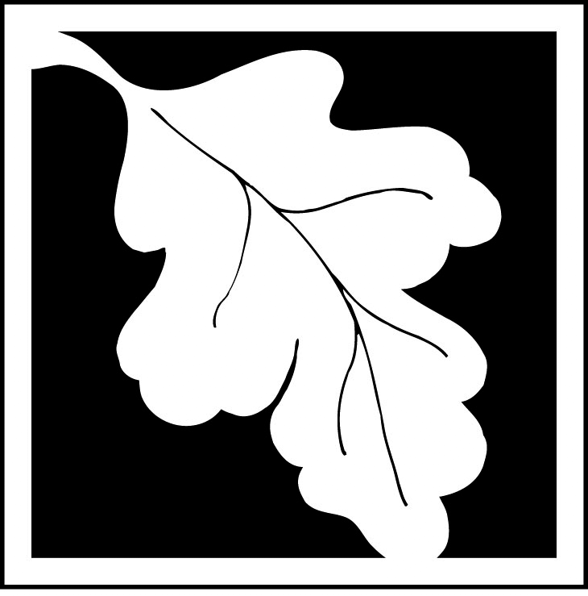 | Massachusetts Department of Environmental Protection  Bureau of Resource Protection - Wetlands  ANRAD Wetland Fee Transmittal Form  Massachusetts Wetlands Protection Act M.G.L. c. 131, §40
Important: When filling out forms on the computer, use only the tab key to move your cursor - do not use the return key.  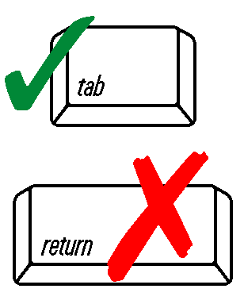 | A. Applicant Information
 | 1. Location of Project:
 | a. Street Address |  |  |  | b. City/Town
 | c. Fee amount |  |  |  | d. Check number
 | 2. Applicant:
 | a. First Name |  | b. Last Name |  |  |  | c. Company
 | d. Mailing Address
 | e. City/Town |  |  |  |  | f. State |  |  | g. Zip Code
 | h. Phone Number
 | 3. Property Owner (if different):
 | a. First Name |  | b. Last Name |  |  |  | c. Company
 | d. Mailing Address
 | e. City/Town |  |  |  |  | f. State |  |  | g. Zip Code
 | h. Phone Number
 | B. Fees
 | The fee is calculated as follows for each Resource Area Delineation included in the ANRAD (check applicable project type). The maximum fee for each ANRAD, regardless of the number of Resource Area Delineations, is $200 for activities associated with a single-family house and $2,000 for any other activity.
 | Bordering Vegetated Wetland Delineation Fee:
Online users: check box if fee exempt. | 1. single family house project | a. feet of BVW |  |  | x $2.00 = |  |  | b. Fee for BVW
Online users: check box if fee exempt. | 2. all other projects | a. feet of BVW |  |  | x $2.00 = |  |  | b. Fee for BVW
Online users: check box if fee exempt. | Other Resource Area (e.g., bank, riverfront area, etc.):
 | 3. single family house project | a. linear feet |  | x $2.00 = |  |  |  | b. Fee
 | 4. all other projects | a. linear feet |  | x $2.00 = |  |  |  | b. Fee
 | Total fee for all Resource Areas: |  |  |  |  |  |  | Fee
 | State share of filing fee: |  |  |  |  |  |  | 5. 1/2 of total fee less $12.50
 | City/Town share of filing fee: |  |  |  |  |  |  | 6. 1/2 of total fee plus $12.50
C. Submittal Requirements

- Send a copy of this form, with a check or money order for the state share of the fee, payable to the Commonwealth of Massachusetts, to:

Department of Environmental Protection
Box 4062
Boston, MA 02211

- To the Conservation Commission: Send the Abbreviated Notice of Resource Area Delineation; a copy of this form; and the city/town fee payment.

- To DEP Regional Office: Send one copy of the Abbreviated Notice of Resource Area Delineation (and any additional documentation required as part of a Simplified Review Buffer Zone Project); a copy of this form; and a copy of the state fee payment. (E-filers of Notices of Intent may submit these electronically.)

