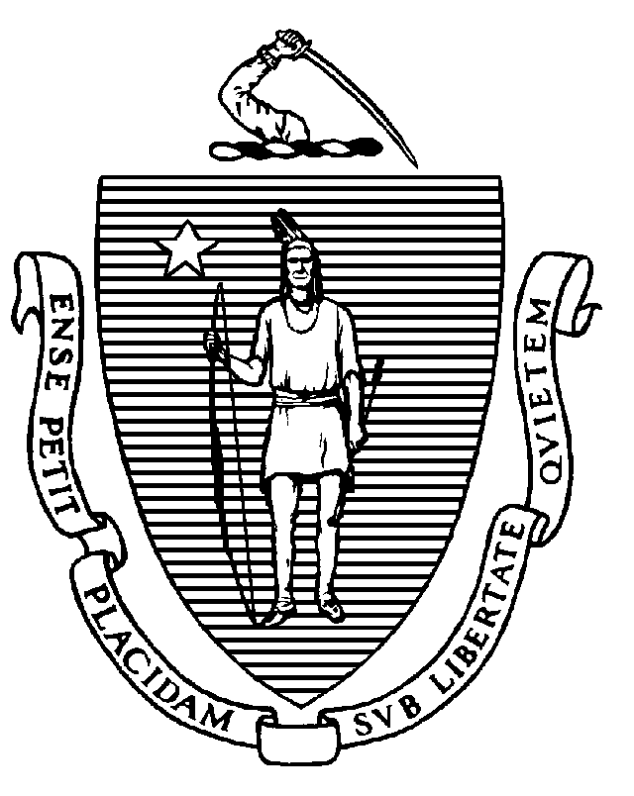
Executive Office of Health and Human Services
Department of Public Health
Bureau of Health Care Safety and Quality
67 Forest Street, Marlborough, MA 01752
CHARLES D. BAKER
Governor
KARYN E. POLITO
Lieutenant Governor
MARYLOU SUDDERS
Secretary
MONICA BHAREL, MD, MPH Commissioner

Tel: 617-624-6000
www.mass.gov/dph

Memorandum

TO: Health Care Facility Chief Executive Officers, Administrators, and Occupational Health Leadership

FROM: Elizabeth D. Kelley, MPH, MBA, Director
Bureau of Health Care Safety and Quality

SUBJECT: Updated Anterior Nares (Nasal Swab) Specimen Collection by Unlicensed Healthcare Personnel

DATE: September 25, 2020

The Massachusetts Department of Public Health (DPH) continues to work with state, federal and local partners on the outbreak of Coronavirus Disease 2019 (COVID-19), caused by the virus SARS-CoV-2, and we continue to appreciate the essential role you have in responding to this evolving situation.

Only healthcare personnel with appropriate training and competency can perform specimen collection for purposes of COVID-19 testing. All personnel performing either nasopharyngeal (NP) or anterior nares (AN) specimen collection should be trained and demonstrate competency to be able to safely collect specimens. While specific licensure is not required, all unlicensed healthcare personnel should be appropriately supervised. When collecting specimens or within 6 feet of patients suspected to be infected with COVID-19, all healthcare personnel must maintain proper infection control and use recommended personal protective equipment, including an N95 or higher-level respirator (full face shield and face mask if N-95 not available), eye protection, gloves, and a gown.

DPH strongly encourages all healthcare personnel in Massachusetts to monitor the CMS and CDC website for up-to-date information and resources:
- CMS website: https://www.cms.gov/About-CMS/Agency-Information/Emergency/EPRO/Current-Emergencies/Current-Emergencies-page
- CDC website: https://www.cdc.gov/coronavirus/2019-ncov/healthcare-facilities/index.html

Additionally, please visit DPH’s website that provides up-to-date information on COVID-19 in Massachusetts: https://www.mass.gov/2019coronavirus.

