Commonwealth of Massachusetts
Executive Office of Health and Human Services

Virtual Gateway

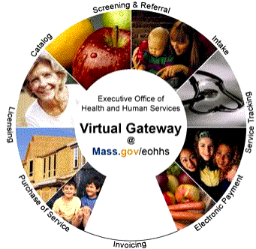

Application Inbox User Manual
August 25, 2005

Table of Contents

Chapter 1: Welcome to the Application Inbox 1
Overview 1
Who uses the Application Inbox? 1
The Application Inbox and Virtual Gateway 1
Chapter 2: Accessing and Navigating the Application Inbox 3
Overview 3
Accessing your Application Inbox 3
Navigating the Application Inbox 4
Chapter 3: Searching for Inbox Applications 7
Overview 7
Searching for Applications 7
Viewing Search Results 8
Viewing and Printing Application Summary 8
Chapter 4: Changing the Status of an Application/Inquiry 11
Overview 11
Changing Application/ Inquiry Status 11
Changing Processing Status 12
Chapter 5: Forwarding an Application/Inquiry 15
Overview 15
Forwarding Applications/ Inquiries 15
Chapter 6: Frequently Asked Questions 17
Questions and Answers 17
Glossary 19
Virtual Gateway 19
Dashboard 19
Application Inbox 19
Appendix 1: Department of Mental Retardation – Application Inbox Forward Routing Information 21
Appendix 2: Elder Affairs – Application Inbox Forward Routing Information 23
Notes: Appendix 3: Massachusetts Rehabilitation Commission – Application Inbox Forward Routing Information 26
Appendix 3: Massachusetts Rehabilitation Commission – Application Inbox Forward Routing Information 27

Copyright © 2005 Massachusetts Executive Office of Health and Human Services (EOHHS).
The copyright for the original documentation and all associated materials, job aids, lesson plans, and worksheets, and other original work related to the EOHHS Virtual Gateway remain with the original author. Virtual Gateway authorized users are permitted to copy or download and use these copyrighted materials free of charge and without acquiring permission form the author.
However, in the event a Virtual Gateway user intends to make use of these copyrighted materials in a website or publications, regardless of whether that use is for profit or not, said user must acquire prior permission from the author.

Welcome to the Application Inbox
Overview | The Application Inbox is a new component of the Virtual Gateway. Your Application Inbox serves as a container for applications and inquiries belonging to programs or agencies that do not accept an electronic transfer from the Virtual Gateway Common Intake at this point in time. As an Application Inbox worker, you will be using the Application Inbox tool to receive applications that need to be processed by your agency.
Who uses the Application Inbox? | Users of the Application Inbox are workers like you that require access to Common Intake applications and inquiries that were submitted online.  Agencies that do not receive an electronic transfer of information from the Virtual Gateway Common Intake Application will also use the Application Inbox. Currently, Virtual Gateway system automates intake processes for these agencies. You can use your Application Inbox to search, sort, forward, view, print, and make status updates to applications and inquiries.  The Application Inbox can be accessed through your Virtual Gateway logon and might seem similar to checking your e-mail.
The Application Inbox and Virtual Gateway | Virtual Gateway enables providers and users to screen for Health and Human Services (HHS) programs, Community Services, and Long Term Support. Provider workers representing organizations enter application data through the intake program. You can access this information through your Application Inboxes.  One Common Intake application may go to several different agencies. When Virtual Gateway distributes application information, it provides only the application information necessary to that agency. Program-specific information is delivered to each Application Inbox as the Virtual Gateway sends an application.

Notes:

Accessing and Navigating the Application Inbox
Overview | This chapter provides information specific to accessing and navigating the Application Inbox. More detailed information about Common Intake access and navigation can be found in the Common Intake User Guide.
Accessing your Application Inbox | Follow these steps to access your Application Inbox:
  Step | Action
  1 | Logon to the Virtual Gateway Dashboard.  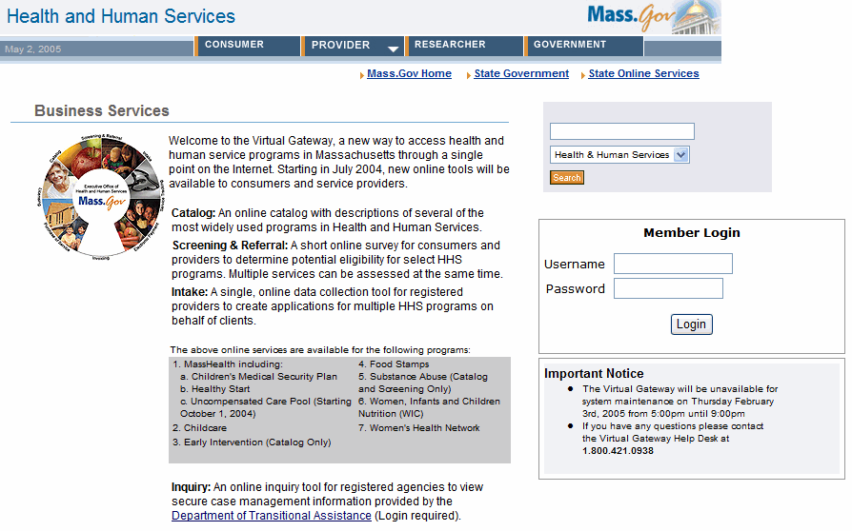  Enter your Username and Password
  2 | Enter the Dashboard through Virtual Gateway Business Services.  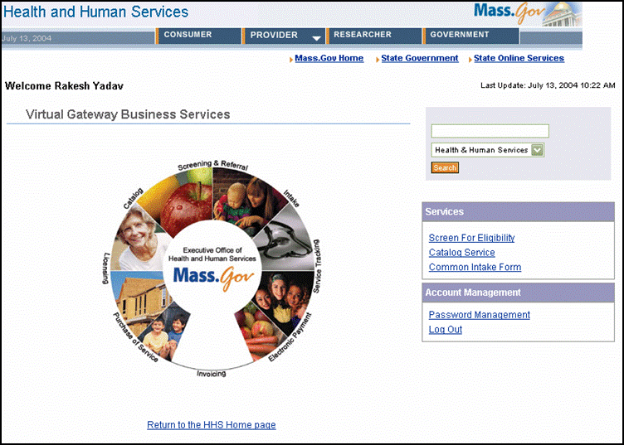  Click on the  Common Intake Form Link
Accessing your Application Inbox  (Continued)
  Step | Action
  3 | Enter your Application Inbox.  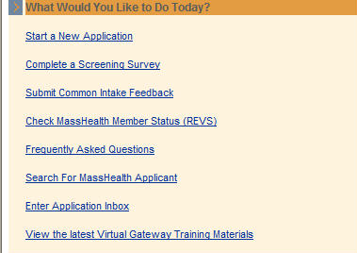  Result: The Enter Application Inbox page appears.
Navigating the Application Inbox  Navigation Tools:  Search for applications  Exit Application Inbox  Search criteria fields | The following is an example of the Application Inbox page and highlights of a few key components.  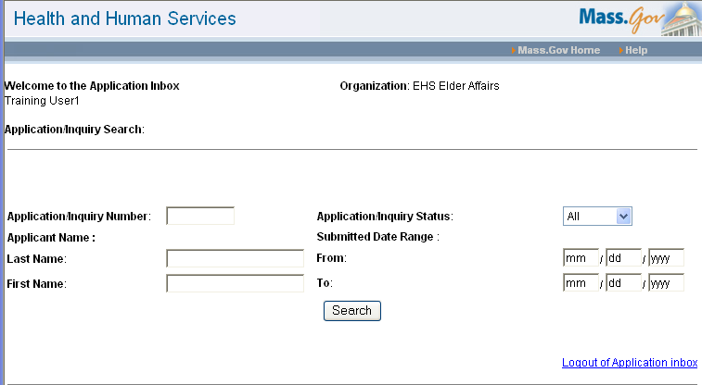  User, site, and page information
Navigating the Application Inbox  (Continued)  Change status of or forward selected applications  Click links to drill down to view/print more information | The following is an example of the Application/Inquiry Inbox page and highlights of a few key components. This page displays results after selecting the Search button. Up to 15 results are displayed on a page.  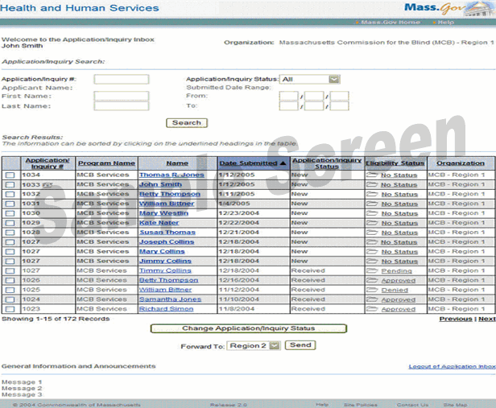  Click a column name to sort. Current sort column appears in dark blue, arrow depicts order  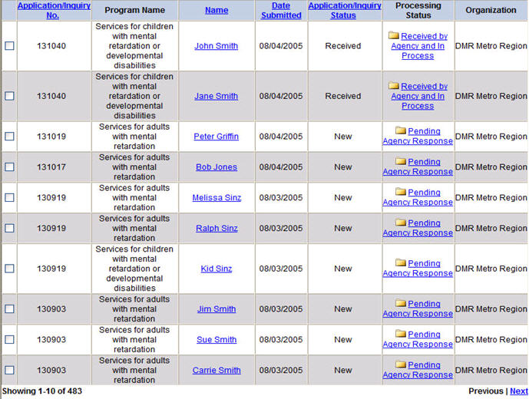  Navigate between the results pages

Notes:

Searching for Inbox Applications
Overview | In order to view your Inbox applications and inquiries, you must first conduct a search. This chapter walks you through the steps to search, view, sort, and print your applications.
Searching for Applications  Enter search parameters:  Application/ Inquiry #  First Name  Last Name  Application/ Inquiry Status  Submitted Date Range | The first page displayed in Application Inbox is the Application/ Inquiry Search page. Your search can be performed using any of the search fields and clicking Search.  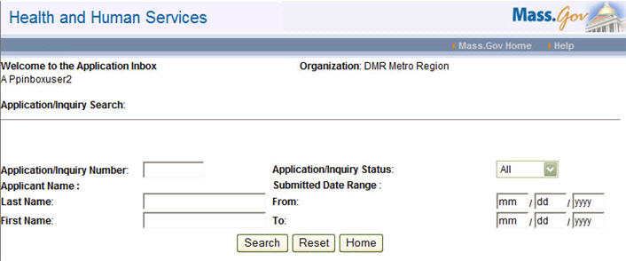  Click the  Search  button  Note: To display all applications in your Inbox, leave the search fields blank and click Search.  Result: The search results display below the search area.  Tips:  - The Reset button clears all the search fields if there is currently data in them.  - The Home button returns the user to the Dashboard.
Viewing Search Results  Sort results by clicking on any underlined column title | After performing a search, you can access the applications/inquiries submitted for your program via the online Common Intake Tool. Search results will display at the bottom of the page. The following features are available to help you view your results:  - Sort the displayed list  - View a summary of the applicant’s information specific to your business use  - Print a copy of the application information  - Initiate a new search  Click on Previous/Next to navigate between the results page
Viewing and Printing Application Summary  Click a name to view/ print summary | The application/inquiry summary you view contains data specific to each agency. You can view and print a program-specific summary for any item displayed in your search results. Locate the item you wish to view/print and click on the applicant name.  Result: The Application Inbox Summary page appears.
Viewing and Printing Application Summary  (Continued) | You can view and print application/inquiry information from the Application Inbox Summary page. When you are finished, click Home to return to your search results.  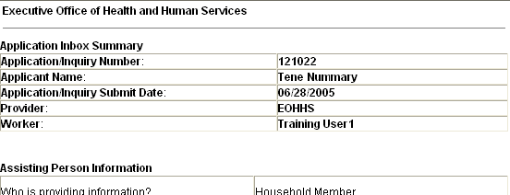  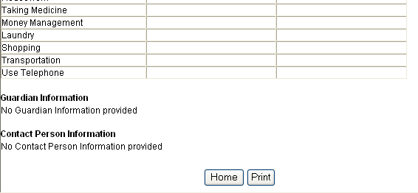  Click Print to print summary detail  Click Home to return to the search results

Notes:

Changing the Status of an Application/Inquiry
Overview | There are two types of statuses reported through the Virtual Gateway and available for update:  - Application/Inquiry Status  - Processing Status  Application/Inquiry status types convey the condition of an application or inquiry that is being transferred from the Virtual Gateway. Processing Status types represent the current status of the information being transferred from the Virtual Gateway.  This chapter discusses how to view and change Application/Inquiry and Processing Statuses.
Changing Application/ Inquiry Status | There are two types of application/inquiry status:  - New: A new application that enters your Inbox through the Common Intake provider input  - Received: An existing application that has a status of received and was already viewed in your Inbox  An application is “New” until it is printed. You can also manually change an application’s status through the Application Inbox.
Click Change Application/ Inquiry Status  Click on the check-box to select items | Use the following steps to change the Application/Inquiry status of an item in your Application Inbox:
  Step | Action
  1 | Select the item(s) which you would like to change
  2 | Click the Change Application/Inquiry Status button  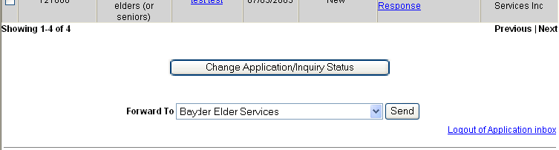
Changing Application/ Inquiry Status  (Continued)
  3 | View the updated status.  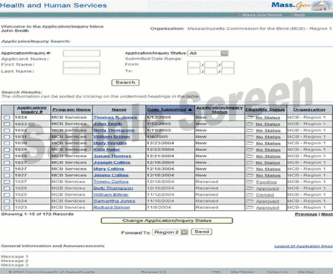
Changing Processing Status | Processing Status represents whether or not an applicant has had their Processing Status determined. The status is specific to each program; your Application Inbox will display the correct status automatically based on program. Through the Application Inbox you will determine the Processing Status of the application or inquiry and update an application/inquiry’s eligibility to a new or different status.
Use the following steps to update the Processing Status for an application/inquiry:
Step | Action
1 | Click on the Processing Status folder for the application/ inquiry you wish to update.  Click on a status folder  Result: The Update Processing Status page appears.

Changing Processing Status  (Continued)  Select new Processing Status
  Step | Action
  2 | The Update Processing Status page allows you to update the Processing Status for the selected applicant. A record of the status history for the applicant/inquiry is also displayed.  To update the Processing Status, select the new status from the Status drop-down box and select Update Status.  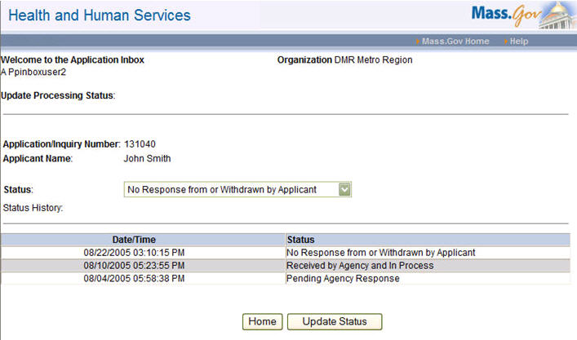  Click Update Status  View status history  Result: The Status History will update reflecting the change.
  3 | Click Home to return to the Application/Inquiry Search page.  Note: If you click Home without clicking Update Status, your changes will not be saved.

Notes:

Forwarding an Application/Inquiry
Overview | Applications can be forwarded to other agencies that may more appropriate for processing that particular application/inquiry. Forwarded applications/inquiries appear on worker’s screen at the new Inbox location.  Note: Not all Application Inboxes have the ability to forward applications. Refer to the Appendices for specific agency inbox and Forwarding rules.
Forwarding Applications/ Inquiries  Select the agency  Click on the check-box to select item(s)
  Step | Action
  1 | Select the item(s) which you would like to forward
  2 | Use the drop-down list to select the region that should review/process the inquiry/application(s)
  3 | Select Send  Select Send  Note: After an application/inquiry is forwarded, it no longer appears in your Application Inbox.

Notes:

Frequently Asked Questions
Questions and Answers | The following frequently asked questions the may help in understanding and using your Application Inbox:
  Question | Answer
  Why does my Inbox appear to be empty? | Your Inbox will appear to be empty until you perform your first search. Perform a search in the “Application/Inquiry Search” section of the Inbox and your results will populate.
  Why are there several items in my search results screen sharing one application number? | Virtual Gateway enables one household application to be distributed to many programs and services. It’s possible more than one person in the household qualifies.
  What is the difference between “Application/ Inquiry Status” and “Processing Status”? | “Application/Inquiry Status” describes the status of the actual application filed. This application status, can be “New” or it can be “Received”. “Processing Status” describes the status of the applicant in reference to the program or service that they are applying for; these statuses include: “Accepted”, “Denied”, and “Pending”.

Notes:

Glossary
Virtual Gateway | Online tool to access health and human service programs for the Commonwealth of Massachusetts. Virtual Gateway offers consumers and service providers a catalog, screening and referral surveys, and an intake tool (providers only) to collect application information.
Dashboard | The Dashboard is a welcome screen for Common Intake users. The Dashboard provides links to start an application, complete an eligibility survey, search for and retrieve incomplete applications, create a report, and view the Application Inbox.
Application Inbox | Container for the Virtual Gateway Community and Long Term Care Support applications that are not automatically sent to a legacy system

Notes:
Appendix 1: Department of Mental Retardation – Application Inbox Forward Routing Information
The table below details the routing information for Department of Mental Retardation applications and inquiries forwarded to new Inboxes through Virtual Gateway. Each Department of Mental Retardation Inbox can transfer to any one of these Inboxes listed (the table references forwarding logic displaying all towns served by each Inbox):

Department of  Mental Retardation Inbox | Towns Served by Inbox
DMR Central West Region | Adams, Agawam, Alford, Amherst, Ashburnham, Ashby, Ashfield, Athol, Auburn, Ayer, Barre, Becket, Belchertown, Bellingham, Berlin, Bernardston, Blackstone, Blandford, Bolton, Boylston, Brimfield, Brookfield, Buckland, Charlemont, Charlton, Cheshire, Chester, Chesterfield, Chicopee, Clarksburg, Clinton, Colrain, Conway, Cummington, Dalton, Deerfield, Douglas, Dudley, East Brimfield, East Brookfield, East Douglas, East Longmeadow, Easthampton, Egremont, Erving, Fitchberg, Florida, Franklin, Gardner, Gilbertville, Gill, Goshen, Grafton, Granby, Granville, Great Barrington, Greenfield, Groton, Hadley, Hampden, Hancock, Hardwick, Harvard, Hatfield, Hawley, Heath, Hinsdale, Holden, Holland, Holyoke, Hopedale, Hubbardston, Huntington, Lancaster, Lanesborough, Lee, Leicester, Lenox, Leominster, Leverett, Leyden, Longmeadow, Ludlow, Lunenberg, Medway, Mendon, Middlefield, Milford, Millbury, Millers’Falls, Millville, Monroe, Monson, Montague, Monterey, Montgomery, Mount Washington, New Ashford, New Braintree, New Marlborough, New Salem, North Adams, North Brookfield, Northampton, Northbridge, Northfield, Oakham, Onset, Orange, Otis, Oxford, Palmer, Paxton, Pelham, Pepperell, Peru, Petersham, Phillipston, Pittsfield, Plainfield, Princeton, Richmond, Rowe, Royalston, Russell, Rutland, Sandisfield, Savoy, Shelburne, Sherborn, Shrewsbury, Shutesbury, Situate, South Hadley, Southampton, Southbridge, Southwick, Spencer, Springfield, Sterling, Stockbridge, Sturbridge, Sunderland, Sutton, Templeton, Tolland, Townsend, Turners Falls, Tyringham, Upton, Uxbridge, Wales, Ware, Warren, Warwick, Washington, Wately, Webster, Wendell, West Boylston, West Brookfield, West Springfield, West Stockbridge, Westfield, Westhampton, Westminster, Whately, Whitinsville, Wilbraham, Williamsburg, Williamstown, Winchendon, Windsor, Worcester, Worthington
DMR Metro Region | Allston, Ashland, Back Bay, Beacon Hill/WestEnd, Belmont, Boston, Brighton, Brookline, Cambridge, Canton, Charlestown, Chelsea, Chinatown, Columbia Point, Dedham, Dorchester, Dover, Downtown Crossing, East Boston, East Mattapan, Fenway, Foxborough, Framingham, Holliston, Hopkinton, Hudson, Hyde Park, Jamaica Plain, Kenmore Square, Marlborough, Mattapan, Medfield, Millis, Natick, Needham, Newton, Norfolk, North Dorchester, North End, Northborough, Norwood, Parker Hill, Plainville, Revere, Roslindale, Roxbury, Sheffield, Shirley,
DMR Metro Region  (Continued) | Somerville, South Boston, South End, South Jamaica Plain, Southborough, Sudbury, Walpole, Waltham, Watertown, Wayland, Wellesley, West End, West Mattapan, West Roxbury, Westborough, Weston, Westwood, Winthrop, Wrentham
DMR Northeast Region | Acton, Amesbury, Andover, Arlington, Bedford, Beverly, Billerica, Boxborough, Boxford, Burlington, Byfield, Carlisle, Chelmsford, Concord, Danvers, Dracut, Dunstable, Essex, Everett, Georgetown, Gloucester, Groveland, Hamilton, Haverhill, Ipswich, Lawrence, Lexington, Lincoln, Littleton, Lowell, Lynn, Lynnfield, Magnolia, Malden, Manchester, Marblehead, Maynard, Medford, Melrose, Merrimac, Methuen, Middleton, Nahant, Newbury, Newburyport, North Andover, North Reading, Peabody, Reading, Rockport, Rowley, Salem, Salisbury, Saugus, Stoneham, Stow, Swampscott , Tewksbury, Topsfield, Tyngsborough, Wakefield, Wenham, West Newbury, Westford, Wilmington, Winchester, Woburn
DMR Southeast Region | Abington, Acushnet, Assonet, Attleboro, Avon, Barnstable, Berkley, Bourne, Braintree, Brewster, Bridgewater, Brockton, Buzzards Bay, Carver, Cataumet, Centerville, Chatham, Chilmark, Chilton, Cohasset, Cotuit, Dartmouth, Dennis, Dennisport, Dighton, Duxbury, East Bridgewater, East Freetown, East Sandwich, Eastham, Easton, Edgartown, Fairhaven, Fall River, Falmouth, Forestdale, Freetown, Gay Head, Gosnold, Halifax, Hanover, Hanson, Harwich, Hingham, Holbrook, Hull, Hyannis, Kingston, Lakeville, Littlefield, Mansfield, Marion, Marshfield, Mashpee, Mattapoisett, Middleborough, Milton, Monument Beach, Nantucket, New Bedford, North Attleboro, North Dartmouth, North Easton, North Westport, Norton, Norwell, Oak Bluffs, Orleans, Osterville, Pembroke, Plymouth, Plympton, Provincetown, Quincy, Randolph, Raynham, Rehoboth, Rochester, Rockland, Sandwich, Seekonk, Sharon, Somerset, Stoughton, Swansea, Taunton, Tisbury, Truro, Vineyard Haven, Wareham, Wellfleet, West Bridgewater, West Tisbury, Westport, Weymouth, Whitman, Woodshole, Yarmouth

Appendix 2: Elder Affairs – Application Inbox Forward Routing Information
The table below details the routing information for Elder Affair applications and inquiries forwarded to new Inboxes through Virtual Gateway. Each Elder Affair Inbox can transfer to any one of these Inboxes listed (the table references forwarding logic displaying all towns served by each Inbox):

Elder Affairs Inbox | Towns Served by Inbox
Baypath Elder Services, Inc. | Sherborn, Ashland, Dover, Framingham, Holliston, Hopkinton, Hudson, Marlborough, Natick, Northborough, Southborough, Sudbury, Wayland, Westborough
Boston ElderINFO | Back Bay, Beacon Hill/WestEnd, Boston, Charlestown, Chelsea, Chinatown, Columbia Point, Dorchester, Downtown Crossing, East Boston, Kenmore Square, North End, Revere, South Boston, West End, Winthrop, Allston, Brighton, Fenway, Jamaica Plain, Parker Hill, Roslindale, South Jamaica Plain, West Roxbury, East Mattapan, Hyde Park, Mattapan, North Dorchester, Roxbury, South End, West Mattapan
Bristol Elder Services, Inc. | Assonet, East Freetown, Fall River, Freetown, Somerset, Swansea, Westport, North Westport, Seekonk, Attleboro, Berkley, Dighton, Mansfield, North Attleboro, Norton, Raynham, Rehoboth, Taunton
Coastline Elderly Services | Gosnold, Acushnet, Dartmouth, Fairhaven, Marion, Mattapoisett, New Bedford, North, Dartmouth, Rochester
Elder Services of Berkshire | Sheffield, Adams, Cheshire, Clarksburg, Florida, Hancock, Lanesborough, New Ashford, North Adams, Savoy, Williamstown, Alford, Becket, Dalton, Egremont, Great Barrington, Hinsdale, Lee, Lenox, Monterey, Mount Washington, New Marlborough, Otis, Peru, Pittsfield, Richmond, Sandisfield, Stockbridge, Tyringham, Washington, West Stockbridge, Windsor
Elder Services of Cape Cod | Barnstable, Bourne, Brewster, Cataumet , Centerville, Chatham, Chilmark, Cotuit, Dennis, Dennisport, East Sandwich, Eastham, Edgartown, Falmouth, Forestdale , Gay Head, Harwich, Hyannis, Mashpee, Monument Beach, Nantucket, Oak Bluffs, Orleans, Osterville, Provincetown, Sandwich, Tisbury, Truro, Vineyard Haven, Wellfleet, West, Tisbury, Woodshole, Yarmouth, Buzzards Bay, Littlefield
Elder Services Merrimac Valley | Amesbury, Andover, Boxford, Byfield, Georgetown, Groveland, Haverhill, Lawrence, Merrimac, Methuen, Newbury, Newburyport, North Andover, Rowley, Salisbury, West Newbury, Billerica, Chelmsford, Dracut, Dunstable, Lowell, Tewksbury, Tyngsborough, Westford
Elder Services Worcester Area | Barre, Gilbertville, Hardwick, New Braintree, Oakham, Rutland, Shrewsbury, Grafton, Millbury, Auburn, Boylston, Holden, Leicester, Paxton, West Boylston, Worcester
Franklin County Home Care Corp | Ashfield, Athol, Bernardston, Buckland, Charlemont, Colrain, Conway, Deerfield, Erving, Gill, Greenfield, Hawley, Heath, Leverett, Leyden, Millers’Falls, Monroe, Montague, New Salem, Northfield, Orange, Petersham, Phillipston, Rowe, Royalston, Sunderland, Turners Falls, Warwick, Wately, Wendell, Whately, Shelburne, Shutesbury
Greater Lynn Senior Services | Lynnfield, Saugus, Lynn, Nahant, Swampscott
Greater Springfield Sr Services | Monson, Palmer, Agawam, East Longmeadow, Hampden, Longmeadow, Springfield, West Springfield, Wilbraham, Brimfield, East Brimfield, Holland, Wales
HESSCO | Dedham, Canton, Millis, Norfolk, Plainville, Wrentham, Medfield, Westwood, Norwood, Foxborough, Sharon, Walpole
Highland Valley Elder Services | Amherst, Cummington, Goshen, Hadley, Hatfield, Pelham, Plainfield, Williamsburg, Chesterfield, Easthampton, Middlefield, Northampton, Southampton, Westhampton, Worthington, Blandford, Chester, Granville, Huntington, Montgomery, Russell, Southwick, Tolland, Westfield
Minuteman Senior Services | Harvard, Acton, Bedford, Boxborough, Burlington, Carlisle, Concord, Littleton, Wilmington, Lexington, Winchester, Woburn, Lincoln, Maynard, Stow, Arlington
Montachusett Home Care Corp | Ashburnham, Ashby, Ayer, Berlin, Bolton, Clinton, Fitchberg, Gardner, Groton, Hubbardston, Lancaster, Leominster, Lunenberg, Pepperell, Princeton, Sterling, Templeton, Townsend, Westminster, Winchendon, Shirley
Mystic Valley Elder Services | Everett, Malden, Medford, Melrose, North Reading, Reading, Stoneham, Wakefield
North Shore Elder Services | Danvers, Marblehead, Middleton, Peabody, Salem
Old Colony Elderly Services | Abington, Avon, Bridgewater, Brockton, East Bridgewater, Easton, North Easton, Rockland, Stoughton, West Bridgewater, Whitman, Chilton, Onset, Wareham, Carver, Duxbury, Halifax, Hanover, Hanson, Kingston, Marshfield, Pembroke, Plymouth, Plympton, Lakeville, Middleborough
SeniorCare, Inc. | Beverly, Essex, Gloucester, Hamilton, Ipswich, Magnolia, Manchester, Rockport, Topsfield, Wenham
Somerville Cambridge Elder Services | Cambridge, Somerville
South Shore Elder Services | Holbrook, Situate, Braintree, Cohasset, Hingham, Hull, Milton, Norwell, Quincy, Randolph, Weymouth
Springwell | Brookline, Newton, Needham, Wellesley, Weston, Belmont, Waltham, Watertown
Tri-Valley Elder Services | Uxbridge, Bellingham, Blackstone, Douglas, East Douglas, Franklin, Hopedale, Medway, Mendon, Milford, Millville, Northbridge, Sutton, Upton, Whitinsville, Brookfield, Charlton, Dudley, East Brookfield, North Brookfield, Oxford, Southbridge, Spencer, Sturbridge, Warren, Webster, West Brookfield
WestMass ElderCare, Inc. | Chicopee, Belchertown, Granby, Holyoke, Ludlow, South Hadley, Ware

Notes:
Appendix 3: Massachusetts Rehabilitation Commission – Application Inbox Forward Routing Information
The table below details the routing information for Massachusetts Rehabilitation Commission applications and inquiries forwarded to new Inboxes through Virtual Gateway. Each Massachusetts Rehabilitation Commission Inbox can transfer to any one of these Inboxes listed (the table references forwarding logic displaying all towns served by each Inbox):

Massachusetts Rehabilitation Commission Inbox | Towns Served by Inbox
MRC Brockton Area Office | Abington, Avon, Bridgewater, Brockton, Canton, East Bridgewater, Easton, Holbrook, North Easton, Rockland, Sheffield, Stoughton, West Bridgewater, Whitman
MRC Brookline Area Office | Allston, Brighton, Brookline, Fenway, Jamaica Plain, Newton, Parker Hill, Roslindale, South Jamaica Plain, West Roxbury
MRC Boston Area Office | Back Bay, Beacon Hill/WestEnd, Boston, Charlestown, Chelsea, Chinatown, Columbia Point, Dedham, Dorchester, Downtown Crossing, East Boston, Kenmore Square, North End, Revere, South Boston, West End, Winthrop
MRC Cape and the Islands Area Office | Barnstable, Bourne, Brewster, Cataumet, Centerville, Chatham, Chilmark, Chilton, Cotuit, Dennis, Dennisport, East Sandwich, Eastham, Edgartown, Falmouth, Forestdale, Gay Head, Gosnold, Harwich, Hyannis, Mashpee, Monument Beach, Nantucket, Oak Bluffs, Onset, Orleans, Osterville, Provincetown, Sandwich, Tisbury, Truro, Vineyard Haven, Wellfleet, West Tisbury, Woodshole, Yarmouth
MRC Fallriver Area Office | Assonet, East Freetown, Fall River, Freetown, Somerset, Swansea, Westport
MRC Fitchburg Area Office | Ashburnham, Ashby, Ayer, Barre, Berlin, Bolton, Clinton, Fitchberg, Gardner, Gilbertville, Groton, Hardwick, Harvard, Hubbardston, Lancaster, Leominster, Lunenberg, New Braintree, Oakham, Pepperell, Princeton, Rutland, Shrewsbury, Sterling, Templeton, Townsend, Westminster, Winchendon
MRC Greenfield Area Office | Amherst, Ashfield, Athol, Bernardston, Buckland, Charlemont, Colrain, Conway, Cummington, Deerfield, Erving, Gill, Goshen, Greenfield, Hadley, Hatfield, Hawley, Heath, Leverett, Leyden, Millers’Falls, Monroe, Montague, New Salem, Northfield, Orange, Pelham, Petersham, Phillipston, Plainfield, Rowe, Royalston, Sherborn, Situate, Sunderland, Turners Falls, Warwick, Wately, Wendell, Whately, Williamsburg
MRC Holyoke Area Office | Chicopee, Belchertown, Chesterfield, Easthampton, Granby, Holyoke, Ludlow, Middlefield, Monson, Northampton, Palmer, South Hadley, Southampton, Ware, Westhampton, Worthington
MRC Lawrence Area Office | Amesbury, Andover, Boxford, Byfield, Georgetown, Groveland, Haverhill, Lawrence, Merrimac, Methuen, Newbury, Newburyport, North Andover, Rowley, Salisbury, West Newbury
MRC Lowell Area Office | Acton, Bedford, Billerica, Boxborough, Burlington, Carlisle, Chelmsford, Concord, Dracut, Dunstable, Littleton, Lowell, Tewksbury, Tyngsborough, Westford, Wilmington
MRC Malden Area Office | Everett, Lexington, Lynnfield, Malden, Medford, Melrose, North Reading, Reading, Saugus, Stoneham, Wakefield, Winchester, Woburn
MRC Milford Area Office | Uxbridge, Bellingham, Blackstone, Douglas, East Douglas, Franklin, Grafton, Hopedale, Medway, Mendon, Milford, Millbury, Millis, Millville, Norfolk, Northbridge, Plainville, Sutton, Upton, Whitinsville, Wrentham
MRC North Adams Area Office | Adams, Cheshire, Clarksburg, Florida, Hancock, Lanesborough, New Ashford, North Adams, Savoy, Williamstown
MRC Natick Area Office | Ashland, Dover, Framingham, Holliston, Hopkinton, Hudson, Lincoln, Marlborough, Maynard, Medfield, Natick, Needham, Northborough, Shirley, Southborough, Stow, Sudbury, Wayland, Wellesley, Westborough, Weston, Westwood
MRC New Bedford Area Office | Acushnet, Buzzards Bay, Dartmouth, Fairhaven, Marion, Mattapoisett, New Bedford, North Dartmouth, North Westport, Rochester, Wareham
MRC Pittsfield Area Office | Alford, Becket, Dalton, Egremont, Great Barrington, Hinsdale, Lee, Lenox, Monterey, Mount Washington, New Marlborough, Otis, Peru, Pittsfield, Richmond, Sandisfield, Shelburne, Stockbridge, Tyringham, Washington, West Stockbridge, Windsor
MRC Plymouth Area Office | Carver, Duxbury, Halifax, Hanover, Hanson, Kingston, Marshfield, Pembroke, Plymouth, Plympton
MRC Quincy Area Office | Braintree, Cohasset, Hingham, Hull, Milton, Norwell, Norwood, Quincy, Randolph, Seekonk, Weymouth
MRC Roxbury Area Office | East Mattapan, Hyde Park, Mattapan, North Dorchester, Roxbury, South End, West Mattapan
MRC Salem Area Office | Beverly, Danvers, Essex, Gloucester, Hamilton, Ipswich, Lynn, Magnolia , Manchester, Marblehead, Middleton, Nahant, Peabody, Rockport, Salem, Swampscott , Topsfield, Wenham
MRC Somerville Area Office | Arlington, Belmont, Cambridge, Somerville, Waltham, Watertown
MRC Springfield Area Office | Agawam, Blandford, Chester, East Longmeadow, Granville, Hampden, Huntington, Longmeadow, Montgomery, Russell, Southwick, Springfield, Tolland, West Springfield, Westfield, Wilbraham
MRC Sturbridge Area Office | Brimfield, Brookfield, Charlton, Dudley, East Brimfield, East Brookfield, Holland, Littlefield, North Brookfield, Oxford, Southbridge, Spencer, Sturbridge, Wales, Warren, Webster, West Brookfield
MRC Taunton Area Office | Attleboro, Berkley, Dighton, Foxborough, Lakeville, Mansfield, Middleborough, North Attleboro, Norton, Raynham, Rehoboth, Sharon, Taunton, Walpole

Notes:

