________________________ July 30, 2010

In the Matter of Docket No. WET-2010-024
George Smith File No. SDA
Hummarock
________________________

FINAL DECISION

The petitioner has filed a Motion for Dismissal without Prejudice of this appeal. The petitioner’s request for dismissal constitutes a waiver by the petitioner to any further administrative review before the Department as well appeal to court of the Superseding Order of Conditions issued by the Department of Environmental Protection on June 8, 2010. Accordingly, the Department issues this final decision incorporating the petitioners’ request, and dismisses this appeal.

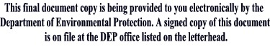
__________________________
Laurie Burt
Commissioner

