________________________
March 12, 2010
In the Matter of Docket No. WET-2009-028
Lyman Property Holdings File No. 201-724 Lexington
________________________

FINAL DECISION

I adopt the Recommended Final Decision of the Presiding Officer. The parties to this proceeding are notified of their right to file a motion for reconsideration of this Decision, pursuant to 310 CMR 1.01(14)(e). The motion must be filed with the Case Administrator and served on all parties within seven business days of the postmark date of this Decision. A person who has the right to seek judicial review may appeal this Decision to the Superior Court pursuant to M.G.L. c. 30A, §14(1). The complaint must be filed in the Court within thirty days of receipt of this Decision.
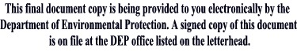

__________________________
Laurie Burt
Commissioner

