___________________________ November 24, 2010

In the Matter of Docket No. 2010-012
Matthew Berard File No. PAN-CE-10-2002
Bellingham
___________________________

FINAL DECISION

I have reviewed the attached Administrative Consent Order With Penalty and Notice of Noncompliance signed on November 5, 2010 by Matthew Berard, and by Martin Suuberg, Regional Director for the Department (ACOP-CE-2-Z018-SETT).
The Department issues this Final Decision incorporating the Administrative Consent Order. The petitioner is ordered to pay a civil administrative penalty of twenty-five thousand dollars ($25,000) with a portion suspended, in accordance with paragraphs 11 and 17 of the Administrative Consent Order. Under the terms of 310 CMR 1.01(8)(c), this proceeding is dismissed with the parties waiving whatever rights they may have to further administrative review before the Department as well as any appeal to court.
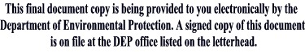
_____________________________
Laurie Burt
Commissioner

