________________________ May 14, 2010

In the Matter of Docket No. 2008-028
City of Methuen File No. WMA Reg. No. 31318101
Methuen
________________________

FINAL DECISION

The petitioners have filed a Voluntary Withdrawal of this appeal. The petitioners’ voluntary withdrawal constitutes a waiver by the petitioners to any further administrative review before the Department as well appeal to court of the Penalty Assessment Notice issued by the Department of Environmental Protection on January 10, 2010. Accordingly, the Department issues this final decision incorporating the petitioners’ voluntary withdrawal, and dismisses this appeal.

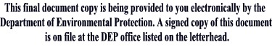
__________________________
Laurie Burt
Commissioner

