________________________ May 9, 2012
OADR Docket No. WET-2011-044
In the Matter of File No. 28-2079
Sam Scola Gloucester, MA
________________________

FINAL DECISION

I adopt the Recommended Final Decision of the Presiding Officer. The parties to this proceeding are notified of their right to file a motion for reconsideration of this Decision, pursuant to 310 CMR 1.01(14)(e). The motion must be filed with the Case Administrator and served on all parties within seven business days of the postmark date of this Decision. A person who has the right to seek judicial review may appeal this Decision to the Superior Court pursuant to M.G.L. c. 30A, §14(1). The complaint must be filed in the Court within thirty days of receipt of this Decision.
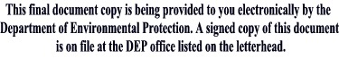

__________________________
Kenneth Kimmell
Commissioner

