________________________

June 14, 2011
In the Matter of Docket No. WET-2011-009
Winchester Country Club File No. 346-395
Winchester
________________________

FINAL DECISION

I have reviewed the attached Settlement Agreement, fully executed by the applicant/petitioner’s representative Matthew Watsky, Esq., by the Winchester Conservation Commission’s representative Elaine Vreeland, Esq., and by C. David Bragg, Esq., for the Department on May 31, 2011. The Department issues this Final Decision incorporating the Settlement Agreement and Final Order of Resource Area Delineation, which I have also reviewed.
Under the terms of 310 CMR 1.01(8)(c), these proceedings are dismissed with the parties waiving whatever rights they may have to further administrative review before the Department as well as appeal to court.
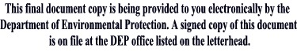
__________________________
Kenneth Kimmell
Commissioner

