FY 2016 Mental Health Consultation Grant
(Fund Code 700)
Appendix A: Online Grant Application Instructions

- Enter the Online Application by clicking Login to Online Application.

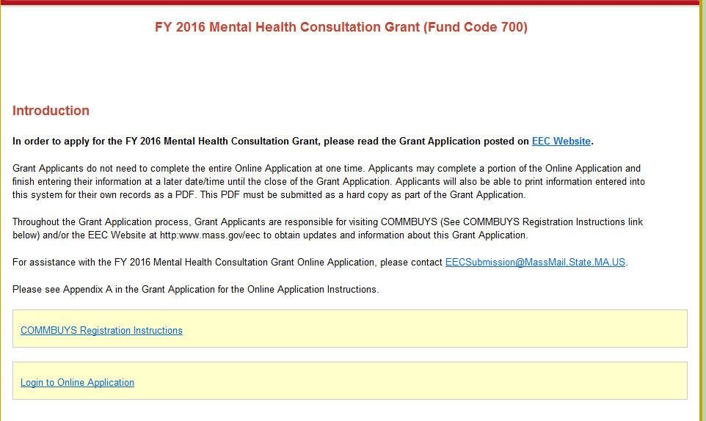

- Please note: While EEC will not be posting the EPS grant on COMMBUYS this year, all vendors and grantees are required to register on COMMBUYS. Please follow the COMMBUYS Registration Instructions in the FY 2016 Online application.
- You must register on COMMBUYS and select the United Nations Standard Products and Services Code (UNSPSC) 84-10-15 for all EEC Grants. If you have already registered, please make sure you add the UNSPSC code to your registration.

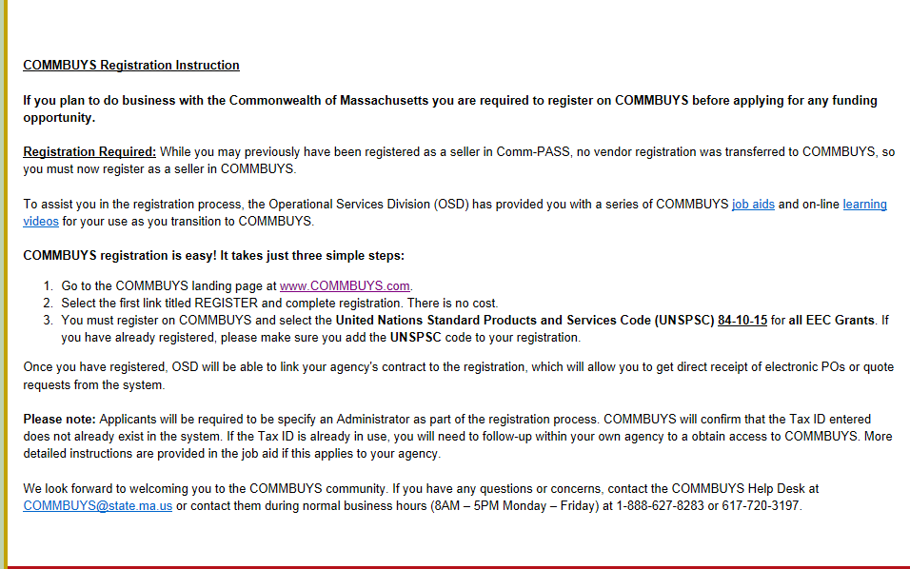

- Select your Agency from the drop-down menu.

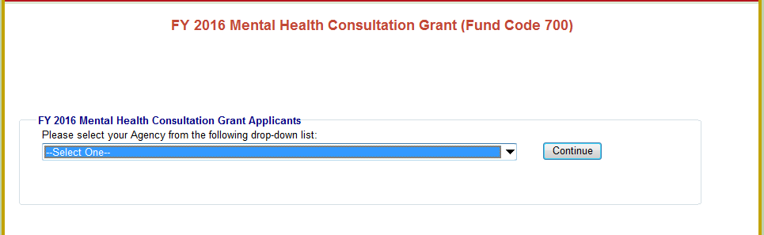

- Create a password. Please write down this password for your records. You will need this password to access your Online Application in the future.

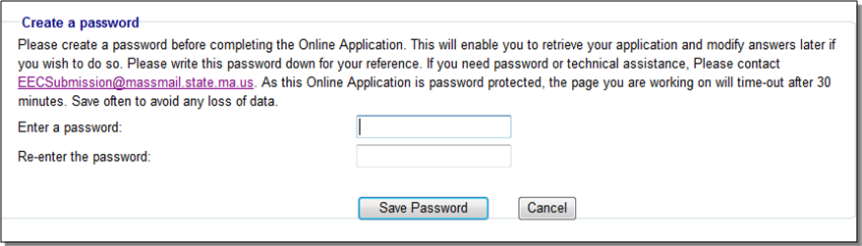

- The next time you log into the Online Application, the system will prompt you to enter your existing password.

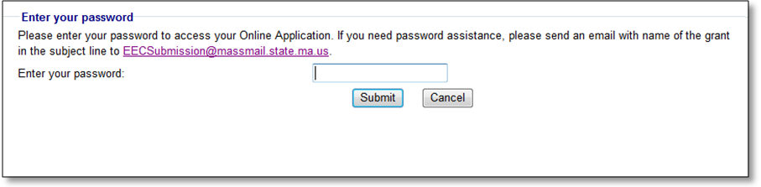

- Please enter your Username/Password to login to the Online Application. Please write down this username and password for your records. You will need this password to access your Online Application in the future.

- HOME PAGE - The home page provides access to each component of the Online Application. The Application consists of 12 parts: Contact Information, Communities Served, Languages Served, Lead Agency Budget, Subcontractor Budget, FY 2016 Budget Summary, Narrative Questions, Projected Deliverables, Required Grant Forms, Checklist, Cover page and Massachusetts Standard Administrative Forms.

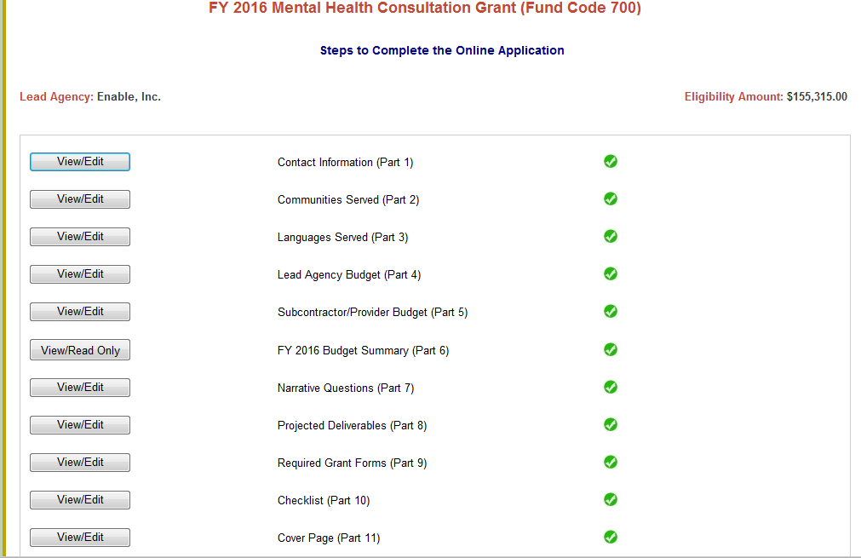

- Part 1- CONTACT INFORMATION: Complete all contact information.
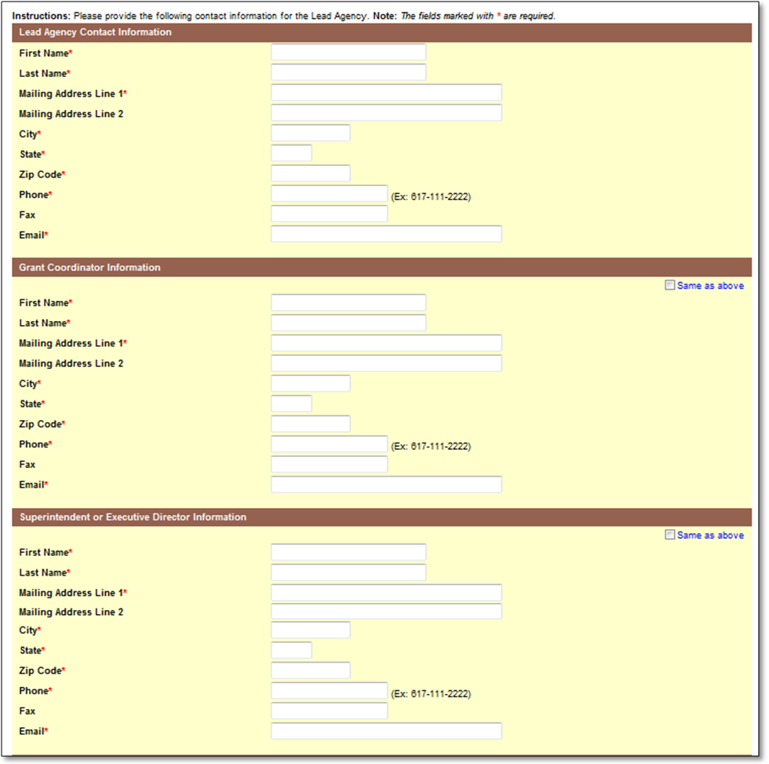

- Part 2 - COMMUNITIES SERVED: Select the names of the cities/towns to be served in each region. When each city/town is selected, demographic information will populate.

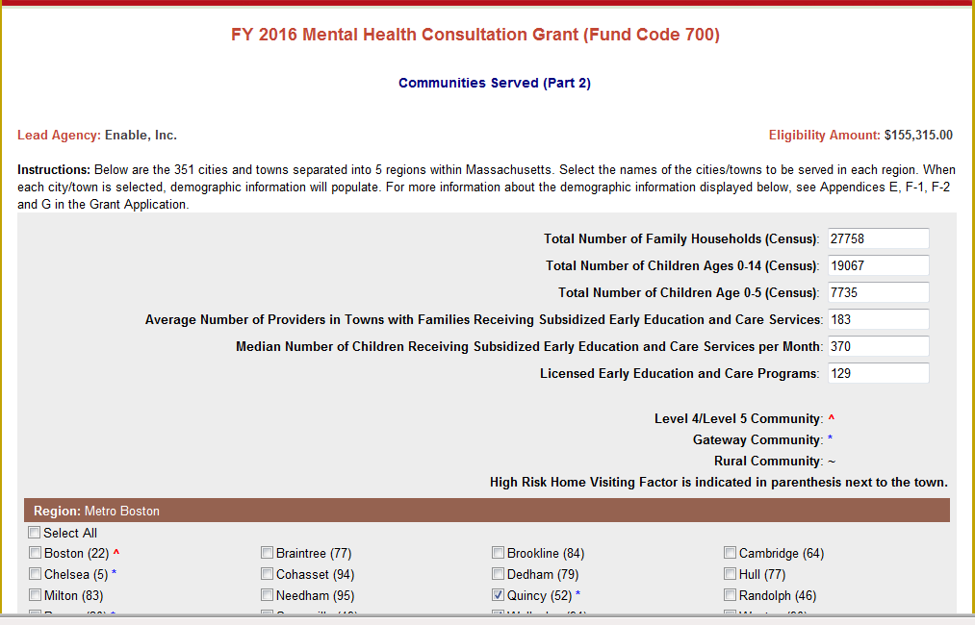
- Part 3 - LANGUAGES SERVED: Please select the languages your agency serves. If choosing 'Other' list name of language(s) in text box provided.

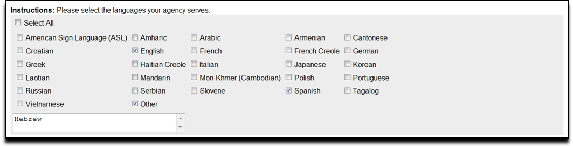

- PART 4 - LEAD AGENCY BUDGET:
  - Please reference the fund use section within the Grant Application and Appendix B: Budget Guidelines to follow specific guidelines regarding the budget for this grant, including program and admin costs.
    - Please note: All budget lines and columns are open to enter information. However, not all budget lines and columns are allowable under this grant.
  - Note: YOU CAN ONLY ENTER WHOLE NUMBERS INTO THE BUDGET.
  - Error messages will appear in RED at the top of the Lead Agency Budget. Errors are outlines in RED BOX(ES) for each item that has an error. A Budget cannot be submitted with any errors.
  - Please ensure that all line items for which you claim funds have a budget narrative that describes how they are aligned with the purpose of the funding.
  - For all staff-related line items (#1-4), please include the Number of Staff and Number of FTEs in the corresponding columns.
    - Please note that the FTEs should not be larger than the number of staff x 1.00 FTEs.
  - For the Fringe Benefits line item (#4), please provide a narrative that includes the components of the fringe benefits, if applicable:
    - Federal Tax, State Tax, FICA, Mass Unemployment, Health Insurance, Worker's Compensation, Medicare, SUTA, Other Retirement Systems, Other.
    - If the amount is coming from another source, please provide the name of the source(s) in Budget Narrative.
  - If the 35% allocation for Fringe has been exceeded, an Alert will appear and a breakdown of fringe will need to be provided in the Budget Narrative.
    - If fringe is less or equal to 35%, provide breakdown of categories and percentages, if possible.

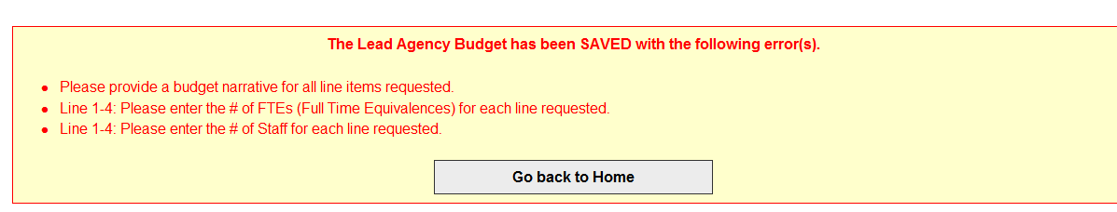



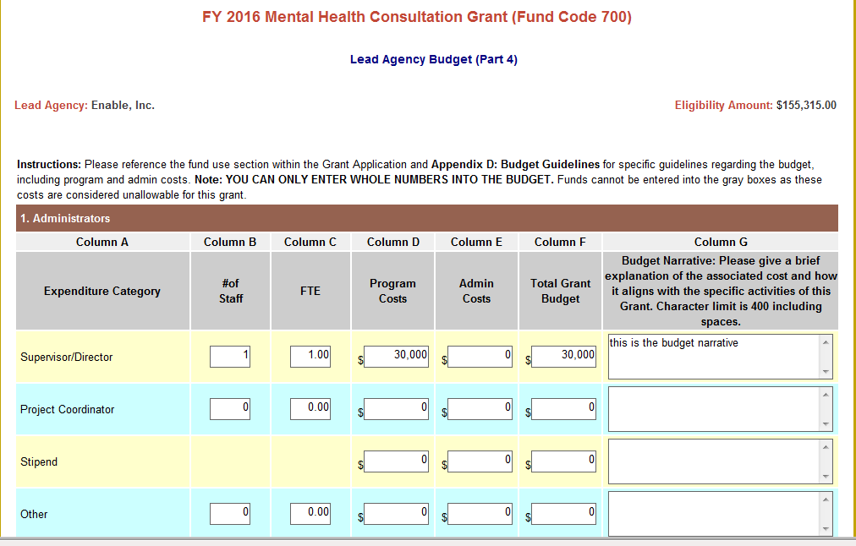

- To save your budget, you must click on of the Save Lead Agency Budget button at the bottom of the page.
- You will also have the ability to save and print your budget by clicking on Save and Print.



- PART 5 - SUBCONTRACTOR BUDGET: Once you have saved the Lead Agency budget you will have the opportunity to access the Subcontractor budget.
- Click Go to Subcontractor Budget (Part 5), if you plan to allocate a portion of your funding to subcontractors.
- Click Go back to Home, if your agency does not have any subcontractors.

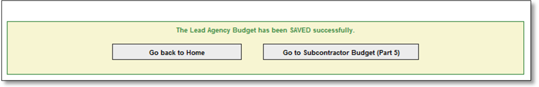

- Add a subcontractor by clicking Add New Subcontractor.

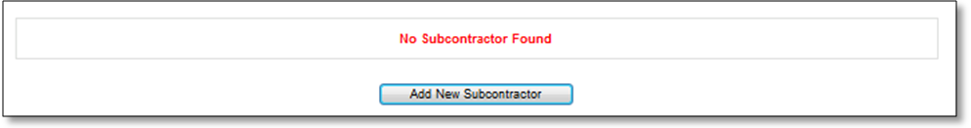

- Subcontractor Budget: Please refer to the Lead Agency Budget as guidance to complete the Subcontractor Budgets.

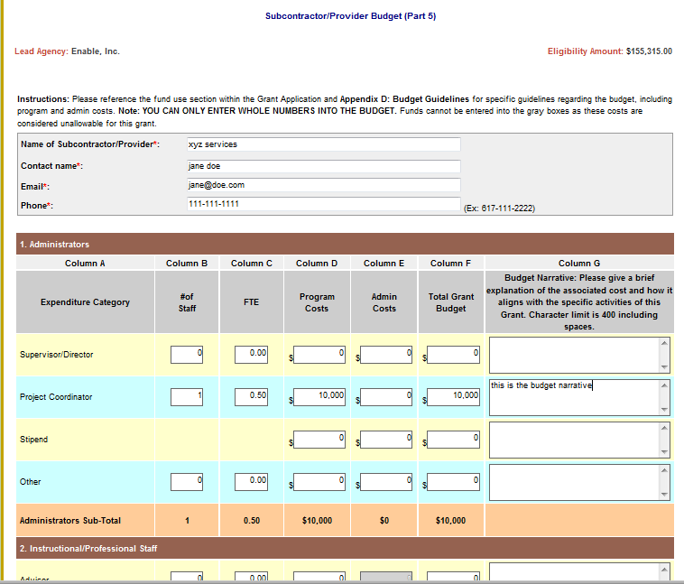

- Click Save Subcontractor Budget to save the information entered in the subcontractor budget.


- You will have the opportunity to enter 20 subcontractors, if applicable.
- To add another Subcontractor, click Go back to Subcontractor list.
- Once you have completed the subcontractor budgets, click Go to FY 2015 Budget Summary (Part 6).

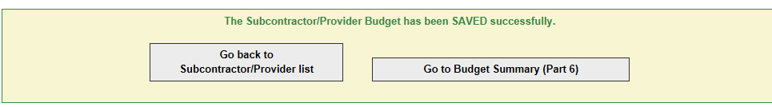

- PART 6 - FY 2016 BUDGET SUMMARY: The Budget Summary combines all line items requested in the Lead Agency Budget and all Subcontractor Budgets. (This is read-only document).

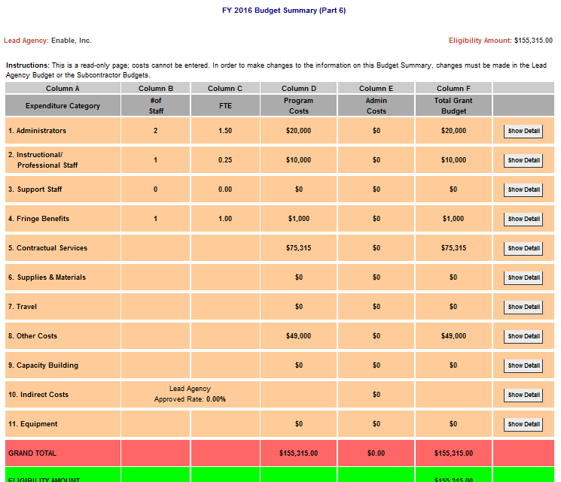

- If the Eligibility amount has been exceeded, an Alert will appear on the Budget Summary. CHANGES will need to be made to the budget so that the Eligibility amount has not been exceeded.
- If the EEC 10% ADMIN limit has been exceeded, an Alert will appear on the Budget Summary. CHANGES will need to be made to the budget so that the 10% Admin limit has not been exceeded.

- Part 7 - NARRATIVE QUESTIONS: Please provide responses to all narrative questions.

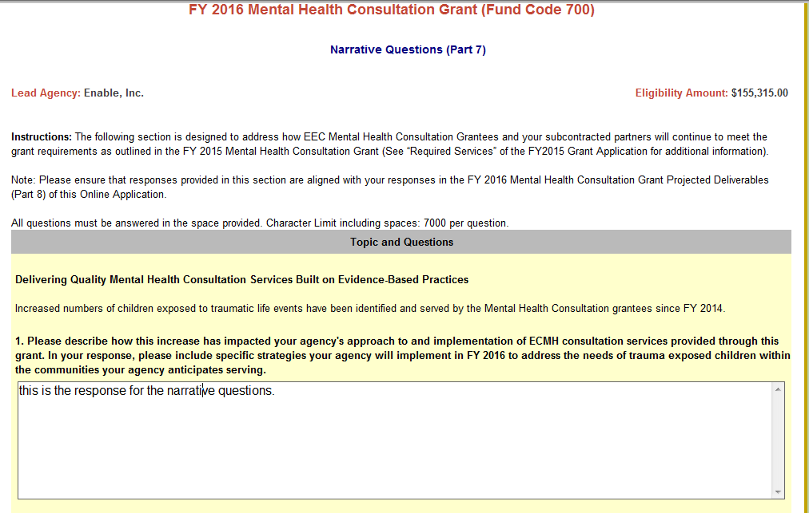

- Part 8 - PROJECTED DELIVERABLES: Please provide responses to sections of the Projected Deliverables.

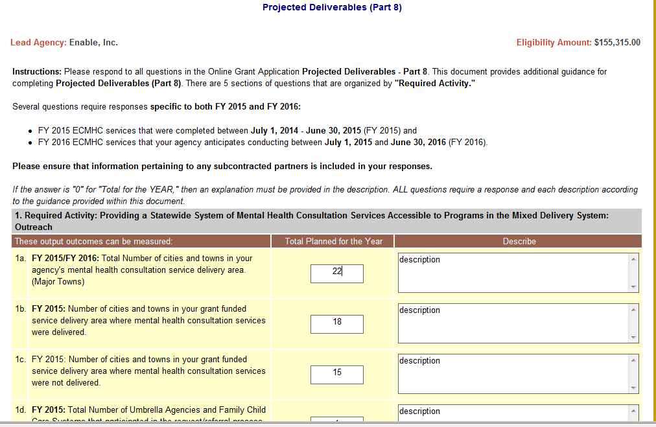

- Part 9 - REQUIRED GRANT FORMS: Please follow the instructions on the Online Application
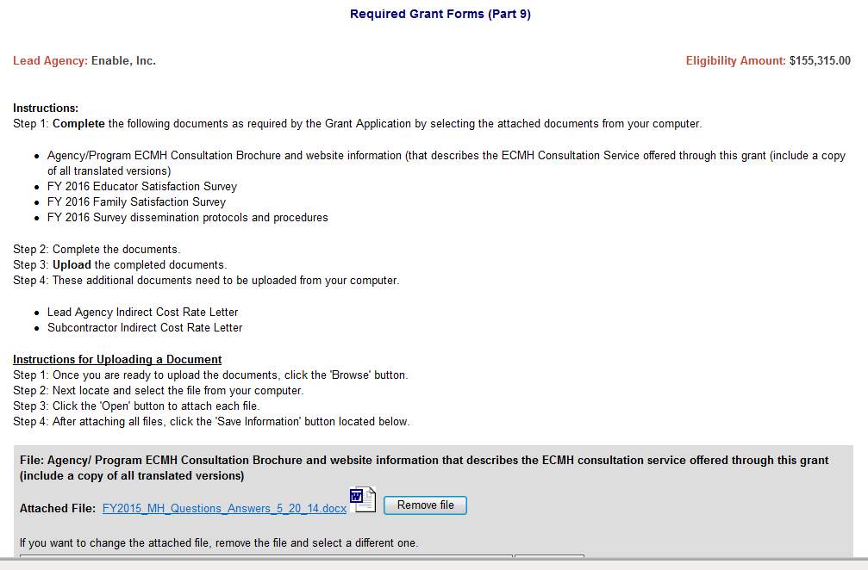

- Part 10 - CHECKLIST - Please make sure that you have checked all items that were completed in the Online Application.

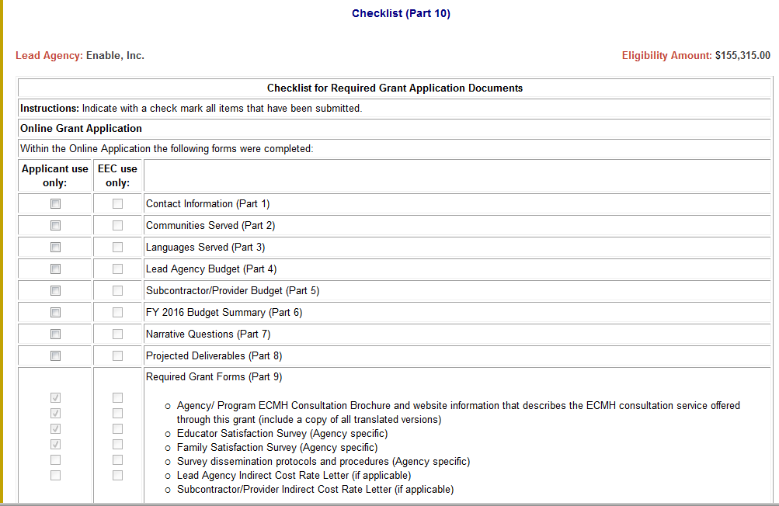

- Part 11 - COVER PAGE: Enter the email and phone number for the primary contact of your Agency.

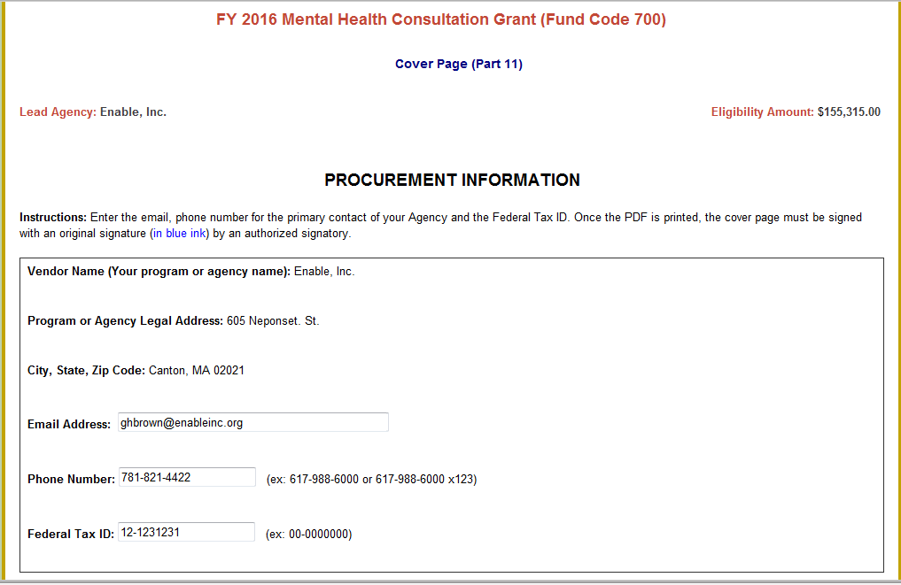

- Please note: Once the PDF is printed, the cover page must be signed with an original signature (in blue ink) by an authorized signatory.

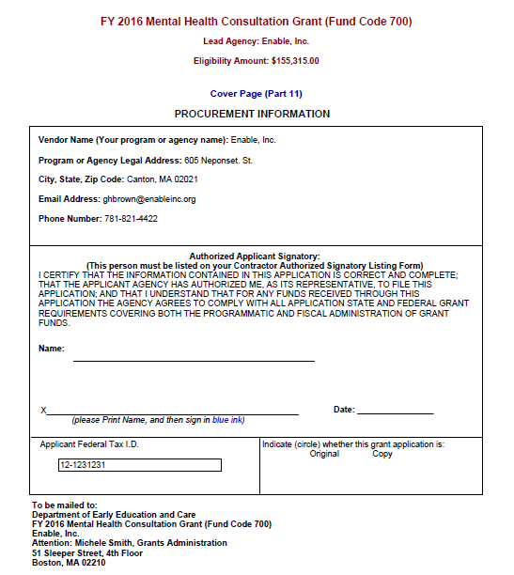

- PART 12 – ADMINISTRATIVE FORMS: If you do not already have the Massachusetts Standard Administrative Forms on file with the Commonwealth, complete and mail each of the forms with the rest of your Grant Application.
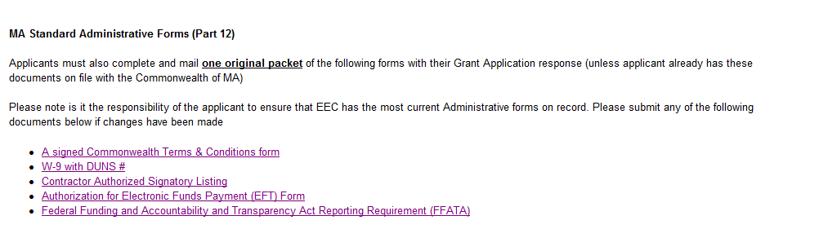
- SUBMIT ONLINE: Once your Online Application is complete, click Submit at the bottom of the home page to send your Online Application to EEC.

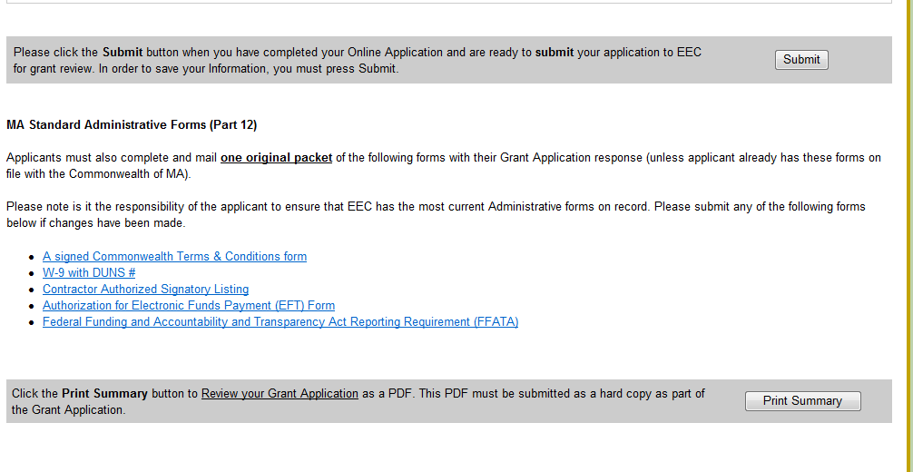

- Once submitted, an Applicant will be able to print their entire application as a PDF by clicking Print Summary. Please ensure that your checklist is complete and accurate at this time.

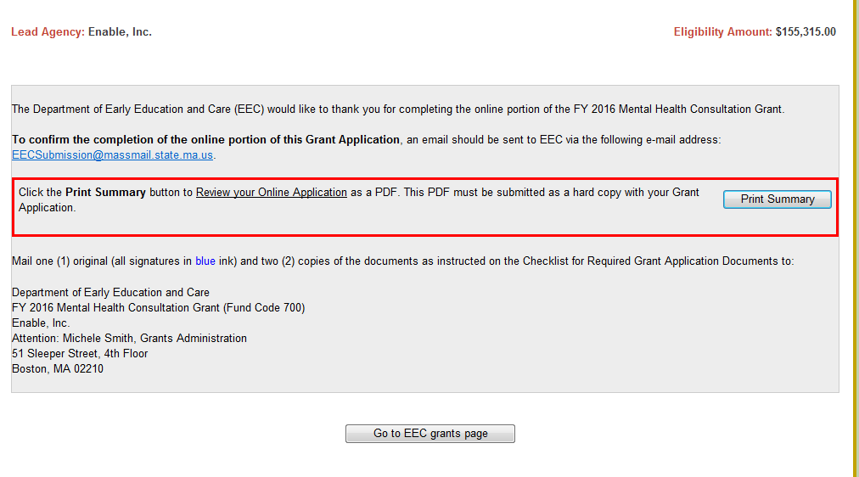

- To alert EEC of your grant submission, please email EECSubmission@massmail.state.ma.us with the subject line “FY 2016 Mental Health Grant Submission Confirmation - Insert Your Agency Name”.

- You also need to submit the required grant forms as email attachments to the above email address.

- Obtain the appropriate signatures on the cover page (all signatures in blue ink) and additional attachments, if necessary.

- Mail the printed PDF summary and one (1) original and two (2) copies to EEC along with any necessary administrative forms. EEC’s mailing address is displayed at the bottom of the cover page.

