**Appendix A: Online Grant Application Instructions**

**FY 2018 Education and Provider Support (EPS) Grant**

* This introduction page includes two links:
  + **COMMBUYS Registration Instructions**
  + **Login to Online Application**

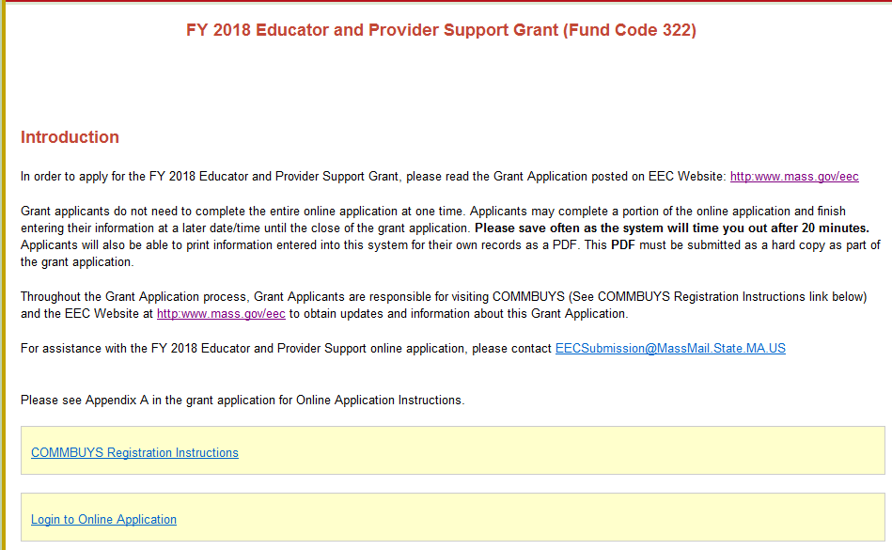

**COMMBUYS**

* Before completing your FY 2017 Educator and Provider Support Online Application (Fund Code 322), please read the Grant Application posted on **COMMBUYS**. You must be registered in **COMMBUYS** and follow the instructions on the **Registration Instructions** link in order to apply for this grant.
* PLEASE NOTE: This is a new UNSPSC code.
* You must register on COMMBUYS and select the **United Nations Standard Products and Services Code (UNSPSC) 00-00-00** for all EEC Grants. If you have already registered, please make sure you add the UNSPSC code to your registration.

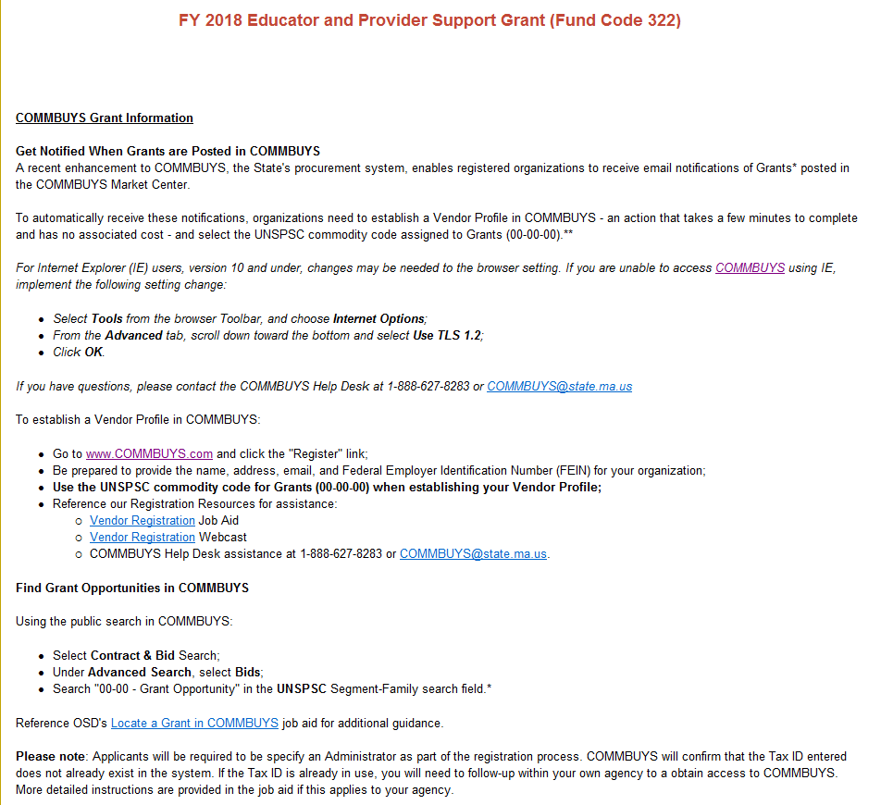

**ONLINE APPLICATION**

* Select your Agency from the drop-down menu.

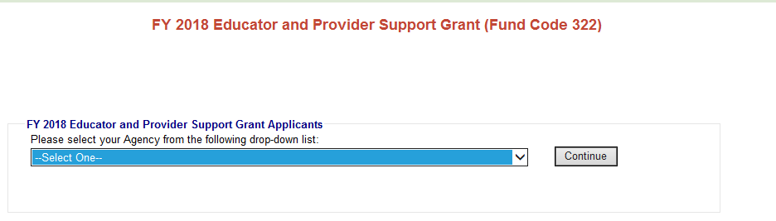

* Create a new **password** for FY 2018. Please write down this password for your records. Please write down this username and password for your reference. You will need this password to access your Online Application in the future.

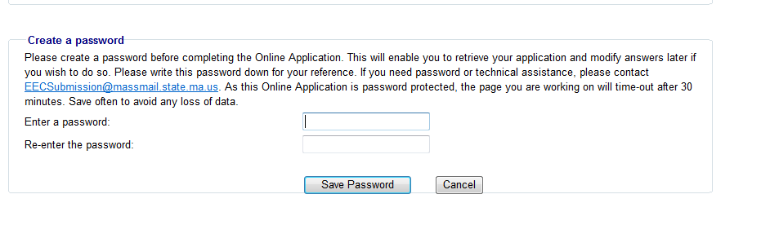

* The next time you log into the Online Application, the system will prompt you to enter your existing password.

**The second time you login, you enter your password.
**

**HOME PAGE -** The home page provides access to each component of the Online Application. The Application consists of 12 parts: **Contact Information, Communities Served, Languages Served, Lead Agency Budget, Subcontractor Budget, FY 2018 Budget Summary, Narrative Questions, Projected Deliverables, Required Grant Forms, Checklist, Cover page** and **Massachusetts Standard Administrative Forms.**

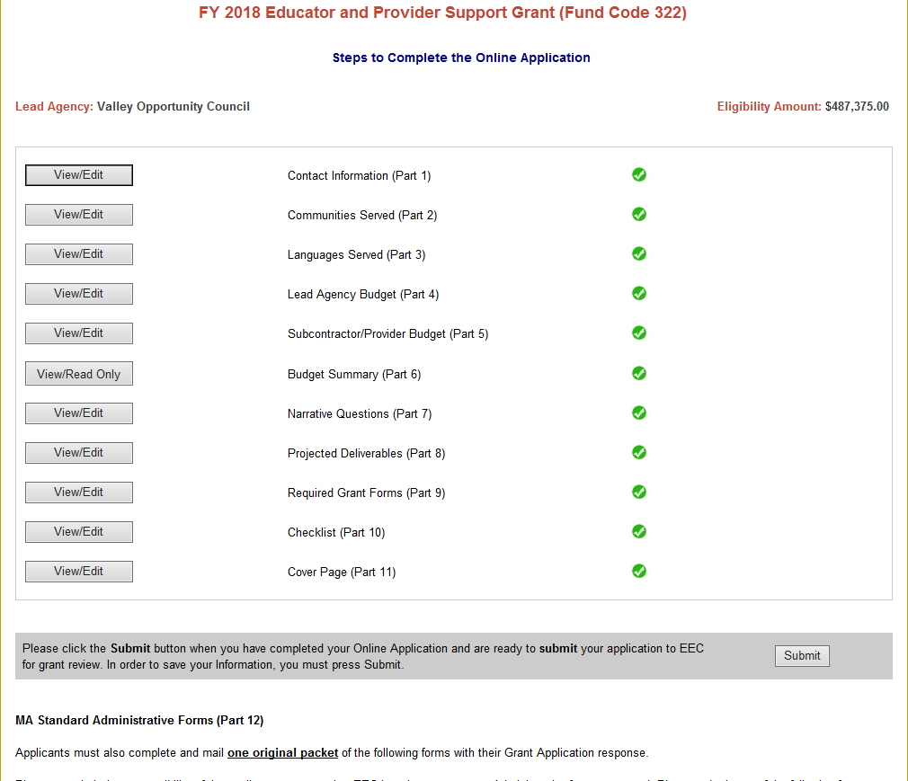

Please remember to hit the **Save** **Information** tab at bottom of each screen.



* **Part 1- CONTACT INFORMATION:** Complete all contact information.

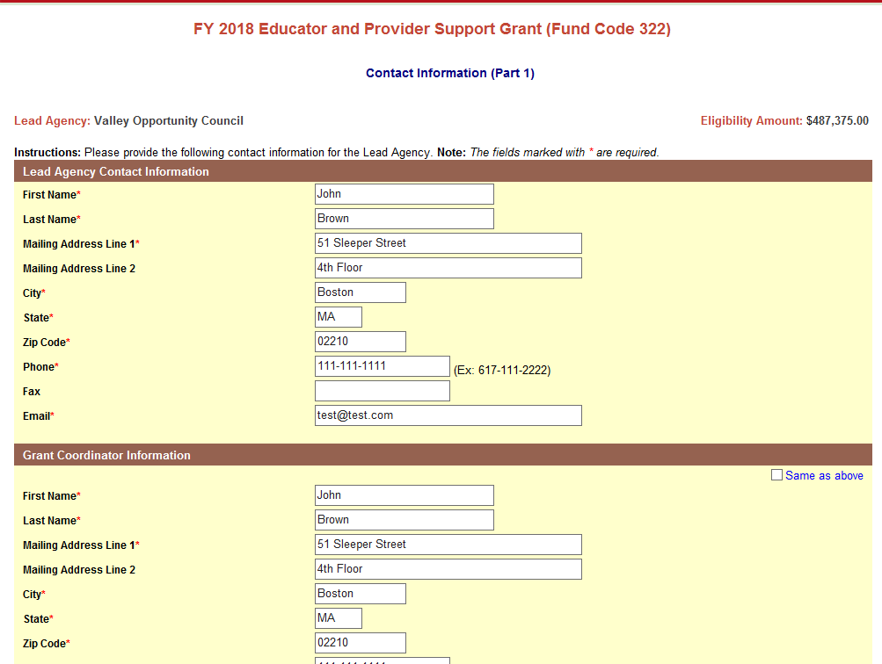

Please remember to hit the **Save Information** tab at bottom.



* **Part 2 - COMMUNITIES SERVED:** Select the Region to be served. When the region is selected, demographic information will populate. See Appendix F-1, F-2, and F-3 or demographic information.

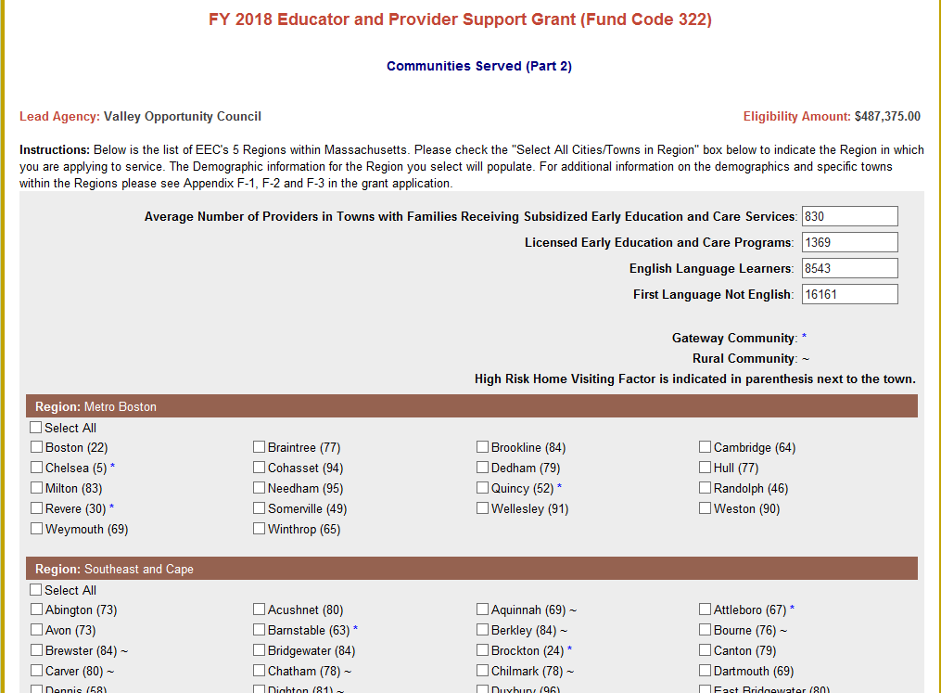

* **Part 3 - LANGUAGES SERVED:** Please select the languages your agency serves. If choosing 'Other' list name of language(s) in text box provided.

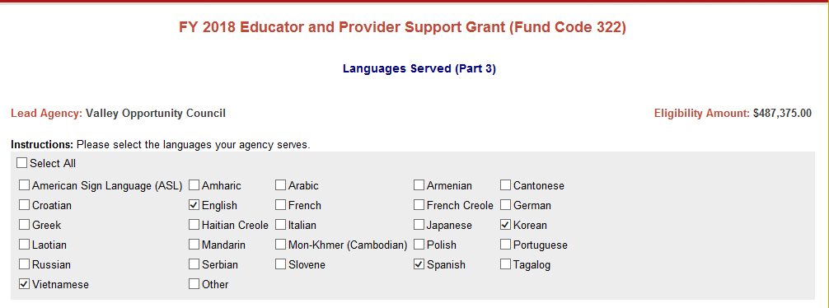

* **PART 4 - LEAD AGENCY BUDGET:**

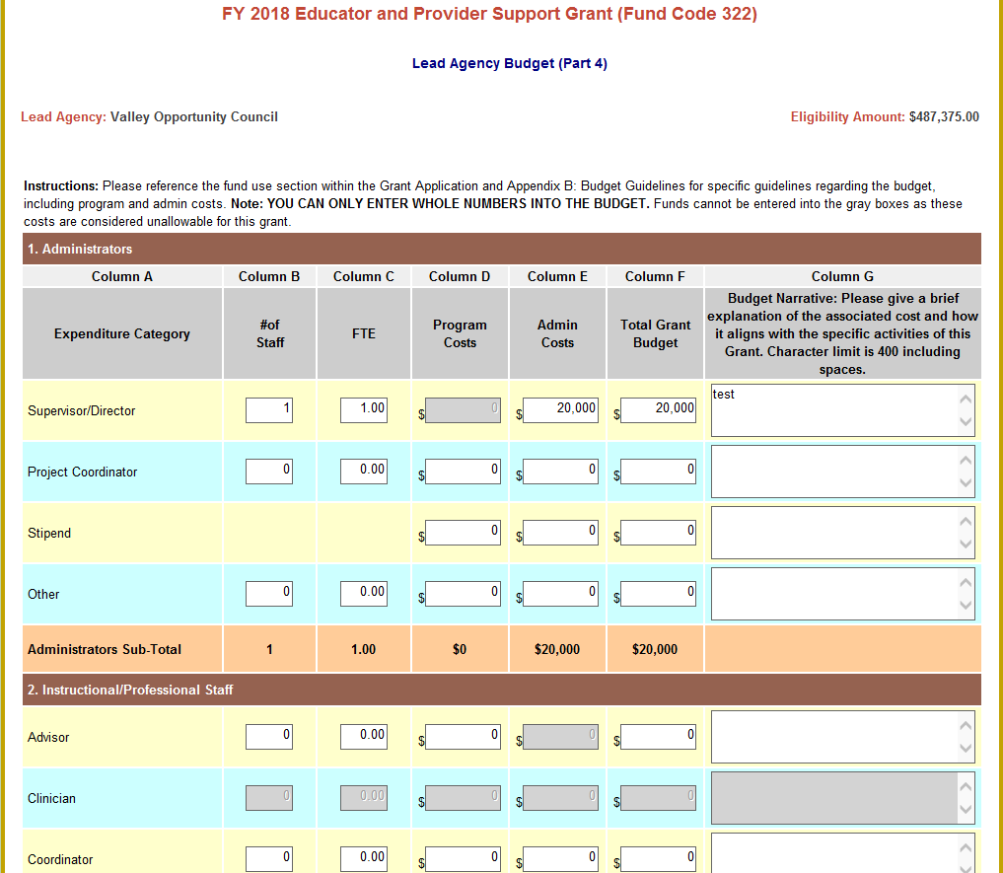

* + Please reference the fund use section within the Grant Application and **Appendix D: Budget Guidelines** to follow specific guidelines regarding the budget for this grant, including **program** and **admin** costs.
    - Please note: Only budget lines and columns are open to enter information for expenditures allowable under this grant.
  + **Note: YOU CAN ONLY ENTER WHOLE NUMBERS INTO THE BUDGET.**
  + Error messages will appear in **RED** at the top of the Lead Agency Budget. Errors are outlines in **RED BOX (ES)** for each item that has an error. A Budget cannot be submitted with any errors.
  + Please ensure that all line items for which you claim funds have a budget narrative that describes how they are aligned with the purpose of the funding.
  + For all staff-related line items (#1-4), please include the **Number of Staff** and **Number of FTEs** in the corresponding columns.
    - Please note that the FTEs should not be larger than the number of staff x 1.00 FTEs.
  + For the Fringe Benefits line item (#4), please provide a narrative that includes the components of the fringe benefits, if applicable:
    - Federal Tax, State Tax, FICA, Mass Unemployment, Health Insurance, Worker's Compensation, Medicare, SUTA, Other Retirement Systems, Other.
    - If the amount is coming from another source, please provide the name of the source(s) in Budget Narrative.
  + If the 35% allocation for Fringe has been exceeded, an Alert will appear and a breakdown of fringe will need to be provided in the Budget Narrative.
    - If fringe is less or equal to 35%, provide breakdown of categories and percentages, if possible.

**Error Message:**

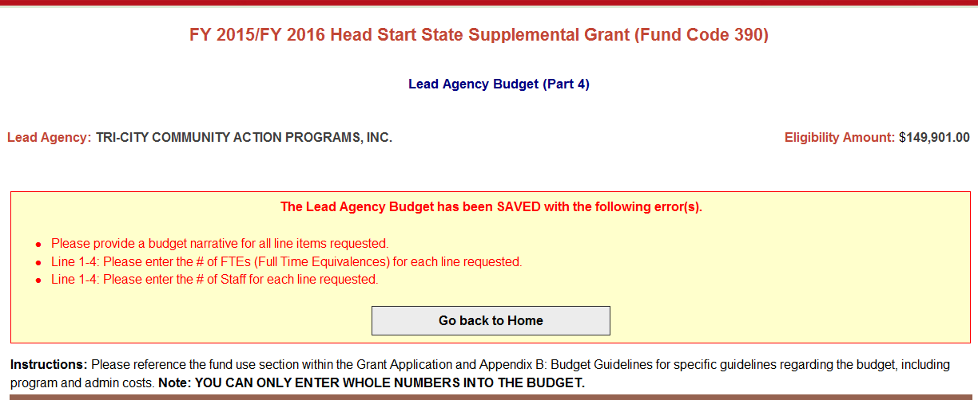



* To save your budget, you must click on of the ***Save Lead Agency Budget*** tab at the bottom of the page frequently as it will time out.
* You will also have the ability to save and print your budget by clicking on ***Save and Print*.**



* **PART 5 - SUBCONTRACTOR BUDGET:** Once you have saved the Lead Agency budget you will have the opportunity to access the Subcontractor budget.
* Click ***Go to Subcontractor Budget (Part 5),*** if you plan to allocate a portion of your funding to subcontractors. **Add a subcontractor by clicking *Add New Subcontractor*.**
* **Click *Go back to Home,*** if your agency does not have any subcontractors.



* **Subcontractor Budget:** Please refer to the Lead Agency Budget as guidance to complete the Subcontractor Budgets.

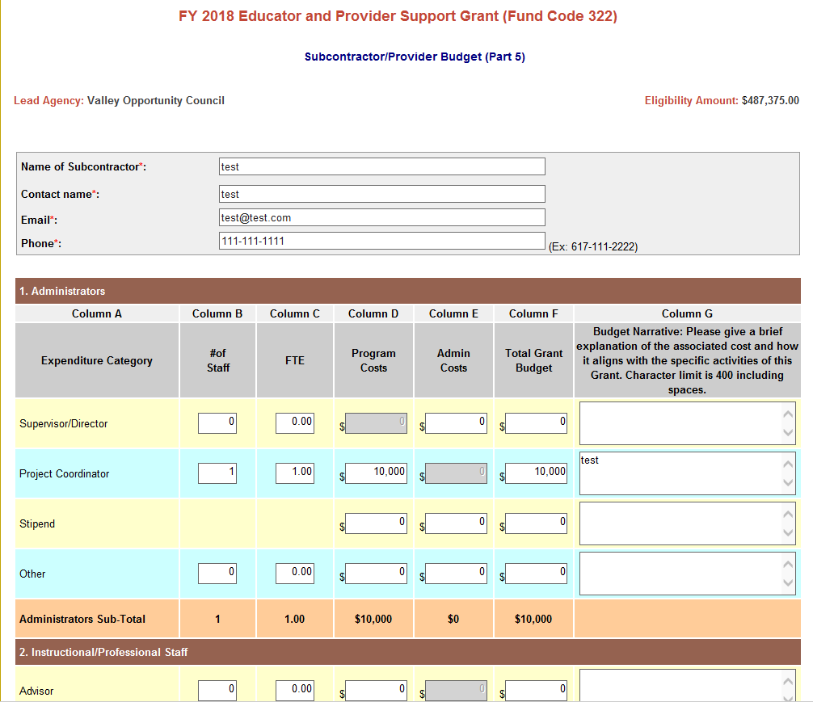

* Click ***Save Subcontractor Budget*** to save the information entered in the subcontractor budget. 
* You will have the opportunity to enter **20 subcontractors**, if applicable.
* To add another Subcontractor, click ***Go back to Subcontractor list.***
* Once you have completed the subcontractor budgets, click ***Go to FY 2018 Budget Summary (Part 6).***

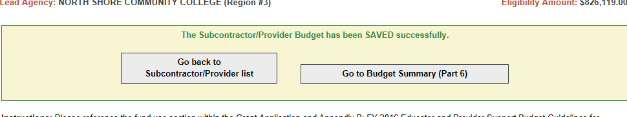

* **PART 6 - FY 2018 BUDGET SUMMARY:** The Budget Summary combines all line items requested in the Lead Agency Budget and all Subcontractor Budgets.

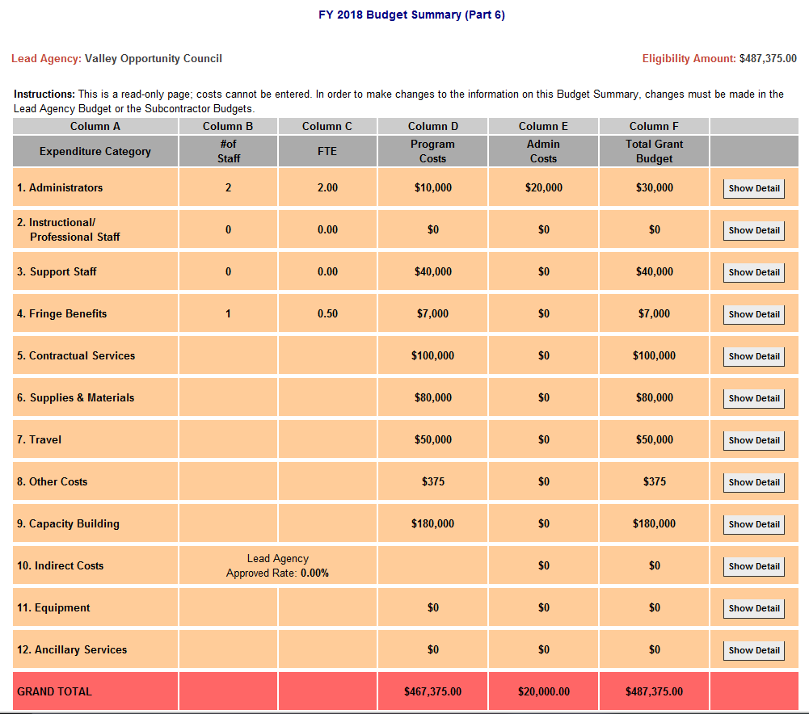

* **If the requested amount does not match the eligibility amount**, an **Alert** will appear on the Budget Summary. **CHANGES** will need to be made to the budget so that the requested amount equals the eligibility amount.
* If the **EEC 10% ADMIN limit** has been exceeded, an **Alert** will appear on the Budget Summary. **CHANGES** will need to be made to the budget so that the 10% Admin limit has not been exceeded.
* Example:

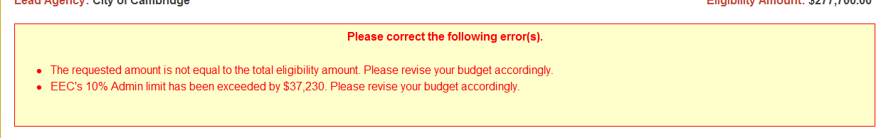

* **Part 7 - NARRATIVE QUESTIONS:** Please provide responses to all narrative questions.

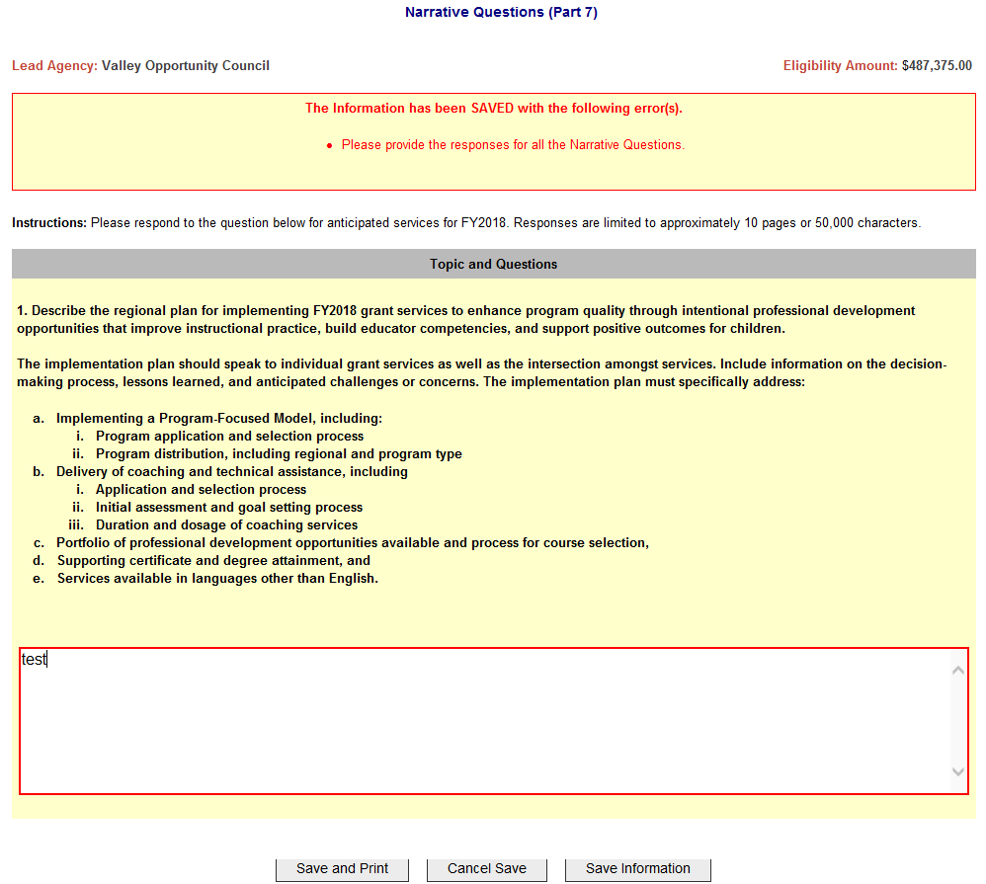

Reminder to hit **Save Information** at the bottom frequently.



* **Part 8 - PROJECTED DELIVERABLES:** Please provide responses to sections of the Projected Deliverables.

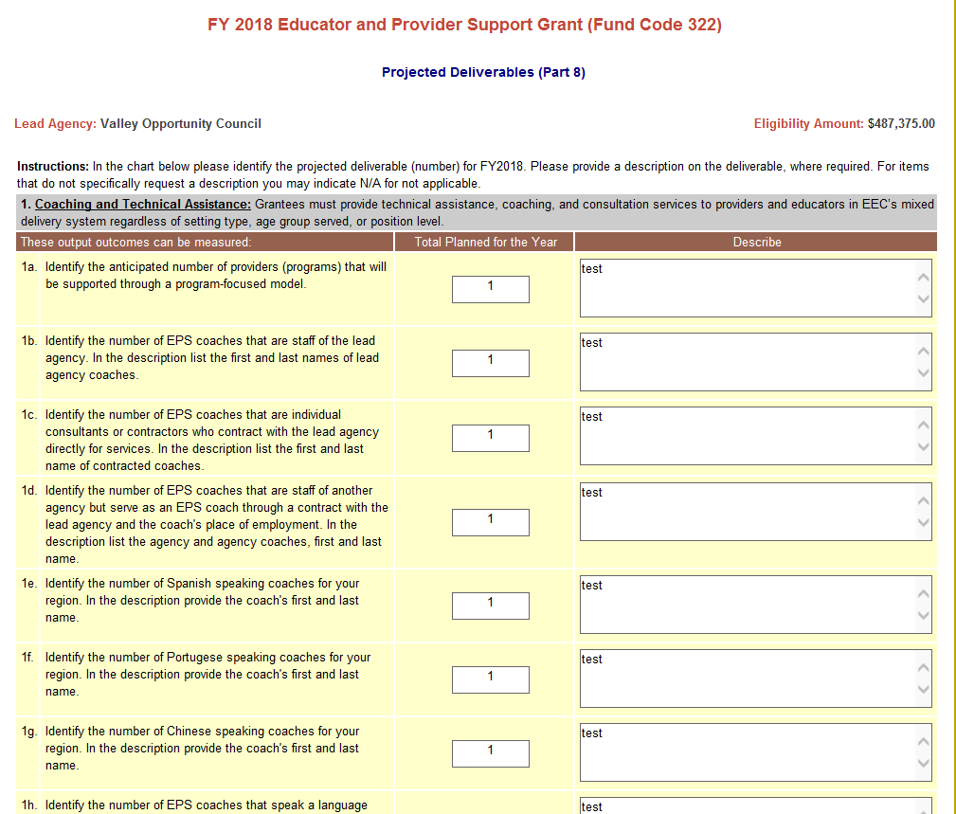



* **Part 9 - REQUIRED GRANT FORMS:** Please follow the instructions on the Online Application.

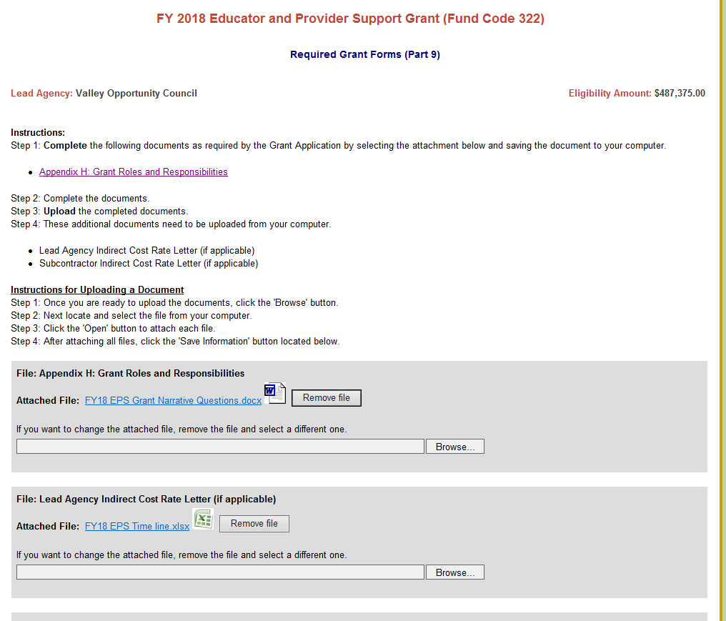

* Please Note: The **Required Grant Forms** must be submitted as **hard copies** and submitted **electronically**, as these do **not** print as part of the **PDF** document. **Grant applications will be considered incomplete if both hard copies and electronic copies are not received.**
* **Part 10 - CHECKLIST -** Please make sure that you have checked all items that were completed in the Online Application.

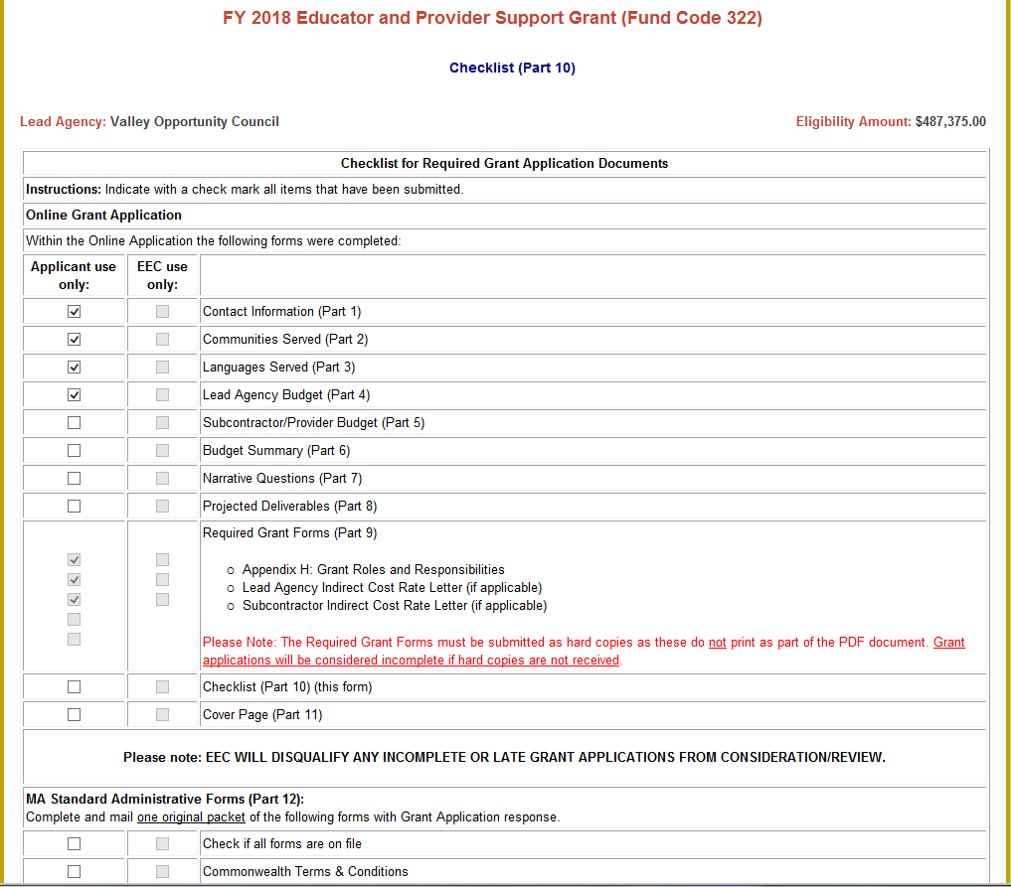

* **Part 11 - COVER PAGE:** Enter the email and phone number for the primary contact of your Agency and the agency's **Federal Tax Id**.

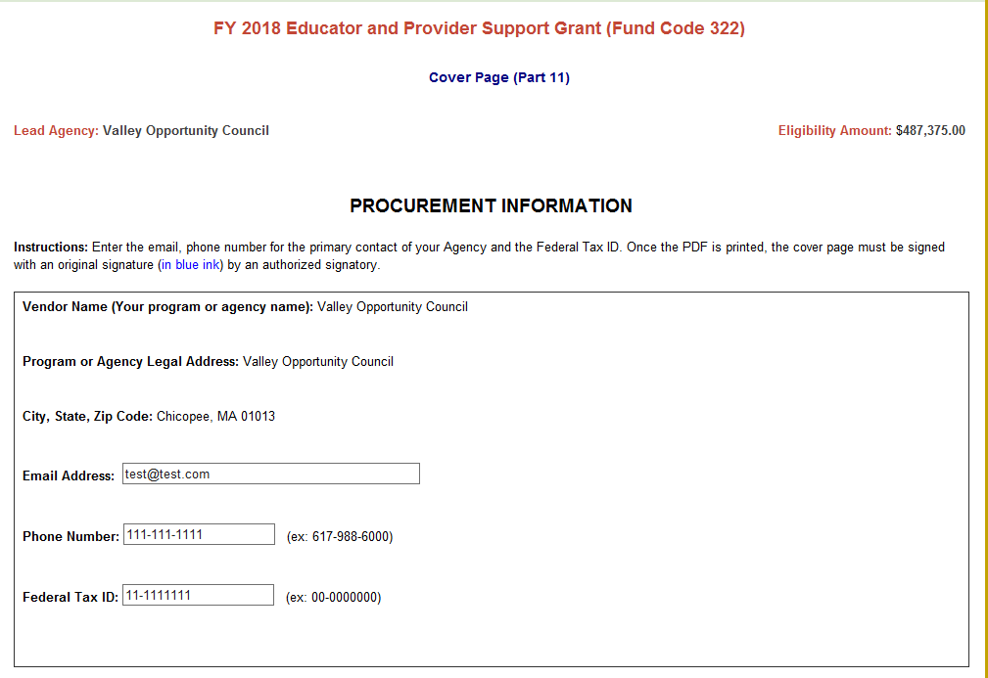

* **PART 12 – ADMINISTRATIVE FORMS:** If you do not already have the Massachusetts Standard Administrative Forms on file with the Commonwealth, complete and mail each of the forms with the rest of your Grant Application.
* **SUBMIT ONLINE:** Once your Online Application is complete, click ***Submit*** at the bottom of the home page to send your Online Application to EEC.

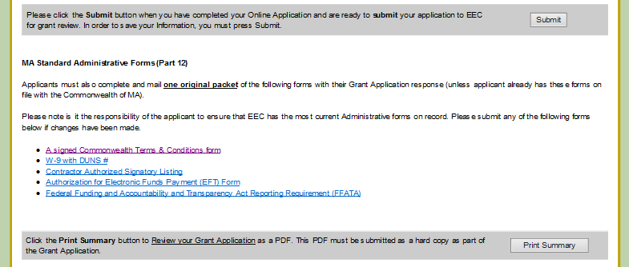

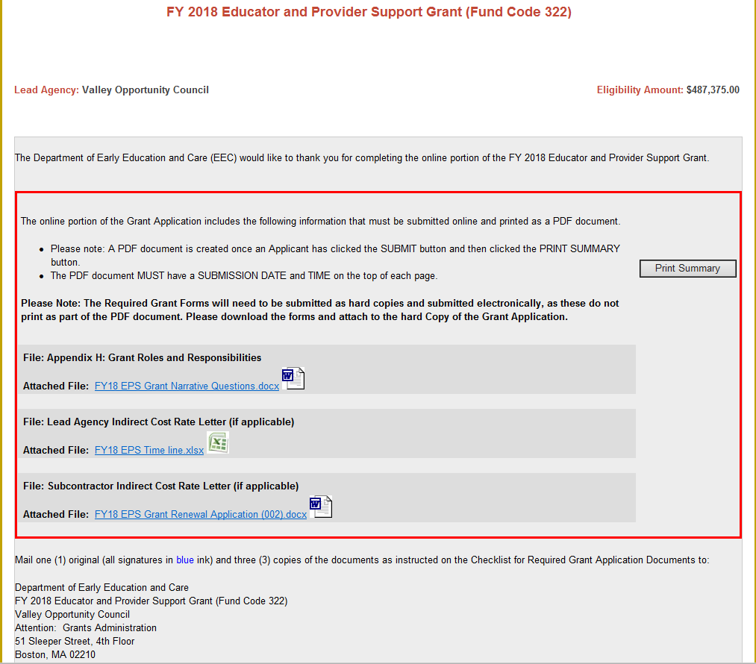

* Once submitted, an Applicant will be able to print their entire application as a PDF by clicking ***Print Summary****.* Please ensure that your checklist is complete and accurate at this time.

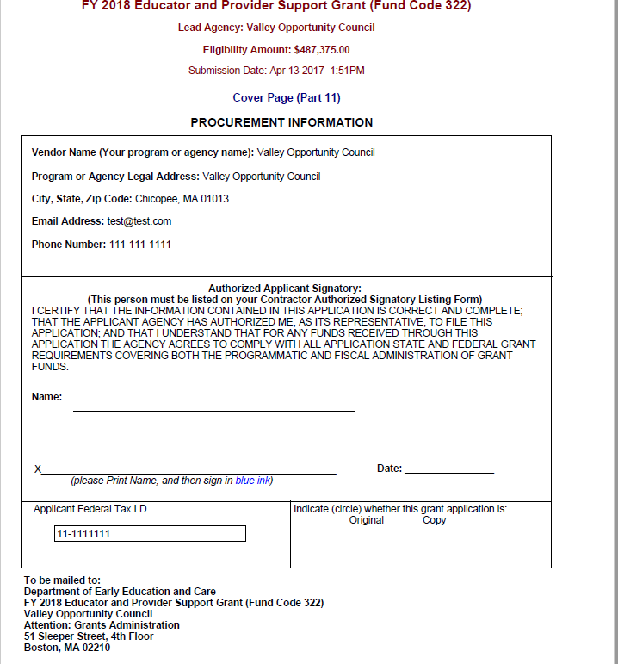

* Please note: Once the PDF is printed, the **cover page must be signed with an original signature (in blue ink) by an authorized signatory**.
* **Mail the printed PDF summary** and **one (1) original** and **three (3) copies** to EEC along with any necessary administrative and required forms. EEC’s mailing address is displayed at the bottom of the cover page.