FY 2015 EARLY CHILDHOOD SPECIAL EDUCATION ENTITLEMENT GRANT (FUND CODE 262)
Appendix A: FY2015 Online Grant Application Portal Reference

- Enter the Online Portal by clicking Complete Online Application.

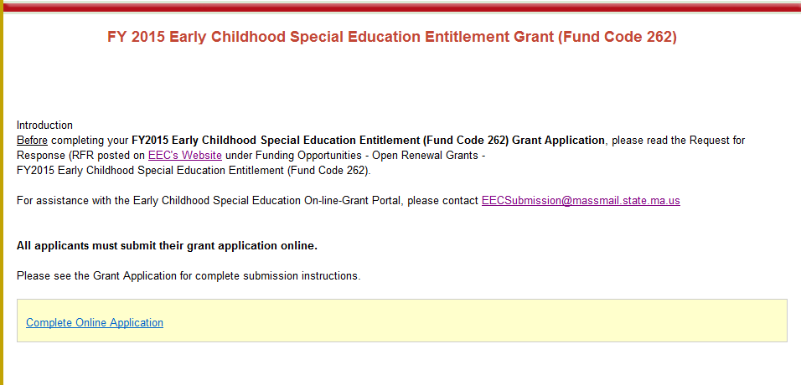
- Select your school district from the drop-down menu.

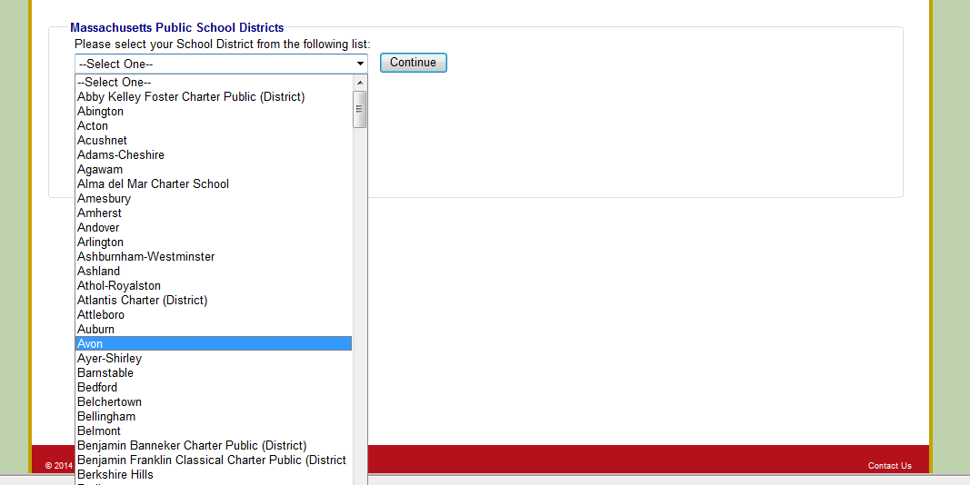

- Create a password. Please write down this password for your records. You will need this password to access your Online Application in the future.

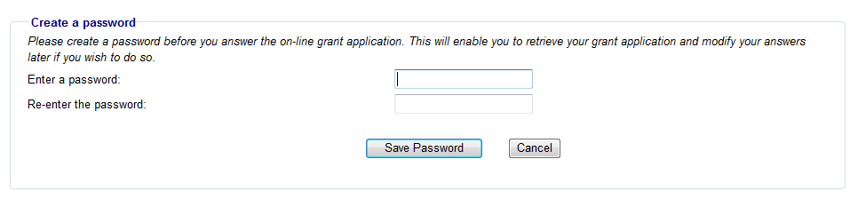

- The next time you log into the Online Application, the system will prompt you to enter your existing password.
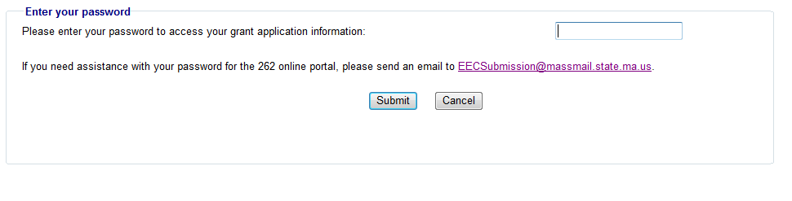

- HOME PAGE - The home page provides access to each component of the application. The application consists of six components: (1) checklist, (2) cover page, (3) Schedule A form (if applicable), (4) budget and narrative, (5) contact information, and (6) Massachusetts standard administrative forms. The first five components must be submitted both online and by mail, and the administrative forms must be submitted by mail if they are not already on file.
  - As you navigate each page, use the Save buttons at the bottom of the page to save the information you have entered. If you do not wish to save your information, return to the Home Page by clicking the Home button in the page’s top left.

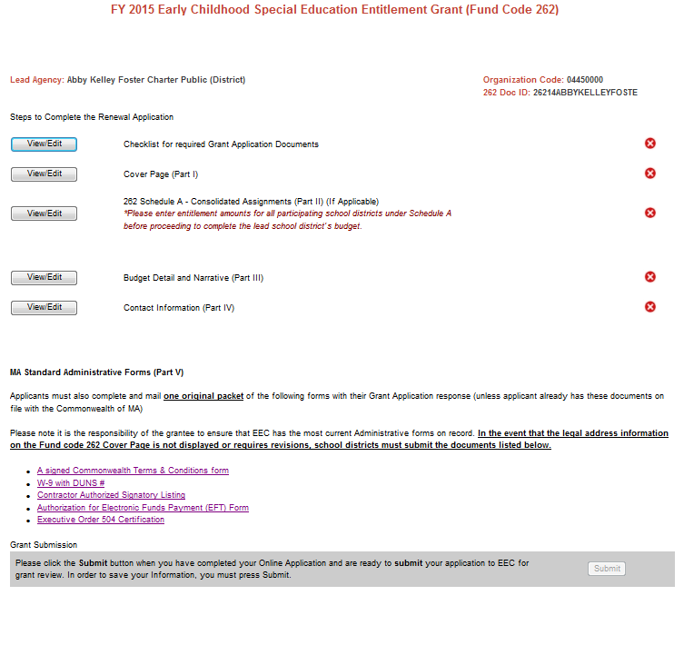

- CHECKLIST - As you complete each part of the application, check it off on the checklist.
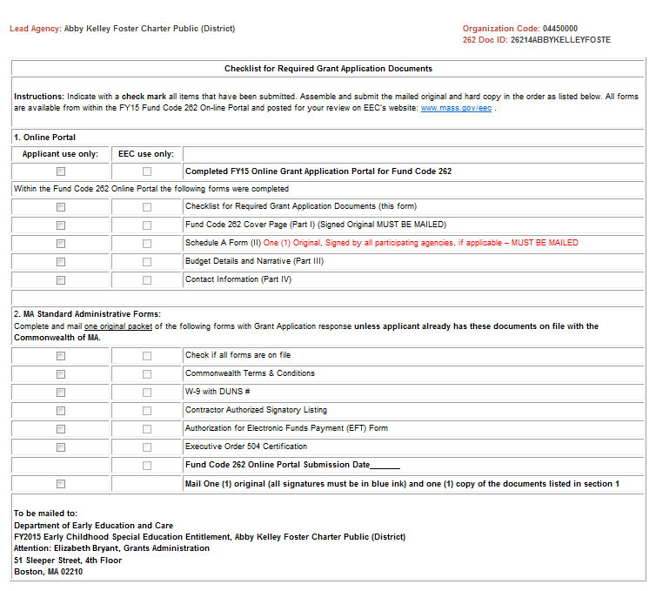

- PART I - COVER PAGE: Enter your primary contact information.

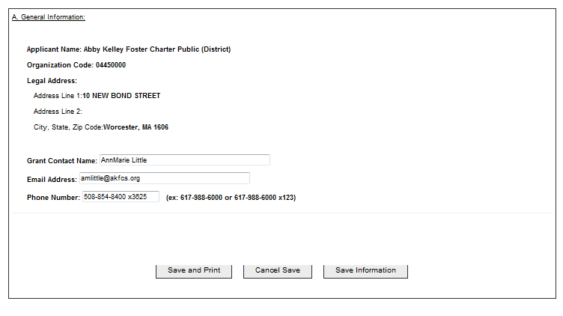

- PART II - SCHEDULE A: If you operate and administer this grant project using funds assigned to more than one agency, complete the Schedule A form. The authorized signatures should be submitted in the mailed copy of the application.
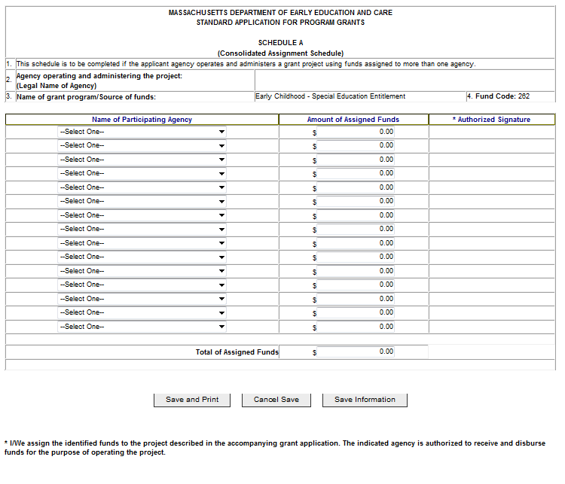
- PART III - BUDGET DETAIL AND NARRATIVE:
  - Please ensure that all line items for which you claim funds have a budget narrative that describes how they are aligned with the purpose of the funding. Budgets without narratives will not be approved.
  - For all staff-related line items (#1-4), please include the Number of Staff and Number of FTEs in the corresponding columns.
  - For line items 1-3, selecting “Yes” for MTRS will automatically fill in an amount equal to 9% of the salaries in the MTRS sub-lines and in the MTRS line item (#6).
  - For the fringe benefits line item (#5), please provide a narrative that includes the number of staff receiving fringe benefits and the components of the fringe benefits, such as health insurance, life insurance, county retirement program, unemployment insurance, etc.
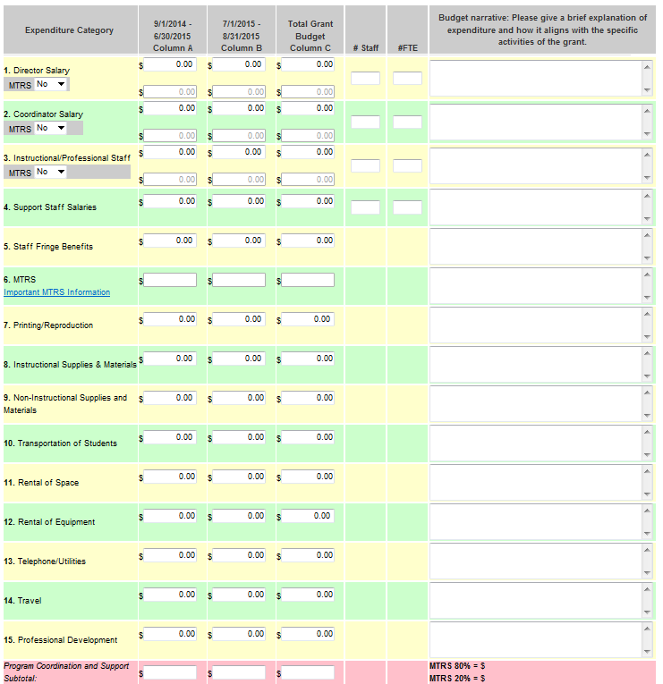

- To save your budget, you must click the Save Budget Information button at the bottom of the page. If the “FY15 TOTAL AMOUNT REQUESTED” does not equal the “262 Entitlement AMOUNT”, you will not be able to submit your budget.
- You will also have the ability to save and print your budget by clicking on Save and Print.
- If you request Schedule A funds, these funds will be added to your entitlement amount. You should include these funds in your budget so that the “FY15 TOTAL AMOUNT REQUESTED” will still equal the “262 Entitlement AMOUNT”.

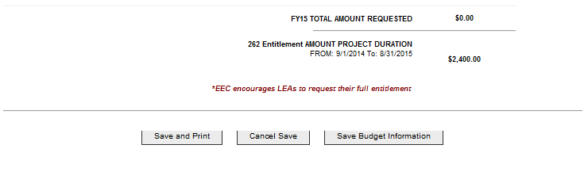

- PART IV - CONTACT INFORMATION: Complete all contact information.
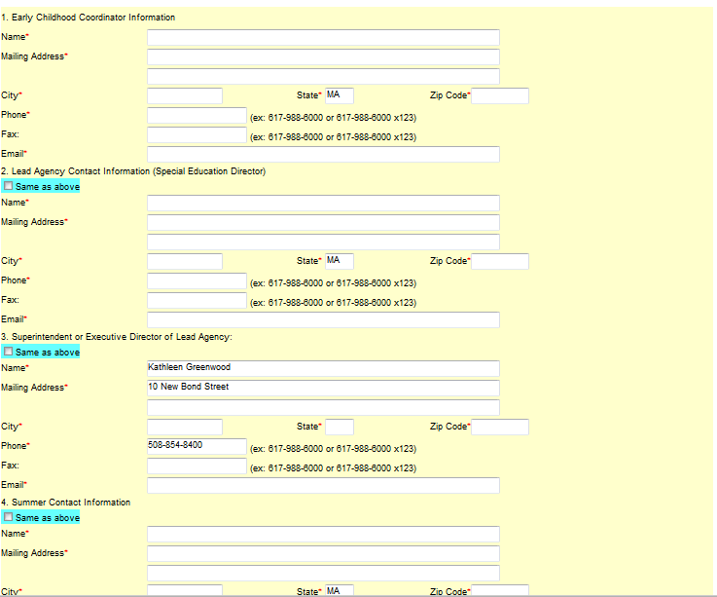

- PART V – ADMINISTRATIVE FORMS: If you do not already have the Massachusetts Standard Administrative Forms on file with the Commonwealth, complete and mail each of the forms with the rest of your Grant Application.
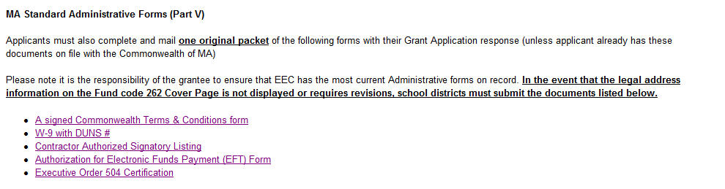
- SUBMIT ONLINE: Once your Online Application is complete, click Submit at the bottom of the home page to send your Online Application to EEC.
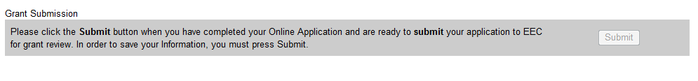
- Once submitted, an Applicant will be able to print their entire Grant Application as a PDF by clicking Print Summary. Please ensure that your checklist is complete and accurate at this time.
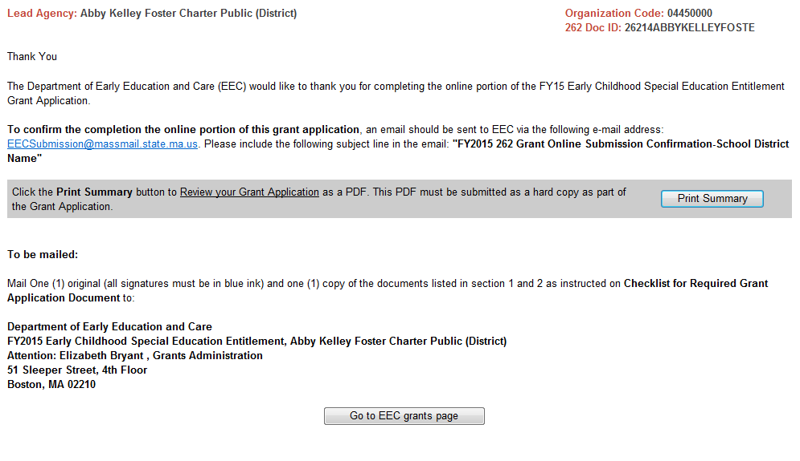

- Confirm submission: To alert EEC of your submission, please email EECSubmission@massmail.state.ma.us with the subject line “FY2015 262 Grant Online Submission Confirmation - Your School District Name.”

- PRINT AND MAIL: Print the summary PDF and obtain the appropriate signatures on the cover page and the Schedule A form (if applicable). Mail the original forms and one copy to EEC along with any necessary administrative forms. EEC’s mailing address is displayed at the bottom of your checklist.

