**FY 2018 INCLUSIVE PRESCHOOL LEARNING ENVIRONMENTS (IPLE) GRANT (Fund Code 391)**

Appendix A: Online Grant Application Instructions

* This introduction page includes two links:
  + **COMMBUYS Grant Information**
  + **Login to Online Application**

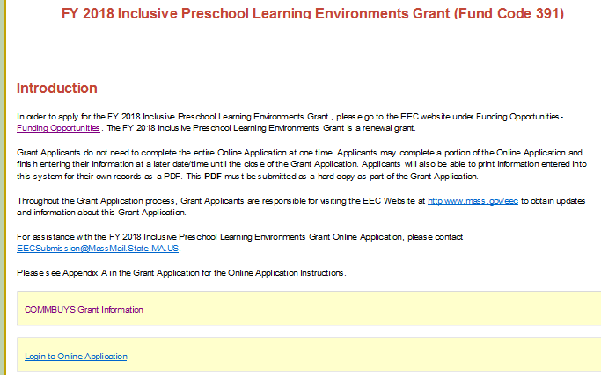

**COMMBUYS Grant Information**

Enter theCOMMBUYS Grant Information by clicking the link.

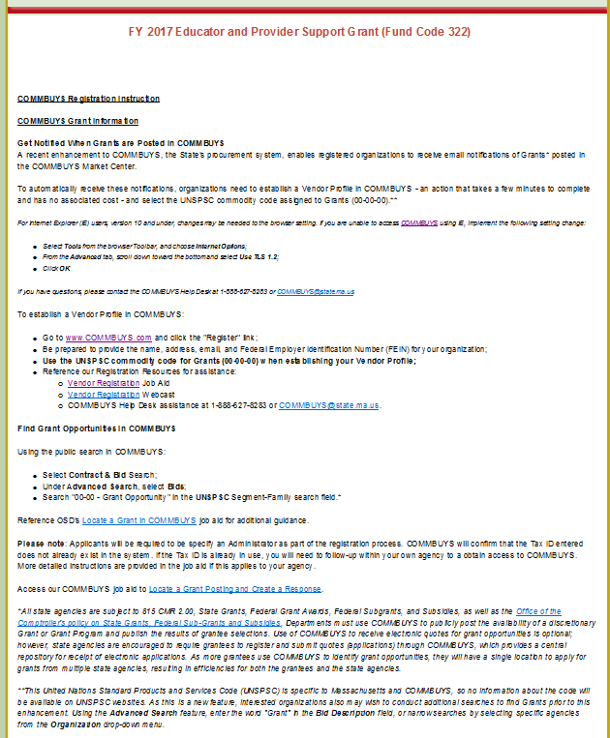

*For Internet Explorer (IE) users, version 10 and under, changes may be needed to the browser setting. If you are unable to access* [COMMBUYS](http://r20.rs6.net/tn.jsp?f=001qyBMXOEiwpObA_R5yAXYzWmG00pimn-yGh7kRZ_0eB1ZM18wO_F0j9x6i5OzUwEmghjR_xX6fLwQnCAf_cJTFl5T1b3gr9D97XNpGvjbimQemCcSl9q-p00rExHpPUIh5sDpZ3dj8uCIX-92FgU3I_Z8wZTEcrTg_PF8YqPoZB-83m7SXyuzgw==&c=EpoZFUlgjd4wkXCXLkW-oFSKnSjuDTgM_oWxZ1n5iEIHTyLw3zF01w==&ch=xggw13x2Dx-tZawIC3NCQ6Wvqw-NInvYY_HaXA41NO2RDK125yqh_Q==) *using IE, implement the following setting change:*

* *Select* ***Tools*** *from the browser Toolbar, and choose* ***Internet Options****;*
* *From the* ***Advanced*** *tab, scroll down toward the bottom and select* ***Use TLS 1.2****;*
* *Click* ***OK****.*

*If you have questions, please contact the COMMBUYS Help Desk at 1-888-627-8283 or* [COMMBUYS@state.ma.us](mailto:COMMBUYS@state.ma.us)*.*

**LOGIN TO ONLINE APPLICATION**

* Enter theOnline Application by clicking ***Login Online Application.***

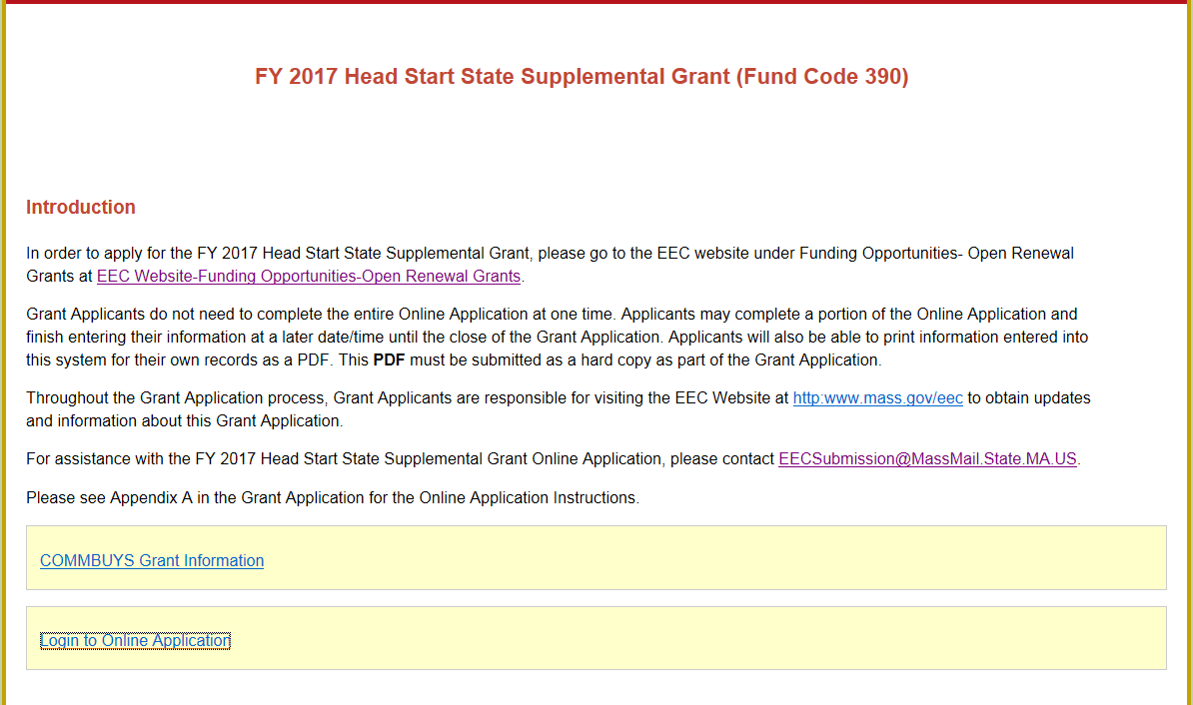

* Select your **Agency** from the **drop-down menu.**

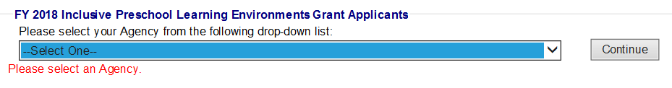

* Create a new **password** for FY 2018. Please write down this password for your records. You will need this password to access your Online Application in the future.

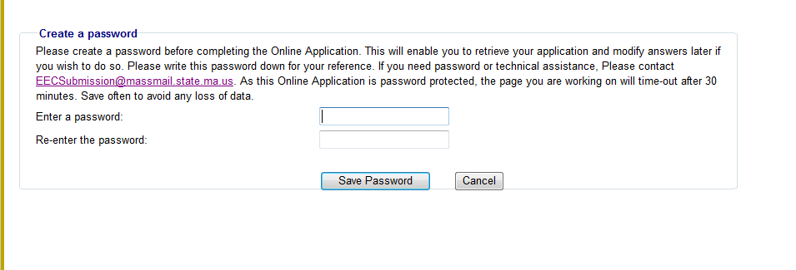

* The next time you log into the Online Application, the system will prompt you to enter your existing password.

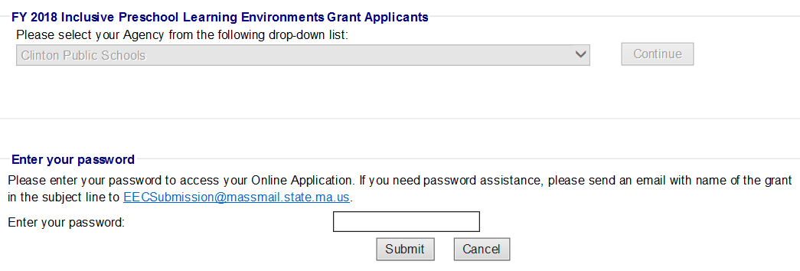

* The 2 links for the grant application are as follows:
  + **FY 2018 IPLE Site Survey**
  + **Grant Online Application**

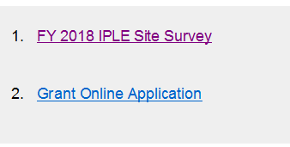

**FY2018 IPLE Site Survey - Detailed Instructions in Appendix D: Site Survey Guidelines**

* An IPLE Site Survey must be completed for each program site that the IPLE Lead Agency is proposing to fund with FY 2018 IPLE funds.
* **You will find the detailed instructions in Appendix D**.
* **Please** **complete one IPLE site survey for each group and center based program; Head Start program; and/or public preschool program where IPLE funds will be used.**
* **Please review and revise responses, as needed, to ensure information provided in the Site Survey is consistent will all other sections of the Grant Application.**
* Click **'Save Information'** when you are done entering all the program and enrollment information



* **NOTE: You will need to download files for the “Required Grant Forms-Part 9” for the grant submission.**
* Once you have completed the **FY 2018 IPLE Site Survey**, click on the **Grant Online Application from the Home Page.**

**GRANT ONLINE APPLICATION**

* **HOME PAGE -** The home page provides access to each component of the Online Application. The Application consists of 12 parts: Contact Information, Communities Served, Languages Served, Lead Agency Budget, Subcontractor Budget, FY 2018 Budget Summary, Narrative Questions, Projected Deliverables, Required Documents, Checklist, Cover page and Massachusetts Standard Administrative Forms.

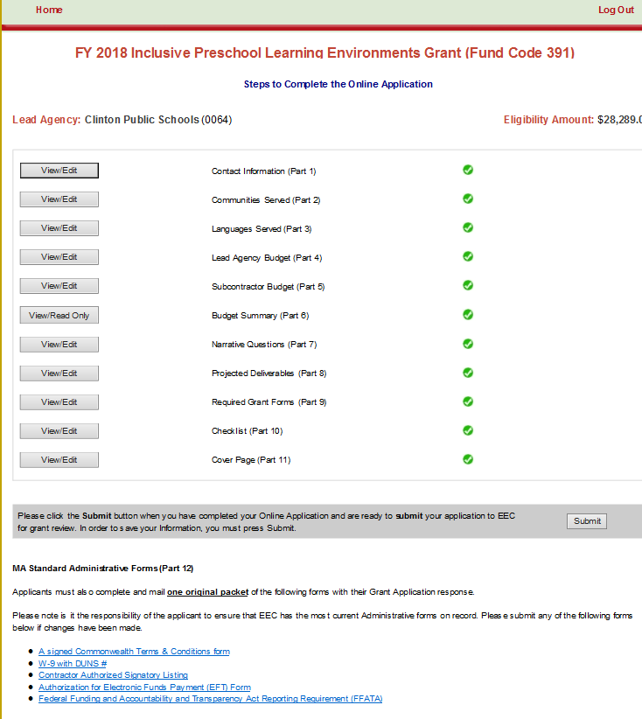

**You will click on View/Edit to Proceed with Part 1 from the Home Page.**

**Part 1- CONTACT INFORMATION: Complete all contact information.** 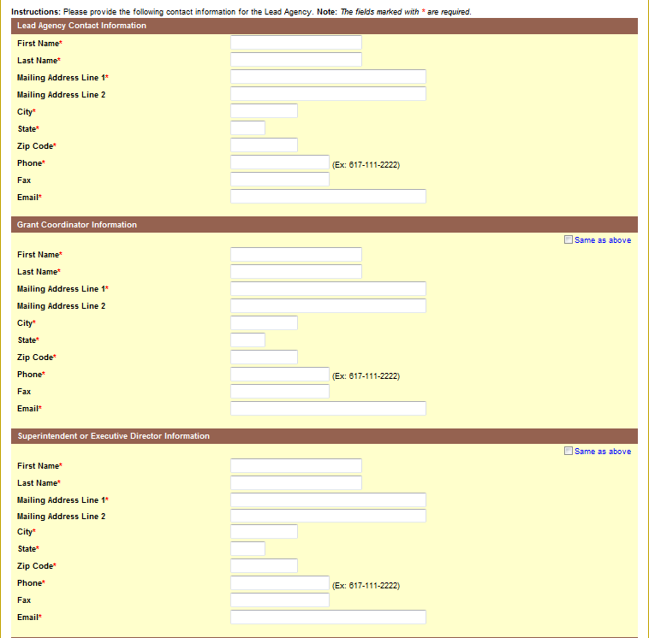

**PART 2 - COMMUNITIES SERVED:** Select the names of the cities/towns to be served in each region. When each city/town is selected, demographic information will populate. For more information about the demographic information displayed below, see **Appendix F-1, F-2, F-3** in the Grant Application.

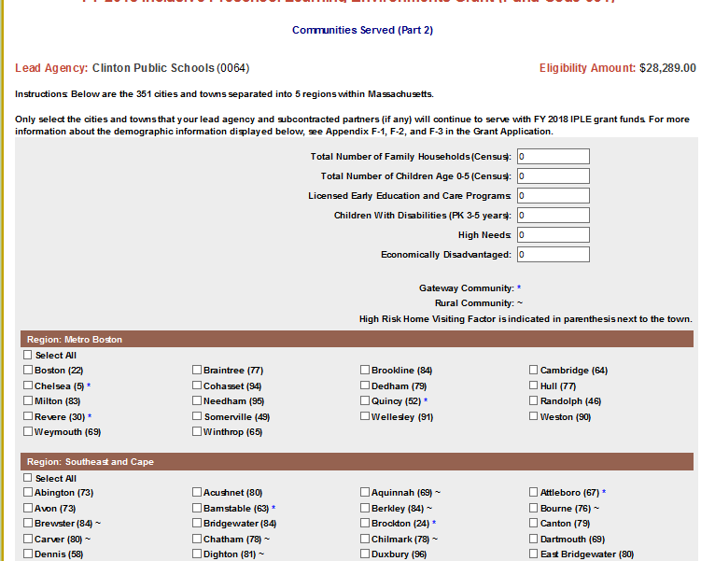

**PART 3 - LANGUAGES SERVED:** Please select the languages your agency serves. If choosing 'Other' list name of language(s) in text box provided.

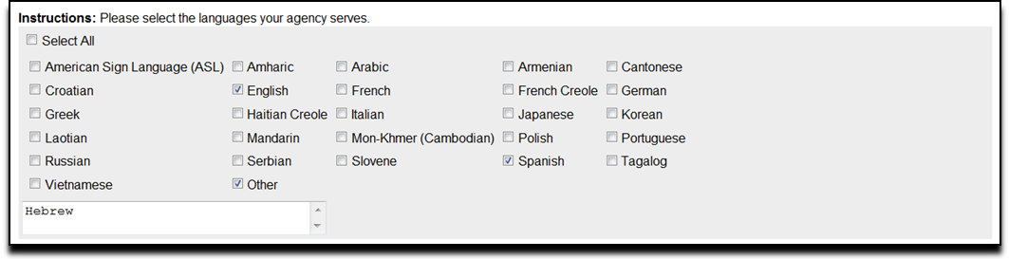

**PART 4 - LEAD AGENCY BUDGET:**

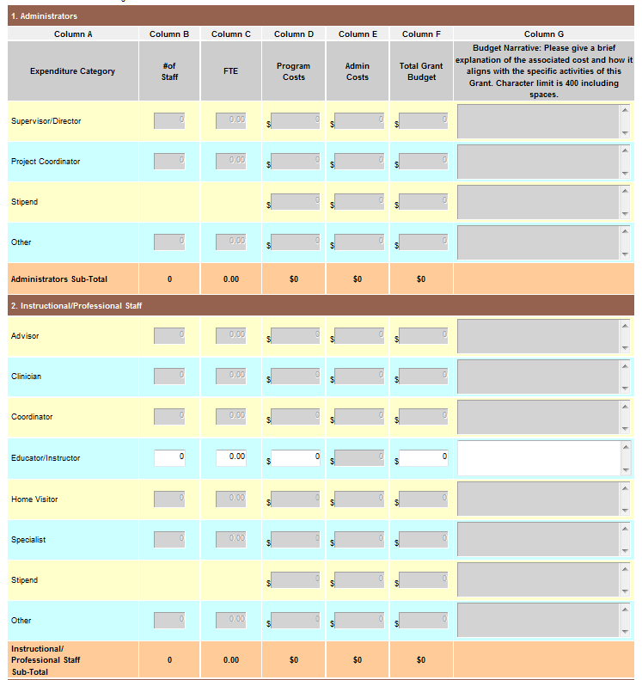

* + Please reference the fund use section within the Grant Application and **Appendix B: Budget Guidelines** to follow specific guidelines regarding the budget for this grant, including **program** and **admin** costs.
  + **Note: YOU CAN ONLY ENTER WHOLE NUMBERS INTO THE BUDGET.** Funds cannot be entered into the gray boxes as these costs are considered unallowable for this grant.
  + Error messages will appear in **RED** at the top of the Lead Agency Budget. Errors are outlines in **RED BOX(ES)** for each item that has an error. A Budget cannot be submitted with any errors.
  + Please ensure that all line items for which you claim funds have a **budget narrative** that describes how they are aligned with the purpose of the funding.
  + For all staff-related line items (#1-4), please include the **Number of Staff** and **Number of FTEs** in the corresponding columns.
    - Please note that the FTEs should not be larger than the number of staff x 1.00 FTEs.
  + For the Fringe Benefits line item (#4), please provide a narrative that includes the components of the fringe benefits, if applicable:
    - Federal Tax, State Tax, FICA, Mass Unemployment, Health Insurance, Worker's Compensation, Medicare, SUTA, Other Retirement Systems, Other.
    - If the amount is coming from another source, please provide the name of the source(s) in Budget Narrative.
  + If the 35% allocation for Fringe has been exceeded, an Alert will appear and a breakdown of fringe will need to be provided in the Budget Narrative.
    - If fringe is less or equal to 35%, provide breakdown of categories and percentages, if possible.

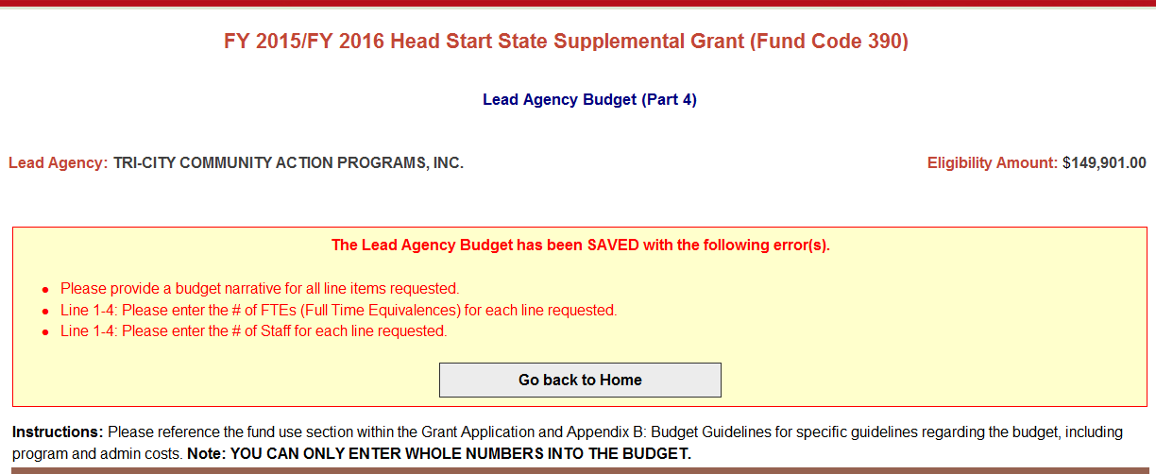



* To save your budget, you must click on of the ***Save Lead Agency Budget*** button at the bottom of the page.
* You will also have the ability to save and print your budget by clicking on ***Save and Print***.



* **PART 5 - SUBCONTRACTOR/PROVIDER BUDGET:** Once you have saved the Lead Agency budget you will have the opportunity to access the Subcontractor/Provider budget.
* Click ***Go to Subcontractor/Provider Budget (Part 5),*** if you plan to allocate a portion of your funding to subcontractors/providers.
* Add a subcontractor/providerby clicking **'*Add New Subcontractor/Provider*.'**
* Click ***Go back to Home,*** if your agency does not have any subcontractors/providers.

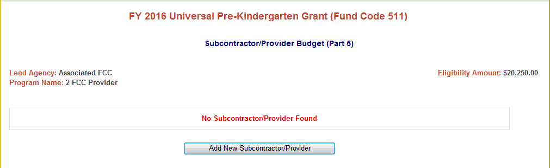

* **Subcontractor/Provider Budget:** Please refer to the Lead Agency Budget as guidance to complete the Subcontractor/Provider Budgets.

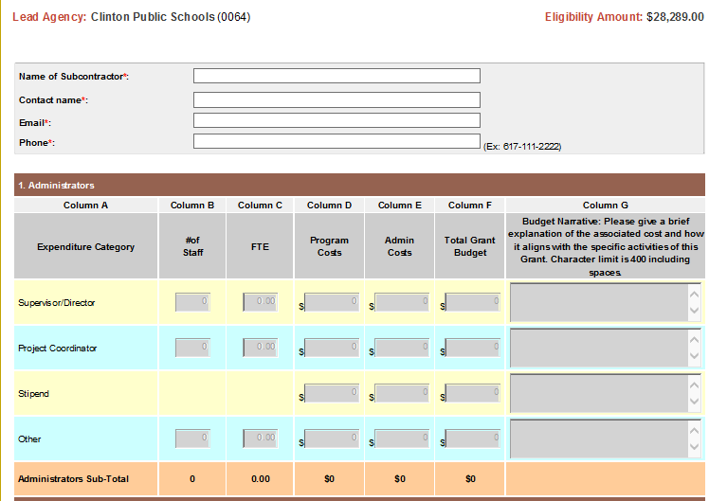

* Click ***Save Subcontractor/Provider Budget*** to save the information entered in the subcontractor budget.



* You will have the opportunity to enter 20 subcontractors/providers, if applicable.
* To add another Subcontractor, click ***Go back to Subcontractor/Provider list****.*

* **If the Eligibility amount has been exceeded, an Alert will appear on the Budget Summary. CHANGES will need to be made to the budget so that the Eligibility amount has not been exceeded.**
* **If the EEC 10% ADMIN limit has been exceeded, an Alert will appear on the Budget Summary. CHANGES will need to be made to the budget so that the 10% Admin limit has not been exceeded.**

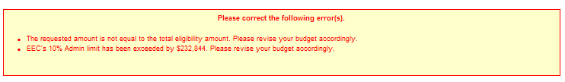

* Once you have completed the subcontractor/provider budgets, click ***Go to FY 2018 Budget Summary (Part 6).***



* **PART 6 - FY 2018 BUDGET SUMMARY:** The Budget Summary combines all line items requested in the Lead Agency Budget and all Subcontractor/provider Budgets. (**This is read-only document**).

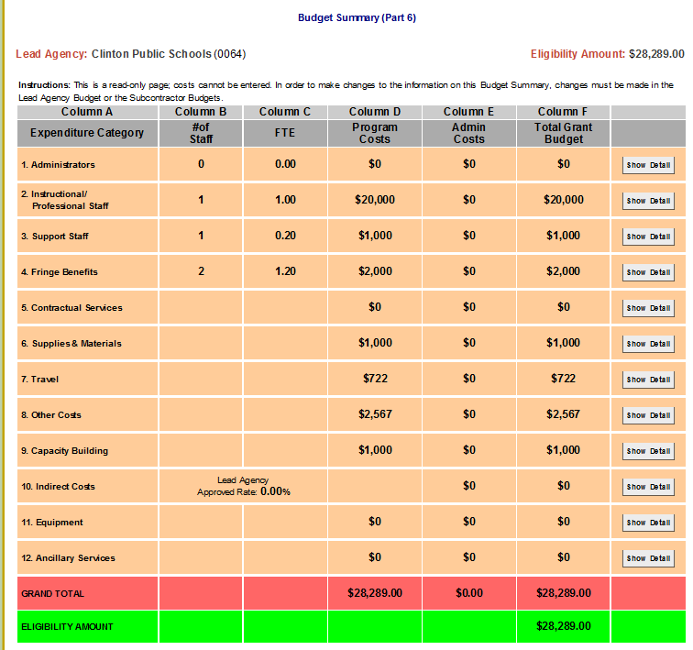

* **If the requested amount does not match the eligibility amount**, an **Alert** will appear on the Budget Summary. **CHANGES** will need to be made to the budget so that the requested amount equals the eligibility amount.
* **If the EEC 10% ADMIN limit has been exceeded**, an Alert will appear on the Budget Summary. **CHANGES** will need to be made to the budget so that the 10% Admin limit has not been exceeded.
* Once complete you will click “Go Back to Home” page.



* From the Home Page you will click on Narrative Questions – Part 7

**PART 7 - NARRATIVE QUESTIONS:** Please provide responses to all narrative questions. The character limit including spaces for each question and all of its sub-questions is 7,000. Please note: Review the PDF to ensure that your full response is included. If the full response is not visible, you have exceeded your character limit and you will need to revise your response. Please provide responses to all seven narrative questions.

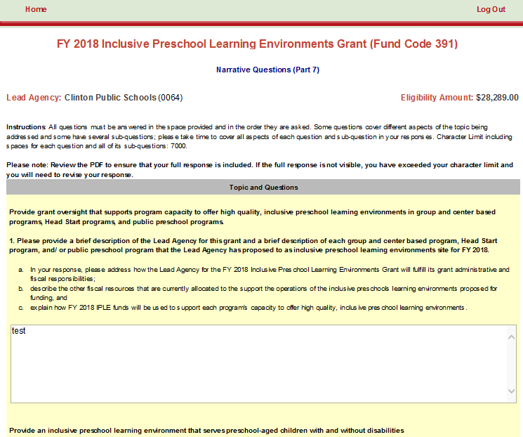

* Once you provided answers to all seven (7) questions, you will Hit the “Save Information.”



* Hit “Go to Projected Deliverables (Part 8)” to continue with application.



**PART 8 - PROJECTED DELIVERABLES: Please provide responses to sections of the Projected Deliverables.**

**See Appendix E: FY18 IPLE Projected Deliverables Guidelines**

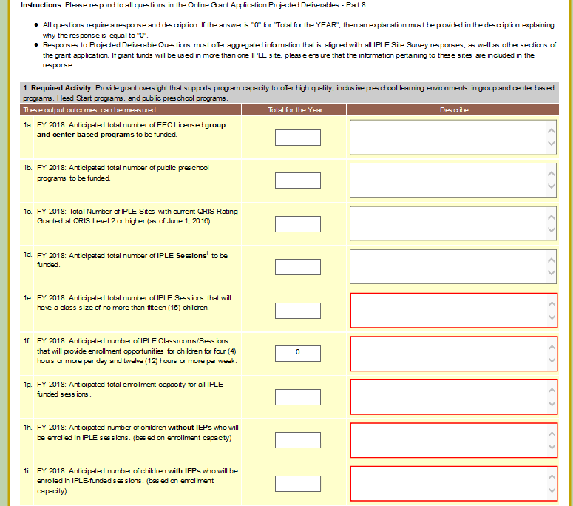

* Once you have responded to all Projected Deliverable Questions Hit “Save Information” and then proceed to “Required Grant Forms (Part 9)”.





**PART 9 - REQUIRED GRANT FORMS:**

* You must upload the following:
  + **Preschool Tuition Policies and Procedures and Preschool Tuition Sliding Scale**
  + **IPLE Site Survey Summary**
  + **IPLE Site Survey Reports**
  + **QRIS Participation Document**
  + **Indirect Cost Rate Approved Letter - Lead Agency**
  + **Indirect Cost Rate Approved Letter - Subcontractor**
* Please Note: The **Required Grant Forms** must be submitted as **hard copies** and submitted **electronically**, as these do **not** print as part of the **PDF** document. **Grant applications will be considered incomplete if both hard copies and electronic copies are not received.**

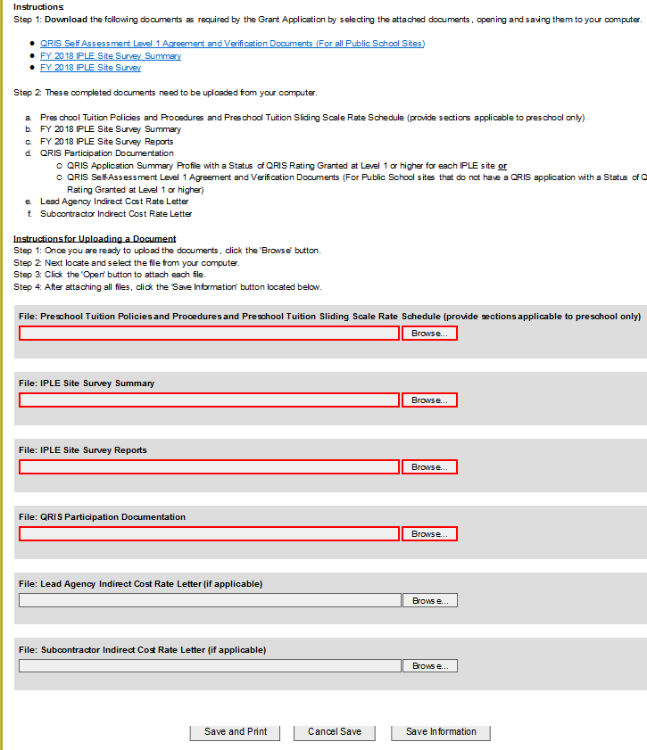

You will click “Save Information” and then Hit “Go to Checklist (Part 10)”



* **PART 10 - CHECKLIST - Please make sure that you have checked all items that were completed in the Online Application.**

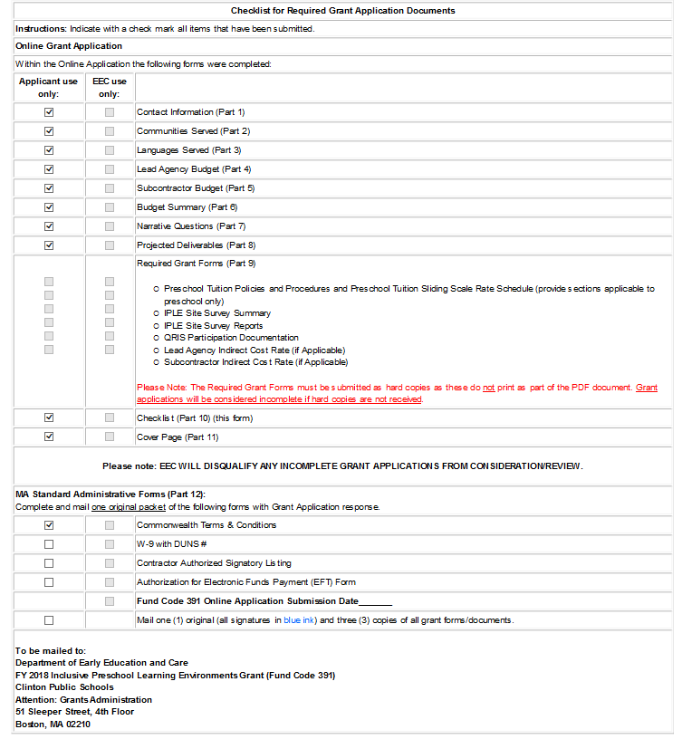

You will click “Save Information” and then Hit “Go to Cover Page (Part 11)”





* **PART 11 - COVER PAGE:** Enter the email and phone number for the primary contact of your Agency and your Federal Tax ID number.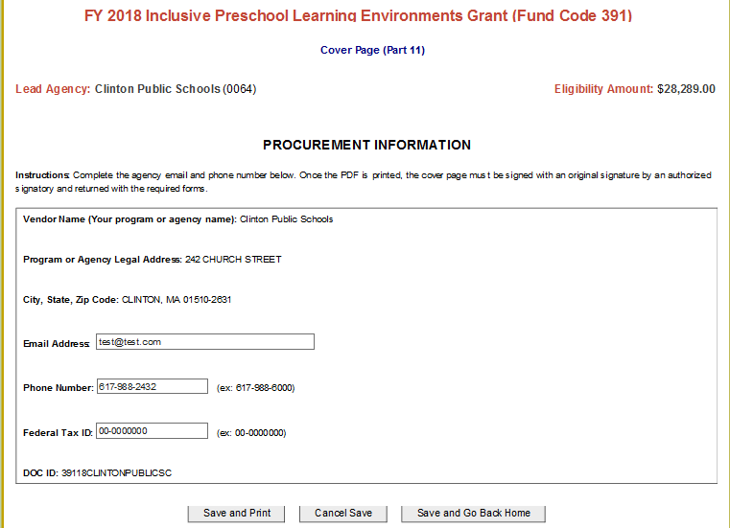
* **Please note:** Once the PDF is printed, the cover page must be signed with an original signature (**in blue ink**) by an authorized signatory.
* **PART 12 – ADMINISTRATIVE FORMS:** If you do not already have the Massachusetts Standard Administrative Forms on file with the Commonwealth, complete and mail each of the forms with the rest of your Grant Application.

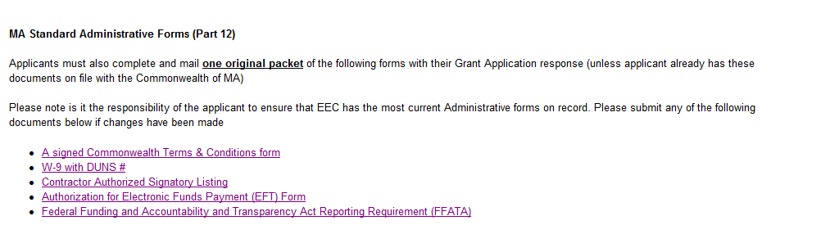

* **SUBMIT ONLINE**: Once your Online Application is complete, click ***Submit*** at the bottom of the home page to send your Online Application to EEC.



* Once submitted, an Applicant will be able to print their entire application as a PDF by clicking *Print Summary.* Please ensure that your checklist is complete and accurate at this time.
  + Please note: A **PDF** document is created once an Applicant has clicked the **SUBMIT** button and then clicked the **PRINT** **SUMMARY** button.
  + The **PDF** document **MUST** have a **SUBMISSION DATE** and **TIME** on the top of each page.

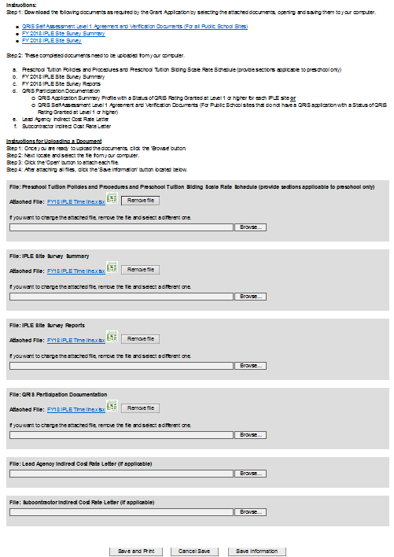

* **Obtain the appropriate signatures on the cover page (all signatures in blue ink) and additional attachments, if necessary.** With original wet signature on the Cover Page
  + *(This is the only hard copy page that can be submitted without a* ***submission******date*** *and* ***time****.)*
* Mail the printed **PDF summary and one (1) original and three (3) copies** to EEC along with any necessary administrative forms. EEC’s mailing address is displayed at the bottom of the cover page.
* Please Note: The **Required Grant Forms** must be submitted as **hard copies**, as these do **not** print as part of the **PDF** document. **Grant applications will be considered incomplete if the hard copies are not received.**