**FY 2017 EARLY CHILDHOOD SPECIAL EDUCATION ENTITLEMENT GRANT (FUND CODE 262)**

Appendix A: FY2017 Online Grant Application Portal Reference

* 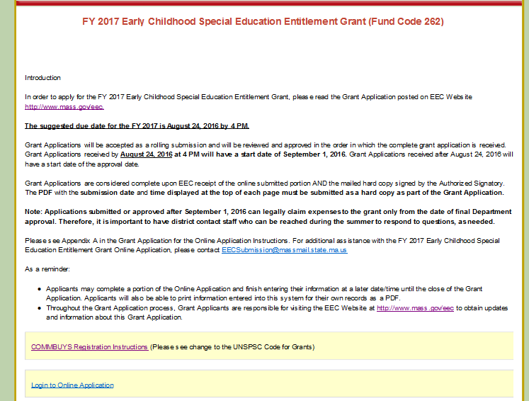Enter the Online Portal by clicking ***Complete Online Application.***
* Please note: A**ll vendors and grantees are required to register on COMMBUYS**. Please follow the COMMBUYS Registration Instructions in the FY 2017 Online application.
* You must register on COMMBUYS and select the **United Nations Standard Products and Services Code (UNSPSC) 00-00-00** for all EEC Grants. If you have already registered, please make sure you add the UNSPSC code to your registration.

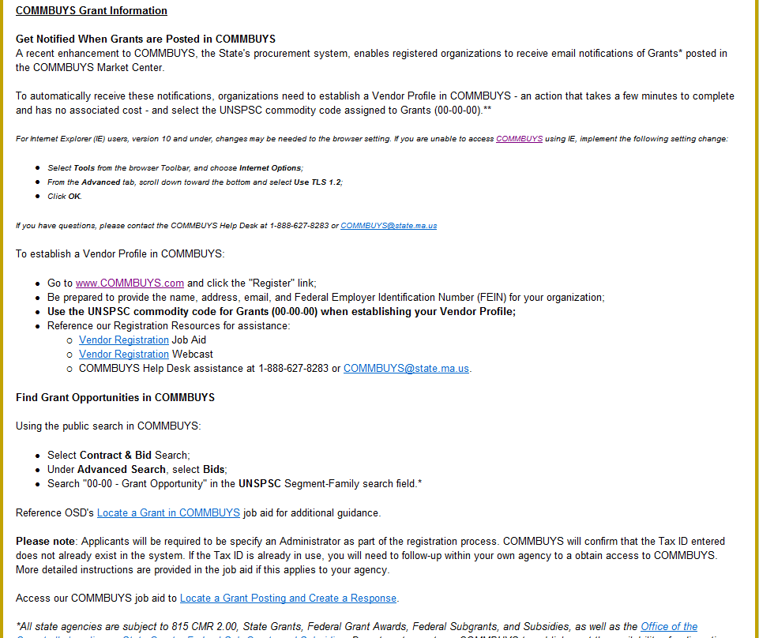

**Click on the Login to Online Application**

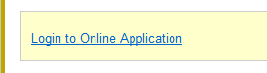

* Select your **school district** from the **drop-down menu**.

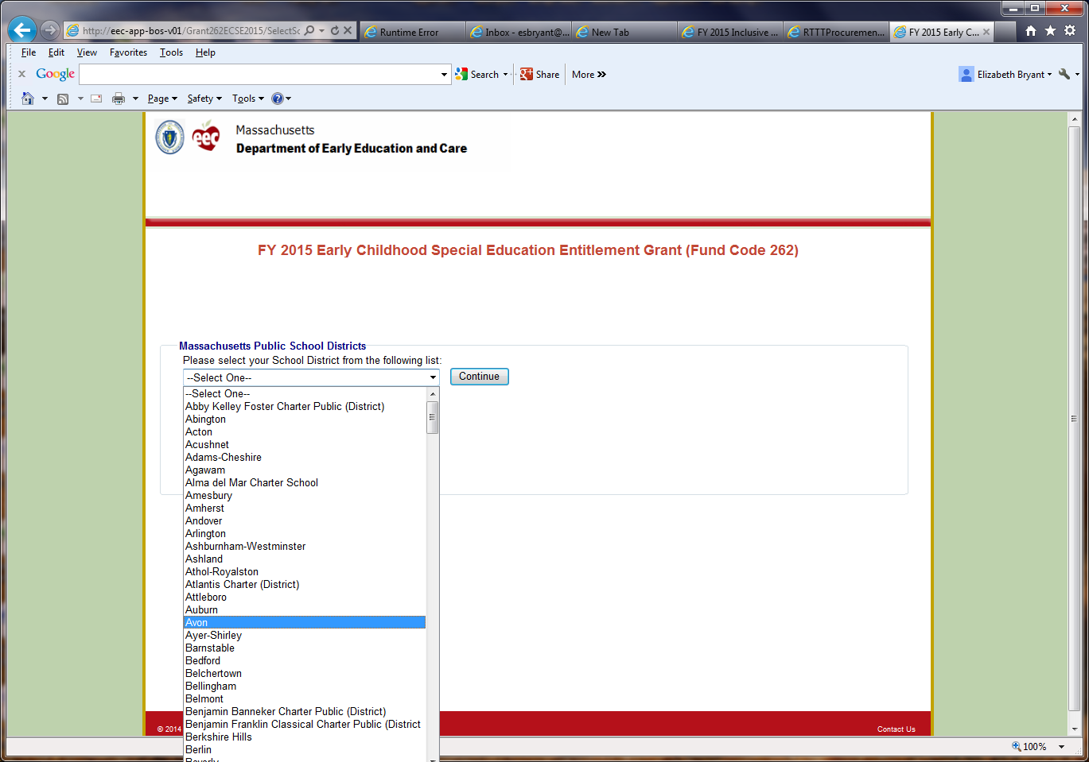

* **Create a password.** Please **write down** this **password** for your **records.** You will need this password to access your Online Application in the future.

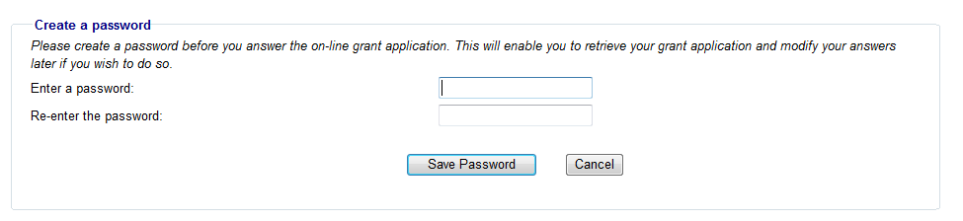

* The next time you log into the Online Application, the system will prompt you to enter your existing password.

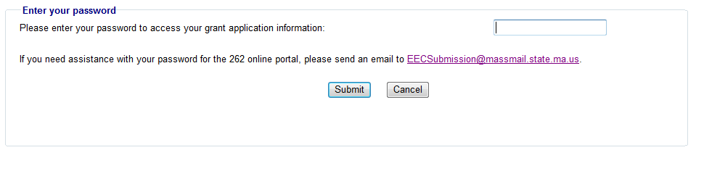

* **HOME PAGE –**

The home page provides access to each component of the application. The application consists of the following components: **Contact Information; Schedule A Form** (if applicable) **;** **Budget and Narrative; Checklist; Cover Page; Massachusetts Standard Administrative Forms;** andthe **FY17 Request for Funds Form.** The **first five components** must be **submitted both online** *and* by **mail,** and the **administrative forms must be submitted by mail if they are not already on file.**

* + As you navigate each page, use the **Save buttons** at the bottom of the page to save the information you have entered. If you do not wish to save your information, return to the Home Page by clicking the Home button in the page’s top left.

**The home page provides access to each component of the application. The application consists of the following components: contact information, Schedule A form (if applicable), budget and narrative, checklist, cover page, Massachusetts standard administrative forms, and the Request for Funds Form. The first five components must be submitted both online and by mail, and the administrative forms must be submitted by mail if they are not already on file.

As you navigate each page, use the Save buttons at the bottom of the page to save the information you have entered. If you do not wish to save your information, return to the Home Page by clicking the Home button in the page’s top left.
**

* **PART 1 – CONTACT INFORMATION:** Complete all contact information.

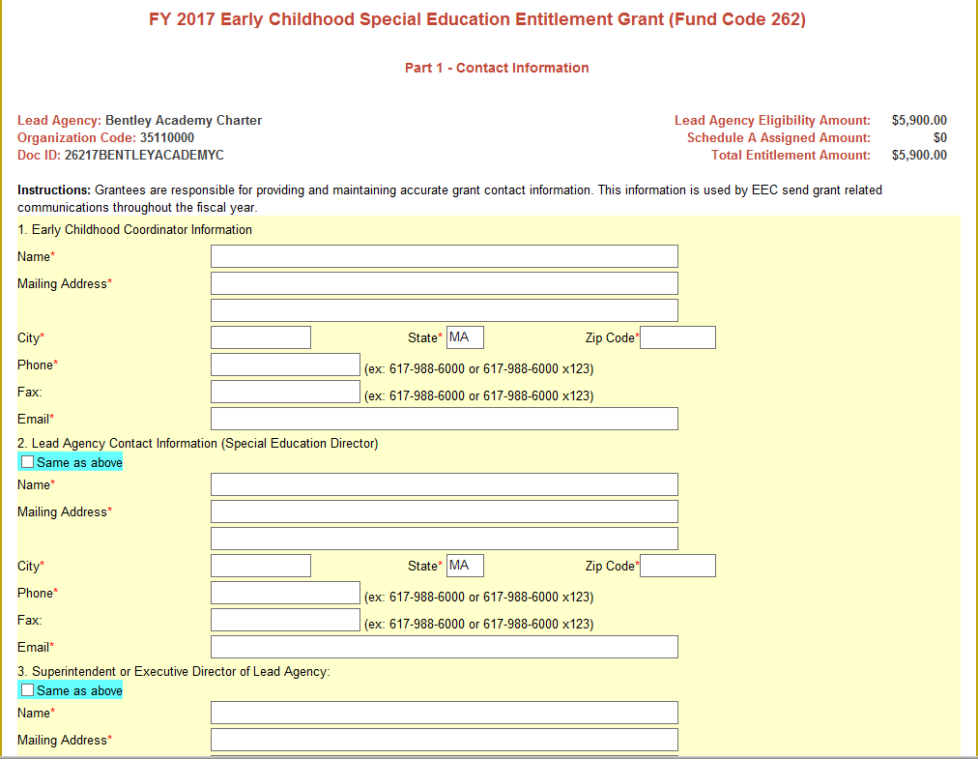

* **PART 2 – SCHEDULE A:** If you operate and administer this grant project using funds assigned to more than one agency, complete the Schedule A form. The authorized signatures should be submitted in the mailed copy of the application.
* If the Lead Agency is only requesting funds associated to their lead agency amount listed on the FY 2017 ECSE Entitlement Allocation List, then the Schedule A Form must remain blank. Please click, "Cancel Save" to return to the Home Page.

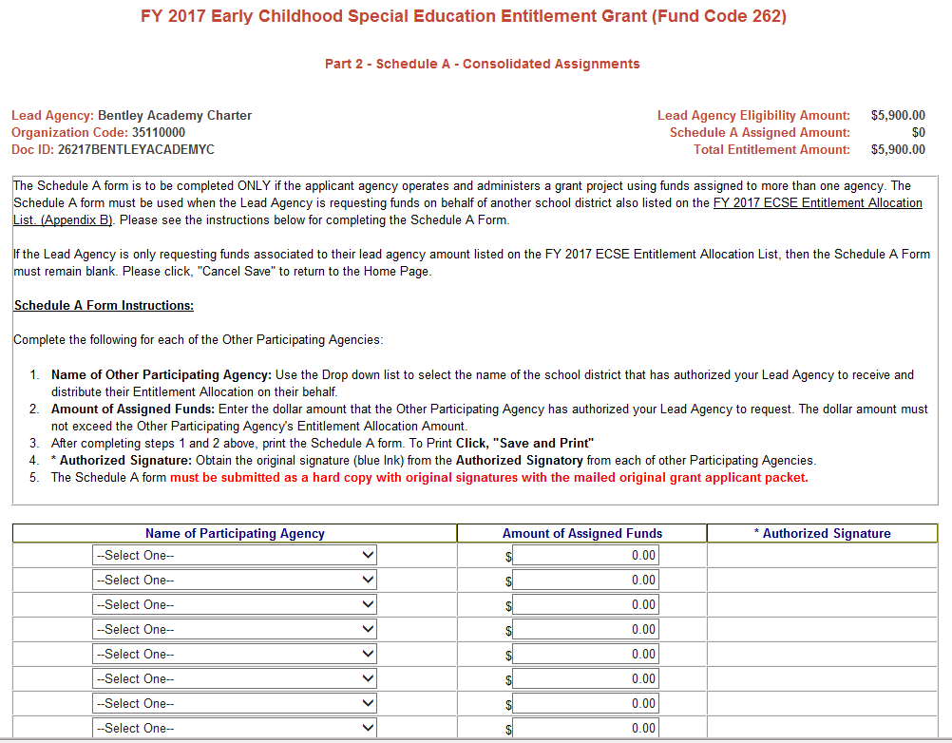

**Schedule A Form Instructions:**   
Complete the following for each of the Other Participating Agencies:

1. **Name of Other Participating Agency:** Use the Drop down list to select the name of the school district that has authorized your Lead Agency to receive and distribute their Entitlement Allocation on their behalf.
2. **Amount of Assigned Funds:** Enter the dollar amount that the Other Participating Agency has authorized your Lead Agency to request. The dollar amount must not exceed the Other Participating Agency's Entitlement Allocation Amount.
3. After completing steps 1 and 2 above, print the Schedule A form. To Print **Click, "Save and Print"**
4. **\* Authorized Signature:** Obtain the original signature (blue Ink) from the **Authorized Signatory** from each of other Participating Agencies.

The Schedule A form **must be submitted as a hard copy with original signatures with the mailed original grant applicant packet.**

* **PART 3 – BUDGET DETAIL AND NARRATIVE:**

Use Column A for activities to be conducted between 9/1/2016 -6/30/2017.  
Use Column B for activities to be conducted between 7/1/2017 -8/31/2017.  
  
Budget Narrative: Provide a Budget narrative that clearly describes the proposed use of these federal entitlement funds that includes a brief explanation of each expenditure and how it aligns with the specific activities of the grant.

Please ensure that all line items for which you claim funds have a budget narrative that describes how they are aligned with the purpose of the funding. **Budgets without narratives will not be approved.**

Please ensure that all line items for which you claim funds have a budget narrative that describes how they are aligned with the purpose of the funding. Budgets without narratives will not be approved. For all staff-related line items (#1-4), please include the Number of Staff and Number of FTEs in the corresponding columns. For line items 1-3, selecting “Yes” for MTRS will automatically fill in an amount equal to 9% of the salaries in the MTRS sub-lines and in the MTRS line item (#6). For the fringe benefits line item (#5), please provide a narrative that includes the number of staff receiving fringe benefits and the components of the fringe benefits, such as health insurance, life insurance, county retirement program, unemployment insurance, etc.


* For all staff-related line items (#1-4): please include the **Number of Staff** and **Number of FTEs** in the corresponding columns.
* For line items 1-3, selecting “Yes” for MTRS will automatically fill in an amount equal to 9% of the salaries in the MTRS sub-lines and in the MTRS line item (#6).
* For the fringe benefits line item (#5): please provide a narrative that includes the number of staffreceiving fringe benefitsand the components of the fringe benefits, such as health insurance, life insurance, county retirement program, unemployment insurance, etc.
* Instructional Supplies and Materials: provide a description of the types and kinds of materials you intend to purchase, quantity and cost per units should be included.
* Non-Instructional Supplies and Materials: provide a description of the types and kinds of materials you intend to purchase. , quantity and cost per units should be included as appropriate.
* Indirect Costs: Public School Districts and Public Schools do not need an Indirect Cost Rate approval letter, as the Restricted Indirect Cost Rate is provided by DESE ([DESE-Indirect Cost Information](http://www.doe.mass.edu/grants/essential.html%20%20%20%20) ) . Please enter the approved indirect cost rate. The dollar amount requested must not exceed the your approved Restricted Indirect Cost rate.
* To save your budget, you must click the ***Save Budget Information*** button at the bottom of the page. **If the “FY17 TOTAL AMOUNT REQUESTED”** does not equal the **“262 Entitlement AMOUNT”,** you will not be able to submit your budget.
* You will also have the ability to save and print your budget by clicking on ***Save and Print*.**



* If you request **Schedule A funds,** these funds will be added to your entitlement amount. You should include these funds in your budget so that the **“FY17 TOTAL AMOUNT REQUESTED”** will still **equal** the **“262 Entitlement AMOUNT”.**
* **PART 4 – CHECKLIST -** As you complete each part of the application, check it off on the **checklist.**

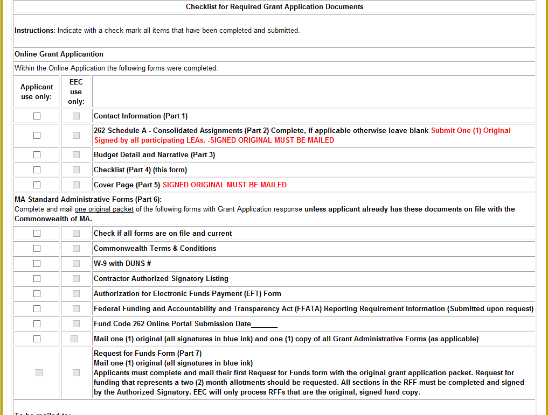

**PART 5 – COVER PAGE:** Please complete the **Grant Contact Name**, **Email Address**, **Phone Number** and **Federal Tax ID**.

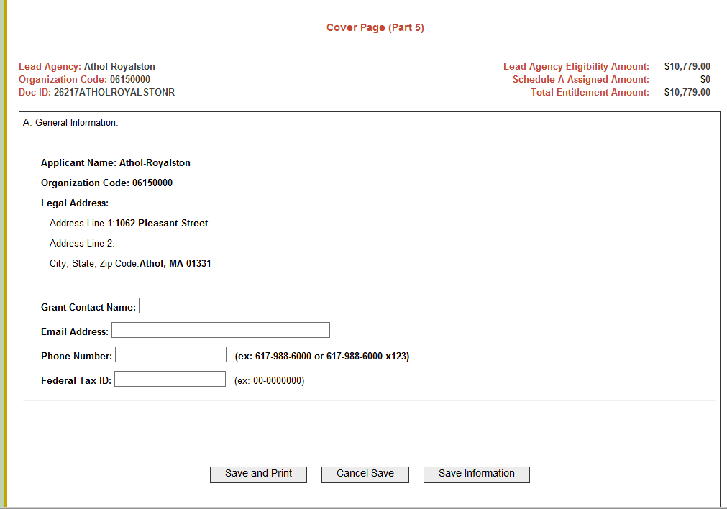

* **PART 6 – ADMINISTRATIVE FORMS:** If you do not already have the Massachusetts Standard Administrative Forms on file with the Commonwealth, complete and mail each of the forms with the rest of your Grant Application. Please note is it the responsibility of the applicant to ensure that EEC has the most current Administrative forms on record. Please submit any of the following forms below if there have been any changes to the information (address or New Superintendent).
* **PART 7 – REQUEST FOR FUNDS FORM:** Applicants must complete and mail their first Request for Funds (RFF) form with the original grant application packet.
* To determine your 2 month allotment dived the entitlement amount by 5.
* If you have requested MTRS, Subtract the 80% of the MTRS- which is paid by EEC, from the entitlement amount , then to determine your 2 month allotment divide balance of the entitlement amount by 5.

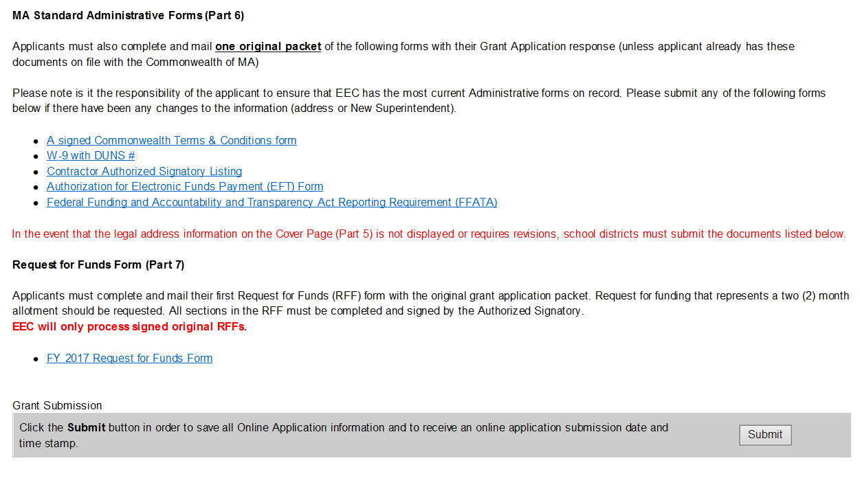

* **SUBMIT ONLINE:** Once your Online Application is complete, click ***Submit*** at the bottom of the home page to send your Online Application to EEC. **You must click the SUBMIT button in order for your Online Application to be submitted to EEC.**

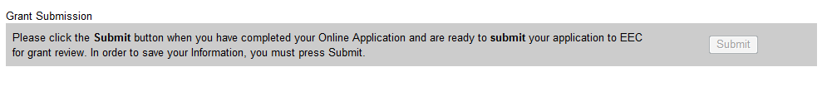

* In order to get the entire PDF, you click the **SUBMIT** button and then click the **PRINT SUMMARY** button.

**In order to get the entire PDF, you click the SUBMIT button and then click the PRINT SUMMARY button. You must have a submission date and time on the top of each page. The cover page is the only hard copy page that can be submitted without a submission date and time.
**

* **Please note:** Once the PDF is printed, the cover page must be signed with an **original signature (in blue ink) by an authorized signatory**.
  + You must have a **submission date** and **time** on the top of each page.
  + The cover page is the only hard copy page that can be submitted without a **submission** **date** and **time**.

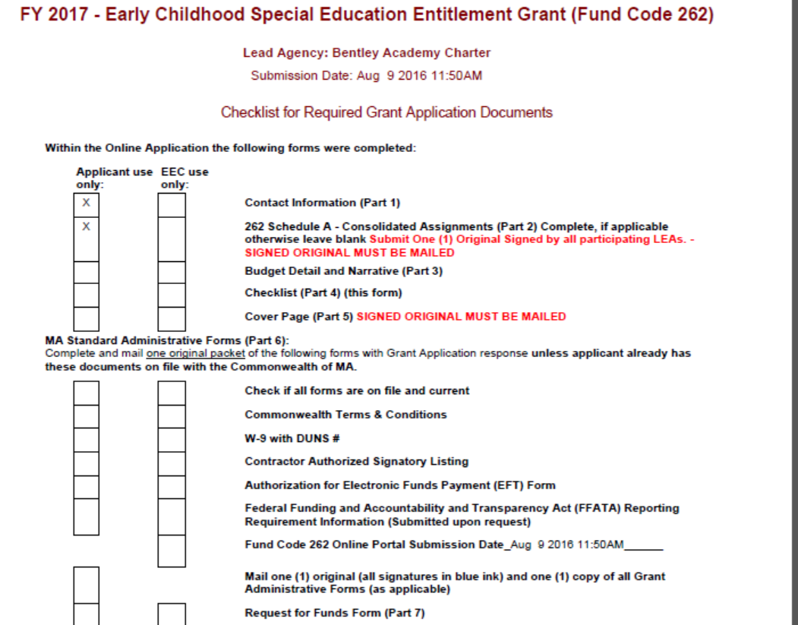

* To alert EEC of your grant submission, please email [EECSubmission@massmail.state.ma.us](mailto:EECSubmission@massmail.state.ma.us) with the subject line "FY17 262 Grant Online Submission Confirmation - Insert Your School District Name".
* Obtain the appropriate signatures on the Cover page, the MA Standard Administrative Forms, andtheRequest for Funds Form (RFF). All original signatures must be in blue ink.
* **To be mailed:**
  + One (1) signed original and one (1) copy of the entire PDF of the 262 Online Application. **The PDF must be submitted as a hard copy as part of the Grant Application.** Your hard copy must have a **SUBMISSION DATE & TIME** on the top of each page.
  + One (1) signed original of each MA Standard Administrative Form (as applicable)
  + One (1) signed original of the first Request for Funds Form (RFF)

**Mail Entire Grant Application Packet to:**

**Department of Early Education and Care  
FY 2017 Early Childhood Special Education Entitlement, District Name  
Attention: Cathy Kelley, Grants Administration  
51 Sleeper Street, 4th Floor  
Boston, MA 02210**