Strategy for Utilization of Carbon Reduction Program Formula Funding

Table of Contents

Table of Contents 2

Purpose 3

Carbon Reduction Program (CRP) formula funding 3

Supporting the Commonwealth's climate change response 3

Eligible programs 4

Allocation of CRP funds to programs and projects 14

Evaluating impacts of CRP funds 15

Projects programmed with CRP funds 16

# Purpose

Federal law requires the Massachusetts Department of Transportation (MassDOT) to create a Carbon Reduction Strategy (CRS). The purpose of this strategy is to enable the funding of Carbon Reduction Program (CRP)-eligible programs and projects outlined below.

# Carbon Reduction Program (CRP) formula funding

The Infrastructure Investment and Jobs Act (IIJA) (Public Law 117-58, also known as the “Bipartisan Infrastructure Law” (BIL)) was passed in November 2021 and authorized a new Carbon Reduction Program. The CRP, codified in 23 United States Code (U.S.C.) 175, provides federal formula funds for projects designed to reduce transportation emissions, which the law defines as “carbon dioxide (CO2) emissions from on-road highway sources.”[1] The estimated 5-year total of federal CRP funds for Massachusetts is $93.7 million.[2] The federal fiscal year (FFY) apportionment of CRP funds is detailed in the Federal Funding Overview chapter under the Highway Funding Programs section. All projects funded with CRP funds will be included as a line item in the “2024-2028 Investment Tables: Highway” section.

# Supporting the Commonwealth's climate change response

Massachusetts has a well-established legal and policy framework for mitigating climate change. The Global Warming Solutions Act (GWSA) was signed into law in August 2008 and required the establishment of economy-wide greenhouse gas (GHG) emission reduction targets for the Commonwealth.[3] The GWSA was amended in 2021 by An Act Creating A Next-Generation Roadmap for Massachusetts Climate Policy, which established new interim goals for emissions reductions.[4]

The Clean Energy and Climate Plan for 2025/2030 (CECP) is a roadmap of actions for all sectors in the Commonwealth, including transportation, to reach emissions reduction goals required by the GWSA. The CECP was developed with the support of extensive stakeholder input and sophisticated economy-wide modeling, including the 2050 Roadmap Study which scoped eight pathways that examined potential annual energy supplies necessary to serve projected demand in all sectors in the Commonwealth while achieving net zero emissions by 2050.[5]

Informed by the 2050 Roadmap Study, sector specific GHG emissions sublimits were set. Transportation sublimits for 2025, 2030, and 2050 are 18%, 34%, and 86% below the 1990 level, respectively.[6]

**Aligning the use of CRP funds with the CECP**

The CECP describes a wide range of policies to reduce emissions in the transportation sector. These include actions across government to: regulate for increased sales of clean vehicles; reform zoning to encourage housing production near transit; issue subsidies for e-bikes, zero-emission passenger vehicles, and medium and heavy-duty vehicles; electrify school buses; provide technical support for fleet operators and changes to building codes to facilitate electric vehicle (EV) charging.

Consistent with MassDOT’s function as an investor in transportation infrastructure, the CECP includes a role for MassDOT and the Massachusetts Bay Transportation Authority (MBTA) to:

1. Support the electrification of public transit buses.
2. Expand programs that make the Commonwealth's streets more complete.
3. Build fast charging along major highway corridors.

# Eligible programs

MassDOT’s approach to the use of CRP funds will be to allocate them between programs that deliver on these priorities.

**Supporting the electrification of public transit MBTA and Regional Transit Authorities (RTAs) buses**

MBTA and Regional Transit Authorities (RTAs) bus ridership was approximately 80 million unlinked passenger trips in 2021.[7] Transitioning the Commonwealth’s public transit buses from fossil fuel-powered to zero-emission fleets will help reduce transportation emissions, improve air quality, and provide low-emissions transportation alternatives to millions of bus riders in the Commonwealth. To support this transition, the CRS enables the use of CRP funds for the MBTA’s and RTAs’ procurement of zero-emission public transit buses and charging infrastructure.

**MBTA Bus Modernization Program**

The MBTA is working to convert its entire bus fleet to battery electric buses and build new fleet maintenance facilities equipped with electric charging infrastructure by 2040. The MBTA’s current bus fleet includes both 40- and 60-foot buses with a mix of propulsion types, detailed in the table below. The MBTA currently has nine bus maintenance facilities in Quincy, Arborway, Fellsway, Lynn, Albany, North Cambridge, Cabot, Southampton, and Charlestown illustrated in Figure 1. The MBTA conducted an in-depth evaluation to instruct the scale and sequencing of facility modernization investments. Replacements for Quincy and Arborway as well as a small-scale retrofit for North Cambridge are prioritized in the first round of modernization updates between 2025 and 2028. By 2040, the MBTA targets upgrades for Charlestown, Cabot, Southampton, and a new facility consolidating Albany and North Cambridge.

This strategy intends that CRP funds will be available to program for procuring zero-emission public transit MBTA buses and charging infrastructure for the MBTA’s Bus Modernization program.

Analysis for the MBTA found that 47% of systemwide bus riders are considered minorities and 42% have low incomes. MBTA bus riders represent a much greater share of minority and low-income riders compared to other modes of transportation.[8] The MBTA prioritized community involvement when developing its bus electrification and facility modernization plans. Additionally, to accelerate emissions reductions in historically marginalized communities, the MBTA used American Community Survey (ACS) data to identify the percentages of people of color and low-income households in service areas to guide the development of the MBTA bus electrification and facility modernization prioritization plans. Zero-emission MBTA buses have the potential to improve the health conditions and transportation options of bus riders and residents who live in service areas in the Commonwealth.[9]

**MBTA’s 2022 bus fleet by fuel type**[10]

|  |  |
| --- | --- |
| **Propulsion type** | **Number of active buses** |
| Diesel | 368 |
| Hybrid | 568 |
| CNG | 175 |
| Battery-Electric | 5 |
| DMA (Dual Mode) | 32 |
| Total number of active buses | 1,148 |

**Figure 1: MBTA bus facilities and bus capacity**[11]

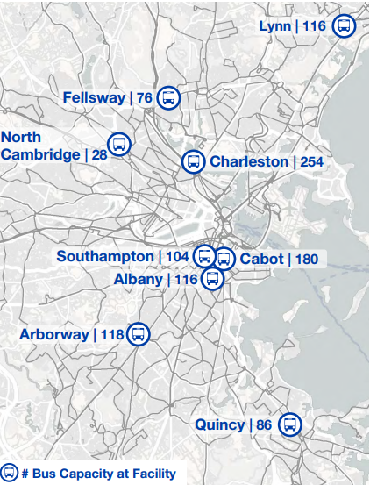

**RTA fleet and facility upgrade programs**

The 15 RTAs in the Commonwealth, displayed in Figure 2, tailor their services to meet local needs and provide essential public transit options to the 270+ cities and towns outside the limits of the MBTA. RTAs offer fixed-route and paratransit services, and some provide additional amenities, such as long-distance medical shuttles to Boston.[12] According to the NTD, the 15 RTAs operate approximately 644 transit buses.[13] Figure 3 shows the percentage of RTA fixed-route bus fleets by fuel type. MassDOT Rail and Transit Division’s (RTD) key transit capital investment priority is to ensure RTA fleets and facilities remain in a State of Good Repair (SGR).

This strategy intends that CRP funds will be available to program for procuring zero-emission public transit RTA buses and appropriate charging infrastructure, to support RTAs transitioning towards cleaner vehicle fleets.

RTA networks cover a large part of the Commonwealth and provide essential transportation services to residents, specifically to riders who are disproportionately low-income, identify as minorities, and are more likely to rely on public transit to get to work, school, and essential services. For example, a 2019 Southeastern Regional Transit Authority (SRTA) report found that 47% of passengers identify as minorities, 47% percent identify as low-income, and a majority of customers use the SRTA bus services several times per week.[14] Enabling the use of CRP funds for zero-emission RTA buses and charging infrastructure offers the potential to expand more clean bus services to and improve air quality in disadvantaged communities.

**Figure 2: Regional Transit Authorities in Massachusetts**[15]

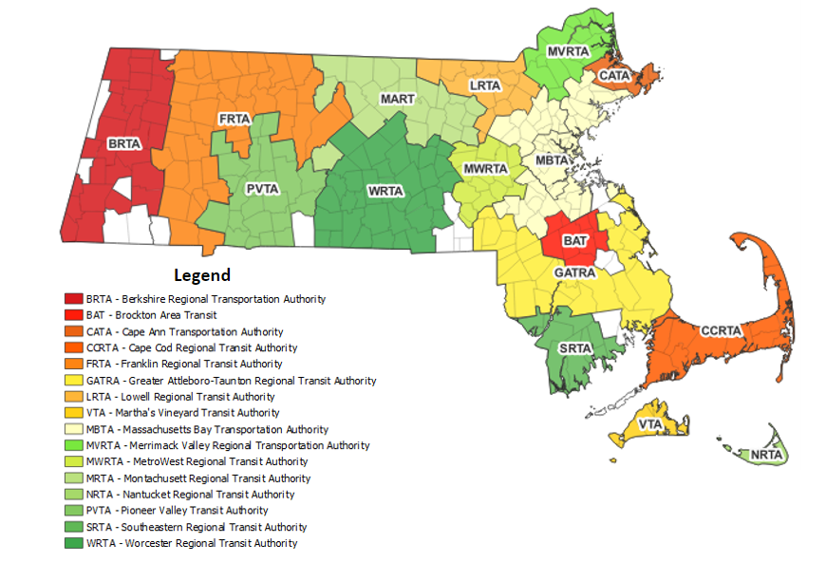

**Figure 3: Percentage of RTA fixed-route fleets by fuel type**[16]

**Making the Commonwealth’s streets more complete**

Complete streets are streets designed and maintained to allow safe, comfortable, and accessible travel for all people and transportation modes.[17] MassDOT emphasizes the value of considering the needs of all modes of transportation by prioritizing complete street enhancements in both the Statewide Bicycle Transportation Plan and Statewide Pedestrian Transportation Plan.

This strategy intends that CRP funds will be available to program for infrastructure projects that deliver more complete streets, specifically under the Complete Streets Funding Program and the Safe Routes to School (SRTS) Program. Together, these CRP-eligible programs help reduce transportation emissions by making the Commonwealth’s streets more accessible, connected, and safer for bicyclists, pedestrians, and public transit users through investments in infrastructure for low and zero-carbon transportation modes.

Complete streets can help address disproportionate burdens of higher rates of traffic incidents, air pollution, and a lack of connected transportation networks experienced by underserved populations.[18] Complete streets policies and programs help to address these issues because the design concept prioritizes the unique needs of users, safety, comfortability, and connectivity for all people and transportation modes. If implemented correctly, the results can include safe, accessible, and equitable transportation networks.

**Complete Streets Funding Program**

MassDOT’s Complete Streets Funding Program is a state-funded initiative that provides municipalities with technical assistance and construction funding to address critical network gaps and advance complete streets on local roadways. The program encourages long-term change by requiring municipalities to adopt a complete streets policy and Prioritization Plan before receiving project funding.[19] Since its inception in 2016, 288 municipalities have registered with the Complete Streets Funding Program and 245 individual projects have been funded.[20] Figure 4 illustrates the broad municipal participation in the program.

The intent of this strategy is to enable the use of CRP funds to expand MassDOT’s Complete Streets Funding Program by providing additional construction project funding. The CRP funding would allow the program to approve projects that otherwise may not be funded due to existing budget constraints. Eligible projects include new or expanded pedestrian and bicycle facilities, traffic calming, intersection redesign, transit improvements, streetscape investments, and more. The program accepts and reviews project applications twice per fiscal year.

MassDOT’s Complete Streets Funding Program allocates at least one-third of program funding to communities with income levels below the statewide median household income.[21] The Complete Streets Funding Program also encourages municipalities to include equity as an evaluation criterion in their Prioritization Plans and facilitate a proactive local public engagement approach to ensure collective, community involvement in policy and planning decisions. Expanding this program will provide more opportunities for municipalities to implement complete streets projects that prioritize equity in their communities.

**Figure 4: Complete Streets Funding Program participation**[22]

**Safe Routes to School (SRTS)**

MassDOT’s SRTS Program is a federally funded initiative that utilizes six e’s to implement its program: education, encouragement, engagement, evaluation, engineering, and equity.[23] The infrastructure project funding component of the program comprises the engineering element of the “six e’s” strategy and facilitates infrastructure projects that serve students who commute to school by walking, biking, or using a wheeled mobility device.[24] SRTS seeks to reduce transportation emissions and traffic congestion near schools while promoting a collaborative, community-focused approach to increasing active transportation for students in kindergarten through twelfth grade across the Commonwealth. SRTS serves over 463,000 students at partner schools and has 72 completed and/or in progress infrastructure projects since the program’s inception in 2005.[25] Figure 5 illustrates school participation in the SRTS program across the Commonwealth, which accounts for over 70% of Massachusetts public and charter K-8 schools.

The intent of this strategy is to enable the use of CRP funds to expand MassDOT’s SRTS program, specifically the infrastructure project funding component.

Allocation of resources is determined by greatest need and the SRTS Outreach team encourages communities that score higher on the SRTS Equity Prioritization scale (that assesses four equity indicators: economically disadvantaged students, students with a disability, students identified non-White or Hispanic, and students with limited English proficiency) to become SRTS partners and apply for infrastructure funding.[26]

**Figure 5: SRTS school participation in the Commonwealth**[27]

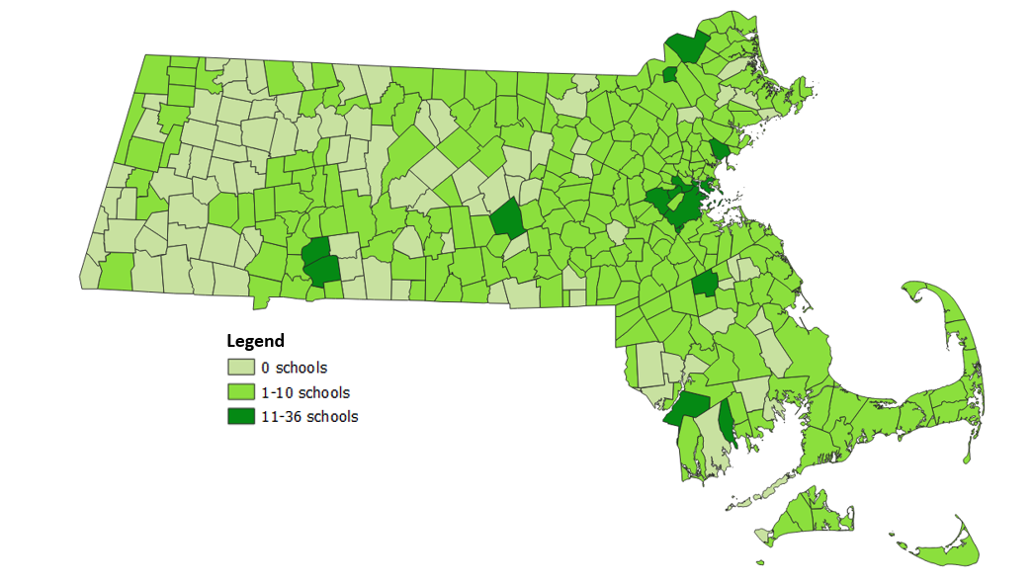

**Building out fast charging along major highway corridors**

The 2025/2030 CECP emphasizes the importance of expanding EV adoption in the Commonwealth to achieve emissions limits. Enabling the use of CRP funds to build out a complete, financially stable, reliable, and equitable network of fast charging along major highway corridors will help reduce EV range anxiety of potential EV owners.

**The National Electric Vehicle Infrastructure (NEVI) Program Deployment Plan**

MassDOT’s National Electric Vehicle Infrastructure (NEVI) Deployment Plan (NEVI Plan), approved by the Federal Highway Administration (FHWA) on September 14, 2022**,** describes how MassDOT will use NEVI funds to fill gaps in high-quality direct current fast charging (DCFC) infrastructure along major highway corridors and invest in corridor segments where gaps have been identified between supply and projected fast charging demand.[28] Figure 6 displays the federally designated EV Alternative Fuel Corridors (AFCs) in Massachusetts, which serve as the basis for the implementation of the NEVI Plan.

The intent of this strategy is that CRP funds will be available to program for the provision of fast charging equipment along major highway corridors in accordance with MassDOT’s NEVI Plan.

Equity considerations are built into MassDOT’s NEVI Plan. During the sixth round of nominations for the alternative fuel corridors, MassDOT used proximity to environmental justice (EJ) communities as a corridor selection criterion and the NEVI Plan considered proximity to EJ communities when prioritizing which corridors to invest in. One of the four core goals in MassDOT’s NEVI Plan is to provide disadvantaged communities with access to DCFC for long-distance travel that meets or exceeds the access to DCFC of non-disadvantaged communities. The NEVI Plan development process also included various outreach methods to gather input from the general public, underserved communities, and various other stakeholder groups.

**Figure 6: EV Alternative Fuel Corridors in Massachusetts**[29]

# Allocation of CRP funds to programs and projects

The allocation of CRP funds between eligible programs will vary year-to-year and depend on the demand for projects under each program.

The distribution of CRP funds relies on existing channels for eligible programs and project types as described below. The CRS is not creating a new competitive grant application process.

**MBTA and RTA fleet and facility modernization programs**

The MBTA’s Capital Investment Plan (CIP) is a short-term, financially constrained investment program that includes all projected capital expenditures for the next five years. It is a rolling plan that is updated annually. Internal departments submit funding requests to Capital Program Planning, which are then scored, prioritized, and ultimately funded based on the amount of funding expected to be available in the next five years. The MBTA CIP includes a bus modernization program and several distinct projects that contribute to this goal, including battery electric bus procurements and facility upgrades or replacements.

The Commonwealth’s RTAs work with MassDOT’s RTD to develop capital requests. When an RTA submits a capital request for zero-emission transit buses and/or charging infrastructure, the RTA works with RTD to submit their capital requests into MassDOT’s preliminary STIP. Once the capital request is approved in the CIP, the project is programmed under the CIP Fleet Upgrades Program or the CIP Facility and System Modernization Program.

**Complete Streets Funding Program**

To join the Complete Streets Funding Program, municipalities must attend a complete streets training, develop and pass a Complete Streets Policy, and establish a Prioritization Plan. MassDOT reviews and scores the submitted Complete Street Policies using a public scoring rubric to ensure the policy meets MassDOT and national best practice standards. MassDOT also evaluates the Prioritization Plan based on completeness and project eligibility. Once the policy and Prioritization Plan are approved, municipalities can apply for complete streets project funding. The program accepts applications for project funding twice per fiscal year. Applications are reviewed by a committee of both MassDOT District and Headquarters staff. The most competitive projects are approved for funding as the program budget allows.[30]

**Safe Routes to School Program**

Schools that receive public funding (including Charter schools) in Massachusetts are eligible to apply for SRTS infrastructure project funding. Schools interested in applying must first participate in the non-infrastructure program by completing education, encouragement, engagement, and evaluation activities. After six months of being a SRTS partner, eligible schools can apply for infrastructure project funding. Eligible projects must be within two miles of a school, meet the objectives of the SRTS Program, and satisfy specific design requirements outlined in the MassDOT Engineering Directive, “Controlling Criteria and Design Justification Process for MassDOT Highway Division Projects.”[31] Applications are then reviewed and scored by the Project Selection Committee.[32]

**NEVI Plan implementation**

MassDOT’s solicitation for NEVI implementation is currently in development. MassDOT intends to partner with a private entity to construct, maintain, and operate DCFC equipment to serve long-distance travel corridors in Massachusetts through a competitive solicitation process.[33]

# Evaluating impacts of CRP funds

MassDOT and the Commonwealth’s MPOs consider GHG impacts during project selection processes and report on estimated GHG impacts of the projects in Transportation Improvement Plans (TIPs) and the STIP. The GHG emissions impacts of STIP investments are reported in the GHG appendix of the STIP. This will be the case for projects funded with CRP funds.

MassDOT investments in GHG reducing projects have a median levelized cost of CO2 (LCC) between $1,800-$17,000 per metric ton of CO2.[34] This suggests that once programmed, MassDOT’s annual CRP apportionment of approximately $22 million per fiscal year will reduce emissions by approximately 1,200-12,000 metric tons of CO2, assuming all projects funded are additional. The Commonwealth’s total on-road transportation sector CO2 emissions were approximately 23.8 million metric tons in 2021.[35]

MassDOT’s efforts to ensure that the benefits of transportation investments are spread equitably across the Commonwealth’s communities will also apply to CRP funds. Before MassDOT’s CIP is approved, an equity analysis is conducted to evaluate all MassDOT and MBTA investments per capita at the municipality and census tract levels.[36] This analysis determines if the CIP equitably distributes investments among minority, low-income, and Limited English Proficient (LEP) populations. The CIP also describes how MassDOT works to ensure an equitable regional distribution of investments across the Commonwealth.

These existing mechanisms will support consideration of GHG impacts of CRP-funded projects and equitable distribution of funds.

In addition, 65% of Massachusetts' Carbon Reduction Program apportionment is sub-allocated by urbanized area (UZA), including to rural and small urban areas. The anticipated annual apportionments of these funds appear in the Fiscal Constraint Analysis and the Highway Funding Categories and Assumptions sections of the STIP.

# Projects programmed with CRP funds

This section of the strategy updates MassDOT’s CRS with a description of projects that were programmed with CRP funds in prior fiscal years, and that no longer appear in the current STIP. These are listed below:

**FFY24 programmed projects**

MassDOT’s FFY 2024-2028 STIP programmed CRP funds for two projects in FFY24. The first project is an MBTA investment in the Quincy Bus Facility to create a battery electric bus charging and maintenance facility. The Boston MPO Region flexed $20,551,211 of Boston Urbanized Area CRP highway funds to the Federal Transit Administration (FTA) that will be obligated by the MBTA toward the project.[37]

The second project is a Pioneer Valley Transit Authority (PVTA) investment in the Pioneer Valley MPO region to create a battery electric bus charging and maintenance facility. The Pioneer Valley MPO region flexed $3,033,569 of Pioneer Valley Urbanized Area CRP highway funds to FTA, that will be obligated by the PVTA toward the project.

**FFY25 programmed projects**

MassDOT’s FFY 2025-2029 STIP programmed CRP funds for three projects in FFY25. The first project is an MBTA investment in the Quincy Bus Facility to create a battery electric bus charging and maintenance facility. The Boston MPO Region flexed $4,716,893 of Boston Urbanized Area CRP highway funds to the FTA that will be obligated by the MBTA toward the project.

The second project is an MBTA investment to procure 40 ft battery electric buses to support bus fleet electrification. The Boston MPO region flexed $2,893,261 of Boston Urbanized Area CRP highway funds to FTA, that will be obligated by the MBTA toward the project.

The third project is a Metrowest Regional Transit Authority (MWRTA) investment for an electric bus procurement. The Boston MPO region flexed $1,250,000 of Boston Urbanized Area CRP highway funds to FTA, that will be obligated by the MWRTA toward the project.

Future projects programmed with CRP funds are included as a line item in the “2026-2030 Investment Tables: Highway.”

1. <https://www.fhwa.dot.gov/environment/sustainability/energy/policy/crp_guidance.pdf>
2. <https://www.fhwa.dot.gov/bipartisan-infrastructure-law/crp_5year_funding_by_state.cfm>
3. <https://www.mass.gov/service-details/global-warming-solutions-act-background>
4. <https://www.mass.gov/doc/clean-energy-and-climate-plan-for-2025-and-2030/download>
5. <https://www.mass.gov/info-details/massachusetts-clean-energy-and-climate-plan-for-2025-and-2030>
6. <https://www.mass.gov/doc/2025-and-2030-ghg-emissions-limit-letter-of-determination/download>; <https://www.mass.gov/doc/determination-letter-for-the-2050-cecp/download>
7. <https://www.transit.dot.gov/ntd/data-product/monthly-module-adjusted-data-release>. This estimate does not include Franklin Regional Transit Authority.
8. <https://cdn.mbta.com/sites/default/files/2022-5-Bus-Electrification-Plan.pdf>
9. <https://cdn.mbta.com/sites/default/files/2022-5-Bus-Electrification-Plan.pdf>
10. <https://cdn.mbta.com/sites/default/files/2022-5-Bus-Electrification-Plan.pdf>
11. <https://cdn.mbta.com/sites/default/files/2022-5-Bus-Electrification-Plan.pdf>
12. <https://www.mass.gov/info-details/public-transportation-in-massachusetts#regional-transit-authorities->
13. <https://www.transit.dot.gov/ntd/data-product/monthly-module-adjusted-data-release>
14. <http://www.srtabus.com/wp-content/uploads/TitleVIReport_2019_FINALwAppendices.pdf>
15. <https://www.mass.gov/info-details/public-transportation-in-massachusetts#map-of-transit-authorities-in-massachusetts->
16. <https://www.massdottracker.com/wp/divisions/rail-transit/rta-healthy-sustainable-transportation/>
17. <https://www.mass.gov/complete-streets-funding-program>
18. <https://highways.dot.gov/complete-streets/complete-streets-fhwa>
19. <https://gis.massdot.state.ma.us/CompleteStreets/Content/Docs/Complete%20Streets%20Funding%20Program%20Guidance%20and%20Appendix.pdf>
20. <https://gis.massdot.state.ma.us/completestreets/Map/>
21. <https://gis.massdot.state.ma.us/CompleteStreets/Content/Docs/Complete%20Streets%20Funding%20Program%20Guidance%20and%20Appendix.pdf>
22. <https://gis.massdot.state.ma.us/completestreets/Map/>
23. <https://www.mass.gov/safe-routes-to-school>
24. <https://www.mass.gov/info-details/safe-routes-to-school-engineering>
25. <https://www.mass.gov/doc/srts-program-statistics/download>
26. <https://www.mass.gov/doc/safe-routes-to-school-infrastructure-application-guidance-update-oct-2022/download>
27. Safe Routes to Schools program
28. <https://www.mass.gov/doc/massdot-nevi-plan-accessible-version/download>
29. <https://www.mass.gov/doc/massdot-nevi-plan/download>. AFC endpoints displayed throughout the MassDOT NEVI Plan are not exact. Please refer to the FHWA [website](https://www.fhwa.dot.gov/environment/alternative_fuel_corridors/).
30. <https://gis.massdot.state.ma.us/CompleteStreets/Content/Docs/Complete%20Streets%20Funding%20Program%20Guidance%20and%20Appendix.pdf>
31. <https://www.mass.gov/doc/controlling-criteria-and-design-justification-process-for-massdot-highway-division-projects-e/download>
32. <https://www.mass.gov/info-details/safe-routes-to-school-engineering#srts-infrastructure-project-funding-program->
33. <https://www.mass.gov/massdot-nevi-plan>
34. <http://www.umasstransportationcenter.org/Document.asp?DocID=309>
35. The on-road CO2 emissions in Massachusetts utilized fuel volume data from Fuels and FASH, fuel composition data from EIA, and emissions factors from the EPA.
36. <https://www.mass.gov/capital-investment-plan-cip>
37. CRP funds can be flexed to the Federal Transit Administration (FTA) to finance transit projects. When FHWA Title 23 funds are flexed to FTA, section 104(f) of title 23, U.S.C. permits these monies to be utilized for transit projects or transportation planning and managed in line with chapter 53 of title 49, U.S.C., but the original federal cost-sharing rules continue to govern these transferred funds. See more here: <https://www.fhwa.dot.gov/environment/sustainability/energy/policy/crp_guidance.pdf>