Submission of a Request to Extend the MassHealth Section 1115 Demonstration:
Summary and Public Comment Period
August 20, 2013
The Massachusetts Executive Office of Health and Human Services (EOHHS) announces its intent to submit a request to extend the MassHealth Section 1115 Demonstration (Demonstration Extension Request) to the Centers for Medicare and Medicaid Services (CMS) on September 30, 2013.
Public Comment Period:
EOHHS will accept comments on the proposed Demonstration Extension Request through September 19, 2013. Written comments may be delivered by email or mail. By email, please send comments to laxmi.tierney@state.ma.us and include “Comments for Demonstration Extension Request” in the subject line. By mail, please send comments to: Laxmi Tierney, EOHHS Office of Medicaid, One Ashburton Place, 11th Floor, Boston, MA 02108. Comments must be received by 5pm on September 19, 2013 in order to be considered.
EOHHS will host two Stakeholder Meetings open to the public on the proposed Demonstration Extension Request. The meeting details are as follows:
Stakeholder Meeting #1, in conjunction with a meeting of the MassHealth Medical Care Advisory Committee and the MassHealth Payment Policy Advisory Board:
Date: Tuesday, August 27
Time: 10:00am-12:00pm
Location: Transportation Building
10 Park Plaza
Boston, MA

Stakeholder Meeting #2:
Date: Thursday, August 29
Time: 10:00am-12:00pm
Location: Worcester Public Library
3 Salem Square
Worcester, MA

The Demonstration Extension Request documents may be obtained on the MassHealth 1115 Demonstration website: http://www.mass.gov/eohhs/gov/departments/masshealth/masshealth-and-health-care-reform.html. Additional updates and final submissions to CMS will also be posted on this website.
Paper copies of the documents may be obtained in person by request from 9am-5pm at EOHHS, One Ashburton Place, 11th Floor, Boston, MA 02108.
Background:
The MassHealth 1115 Demonstration provides federal authority for Massachusetts to expand eligibility to individuals who are not otherwise Medicaid or CHIP eligible, offer services that are not typically covered by Medicaid, and use innovative service delivery systems that improve care, increase efficiency, and reduce costs. The current 1115 Demonstration is authorized through June 30, 2014.
The Commonwealth’s Demonstration Extension Request outlines the specific authorities being requested from CMS from July 1, 2014 to June 30, 2019 to sustain and improve upon the gains in coverage, affordability and access to health care achieved to date under the Demonstration.
The MassHealth 1115 Demonstration has been a key element in the Commonwealth’s achievement of near-universal coverage since the enactment of Chapter 58 of the Acts of 2006. Now, as required by the federal Affordable Care Act (ACA) and recent state legislation (Chapter 224 of the Acts of 2012), the next phase of health care reform focuses on cost containment and delivery system reforms. MassHealth is well positioned to continue its leadership role in these areas by advancing alternative payment methodologies and delivery system transformation including medical homes and integrated care for high risk populations. To meet the 1115 Demonstration’s goals and gain additional benefits through reform, the Commonwealth’s partnership with CMS through the Demonstration remains central to the Demonstration’s continued success.
The Demonstration Extension Request affects eligibility, benefits, payment methodologies and delivery systems, as well as changes to expenditure authorities under the Demonstration.
Summary of Requested Changes to the Demonstration:

Five-Year Renewal Term and the One Care Integrated Care Model
A five-year renewal term, as authorized by the Social Security Act, will support the full implementation of the Commonwealth’s Duals Demonstration and its integrated care model known as One Care, which provides coverage for individuals under age 65 who are eligible for Medicaid and Medicare. The Duals Demonstration and the 1115 Demonstration are closely interrelated and provide complementary authorities that enable the Commonwealth’s efforts to institute a fully integrated and fully capitated delivery model for disabled members. Massachusetts aims to learn from the Duals Demonstration and explore expanding the One Care model to non-dual eligible disabled members through the 1115 Demonstration in future years.

Advancing Alternative Payment Models
MassHealth’s new Primary Care Payment Reform Initiative (PCPRI) is the primary vehicle to transition MassHealth members to alternative payment methodologies, as required by Chapter 224, the Commonwealth’s pioneering 2012 payment reform and cost containment legislation. To transform health care delivery and payment through the PCPRI, the Commonwealth requests authority to set shared savings / risk targets for providers and to make shared savings payments or, as applicable, recoup payments to providers under alternative payment arrangements involving shared risk. This authority will establish the basis for the Commonwealth to fully implement both the PCPRI and an Accountable Care Organization (ACO) model currently in development. With PCPRI as its foundation, MassHealth would consider making three key changes to the future ACO model: shifting the contracting entity from a Primary Care Clinician (PCC) to an ACO; adjusting the payment model to encourage providers to take on higher levels of risk; and modifying quality metrics and delivery model requirements to extend beyond a medical home to a “medical neighborhood.”

Pediatric Asthma Pilot Program
The Commonwealth requests continued authority to implement a Pediatric Asthma Pilot Program for MassHealth members aged two through 18 with high risk or poorly controlled asthma who are enrolled in selected PCC Plan practices.

Safety Net Care Pool
The Commonwealth requests the following authorities for the Safety Net Care Pool:
- Elimination of the Provider Sub-Cap;
- Continued expenditure authority for existing Designated State Health Programs and new authority for additional programs, including:
- State-supported subsidies for individuals with incomes up to 300 percent of the Federal Poverty Level (FPL) who enroll in health insurance through the Health Connector; and
- New state health programs associated with Chapter 224 and related efforts to advance Massachusetts’ ambitious health care reform and cost containment agenda;
- Continued authority for the Delivery System Transformation Initiatives;
- Continued authority for supplemental payments to Cambridge Health Alliance; and
- Continued authority for the Infrastructure and Capacity Building Grants program.

Express Lane Renewal
The Commonwealth is proposing to continue its current Express Lane renewal process for families, with certain changes to account for implementation of the ACA on January 1, 2014. In addition, the Commonwealth is seeking authority to expand the Express Lane renewal process to childless adults receiving Medicaid benefits with MassHealth-verified income at or below 133 percent FPL and income verified by the Supplemental Nutrition Assistance Program at or below 163 percent FPL.

Medicare Cost Sharing Assistance
For MassHealth Standard disabled or caretaker/parent elderly members at or under 133 percent FPL who are eligible for Medicare, the Commonwealth requests authority to pay the cost of monthly Medicare Part A and Part B premiums and the cost of deductibles and coinsurance under Medicare Part A and Part B.

Early Intervention / Applied Behavioral Analysis for Autism
MassHealth requests continued authority for coverage of enhanced early intervention program services including medically necessary Applied Behavioral Analysis-based treatment services for children with autism spectrum disorders.

NOTICE OF AGENCY ACTION
SUBJECT: MassHealth: Notice of Submission of a Request to extend the MassHealth Section 1115 Demonstration
AGENCY: Massachusetts Executive Office of Health and Human Services
The Massachusetts Executive Office of Health and Human Services (EOHHS) announces its intent to submit a Request to extend the MassHealth Section 1115 Demonstration to the Centers for Medicare and Medicaid Services (CMS) on September 30, 2013.
The MassHealth Section 1115 Demonstration provides federal authority for Massachusetts to expand eligibility to individuals who are not otherwise Medicaid or CHIP eligible, offer services that are not typically covered by Medicaid, and use innovative service delivery systems that improve care, increase efficiency, and reduce costs.
The Demonstration Extension Request outlines the specific authorities being requested from CMS from July 1, 2014 to June 30, 2019 to sustain and improve upon the gains in coverage, affordability and access to health care achieved to date under the Demonstration. Consistent with Chapter 224 and the Affordable Care Act, the next phase of the Demonstration focuses on cost containment and delivery system reforms. This request will affect eligibility, benefits, payment methodologies and delivery systems, as well as changes to expenditure authorities under the Demonstration.
Public Comment Period: EOHHS will accept comments on the proposed Demonstration Extension request through September 19, 2013. In addition, EOHHS will host two public hearings on the proposed Extension Request in Boston on August 27 and in Worcester on August 29. The proposed Extension Request; details on where to submit comments; the date, time, and location of the public hearing; and additional relevant information are available at: http://www.mass.gov/eohhs/gov/departments/masshealth/masshealth-and-health-care-reform.html.

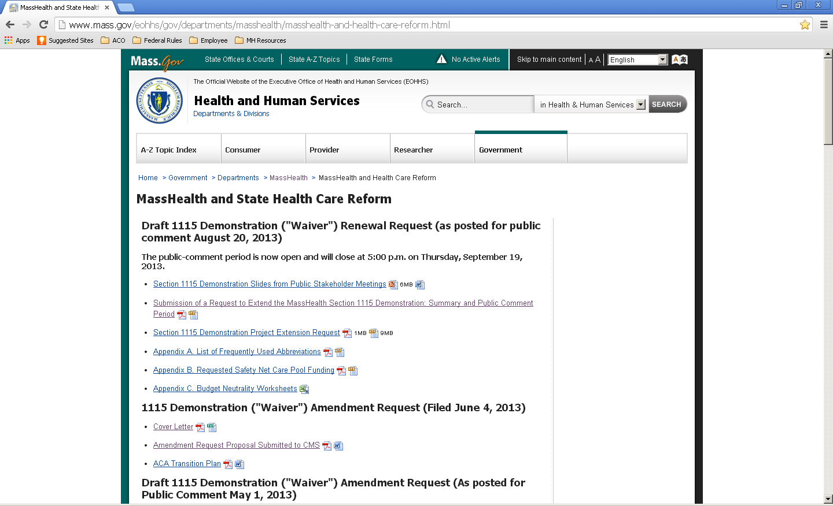

Tierney, Laxmi (EHS)
From: MA-ACA Update <ma-aca-update@umassmed.edu>
Sent: Thursday, August 22, 2013 5:01 PM
To: Tierney, Laxmi (EHS)
Subject: MA-ACA Update
Having trouble viewing this email? Click here

AFFORDABLE CARE ACT
MASSACHUSETTS IMPLEMENTATION
ANNOUNCEMENT

August 22, 2013

Quick Links
MA-ACA Website

The Massachusetts Executive Office of Health and Human Services (EOHHS) announces its intent to submit a request to extend the MassHealth Section 1115 Demonstration to the Centers for Medicare and Medicaid Services (CMS) on September 30, 2013. The Demonstration documents can be found here: http://www.mass.gov/eohhs/gov/departments/masshealth/masshealth-and-health-care-reform.html
Paper copies can be obtained at EOHHS' office at 1 Ashburton Place, 11th Floor in Boston.

EOHHS will host two Stakeholder Meetings open to the public on the proposed Demonstration Extension Request. The meeting details are as follows:

Stakeholder Meeting #1 (in conjunction with a meeting of the MassHealth Medical Care Advisory Committee and the MassHealth Payment Policy Advisory Board):
Date: Tuesday, August 27
Time: 10:00am-12:00pm
Location: Transportation Building
10 Park Plaza
Boston, MA

Stakeholder Meeting #2:
Date: Thursday, August 29
Time: 10:00am-12:00pm
Location: Worcester Public Library
3 Salem Square
Worcester, MA

Public Comment Period:
EOHHS will accept comments on the proposed Demonstration Extension Request through September 19, 2013. Written comments may be delivered by email or mail. By email, please send comments to laxmi.tierney@state.ma.us and include "Comments for Demonstration Extension Request" in the subject line. By mail, please send comments to: Laxmi Tierney, EOHHS Office of Medicaid, One Ashburton Place, 11th Floor, Boston, MA 02108. Comments must be received by 5pm on September 19, 2013 in order to be considered.

We encourage you all to attend the stakeholder hearings and submit comments. We look forward to seeing you and receiving your feedback!

Bookmark the Massachusetts National Health Care Reform website at:
National Health Care Reform to read updates on ACA implementation in Massachusetts.

Remember to check the Mass.Gov website at: Dual Eligibles for information on the "Integrating Medicare and Medicaid for Dual Eligible Individuals" initiative.

These Updates, published by the Executive Office of Health and Human Services (EOHHS) in consultation with the other state agencies involved in ACA implementation, will bring you news related to the implementation of provisions of the ACA here in Massachusetts.

Forward email

This email was sent to laxmi.tierney@state.ma.us by ma-aca-update@umassmed.edu |
Update Profile/Email Address | Instant removal with SafeUnsubscribe™ | Privacy Policy.
UMass Medical School | 333 South Street | Shrewsbury | MA | 01545

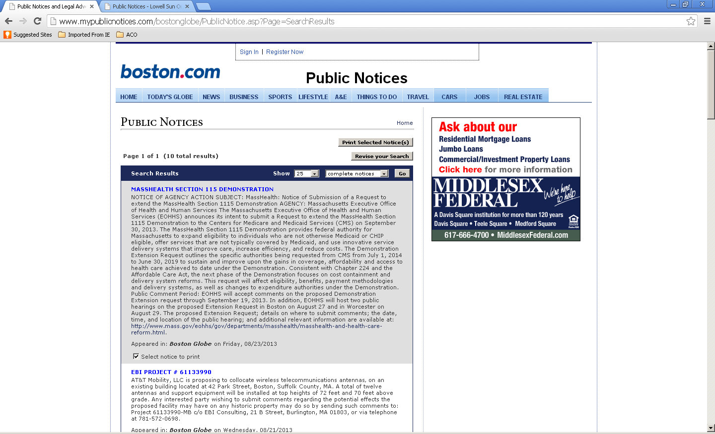

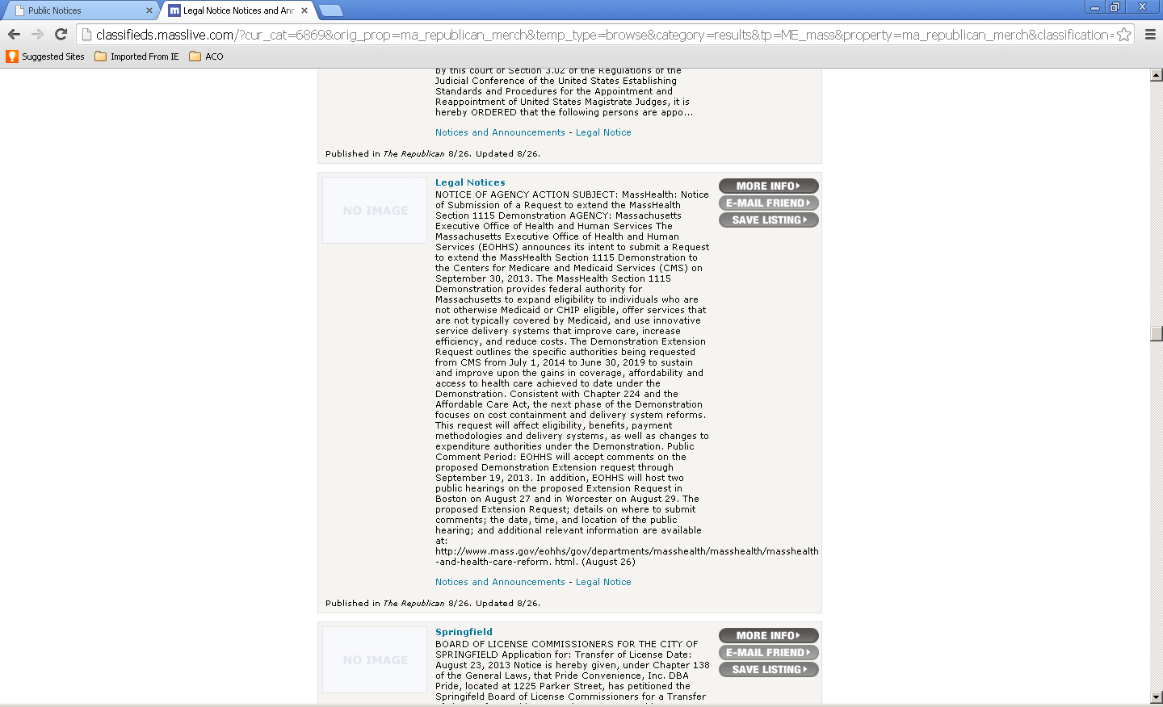

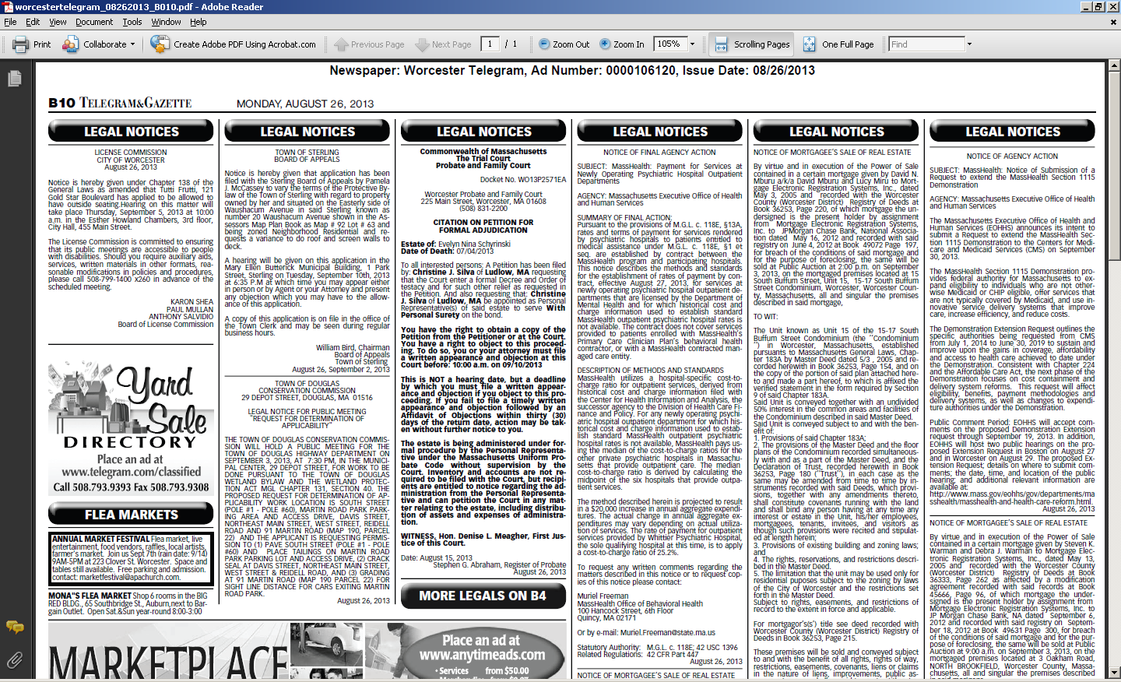

Tierney, Laxmi (EHS)
From: Kirchgasser, Alison (EHS)
Sent: Friday, August 02, 2013 3:05 PM
To: Cheryl Andrews-Maltais; 'Chris Knowles'; Durwood Vanderhoop; Stephanie White; 'Ryan
Malonson'; Cheryl Frye-Cromwell; Wendy Pocknett; 'KFrye@mwtribe.com'; Leslie Jonas;
'Gonsalves, Rita (IHS/NAS)'; Kathleen.Bird@ihs.gov; Reels, Lorraine (IHS/NAS);
'Susan.nal@verizon.net'; hope.nal@live.com
Cc: Wong, Shirley (EHS); Coleman, Michael (EHS); Schmidt, Bill (EHS); Guerino, Robert (EHS);
Kemp, Julie (EHS); Chiev, Sokmeakara (EHS); Rudin, Whitney (EHS); Cassel Kraft, Amanda
(EHS); Dunbar-Hester, Anna (EHS); Callahan, Robin (EHS); Pitzi, Carolyn (EHS); Tierney,
Laxmi (EHS); Bennett, Joan (EHS); Theriault, Anne (EHS)
Subject: Notice of 1115 waiver renewal

Good Afternoon,

As we discussed on the Tribal Consultation call on July 31, 2013, The MassHealth Section 1115 Demonstration provides federal authority for Massachusetts to expand eligibility to individuals who are not otherwise Medicaid or CHIP eligible, offer services that are not typically covered by Medicaid, and use innovative service delivery systems that improve care, increase efficiency, and reduce costs.

The current 1115 Demonstration is authorized through June 30, 2014. The Executive Office of Health and Human Services is requesting an Extension to the Demonstration, in order to continue providing the services that are currently offered, as well as creating additional authorities to achieve the goals of health care reform. MassHealth plans to submit our request to extend the 1115 Demonstration to the Centers for Medicare and Medicaid Services (CMS) on September 30 of this year.

The Extension request will build on the Amendment request that was recently submitted to CMS, which proposes significant changes to programs in conjunction with implementation of the Affordable Care Act. The Extension request will propose to continue many of the changes established in the Amendment. It will also include requests for authority to expand the use of alternative payment models rather than fee-for-service payment models, requests to further streamline some of MassHealth’s eligibility processes, and requests related to certain payments to hospitals and community health centers that are authorized through the Demonstration.

As our 1115 Demonstration grants the state the authority for a variety of programs and policies, it impacts nearly all MassHealth members, including Tribal members. We therefore want to be sure you have the opportunity to share any concerns or any ideas with us of items you would like to see included in the Demonstration. MassHealth plans to submit the Extension request to CMS on September 30, 2013. We are providing 60 days notice of our intent to extend the Demonstration, and you also will have at least 30 days to review the 1115 Demonstration Extension request documents and share with us any questions, concerns, feedback or advice before we submit the request to CMS.

The Extension request documents will be posted online and available in paper format for comment. As we prepare to submit our completed 1115 Demonstration Extension request, we will send out information to you about where the renewal request documents will be found online or in paper form and the exact time period for comments and questions. We will also send additional information regarding the two public hearings held in Boston and Worcester.

While we encourage you to take advantage of the regular public comment process, you also are welcome to reach out directly to Carolyn Pitzi by email (carolyn.pitzi@state.ma.us) or phone (617-573-1776) with any comments or questions. Also, as noted on the call, Tribal governments may request that MassHealth meet in-person with tribal representatives to discuss any issues related to the proposed renewal. Please let Carolyn know if you would be interested in such a meeting.

Sincerely,

Alison Kirchgasser
Massachusetts Office of Medicaid
617-573-1741

Tierney, Laxmi (EHS)
From: Pitzi, Carolyn (EHS)
Sent: Wednesday, August 21, 2013 2:37 PM
To: 'Susan.nal@verizon.net'; 'hope.nal@live.com'; 'Cheryl Frye-Cromwell'; Kym Frye; Wendy
Pocknett; 'Leslie Jonas'; Gonsalves, Rita (IHS/NAS); Reels, Lorraine (IHS/NAS);
'chairwoman@wampanoagtribe.net'; Durwood Vanderhoop; Stephanie White; 'Chris Knowles';
'Ryan Malonson'; Richard Randolph; Cheron Watchman
Cc: Kirchgasser, Alison (EHS); Coleman, Michael (EHS); Worstell, Pamela (EHS); Schmidt, Bill
(EHS); Wong, Shirley (EHS); Chiev, Sokmeakara (EHS); Dunbar-Hester, Anna (EHS);
Tierney, Laxmi (EHS); Cassel Kraft, Amanda (EHS); Bennett, Joan (EHS); Theriault, Anne
(EHS); Rudin, Whitney (EHS); Kemp, Julie (EHS); Guerino, Robert (EHS); Callahan, Robin
(EHS)
Subject: Notice of 1115 waiver renewal - documents posted online

Good afternoon,
As a follow up to our Tribal Consultation call on July 31, 2013 and our August 2, 2013 email we wanted to notify you that our 1115 Demonstration Extension documents have been posted online and are also available in paper format for comment. Below you will find information on where you can view these documents online as well as information regarding two public hearings that we be held in Boston and Worcester.

While we encourage you to take advantage of the regular public comment process, you also are welcome to reach out directly to me by email (carolyn.pitzi@state.ma.us) or phone (617-573-1776) with any comments or questions by September 19, 2013. Also, as noted on the call, Tribal governments may request that MassHealth meet in-person with tribal representatives to discuss any issues related to the proposed renewal. Please let me know if you would be interested in such a meeting.

Sincerely,

Carolyn Pitzi
Director Outreach and Education
Office of Medicaid
One Ashburton Place, 11th Floor
Boston, MA 02108
(617) 573-1776
Carolyn.Pitzi@state.ma.us

The Massachusetts Executive Office of Health and Human Services (EOHHS) announces its intent to submit a request to extend the MassHealth Section 1115 Demonstration (Demonstration Extension Request) to the Centers for Medicare and Medicaid Services (CMS) on September 30, 2013.

Public Comment Period:
EOHHS will accept comments on the proposed Demonstration Extension Request through September 19, 2013. Written comments may be delivered by email or mail. By email, please send comments to laxmi.tierney@state.ma.us and include “Comments for Demonstration Extension Request” in the subject line. By mail, please send comments to: Laxmi Tierney, EOHHS Office of Medicaid, One Ashburton Place, 11th Floor, Boston, MA 02108. Comments must be received by 5pm on September 19, 2013 in order to be considered.

EOHHS will host two Stakeholder Meetings open to the public on the proposed Demonstration Extension Request. The meeting details are as follows:

Stakeholder Meeting #1, in conjunction with a meeting of the MassHealth Medical Care Advisory Committee and the MassHealth Payment Policy Advisory Board:
Date: Tuesday, August 27
Time: 10:00am-12:00pm
Location: Transportation Building
10 Park Plaza
Boston, MA

Stakeholder Meeting #2:
Date: Thursday, August 29
Time: 10:00am-12:00pm
Location: Worcester Public Library
3 Salem Square
Worcester, MA

The Demonstration Extension Request documents may be obtained on the MassHealth 1115 Demonstration website: http://www.mass.gov/eohhs/gov/departments/masshealth/masshealth-and-health-care-reform.html. Additional updates and final submissions to CMS will also be posted on this website. Paper copies of the documents may be obtained in person by request from 9am-5pm at EOHHS, One Ashburton Place, 11th Floor, Boston, MA 02108.

Background:
The MassHealth 1115 Demonstration provides federal authority for Massachusetts to expand eligibility to individuals who are not otherwise Medicaid or CHIP eligible, offer services that are not typically covered by Medicaid, and use innovative service delivery systems that improve care, increase efficiency, and reduce costs. The current 1115 Demonstration is authorized through June 30, 2014.
The Commonwealth’s Demonstration Extension Request outlines the specific authorities being requested from CMS from July 1, 2014 to June 30, 2019 to sustain and improve upon the gains in coverage, affordability and access to health care achieved to date under the Demonstration.
The MassHealth 1115 Demonstration has been a key element in the Commonwealth’s achievement of near-universal coverage since the enactment of Chapter 58 of the Acts of 2006. Now, as required by the federal Affordable Care Act (ACA) and recent state legislation (Chapter 224 of the Acts of 2012), the next phase of health care reform focuses on cost containment and delivery system reforms. MassHealth is well positioned to continue its leadership role in these areas by advancing alternative payment methodologies and delivery system transformation including medical homes and integrated care for high risk populations. To meet the 1115 Demonstration’s goals and gain additional benefits through reform, the Commonwealth’s partnership with CMS through the Demonstration remains central to the Demonstration’s continued success. The Demonstration Extension Request affects eligibility, benefits, payment methodologies and delivery systems, as well as changes to expenditure authorities under the Demonstration.

Summary of Requested Changes to the Demonstration:
Five-Year Renewal Term and the One Care Integrated Care Model
A five-year renewal term, as authorized by the Social Security Act, will support the full implementation of the Commonwealth’s Duals Demonstration and its integrated care model known as One Care, which provides coverage for individuals under age 65 who are eligible for Medicaid and Medicare. The Duals Demonstration and the 1115 Demonstration are closely interrelated and provide complementary authorities that enable the Commonwealth’s efforts to institute a fully integrated and fully capitated delivery model for disabled members. Massachusetts aims to learn from the Duals Demonstration and explore expanding the One Care model to non-dual eligible disabled members through the 1115 Demonstration in future years.
Advancing Alternative Payment Models
MassHealth’s new Primary Care Payment Reform Initiative (PCPRI) is the primary vehicle to transition MassHealth members to alternative payment methodologies, as required by Chapter 224, the Commonwealth’s pioneering 2012 payment reform and cost containment legislation. To transform health care delivery and payment through the PCPRI, the Commonwealth requests authority to set shared savings / risk targets for providers and to make shared savings payments or, as applicable, recoup payments to providers under alternative payment arrangements involving shared risk. This authority will establish the basis for the Commonwealth to fully implement both the PCPRI and an Accountable Care Organization (ACO) model currently in development. With PCPRI as its foundation, MassHealth would consider making three key changes to the future ACO model: shifting the contracting entity from a Primary Care Clinician (PCC) to an ACO; adjusting the payment model to encourage providers to take on higher levels of risk; and modifying quality metrics and delivery model requirements to extend beyond a medical home to a “medical neighborhood.”
Pediatric Asthma Pilot Program
The Commonwealth requests continued authority to implement a Pediatric Asthma Pilot Program for MassHealth members aged two through 18 with high risk or poorly controlled asthma who are enrolled in selected PCC Plan practices.
Safety Net Care Pool
The Commonwealth requests the following authorities for the Safety Net Care Pool:
- Elimination of the Provider Sub-Cap;
- Continued expenditure authority for existing Designated State Health Programs and new authority for additional programs, including:
- State-supported subsidies for individuals with incomes up to 300 percent of the Federal Poverty Level (FPL) who enroll in health insurance through the Health Connector; and
- New state health programs associated with Chapter 224 and related efforts to advance Massachusetts’ ambitious health care reform and cost containment agenda;
- Continued authority for the Delivery System Transformation Initiatives;
- Continued authority for supplemental payments to Cambridge Health Alliance; and
- Continued authority for the Infrastructure and Capacity Building Grants program.
Express Lane Renewal
The Commonwealth is proposing to continue its current Express Lane renewal process for families, with certain changes to account for implementation of the ACA on January 1, 2014. In addition, the Commonwealth is seeking authority to expand the Express Lane renewal process to childless adults receiving Medicaid benefits with MassHealth-verified income at or below 133 percent FPL and income verified by the Supplemental Nutrition Assistance Program at or below 163 percent FPL.
Medicare Cost Sharing Assistance
For MassHealth Standard disabled or caretaker/parent elderly members at or under 133 percent FPL who are eligible for Medicare, the Commonwealth requests authority to pay the cost of monthly Medicare Part A and Part B premiums and the cost of deductibles and coinsurance under Medicare Part A and Part B.
Early Intervention / Applied Behavioral Analysis for Autism
MassHealth requests continued authority for coverage of enhanced early intervention program services including medically necessary Applied Behavioral Analysis-based treatment services for children with autism spectrum disorders.

From: Kirchgasser, Alison (EHS)
Sent: Friday, August 02, 2013 3:05 PM
To: Cheryl Andrews-Maltais; 'Chris Knowles'; Durwood Vanderhoop; Stephanie White; 'Ryan Malonson'; Cheryl Frye-Cromwell; Wendy Pocknett; 'KFrye@mwtribe.com'; Leslie Jonas; 'Gonsalves, Rita (IHS/NAS)'; Kathleen.Bird@ihs.gov; Reels, Lorraine (IHS/NAS); 'Susan.nal@verizon.net'; hope.nal@live.com
Cc: Wong, Shirley (EHS); Coleman, Michael (EHS); Schmidt, Bill (EHS); Guerino, Robert (EHS); Kemp, Julie (EHS); Chiev, Sokmeakara (EHS); Rudin, Whitney (EHS); Cassel Kraft, Amanda (EHS); Dunbar-Hester, Anna (EHS); Callahan, Robin (EHS); Pitzi, Carolyn (EHS); Tierney, Laxmi (EHS); Bennett, Joan (EHS); Theriault, Anne (EHS)
Subject: Notice of 1115 waiver renewal

Good Afternoon,

As we discussed on the Tribal Consultation call on July 31, 2013, The MassHealth Section 1115 Demonstration provides federal authority for Massachusetts to expand eligibility to individuals who are not otherwise Medicaid or CHIP eligible, offer services that are not typically covered by Medicaid, and use innovative service delivery systems that improve care, increase efficiency, and reduce costs.

The current 1115 Demonstration is authorized through June 30, 2014. The Executive Office of Health and Human Services is requesting an Extension to the Demonstration, in order to continue providing the services that are currently offered, as well as creating additional authorities to achieve the goals of health care reform. MassHealth plans to submit our request to extend the 1115 Demonstration to the Centers for Medicare and Medicaid Services (CMS) on September 30 of this year.

The Extension request will build on the Amendment request that was recently submitted to CMS, which proposes significant changes to programs in conjunction with implementation of the Affordable Care Act. The Extension request will propose to continue many of the changes established in the Amendment. It will also include requests for authority to expand the use of alternative payment models rather than fee-for-service payment models, requests to further streamline some of MassHealth’s eligibility processes, and requests related to certain payments to hospitals and community health centers that are authorized through the Demonstration.

As our 1115 Demonstration grants the state the authority for a variety of programs and policies, it impacts nearly all MassHealth members, including Tribal members. We therefore want to be sure you have the opportunity to share any concerns or any ideas with us of items you would like to see included in the Demonstration. MassHealth plans to submit the Extension request to CMS on September 30, 2013. We are providing 60 days notice of our intent to extend the Demonstration, and you also will have at least 30 days to review the 1115 Demonstration Extension request documents and share with us any questions, concerns, feedback or advice before we submit the request to CMS.

The Extension request documents will be posted online and available in paper format for comment. As we prepare to submit our completed 1115 Demonstration Extension request, we will send out information to you about where the renewal request documents will be found online or in paper form and the exact time period for comments and questions. We will also send additional information regarding the two public hearings held in Boston and Worcester.

While we encourage you to take advantage of the regular public comment process, you also are welcome to reach out directly to Carolyn Pitzi by email (carolyn.pitzi@state.ma.us) or phone (617-573-1776) with any comments or questions. Also, as noted on the call, Tribal governments may request that MassHealth meet in-person with tribal representatives to discuss any issues related to the proposed renewal. Please let Carolyn know if you would be interested in such a meeting.

Sincerely,

Alison Kirchgasser
Massachusetts Office of Medicaid
617-573-1741

