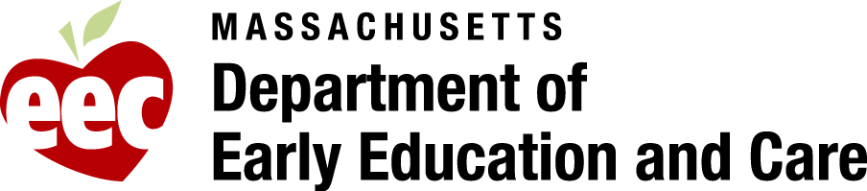**------------------------------------------------------------------------------------**

**Appendix G: Resources for Grantees**

**Resources for Inclusion:**

http://ectacenter.org/topics/inclusion/overview/overview.asp

**Inclusion in Least Restrictive Environments**

* http://ectacenter.org/topics/inclusion/default.asp

Early Childhood Inclusion Video includes highlights from the recently released *Joint Position Statement on Early Childhood Inclusion* as well as bite-sized information on big ideas about inclusion. The video was produced by [CONNECT](http://community.fpg.unc.edu/connect), an Office of Special Education Programs-funded national center that is developing web-based resources and modules on effective and evidence-based practices to support professional development.

For more information and to view the video: <http://community.fpg.unc.edu/connect>  
To view or download the position statement:[**http://community.fpg.unc.edu/resources/articles/Early_Childhood_Inclusion**](http://community.fpg.unc.edu/resources/articles/Early_Childhood_Inclusion)

**Early Childhood Inclusion Training Resources That Work**

SpecialQuest Multimedia Training Library http://napacoe.pointinspace.com/preschool_series.lasso

**Financing Strategies and Collaborative Funding**

* http://ectacenter.org/topics/inclusion/funding/funding.asp

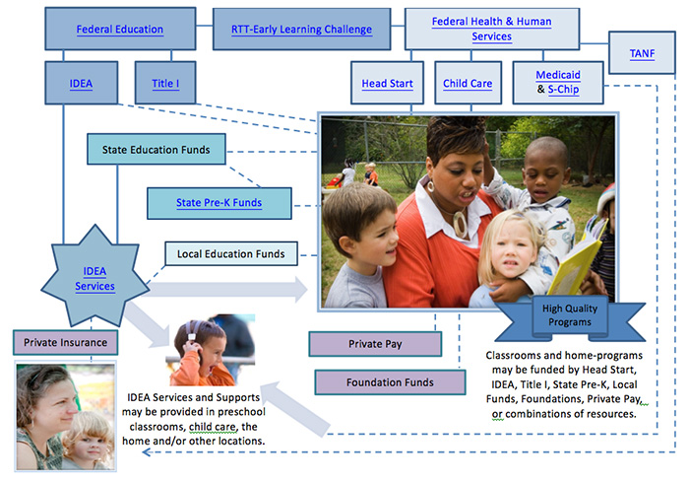

**Transitions:**

**Continuing the Journey: Best Practices in Early Childhood Transitions: A Guide for Families**

http://www.mass.gov/edu/docs/eec/2014/20140515-early-childhood-transition-english.pdf

**Massachusetts Quality Rating and Improvement System (QRIS)**

**FY18 IPLE Grantee Timelines for QRIS Participation**

|  |  |  |  |  |  |
| --- | --- | --- | --- | --- | --- |
| **IPLE Site Status** | **Current QRIS Status** | **QRIS Documentation Requirements** | **Submission Type** | **Documentation Due Date** | **Date QRIS Rating must be attained** |
| **FY17 IPLE-funded Site** | * QRIS Rating Granted: Level 1 * QRIS Rating Granted: Level 2 * QRIS Rating Granted: Level 3 * QRIS Rating Granted: Level 4 | *QRIS Summary Profile PDF*from QPM showing Rating Granted | * Online grant Application Require Form   **and**   * Grant Application -Hard copy | FY18 Grant Application Submission Date | By or before the FY18 Grant Application Submission Date |
| **FY17 IPLE-funded Site** | * **NO QRIS Rating Granted** * EEC Review Complete * EEC review in Progress * Self-Assessed- Final Submitted to EEC * Draft Application | *Continuous Quality Improvement Plan (CQIP)* | * Online grant Application Require Form   **and**   * Grant Application -Hard copy | FY18 Grant Application Submission Date | Must attain a QRIS Rating Granted at QRIS Level 1 or higher **by or before** **December 1, 2017[1]** |
| **FY18**  **"new Site** | * **No QRIS Application** | *QRIS Level 1 Self-Assessment for Public School Early Education Programs,*    *CQIP and*  **EEC notification** | * Online grant Application Require Form   **and**  Grant Application -Hard copy | FY18 Grant Application Submission Date |  |
| **FY18**  **"new Site** | * **No QRIS Application** | Completed and submitted a Center based/School Based QRIS Application with a QRIS status of Final Submitted to EEC with a self-assessed level at Level 1 or higher. | QPM Electronic and Supporting Documentation per QRIS requirements | by or before **December 1, 2017[2]** | Must attain a QRIS Rating Granted at QRIS Level 1 or higher **by or before June 1, 2017** |

**Additional resources related to the Massachusetts QRIS**

* [**QRIS resources**](http://www.mass.gov/edu/birth-grade-12/early-education-and-care/qris/qris-resources-for-programs.html)**: Includes an overview of QRIS and measurement tools for your program.**
* [**MA-QRIS Center Based/School Based Standards with Guidance**](http://www.mass.gov/edu/docs/eec/qris/qris-center-based-school-based-standards-guidance.docx)

Program Quality Unit Contact Information

* [**http://www.mass.gov/edu/birth-grade-12/early-education-and-care/provider-and-program-administration/quality-rating-and-improvement-system-qris.html**](http://www.mass.gov/edu/birth-grade-12/early-education-and-care/provider-and-program-administration/quality-rating-and-improvement-system-qris.html)

Resources for Public School Early Education Programs

* Early education programs operating in public school settings that serve infants, toddlers and/or preschool children, and are not licensed by the Department of Early Education and Care, must complete and submit:
* the QRIS Level 1 Self-Assessment for Public School Early Education Programs
* the Continuous Quality Improvement Plan(CQIP) if any of the identified criteria are not met, and
* a copy of the agreement form signed by the program director AND the school principal or superintendent
* [QRIS Level 1 self-assessment and agreement for public school programs](http://www.mass.gov/edu/docs/eec/qris/qris-level-1-self-assessment-agreement-public-school.docx)

QRIS Toolbox

The QRIS Toolbox includes resources to help programs and providers with their QRIS applications. For each program type, EEC has provided the QRIS Standards with guidance, a Continuous Quality Improvement Plan (CQIP) and guidance document, a checklist with all QRIS requirements for each Level, and Environment Rating Scales resources.

* [**QRIS Toolbox for Center Based/School Based Programs**](http://www.mass.gov/edu/birth-grade-12/early-education-and-care/qris/qris-toolbox-for-center-based-school-based-programs.html)

QRIS Measurement Tools

All programs participating in QRIS are required to use QRIS Measurement tools at Level 2, Level 3 and Level 4 as part of their QRIS self-assessment process. These QRIS Measurement tools are used to effectively measure process quality indicators (teacher-child interactions) and structural quality indicators (program administration & leadership) consistently. The links below provide additional information about the QRIS Measurement Tools used by each of the QRIS Program Types.

* [**Center-based / School-based Programs QRIS Measurement Tools**](http://www.mass.gov/edu/birth-grade-12/early-education-and-care/provider-and-program-administration/qris-resources-for-programs/qris-measurement-tools/center-based-school-based-programs-qris.html)

1. A program's failure to attain a QRIS Rating Granted Status at Level 1 or higher in the QRIS Program Manager (QPM) online application by December 1, 2017 **may result in the withholding and/or exclusion from FY 2018 IPLE grant funds.**
2. A program's failure to complete and submit a QRIS Application with a QRIS self-assessed status of Final Submitted to EEC at Level 1 or higher in the QRIS Program Manager (QPM) and submit the required QRIS documentation **by or before December 1, 2017** may result in the withholding and/or exclusion from FY 2018 IPLE grant funds.