Instructions for Completing
DEPARTMENT OF EARLY EDUCATION AND CARE
FY2014 Head Start Supplemental Renewal Grant
Budget Workbook
(Fund Code 390)

Completing the Electronic Workbook – Budget Workbook

OPENING THE FILE: Click on the link, FY2014_HS_ Budget.xls. A page will appear like the one below.

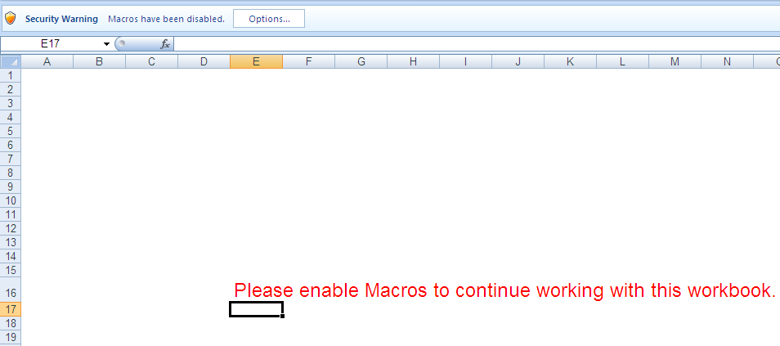

You must click, on the Options box located to the right of the Security Warning. A box will appear, prompting you to disable or enable macros – in order to use the workbook; you must click ‘Enable this content’.

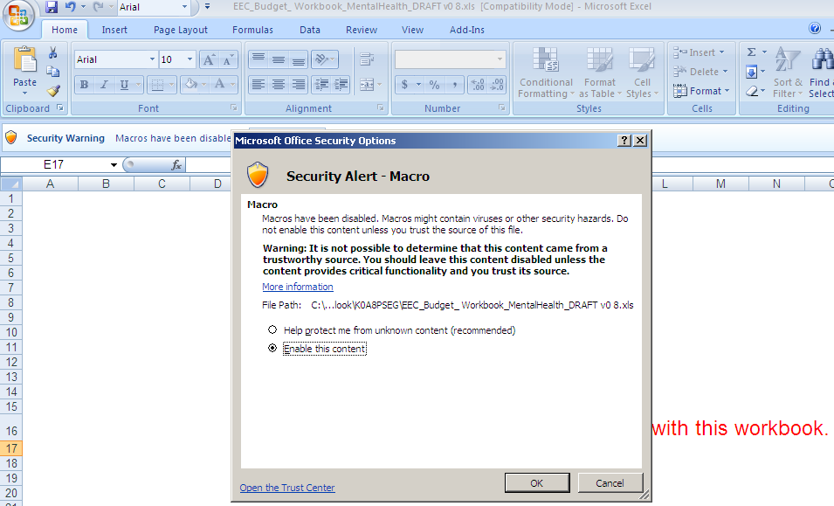

SAVING AND NAMING THE FILE: Once the file is open, select ‘File’ and then select ‘Save As’. Indicate where you want to save the file. The file is currently named FY2014_HS_ Budget_Agency_Name.xls. Edit the current file name by replacing the words ‘Agency Name’ with your Agency Name. The file will now have the following name format:

FY2014_HS_Budget_Clinical Partners.xls

Be sure to keep the exact filename as designated by the Department of Early Education and Care.

Opening the Application for Program Grants:

When you open the excel document, you may need to maximize the window by clicking on the middle box in the upper right-hand corner of the Budget Workbook. This will enable you to see the TABS at the bottom.

Using the Budget Workbook for Head Start Supplemental Renewal Grant - Fund Code 390:
In the excel document, look for a series of colored tabs. These tabs are located on the bottom of the excel spreadsheet. Click a colored tab to access a specific page (each tab is labeled). You can navigate the tabs by using the arrows found on the lower, left hand corner of the excel document.

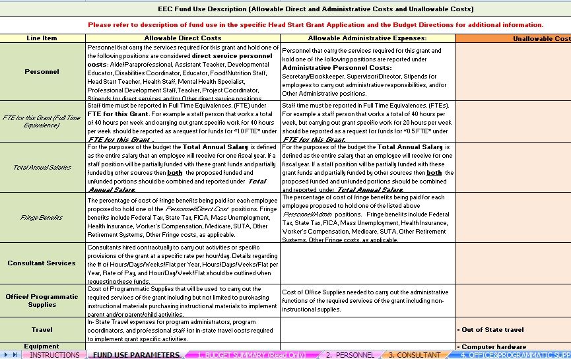

These are the different tabs for the grant application. Tabs #2-10 must be filled in by you. The first 3 tabs are for your reference only.
Use these arrows to navigate and access all of the tabs.

Important Instructions and Information
Please Read 1-3 BEFORE filling out Budget Workbook

1. Tabs within the budget workbook:
- There are 12 tabs that make up the entire budget workbook. The first four tabs are for reference only. You should see all of these tabs at the bottom of your budget workbook.
- Read the instructions, the allowable and un-allowable tabs, and review your Budget Summary prior to submission, as these will help you to complete the budget workbook accurately.
- When filling in the workbook, you are only required to fill in tabs #2-10, as the tabs are titled:
- Instructions (read only)
- Fund Use Parameters (read only)
- #1 Budget Summary (read only)
- #2 Personnel
- #3 Consultant
- #4 Office and Programmatic Supplies
- #5 Travel
- #6 Equipment
- #7 Other Costs
- #8 Budget Narrative
- #9 Subcontractors
- #10 Subcontractor Narrative
3. Match/In-Kind Funds:
For FY 2014, EEC is not requiring match/in-kind contribution. In an effort to move toward future match/in-kind requirements, EEC has deliberately displayed fields allocated for match. Match/In-Kind fields are currently blocked as you will not have to fulfill this requirement for FY 2014.

TAB #1: Budget Summary
Located at the bottom of the excel document is a magenta tab labeled: ‘1. Budget Summary.’ Click the tab to access this specific page.
- This tab has all of the totals from your entire budget request. (Ex: if you have requested funds in tab 4 and tab 7A, these amounts will show up automatically in tab 1).
- YOU DO NOT FILL IN ANY INFORMATION IN THIS TAB.
- If the Eligibility amount has been exceeded, an Alert will appear on the Budget Summary tab.
Example of Alert:
    - YOU HAVE EXCEEEDED THE ELIGIBIILTY AMOUNT. YOUR BUDGET IS REJECTED. DO NOT SUBMIT.
- If the Eligibility amount has NOT been exceeded, an Alert will appear on the Budget Summary tab.
Example of Alert:

- THE ‘TOTAL REQUEST’ AMOUNT IS LESS THAN THE ELIGIBILITY AMOUNT. DO NOT SUBMIT.”

- If the 8% ADMIN LIMIT has been exceeded, an Alert will appear on the Budget Summary tab.
Example of Alert:
    - YOU HAVE EXCEEEDED THE EEC 8% ADMIN LIMIT. YOUR BUDGET IS REJECTED. DO NOT SUBMIT.

TAB #2: Personnel (start filling in grant information)
In the excel document, look for the pink tab labeled: ‘2. Personnel.’ Click on tab and this page looks like:

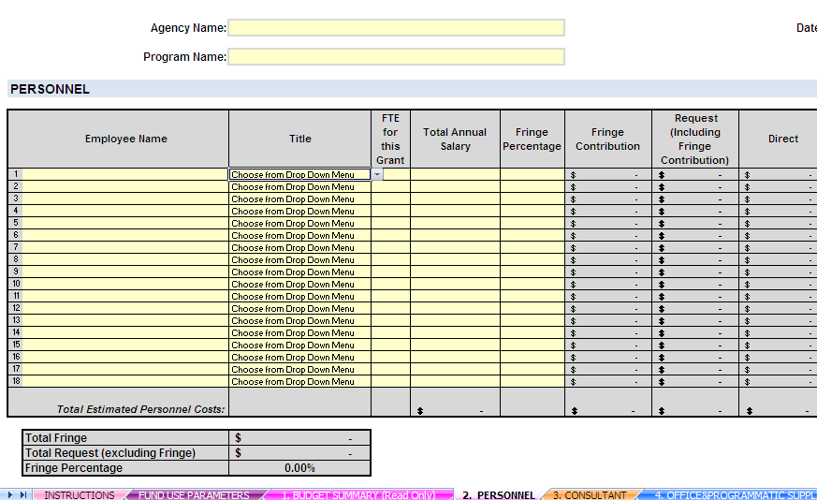

At the top of the page: Select the Agency Name from the drop down list. Next, type in the Program Name and Date. (This information will populate onto the rest of the tabs.)

DIRECT costs for Personnel:
- Aides/Paraprofessional
- Assistant Teacher
- Developmental Educator
- Disabilities Coordinator
- Educator
- Food/Nutrition Staff
- Head Start Teacher
- Health Staff
- Mental Health Specialist
- Professional Development Staff
- Teacher
- Project Coordinator
- Stipends(Direct)

ADMIN costs for Personnel (Fringe is also ADMIN):
- Secretary/Bookkeeper
- Stipends (Admin)
- Supervisor/Director

- Provide: number of employees, their job title, the Full Time Equivalence (FTE), the total annual salary, and the percentage of fringe being paid.
  - Full Time Equivalence (FTE): Staff time must be reported in Full Time Equivalences (FTE) under this grant. For example, a staff person that works a total of 40 hours per week and carries out grant specific work for 40 hours per week should report a request for funds for “1.0 FTE” under FTE for this grant.
  - Total Annual Salaries: For the purposes of the budget the Total Annual Salary is defined as the entire salary that an employee will receive for one fiscal year. If a staff position will be partially funded with these grant funds and partially funded by other sources then both the proposed funded and unfunded portions should be combined and reported under Total Annual Salary.
- Once you enter the Total Annual Salary, the Request column and Direct and Admin columns will automatically populate based on the information you provide.
- If choosing “Other”, a gray alert box will appear with further instructions for your Tab 8) Budget Narrative.
Fringe Benefits (Fringe Benefits are located on the Personnel Tab and the Subcontractor Tab):
- Once you enter the percentage of Fringe, the Fringe contribution will automatically populate based on the information you provide.
- The Fringe Contribution is calculated based on the FTE, the Total Annual Salary, and Fringe Percentage.
- The Fringe Contribution amount is added to the Total Request amount.
- Provide a breakdown and explanation in the Budget Narrative for Fringe.
  - If fringe exceeds 35%, provide a breakdown of categories and percentages.
  - If fringe is less or equal to 35%, provide breakdown of categories and percentages, if possible.
  - EEC will review the breakdown and contact you.
- If the amount is coming from another source, please provide the name of the source(s) in Budget Narrative.
- If you exceed the 35% allocation for Fringe, you will see an Alert on the Personnel Tab and you will need to provide a breakdown of fringe in the Budget Narrative.
Example of Alert:
    - FRINGE OVER 35% - PLEASE PROVIDE A ‘FRINGE BREAKDOWN’ IN THE BUDGET NARRATIVE FOR ALL PERSONNEL.

TAB #3: Consultant Services
In the excel document, look for the orange tab labeled: ‘3.Consultant.’ This tab looks like this:

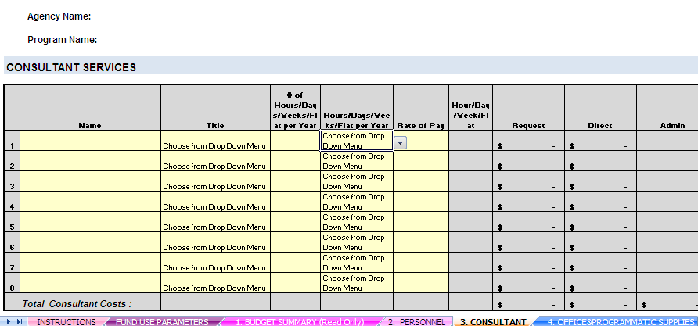

- Please fill in: Name
- Select the title from the list choices in the drop-down menu.
- Fill in the # that corresponds to the hours, days, weeks, or flat rate of the consultant role.
- Select if that # is an hour, day, week, or flat rate per year in the drop-down menu. This will automatically populate the column marked Hour/Day/Week or Flat.
- Fill in Rate of Pay ($).
- The Request column will automatically populate based on the information provided in the other columns.
- If choosing “Other”, a gray alert box will appear with further instructions for your Tab 8) Budget Narrative.

TAB #4: Office and Programmatic Supplies
In the excel document, look for the blue tab labeled: ‘4. Office and Programmatic Supplies.’ This tab looks like this:
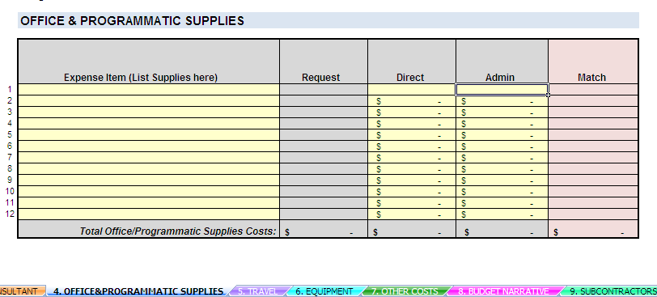

- Please list Expense Items (List Supplies here column).
- For each expense item listed, fill in the cost under Direct and/or Admin cost.
- A grantee can charge Office and Programmatic Supplies to Admin if those supplies are related to the administrative function of the grant.
- The Request column will automatically populate.
TAB #5: Travel
In the excel document, look for the purple tab labeled: ‘5. Travel.’ This tab will look like this:
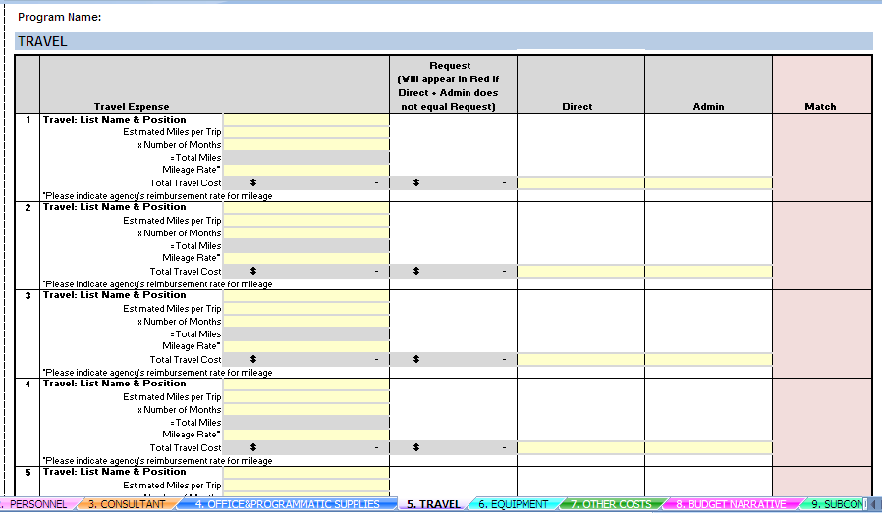

- In the ‘Travel Expense Item’ column, list: Name and Position of staff who is traveling
- Fill in: Estimated Miles per Month and the Number of months
- The ‘Total Miles’ will automatically be filled in.
- Please fill in the ‘Mileage Rate*’ (*must be your agency’s reimbursement rate, if applicable).
- The ‘Total Travel Cost’ will automatically populate.
- Write the Total Travel Cost in the Direct cost and/or Admin cost column.
- The Request column will pre-populate from the Direct and Admin cost columns.
- The Request column must match the Total Travel Cost. If they do not, the amount will appear in RED. This means that the cost must be changed to match the Total Travel Cost.

TAB #6: Equipment:
In the excel document, look for turquoise tab labeled: ‘6. Equipment.’ This tab will look like this:
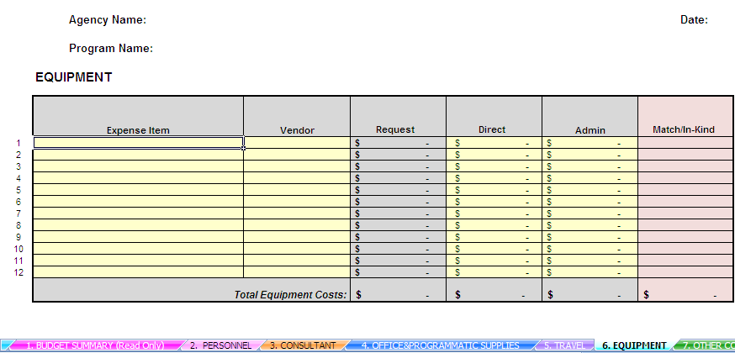
- Fill in the: Expense Item (the equipment item)
- For each Expense item, provide the Vendor, Direct, and/or Admin costs.
- The Request column will populate from the Direct and Admin cost columns.

TAB # 7: Other Costs
In the excel document, look for the green tab labeled: ‘7. Other Costs.’ This tab will look like this:
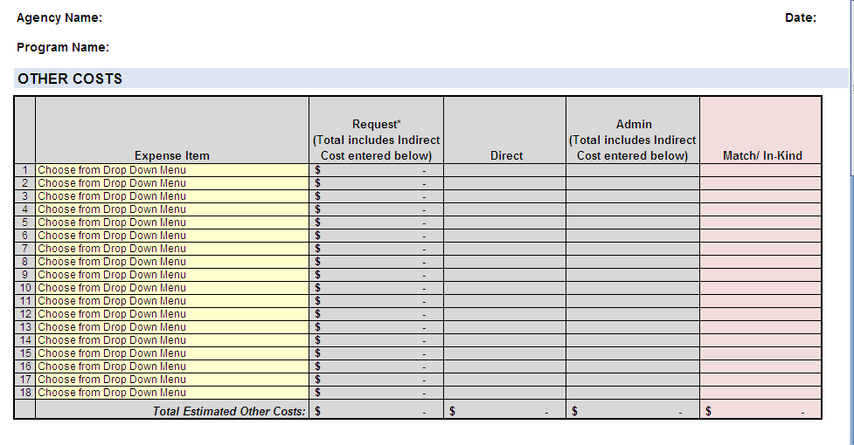
Keep in mind:
ADMIN expenses for ‘Other Costs’ include the following and are part of the EEC 8% Admin limit:
- Salary of Supervisor/Director
  - Secretary/Bookkeeper salary/wages
  - Stipends for Secretary/Bookkeeper
  - Fringe Benefits for Secretary/Bookkeeper
  - Rental of Space
  - Telephone/Utilities
  - Equipment Rental
  - Indirect Costs
The other items under ‘Other Costs’ are direct costs:
- Advertising
- Maintenance/Repairs
- Printing/Reproduction
- Memberships and Subscriptions - Costs of membership in civic, business, technical, and professional organizations are reimbursable provided that: (a) the benefit from the membership is related to the project, (b) the expenditure is for agency -- and not individual -- membership, and (c) the cost of the membership is reasonably related to the value received.
- Training Costs for on-site training provided to programs and educators in the context of delivering specific areas related to the priority areas of this grant services. These professional development sessions cannot be the only consultation service received. Other programs and providers can be considered for inclusion in this training opportunity to ensure maximum resources for training purposes. While the priority will be given to support salaries, training costs must not exceed 5% of the total amount requested for this grant. To maximize training resources, grantees must consider including other professionals (non-funded) for these grant-funded training opportunities. A detailed description must be delineated on the budget narrative. EEC reserves the right to approve/deny any costs associated with training requests if justification is deemed insufficient and unacceptable.
- Rental space
- Transportation of Students
- Subcontractors. All subcontractors and partners performing services on behalf of the applicant to meet the required services of this grant proposal must be approved by EEC.
  - If an applicant proposes subcontracting some of its required services, the applicant must submit the proposed subcontracted services from each subcontractor and other partners as part of its grant application response.
- From a drop-down menu: select each Expense Item.
- Once the Expense item is selected, either the Direct or Admin column will appear in yellow according to which expenses are direct or admin costs. Provide: cost amount in the correct yellow box.
- The Request column will populate from the Direct and Admin cost columns.
- If choosing “Other”, a gray alert box will appear with further instructions for your Tab 8) Budget Narrative.

Indirect Cost (This box is located on Tab #7: ‘Other Costs’ and on the Subcontractor Tab):
- The box will look like this:
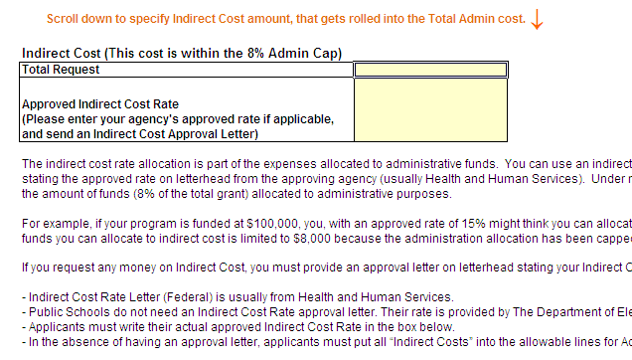

- Please enter in the Total Request for the Indirect Cost, if applicable. (Please see the directions below the box to determine if Indirect Costs can be claimed.)
- The Indirect Cost amount entered here will be added to the Total Admin cost and the Total Request cost in the Other Costs chart.
- Please enter your agency’s approved rate, if applicable and include an Indirect Cost Approval letter with your application.
- The indirect cost rate allocation is part of the expenses allocated to administrative funds. You can use an indirect cost rate ONLY IF your agency submits documentation stating the approved rate on letterhead from the approving agency (usually Health and Human Services). Under no circumstances can the use of the indirect cost rate exceed the amount of funds (8% of the total grant) allocated to administrative purposes.
  - For example, if your program is funded at $100,000.00 you, with an approved rate of 15% might think you can allocate $15,000.00, but that would not be accurate. The amount of funds you can allocate to indirect cost is limited to $8,000.00 because the administration allocation is capped at 8%.
    - Indirect Cost Rate Letter (Federal) is usually from Health and Human Services
    - Public Schools do not need an Indirect Cost Rate approval letter. Their rate is provided by The Department of Elementary and Secondary Education.
    - Applicants must write their actual approved Indirect Cost Rate in the box located on the “Other Costs” tab.
    - In the absence of having an approval letter, applicants must put all “Indirect Costs” into the allowable lines for Admin costs.

If you exceed the EEC 8% ADMIN limit, you will see this Alert on the Budget Summary and you will need to CHANGE the budget so that you are not over the 8% Admin limit.
Example of Alert:
    - YOU HAVE EXCEEDED THE EEC 8% ADMIN LIMIT. YOUR BUDGET IS REJECTED. DO NOT SUBMIT.

TAB # 8: Budget Narrative:
In the excel document, look for pink tab labeled: ‘8. Budget Narrative.’ This tab will look like this:
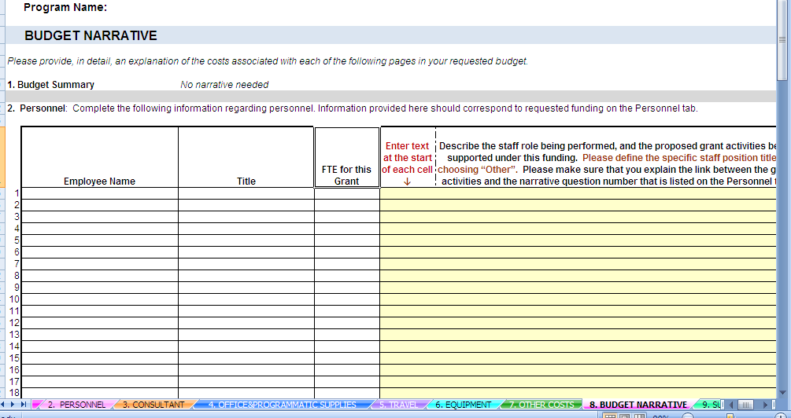
- This tab has sections (1-7).
- In this tab, fill in information about: 2. Personnel, 2a. Fringe, 3. Consultant, 4. Office and Programmatic Supplies, 5. Travel, 6. Equipment, 7. Other Costs.
- Scroll through ALL SECTIONS in this tab and fill in ALL relevant information.
- IN ORDER TO COPY AND PASTE WITHIN THE WORBOOK, YOU MUST DOUBLE CLICK ON THE SOURCE CELL, COPY THE TEXT AND THEN DOUBLE CLICK ON THE DESTINATION CELL AND PASTE.
- IN ORDER TO PASTE TEXT COPIED FROM AN EXTERNAL SOURCE, DOUBLE CLICK ON THE DESTINATION CELL AND PASTE.

2. Personnel:
- Employee Name, Title and FTE will populate from the Personnel tab. If the staff position title ‘Other’ was chosen, it will appear in RED.
- When filling out the budget narrative for this section, start entering your text at the start of each cell, as indicated on the page. The text will populate into the entire cell and expand if necessary.
- Components to include in Narrative:
  - Describe the staff role being performed.
  - The proposed grant activities being supported under this funding.
  - Please define the specific staff position title if choosing, “Other”.
  - Please make sure that you explain the link between the grant activities and the narrative question that is listed on the Personnel tab.

2A. Fringe:
- Employee Name and Fringe Rate will populate from the Personnel tab.
- When filling out the budget narrative for this section, start entering your text at the start of each cell, as indicated on the page. The text will populate into the entire cell and expand if necessary.
- Components to include in Narrative (if applicable):
  - Items to include in the Fringe Breakdown, if applicable: Federal Tax, State Tax, FICA, Mass Unemployment, Health Insurance, Worker's Compensation, Medicare, SUTA, Other Retirement Systems, Other.

3. Consultant: Name, Title, # of Hours/Years, Day/Year, Week/Yr, Flat and Rate of Pay, and Hour/Day/Week/Flat will populate from the Consultant tab.
- If the consultant position title ‘Other’ was chosen it will appear in RED.
- When filling out the budget narrative for this section, start entering your text at the start of each cell, as indicated on the page. The text will populate into the entire cell and expand if necessary.
- Components to include in Narrative:
  - Describe the consultant role being performed.
  - The proposed grant activities being supported under this funding.
  - Please define the specific consulting position title if choosing, “Other”.
  - Please make sure that you explain the link between the grant activities and the narrative question that is listed on the Consultant tab.

4. Office & Programmatic Supplies:
- Expense item will populate from the Office & Programmatic Supplies tab.
- When filling out the budget narrative for this section, start entering your text at the start of each cell, as indicated on the page. The text will populate into the entire cell and expand if necessary.
- Components to include in Narrative:
  - Describe how each expense item supports the proposed grant activities with this funding.
- Include: the ‘Quantity to be Purchased’ and ‘Basis for Computation’ of each expense item.

5. Travel:
- The Travel Expense: Staff Name and Position, Estimated Miles per Trip, # of Months, Total Miles, and Mileage Rate will populate from the Travel tab.
- When filling out the budget narrative for this section, start entering your text at the start of each cell, as indicated on the page. The text will populate into the entire cell and expand if necessary.
- Components to include in Narrative:
  - Provide a brief statement explaining how each travel expense supports the proposed grant activities under this funding.

6. Equipment:
TAB #6: Equipment: THIS SECTION IS DISABLED FOR THE HS GRANT as costs associated with equipment is not allowable. Please reference list of allowable/unallowable costs in the funds parameters tab for more detailed information.
In the excel document, look for turquoise tab labeled: ‘6. Equipment.’ This tab will look like this:

7. Other Costs:
- Expense items will populate from the Other Costs tab.
- When filling out the budget narrative for this section, start entering your text at the start of each cell, as indicated on the page. The text will populate into the entire cell and expand if necessary.
- Components to include in Narrative:
  - Provide a brief statement explaining how each expense item supports the proposed grant activities under this funding.

TAB # 9: Subcontractors
In the excel document, look for green tab labeled: ‘9. Subcontractors.’ This tab will look like this:

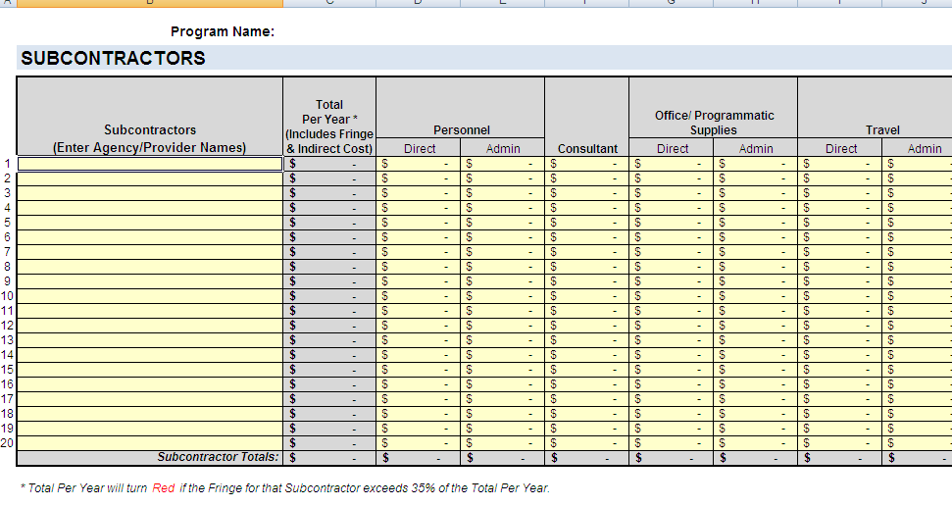
- List each subcontractor: Include Agency and Provider Name.
  - You will need to type this information before you fill out any of the costs.
  - This Subcontractor information will then automatically populate into the Fringe & Indirect Cost table as well as the Subcontractor Narrative.
- Fill in: total cost for Personnel, Consultant, Office & Programmatic Supplies, Travel, Equipment and Other Costs for each subcontractor.
  - Please note that each column is divided into Direct and Admin costs (except the Consultant column.) Please make sure that you use the same guidelines as the Lead Agency for claiming Direct and Admin costs.
- The Total per Year will add the total costs in all the columns and populate automatically.
- Once the Fringe Cost is added in the table below, the Total per Year will include the Fringe Amount.
  - Please note: The Total per Year will turn RED if fringe for that Subcontractor exceeds 35% of the Total per Year (excluding fringe).
- Enter the Total Fringe amounts for Personnel in the Direct or Admin cost columns depending on whether the staff position is a Direct or Admin expense. Each line must contain the total fringe amount per Subcontractor.
- Fill out the Total Indirect Cost amount and Indirect Cost Rate, if eligible. Each line must contain the total indirect cost amount per Subcontractor.
- The Fringe (Direct and Admin) amounts entered here will be added to the Total Request cost in the Subcontractors chart.
TAB # 10: Subcontractor Narrative
In the excel document, look for the brown tab labeled: ‘10. Subcontractor Narrative.’
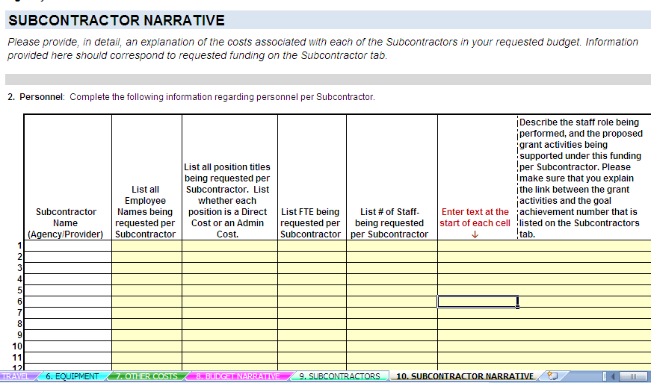

- This tab has sections (2-7).
- In this tab, fill in information about: 2. Personnel, 2a. Fringe, 3. Consultant, 4. Office and Programmatic Supplies 5. Travel, 6. Equipment, 7. Other Costs.
- Scroll through this entire tab and fill in ALL relevant information.
- IN ORDER TO COPY AND PASTE WITHIN THE WORBOOK, YOU MUST DOUBLE CLICK ON THE SOURCE CELL, COPY THE TEXT AND THEN DOUBLE CLICK ON THE DESTINATION CELL AND PASTE.
- IN ORDER TO PASTE TEXT COPIED FROM AN EXTERNAL SOURCE, DOUBLE CLICK ON THE DESTINATION CELL AND PASTE.

2. Personnel: Each line corresponds to one specific Subcontractor.
- The Subcontractor Name (Agency/Provider) will populate from the Subcontractor tab.
- List all Employee Names being requested per Subcontractor. List employee names on the same line, if there is more than one employee.
- List all Position Titles being requested per Subcontractor. List whether each position is a Direct cost or an Admin cost.
  - List all position titles on the same line, if there is more than one employee.
  - Make sure that the order of position titles matches the order of employee names.
- List all FTEs being requested per Subcontractor.
  - FTEs for each employee must be written on the same line, if there is more than one employee.
  - Make sure that the order of FTEs match the order of employee names and position titles.
- List # of Staff being requested per Subcontractor.
  - # of Staff for each employee must be written on the same line, if there is more than one employee.
  - Make sure that the order of ‘# of Staff’ match the order of employee names, position titles, and FTEs.
- When filling out the budget narrative for this section, start entering your text at the start of each cell, as indicated on the page. The text will populate into the entire cell and expand if necessary.
- Components to include in Narrative:
  - Describe the staff role being performed,
  - The proposed grant activities being supported under this funding per Subcontractor.
  - Please make sure that you explain the link between the grant activities and the narrative question number that is listed on the Subcontractors tab for Personnel.
  - Make sure that the order of the ‘Narrative’ matches the order of employee names, position titles, FTEs, and # of Staff.

2A. Fringe: Each line corresponds to one specific Subcontractor.
- The Subcontractor Name (Agency/Provider) will populate from the Subcontractor tab.
- List all Employee Names being requested per Subcontractor.
  - List all employee names on the same line, if there is more than one employee.
- List all Fringe Rate being requested per Subcontractor.
  - List fringe rates for each employee on the same line, if there is more than one employee.
  - Make sure that the order of the fringe rates match the order of the employee names.
- When filling out the budget narrative for this section, start entering your text at the start of each cell, as indicated on the page. The text will populate into the entire cell and expand if necessary.
- Components to include in Narrative (per subcontractor):
  - Items to include in the Fringe Breakdown, if applicable: Federal Tax, State Tax, FICA, Mass Unemployment, Health Insurance, Worker's Compensation, Medicare, SUTA, Other Retirement Systems, Other.

3. Consultant: Each line corresponds to one specific Subcontractor.
- The Subcontractor Name (Agency/Provider) will populate from the Subcontractor tab.
- List all Consultant Names being requested per Subcontractor. List all consultant names on the same line, if there is more than one consultant.
- List all Rates of Pay being requested per Subcontractor. Include Hours/Yr, Day/Yr, Week/Yr or Flat Rate.
- When filling out the budget narrative for this section, start entering your text at the start of each cell, as indicated on the page. The text will populate into the entire cell and expand if necessary.
- Components to include in Narrative:
  - Describe the consultant role being performed
  - The proposed grant activities being supported under this funding per Subcontractor
  - Please make sure that you explain the link between the grant activities and the narrative question number that is listed on the Subcontractors tab for the Consultant column.

4. Office & Programmatic Supplies: Each line corresponds to one specific Subcontractor.
- The Subcontractor Name (Agency/Provider) will populate from the Subcontractor tab.
- List all Expense items being requested per Subcontractor. List all expense items on the same line, if there is more than one expense item.
- When filling out the budget narrative for this section, start entering your text at the start of each cell, as indicated on the page. The text will populate into the entire cell and expand if necessary.
- Components to include in Narrative:
  - Describe how each expense item supports the proposed grant activities being under this funding.
- Include: the ‘Quantity to be Purchased’ and ‘Basis for Computation’ of each expense item.

5. Travel: Each line corresponds to one specific Subcontractor.
- The Subcontractor Name (Agency/Provider) will populate from the Subcontractor tab.
- List all Travel Expense items or Staff Names and Positions of those traveling being requested per Subcontractor. List all expense items/staff names and positions on the same line, if there is more than one.
- List all Estimated Miles per Trip being requested per Subcontractor. List all estimated miles per trip on the same line, if there is more than one.
- When filling out the budget narrative for this section, start entering your text at the start of each cell, as indicated on the page. The text will populate into the entire cell and expand if necessary.
- Components to include in Narrative:
  - Provide a brief statement explaining how each travel expense supports the proposed grant activities under this funding.

6. Equipment: Each line corresponds to one specific Subcontractor. Costs associated with equipment is not an allowable cost under the FY 2014 Head Start Supplemental Renewal Grant

7. Other Costs: Each line corresponds to one specific Subcontractor.
- The Subcontractor Name (Agency/Provider) will populate from the Subcontractor tab.
- List all Expense items being requested per Subcontractor. List all expense items on the same line, if there is more than one expense item.
- When filling out the budget narrative for this section, start entering your text at the start of each cell, as indicated on the page. The text will populate into the entire cell and expand if necessary.
- Components to include in Narrative:
  - Provide a brief statement explaining how each expense item supports the proposed grant activities under this funding.

