UMASS MEMORIAL MEDICAL CENTER
DETERMINATION OF NEED
DON APPLICATION # UMMHC-21120810-RE

APPLICATION FOR DETERMINATION OF
NEED FOR THE ACQUISITION OF DON-
REQUIRED EQUIPMENT BY UMASS
MEMORIAL MEDICAL CENTER

JANUARY 25, 2022

BY

UMASS MEMORIAL MEDICAL CENTER
ONE BIOTECH PARK
365 PLANTATION STREET WORCESTER, MA 01605

UMASS MEMORIAL MEDICAL CENTER – DETERMINATION OF NEED

DON APPLICATION # UMMHC-21120810-RE

TABLE OF CONTENTS
Appendix 1 | Application Form
Appendix 2 | Narrative
Appendix 3 | Factor 6 Supplemental Documents
 | 3.1 CHI Narrative
 | 3.2 CHNA Self-Assessment Form
 | 3.3 Greater Worcester 2021 Community Health Assessment
Appendix 4 | Affiliated Parties
Appendix 5 | Change in Service
Appendix 6 | Notice of Intent
Appendix 7 | Articles of Incorporation
Appendix 8 | Affidavit
Appendix 9 | Filing Fee

APPENDIX 1

APPLICATION FORM

Massachusetts Department of Public Health
Determination of Need
Application Form
Version: 11-8-17
Application Type: DoN-Required Equipment
Application Date: 1/25/2022
Applicant Name: UMass Memorial Health Care, Inc.
Mailing Address: One Biotech Park, 365 Plantation Street
City: Worcester State: Massachusetts Zip Code: 01605
Contact Person: David Bierschied Title: Sr. Director of Strategic Financial Planning
Mailing Address: 306 Belmont Street
City: Worcester State: Massachusetts Zip Code: 01605
Phone: 5083340463 Ext: E-mail: david.bierschied@umassmemorial.org

Facility Information
List each facility affected and or included in Proposed Project
Facility Name: UMass Memorial Medical Center
Facility Address: 55 Lake Avenue North City: Worcester State: Massachusetts Zip Code: 01655
Facility type: Hospital CMS Number: 22-0163

1. About the Applicant
1.1 Type of organization (of the Applicant): nonprofit
1.2 Applicant's Business Type: Corporation
1.3 What is the acronym used by the Applicant's Organization? UMMHC
1.4 Is Applicant a registered provider organization as the term is used in the HPC/CHIA RPO program? Yes
1.5 Is Applicant or any affiliated entity an HPC-certified ACO? No
1.6 Is Applicant or any affiliate thereof subject to M.G.L. c. 6D, § 13 and 958 CMR 7.00 (filing of Notice of Material Change to the Health Policy Commission)? No
1.7 Does the Proposed Project also require the filing of a MCN with the HPC? No
1.8 Has the Applicant or any subsidiary thereof been notified pursuant to M.G.L. c. 12C, § 16 that it is exceeding the health care cost growth benchmark established under M.G.L. c. 6D, § 9 and is thus, pursuant to M.G.L. c. 6D, §10 required to file a performance improvement plan with CHIA?
1.9 Complete the Affiliated Parties Form

2. Project Description
2.1 Provide a brief description of the scope of the project.
See attached Narrative
2.2 and 2.3 Complete the Change in Service Form

3. Delegated Review
3.1 Do you assert that this Application is eligible for Delegated Review? Yes
3.1.a If yes, under what section? Certified ACO/DoN-Required Service or Equipment

4. Conservation Project
4.1 Are you submitting this Application as a Conservation Project? No

5. DoN-Required Services and DoN-Required Equipment
5.1 Is this an application filed pursuant to 105 CMR 100.725: DoN-Required Equipment and DoN-Required Service? Yes
5.2 If yes, is Applicant or any affiliated entity thereof a HPC-certified ACO? No
5.3 See section on DoN-Required Services and DoN-Required Equipment in the Application Instructions

6. Transfer of Ownership
6.1 Is this an application filed pursuant to 105 CMR 100.735? No

7. Ambulatory Surgery
7.1 Is this an application filed pursuant to 105 CMR 100.740(A) for Ambulatory Surgery? No

8. Transfer of Site
8.1 Is this an application filed pursuant to 105 CMR 100.745? No

9. Research Exemption
9.1 Is this an application for a Research Exemption? No

10. Amendment
10.1 Is this an application for a Amendment? No

11. Emergency Application
11.1 Is this an application filed pursuant to 105 CMR 100.740(B)? No

12. Total Value and Filing Fee
Enter all currency in numbers only. No dollar signs or commas. Grayed fields will auto calculate depending upon answers above. Your project application is for: DoN-Required Equipment
12.1 Total Value of this project: $3,832,862.00
12.2 Total CHI commitment expressed in dollars: (calculated) $191,643.10
12.3 Filing Fee: (calculated) $7,665.72
12.4 Maximum Incremental Operating Expense resulting from the Proposed Project: $856,168
12.5 Total proposed Construction costs, specifically related to the Proposed Project, If any, which will be contracted out to local or minority, women, or veteran-owned businesses expressed in estimated total dollars. <No Value Entered>

13. Factors
Required Information and supporting documentation consistent with 105 CMR 100.210
Some Factors will not appear depending upon the type of license you are applying for. Text fields will expand to fit your response.
Factor 1: Applicant Patient Panel Need, Public Health Values and Operational Objectives
F1.a.i Patient Panel:
Describe your existing Patient Panel, including incidence or prevalence of disease or behavioral risk factors, acuity mix, noted health disparities, geographic breakdown expressed in zip codes or other appropriate measure, demographics including age, gender and sexual identity, race, ethnicity, socioeconomic status and other priority populations relevant to the Applicant's existing patient panel and payer mix.
See attached Narrative
F1.a.ii Need by Patient Panel:
Provide supporting data to demonstrate the need for the Proposed Project. Such data should demonstrate the disease burden, behavioral risk factors, acuity mix, health disparities, or other objective Patient Panel measures as noted in your response to Question F1.a.i that demonstrates the need that the Proposed Project is attempting to address. If an inequity or disparity is not identified as relating to the Proposed Project, provide information justifying the need. In your description of Need, consider the principles underlying Public Health Value (see instructions) and ensure that Need is addressed in that context as well.
See attached Narrative
F1.a.iii Competition:
Provide evidence that the Proposed Project will compete on the basis of price, total medical expenses, provider costs, and other recognized measures of health care spending. When responding to this question, please consider Factor 4, Financial Feasibility and Reasonableness of Costs.
See attached Narrative
F1.b.i Public Health Value /Evidence-Based:
Provide information on the evidence-base for the Proposed Project. That is, how does the Proposed Project address the Need that Applicant has identified.
See attached Narrative
F1.b.ii Public Health Value /Outcome-Oriented:
Describe the impact of the Proposed Project and how the Applicant will assess such impact. Provide projections demonstrating how the Proposed Project will improve health outcomes, quality of life, or health equity. Only measures that can be tracked and reported over time should be utilized.
See attached Narrative
F1.b.iii Public Health Value /Health Equity-Focused:
For Proposed Projects addressing health inequities identified within the Applicant's description of the Proposed Project's needbase, please justify how the Proposed Project will reduce the health inequity, including the operational components (e.g. culturally competent staffing). For Proposed Projects not specifically addressing a health disparity or inequity, please provide information about specific actions the Applicant is and will take to ensure equal access to the health benefits created by the Proposed Project and how these actions will promote health equity.
See attached Narrative
F1.b.iv Provide additional information to demonstrate that the Proposed Project will result in improved health outcomes and quality of life of the Applicant's existing Patient Panel, while providing reasonable assurances of health equity.
See attached Narrative
F1.c Provide evidence that the Proposed Project will operate efficiently and effectively by furthering and improving continuity and coordination of care for the Applicant's Patient Panel, including, how the Proposed Project will create or ensure appropriate linkages to patients' primary care services.
See attached Narrative
F1.d Provide evidence of consultation, both prior to and after the Filing Date, with all Government Agencies with relevant licensure, certification, or other regulatory oversight of the Applicant or the Proposed Project.
F1.e.i Process for Determining Need/Evidence of Community Engagement: For assistance in responding to this portion of the Application, Applicant is encouraged to review Community Engagement Standards for Community Health Planning Guideline. With respect to the existing Patient Panel, please describe the process through which Applicant determined the need for the Proposed Project.
See attached Narrative
F1.e.ii Please provide evidence of sound Community Engagement and consultation throughout the development of the Proposed Project. A successful Applicant will, at a minimum, describe the process whereby the “Public Health Value” of the Proposed Project was considered, and will describe the Community Engagement process as it occurred and is occurring currently in, at least, the following contexts: Identification of Patient Panel Need; Design/selection of DoN Project in response to “Patient Panel” need; and Linking the Proposed Project to “Public Health Value”.
See attached Narrative

Factor 2: Health Priorities
Addresses the impact of the Proposed Project on health more broadly (that is, beyond the Patient Panel) requiring that the Applicant demonstrate that the Proposed Project will meaningfully contribute to the Commonwealth's goals for cost containment, improved public health outcomes, and delivery system transformation.
F2.a Cost Containment:
Using objective data, please describe, for each new or expanded service, how the Proposed Project will meaningfully contribute to the Commonwealth's goals for cost containment.

See attached Narrative
F2.b Public Health Outcomes:
Describe, as relevant, for each new or expanded service, how the Proposed Project will improve public health outcomes.
See attached Narrative

F2.c Delivery System Transformation:
Because the integration of social services and community-based expertise is central to goal of delivery system transformation, discuss how the needs of their patient panel have been assessed and linkages to social services organizations have been created and how the social determinants of health have been incorporated into care planning.

See attached Narrative

Factor 3: Compliance
Applicant certifies, by virtue of submitting this Application that it is in compliance and good standing with federal, state, and local laws and regulations, including, but not limited to M.G.L. c. 30, §§ 61 through 62H and the applicable regulations thereunder, and in compliance with all previously issued notices of Determination of Need and the terms and conditions attached therein.
F3.a Please list all previously issued Notices of Determination of Need

Project Number | Date Approved | Type of Notification | Facility Name
20121712-TO | 05/21/2021 | Transfer of Ownership | Harrington Memorial Hospital, Inc.
20120208-AM |  | Amendment | UMass Memorial Imaging Center
2-3C60 | 06/15/2017 | Hospital/Clinic Substantial Change in Service | UMass Memorial Medical Center
1-3C59 | 02/08/2017 | Hospital/Clinic Substantial Change in Service | UMass Memorial Medical Center

Factor 4: Financial Feasibility and Reasonableness of Expenditure and Costs
Applicant has provided (as an attachment) a certification, by an independent certified public accountant (CPA) as to the availability of sufficient funds for capital and ongoing operating costs necessary to support the Proposed Project without negative impacts or consequences to the Applicant’s existing Patient Panel.
F4.a.i Capital Costs Chart:
For each Functional Area document the square footage and costs for New Construction and/or Renovations.

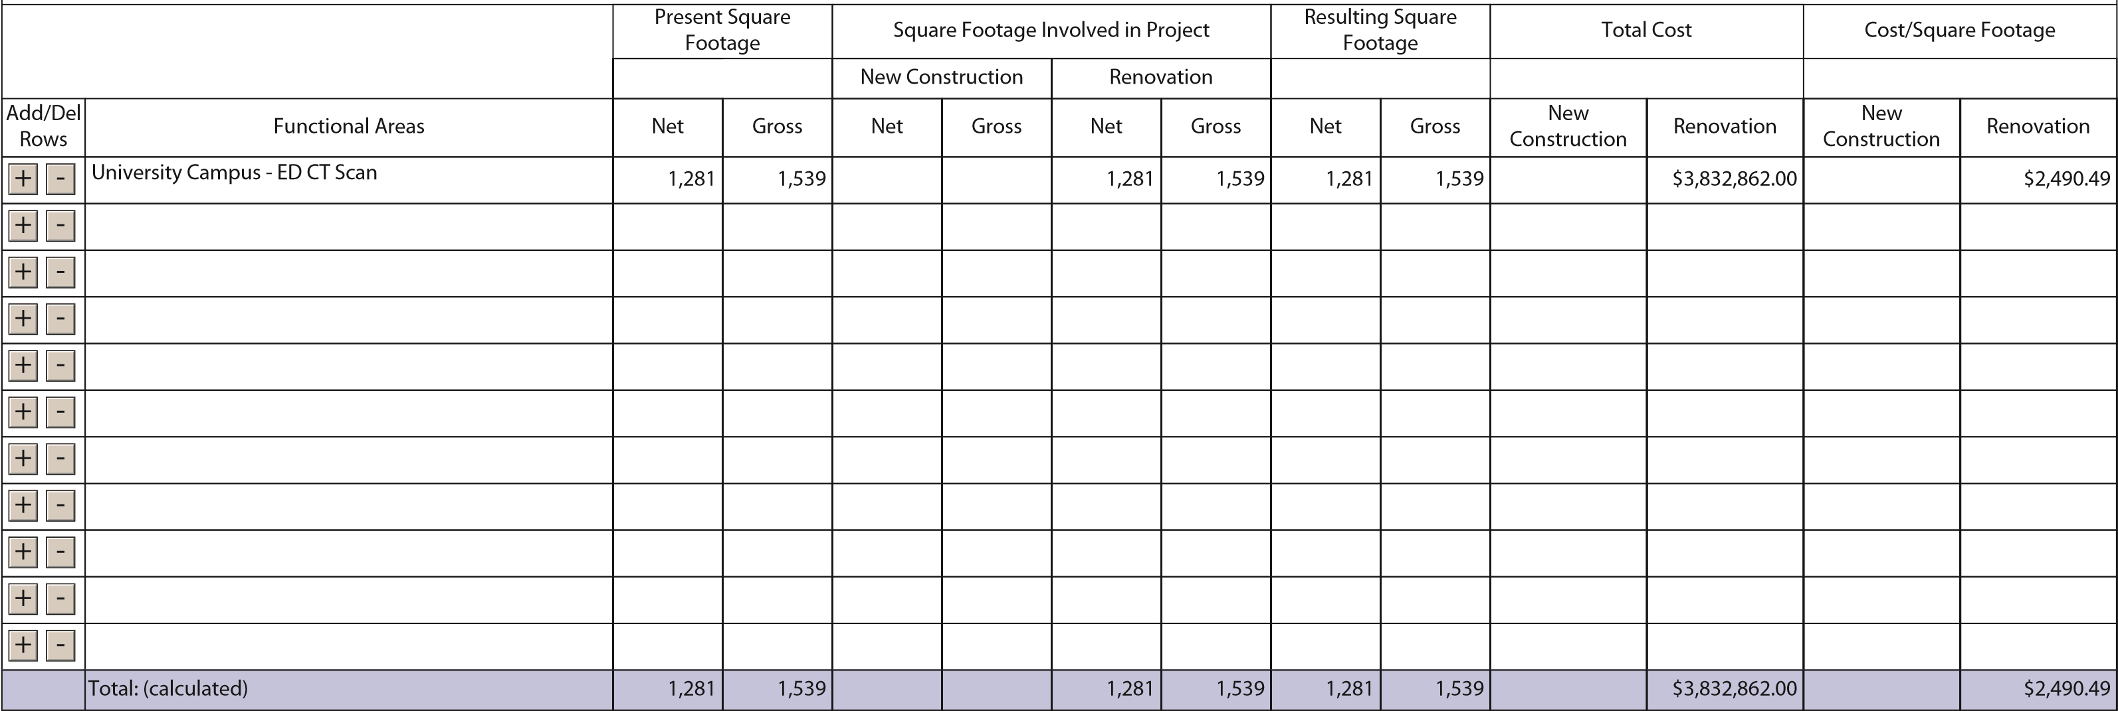
Application Form UMass Memorial Health Care, Inc. UMMHC-21120810-RE
UMMHC-21120810-RE - 11

F4.a.ii For each Category of Expenditure document New Construction and/or Renovation Costs.
 | Category of Expenditure | New Construction | Renovation | Total (calculated)
 | Land Costs
 | Land Acquisition Cost
 | Site Survey and Soil Investigation
 | Other Non-Depreciable Land Development
 | Total Land Costs
 | Construction Contract (including bonding cost)
 | Depreciable Land Development Cost
 | Building Acquisition Cost
 | Construction Contract (including bonding cost) |  | $2355561. | $2355561.
 | Fixed Equipment Not in Contract
 | Architectural Cost (Including fee, Printing, supervision etc.) and  Engineering Cost |  | $166344. | $166344.
 | Pre-filing Planning and Development Costs |  | $37281. | $37281.
 | Post-filing Planning and Development Costs |  | $25061. | $25061.
Add/Del  Rows | Other (specify)
+ -
 | Net Interest Expensed During Construction
 | Major Movable Equipment |  | $1248615. | $1248615.
 | Total Construction Costs |  | $3832862. | $3832862.
 | Financing Costs:
 | Cost of Securing Financing (legal, administrative, feasibility studies, mortgage insurance, printing, etc
 | Bond Discount
Add/Del  Rows | Other (specify
+ -
 | Total Financing Costs
 | Estimated Total Capital Expenditure |  | $3832862. | $3832862.

Factor 5: Relative Merit
F5.a.i Describe the process of analysis and the conclusion that the Proposed Project, on balance, is superior to alternative and substitute methods for meeting the existing Patient Panel needs as those have been identified by the Applicant pursuant to 105 CMR
100.210(A)(1). When conducting this evaluation and articulating the relative merit determination, Applicant shall take into account, at a minimum, the quality, efficiency, and capital and operating costs of the Proposed Project relative to potential alternatives or substitutes, including alternative evidence-based strategies and public health interventions.
Proposal:
See Attached Narrative

Quality:
See Attached Narrative

Efficiency:
See Attached Narrative

Capital Expense:
See Attached Narrative

Operating Costs:
See Attached Narrative

List alternative options for the Proposed Project:
Alternative Proposal:
See Attached Narrative

Alternative Quality:
See Attached Narrative

Alternative Efficiency:
See Attached Narrative

Alternative Capital Expense:
See Attached Narrative

Alternative Operating Costs:
See Attached Narrative

F5.a.ii Describe the process of analysis and the conclusion that the Proposed Project, on balance, is superior to alternative and substitute methods for meeting the existing Patient Panel needs as those have been identified by the Applicant pursuant to 105 CMR 100.210(A)(1). When conducting this evaluation and articulating the relative merit determination, Applicant shall take into account, at a minimum, the quality, efficiency, and capital and operating costs of the Proposed Project relative to potential alternatives or substitutes, including alternative evidence-based strategies and public health interventions.
See Attached Narrative

Documentation Check List
The Check List below will assist you in keeping track of additional documentation needed for your application.
Once you have completed this Application Form the additional documents needed for your application will be on this list. E-mail the documents as an attachment to: DPH.DON@state.ma.us
- Copy of Notice of Intent
- Affidavit of Truthfulness Form
- Scanned copy of Application Fee Check
- Affiliated Parties Table Question 1.9
- Change in Service Tables Questions 2.2 and 2.3
- (Not included) Certification from an independent Certified Public Accountant
- Articles of Organization / Trust Agreement
- Current IRS Form, 990 Schedule H CHNA/CHIP and/or Current CHNA/CHIP submitted to Massachusetts AGO's Office
- Community Engagement Stakeholder Assessment form
- Community Engagement-Self Assessment form

Document Ready for Filing
When document is complete click on "document is ready to file". This will lock in the responses and date and time stamp the form. To make changes to the document un-check the "document is ready to file" box. Edit document then lock file and submit Keep a copy for your records. Click on the "Save" button at the bottom of the page.
To submit the application electronically, click on the "E-mail submission to Determination of Need" button.

This document is ready to file: Date/time Stamp:

Application Number: UMMHC-21120810-RE
Use this number on all communications regarding this application.

Community Engagement-Self Assessment form

APPENDIX 2

NARRATIVE

2. Project Description

UMass Memorial Health Care, Inc. (“UMMHC” or the “Applicant”), located at One Biotech Park, 365 Plantation Street, Worcester, MA, 01605, is filing a Notice of Determination of Need (“Application”) with the Massachusetts Department of Public Health (“Department”) for the acquisition of DoN-Required Equipment by UMass Memorial Medical Center (“UMMMC” or the “Hospital”). Specifically, the Proposed Project is for the acquisition of one computed tomography (“CT”) unit to be located in the emergency department of the Hospital’s University Campus at 55 Lake Avenue North, Worcester, MA 01655.

UMMHC is the largest health care system in Central Massachusetts comprised of one teaching hospital and three acute care hospitals: HealthAlliance-Clinton Hospital, Marlborough Hospital, and Harrington Hospital. The system also includes behavioral health services through CommunityHealthlink, primary care, specialists, urgent care through CareWell Urgent Care, home health, and hospice.

UMMMC is the Applicant’s teaching hospital and includes three campuses: Hahnemann, Memorial, and University. The Hospital’s University Campus is the only Level 1 trauma center in Central Massachusetts and operates the second largest emergency department in Massachusetts. In addition to emergency care, the campus also provides comprehensive inpatient and outpatient services, including cardiology, oncology, and radiology.

The Proposed Project seeks to meet the needs of the Hospital’s existing and future patients by expanding its CT service in order to provide timely access to CT. The Hospital has experienced significant patient panel growth as well as CT demand. Historical utilization data demonstrates increased demand for CT imaging because of its ability to quickly result in an accurate diagnosis, which allows treatment to begin sooner. However, the Hospital is using the ED’s existing unit above its capacity, resulting in significant delays and suboptimal ED throughput. The Proposed Project seeks to improve health outcomes and patient satisfaction through timely CT imaging and improved hospital throughput.

Finally, the Proposed Project is aligned with Massachusetts’ goals for cost containment by improving CT access and as a result, reducing ED overcrowding. Moreover, there will be no change to reimbursement rates for CT imaging due to the acquisition of an additional CT unit. To that end, the Hospital asserts that health care costs will not be adversely impacted as a result of the new CT unit. Therefore, the Proposed Project will not adversely impact the Commonwealth’s goal of containing the rate of growth of total medical expenses (“TME”) and total healthcare expenditures (“THCE”).

In conclusion, the Proposed Project is needed to ensure the Hospital has adequate CT capacity to provide timely CT access to its emergency patients. Without additional capacity, the Hospital will continue to operate above capacity, resulting in long wait times, poor patient experiences, and reduced ED throughput. By improving access, the Hospital will improve timely diagnosis and treatment, which will not only improve health outcomes, but also optimize hospital resources and ED throughput. Accordingly, the Proposed Project meets the factors of review for Determination of Need approval.

Factor 1: Applicant Patient Panel Need, Public Health Values and Operational Objectives

F1.a.i Patient Panel
Describe your existing Patient Panel, including incidence or prevalence of disease or behavioral risk factors, acuity mix, noted health disparities, geographic breakdown expressed in zip codes or other appropriate measure, demographics including age, gender and sexual identity, race, ethnicity, socioeconomic status and other priority populations relevant to the Applicant's existing patient panel and payer mix.

A. UMass Memorial Health Care
UMMHC serves a large and diverse patient panel, caring for over 370,000 patients each year at its hospitals, urgent care clinics, and physician groups. The UMMHC patient panel during FY19 through FY21 was approximately 56% female and 44% male for each of the three years. Age demographics show that the majority (approximately 60%) of patients were ages18-64. Approximately 21% of UMMHC patients are aged 65 plus and 19% are aged 0-17. With respect to race and ethnicity as self-reported by UMMHC patients, the predominant race served by UMMHC hospitals is White, making up approximately 76% of the patient panel. Additionally, patients identified as Hispanic/Latino - 15%; Black/African American - 6%; and Asian - 3.8%. As noted earlier, these are self-reported figures and accordingly there is a significant percentage (13.5% in FY19, 14.1% in FY20 and 13.5% in FY21) of patients that either chose not to report or reported in a category not reported here. Lastly, the majority of hospital patients (approximately 90%) reside in Central Massachusetts, while less than 4% come from out of state.
Table 1: UMMHC Patient Panel Demographics
 | FY19 |  | FY20 |  | FY21
 | Count | % | Count | % | Count | %
Total Patients | 371,488 | 100.0% | 345,864 | 100.0% | 393,429 | 100.0%
GENDER
Female | 208,885 | 56.2% | 194,323 | 56.2% | 218,434 | 55.5%
Male | 161,945 | 43.6% | 151,096 | 43.7% | 174,530 | 44.4%
Unknown | 658 | 0.2% | 445 | 0.1% | 465 | 0.1%
Total Gender | 371,488 | 100.0% | 345,864 | 100.0% | 393,429 | 100.0%
AGE
0-17 | 71,193 | 19.2% | 62,821 | 18.2% | 72,425 | 18.4%
18-64 | 220,271 | 59.3% | 206,373 | 59.7% | 237,664 | 60.4%
65+ | 80,007 | 21.5% | 76,662 | 22.2% | 83,332 | 21.2%
Unknown | 17 | 0.0% | 8 | 0.0% | 8 | 0.0%
Total Age | 371,488 | 100.0% | 345,864 | 100.0% | 393,429 | 100.0%
RACE
American Indian or Alaska Native | 820 | 0.2% | 749 | 0.2% | 894 | 0.2%
Asian | 12,622 | 3.4% | 11,220 | 3.2% | 15,024 | 3.8%
Black or African American | 22,274 | 6.0% | 20,595 | 6.0% | 23,378 | 5.9%
Declined | 2,258 | 0.6% | 1,898 | 0.5% | 3,275 | 0.8%
Multi-Racial | 454 | 0.1% | 120 | 0.0% | 0 | 0.0%
Native Hawaiian or Other Pacific Islander | 139 | 0.0% | 127 | 0.0% | 190 | 0.0%
Other/Unknown | 50,135 | 13.5% | 48,793 | 14.1% | 52,988 | 13.5%
White | 282,786 | 76.1% | 262,362 | 75.9% | 297,680 | 75.7%
Total Race | 371,488 | 100.0% | 345,864 | 100.0% | 393,429 | 100.0%
ETHNICITY
Decline to Answer | 5,460 | 1.5% | 4,930 | 1.4% | 6,472 | 1.6%
Hispanic or Latino | 53,935 | 14.5% | 51,607 | 14.9% | 59,041 | 15.0%
Not Hispanic or Latino | 307,105 | 82.7% | 282,540 | 81.7% | 317,480 | 80.7%
Unknown | 4,988 | 1.3% | 6,787 | 2.0% | 10,436 | 2.7%
Total Ethnicity | 371,488 | 100.0% | 345,864 | 100.0% | 393,429 | 100.0%
PATIENT ORIGIN
Central Mass | 334,998 | 90.2% | 313,051 | 90.5% | 352,496 | 89.6%
Eastern Mass | 14,363 | 3.9% | 13,932 | 4.0% | 19,587 | 5.0%
Western Mass | 8,434 | 2.3% | 7,650 | 2.2% | 8,881 | 2.3%
Out of State | 13,693 | 3.7% | 11,231 | 3.2% | 12,465 | 3.2%
Total Patient Origin | 371,488 | 100.0% | 345,864 | 100.0% | 393,429 | 100.0%

As illustrated in the table below, the majority of UMMHC’s patients between FY19-FY21 were commercially insured (avg. 30.4%), though there was a slight decline from 31.2% to 29.7%. There was a corresponding increase amongst patients with Commercial Medicare, 12.7% to 14.8%. Patients were also insured by Original Medicare (avg. 28.7%), MassHealth (avg. 17.5%) and Managed Medicaid (avg. 6.1%), as well as self-pay, Worker’s Compensation, and TriCare (avg. 3.6%).
Table 2: UMMHC Payer Mix
 | FY19 | FY20 | FY21
Commercial PPO/Indemnity | 2.50% | 3.30% | 3.00%
Commercial HMO/POS | 28.70% | 27.10% | 26.70%
MassHealth | 17.40% | 17.60% | 17.50%
Managed Medicaid | 5.40% | 6.50% | 6.40%
Commercial Medicare | 12.70% | 13.40% | 14.80%
Medicare FFS | 29.20% | 28.70% | 28.40%
All other (e.g. HSN, self-pay, TriCare) | 4.10% | 3.50% | 3.20%
Total | 100.00% | 100.00% | 100.00%

B. UMass Memorial Medical Center Patient Panel

As reported on the next page, the UMMMC patient panel is very similar to the overall UMMHC patient panel. For FY19-21, approximately 56% of the patients served by UMMMC were female and approximately 44% were male. UMMMC’s patients were roughly the same age as the overall panel. In FY21, approximately 19% were aged 0-17, 59% aged 18-64, and 22% are 65 and older. Consistent with the overall UMMHC patient panel, the predominant self-reported race of patients cared for at UMMC is White (approximately 74%). Additionally, the UMMMC patient panel identified as: Hispanic/Latino – 14.8%; Black/African American – 6.5%; and Asian – 4%. Lastly, 89% of UMMMC patients reside in Central Massachusetts while only 3.4% of patients came from out of state.
Table 3: UMMMC Patient Panel Demographics
 | FY19 |  | FY20 |  | FY21
 | Count | % | Count | % | Count | %
Total Patients | 278,919 | 100.0% | 257,326 | 100.0% | 295,417 | 100.0%
GENDER
Female | 155,682 | 55.8% | 144,075 | 56.0% | 164,339 | 55.6%
Male | 122,900 | 44.1% | 113,123 | 44.0% | 130,911 | 44.3%
Unknown | 337 | 0.1% | 128 | 0.0% | 167 | 0.1%
Total Gender | 278,919 | 100.0% | 257,326 | 100.0% | 295,417 | 100.0%
AGE
0-17 | 56,818 | 20.4% | 50,622 | 19.7% | 55,748 | 18.9%
18-64 | 161,610 | 57.9% | 149,042 | 57.9% | 173,745 | 58.8%
65+ | 60,478 | 21.7% | 57,656 | 22.4% | 65,919 | 22.3%
Unknown | 13 | 0.0% | 6 | 0.0% | 5 | 0.0%
Total Age | 278,919 | 100.0% | 257,326 | 100.0% | 295,417 | 100.0%
RACE
American Indian or Alaska Native | 711 | 0.3% | 650 | 0.3% | 762 | 0.3%
Asian | 10,565 | 3.8% | 9,490 | 3.7% | 11,852 | 4.0%
Black or African American | 18,514 | 6.6% | 17,042 | 6.6% | 19,195 | 6.5%
Declined | 2,283 | 0.8% | 1,952 | 0.8% | 2,850 | 1.0%
Multi-Racial | 237 | 0.1% | 43 | 0.0% | 0 | 0.0%
Native Hawaiian or Other Pacific Islander | 124 | 0.0% | 122 | 0.0% | 153 | 0.1%
Other/Unknown | 37,221 | 13.3% | 35,647 | 13.9% | 40,327 | 13.7%
White | 209,264 | 75.0% | 192,380 | 74.8% | 220,278 | 74.6%
Total Race | 278,919 | 100.0% | 257,326 | 100.0% | 295,417 | 100.0%
ETHNICITY
Decline to Answer | 5,137 | 1.8% | 4,571 | 1.8% | 5,528 | 1.9%
Hispanic or Latino | 40,365 | 14.5% | 38,033 | 14.8% | 43,675 | 14.8%
Not Hispanic or Latino | 230,892 | 82.8% | 210,580 | 81.8% | 239,526 | 81.1%
Unknown | 2,525 | 0.9% | 4,142 | 1.6% | 6,688 | 2.3%
Total Ethnicity | 278,919 | 100.0% | 257,326 | 100.0% | 295,417 | 100.0%
PATIENT ORIGIN
Central Mass | 248,964 | 89.3% | 230,632 | 89.6% | 262,968 | 89.0%
Eastern Mass | 11,167 | 4.0% | 10,295 | 4.0% | 13,865 | 4.7%
Western Mass | 8,042 | 2.9% | 7,345 | 2.9% | 8,519 | 2.9%
Out of State | 10,746 | 3.9% | 9,054 | 3.5% | 10,065 | 3.4%
Total Patient Origin | 278,919 | 100.0% | 257,326 | 100.0% | 295,417 | 100.0%

The chart included below shows the similarity of socioeconomic status of the populations served by UMMHC and UMMC as indicated by payor mix, such as the high percentage of patients insured through government insurance programs. For FY19-21, the majority of UMMMC’s patients were commercially insured (31%), followed closely by patients with Original Medicare (28.6%). The remaining percentage of patients were insured through Medicaid (18.2%), Managed Medicare (12.8%) and Managed Medicaid (5.7%), as well as self-pay, Worker’s Compensation, and TriCare (3.5%).
Table 4: UMMMC Payer Mix
 | FY19 | FY20 | FY21
Commercial PPO/Indemnity | 2.80% | 3.60% | 3.40%
Commercial HMO/POS | 28.90% | 27.50% | 27.00%
MassHealth | 18.20% | 18.30% | 18.10%
Managed Medicaid | 5.10% | 6.10% | 6.10%
Commercial Medicare | 11.80% | 12.60% | 14.10%
Medicare FFS | 29.10% | 28.50% | 28.30%
All other (e.g. HSN, self-pay, TriCare) | 4.10% | 3.40% | 3.10%
Total | 100.00% | 100.00% | 100.00%

F1.a.ii Need by Patient Panel:
Provide supporting data to demonstrate the need for the Proposed Project. Such data should demonstrate the disease burden, behavioral risk factors, acuity mix, health disparities, or other objective Patient Panel measures as noted in your response to Question F1.a.i that demonstrates the need that the Proposed Project is attempting to address. If an inequity or disparity is not identified as relating to the Proposed Project, provide information justifying the need. In your description of Need, consider the principles underlying Public Health Value (see instructions) and ensure that Need is addressed in that context as well.

The Applicant seeks DoN approval to add a fourth CT unit at the Hospital’s University Campus. The additional unit will be located in the emergency department, resulting in two dedicated CT units to serve emergency patients. The Hospital has experienced increasingly high demand for CT imaging, particularly for ED patients. As a result, the current CT unit in the ED is operating in excess of reasonable capacity. The data below demonstrates the need for a second CT unit to serve ED patients at University Campus.
As a tertiary academic medical center, stroke center and the only Level 1 trauma center serving Central Massachusetts, the Hospital serves over 100,000 patients in its ED annually and must be able to ensure timely access to CT imaging for all patients, including emergency patients. With a dual designation as a Level 1 trauma center and a stroke center, there are competing needs for timely access to CT. In addition, all emergency patients, regardless of acuity, are experiencing high wait times for CT imaging, leading to delays in diagnosis and treatment. Moreover, high demand has a downstream effect on the Hospital’s ability to efficiently operate the ED as patients occupy ED bays waiting for CT imaging thereby delaying discharge from the ED and the ability to care for other patients. With adequate CT capacity, the Hospital can reduce ED length of stay and decrease avoidable admissions caused by deterioration of patient condition while waiting for diagnosis and treatment in the ED. The Hospital also performs CT angiography on ED patients and outpatients to expedite diagnosis of coronary disease that reduce the need for admission or cardiac catherization; however, these scans have longer protocols and can result delays in CT access for other ED patients while CTA is being performed. Finally, as the Hospital has one unit to serve its ED, if the unit has unexpected downtime for repair, emergency patients are transported to the radiology department, adversely impacting care delivery for scheduled patients.

Historic Utilization

At the Hospital’s University Campus, the number of CT scans performed on its existing 3 CT units has increased year over year.

Table 5: University Campus Historical CT Volume
 | FY19 | FY20 | FY21
Emergency | 36,628 | 37,172 | 37,648
Total | 54,020 | 55,246 | 58,002

CT demand at the University Campus increased 7.5% from FY19 to FY21. Even during the height of the COVID pandemic in FY20, CT scan volume continued to increase even while other hospitals saw a decrease in utilization during this time. In FY19, University Campus performed 36,628 emergency CT scans. Emergent CT volume grew to 37,648 CT scans in FY21, for an increase of 3% between FY19 and FY21.

On average, each of the 3 CT units performed 19,334 scans in FY21. A unit operating 24/7 has the capacity to perform 17,520 based on an average 30 minute scan time (including room turnover time). The Hospital’s ED CT unit performed 30,728 scans in FY21, 75% over capacity. This results in overtaxing of the CT unit which causes down time and need for repair more frequently than if the unit was operated at a lower capacity. As discussed above, down time results in adverse impacts for all patients requiring CT at the hospital. Emergency patients must be transported out of the ED to the radiology department. Scheduled outpatients or inpatients are then bumped to allow the emergent patient to be scanned, thereby delaying care to those patients and potentially resulting in deferred care for outpatients who are unable to reschedule in a timely manner. To that end, the Hospital determined that adding a second CT unit in the ED would have the greatest impact on providing timely CT scanning for all patients.

The most common reason for University Campus ED patients requiring CT are as follows: sepsis; syncope and collapse; unspecified injury of head; headache; dizziness and giddiness; chest pain; right lower quadrant pain; altered mental status; and generalized abdominal pain. However, these diagnoses only represent approximately 20% of all diagnoses made in the ED using CT.

Wait times for emergent CT scans also has increased each year. The average order to begin time was 114 minutes in FY19, 121 minutes in FY20 and 161 minutes in FY21. Patients who remain in the ED longer due to delays in CT scan can deteriorate resulting in avoidable admissions. Delayed access to emergency CT impact not only the patient who is waiting, but also the Hospital’s ability to efficiently operate the ED. For example, patients waiting for CT occupy needed space in ED requiring other patients to wait to be seen and thereby delaying care of all patients. Timely access to CT in the ED can lead to decreased ED length of stay and improved health outcomes for all patients.

Wait time for CT is particularly important because the University Campus is a Level 1 trauma center and stroke center. The state EMS protocols automatically send trauma and stroke patients to the University Campus ED. These patients often require timely imaging due to the critical nature of their condition. Notably, clinical guidelines for stroke recommend that patients receive CT imaging within 25 minutes of arrival at the ED. Among the top reasons for CT imaging in at the University ED are head injury, sepsis, abdominal pain, neurological conditions such as syncope and collapse, headache, dizziness and giddiness, and altered mental state, as well as cardiac conditions including chest pain. CT is highly utilized for emergency patients because of its ability to provide practitioners with reliable imaging data quickly for a number of conditions.

Projected Growth and Future Demand

Based on recent historical utilization trends, the Hospital anticipates that demand for CT will continue to grow overall, including for emergency patients. The following projections are supported by historical CT volume as well as the growth of the Hospital’s patient panel. From FY19 to FY21, the Hospital’s panel increased by 4%. The panel is likely to increase as supported by UMass Donohue Institute which projects that the population Central Massachusetts to grow by 2.3% between 2020 and 2025 and another 2.0% between 2025 and 2030.

Table 6: University Campus Projected CT Volume
 | Year 1 | Year 2 | Year 3 | Year 4 | Year 5
Emergency | 37,648 | 37,648 | 37,648 | 37,648 | 37,648
Total CT Service Volume | 59,846 | 59,869 | 59,891 | 59,914 | 59,937

Moreover, with the existing units operating in excess of capacity, the University Campus requires an additional CT to provide redundancy in its ED and ensure timely access for stroke and trauma patients and reduce wait times for all ED patients. This access will improve care delivery for all ED patients and allow the Hospital to avoid unnecessary disruption for scheduled outpatients and inpatients requiring CT. Overall access to diagnosis and treatment and health outcomes will be improved by adding a unit in the ED. Without an additional unit, the Hospital will not be able to meet projected CT demand in the future.

F1.a.iii Competition:
Provide evidence that the Proposed Project will compete on the basis of price, total medical expenses, provider costs, and other recognized measures of health care spending. When responding to this question, please consider Factor 4, Financial Feasibility and Reasonableness of Costs.

The Proposed Project will compete on the basis of price, total medical expenses, provider costs, and other recognized measures of health care spending because it will enable the Hospital to provide more timely access to emergency CT imaging, in turn improving health outcomes, reducing ED overcrowding, and maximizing overall hospital efficiency. As the only Level 1 Trauma Center in Central Massachusetts, the Hospital must have sufficient capacity to provide urgent and immediate diagnosis and treatment. Through the Proposed Project, the Hospital seeks to ensure timely access to an emergency service without negatively impacting overall health care costs.
First, it is imperative that trauma centers be equipped with the diagnostic capabilities to serve their patients and the community. Sufficient capacity to provide timely CT imaging to trauma patients at the Hospital is needed when treatment is the most likely to be successful. Alternatively, emergency patients will experience longer wait times for CT, which may contribute to delayed diagnosis and treatment, longer lengths of stay, and poor patient experience. Improving access to CT imaging in the ED will reduce ED overcrowding and improve hospital throughput which is necessary for reducing overall hospital costs.
As further discussed in Section F1.b.1, the colocation of imaging in the emergency department has demonstrated significant workflow efficiency. Moreover, as the scanner will be in addition to an existing scanner, the Hospital will further maximize operational efficiency by leveraging existing staff in addition to new staff who will be hired. With respect to direct costs, the additional unit will be reimbursed at the same rate as the Hospital’s existing CT units. Therefore, there will be no change in cost to insurers or patients who receive imaging through the Proposed Project.
Based on these considerations, the Applicant asserts the Proposed Project will improve emergency access to CT, reduce wait times, and maximize hospital workflow and efficiency. Moreover, the Proposed Project is necessary to ensure timely imaging access and treatment, and for containing health care costs through timely diagnosis and care. As a result, the Proposed Project will not negatively impact overall health care costs.
F1.b.i Public Health Value /Evidence-Based:
Provide information on the evidence-base for the Proposed Project. That is, how does the Proposed Project address the Need that Applicant has identified.

As discussed in Section F1.a.ii, the Applicant’s Proposed Project is necessary to support timely to CT imaging for emergent patients as well as overall hospital throughput. Discussed below is a summary of how the Proposed Project will improve access and health outcomes.

- Computed Tomography Technology
CT is a form of x-ray technology that uses a series of radiation beams to create detailed internal images. These images are referred to as slices and can be used to construct 3-dimensional images of soft tissue, internal organs, and bone. Moreover, CT imaging provides the option to rotate the 3-dimensional image and view the slices in succession so that the exact location of the abnormality can be identified. CT is frequently used by providers to diagnose abnormalities, such as cancerous tumors or determine what type of stroke a patient is experiencing by imaging blood vessels in the brain. Because of the level of detail available in a CT image and the speed at which the scan can be completed, CT imaging is considered an essential component of hospital care.⁹
- Clinical Application in the Emergency Department
As noted above, CT imaging is an important diagnostic tool because of its speed, accuracy, and general availability. In particular, CT scanning is the preferred diagnostic modality in the ED because of its high diagnostic confidence within a short amount of time.¹¹ In addition, early CT imaging may improve patient outcomes through their ability to expedite intervention and treatment. For example, a coronary computed tomography angiogram (CTA), which is used to detect blockages in the coronary arteries, can be performed much faster than a cardiac catheterization. Moreover, a coronary CTA may be performed with potentially less risk and discomfort and may require less recovery time. Furthermore, the co-location of a CT scanner in a hospital’s ED can further improve a patient’s ability to receive timely imaging. Studies have demonstrated that the placement of a CT scanner in the ED can reduce the length of time between order entry and preliminary interpretation by up to 16 minutes. For these reasons, the Applicant asserts adequate CT capacity in the ED setting is necessary to ensure timely diagnosis and treatment.

F.1.b.ii Public Health Value /Outcome-Oriented:
Describe the impact of the Proposed Project and how the Applicant will assess such impact. Provide projections demonstrating how the Proposed Project will improve health outcomes, quality of life, or health equity. Only measures that can be tracked and reported over time should be utilized.

To assess the impact of the proposed Project, the Applicant developed the following quality metrics and reporting schematic, as well as metric projections for quality indicators that will measure patient satisfaction and quality of care. The measures are discussed below and will be reported to DPH on an annual basis following implementation of the Proposed Project.

- Patient Experience/Satisfaction: Patients who are satisfied with care are more likely to seek additional treatment when necessary.
  - Measure: Likelihood to recommend as demonstrated by selection of top box.
  - Projections: Baseline: 38.51%; Year 1: 39%; Year 2: 40%; Year 3: 40%
- Wait Times: The Proposed Project seeks to ensure timely access to CT services. Accordingly,
UMMMC will track the average time from order placement to begin time for ED patients requiring CT.
  - Measure: Average time interval from when the CT service was ordered to when the scan began.
  - Projections: Baseline: 161 minutes; Year 1: 104 minutes; Year 2: 80 minutes; Year 3: 60 minutes
F1.b.iii Public Health Value /Health Equity-Focused:
For Proposed Projects addressing health inequities identified within the Applicant's description of the Proposed Project's needbase, please justify how the Proposed Project will reduce the health inequity, including the operational components (e.g. culturally competent staffing). For Proposed Projects not specifically addressing a health disparity or inequity, please provide information about specific actions the Applicant is and will take to ensure equal access to the health benefits created by the Proposed Project and how these actions will promote health equity.

As discussed throughout Factor 1, the Proposed Project is centered on improving health outcomes and quality of life for UMMMC’s patient panel by ensuring timely access to CT imaging that is accessible to its patient panel and the community at large. To that end, UMMMC is committed to promoting comprehensive patient education through language accessibility and utilizing data to maximize its potential to improve care and outcomes. Beyond care delivery, UMMHC is committed to actively addressing the social determinants of health as part of its mission of improving health. Therefore, the Applicant anticipates that the Proposed Project will result in improved patient care experiences and quality outcomes while promoting health equity.

A. Language Accessibility
EDs frequently serve as the entry point to health care in the US and as a result, often provide primary care services with greater rates of utilization among Limited English Proficiency and non-English speakers as well as publicly insured patients. As a result, the Proposed Project will improve health outcomes as well as the patient experience for underserved patient populations. A large part of a patient’s experience is influenced by their ability to communicate with and understand their providers. To that end, UMMMC provides qualified medical interpreters to patients and families who want to receive health information in a language other than English, including American Sign Language interpreters for patients who are deaf or hard of hearing. Interpreters are available free of charge 24 hours a day, seven days a week across both campuses and for all hospital services. Interpreters are available in person, over the phone and via remote video interpretation to ensure support for over 100 languages spoken by UMMMC’s patient population. UMMMC ensures the availability of ASL interpreters 24/7 through the use of Video Remote Interpreter (VRI) Solution, which consists of a mobile device (e.g., iPad) secured to a cart with a speaker incorporated to amplify the mobile device’s sound output. The mobile device is connected to the hospital’s secure Wi-Fi to allow users the ability to connect to readily available, qualified medical interpreters to provide language access for limited English proficient patients and for the deaf and hard of hearing. The VRI Solution offers 34 video language interpreters on demand, and 250 telephonic-only relay interpreters, with a majority accessible 24/7. VRI is available across the ED, ambulatory clinics, inpatient areas, as well as patient service areas, radiology and procedure areas. In addition to on-site capabilities, the Interpreter Services can help respond to calls from patients for both medical and nonmedical issues (e.g., medication refills, urgent visits, billing, financial services, appointment scheduling, etc.). For deaf or hard of hearing patients, TTYs and assistive listening devices are available. Accordingly, the Proposed Project will contribute to improved health outcomes and patient experience through access to timely CT and comprehensive language access.
F1.b.iv Provide additional information to demonstrate that the Proposed Project will result in improved health outcomes and quality of life of the Applicant's existing Patient Panel, while providing reasonable assurances of health equity.

Related to the provision of timely CT access, UMMHC is in the process of implementing a PCP Fast Track program to facilitate expedited CT scanning outside of the ED. This program seeks to reduce ED utilization while also ensuring patients receive medically appropriate CT imaging. To that end, this program will afford patients with same day access to CT to ensure compliance and they receive the imaging studies they need to assist with accurate and timely diagnosis. Through this program, UMMHC seeks to improve health outcomes by facilitating access to timely diagnosis and treatment.

While not specific to the Proposed Project, UMMHC and its hospitals are committed to further health and social equity through the following initiatives:
- UMMMC is a disproportionate share hospital and, as a result, is part of the health care safety net for the most vulnerable populations. UMMHC hospitals treat all patients regardless of ability to pay and provide all patients with the highest quality care and patient experience. UMMHC is experienced in providing access, and high-quality care, to vulnerable populations and will continue to support at-risk members of its community through the Proposed Project.

- UMMHC is deeply committed to health equity and has been an early participant in the “Healthcare Anchor Network” of the Democracy Collaborative, where it looks at the socio-economic determinants of health, and incorporates these in its medical records for greater understanding of the needs of its patients and its approaches to health care delivery. Further, UMMHC believes that it can work toward improvements in the socio-economic factors of the community through its “Purchasing Pillar, Investment Pillar, and Hiring Pillar” committees that are addressing the needs of its communities in creative ways, by emphasizing local purchasing, investing, and hiring.

- UMMHC has been recognized by the Lown Institute as part of its Hospital Index which emphasizes civic leadership, value of care and patient outcomes. Three UMMHC hospitals, including UMMMC, have achieved top ratings in the state and high ratings in the national rankings:

Massachusetts Hospital Rankings (comparing 55 hospitals):
- #1 HealthAlliance-Clinton Hospital
- #3 UMass Memorial Medical Center
- #9 Marlborough Hospital

National Hospital Rankings (comparing 3,282 hospitals):
- #8 HealthAlliance-Clinton Hospital
- #24 UMass Memorial Medical Center
- #94 Marlborough Hospital

F1.c Provide evidence that the Proposed Project will operate efficiently and effectively by furthering and improving continuity and coordination of care for the Applicant's Patient Panel, including, how the Proposed Project will create or ensure appropriate linkages to patients' primary care services.

- Coordination of Care and Linkages

The Applicant has programs in place to facilitate care coordination as described below. All UMMHC hospitals and campuses utilize Epic for an electronic health record which provides efficiencies, economies of scale, consistency, shared learnings and protocols, and superior continuity and coordination of care through improved shared documentation. UMMHC has a patient-centric approach and has developed a significant infrastructure to support this approach to care. Care coordination across the continuum of care is the key to successfully impacting the health of patients. Additionally, UMMHC has developed and implemented clinical pathways, collaborative initiatives, and coordinated care. The longitudinal care approach stems from the realization that in order to significantly impact the quality, utilization, and patient experience, UMMHC must view population health beyond the walls of UMMHC itself. From the community and homes of UMMHC’s patients, through its emergency departments and hospitals, and reaching across the post-acute care settings, UMMHC’s care must include the entirety of the community. UMMHC’s infrastructure is well-positioned to support care coordination between UMMMC’s ED and the entirely of a patient’s care team.

- Community-Based Care
UMMHC is committed to ensuring care extends beyond the walls of its campuses and providers. With respect to the Proposed Project, ED case managers and social workers are embedded within in the ED to meet with patients and families and connect them with the appropriate services. For many years, UMMHC has cultivated relationships with community-based organizations (CBOs) that provide excellent resources for its patients, culminating in a web- based platform, CommunityHELP. This search engine provides caregivers, individuals, care managers, and health care teams with resources across the entire spectrum of needs. It provides immediate translation into over 100 languages and enables electronic referrals to the CBOs to connect patients with resources. This is one of many tools UMMHC has developed to meet the needs of UMMHC’s patients, understanding that health care alone cannot conquer chronic disease and poor health.
Locally, food insecurity, access to dental care, and housing have emerged as consistent stressors. Enhancing CBO collaboration directly targeting these areas such as “food pharmacies”, free clinics for the housing threatened population brought to them with mobile services, and identifying free dental care are a few examples of how UMMHC has responded to community needs.

F1.d Provide evidence of consultation, both prior to and after the Filing Date, with all Government Agencies with relevant licensure, certification, or other regulatory oversight of the Applicant or the Proposed Project.

The Applicant carried out a diverse consultative process with individuals at various regulatory agencies and departments regarding the Proposed Projects. The following individuals and agencies are some of those consulted regarding this Project:
- Rebecca Rodman, Esq., Deputy General Counsel, Department of Public Health
- Lara Szent-Gyorgyi, Director, Determination of Need Program, Department of Public Health
- Jennica Allen, Office of Community Health Planning and Engagement, Department of Public Health
- Elizabeth Maffei, Office of Community Health Planning and Engagement, Department of Public Health
- Massachusetts Executive Office of Health and Human Services
- Health Policy Commission
- Center for Health Information and Analysis
- The Centers for Medicare & Medicaid Services

F1.e.i Process for Determining Need/Evidence of Community Engagement: For assistance in responding to this portion of the Application, Applicant is encouraged to review Community Engagement Standards for Community Health Planning Guideline. With respect to the existing Patient Panel, please describe the process through which Applicant determined the need for the Proposed Project.

As more thoroughly described in Section F1.a.ii, the Applicant determined the need for the Proposed Project based on the growth of its existing Patient Panel and well as the Patient Panel’s increased CT utilization and corresponding increased wait times.

F1.e.ii Please provide evidence of sound Community Engagement and consultation throughout the development of the Proposed Project. A successful Applicant will, at a minimum, describe the process whereby the "Public Health Value" of the Proposed Project was considered, and will describe the Community Engagement process as it occurred and is occurring currently in, at least, the following contexts: Identification of Patient Panel Need; Design/selection of DoN Project in response to "Patient Panel" need; and Linking the Proposed Project to "Public Health Value".

To more fully involve patients and families in the Proposed Project, the Applicant engaged the community presenting to Proposed Project and soliciting feedback.

First, the Proposed Project was presented the Hospital’s Community Benefits Advisory Committee (“CBAC”) on December 7, 2021 with seven (7) individuals in attendance, including four (4) members of the community and three (3) representatives from UMMMC. Hospital representatives spoke about the need for the Proposed Project and how it will positively impact the Hospital’s patient panel.

The Proposed Project will also be presented to the Hospital’s Patient and Family Advisory Council on January 25, 2022.

Factor 2: Health Priorities

Addresses the impact of the Proposed Project on health more broadly (that is, beyond the Patient Panel) requiring that the Applicant demonstrate that the Proposed Project will meaningfully contribute to the Commonwealth's goals for cost containment, improved public health outcomes, and delivery system transformation.

F2.a. Cost Containment:
Using objective data, please describe, for each new or expanded service,
how the Proposed Project will meaningfully contribute to the Commonwealth's goals for cost containment.

The Proposed Project will meaningfully contribute to and further the Commonwealth’s goals for cost containment by ensuring timely and equitable access to high-quality imaging services. As demonstrated in Factor 1, the Proposed Project is necessary to improve health outcomes through faster diagnosis and treatment as well as improved ED throughput, which will further contribute to advancing health outcomes as well as patient satisfaction. As a result of improved access to emergency CT scanning, the Proposed Project will meaningfully contribute to the Commonwealth’s goals of cost containment by having a neutral impact on overall TME.

F2.b. Public Health Outcomes:
Describe, as relevant, for each new or expanded service, how the Proposed Project will improve public health outcomes.

The Proposed Project will improve public health outcomes by ensuring adequate emergency access to CT imaging. UMMMC operates the second largest ED in the Commonwealth and is the only Level 1 Trauma Center in Central Massachusetts. Furthermore, the Hospital is designated by DPH as a Primary Stroke Service. Given the importance of early CT imaging for trauma, stroke, cardiac and other emergency patients, the Hospital must have adequate capacity to provide timely CT imaging through its ED. In addition to reducing poor health outcomes due to delayed diagnosis and intervention, the Hospital anticipates that the Proposed Project will further improve health outcomes by reducing the amount of time patients wait in the ED

F2.c. Delivery System Transformation:
Because the integration of social services and community-based expertise is central to goal of delivery system transformation, discuss how the needs of their patient panel have been assessed and linkages to social services organizations have been created and how the social determinants of health have been incorporated into care planning.

Social Determinant of Health (“SDOH”) screening takes place the primary care setting. During the office visit, medical assistants conduct an SDOH screening and can provide referrals to appropriate community resources. In addition, case managers embedded within the emergency department perform a primary screen and case managers in the impatient setting also screen for SDOH and assess for referrals to community services. Following discharge follow up to ensure compliance varies and in most instances the primary care physician is responsible for following the patient. The Applicant will continue to work with patients and primary care providers to ensure patients are connected to services as needed.

Factor 5: Relative Merit

F5.a.i Describe the process of analysis and the conclusion that the Proposed Project, on balance, is superior to alternative and substitute methods for meeting the existing Patient Panel needs as those have been identified by the Applicant pursuant to 105 CMR 100.210(A)(1). When conducting this evaluation and articulating the relative merit determination, Applicant shall take into account, at a minimum, the quality, efficiency, and capital and operating costs of the Proposed Project relative to potential alternatives or substitutes, including alternative evidence-based strategies and public health interventions.

This Proposal: The Proposed Project is for the acquisition of a CT unit to be located in the ED of the Hospital’s University Campus.

Quality: The Proposed Project is being pursued by the Applicant because of its ability to positively impact patient outcomes, quality of life, and patient satisfaction. The Hospital requires additional CT capacity in order to provide timely access to patients experience medical emergencies.

Efficiency: As discussed in Section F1.b.1, co-locating a second CT unit in the ED provides superior efficiency through reduced times between CT order and CT interpretation. Moreover, a second CT unit in the ED will reduce disruptions to inpatient and outpatient imaging.

Capital Expense: The total capital expenditure for the CT unit and required construction is $3,832,862.

Operating Costs: The first-year operating expenses for the CT unit are anticipated to be $856,168.

Alternative Proposal: Do not acquire a CT unit and continue to serve patients through the existing units on campus.

Alternative Quality: This alternative does not address the need of UMMMC’s patient population to have timely access to CT imaging in the ED. This option would further exacerbate wait times for emergency patients, in turn delaying diagnosis and treatment. These consequences will negatively impact health outcomes as well as patient experience.

Alternative Efficiency: The Hospital’s resources will continue to be strained under this alternative, further contributing to diversions and overcrowding.

Alternative Capital Expenses: There are no capital expenses under this alternative.

Alternative Operating Costs: The Applicant asserts operating expenses will increase over time under this alternative as a result of ED diversions, ED overcrowding, and delayed diagnosis and treatment.

APPENDIX 3 FACTOR 6 SUPPLEMENTAL DOCUMENTS
APPENDIX 3.1 CHI NARRATIVE

I. Community Health Initiative Monies
The breakdown of Community Health Initiative (“CHI”) monies for the Proposed Project is as follows. Please note, all totals are presented in the order calculated, beginning with the Maximum Capital Expenditure (“MCE”).
 | Total | Description
MCE | $3,832,862.00
CHI Monies | $191,643.10 | (5% of Maximum Capital Expenditure)
Administrative Fee | $7,665.72 | (4% of the CHI Monies, retained by UMMHC)
Remaining Monies | $183,977.38 | (CHI Monies minus the Administrative fee)
Statewide Initiative | $18,397.74 | (10% of remaining monies, paid to State-wide fund)
Local Initiative | $165,579.64 | (90% of remaining monies)
Evaluation Monies | $16,557.96 | (10% of Local Initiative Monies, retained by UMMHC)
CHI Monies for Local Disbursement | $149,021.68

II. Overview and Discussion of CHNA/CHI Processes
The CHI for the Proposed Project will be led by UMass Memorial Health Care, Inc (“UMMHC” or the “Applicant”). The Applicant participated in the 2021 Greater Worcester Regional Community Health Needs Assessment (the “CHNA”) which will serve as the basis for the CHI. The CHNA was collaboratively developed and carried out by the Worcester Division of Public Health, Fallon Health, The Hanover Insurance Group Foundation, and the Applicant. The entities have collaborated since 2008 to plan and conduct regional assessments aimed at identifying community health issues, barriers to care, inequities in care and disparities in outcomes, and gaps in the health service system.
In order to understand the health issues facing Greater Worcester, the CHNA utilized a mixed-methods assessment approach that integrates quantitative and qualitative data and sought information on the lived experiences of the community’s diverse populations. The full CHNA 2021 effort focused on compiling information through an extensive community engagement effort that involved stakeholder interviews, focus groups, and a community health survey, as described below. Data and findings from recent local assessment and planning efforts were also incorporated into the CHNA. Accordingly, the CHNA was completed in close partnership with local stakeholders, including health and social service providers, advocates, elected and appointed officials, faith leaders, community organizations, Boards and Commissions, and community residents.
The CHNA sought to include an engaged and representative sample of individuals from Greater Worcester residents. To that end, hundreds of individuals participated through 45 interviews, nine (9) focus groups, and one (1) Community Health Survey. Furthermore, the CHNA was used to inform the Greater Worcester Community Health Improvement Plan (“CHIP”) and strategies, which was led by the Coalition for a Healthy Greater Worcester.

III. Oversight of the CHI Process
The Applicant will leverage its robust and well-represented Determination of Need Committee (the
“Advisory Committee”) to oversee the development and implementation of the CHI. The Committee is comprised of community members, leaders, and stakeholders, as well as key employees across the Applicant’s organization.

IV. Advisory Committee Duties
The Advisory Committee’s scope of work includes:
- Selecting the CHI’s Health Priorities based upon the needs identified in the 2021 CHNA and in alignment with DPH’s and EOHHS’s Health Priorities and Focus Areas.
- Providing oversight of the evaluation of CHI-funded projects.
- Conducting a conflict of interest disclosure process to determine which members also will comprise the Allocation Committee.
- Ongoing monitoring and reporting to DPH.

V. Allocation Committee Duties
The Allocation Committee will be comprised of individuals from the Advisory Committee who do not have a conflict of interest with respect to funding CHI strategies. The scope of work that the Allocation Committee will carry out includes:
- Selecting Strategies for the noted Health Priorities consistent with DPH’s CHI guidelines.
- Carrying out a formal request for proposal (“RFP”) process (or an equivalent, transparent process) for the disbursement of CHI funds.
- Engaging resources that can support and assist applicants with their responses to the RFP.
- Disbursement of CHI funding.
- Providing oversight to the evaluation process.

VI. Timeline for CHI Activities
Upon a Notice of Determination of Need being issued by the Public Health Council, the Advisory Committee will commence meeting and begin the CHI Process. The timeline for CHI activities is as follows:
- Six weeks post-approval: The Advisory Committee will meet to review their responsibilities and the 2021 CHNA in furtherance of selecting Health Priorities.
- Three months post-approval: The Advisory Committee determines Health Priorities and Strategies for funding.
- Four months post-approval: The Advisory Committee conducts a Conflicts of Interest process to determine which members will form the Allocation Committee.
- Five months post-approval: The Allocation Committee develops the funding process for the selected strategies.
- Six months post-approval: The RFP for funding is released.
- Eight months post-approval: Responses are due for the RFP.
- Nine to ten months post-approval: Funding decisions are made, and the disbursement of funds begins.
- Eighteen months to two years post-approval: Ongoing evaluation efforts and reporting to DPH.

VII. Request for Multi-Year Funding
The Applicant is requesting the flexibility to extend the life of the CHI grants up to three (3) years depending on the number and nature of applications received and ultimately funded.

VIII. Administrative Monies
UMMHC is requesting to use up to $7,665.72 in administrative funding. These monies will be used to fund support staff, provide support to Advisory Committee and Allocation Committee members, and assist with the development of community communication materials, including publicizing and facilitating the RFP process.

IX. Evaluation Overview
The Applicant anticipates using the allowed 10% of local CHI funding ($16,557.96) for evaluation efforts. The money will be used to develop and implement an evaluation plan for CHI-funded projects.
APPENDIX 3.2 CHNA SELF-ASSESSMENT FORM

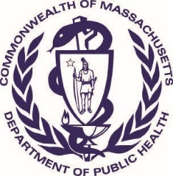Massachusetts Department of Public Health _{Version:} ₈₋₁₋₁₇ Determination of Need
Community Health Initiative
CHNA / CHIP Self Assessment
This self-assessment form is to understand the Community Engagement process that has led/ will lead to the identification of priorities for community health planning processes. It is being used to demonstrate to DPH that an existing community health planning process adequately meets DPH standards for community engagement specific to Determination of Need, Community Health Initiative purposes.
This form will provide the basic elements that the Department will use to determine if additional community engagement activities will be required. When submitting this form to DPH, please also submit your IRS Form 990 and Schedule H CHNA/CHIP and/or current CHNA/
CHIP that was submitted to the Massachusetts Attorney General's Office. Additionally, the Applicant is responsible for ensuring that the Department receives Stakeholder-Assessments from the stakeholders involved in the CHNA / CHIP process.
All questions in the form, unless otherwise stated, must be completed.
Approximate DoN Application Date:
25
/
01
5
/2022
DoN-Required Equipment
DoN Application Type:
What CHI Tier is the project?
Tier 1
Tier 2
Tier 3
1
. DoN Applicant Information
Applicant Name:
UMass Memorial Health Care, Inc.
Mailing Address:
One Biotech Park, 365 Plantation Street
Worcester
City:
State:
Massachusetts
Zip Code: 01605
2
. Community Engagement Contact Person
City:
Contact Person: Monica Lowell
Title:
Vice President Community Health Transformation/Communi
t
Mailing Address:
16
Shaffner St.
Worcester
Massachusetts
State:
Zip Code: 01605
5083347639
Phone:
Ext:
E-mail:
Monica.Lowell@umassmemorial.org

3. About the Community Engagement Process
Please indicate what community engagement process (e.g. the name of the CHNA/CHIP) the following form relates to. This will be use as a point of reference for the following questions and does not need to be a fully completed CHNA or implemented CHIP.
(please limit the name to the following field length as this will be used throughout this form): 2021 Greater Worcester CHNA/CHIP
Page 1 of 14

2021 Greater Worcester CHNA/CHIP
4. Associated Community Health Needs Assessments
In addition to the above engagement process, please list Community Health Needs Assessments and/or Community Health Improvement Planning Processes, if any that the Applicant been involved with in the past 5 years (i.e. CHNA/ CHIP processes not led by the Applicant bur where the Applicant was involved?
(Please see page 22 of the Community-Based Health Initiative Guidelines for reference http://www.mass.gov/eohhs/docs/dph/quality/don/guidelines-community-engagement.pdf)
Add/  Del  Rows | Lead Organization Name / CHNA/CHIP Name | Years of Collaboration | Name of Lead Organizer | Phone Number | Email Address of Lead Organizer
 | The Coalition for a Healthy Greater Worcester CHIP Annual  Report | 13 | Casey Burns, Director | 5084250729 | casey@healthygreaterworcester.org
Factor 6 Self Assessment UMass Memorial Health Care, Inc. Page 2 of 14
UMMHC-21120810-RE - 39

5. CHNA Analysis Coverage
Within the 2021 Greater Worcester CHNA/CHIP , please describe how the following DPH Focus Issues were analyzed DoN Health Priorities and Focus Issues (please provide summary information including types of data used and references to where in the submitted CHNA/CHIP documents these issues are discussed):
5.1 Built Environment
Primary and secondary data and data from local related reports were incorporated

Four key stakeholder interviews were conducted related to Built Environment for the 2021 Community Health Needs Assessment (CHNA).
These included:
- Built Environment & Food Systems Coordinator, City of Worcester
- Director of Accessibility, City of Worcester
- Two Transportation Planners for the Central Massachusetts Regional Planning Commission

Built Environment, Transportation & Accessibility was included as a topic of focus in the 2021 CHNA and discussed on pages 45 & 46.

CHIP Community Conversations SDOH/CHIP Strategies and Actions:
- Included in SDOH CHIP Community Conversation resulting in two strategies related to the Built Environment, one being not only access to public, affordable transportation and also disability access to bus stop locations
- Implementation of the Complete Streets policy in process current with the Worcester Division of Public Health • Free access to high quality internet
5.2
Education
Primary and secondary data and data from local related reports were incorporated

Five subject matter experts from the Education sector (Higher Ed, Worcester Public Schools superintendent and early childhood) were
interviewed as key stakeholders for the CHNA.
T
hese included:
• Superintendent, Worcester Public Schools
• Grafton Public Schools
• President, Quinsigamond Community College
• President, Worcester State College
• Executive Director, Edward Street Early Childhood Center

Education was included as a topic of focus in the CHNA and discussed on pages Education pages 33 & 37
CHIP Community Conversations SDOH/CHIP Strategies and Actions:
• Recognized need for improving universal and expanding access to affordable, high-quality early education
• Implementing comprehensive sex education
• Improvement in access to educational informational resources in multiple languages
5.3
Employment
Primary and secondary data and data from local related reports were incorporated

T
wo key informant interviews related to employment were conducted for the CHNA.
T
hese included:
• Executive Vice President and Vice President of Government Affairs and Public Policy, Worcester Chamber of Commerce

A Focus Group was also held with the Worcester Together Coalition’s Undocumented Working Group

Employment was discussed on pages: 33,36,37,42 & 57 of the CHNA

CHIP Community Conversations SDOH/CHIP Strategies and Actions:
• Recruitment and retention of public health and para-professional mental health employees
• Strategies for workforce pipeline development
Page 3 of 14
5.4 Housing
Primary and secondary data and data from local related reports were incorporated
Four key informant interviews related to or including discussions of housing were conducted for the completion of the 2021 CHNA.
These included:
• Executive Director, Central Massachusetts Housing Alliance
• City Manager for Worcester
• Town Manager and Assistant Town Manager, town of Shrewsbury
Housing pages 49, 51, 64, 75
CHIP Community Conversations SDOH/CHIP Strategies and Actions:
• Policy change campaign to eliminate barriers to housing affordability (Housing First Model)
• Housing for people in recovery
5.5 Social Environment
Primary and secondary data and data from local related reports were incorporated
Five key stakeholders were interviewed that addressed social environment for the completion of the 2021 CHNA. These included:
• Program Director, Worcester Family Resource Center/ Seven Hills Foundation
• Program Director, Worcester Community Connections
• Director, Wellness & Health Equity, YWCA
• Director, Black Families Together
• Director, Southeast Asian Coalition
A Focus Group discussion was also held with the Worcester Together Coalition
Social Environment – (referred to in the CHNA as Social Vulnerability Index) pages 31, 32, 70
CHIP Community Conversations SDOH/CHIP Strategies and Actions:
• Leading with Race Approach- Adopting Municipal Racial Policies
• Adopt community-led racial equity training for all municipal employees
• Work with and compensate grass-roots leaders in oversight and decision making
• Use community-vetted equity tools in department Board planning and decision making
• Community testimonials related to access to care and their experience in racism and implicit bias –
• Implement training on anti-racism targeting workers who serve most oppressed populations (i.e. LGBTQI+)

5.6 Violence and Trauma
Primary and secondary data and data from local related reports were incorporated

Two Focus Group discussions were held in the completion of the CHNA (see Mental Health also below). These included:
- The City of Worcester Mayors Mental Health Task Force
- The Worcester Together Mental Heath Committee including robust representation from mental providers and organizations

Violence and Trauma were discussed on the following pages of the CHNA: Violence: pages 24, 56
Trauma: pages 22, 28, 49, 57, 75

CHIP Strategies and Actions:
- Related to Integrated Care; connecting to housing assistance and mental health
- Broadening and scaling resource navigation systems for those experiencing violence and trauma and actively in recovery services
- Policy change campaign for universalizing access to home visiting services for families related to Adverse Childhood Experiences
(ACES); requiring that at a minimum that every family will have one home visit from a nurse practitioner 5.7 5.7 The following specific focus issues
Page 4 of 14
a. Substance Use Disorder
Primary and secondary data and data from local related reports were incorporated Discussed in the CHNA on pages: 28, 48, 56, 57, 74

CHIP Strategies and Actions:
- Related CHIP Community Conversation: Integrated Topics. Tandem need for health and mental health services but also food, housing and other social needs being coordinated. Wrap around services.
- Broadening and scaling resource navigation systems for who experienced violence and trauma and who were also actively in recovery services
- Policy change campaign to implement a crisis response team approach through community collaboration including specifically related to substance use and overdose

b. Mental Illness and Mental Health
Primary and secondary data and data from local related reports were incorporated
Two Focus Group discussions were held with the City of Worcester Mayors Mental Health Task Force and the Worcester Together Mental Health Committee including robust representation from mental providers and organizations
Mental illness and Mental and Behavioral Health was discussed in the CHNA on pages:
21, , 22, 25, 26, 28, 33, 36, 48, 56 and 57
CHIP Strategies and Actions:
• CHIP Community Conversation: Access to mental health services strategies particularly related to shortage of mental health providers and beds

c. Housing Stability / Homelessness
Primary and secondary data and data from local related reports were incorporated
Four key informant interviews related to or including discussions of housing and housing stability were conducted for the completion of the 2021 CHNA. These included:
• Executive Director, Central Massachusetts Housing Alliance
• City of Worcester Manager
• Town Manager and Assistant Town Manager, town of Shrewsbury
Key informant interviews were held in completion of the CHNA with stakeholders from the housing sector and related organizations serving the homeless populations
Housing Stability/Homelessness was discussed in the CHNA on pages:
23, , 26, 31, 33, 36, 40, 48, 49, 50 and 63
CHIP Community Conversations SDOH/CHIP Strategies and Actions:
• Eliminate barriers to housing affordability and assistance
- Implement crisis response team

d. Chronic Disease with a focus on Cancer, Heart Disease, and Diabetes
Primary and secondary data and data from local related reports were incorporated
A total of eleven health care providers and one service provider were included as key stakeholder interviews in the completion of the CHNA. These included:
• CEO, Fallon Health
• Medical Director, Medicaid ACO, Fallon Health
• President/CEO, UMass Memorial Health
• Chief of Staff, UMass Memorial Health
• VP of Strategy, Development and Advancement, Family Health Center

• President/CEO, Edward M. Kennedy Community Health Center
• Vice President of Operations, Edward M. Kennedy Community Health Center
• MD/Internal Medicine Specialist, Reliant Medical Group
• CEO, St. Vincent Hospital
• VP/Medical Director, Summit Eldercare
• Director, Wellness & Health Equity, YWCA
A related Older Adults Focus Group was also conducted
Chronic disease: pages 46, 54
Cancer: pages 51,61,62, 63
Diabetes: pages 54, 63, 68, 71
Heart disease/cardiovascular: pages 6, 60
CHIP Strategies and Actions:
• CHIP Community Conversation screenings and early intervention/prevention
• Development of a data dashboard for tracking racial disparities across chronic conditions
• Training the health and human service workforce on empathetic patient care

Page 5 of 14

6. Community Definition
Specify the community(ies) identified in the Applicant's 2021 Greater Worcester CHNA/CHIP
 | Municipality | If engagement occurs in specific neighborhoods, please list those specific neighborhoods:
Worcester |  | Secondary incorporated into the CHNA included some census-tract and neighborhood level-data as well as findings and data gathered through regarding COVID-19 and Social Vulnerability. This included specific neighborhoods in the City of Worcester such as Main South, Bell Hill/Lincoln Street, Canal District, Worcester’s downtown area and Grafton/Union Hill.
Grafton
Millbury
Shrewsbury
West Boylston
Page 6 of 14

7. Local Health Departments
Please identify the local health departments that were included in your 2021 Greater Worcester CHNA/CHIP . Indicate which of these local health departments were engaged in this 2021 Greater Worcester CHNA/CHIP . For example, this could mean participation on an advisory committee, included in key informant interviewing, etc. (Please see page 24 in the Communit further description of this requirement http://www.mass.gov/eohhs/docs/dph/quality/don/guidelines-community-engagement.pdf.)
Add/
Del
Rows
Municipality
Name of Local Health Dept
Name of Primary Contact
Email address
Describe how the health department was involved

-
+
Worcester
Worcester Division of Public Health
Karyn E. Clark, Director
ClarkKE@worcesterma.gov
WDPH participated in the development of the 2021 Greater
Worcester Regional Community Health Needs Assessment (CHNA)
along with Fallon Health, The Hanover Insurance Group Foundation,
the Coalition for a Healthy Greater Worcester, and UMass Memorial
Health.

WDPH played a key leadership role in the planning of the 2021 and
in ensuring broad, diverse and maximum representation and input
from community stakeholders and the community at-large
including through Key stakeholder interviews, Focus Groups, CHIP
Discussions and development and dissemination of the CHNA Public
Survey.

WDPH Director, Karyn Clark is also co-Chair of the Coalition for a
Healthy Greater Worcester, which collaborated in the completion of
the CHNA through the input of data as well as CHIP discussions,
member participation and community engagement overall.
-
+
Worcester
Worcester Division of Public Health
Cassandra Anderson, Chief of
Community Health
AndersonC@Worcester.ma.gov
Played a significant role in the WDPH CHNA involvement described
above.
-
+
Worcester
Worcester Division of Public Health
Nikki Nixon, Epidemiologist
NixonN@Worcesterma.gov

Provided data review and analysis in the completion of the CHNA as
well as the development and distribution of the CHNA Community
Health survey in multiple languages.
8
. CHNA / CHIP Advisory Committee
Please list the community partners involved in the CHNA/CHIP Advisory Committee that guided the 2021 Greater Worcester CHNA/CHIP . (please see the
required list of sectorial representation in the Community Engagement Standards for Community Health Planning Guidelines http://www.mass.gov/eohhs/docs/dph/ quality/don/guidelines-community-engagement.pdf) Please note that these individuals are those who should complete the Stakeholder Engagement Assessment form.
It is the responsibility of the Applicant to ensure that DPH receives the completed Stakeholder Engagement Assessment form:
 | Sector Type | Organization Name | Name of Primary  Contact | Title in Organization | Email Address | Phone Number
Municipal Staff |  | Worcester Division of Public  Health | Karyn E. Clark | Director | ClarkKE@worcesterma.gov | 5087991762
44
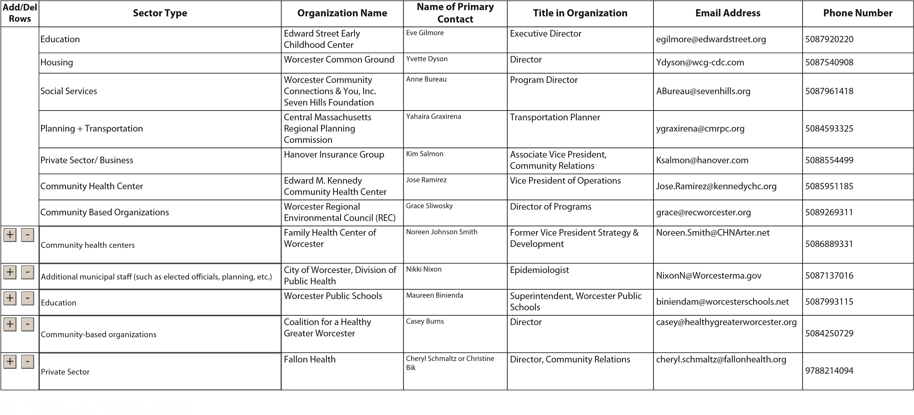
For Tier 2 and Tier 3 CHI Projects, is the the Applicant's CHNA / CHIP Advisory Board the same body that will serve as the CHI advisory committee as outlined in the Table 1 of the Determination of Need Community-Based Health Initiative Guideline (http://www.mass.gov/eohhs/docs/dph/quality/don/guidelines-chi-planning.pdf)? No
45
For Tier 2 DON CHI Applicants: The CHI Advisory Committee is tasked with helping select DoN Health Priorities based on the CHNA / CHIP unless the Applicant is directed by DPH to conduct additional community engagement. If so, the advisory committee's role is to guide that additional work.
For Tier 3 DON CHI Applicants: The CHI Advisory Committee is to select DoN Health Priorities based on, but not exclusive to, the CHNA / CHIP. This includes the additional community engagement that must occur to develop the issue priorities.
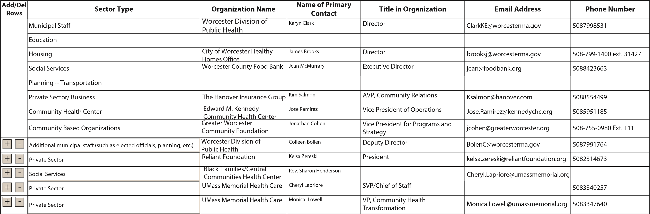

9. Engaging the Community At Large
Thinking about the extent to which the community has been or currently is involved in the 2021 Greater Worcester CHNA/CHIP , please choose one response for each engagement activity below. Please also check the box to the left to indicate whether that step is complete or not. (For definitions of each step, please see pages 12-14 in the Community Engagement Standards for Community Health Planning Guidelines http://www.mass.gov/eohhs/docs/dph/quality/don/guidelines-community-engagement.pdf).
 | Inform | Consult | Involve | Collaborate | Delegate | Community -  Driven / -Led
Assess Needs and Resources: Collaborate
Please describe the engagement process employed during the “Assess Needs and Resources” phase.
Focus on What's Important: Collaborate
Please describe the engagement process employed during the “Focus on What's Important” phase.
Choose Effective Policies and Programs: Community-Driven/-Led
Please describe the engagement process employed during the “Choose Effective Policies and Programs” phase.
Act on What's Important: Collaborate
Please describe the engagement process employed during the “Act on What's Important” phase.
Evaluate Actions: Collaborate
Please describe the engagement process employed during the “Evaluate Actions” phase.

10. Representativeness
Approximately, how many community agencies are currently involved in within the engagement 2021 Greater Worcester CHNA/CHIP of the community at large?
244 Agencies
Approximately, how many people were engaged in the process (please include team members from all relevant agencies and independent community members from the community at large)?
1,226 Individuals
Page 10 of 14
Please describe the diversity of the people who have been engaged in the process both within the CHNA/CHIP Advisory Committee and the community at large. Explicitly describe how the process included diverse representation from different groups/individuals with varied gender, sexual orientation, race/ethnicity, disability status, international status and age. Please see page 10 and Appendix A of the Community Engagement Standards for Community Health Planning Guideline (http:// www.mass.gov/eohhs/docs/dph/quality/don/guidelines-community-engagement.pdf) for further explanation of this.
The CHNA planning partners strive to provide opportunities for as much community input as possible. Both the CHNA and CHIP are completed by incorporating representation from a broad and diverse range of community stakeholders and sectors through conducting key stakeholder interviews, Focus Group discussions, Community Forums and through an online Community Health survey distributed in multiple languages. Participation includes representation from community serving organizations such as grass roots organizations and coalitions, health care organizations, social service and mental/behavioral health providers, faithbased, workforce, philanthropy, public health, city government and the community at large. The CHNA/CHIP Community engagement process includes a diverse mix of representation including age, gender, ethnicity, sexual identity, disability status, socioeconomic status, race and health status and a commitment to incorporating as broad community representation and input as possible. The demographic results from the CHIP Community Conversations: 46.2% were White, 32% were Black, 19% Latinx/
Hispanic, 5% Asian and 6.4% American Indian/Alaskan, Indian Nations or Indigenous. 3% multi-racial. 1.3% Dominican, 1% Jewish, 1% Afro-Caribbean and 1% African
Please describe the type of representation that was/is employed in the community engagement process and the rationale for that type of representation. For more information on types of representation and representativeness, please see Appendix A from the Community Engagement Standards for Community Health Planning Guidelines (http://www.mass.gov/eohhs/docs/dph/ quality/don/guidelines-community-engagement.pdf). Please include descriptions of both the Advisory Board and the Community at large.
Representation in the community engagement process includes representation from community serving organizations such as grass roots organizations and coalitions, health care organizations, social service and mental/behavioral health providers, faithbased, workforce, philanthropy, public health, city government (municipal government, City Council members, an Administrator and Board of Health), college/universities, regional planning staff, transportation sector, housing, school districts, community health centers and providers, legal/undocumented advocates, seniors, the United Way and the community at large.
To your best estimate, of the people engaged in approximately how many: Please indicate the 2021 Greater Worcester CHNA/CHIP number of individuals.
Number of people who reside in rural area: 0
Number of people who reside in urban area: 90%
Number of people who reside in suburban area: 10%
11. | Resource and Power Sharing
For more information on Power Sharing, please see Appendix A from the Community Engagement Standards for Community Health Planning Guidelines (http://www.mass.gov/eohhs/docs/dph/quality/don/guidelines-community-engagement.pdf).
By community partners, we mean agencies, organizations, tribal community, health departments, or other entities representing communities.
By Applicant partners, we mean the hospital / health care system applying for the approval of a DoN project
 | Community  Partners | Applicant  Partners | Both | Don't Know | Not Applicable
Which partner hires personnel to support the community engagement activities?: Both
Page 11 of 14
Who decides the strategic direction of the engagement process?: Both
Who decides how the financial resources to facilitate the engagement process are shared?: Both
Who decides which health outcomes will be measured to inform the process?: Community Partners

12. Transparency
Please describe the efforts being made to ensure that the engagement process is transparent. For more information on transparency, please see Appendix A from the Community Engagement Standards for Community Health Planning Guidelines.
Community outreach and input for the completion of the 2021 CHNA included a total of 45 Key Stakeholder Interviews were completed with 45 community leaders, service providers, public officials, advocates, and representatives from community stakeholders, faith-based organizations and academia. Due to the pandemic, all interviews were completed virtually, via phone or Zoom, using a standard interview guide.

A series of nine virtual Focus Groups were also completed. These sessions allowed for the collection of critical input from service providers and community residents, with an emphasis on understanding Social Determinants of Hhealth (SDOH) and health needs and experiences of vulnerable populations. Focus groups were organized in collaboration with stakeholder interviewees to leverage their community connections and to help ensure participation.

In June, the Worcester Division of Public Health administered a web-based Community Health Survey, open to all individuals who live, work and play in Greater Worcester. The survey was implemented as a way to gather information from populations that may have not been connected to other assessment activities. The CHNA Sponsors worked with staff at the Worcester Division of Public Health to craft a survey that was accessible and easy to understand (Attachment A). It was available in three languages (English, Spanish, Vietnamese) and distributed widely, from June 5, 2021 – August 11, 2021. Overall, 909 individuals took the survey. Methods of distribution included:

- Boards of Health in the CHNA Service Area
- Monthly newsletters to towns
- Employee newsletters by all partner organizations
- Postings on partner Facebook pages and social media platforms
- E-newsletter distribution by the Coalition for a Healthy Greater Worcester to approximately 850 community members and organizations (sent three times and posted on social media)
- Distribution to the Worcester Together Coalition including over 150 members
- Other email distribution lists and at community outreach events, such as the COVID-19 Feet on the Street, COVID testing, and vaccination sites

Public posting of the CHNA:
The competed CHNA is posted on UMass Memorial’s website as well as the CHNA Planning Committee member websites (Worcester Division of Public Health, Fallon Health, The Hanover Insurance Group and the Coalition for a Healthy Greater Worcester). UMass Memorial solicits from the community on the CHNA on its website where the report is posted as well as within the CHNA itself.

13. Formal Agreements
Does / did the 2021 Greater Worcester CHNA/CHIP have written formal agreements such as a Memorandum of Agreement/
Understanding (MOU) or Agency Resolution?
No, there are no written formal agreements
Did decision making through the engagement process involve a verbal agreement between partners?
No, there are no verbal agreements
Page 12 of 14

14. Formal Agreement Specifics
Thinking about your MOU or other formal agreement(s), does it include any provisions or language about:
Distribution of funds: No
Written Objectives: No
Clear Expectations for
Partners' Roles: No
Clear Decision Making
Process (e.g. Consensus vs. Voting): No
Conflict resolution: No
Conflict of Interest Paperwork: No
Page 13 of 14

15. Document Ready for Filing
When the document is complete click on "document is ready to file". This will lock in the responses and date and time stamp the form. To make changes to the document un-check the "document is ready to file" box. Edit document then lock file and submit Keep a copy for your records. Click on the "Save" button at the bottom of the page.
To submit the application electronically, click on the "E-mail submission to DPH" button.

When providing the Stakeholder Assessment Forms to the community advisory board members(individuals identified in Section 8 of this form), please include the following information in your correspondence with them. This will aid in their ability to complete the form:
- Community Engagement Process: 2021 Greater Worcester CHNA/CHIP
- Applicant: UMass Memorial HealthCare, Inc.
- A link to the DoN CHI Stakeholder Assessment
APPENDIX 3.3
GREATER WORCESTER 2021
COMMUNITY HEALTH ASSESSMENT

Greater Worcester

Community Health Assessment 2021 CHA

Table of Contents
Background & Purpose ................................................................................................................................. 3
Community Health Needs Assessment Sponsors ........................................................................................ 4
Central Massachusetts Regional Public Health Alliance ............................................................................ 4
Fallon Health .............................................................................................................................................. 4
The Hanover Insurance Group Foundation ............................................................................................... 4
UMass Memorial Medical Center .............................................................................................................. 4
Acknowledgements ....................................................................................................................................... 5
Approach & Methods .................................................................................................................................... 6
Qualitative Data & Community Engagement 8
Stakeholder Interviews 8
Focus Groups ......................................................................................................................................... 9
Community Health Survey 10

CHIP Community Conversations .......................................................................................................... 11
Quantitative Data & Data Limitations ..................................................................................................... 11
Community Assets ................................................................................................................................... 12
Feedback from Last Community Health Needs Assessment ................................................................... 12
CHA Service Area ......................................................................................................................................... 12
REGIONAL AND COMMUNITY CHARACTERISTICS...................................................................................... 13
Total Population....................................................................................................................................... 14
Age ........................................................................................................................................................... 14
Race & Ethnicity ....................................................................................................................................... 15
Immigrants, Refugees, & Non-English Speakers...................................................................................... 17
Early Childhood, Youth, & Adolescent Health ......................................................................................... 21
Older Adult Health & Healthy Aging ........................................................................................................ 22
LGBTQ+ Health ......................................................................................................................................... 24
People with Disabilities ............................................................................................................................ 26
Veterans ................................................................................................................................................... 28
SOCIAL DETERMINANTS OF HEALTH .......................................................................................................... 30
Social Vulnerability Index (SVI) ................................................................................................................ 31
Socioeconomics ....................................................................................................................................... 33
Education ............................................................................................................................................. 33
Employment, Income, & Poverty ......................................................................................................... 36 Food Insecurity ........................................................................................................................................ 39
Built Environment, Transportation & Accessibility.................................................................................. 45
Housing & Homelessness ......................................................................................................................... 48
Environmental Health .............................................................................................................................. 51
Health Insurance and Navigation ............................................................................................................ 51
HEALTH RISKS, BEHAVIORS, AND OUTCOMES ........................................................................................... 53
Health Risk Factors .................................................................................................................................. 54
Life Expectancy and Overall Mortality ..................................................................................................... 55
Mental/Behavioral Health ....................................................................................................................... 56
Substance Use Disorder ........................................................................................................................... 57
Cardiovascular Disease & Stroke ............................................................................................................. 60
Cancer ...................................................................................................................................................... 61
Diabetes and Asthma ............................................................................................................................... 63
Maternal & Infant Health ........................................................................................................................ 64
Infectious Disease & Sexual Health ......................................................................................................... 65
COVID-19.................................................................................................................................................. 67
Oral Health ............................................................................................................................................... 71
CHIP & CHA PRIORITIES............................................................................................................................... 72
Priority Populations ................................................................................................................................. 73
Priority Areas and Cross Cutting Issues ................................................................................................... 74
ATTACHMENT A: COMMUNITY HEALTH SURVEY ....................................................................................... 75
ATTACHMENT B: COMMUNITY ASSET LISTING ........................................................................................... 80
ATTACHMENT C: UMass Memorial Medical Center Community Benefits Impact Measures 2018-2021..85

Background & Purpose

The 2021 Greater Worcester Regional Community Health Needs Assessment (CHA) was developed collectively by the Worcester Division of Public Health – the lead agency of the Central Massachusetts Regional Public Health Alliance (CMRPHA), Fallon Health, The Hanover Insurance Group Foundation, and UMass Memorial Health. Since 2008, these entities have worked collaboratively to plan and conduct a regional assessment effort, aimed at identifying community health issues, barriers to care, disparities in health outcomes, vulnerable populations, gaps in the health service system, and opportunities for collaboration. CHA findings will be used to help ensure that community health improvement efforts are appropriately focused and delivered in ways that allow people to access health and health-related services when, where, and how they need them.
Since 1994, the Massachusetts Attorney General’s Office has published Community Benefit Guidelines that encourage nonprofit hospitals and health maintenance organizations (HMOs) to address social determinants of health in the communities they serve. In 2012, the federal Affordable Care Act (ACA) further reinforced these expectations by mandating that these entities engage in similar assessment, planning, and community health improvement activities. Local and state health departments have similar requirements and obligations born out of their civic obligation to ensure the health and wellbeing of those who live, work or visit their communities. The Worcester Division of Public Health has opted to build on its commitment to strong public health principles by becoming an accredited public health department under the auspices and accreditation guidelines of the Public Health Accreditation Board (PHAB). To identify leading social determinants, major health issues, and vulnerable populations, the Community Benefit Guidelines encourage institutions to conduct comprehensive community health needs assessments. In developing these materials, institutions are expected to fully engage the community-at-large and to collaborate with other community health stakeholders.
A primary goal of the CHA is to gather information on the lived experiences of Greater Worcester's diverse populations. Collecting this information is critical in efforts to center health equity and address needs and barriers in ways that are comprehensive, accessible, and culturally competent. The CHA was completed in close partnership with local stakeholders, including health and social service providers, advocates, elected and appointed officials, faith leaders, community organizations, Boards and Commissions, and community residents.
The Community Benefits and PHAB guidelines include the expectation that institutions conduct their CHAs and develop their strategic implementation plans in close collaboration with existing multisector, community coalitions to take advantage of and leverage work already completed—as well as to avoid duplication of efforts. In this regard, this CHA has worked in close cooperation with the Coalition for a
Healthy Greater Worcester as part of the Greater Worcester Community Health Improvement Plan (CHIP). The Worcester CHIP acts as the strategic plan for the CHA sponsors and other local stakeholders.

Community Health Needs Assessment Sponsors

Central Massachusetts Regional Public Health Alliance
The mission of the Worcester Division of Public Health (WDPH) /Central Massachusetts Regional Public Health Alliance (CMRPHA) is to equitably improve health outcomes and quality of life for all residents by providing high quality, data drive, public health leadership and services. The Division provides an array of public health services including public health nursing, community health initiatives, emergency preparedness and response, environmental health inspections and policy technical assistance. In 2016, WDPH / CMRPHA became the first nationally accredited public health department in Massachusetts.
Fallon Health
Founded in 1977, Fallon Health is a nationally recognized, not-for-profit health care services organization that is committed to the vision of creating healthier lives by supporting the diverse and changing needs of those we serve. Since its inception, Fallon has worked to improve the quality of life and the health status of individuals by offering access to high quality, affordable medical care and services. As both an insurer and a provider of care, Fallon offers a variety of health plan options, with a renewed focus on—and commitment to—Medicare and Medicaid. Fallon works cooperatively with health care and community-based organizations, as well as state and federal agencies, to lead the creation of innovative health care solutions, seek healthy outcomes and improve access to health care services. Fallon is proud to have a strong record of partnership and collaboration with community organizations and residents throughout the Commonwealth.
The Hanover Insurance Group Foundation
The goal of The Hanover Insurance Group Foundation, Inc. (The Hanover Insurance Company, and Citizens Insurance Company of America, companies of The Hanover Insurance Group) is to improve the quality of life in communities where our companies—The Hanover and Citizens Insurance— have a major presence, placing a special emphasis on helping to build world-class public education systems and inspiring and empowering youth to achieve their full potential.
UMass Memorial Health
UMass Memorial Health is the largest not-for-profit health care delivery system in Central
Massachusetts, with 1,700 physicians and 15,000 employees. UMass Memorial Medical Center, located in Worcester, is a teaching hospital and the clinical partner of the University of Massachusetts Medical School. UMass Memorial Health’s Community Benefits mission incorporates the World Health Organization’s broad definition of health, defined as “a state of complete physical, mental and social well-being and not merely the absence of disease.” Further, as described in their mission, "UMass Memorial Health is committed to improving the health status of all those it serves and to addressing the health problems of the poor and other medically underserved populations. In addition, nonmedical conditions that negatively impact the health and wellness of our community are addressed.”

Acknowledgements
Since the assessment began in the spring of 2021, hundreds of individuals participated in the CHA, through interviews, focus groups, and a Community Health Survey. The information gathered through these efforts enabled the CHA to engage the community and gain a better understanding of the region’s capacity, strengths and weaknesses, as well as health status, barriers to care, service gaps and underlying determinants of health. While it was not possible for this assessment to involve all community stakeholders, it engaged a comprehensive and inclusive sample of the population; those involved showed commitment to strengthening the region’s health system, particularly for people most at-risk.
The CHA sponsors would like to thank everyone who was involved in this effort, but particularly the region’s service providers, advocacy groups, and community members who invested their time, effort and expertise. They would like to especially acknowledge the participation and in-kind support provided by the Coalition for a Healthy Greater Worcester (CHGW), who provided access to valuable information gathered through CHIP Community Conversations. They would also like to thank SparkMap, BroadStreet, and the Worcester Regional Research Bureau (WRRB) for allowing the assessment to draw on their data resources. This assessment would not have been possible without their support.
This work was supported by John Snow, Inc. (JSI), a public health research and consulting organization dedicated to improving the health of individuals and communities.

Approach & Methods
Over the past decade, there has been an increased understanding—among policymakers, public officials, HMOs and service providers—of the importance of developing broad system-wide plans to guide public and private agencies, service providers and other stakeholders as they work collectively to address barriers to care, improve health status and strengthen regional health systems. To be effective, these plans and their assessments and recommendations must be:
- Comprehensive—involving the full range of health care, social service and public health providers
- Data-driven—applying quantitative and qualitative data from primary and secondary sources in ways that allow for sound decision making
- Collaborative—engaging all relevant stakeholders including, public agencies, service providers and the at-large community in a transparent, inclusive process
- Action-oriented, measurable and justifiable—providing a clear path or roadmap that guides action in clear, specific, measurable ways and allows for the implementation of short-term and long-term strategies
- Evidence-based—implementing projects and strategies that are proven, rooted in clinical or service provider experience and that take into consideration the interests and needs of the target population
FIGURE 1: FRAMEWORK FOR COMMUNITY HEALTH IMPROVEMENT
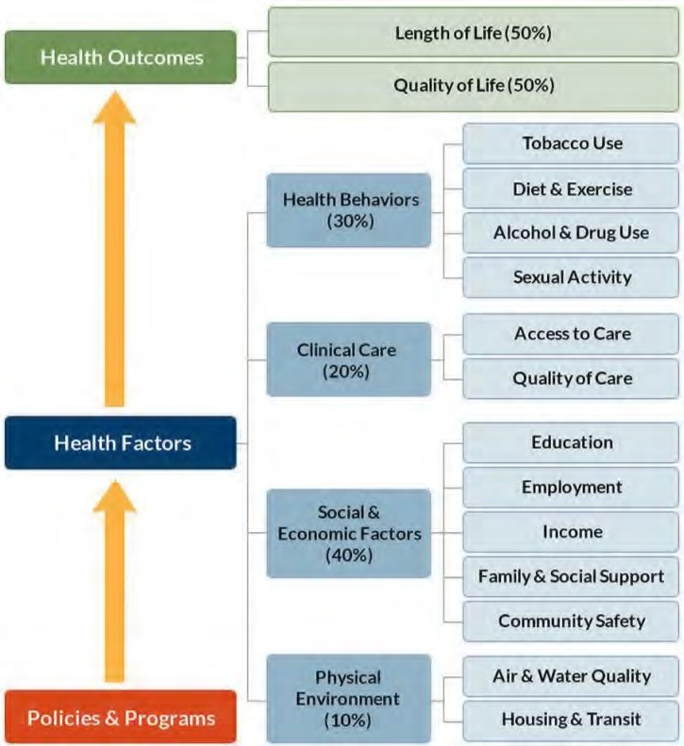The CHA utilized a mixed-methods assessment approach that integrates quantitative and qualitative data. The 2021 effort focused on compiling information through an extensive community engagement effort that involved stakeholder interviews, focus groups, and a community health survey, as described below. Data and findings from recent local assessment and planning efforts have also been integrated into this report.
Historically, the health care system has focused more on clinical services, physical health and treatment of chronic conditions, such as heart disease, cancer, asthma and diabetes. Over the past decade, there has been a clear shift to focus on preventing and addressing the underlying social,
Source: Robert Wood Johnson Foundation economic, behavioral and physical
determinants of health. There is increasing awareness that these issues are at the root of poor individual health status, community well-being and overall population health. As shown in Figure 1, there is growing body of research shows that only a small portion of one’s overall health can be attributed directly to access to and quality of clinical care. The remainder is linked to genetics, health behaviors, social and economic factors, and physical residential environments. With respect to community health assessment and improvement, the efforts of the Greater Worcester Regional CHA, the CHIP, along with the expectations of the Commonwealth, the federal government, and PHAB are framed with these ideas in mind.
FIGURE 2: SOCIAL DETERMINANTS OF HEALTH
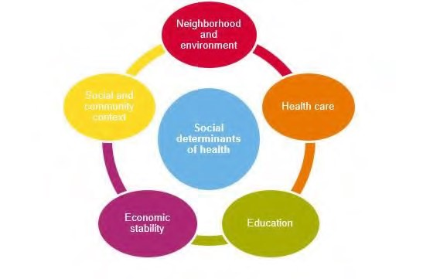
The Massachusetts Attorney General’s Office Community Benefits Guidelines and the Massachusetts Department of Public Health (MDPH) Determination of Need Guidelines have established priorities to guide and focus the community health improvement work of hospitals and HMOs across the
Commonwealth. With emphasis on helping disadvantaged populations, reducing health disparities and promoting wellness, these priorities include chronic disease management, mental health, substance use, housing and violence.
These guidelines are not meant to restrict the unique issues that not-for-profit hospitals and HMOs decide to prioritize. Rather, they clarify the idea that in order to reduce health-related disparities and have a genuine and sustained impact on health and well-being, CHAs and the subsequent strategic implementation plans must address the underlying social determinants, inequities and injustices at the root of health status issues.
The CHA Sponsors also understood the need for the CHA to be aligned with the region’s broader agenda of promoting health and well-being, addressing health disparities and conducting their efforts in the context of health equity. Health equity is the attainment of the highest level of health for all people.
Achieving health equity requires valuing everyone equally, with focused, ongoing societal efforts to address avoidable inequalities, underlying socioeconomic factors and injustices, whether historical or contemporary.
FIGURE 3: EQUALITY VS. EQUITY
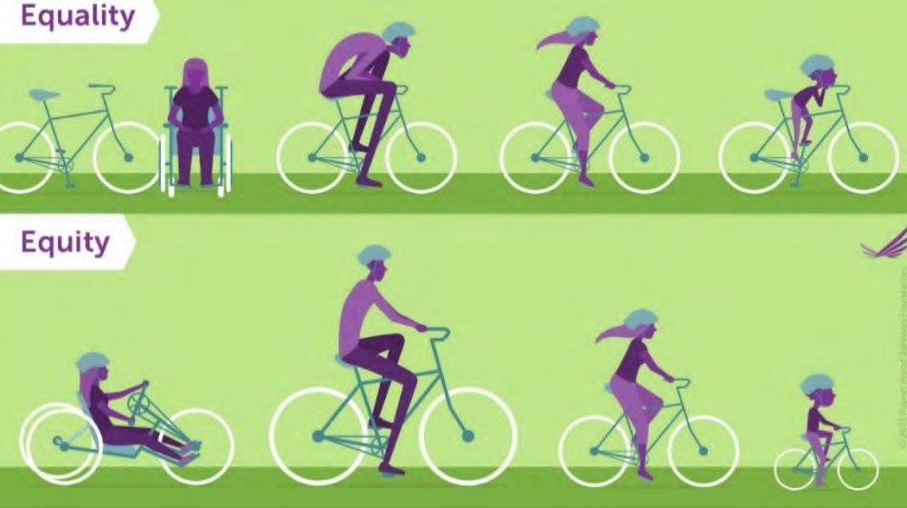
Source: Robert Wood Johnson Foundation

Qualitative Data & Community Engagement

Stakeholder Interviews
Staff from JSI worked with the CHA sponsors to conduct stakeholder interviews with 45 community leaders, service providers, public officials, advocates, and representatives from community stakeholders, faith-based organizations and academia. Due to the pandemic, all interviews were completed virtually, via phone or Zoom, using a standard interview guide:
Interviewee | Role & Affiliation
Bayda Asbridge | Arabic Interpreter, UMass Medical Health
Sandy Amoakohene | Built Environment & Food Systems Coordinator, Worcester REACH Project
Edward Augustus | City Manager, City of Worcester
Maureen Binienda | Superintendent, Worcester Public Schools
Rev. Louis Bond | Covenant United Methodist Church
Leah Bradley | Executive Director, Central Massachusetts Housing Alliance
Anne Bureau | Worcester Community Connections Coalition
Richard Burke | President and CEO, Fallon Health
Dr. Matilde Castiel | Commissioner, Worcester Health and Human Services
Jonathan Cohen | VP for Programs and Strategy, Greater Worcester Community Foundation
James Cummings | Superintendent, Grafton Public Schools
Dr. Eric Dickson | President and CEO, UMass Memorial Health
David Fort | Chair, Worcester Board of Health
Tim Garvin | President and CEO, United Way of Central Massachusetts
Interviewee | Role & Affiliation
Jennifer Gaskin | President, Worcester Caribbean American Carnival Association
Eve Gilmore | Executive Director, Edward Street Child Care Center
Yahaira Graxirena | Transportation Planner, Central Massachusetts Regional Planning Commission
Isabel Gonzalez | Director, Worcester Interfaith
Alex Guardiola | VP of Government Affairs and Public Policy, Worcester Regional Chamber of Commerce
Sharon Henderson | Covenant United Methodist Church
Dr. Michael Hirsh | Medical Director, Worcester Division of Public Health
Mona Ives | President & Board Chair, Ansaar of Worcester
Carolyn Jackson | CEO, Saint Vincent Hospital
Noreen Johnson Smith | Former VP of Development/Advancement, Family Health Center
Jermoh Kamara | Director of Wellness and Health Equity, YWCA
Steve Kerrigan | President and CEO, Edward M. Kennedy Health Center
Eric Kneeland | Director of Programs & Operations, Worcester Regional Research Bureau
Cheryl Lapriore | Chief of Staff, UMass Memorial Health
Kristen Las | Assistant Town Manager, Shrewsbury
Barry Maloney | President, Worcester State University
Paul Mathews | Executive Director and CEO, Worcester Regional Research Bureau
Kevin Mizikar | Town Manager, Shrewsbury
Gina Plato-Nina | Community Legal Aid Attorney, Central West Justice Center
Dr. Luis Pedraja | President, Quinsigamond Community College
Karen Pelletier | Executive Vice President, Worcester Regional Chamber of Commerce
Brian Pigeon | Senior Transportation Planner, City of Worcester
Dr. Jose Ramirez | Vice President of Operations, Edward M. Kennedy Community Health Center
Robert Ramirez | Spanish Interpreter, UMass Memorial Health
Anh Vu Sawyer | Executive Director, The Southeast Asian Coalition
Dr. Rob Schreiber | VP/Medical Director, Summit Eldercare
Dr. Michael Sheehy | Chief of Population Health and Analytics, Reliant Medical Group
Emily Swalec | Program Director, Worcester Family Resource Center
Jayna Turchek | Director of Accessibility, City of Worcester
Dr. Linda Weinreb | Vice President and Medical Director, Director of Medicaid Programs/ACOs at Fallon Health
Dr. Jan Yost | President and CEO, Health Foundation of Central Massachusetts

Focus Groups
Staff from JSI conducted a series of nine (9) virtual focus groups. These sessions allowed for the collection of critical input from service providers and community residents, with an emphasis on understanding the health needs and experiences of vulnerable populations. Focus groups were organized in collaboration with stakeholder interviewees to leverage their community connections and to help ensure participation:

Focus Group Cohort | Date
Worcester Together: Undocumented Working Group | June 9, 2021
Coalition for a Healthy Greater Worcester | June 15, 2021
Worcester Together: Food Insecurity & Food Access | June 22, 2021
Worcester Together -at large meeting | July 8, 2021
Mayor’s Mental Health Task Force & Worcester Together: Mental Health Committee | July 14, 2021
Worcester Together: Logistics Committee | July 14, 2021
UMass Memorial Medical Center: Interpreter Services | July 15, 2021
Worcester Together: Older Adults | July 16, 2021
City of Worcester Accessibility Advisory  Commission | July 20, 2021

Community Health Survey
In June, the Worcester Division of Public Health administered a web-based community health, open to all individuals who live, work and play in Greater Worcester. The survey was implemented as a way to gather information from populations that may have not been connected to other assessment activities. The CHA Sponsors worked with staff at the Worcester Division of Public Health to craft a survey that was accessible and easy to understand (Attachment A). It was available in three languages (English, Spanish, Vietnamese) and distributed widely, from June 5, 2021 – August 11, 2021. Methods of distribution included:
- Boards of Health in the CHA Service Area
- Monthly newsletters to towns
- Employee newsletters by all partner organizations
- Postings on partner Facebook pages and social media platforms
- E-newsletter distribution by the Coalition for a Healthy Greater Worcester to approximately 850 community members and organizations (sent three times and posted on social media)
- Distribution to the Worcester Together Coalition including over 150 members
- Other email distribution lists and at community outreach events, such as the COVID-19 Feet on the Street, COVID testing, and vaccination sites
Overall, 909 individuals took the survey. Highlights include:
- When asked to choose the conditions that make for a healthy community, the top five responses were:
  - Access to good health care (93% of respondents) o Safety (86% of respondents)
  - Education – good schools, equity in schools (85% of respondents) o Access to healthy food (82% of respondents) o Public parks and green spaces (82% of respondents)
- 82% of respondents rated their community as healthy (38%) or somewhat healthy (44%)
- 60% responded that they are satisfied with quality of life in their community
- 54% responded that they were satisfied with the health care system in the community
- 82% responded that they feel safe in their community, and 96% responded that they feel safe at home
- 59% responded that they agreed that the community is a good place to raise children
- 49% responded that they agreed that the community is a good place to grow old

CHIP Community Conversations
Data from the Coalition for a Healthy Greater Worcester and the CHIP's "Community Conversations" were used to inform this CHA report. As part of the CHIP’s planning effort, community residents were engaged in a series of Community Conversations in November-December of 2020. In total, 97 people were interviewed through 35 1-on-1 and small group discussions. Participants were recruited by advertising on social media, through email, and snowball sampling. Engaging with individuals who had never been a part of the CHIP process, and/or were not employed by CHIP partnership institutions, was paramount to the CHIP’s goals around advancing health equity. Individuals who had been part of the CHIP process or who were employed by partnership institutions were not excluded, but the effort aimed to focus on people who had lived experience, and who were disproportionately affected by health system issues outlined in the 2018 CHA.
Quantitative Data & Data Limitations
For this report, data was gathered from a broad range of sources to characterize the community, better understand health status in the region, and to inform a comprehensive understanding of the many factors associated with poor health status. Whenever possible, data was collected at the municipal or zip code level. The primary sources of data include US Census Bureau American Community Survey 5Year Estimates (2015-2019), the CDC’s 500 Places Project, data gathered by the Worcester Regional Research Bureau for the 2020 Worcester Almanac, and others. Note that the US Census Bureau will release a new data set in December of 2021. Efforts will be made to update data in this report upon that release.
The Massachusetts Department of Public Health (MDPH) created the Population Health Information Tool (PHIT), which is meant to present data stratified by demographic and socioeconomic variables (e.g., gender identity, age, race, ethnicity, disability status, poverty level) for counties, states, and municipalities. At the time this report was produced, data available via the PHIT was extremely limited. The most significant issue this limitation caused was the availability of timely data related to morbidity, mortality, health behaviors, and service utilization. Additionally, not all quantitative data was available in ways that stratified by demographic characteristics, which limited the ability to identify health disparities in an objective way. Qualitative activities allowed for exploration of these issues, but the lack of objective quantitative data constrained the effort.
Community Assets
Federal, Commonwealth, and PHAB requirements indicate that a Resource Inventory should be created to inform the extent to which there are gaps in health-related services. To this end, a list of community assets has been developed and can be found in Attachment B.
Feedback from Last Community Health Needs Assessment
There was no written feedback on the previous CHA or Implementation Plan since its posting in 2018. There was also no feedback on the Massachusetts Attorney General’s website, which publishes the hospital’s community benefits reports and provides an opportunity for public comment. The CHA Sponsors encourage feedback and comments on this report; any feedback is taken into account when planning future CHA processes.

CHA Service Area
The CHA service area includes the municipalities of the Central Massachusetts Regional Public Health Alliance: Grafton, Millbury, Shrewsbury, West Boylston, and Worcester. As a population-based assessment, the CHA considers the needs of the entire population - regardless of demographics, socioeconomics, health status, and if/where people receive health care services. Special attention is given to addressing the needs of populations that face disparities in health-related outcomes, have been disenfranchised, and those who are more likely to experience barriers to care. FIGURE 4: CHA SERVICE AREA
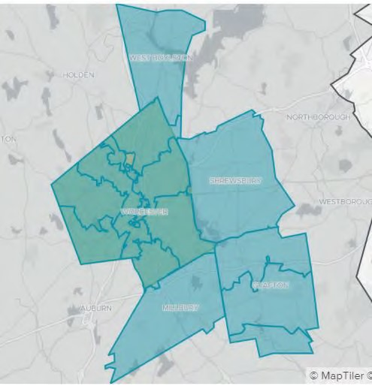

REGIONAL AND
COMMUNITY
CHARACTERISTICS

Total Population
The CHA service area sits squarely in Central Massachusetts. Worcester, the second-largest city in New
England, has approximately 185,000 residents (as of the 2015-2019 American Community Survey, 5-Year
Estimates). Grafton has the smallest population among all CHA municipalities. In August of 2021, the US Census Bureau released new total population estimates that indicate Worcester’s population increased 14% between 2010 and 2020, from 181,045 to 206,518.
TABLE 1: TOTAL POPULATION, LAND AREA, POPULATION DENSITY
 | Total Population | Total Land Area  (Square Miles) | Population Density (Per  Square Mile)
Grafton | 18,743 | 23.28 | 778.7 (
Millbury | 13,732 | 15.71 | 844.2
Shrewsbury | 37,086 | 20.75 | 1,717.09
West Boylston | 7,693 | 12.95 | 592.40
Worcester | 185,143 | 37.36 | 4,955.70
01545 | 37,086 | 20.75 | 1,787.63
01583 | 7,693 | 12.62 | 609.64
01602 | 22,900 | 5.77 | 3,971.76
01603 | 19,731 | 4.51 | 4,370.58
01604 | 38,191 | 6.44 | 5,932.86
01605 | 28,533 | 5.64 | 5,056.98
01606 | 19,896 | 5.93 | 3,356.16
01607 | 8,167 | 3.16 | 2,582.61
01608 | 4,471 | 0.45 | 9,991.06
01609 | 21,628 | 3.82 | 5,661.93
01610 | 22,023 | 2.13 | 10,359.38
Worcester County | 824,772 | 1,510.65 | 545.97
Massachusetts | 6,850,553 | 7,800.98 | 878.17
Source: Data from US Census Bureau 5-year estimates, 2015-2019.
Age
Age is a fundamental factor to consider when assessing individual and community health status. Older individuals typically have more physical and mental health vulnerabilities and are more likely to rely on immediate community resources for support compared to young people.

TABLE 2: AGE
 | Median Age | Age 0-  4 | Age 5-  17 | Age 18‐  24 | Age 25‐  34 | Age 35‐  44 | Age 45‐  54 | Age 55‐  64 | Age  65+
Grafton | 41.2 | 6.10% | 18.10% | 6.1% | 12.2% | 13.1% | 17.9% | 13.3% | 13.10%
Millbury | 44.9 | 4.95% | 15.13% | 7.81% | 10.17% | 12.09% | 17.75% | 14.38% | 17.73%
Shrewsbury | 41.5 | 4.89% | 18.51% | 7.38% | 10.82% | 12.92% | 14.78% | 13.90% | 16.80%
West  Boylston | 42.6 | 3.6% | 10.2% | 7.30% | 16.70% | 14.40% | 15.20% | 13.40% | 19.01%
Worcester | 34.7 | 5.05% | 18.83% | 15.54% | 16.12% | 11.74% | 12.50% | 11.67% | 13.60%
01545 | 41.9 | 4.89% | 23.40% | 7.38% | 10.82% | 12.92% | 14.78% | 13.90% | 16.80%
01583 | 42.2 | 3.77% | 14.34% | 7.20% | 16.83% | 14.70% | 15.03% | 13.51% | 18.39%
01602 | 41.5 | 3.66% | 16.14% | 13.45% | 12.73% | 11.13% | 14.21% | 14.62% | 17.72%
01603 | 36.1 | 6.30% | 19.47% | 12.99% | 16.10% | 12.29% | 13.79% | 11.78% | 13.58%
01604 | 34.7 | 6.55% | 21.93% | 9.41% | 19.19% | 13.07% | 12.67% | 11.84% | 11.89%
01605 | 32.6 | 6.19% | 22.77% | 13.15% | 17.93% | 11.74% | 10.70% | 10.18% | 13.54%
01606 | 41.3 | 4.62% | 20.22% | 8.54% | 14.61% | 12.63% | 13.44% | 14.79% | 15.77%
01607 | 39.2 | 4.70% | 20.15% | 7.85% | 17.44% | 12.54% | 16.96% | 12.04% | 13.03%
01608 | 28.2 | 4.34% | 26.33% | 14.65% | 20.53% | 14.20% | 10.60% | 5.70% | 7.98%
01609 | 33.2 | 2.45% | 11.80% | 27.56% | 12.47% | 9.70% | 10.30% | 11.19% | 16.98%
01610 | 27.8 | 4.42% | 13.96% | 31.13% | 15.52% | 10.04% | 11.77% | 8.75% | 8.82%
Worcester County | 40.1 | 5.40% | 21.30% | 9.77% | 12.81% | 12.15% | 14.60% | 14.09% | 15.28%
MA | 39.5 | 5.27% | 20.02% | 10.18% | 14.21% | 12.21% | 13.69% | 13.53% | 16.16%
United States | 38.1 | 6.09% | 22.61% | 9.44% | 13.87% | 12.62% | 12.96% | 12.86% | 15.64%
Source: Data from US Census Bureau 5-year estimates, 2015-2019.

Race & Ethnicity
An extensive body of research illustrates the health disparities and differences in health care access and utilization by race and ethnicity. As stated by the Center for American Progress, "these disparities are not a result of individual or group behavior but decades of systematic inequality in American economic, housing, and health care systems." These disparities illustrate the disproportionate and often avoidable inequities that exist within communities, and reinforce the importance of understanding demographics to identify populations more likely to experience adverse health outcomes.
"One of the dynamics related to the social determinants of health is the lack of representation of people who are actually utilizing the system in groups that are planning to augment the system. We need more efforts to bring people who are directly affected into the center of the conversation, and prioritize their needs and experiences.” –CHA Focus Group participant
Participants in CHA focus groups and CHIP Community Conversations described experiences where people of color felt they received differential treatment compared to white peers (e.g., being advised to "wait out" symptoms while others were treated, receiving less information about follow-up procedures). Participants also identified a need for more diversity and representation among health care and social service providers.
"I am very open and will tell everything to my doctor...there isn’t anything that I have difficulty discussing. They just aren’t listening. I do feel like they are not going to believe me because I go too much. Are they tired of me? Are they trying to help me? Not many physicians take the time to understand a patient’s culture and perspective in the course of providing care." - CHIP Community Conversation participant
"When a person doesn’t look like you, they aren’t able to connect with you. There is a disconnect, even when a person is righteous." - CHA Focus Group participant
TABLE 3: RACE AND ETHNICITY
 | Non‐  Hispanic White | Hispanic or Latino of any race | Black or  African American | Asian | Multiple Race
Grafton | 83.7% | 6.3% | 3.1% | 8.1% | 3.6%
Millbury | 91.91% | 1.23% | 1.42% | 2.52% | 2.49%
Shrewsbury | 72.9% | 4.80% | 3.0% | 19.10% | 3.50%
West Boylston | 88.77% | 12.36% | 5.99% | 1.91% | 1.99%
Worcester | 55.17% | 21.88% | 13.29% | 7.40% | 3.96%
01545 | 70.17% | 4.62% | 2.70% | 19.27% | 3.48%
01583 | 79.45% | 12.36% | 5.99% | 1.91% | 1.99%
01602 | 75.53% | 8.87% | 7.38% | 5.59% | 3.13%
01603 | 51.64% | 22.50% | 11.75% | 12.96% | 3.26%
01604 | 51.20% | 22.74% | 14.24% | 9.15% | 3.78%
01605 | 43.03% | 30.32% | 19.10% | 5.38% | 5.19%
01606 | 69.22% | 10.09% | 11.97% | 5.93% | 4.77%
01607 | 56.84% | 16.49% | 21.54% | 3.58% | 2.09%
01608 | 23.62% | 43.55% | 22.19% | 6.91% | 3.09%
01609 | 65.79% | 17.85% | 8.60% | 5.27% | 2.87%
01610 | 42.96% | 34.36% | 12.54% | 8.67% | 5.33%
Worcester County | 76.38% | 11.49% | 5.02% | 4.91% | 2.87%
Massachusetts | 71.58% | 11.81% | 7.63% | 6.60% | 3.26%
United States | 60.70% | 18.01% | 12.70% | 5.52% | 3.32%
Source: Data from US Census Bureau 5-year estimates, 2015-2019
TABLE 4: ASIAN BY SPECIFIC ORIGIN, 2015-2019 (%)
 | Asian  Indian | Chinese | Filipino | Japanese | Korean | Vietnamese | Other Asian
Grafton | 4.3 | 1.4 | 0.3 | 0.5 | 0.3 | 0.6 | 0.7
Millbury | 1.8 | 0.0 | 0.2 | 0.1 | 0.0 | 0.4 | 0.0
Shrewsbury | 12.0 | 3.5 | 0.0 | 0.4 | 0.8 | 0.9 | 1.5
West Boylston | 0.4 | 0.7 | 0.1 | 0.0 | 0.1 | 0.4 | 0.1
Worcester | 0.9 | 1.4 | 0.3 | 0.1 | 0.1 | 3.7 | 1.0
Massachusetts | 1.6 | 2.4 | 0.2 | 0.1 | 0.4 | 0.7 | 1.1
Source: Data from US Census Bureau 5-year estimates, 2015-2019

TABLE 5: HISPANIC/LATINO BY SPECIFIC ORIGIN, 2015-2019 (%)
 | Mexican | Puerto Rican | Cuban | Dominican | Central American | Southern  American | Other  Hispanic/Latino
Grafton | 9.9 | 52.3 | 9.7 | 3.3 | 3.6 | 17.7 | 3.6
Millbury | 1.2 | 52.7 | 13.6 | 0.0 | 0.0 | 3.0 | 8.3
Shrewsbury | 4.8 | 35.4 | 4.4 | 0.4 | 6.7 | 25.9 | 6.8
West Boylston | 12.3 | 59.8 | 3.2 | 5.6 | 3.5 | 4.7 | 11.0
Worcester | 21.9 | 63.7 | 0.9 | 12.7 | 7.9 | 7.8 | 2.9
Massachusetts | 11.8 | 40.5 | 1.8 | 18.9 | 16.9 | 10.4 | 5.3
Source: Data from US Census Bureau 5-year estimates, 2015-2019

Immigrants, Refugees, & Non-English Speakers
Several key informants identified immigrants, refugees, and undocumented individuals as segments of the population that face extreme barriers to accessing health and social services. One of the most prominent prohibitive factors that affects when individuals seek out or maintain care is fears around immigration status, which leads to distrust and hesitancy.
"In the last 3 years, hospitals have increased the amount of questions they ask regarding identity. If you have an ID without a picture, they won't take it. Patients
do tend to be very afraid. That fear keeps people from accessing services - the fear to be separated from their families, and fear to be sent back to their countries."- CHA Focus Group participant
Beyond the fears around immigrant status, language is a significant barrier to receiving and comprehending health information. A focus group with medical interpreters highlighted the importance of having a trusted professional available to help navigate interactions with providers. Many individuals also reported the need for interpreters and community health workers to help non-English speakers navigate health insurance, complete care transitions, manage medications, and fill out forms.
“We help families understand how to access everything that is available to them. Often language is a major barrier for people who need help. We need to set people up to help navigate society via someone they trust.” - CHA Focus Group participant
"In Worcester, the largest complicating factor is language. We provide care in 55 languages. Our patients speak more than that, but that's what we deliver services in. There were people who did not know that there was a pandemic. We were still informing people last summer, that there was a pandemic going on. People didn't understand mask-wearing and didn't understand what was happening." - CHA Stakeholder interviewee
Finally, many participants identified a specific need for mental health providers that understand or have experience in treating immigrants and/or refugees who have experienced severe trauma.
"We see people coming to the country that have PTSD [post-traumatic stress disorder] or depression. They’re not in the best mental state. A lot of that has to do with being isolated, removed from their culture so suddenly, not knowing how to make friends, or feeling at-odds with the culture around them in many ways. Culturally and spiritually."- CHA Focus Group participant
The table below reports the percentage of the population aged 5 and older who speak a language other than English at home and speak English less than "very well." This indicator is relevant because an inability to speak English well creates barriers to health care access, provider communications, job opportunities and health literacy/education. It also includes the percentage of the population aged 5 years and older living in Limited English speaking households – one that is “linguistically isolated” – where no household member 14 years old and over speaks only English at home, or no household member speaks a language other than English at home and speaks English “very well”.

6: POPULATION WITH LIMITED ENGLISH PROFICIENCY
 | Population Age 5+ with Limited English Proficiency
Grafton | 4.20%
Millbury | 4.19%
Shrewsbury | 9.95%
West Boylston | 5.55%
Worcester, MA | 16.86%
01545 | 9.95%
01583 | 5.55%
01602 | 11.45%
01603 | 16.13%
01604 | 20.14%
01605 | 24.79%
01606 | 8.19%
01607 | 14.52%
01608 | 31.38%
01609 | 10.46%
01610 | 19.63%
Worcester County | 7.63%
Massachusetts | 9.23%
United States | 8.40%
Source: US Census Bureau, 5-Year Estimates (2015-2019)

Table 7 reports the percentage of the population that is foreign‐born. The foreign‐born population includes anyone who was not a U.S. citizen or a U.S. national at birth. This includes any non‐citizens, as well as persons born outside of the U.S. who have become naturalized citizens. The native U.S. population includes any person born in the United States, Puerto Rico, a U.S. Island Area (such as Guam), or abroad of American (U.S. citizen) parent or parents. The latest figures show that 38,606 persons in Worcester are of foreign birth, which represents 20.85% of the report area population. This percentage is greater than the national average of 13.55%. The City of Worcester is very ethnicallydiverse and that diversity continues to grow, primarily due to the city being a Federal Refugee Resettlement Site.

7: FOREIGN-BORN POPULATION, 2015-2019
 | Naturalized U.S. Citizens | Population Without U.S. Citizenship | Foreign‐Birth Population
Grafton | 1,499 | 732 | 11.90%
Millbury | 607 | 516 | 8.18%
Shrewsbury | 4,388 | 4,433 | 23.79%
West Boylston | 267 | 234 | 6.51%
Worcester | 20,171 | 18,435 | 20.85%
01545 | 4,388 | 4,433 | 23.79%
01583 | 267 | 234 | 6.51%
01602 | 3,029 | 1,323 | 19.00%
01603 | 2,648 | 2,003 | 23.57%
01604 | 4,394 | 4,974 | 24.53%
01605 | 2,914 | 2,950 | 20.55%
01606 | 1,886 | 1,029 | 14.65%
01607 | 1,157 | 377 | 18.78%
01608 | 410 | 730 | 25.50%
01609 | 1,523 | 2,318 | 17.76%
01610 | 2,221 | 2,750 | 22.57%
Worcester County | 54,518 | 45,553 | 12.13%
Massachusetts | 613,050 | 535,859 | 16.77%
United States | 21,847,890 | 22,163,980 | 13.55%
Source: US Census Bureau, 5-Year Estimates (2015-2019)

8: NUMBER OF RESIDENTS FROM THE TOP 10 COUNTRIES OF ORIGIN IN WORCESTER, 2011 AND 2018
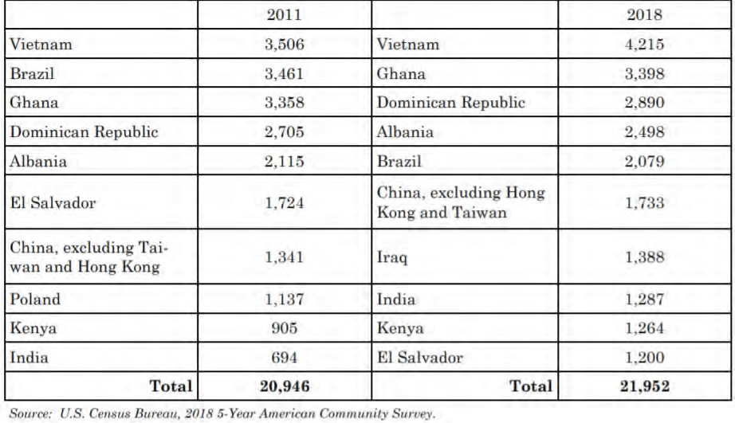
Early Childhood, Youth, & Adolescent Health
Concerns around the health and wellness of young people, including young children, teens, and young adults, were at the forefront of discussions over the course of the Community Health Assessment. Most of the discussion centered on mental health concerns, especially in the wake of COVID-19, where young people may witness and bear the effects of stress in their homes and communities. Many stakeholders and focus group participants identified childcare issues as a critical stress point for many families, particularly over the past year. Families, caregivers, and students have had routines interrupted, resulting in uncertainty, economic concerns, and anxiety.
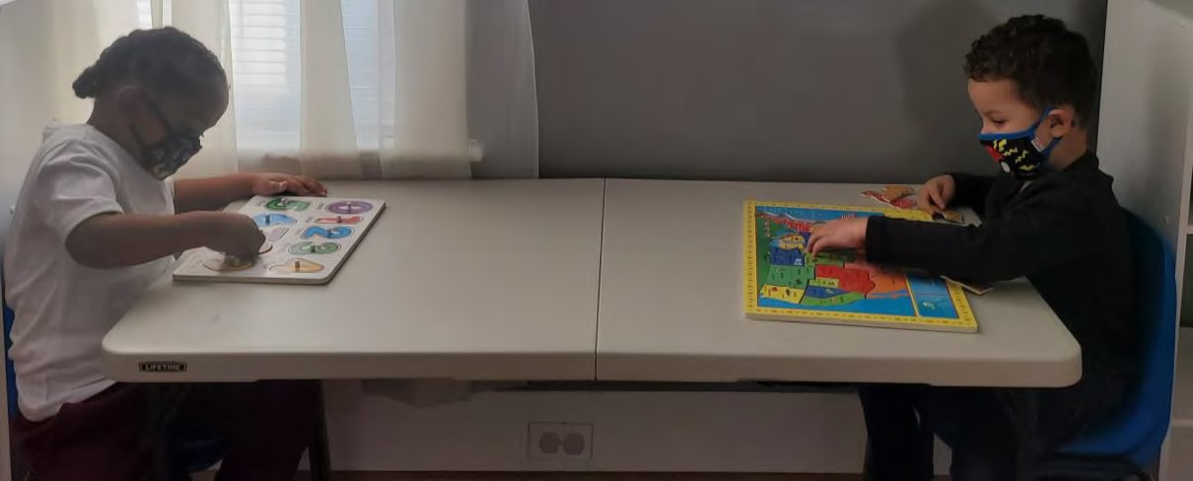
SOCIALLY DISTANCED LEARNING AT RAINBOW CHILD DEVELOPMENT CENTER

"We need clinicians specializing in areas like early childhood, infant and toddler mental health, and trauma related issues - as well as concerns for young parents and mental health impacts on their children." - CHA Stakeholder interviewee
There was also significant discussion around the effects of racism and discrimination on young people - trauma, anger, fear, and anxiety/depression.
"Racism experienced by a child is an adverse childhood experience. When we do not have people of color and other people who represent out community in
childcare and youth spaces, we are doing a disservice to children experiencing
racism. Our youth need to be able to share their stories. Sometimes, we think we know better than youth. We say we are going to amplify their voices, but
unfortunately, kids sometimes feel they aren’t heard. We need more youth
development organizations and to make sure that kids are on city-wide committees." – CHA Focus Group participant
Interviewees and focus group participants were particularly concerned about specific segments of the population, including youth from families with limited economic means, new immigrants and refugees, and non-English speakers. Several individuals identified a need to continue to provide more opportunities to provide health services in schools and non-traditional settings, to ensure that youth have access to care outside of a doctor’s office.
"Worcester needs to help on every front they can when it comes to youth.
Worcester is changing as a community. We're building new schools and have dedicated leadership. I don't think we have the types of problems that other
urban districts have. We don't want to lose what we've got. When we have kids coming that are new Americans, or their parents are struggling with language
barriers - I think there's an opportunity there on the health side, to help. Maybe putting more clinics in the school?" – CHA Stakeholder interviewee

Older Adult Health & Healthy Aging
In the U.S. and the Commonwealth, older adults are among the fastest-growing age groups. Chronic and complex conditions are the leading cause of death among older adults, and older adults are more likely to develop chronic illnesses and conditions such as hypertension, diabetes, COPD, congestive heart failure, depression, anxiety, Alzheimer’s disease, Parkinson’s disease, and dementia than are younger adult cohorts. By 2030, the CDC and the Healthy People 2020 Initiative estimates that 37 million people nationwide, or 60% of those over 65, will have multiple chronic conditions. Some of the greatest barriers to care for this population center around health care accessibility and navigation - understanding their health insurance coverage, transportation to and from medical appointments, navigating care transitions and discharge planning, and medication management. Another major need is more
accessible and affordable home health and home support programs, including care for older adults with behavioral health neurological conditions. A significant percentage of these individuals experience hospitalizations, are admitted to nursing homes and require health services and social supports in home and community settings. The ability to live independently and to "age in-place" – or to find affordable and accessible housing options – is a leading concern among older adults and their caregivers.

"There is plenty of health care - but how do they navigate it?"
- CHA Focus Group participant

The many challenges faced by older adults was discussed in nearly every interview and focus group, especially in the context of COVID-19. Many participants identified homebound older adults, specificallythose without in-home caregivers, as one of the region's most vulnerable populations. Concerns around social isolation, mobility issues, and lack of transportation have, historically, been a concern for older adults; all of these concerns were exacerbated during the pandemic. Many sectors, including health care, were quick to transition in-person programs and services to virtual, though this presented new challenges for older adults, who may be less tech savvy or lack the necessary resources (e.g., smartphones, tablets, computers, broadband internet). This issues was exacerbated for older adults who are non-English speakers.
TABLE 9: OLDER ADULTS IN THE SERVICE AREA
 | Number of older adults 65+ | Older adults 65+, Percent
Grafton | 2,462 | 13.10%
Millbury | 2,435 | 17.70%
Shrewsbury | 6,232 | 16.7%
West Boylston | 1,522 | 19.1%
Worcester | 25,187 | 13.60%
01545 | 6,232 | 16.80%
01583 | 1,415 | 18.39%
01602 | 4,059 | 17.72%
01603 | 2,679 | 13.58%
01604 | 4,542 | 11.89%
01605 | 3,863 | 13.54%
01606 | 3,137 | 15.77%
01607 | 1,064 | 13.03%
01608 | 357 | 7.98%
01609 | 3,673 | 16.98%
01610 | 1,943 | 8.82%
Worcester County | 126,028 | 15.28%
Massachusetts | 1,107,089 | 16.16%
United States | 50,783,796 | 15.64%
Source: US Census Bureau, 5-Year Estimates (2015-2019)
TABLE 10: OLDER ADULTS 65+ LIVING ALONE
 | Percentage of Total Households
Grafton | 10.30%
Millbury | 12.68%
Shrewsbury | 10.0%
West Boylston | 16.5%
Worcester | 12.81%
01545 | 9.99%
01583 | 15.22%
01602 | 12.95%
01603 | 12.41%
01604 | 10.75%
01605 | 15.43%
01606 | 12.45%
01607 | 12.32%
01608 | 5.01%
01609 | 17.43%
01610 | 11.83%
Worcester County | 11.34%
Massachusetts | 11.95%
United States | 10.98%
Source: US Census Bureau, 5-Year Estimates (2015-2019)
"Technology was a way to connect, but also a barrier for many older adults. Not everyone can use it. Not everyone has the tech savvy and Wi-Fi."
- CHA Focus Group participant
The City of Worcester is working towards Age-Friendly designation - characterized as a livable community for people of all ages. There are a number of organizations and collaboratives working to understand and meet the needs of older adults in the region, including needs related to the social determinants of health (e.g., housing, food insecurity, economic security, and transportation).
LGBTQ+ Health
The Boston Indicators project reports that Massachusetts has the second largest LGBTQ+ population of any state in the nation (5%); and that 16% of 18 to 24-year-olds identify as lesbian, gay, bisexual or something else. While societal acceptance of the LGBTQ+ community has increased greatly over the past several decades, this population continues to face issues of disproportionate violence and discrimination, socioeconomic inequality, and health disparities.
Though there is a tendency to view LGBTQ+ as a monolithic identity, some segments of the population experience greater disparities than others. In Massachusetts, nearly two-thirds (65%) of transgender people report experiencing discrimination in public spaces in the past year, and approximately 17% percent of transgender people were living in poverty in 2015, compared to 11.5% of the general population. Many LGBT youth struggle with mental health conditions: in Massachusetts in 2015, 61% of LGBTQ+ youth reported feeling so sad or hopeless that they weren't able to maintain their usual activities, compared to 24% of heterosexual youth. LGBT youth of color also experience these disparities, compounded with other race-based forms of discrimination.
FIGURE 5: SHARE OF TRANSGENDER POPULATION IN MASSACHUSETTS EXPERIENCING DISCRIMINATION IN THE PAST YEAR, BY
PUBLIC PLACE (2014)
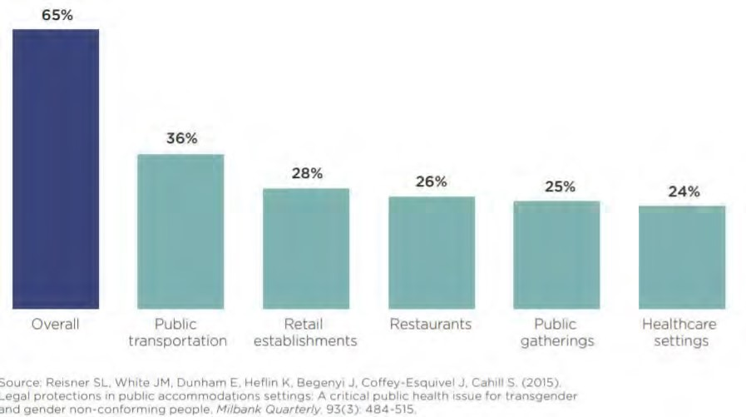
From the Boston Indicators Project

FIGURE 6: SHARE OF ADULT POPULATION EXPERIENCING DEPRESSIVE SYMPTOMS IN MASSACHUSETTS, 2011-2016
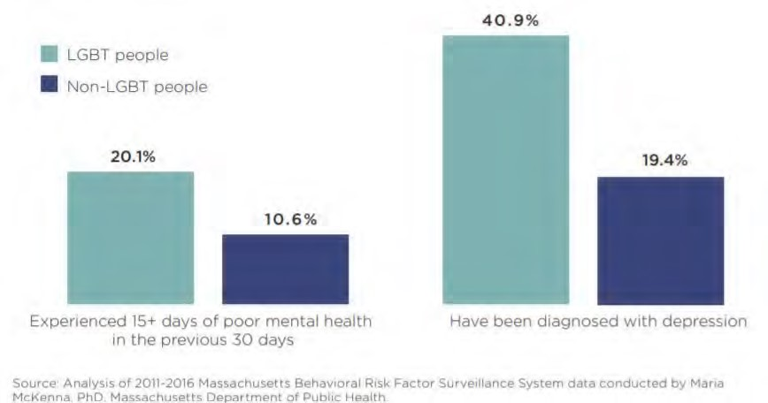
Participants in a CHIP Community Conversation focused on LGBTQ issues reported many health-related barriers, including providers that lack the education, cultural humility, or who are not well versed in LGBTQ health issues.
"Trans people, and especially youth, are not welcomed into health care settings in a way that is respectful of their dignity. [There is a] lack of knowledge, no database, and technical services are not really available." - CHIP Community Conversation participant
"[It's important] to find a provider and know how insurance works, and how to advocate on things that make you uncomfortable. You don't get good healthcare
if you don't talk about what is important to you. Our existence is uncomfortable and difficult to talk about, especially if our concerns are dismissed." - CHIP Community Conversation participant
Individuals reported additional needs, including shelters and emergency housing that is safe for LGBTQ individuals, support groups, mental health providers, and supportive services for youth.
People with Disabilities
Research has shown that individuals with physical, mental, and intellectual disabilities experience significant disadvantages related to the social determinants of health and associated disparities, including lower levels of educational attainment and income, lower screening rates, high rates of obesity, and difficulty accessing health services. In healthcare, there has been increasing recognition of health disparities by demographic characteristics (e.g., by race, ethnicity, income, gender identity), but less so for those with disabilities.

TABLE 11: POPULATION WITH ANY DISABILITY
 | Population with a Disability | Population with a Disability, Percent
Grafton | 1,609 | 8.60%
Millbury | 1,777 | 13.12%
Shrewsbury | 3,486 | 9.42%
West Boylston | 574 | 10.19%
Worcester | 27,273 | 14.90%
01545 | 3,486 | 9.42%
01583 | 574 | 10.19%
01602 | 2,475 | 10.85%
01603 | 2,980 | 15.15%
01604 | 5,314 | 14.00%
01605 | 4,872 | 17.46%
01606 | 2,567 | 13.29%
01607 | 1,613 | 19.79%
01608 | 902 | 20.20%
01609 | 3,215 | 15.17%
01610 | 3,383 | 15.54%
Worcester County | 98,164 | 12.07%
Massachusetts | 784,593 | 11.58%
United States | 40,335,099 | 12.62%
Source: US Census Bureau, 5-Year Estimates (2015-2019)

TABLE 12: DISABILITY CHARACTERISTICS (%)
 | Hearing difficulty | Vision difficulty | Cognitive difficulty | Ambulatory difficulty | Self-care difficulty | Independent living difficulty
Grafton | 3.1 | 1.5 | 3.5 | 4.4 | 2.2 | 4.2
Millbury | 3.6 | 2.0 | 5.4 | 6.9 | 3.4 | 5.8
Shrewsbury | 2.1 | 1.3 | 4.6 | 4.8 | 2.3 | 4.3
West Boylston | 4.1 | 2.5 | 2.1 | 5.4 | 2.0 | 3.2
Worcester | 3.3 | 2.2 | 7.6 | 7.4 | 3.4 | 7.7
Massachusetts | 3.2 | 1.8 | 5.0 | 5.8 | 2.4 | 5.3
Source: US Census Bureau, 5-Year Estimates (2015-2019)

In a focus group with Worcester's Accessibility Advisory Commission, participants identified several persistent issues that prevent disabled individuals from accessing quality care. Many of these issues have persisted for years, with limited recognition or progress.
A major barrier is that many providers lack the education or comfortability to treat disabled individuals. Focus group participants suggested that medical students participate in hands-on learning and training activities. Care may also be improved by recruiting disabled physicians and providers who understand common health needs.
"The interaction between medical personnel and disabled people need to be improved at all levels. From psychiatric services to elder care. There needs to be a significant improvement." - CHA Focus Group participant
Participants also reported issues with the physical spaces and accessibility. There is a great need for providers to evaluate accessibility, and to outfit their facilities with the appropriate equipment, including adjustable exam tables, lifts, ramps, elevators, and scales that can accommodate wheelchairs.
"Medical offices/hospitals not equipped with proper accommodations to provide basic care and testing for people with disabilities." -CHA Focus Group participant
“There has been very little done in this area [accommodations]. An exam table is still fixed. It may or may not have rails on the side. For someone in a wheelchair, you can’t have a trapeze to get from the wheelchair onto the exam table."
- CHA Focus Group participant
There was significant discussion of barriers for individuals with psychiatric disabilities, especially in acute care settings that may be chaotic and require long wait times. Emergency rooms, for example, are not conducive to high-quality care or a healing experience for many individuals.
Beyond issues pertaining to health care, focus group participants also reported challenges related to the social determinants of health. Many landlords are unwilling to make the proper accommodations to support individuals with physical disabilities. Worcester's transportation system, though improved through the zero-fare initiative, is inefficient, and there are limited options beyond the public system. Participants report that there are no wheelchair-accessible taxis, and no transportation programs for those who are visually impaired, deaf, or mute. Many individuals rely on various forms of public transportation to access healthcare and supportive services.
Veterans
Veterans are a population with distinct cultural values and unique health issues. They experience substance use disorders, mental health disorders (including depression, post-traumatic stress disorder and serious mental illnesses), traumatic brain injuries, chronic pain and serious bodily injuries at disproportionate rates compared to civilians. These factors coalesce to produce a complicated set of issues that make it difficult for some veterans to reintegrate successfully into civilian life, exacerbating existing health issues and creating instability in personal and professional lives.

TABLE 13: VETERANS IN THE CHA SERVICE AREA
 | Total Veterans | Veterans, Percent of Total Population
Grafton | 862 | 6.10%
Millbury | 747 | 6.84%
Shrewsbury | 1,679 | 5.91%
West Boylston | 413 | 6.28%
Worcester | 7,692 | 5.12%
01545 | 1,679 | 5.91%
01583 | 413 | 6.28%
01602 | 1,331 | 6.94%
01603 | 1,051 | 6.62%
01604 | 1,470 | 4.93%
01605 | 1,040 | 4.72%
01606 | 815 | 5.14%
01607 | 317 | 4.86%
01608 | 111 | 3.38%
01609 | 1,092 | 5.72%
01610 | 515 | 2.72%
Worcester County | 43,487 | 6.70%
Massachusetts | 303,534 | 5.54%
United States | 18,230,322 | 7.29%
Source: US Census Bureau, 5-Year Estimates (2015-2019)

SOCIAL
DETERMINANTS OF HEALTH
The social determinants of health are the conditions in which people live, work, learn and play. These conditions influence and define quality of life for many segments of the population in the CHA service area. A dominant theme from key informant interviews and community forums was the tremendous impact that the underlying social determinants, particularly economic insecurity, housing, food insecurity, and transportation have on health status.

Social Vulnerability Index (SVI)
The Social Vulnerability Index (SVI) is a census tract level composite measure, used for determining communities that will likely be in need of support before, during, and after emergency events. SVI calculations are based on measures associated with socioeconomic status, household composition, minority and language status, housing, and transportation. In 2018, 10% of Worcester census tracts were designated as 'most vulnerable' communities in the nation - two of which (Bell Hill and Great Brook Valley) were in the top 1% of most vulnerable communities. A team from UMass Memorial Medical Center's Office of Clinical Health Integration has done extensive work to visualize characteristics of the SVI for each of Worcester's neighborhoods, as seen below and throughout this report.
FIGURE 7: SOCIAL VULNERABILITY INDEX OF WORCESTER, BY ZIP CODE, AND SVI PERCENTAGE COMPARED TO THE
NATION, 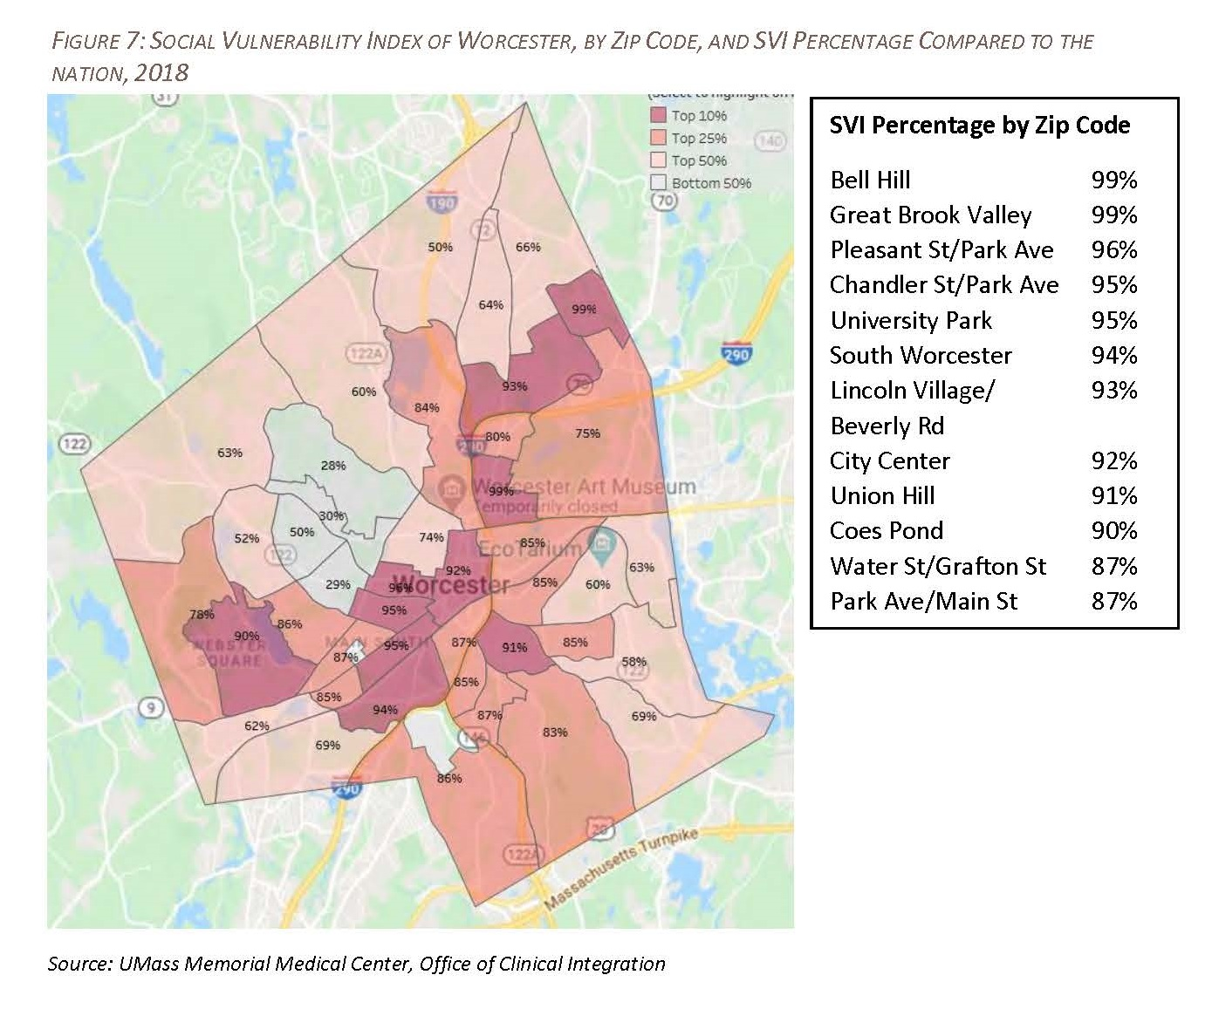2018

Source: UMass Memorial Medical Center, Office of Clinical Integration
FIGURE 8: SOCIAL VULNERABILITY INDEX OF WORCESTER, BY ZIP CODE AND THEME, 2018
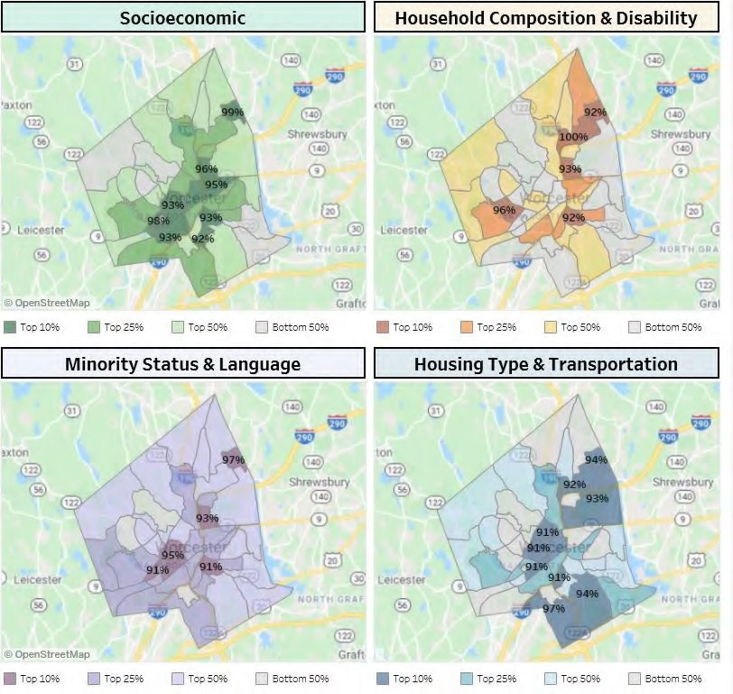
Source: UMass Memorial Medical Center, Office of Clinical Integration

Socioeconomics
Socioeconomic status, as measured by educational attainment, income, employment status, occupation, and the extent to which one lives in areas of economic disadvantage, is closely linked to morbidity, mortality, and overall well-being. Lower-than-average life expectancy is highly correlated with lowincome status.

Education
Higher levels of educational attainment are associated with improved health outcomes and social development at the individual and community levels. Compared with individuals with more education, people with less education are more likely to experience worse health, more chronic conditions, and more limitations/disabilities. The health benefits associated with higher education typically include better access to resources, safer and more stable housing, and better engagement with providers. It is important to note that, in many communities, access to educational opportunities vary depending on historical context and resource allocation. Factors associated with low education that affect health outcomes include the inability to navigate the healthcare system, educational disparities in personal health behaviors, and exposure to chronic stress. Poverty, low educational attainment and limited job opportunities are among the top social determinants leading to lower utilization of health care services and poor health outcomes. As a result, Worcester youth are at high-risk for obesity, gang involvement, violence, poor oral health and a need for mental health services.
TABLE 14: EDUCATIONAL ATTAINMENT AMONG POPULATION 25+
 | No High School Diploma | Associate's Degree or  Higher | Bachelor's Degree or  Higher
Grafton | 4.80% | 60.91% | 50.40%
Millbury | 7.06% | 41.75% | 32.47%
Shrewsbury | 4.89% | 65.92% | 58.56%
West Boylston | 11.81% | 43.95% | 33.60%
Worcester | 15.29% | 38.51% | 30.23%
01545 | 4.89% | 65.92% | 58.56%
01583 | 11.81% | 43.95% | 33.60%
01602 | 7.04% | 53.30% | 44.37%
01603 | 17.10% | 29.48% | 21.07%
01604 | 13.43% | 39.54% | 29.92%
01605 | 18.45% | 31.58% | 24.26%
01606 | 7.41% | 44.99% | 37.24%
01607 | 17.43% | 31.38% | 22.81%
01608 | 32.28% | 29.78% | 25.50%
01609 | 16.00% | 47.82% | 40.68%
01610 | 27.25% | 24.50% | 16.14%
Worcester County | 9.25% | 45.48% | 36.40%
Massachusetts | 9.24% | 51.29% | 43.69%
United States | 12.00% | 40.63% | 32.15%
Interviewees and focus group participants identified the diversity in Worcester’s public schools as an asset, although there was concern that immigrant and refugee students faced a number of significant barriers related to language and culture. There was also concern about disciplinary statistics among students of color compared to white students.

TABLE 15: EARLY CHILDHOOD EDUCATION
 | Population Age 3‐4 Enrolled in School
Grafton | 62.30%
Millbury | 57.37%
Shrewsbury | 72.61%
West Boylston | 80.56%
Worcester | 49.36%
01545 | 72.61%
01583 | 80.56%
01602 | 51.17%
01603 | 68.17%
01604 | 44.12%
01605 | 30.56%
01606 | 50.17%
01607 | 66.96%
01608 | 24.53%
01609 | 60.58%
01610 | 58.00%
Worcester County | 56.79%
Massachusetts | 59.53%
United States | 48.32%
Source: US Census Bureau, 5-Year Estimates (2015-2019)

FIGURE 9: WORCESTER PUBLIC SCHOOLS, ENROLLMENT BY RACE/ETHNICITY (2019-2020)
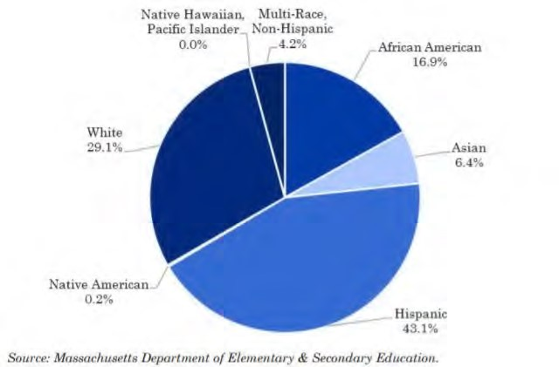
Source: Worcester Regional Research Bureau’s Worcester Almanac, 2020

TABLE 16: DISCIPLINARY STATISTICS IN WORCESTER PUBLIC SCHOOLS BY RACE/ETHNICITY 2018-2019
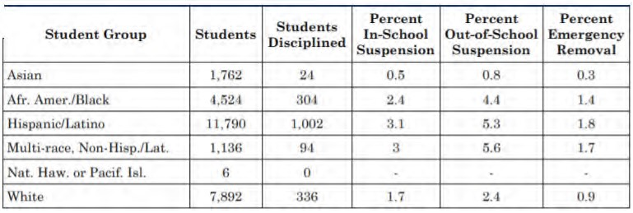
Source: Worcester Regional Research Bureau’s Worcester Almanac, 2020

TABLE 17: DISCIPLINARY STATISTICS IN WORCESTER PUBLIC SCHOOLS BY STUDENT GROUP, 2018-2019
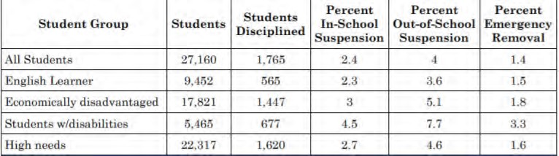
Source: Worcester Regional Research Bureau’s Worcester Almanac, 2020

TABLE 18: 4-YEAR GRADUATION RATES, CLASS OF 2019 (WORCESTER PUBLIC SCHOOLS)

Source: Worcester Regional Research Bureau’s Worcester Almanac, 2020
Note: EL represents students for whom English is a second or other language

Employment, Income, & Poverty
Like education, income influences all aspects of an individual’s life, including the ability to secure housing, needed goods (e.g., food, clothing), and services (e.g., transportation, health care, childcare). It also affects one’s ability to maintain good physical and mental health. Lack of gainful and reliable employment is linked to several barriers to care, including lack of health insurance, inability to pay for health care services and copays, and inability to pay for transportation to enable individuals to receive services. Certain populations struggle to find and retain employment for a variety of reasons – from mental and physical health issues, to lack of childcare, to transportation issues and other factors.
Many of the issues associated with COVID-19 are exacerbated by issues related to socioeconomic status. Research has shown that test positivity rates and testing delays were higher in low-income municipalities; there is a strong correlation between low socioeconomic status and COVID-19 attributed deaths, and people in low socioeconomic status municipalities were not able to reduce their mobility (e.g., quarantine, work from home, social distance) as much as those in more affluent communities.
Table 19, includes the labor force participation rate. This is a measure of an economy's active workforce – the sum of all workers who are employed or actively seeking employment divided by the total working age population.
TABLE 19: LABOR FORCE PARTICIPATION AND UNEMPLOYMENT RATES
 | Labor force participation rate | Unemployment rate
Grafton | 72.70% | 5.0%
Millbury | 70.17% | 6.9%
Shrewsbury | 67.52% | 3.8%
West Boylston | 47.55% | 3.1%
Worcester | 60.26% | 3.8%
01545 | 67.52% | No data
01583 | 47.55% | No data
01602 | 63.72% | No data
01603 | 61.25% | No data
01604 | 66.73% | No data
01605 | 60.04% | No data
01606 | 65.66% | No data
01607 | 59.52% | No data
01608 | 59.73% | No data
01609 | 49.67% | No data
01610 | 51.47% | No data
Worcester County | 66.14% | 4.4%
Massachusetts | 67.20% | 3.9%
United States | 62.99% | 4.5%
Source: US Census Bureau, 5-Year Estimates (2015-2019)

TABLE 20: MEDIAN HOUSEHOLD INCOME
 | Median Household  Income | Families with Income  Over $75,000 | Households with  Public Assistance  Income
Grafton | $106,250 | 63.80% | 1.40%
Millbury | $85,781 | 66.80% | 1.33%
Shrewsbury | $105,014 | 77.94% | 1.40%
West Boylston | $90,688 | 68.81% | 2.04%
Worcester | $48,139 | 42.22% | 5.52%
01545 | $105,014 | 77.94% | 1.40%
01583 | $90,688 | 68.81% | 2.04%
01602 | $64,942 | 58.22% | 2.10%
01603 | $42,904 | 37.08% | 7.19%
01604 | $55,665 | 43.26% | 4.00%
01605 | $40,390 | 30.66% | 6.28%
01606 | $65,708 | 55.04% | 2.71%
 | Median Household  Income | Families with Income  Over $75,000 | Households with  Public Assistance  Income
01607 | $39,928 | 39.18% | 9.16%
01608 | $31,384 | 7.87% | 7.20%
01609 | $45,992 | 54.08% | 6.50%
01610 | $33,695 | 19.75% | 9.72%
Worcester County | $74,679 | 61.84% | 2.93%
Massachusetts | $81,215 | 64.23% | 2.67%
United States | $62,843 | 51.51% | 2.36%
Source: US Census Bureau, 5-Year Estimates (2015-2019)

TABLE 21: POPULATION LIVING BELOW THE POVERTY LINE
 | Population in Poverty, Percent | Children under 18 in Poverty,  Percent
Grafton | 5.30% | 1.5%
Millbury | 4.38% | 2.9%
Shrewsbury | 3.95% | 1.9%
West Boylston | 9.28% | 15.0
Worcester | 19.98% | 27.00%
01545 | 3.95% | 1.62%
01583 | 9.28% | 15.00%
01602 | 12.91% | 15.08%
01603 | 20.20% | 21.05%
01604 | 16.15% | 23.60%
01605 | 27.24% | 38.24%
01606 | 10.70% | 16.47%
01607 | 17.69% | 22.60%
01608 | 43.53% | 74.56%
01609 | 22.43% | 26.68%
01610 | 28.45% | 33.12%
Worcester County | 10.12% | 12.34%
Massachusetts | 10.29% | 13.15%
United States | 13.42% | 18.52%
Source: US Census Bureau, 5-Year Estimates (2015-2019)
TABLE 22: LIVING BELOW THE FEDERAL POVERTY LINE, BY RACE/ETHNICITY
 | White | Black/African American | Hispanic/  Latino | Native  American/ Alaska Native | Asian | Native  Hawaiian/  Pacific  Islander | Some other race | Multiple race
Grafton | 4.63% | 0.65% | 0.0% | No data | 7.13% | No data | 0.0% | 0.0%
Millbury | 4.63% | 4.10% | 1.44% | 0.0% | 1.73% | 0.0% | 0.60% | 0.31%
Shrewsbury | 3.12% | 3.40% | 4.06% | 0.0% | 7.07% | No data | 1.25% | 5.57%
West Boylston | 7.63% | 63.20% | 5.59% | 30.0% | 26.19% | No data | 33.33% | 1.77%
Worcester | 19.89% | 16.87% | 30.91% | 28.81% | 17.58% | 15.00% | 25.22% | 27.61%
01545 | 3.12% | 3.40% | 4.06% | 0.00% | 7.07% | No data | 1.25% | 5.57%
01583 | 7.63% | 63.20% | 5.59% | 30.00% | 26.19% | No data | 33.33% | 1.77%
01602 | 13.53% | 13.29% | 18.66% | 65.38% | 2.49% | 0.00% | 19.19% | 8.64%
01603 | 20.68% | 19.56% | 28.27% | 81.82% | 12.04% | 0.00% | 33.59% | 21.79%
01604 | 16.67% | 11.85% | 22.58% | 12.61% | 16.11% | 0.00% | 16.65% | 24.01%
01605 | 28.54% | 21.10% | 34.24% | 0.00% | 23.39% | No data | 27.87% | 38.59%
01606 | 9.73% | 8.46% | 15.79% | 0.00% | 13.49% | No data | 2.59% | 31.04%
01607 | 19.35% | 8.04% | 52.34% | No data | 0.34% | No data | 77.25% | 9.36%
01608 | 44.58% | 35.59% | 60.09% | 53.23% | 9.06% | No data | 59.72% | 73.19%
01609 | 22.60% | 15.92% | 38.78% | 0.00% | 35.29% | No data | 26.26% | 16.53%
01610 | 28.78% | 25.91% | 30.32% | 80.70% | 33.54% | 100.00% | 18.11% | 33.16%
Worcester  County | 8.96% | 15.95% | 25.44% | 20.96% | 10.97% | 5.73% | 22.63% | 17.72%
Massachusetts | 8.25% | 18.71% | 24.54% | 22.25% | 12.86% | 12.85% | 23.84% | 16.36%
United States | 11.15% | 23.04% | 19.64% | 24.86% | 10.94% | 17.51% | 21.04% | 16.66%
Source: US Census Bureau, 5-Year Estimates (2015-2019)

Food Insecurity
Food insecurity is one of the nation's leading health issues; research has shown that food-insecure children are at least twice as likely to be in poor or fair health and more likely to have asthma than children who are not food insecure. Food-insecure older adults are more likely to have depression, asthma, diabetes, and congestive heart failure compared to those who are not.
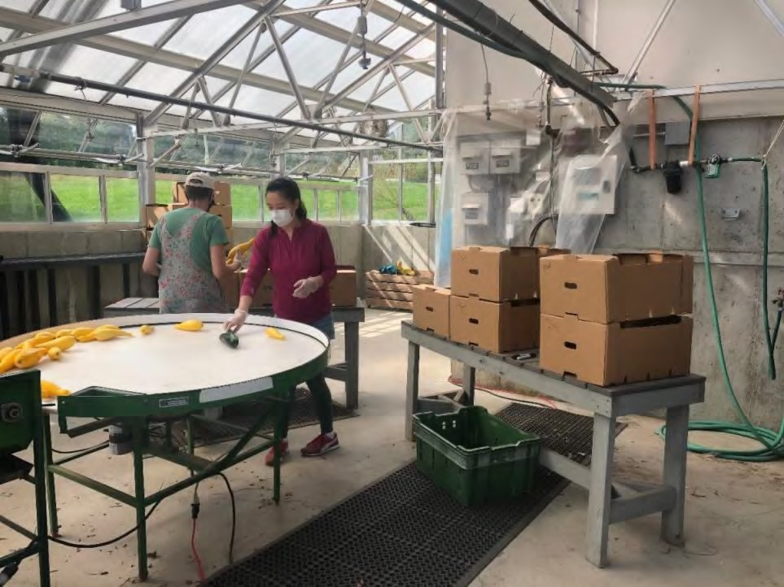Food insecurity is inextricably linked to poverty, but is also more prevalent among single-parent households, Black households, Hispanic/Latinx households, individuals with disabilities, older adults with chronic conditions, and immigrants. Participants in a CHA focus group on food insecurity reported that many undocumented
residents need access to food resources,
but fear prevents them from engaging in services. There is also a need to recognize that food needs are varied, based on culture, medical needs, allergies, and storage capacity.
"There is fear among undocumented families. They need help and want to apply for things, but they're terrified of how it will affect their status and their efforts to gain citizenship in the future." - CHA Focus Group participant
Many interviewees and focus groups reported food insecurity as a major concern in the CHA service area, exacerbated significantly by COVID-19 - especially for homebound older adults, low-income individuals and families, and those children/families who relied on meals provided in schools. Many organizations quickly shifted their efforts to be sure that these individuals were getting their needs met despite the call to social distance and remain at home. Representatives from the Worcester Senior Center reported that, among calls to the Center for assistance, food-related calls were #2 behind health/COVID-19 related calls.
"Food insecurity starts with economic insecurity and housing insecurity. When people are in a situation that they can’t meet basic needs. Programs like SNAP and WIC are so important; but the problem with those programs are in the
realms of access, paperwork, and barriers. The boost in SNAP and EBT benefits have come together to help people lift themselves out of a food insecurity problem - but policies have been put in place and have shown that these programs can solve hunger. It’s incumbent on us to advocate for real solutions.
Food pantries help but they’re not sustainable, they’re not systemic. We need to look at big bold policy actions to see how we can keep those programs that are helping people more permanent." – CHA Stakeholder interviewee
"Our reliance on emergency food systems is a big red flag [that food security is an issue.] We get so many requests to open new food pantries. We’re focused on temporary solutions instead of causes. When 80-90% of someone's income is
going towards rent and utilities, food comes second. Kids are relying on food from school. Prices have gone up since the pandemic - fresh fruits & veggies are
expensive! These foods aren’t subsidized." – CHA Stakeholder interviewee
While there are many organizations working to combat food insecurity, there is recognition that programs must adapt to people's needs. Mobile food programs and other efforts that bring food and resources directly to individuals and neighborhoods are one way to increase accessibility.
"We're still receiving phone calls about homebound elderly. They continue to need home delivery of food. That isn’t going to go away. These issues existed
before COVID, but were exacerbated by the pandemic. Mobility will continue to
be a barrier; It takes a lot for an organization to move their services mobile - but the need isn’t going away." – CHA Focus Group participant

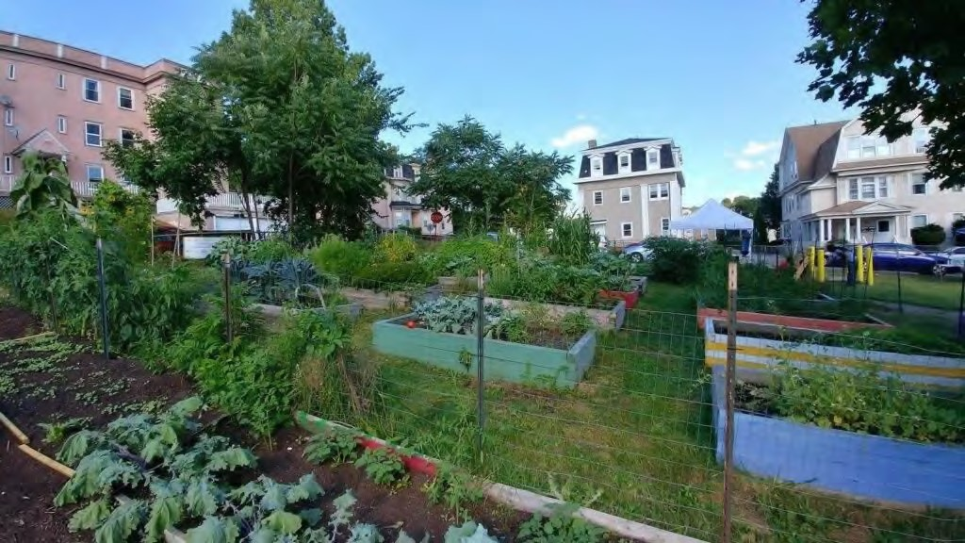
Worcester Regional Environmental Council’s YouthGROW, Grant Square Community Garden. YouthGROW (Youth Growing Organics in Worcester) is a year-round urban agricultural program that annually benefits 35-40 lowincome, at-risk youth ages 14 - 18 through employment and engagement in a formal leadership development and jobs/life skills curriculum. Programming takes place at two urban farm campuses in Worcester’s Main South and Bell Hill neighborhoods, at REC’s farmers markets, and through additional year-round afterschool support, mentorship, internships, and volunteer opportunities.

TABLE 23: FOOD INSECURITY RATE
 | Food Insecure Population, Total | Food Insecurity Rate
Grafton | 584 | No data
Millbury | 1,173 | No data
Shrewsbury | 3,127 | No data
West Boylston | 672 | No data
Worcester | 16,042 | 8.60%
01545 | 3,127 | No data
01583 | 672 | No data
01602 | 2,021 | No data
01603 | 1,764 | No data
01604 | 3,072 | No data
01605 | 2,323 | No data
01606 | 1,690 | No data
01607 | 740 | No data
01608 | 344 | No data
01609 | 1,986 | No data
 | Food Insecure Population, Total | Food Insecurity Rate
01610 | 2,121 | No data
Worcester County | 70,760 | 8.60%
Massachusetts | 616,090 | 9.00%
United States | 41,133,950 | 12.63%
Source: Feeding America, 2017

In the City of Worcester area, an estimated 15,231 or 21.59% households receive Supplemental Nutrition Assistance Program (SNAP) benefits compared to the national average of 11.74%. This indicator is relevant because it assesses vulnerable populations which are more likely to have multiple health access, health status, and social support needs; when combined with poverty data, providers can use this measure to identify gaps in eligibility and enrollment.

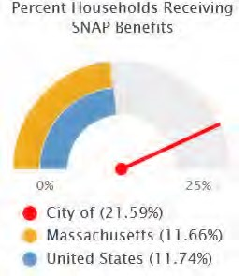

TABLE 24: HOUSEHOLDS RECEIVING SNAP BENEFITS IN WORCESTER
 | Total Households | Households Receiving SNAP Benefits | Percent Households Receiving  SNAP Benefits
Worcester | 70,560 | 15,231 | 21.59%
Worcester County | 309,951 | 38,243 | 12.34%
Massachusetts | 2,617,497 | 305,089 | 11.66%
United States | 120,756,048 | 14,171,567 | 11.74%
Source: US Census Bureau, 5-Year Estimates (2015-2019)

TABLE 25: SNAP BENEFITS BY RACE/ETHNICITY IN WORCESTER
 | Total  Population | Non‐  Hispanic White | Black | Asian | American Indian or Alaska Native | Some  Other Race | Multiple  Race | Hispanic or Latino
Worcester | 21.59% | 12.88% | 21.59% | 17.36% | 53.82% | 36.94% | 31.57% | 43.79%
Worcester County | 12.34% | 8.61% | 21.26% | 9.48% | 49.55% | 30.88% | 21.49% | 36.49%
Massachusetts | 11.66% | 7.28% | 26.13% | 10.83% | 34.22% | 33.66% | 20.81% | 33.79%
United States | 11.74% | 7.03% | 25.07% | 6.97% | 23.85% | 20.78% | 17.39% | 19.57%
Source: US Census Bureau, 5-Year Estimates (2015-2019)

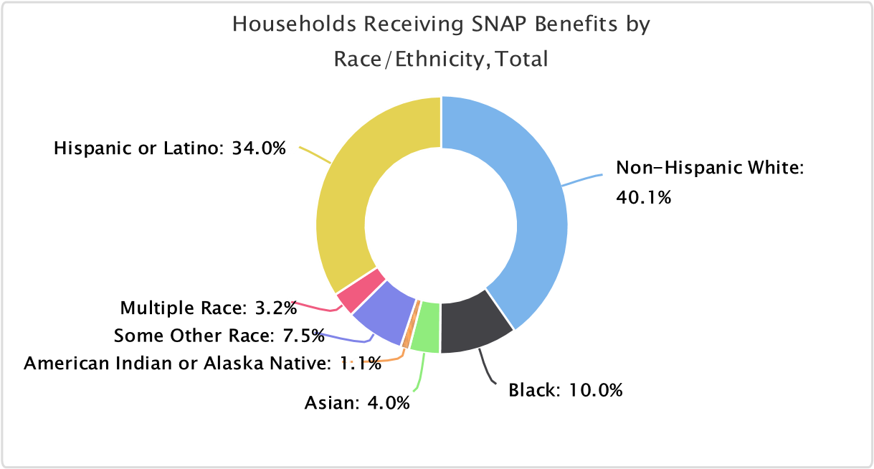
Built Environment, Transportation & Accessibility
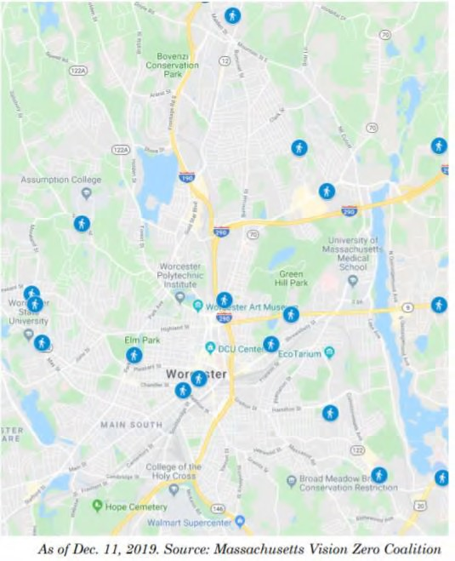The built environment, and one's ability FIGURE 10: PEDESTRIAN FATALITIES IN WORCESTER, 2016-2019 to navigate their community, has significant influences on health. Whether an individual has access to transportation, walking and biking routes, safe sidewalks, and green space directly affects their ability to work, attend school, receive healthcare and other services, exercise, and more. Furthermore, it is important that these spaces are accessible for all individuals, including those with disabilities.
Many organizations are working to make Worcester a more accessible
community. Over the past several years, Worcester's zero-fare transportation effort, walkability audits, and major projects focused on redesigning the city's streets have brought public health professionals, city planners, disabled individuals, businesses, and advocates together. Worcester has an interdepartmental Transportation Planning Advisory Group and an active citizen’s advisory group (WalkBike Worcester).
Stakeholder interviewees reported that accessibility was a critical issue in certain neighborhoods. Damaged sidewalks, lack of streetlights, lack of green space, and general neglect all contribute to issues of accessibility.

FIGURE 11: GREEN SPACES IN WORCESTER, BY PURPOSE AND OWNERSHIP
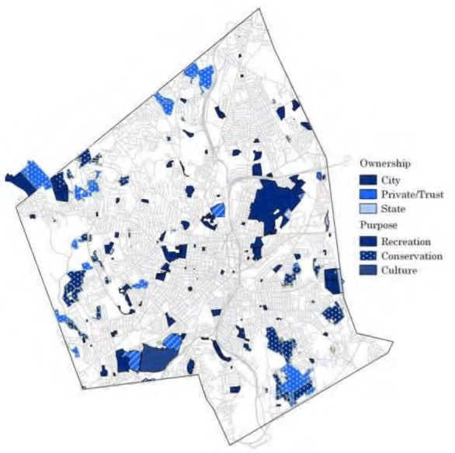Source: Worcester Regional Research
Bureau’s Worcester Almanac, 2020

"We know that lack of physical activity is so connected to chronic diseases. We’ve found that when we look at the City’s infrastructure, there are some
neighborhoods that don’t have the infrastructure that is conducive to physical
activity. I’ve been living in Worcester for 10 years and have been able to move to different neighborhoods. The neighborhood where I live now – I see people
walking all the time. People with strollers and walking their dogs, and kids riding
their bikes. In my other neighborhood, people were walking because they needed to walk to transit stop or walk to the corner store to get food. There is a difference. We need to start putting funds in the right place.”
—CHA Stakeholder interviewee
"The long and the short of it, is it's all the same neighborhoods [with accessibility/built environment issues]: primarily minority neighborhoods that also
have the worst health outcomes. It's all the same census tracts. It becomes an issue of equity."- CHA Stakeholder interviewee

TABLE 26: COMMUTING PATTERNS TO WORK,
 | Drive alone | Carpool | Public transportation | Bike or walk | Taxi or other | Work at home
Grafton | 80.4% | 6.2% | 3.8% | 0.5% | 1.3% | 7.9%
Millbury | 83.5% | 4.3% | 1.4% | 2.5% | 3.6% | 4.7%
Shrewsbury | 83.2% | 6.5% | 3.4% | 1.1% | 0.6% | 5.2%
West Boylston | 86.9% | 5.9% | 0.8% | 0.3% | 1.3% | 4.8%
Worcester | 71.3% | 10.4% | 3.5% | 7.0% | 2.5% | 5.3%
01545 | 83.2% | 6.5% | 3.4% | 1.1% | 0.6% | 5.2%
01583 | 86.9% | 5.9% | 0.8% | 0.3% | 1.3% | 4.8%
01602 | 81.6% | 7.9% | 1.6% | 2.5% | 0.8% | 5.6%
01603 | 71.8% | 12.9% | 4.3% | 5.1% | 2.5% | 3.4%
01604 | 75.6% | 11.6% | 2.0% | 3.3% | 3.4% | 4.2%
01605 | 68.0% | 12.1% | 4.9% | 7.2% | 3.0% | 4.8%
01606 | 83.2% | 4.6% | 2.4% | 2.1% | 1.9% | 5.9%
01607 | 81.7% | 7.3% | 2.4% | 1.3% | 1.9% | 5.5%
01608 | 48.3% | 14.0% | 7.8% | 20.3% | 3.0% | 6.6%
01609 | 59.2% | 11.6% | 4.0% | 16.2% | 1.5% | 7.6%
01610 | 52.0% | 12.0% | 6.5% | 18.5% | 4.4% | 6.6%
Worcester County | 79.8% | 7.9% | 2.0% | 3.1% | 1.6% | 5.7%
Massachusetts | 69.9% | 7.5% | 10.4% | 5.8% | 1.3% | 5.2%
United States | 76.3% | 9.0% | 5.0% | 3.2% | 1.3% | 5.2%
Source: US Census Bureau, 5-Year Estimates (2015-2019)
Many organizations have gathered data that illustrate disparities by neighborhood. Click the links below to read more.
Overview and Assessment of Transportation Needs
Pedestrian and Bike Safety Impact on Health - Dashboard
Worcester Regional Research Bureau: Walkability

Beyond transportation, there was also significant discussion around disparities in access to technology (e.g., Broadband, Wi-Fi, electronic devices). COVID-19 brought these disparities to light, as many services (healthcare and otherwise), moved virtual.

TABLE 27: INTERNET ACCESS METRICS IN WORCESTER, 2019
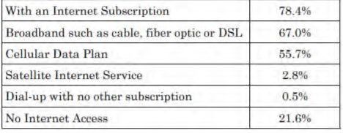
Source: Worcester Regional Research Bureau’s Worcester Almanac, 2020

Housing & Homelessness
Lack of affordable housing and poor housing conditions contribute to a wide range of health issues, including respiratory diseases, lead poisoning, infectious diseases, and poor mental health. At the extreme are those without housing, including those who are unhoused or living in unstable or transient housing situations. They are more likely to delay medical care and have mortality rates up to four times

higher than those who have secure housing.
Adults who are experiencing homelessness or living in unstable situations are more likely to experience mental health issues, substance use, intimate partner violence, and trauma; children in similar situations have difficulty in school and are more likely to exhibit antisocial behavior.
Interviewees and focus group participants reported a number of housing-related issues and needs in the service area. Housing stock, including the availability of rental units, continues to decline, especially for those who are low or moderate-income. The Worcester Regional Research Bureau's report, Achieving the American Dream, outlines disparities in homeownership by neighborhood, race/ethnicity, and by level of education. These disparities contribute to a city that is largely segregated; many of the neighborhoods with the largest percentage of non-White residents are also those with the lowest rates of homeownership, highest rates of poverty, and worse health outcomes.

FIGURE 12: PERCENT OF ORIGINATED MORTGAGES GOING 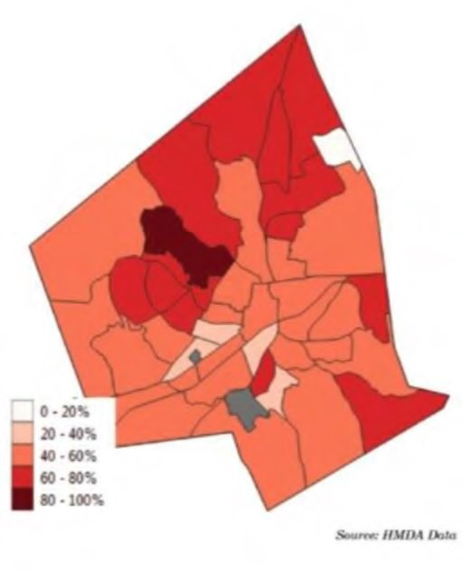TO WHITE HOMEOWNERS IN WORCESTER, 2019
Source:

Worcester Regional Research Bureau’s Worcester
Almanac, 2020

TABLE 28: COST BURDENED HOUSEHOLDS
 | Cost burdened households (housing costs exceed 30% of income) | Severe cost burdened households  (housing costs exceed  50% of income)
Grafton (01519 only) | 24.44% | 7.71%
Millbury | 28.32% | 10.54%
Shrewsbury | 23.01% | 7.21%
West Boylston | 24.65% | 13.30%
Worcester | 41.26% | 20.34%
01545 | 23.01% | 7.21%
01583 | 24.65% | 13.30%
01602 | 33.46% | 12.93%
01603 | 40.38% | 21.89%
01604 | 40.65% | 19.60%
01605 | 45.23% | 21.08%
01606 | 33.04% | 15.95%
01607 | 31.52% | 20.04%
01608 | 57.72% | 27.35%
01609 | 46.35% | 27.61%
01610 | 51.57% | 24.21%
Worcester County | 31.35% | 13.27%
Massachusetts | 34.16% | 15.37%
United States | 30.85% | 13.99%
Source: US Census Bureau, 5-Year Estimates (2015-2019)

Over the past several years, through efforts by the City of Worcester’s Department of Health and Human Services and many community organizations, the number of chronically homeless individuals has declined over time. In December of 2020, Worcester’s Housing First Coordinating Council released their Second Annual Report which describes a number of initiatives taken to reverse chronic homelessness.
As with many other issues, the total effects of the COVID-19 pandemic are yet to be seen. Many individuals faced significant economic hardship because of layoffs, cut hours, and childcare constraints on the ability of people to work. Further, for many, stress and trauma as a result of the pandemic limited their ability to maintain normal routines, including work. Interviewees and focus group participants reported that while the number of traditionally "homeless" individuals may not increase, the number of individuals and families couch surfing or doubling- and tripling-up to save money is on the rise. Despite homeless shelters and emergency resources, these settings are not ideal for all. In December of 2020, Worcester’s Housing First Coordinating Council released their Second Annual Report which outlines a number of other initiatives taken to address chronic homelessness.
There were approximately 2,000 homeless students in the Worcester Public School system in 2020; the majority of those students (1,399) live in shared living arrangements, or are “doubled up.” There are nearly 400 students in shelters or scattered-site apartments, and another 300 in foster care. This number was likely underreported because of remote learning.
"We need to provide shelter that allows for dignity; that lets people stay during the day and have a private bathroom. This helps improve likelihood of getting out of homelessness." – CHA Stakeholder interviewee
"Youth experience homelessness in a very different way. We need to create a better [shelter] system for youth." – CHA Stakeholder interviewee

TABLE 29: ANNUAL POINT-IN-TIME HOMELESSNESS SURVEY, CITY OF WORCESTER (2019)
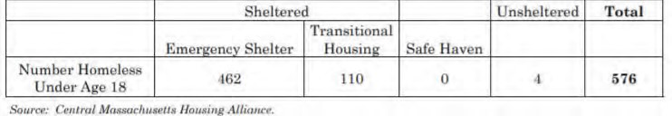
Source: Worcester Regional Research Bureau’s Worcester Almanac, 2020
Approximately 78% of Worcester’s housing stock was built before lead paint was banned in the United States (1978). For many years, city officials have worked on lead abatement initiatives with property owners and landlords. In 2019, the city received a $5.6 million grant from the US Department of Housing and Urban Development (HUD) for lead abatement – the single largest abatement in HUD’s history. Approximately 250 units have or will get direct lead abatement, while another 120 units will be screened for mold, radiation, and other potential hazards. In 2019, 71% of children in Worcester aged 9 -4 years had blood lead levels tested. Among these children, 2% had blood lead levels greater than 5µg/dL (the CDC reference level).

TABLE 30: SCREENING AND PREVALENCE OF CHILDHOOD BLOOD LEAD LEVELS (AGES 9 MONTHS-4 YEARS)
 | Population 9 months-4 years (#) | Percent screened | Blood Lead Level ≥5 µg/dL (%) | Pre-1978 Housing Units (%)
Grafton | 7,321 | 63% | 0% | 48%
Millbury |  | 73% | 0% | 60%
Shrewsbury |  | 64% | 1.2% | 52%
West Boylston |  | 88% | 0% | 71%
Worcester |  | 71% | 2.0% | 78%
Massachusetts | 240,575 | 72% | 1.1% | 69%
Source: Massachusetts Department of Public Health Childhood Lead Poisoning Prevention Program

Environmental Health
Environmental health focuses on the relationships between people and the climate and environment in which they live. Changes to our climate are already having significant impacts on our communities. The Northeast, specifically, is at risk for more extreme weather events and temperature-related illnesses and death.

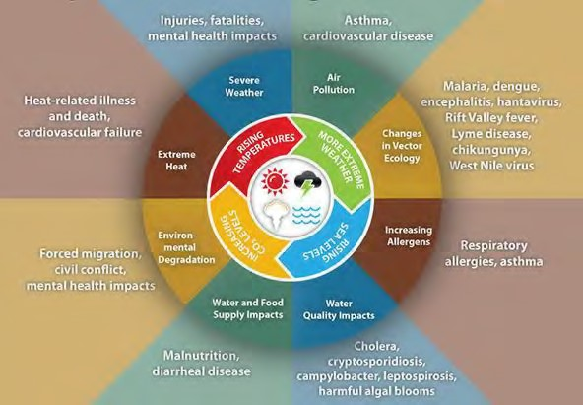HeFIGURE 13 IMPACTS OF CLIMATE CHANGE ON HUMAN HEALTH
Source: Centers for Disease Control and Prevention

Working In partnership with the Green Worcester Working Group, the City of Worcester released the Green Worcester Plan in 2020. The Plan outlines 10 vision areas, each with several associated goals.
The table below reports the non‐cancer respiratory hazard index score, based on air toxicity. This score represents the potential for non-cancer adverse health effects, where scores less than 1.0 indicate adverse health effects are unlikely, and scores of 1.0 or more indicate a potential for adverse health effects.
TABLE 31: RESPIRATORY HAZARD INDEX
 | Respiratory Hazard Index Score
Worcester | 1.78
Worcester County | 1.32
Massachusetts | 1.62
United States | 1.83
Source: EPA National Air Toxics Assessment, 2011

Health Insurance and Navigation
Whether an individual has health insurance – and the extent to which it helps pay for needed acute services and access to a full continuum of high-quality, timely, and accessible preventive and disease management or follow-up services – has been shown to be critical to overall health and well-being. Access to a usual source of primary care is particularly important, since it greatly affects the individual’s ability to receive regular preventive, routine, and urgent care and to manage chronic diseases.
Massachusetts has the highest health insurance coverage rate in the U.S., but there are still pockets of individuals without coverage, including young adults, low-income individuals, and the undocumented. Many key informants and focus group participants identified issues around navigating the health system, including how to access health insurance, as a major barrier to care. In a focus group, medical interpreters reported that they often go beyond their traditional scope of work to help connect patients to additional services and ease care transitions. Non-English speakers, new immigrants, and refugees face cultural and linguistic barriers that may lead to lapses in care, inappropriate utilization of emergency services, and noncompliance (e.g., follow up plans, medication regimens.)
“We as interpreters - we advocate for the patient. But we can only advocate up to a certain degree. For example, if people are calling and want to ask questions about free care… I don't think we have anything in writing that explains that. If
I’m placed in that position, I let the patient know that they qualify for the health services that they’re offered. We sometimes have to step out of our boundaries.”
– CHA Focus Group Participant
TABLE 32: INSURANCE BY TYPE
 | Uninsured Population | Private Insurance | Public Insurance
Grafton | 2.1% | 85.79% | 27.35%
Millbury | 1.7% | 81.51% | 32.86%
Shrewsbury | 1.6% | 87.91% | 26.00%
West Boylston | 2.4% | 82.98% | 37.05%
Worcester | 2.91% | 62.09% | 49.41%
Worcester County | 2.50% | 75.24% | 38.05%
Massachusetts | 2.72% | 76.28% | 37.27%
United States | 8.84% | 74.52% | 38.51%
Source: US Census Bureau, 5-Year Estimates (2015-2019)

HEALTH RISKS,
BEHAVIORS, AND OUTCOMES
Health Risk Factors
As discussed in the section on food insecurity, one's ability to access nutritious food has significant impacts on health. In addition to access to grocery stores, research shows that there are a number of factors that influence healthy eating, including quality and price of fruits and vegetables, marketing of unhealthy food, and cultural appropriateness of food offerings. It is also important that individuals understand the basics of nutrition - which foods are nutrient-dense, calorie goals, macronutrients, etc.
Lack of physical fitness and poor nutrition are among the leading risk factors associated with obesity and chronic health issues. Both factors help to prevent disease and are essential for the healthy growth and development of children and adolescents, while overall fitness and the extent to which people are physically active reduce the risk for many chronic conditions and are linked to good emotional health. Over the past two decades, obesity rates in the United States have doubled for adults and tripled for children. Overall, these trends have affected all segments of the population, regardless of age, sex, race, ethnicity, education, income, or geographic region.
TABLE 33: OBESITY
 | Obesity
Worcester County | 27.8%
Massachusetts | 24.7%
United States | 29.5%
Data Source: Centers for Disease Control and Prevention, National Center for Chronic Disease Prevention and Health Promotion.
2017.

The table below includes estimated expenditures for fruits/vegetables and for soda purchased for inhome consumption, as a percentage of total food‐at‐home expenditures. This indicator is relevant because current behaviors are determinants of future health, and because unhealthy eating habits may illustrate a cause of significant health issues, such as obesity and diabetes.

TABLE 34: HEALTH RISK FACTORS
 | Number of fitness and  recreation  facilities | Fruits and vegetables as a percentage of food-at-Home Expenditures* | Soda as a percentage of  Food‐At‐Home  Expenditures*
Worcester | 22 | 13.07% | 3.50%
Worcester County | 100 | No data | No data
Massachusetts | 1,236 | 13.10% | 3.35%
United States | 37,758 | 12.68% | 4.02%
Source: Centers for Disease Control and Prevention, National Center for Chronic Disease Prevention and Health Promotion. 2017 *Source: Nielsen SiteReports. 2014.

Life Expectancy and Overall Mortality
The all-cause and premature mortality rates do not indicate that all residents have equal or similar access to care, based simply on their proximity to services. See the data below to explore disparities in life expectancy in Worcester County compared to the state and the nation, and differences in life expectancy by neighborhood in Worcester. These trends follow similar patterns that underlie disparities for people of color, individuals that are low-income, foreign-born residents, and non-English speakers.
The table below shows the average life expectancy at birth, by zip code. Life expectancy measures the average number of years from birth a person can expect to live, according to the current mortality experience (age‐specific death rates) of the population.
TABLE 35: LIFE EXPECTANCY BY ZIP CODE
 | Life Expectancy at Birth (2010‐15)
Worcester | 78.67
01545 | 82.93
01583 | 80.40
01602 | 80.24
01603 | 77.74
01604 | 77.57
01605 | 78.96
01606 | 79.49
01607 | 78.29
01608 | 78.78
01609 | 79.91
01610 | 77.51
Worcester County | 80.06
Massachusetts | 80.60
United States | 78.69
Source: Centers for Disease Control and Prevention and the National Center for Health Statistics, U.S. Small-Area Life Expectancy Estimates Project. 2010-15.

FIGURE 14: LIFE EXPECTANCY, SALISBURY STREET VS KELLY SQUARE (WORCESTER)
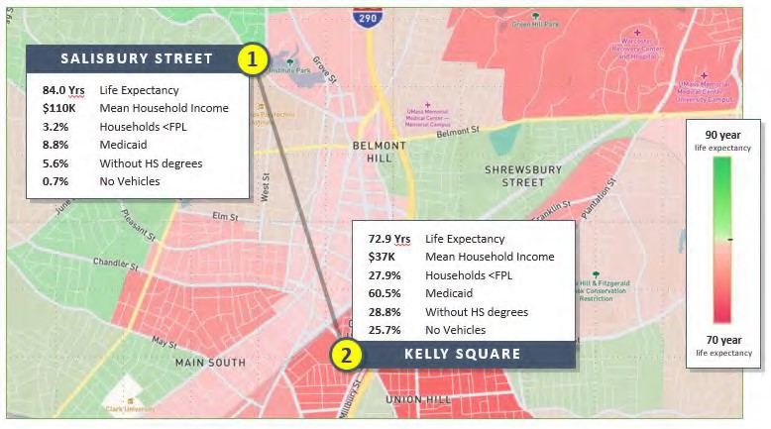
Source: UMass Memorial Medical Center, Office of Clinical Integration

In Figure 14, from UMass Memorial Medical Center’s Office of Clinical Integration, note the 11-year difference in life expectancy in the two neighborhoods – Salisbury Street vs. Kelly Square – despite only being located 2 miles apart.
Mental/Behavioral Health
Mental health—including depression, anxiety, stress, trauma, and other conditions—was overwhelmingly cited as the leading health issue for residents of Worcester and the CHA service area. Individuals from across organizations and sectors discussed:
- The significant burden of stress and anxiety, especially as it relates to socioeconomic status (e.g., poverty, income, cost of living)
- Trauma, racism, and discrimination experienced by people of color, immigrants and refugees, and non-English speakers
- The long-term mental health impact and fatigue associated with marginalization and disenfranchisement in nearly all facets of life (for people of color, non-English speakers, individuals with disabilities, low income, individuals with mental health and SUD)
- The prevalence of mild to moderate depression across all nearly all segments of the population, from children to older adults
- The impact of adverse childhood experiences (e.g., abuse, witness to domestic violence, parents/caregivers with mental health issues or substance use disorder)
Many key informants and focus group participants reported that while these issues have been prevalent for many years, they were exacerbated by COVID-19.
"The past year has exacerbated mental health issues - the isolation has been incredibly painful for people." – CHA Stakeholder interviewee
One population that has taken on significant mental health burdens over the past year are health care workers, especially those that have continued to provide care and services. Caregiver burden, compassion fatigue, and vicarious trauma were all identified as major concerns.
"Our therapists need therapists. This is already an issue, and I think it's going to become more of one." - CHA Focus Group participant
TABLE 36: POOR MENTAL HEALTH
 | Adults with poor mental health
Grafton | 12.49%
Millbury | 13.40%
Shrewsbury | 11.10%
West Boylston | 13.40%
Worcester | 16.70%
01545 | 11.10%
01583 | 13.40%
01602 | 14.00%
01603 | 17.00%
01604 | 15.70%
01605 | 17.20%
01606 | 14.40%
01607 | 16.50%
01608 | 19.50%
01609 | 17.20%
01610 | 21.00%
Worcester County | 13.7%
Massachusetts | 12.9%
United States | 13.4%
Data Source: Centers for Disease Control and Prevention, Behavioral Risk Factor Surveillance System. Accessed via the 500 Cities Data Portal. 2018.

Substance Use Disorder
Substance use was named as a leading health issue among key informants and focus group participants. As with mental health services, there are several community partners working to fill service gaps and address the needs of both individuals and the community at-large, although individuals continue to face delays or barriers to care due to limited culturally appropriate providers and specialists, limited treatment beds, and social determinants that impede access to care (e.g., insurance coverage, transportation, employment). Many participants also discussed the co-morbidity that often occurs between mental health and substance use issues.
As evidenced by the data below, the opioid crisis persists. Focus group participants and interviewees also identified a significant uptick in alcohol use over the course of the pandemic, especially amongst women. There continues to be concerns around vaping and e-cigarette use (especially for youth), changing community norms around marijuana, and prescription drug use. Though there was limited discussion regarding tobacco, Worcester continues to have higher rates of use (20.3% in Worcester compared to 13.7% in Massachusetts overall).

FIGURE 15: DRUG OVERDOSES IN WORCESTER, 2012-2021
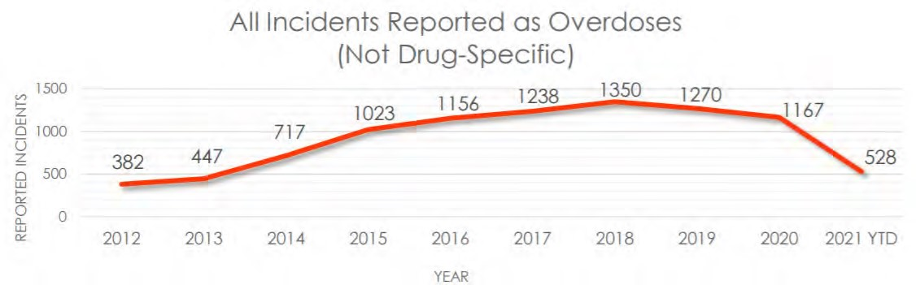
Source: Worcester Police Department, June 2021

FIGURE 16: CONFIRMED AND SUSPECTED HEROIN/OPIATE RELATED OVERDOSES IN WORCESTER
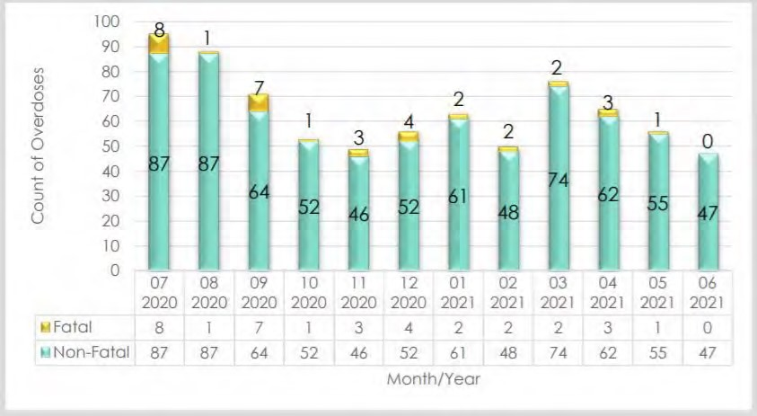
Source: Worcester Police Department, June 2021

TABLE 37: ADULT BINGE DRINKING
 | Percentage of Adults Binge Drinking in the Past 30 Days
Grafton | 20.61%
Millbury | 19.70%
Shrewsbury | 18.40%
West Boylston | 20.00%
Worcester | 18.50%
01545 | 18.40%
01583 | 20.00%
01602 | 18.70%
01603 | 17.50%
01604 | 18.60%
01605 | 16.80%
01606 | 18.80%
01607 | 18.80%
01608 | 17.90%
01609 | 20.10%
01610 | 18.80%
Worcester County | 18.6%
Massachusetts | 19.5%
United States | 16.9%
Data Source: Centers for Disease Control and Prevention, Behavioral Risk Factor Surveillance System. Accessed via the 500 Cities Data Portal. 2018.

TABLE 38: TOBACCO USE
 | Percentage of Adult Current Smokers
Grafton | 15.10%
Millbury | 17.10%
Shrewsbury | 13.30%
West Boylston | 18.10%
Worcester | 20.30%
01545 | 13.30%
01583 | 18.10%
01602 | 16.10%
01603 | 22.20%
01604 | 20.10%
01605 | 21.50%
01606 | 18.00%
01607 | 21.60%
 | Percentage of Adult Current Smokers
01608 | 24.59%
01609 | 18.60%
01610 | 23.80%
Worcester County | 17.2%
Massachusetts | 15.0%
United States | 17.0%
Data Source: Centers for Disease Control and Prevention, Behavioral Risk Factor Surveillance System. Accessed via the 500 Cities Data Portal. 2018.
Cardiovascular Disease & Stroke
Cardiovascular and cerebrovascular diseases, such as heart disease and stroke, are affected by several health and behavioral risk factors, including obesity and physical inactivity, tobacco use, and alcohol use. Hypertension, or high blood pressure, increases the risk of more serious health issues, including heart failure, stroke, and other forms of major cardiovascular disease.
Nationally, rates of high blood pressure and heart disease vary by race and ethnicity.
- High blood pressure is more common among non-Hispanic Black adults (54%) than white adults
(46%), non-Hispanic Asian adults (39%), or Hispanic adults (36%)
- Age-adjusted death rates for heart disease are highest among non-Hispanic Black adults (208 per 100,000) compared to white (168.9), Hispanic (114.1) and Asian/Pacific Islander (85.5) adults
The table below includes the percentage of adults age 18 who report ever having been told by a doctor, nurse, or other health professional that they have high blood pressure. Women who were told high blood pressure only during pregnancy and those who were told they had borderline hypertension were not included. It also includes the percentage of adults age 18 or older who report ever having been told by a doctor, nurse, or other health professional that they had angina or coronary heart disease.

TABLE 39: CARDIOVASCULAR DISEASE
 | Adults with High Blood Pressure | Adults Ever Diagnosed with Coronary Heart Disease
Grafton | 26.20% | 4.70%
Millbury | 29.90% | 5.90%
Shrewsbury | 27.40% | 5.00%
West Boylston | 31.91% | 6.49%
Worcester | 28.90% | 6.00%
01545 | 27.40% | 5.00%
01583 | 31.91% | 6.49%
01602 | 29.00% | 6.00%
01603 | 30.60% | 6.70%
01604 | 29.90% | 6.20%
 | Adults with High Blood Pressure | Adults Ever Diagnosed with Coronary Heart Disease
01605 | 31.20% | 6.70%
01606 | 29.80% | 6.20%
01607 | 30.00% | 5.60%
01608 | 29.19% | 5.71%
01609 | 26.10% | 5.50%
01610 | 25.50% | 5.20%
Worcester County | 30.3% | 6.2%
Massachusetts | 29.4% | 6.0%
United States | 32.9% | 6.9%
Data Source: Centers for Disease Control and Prevention, Behavioral Risk Factor Surveillance System. Accessed via the 500 Cities Data Portal. 2018.

TABLE 40: STROKE
 | Adults who have ever had a stroke | Ischemic Stroke  Hospitalizations, Rate per 1,000 | Age‐Adjusted Death Rate  (Per 100,000  Population)
Grafton | 2.20% | No data | No data
Millbury | 2.80% | No data | No data
Shrewsbury | 2.30% | No data | No data
West Boylston | 3.0% | No data | No data
Worcester |  | 7.1 | 33.6
Worcester County | 2.9% | 7.1 | 33.6
Massachusetts | 2.9% | 7.7 | 27.3
United States | 3.4% | 8.4 | 37.3

Cancer
The most common risk factors for cancer are well known: age, family history of cancer, alcohol and tobacco use, diet, exposure to cancer-causing substances, chronic inflammation, and hormones.
Nationally, cancer incidence and mortality rates continue to decline, as recommendations and requirements around screening and preventative care are implemented. However, certain segments of the population are at an increased risk of illness or death from particular cancer types:
- Black/African Americans have higher cancer mortality rates than other racial and ethnic groups for most types of cancer. Black/African American women are also at an increased risk of mortality from breast cancer, despite comparable incidence rates to white women
- Hispanic/Latinx and Black/African American women have higher incidence of cervical cancer compared to other racial and ethnic groups
- American Indian/Alaska Natives have high mortality rates related to kidney cancer, and the highest incidence of liver and bile duct cancer
- Lesbian, gay, and bisexual youth are more likely to drink and use alcohol than heterosexual youth, putting them at increased risk for certain cancer types
TABLE 41: CANCER SCREENINGS
 | Females Age 50‐74 with Recent Mammogram | Females age 21‐65 with  Recent Pap Smear | Adults with Adequate  Colorectal Cancer  Screening
Grafton | 83.09% | 90.20% | 71.21%
Millbury | 82.10% | 89.00% | 70.70%
Shrewsbury | 83.50% | 89.00% | 71.60%
West Boylston | 81.79% | 88.70% | 68.30%
Worcester | 82.30% | 84.50% | 64.00%
01545 | 83.50% | 89.00% | 71.60%
01583 | 81.79% | 88.70% | 68.30%
01602 | 82.70% | 87.50% | 69.30%
01603 | 81.70% | 83.50% | 60.90%
01604 | 81.90% | 85.90% | 65.40%
01605 | 82.60% | 84.50% | 62.60%
01606 | 82.50% | 87.80% | 67.90%
01607 | 81.70% | 86.40% | 64.00%
01608 | 83.20% | 80.99% | 53.60%
01609 | 82.60% | 82.40% | 64.50%
01610 | 81.90% | 78.80% | 55.00%
Worcester County | 80.6% | 87.4% | 69.4%
Massachusetts | 79.8% | 86.2% | 70.6%
United States | 73.7% | 83.9% | 65.5%
Data Source: Centers for Disease Control and Prevention, Behavioral Risk Factor Surveillance System. Accessed via the 500 Cities Data Portal. 2018.

TABLE 42: CANCER INCIDENCE
 | Cancer  Incidence  Rate (Per  100,000 Population) | Cervical  Cancer  Incidence  Rate (Per  100,000  Population) | Breast Cancer  Incidence  Rate (Per  100,000 Population) | Colorectal  Cancer  Incidence Rate  (Per 100,000 Population) | Cancer  Incidence  Rate (Per  100,000 Population)
Worcester, MA | 470.7 | 6.4 | 137.0 | 33.5 | 66.8
Worcester  County, MA | 470.8 | 5.2 | 137.0 | 33.3 | 67.0
Massachusetts | 452.7 | 7.6 | 137.9 | 35.2 | 61.2
 | Cancer  Incidence  Rate (Per  100,000 Population) | Cervical  Cancer  Incidence  Rate (Per  100,000  Population) | Breast Cancer  Incidence  Rate (Per  100,000 Population) | Colorectal  Cancer  Incidence Rate  (Per 100,000 Population) | Cancer  Incidence  Rate (Per  100,000 Population)
United States | 448.7 |  | 125.9 | 38.4 | 58.3
Source: State Cancer Profiles. 2013‐17.

Diabetes and Asthma
Over the course of a lifetime, approximately 40% of adults in the U.S. are expected to develop type 2 diabetes – this number increases to over 50% for Hispanic men and women. Several factors increase the risk of developing type 2 diabetes, including being overweight, physical inactivity, age, and family history. Having diabetes increases the risk of cardiovascular comorbidities (e.g., hypertension, atherosclerosis), may limit the ability to engage in physical activity, and may have negative impacts on metabolism.
TABLE 43: ADULTS WITH DIABETES IN WORCESTER COUNTY
 | Adults with Diagnosed Diabetes, Age‐ Adjusted Rate
Worcester County, MA | 8.0%
Massachusetts | 7.7%
United States | 9.5%
Source: Dartmouth College Institute for Health Policy & Clinical Practice, Dartmouth Atlas of Health Care. 2017.
Respiratory diseases such as asthma and COPD are exacerbated by behavioral, environmental, and location-based risk factors, including smoking, diet and nutrition, substandard housing, and environmental exposures (e.g., air pollution, secondhand smoke). They are the third leading cause of death in the United States. In many scenarios, quality of life for those with respiratory diseases can improve with proper care and management.
In 2021, the Asthma and Allergy Foundation of America released their report Asthma Capitals 2021: The Most Challenging Places to Live with Asthma. Worcester is named as #11 in a list of the top 20 asthma capitals in the United States, based on estimated asthma prevalence, emergency department visits due to asthma, and asthma-related fatalities. In Worcester, crude asthma death rates and emergency room visits are worse than average. The report states that poverty, air pollution, living in rental housing, number of manufacturing and industrial businesses, proximity to high-traffic roadways, and access to specialists are risk factors in the Northeast.
Pediatric asthma has been a historic concern in Worcester. Nationally, rates of pediatric asthma are higher among Black children compared to white children, and Massachusetts is no exception. In 2015, approximately 9.9% of white children in Massachusetts have asthma, compared to 24% of Black children.
TABLE 44: RESPIRATORY DISEASE
 | Adults with asthma | Adults ever diagnosed with chronic lower respiratory disease
Grafton | 9.70% | 4.70%
Millbury | 10.10% | 5.80%
Shrewsbury | 9.10% | 4.40%
West Boylston | 9.91% | 6.20%
Worcester | 11.00% | 6.20%
01545 | 9.10% | 4.40%
01583 | 9.91% | 6.20%
01602 | 10.40% | 5.70%
01603 | 11.00% | 6.90%
01604 | 10.70% | 6.30%
01605 | 11.40% | 6.80%
01606 | 10.40% | 6.10%
01607 | 11.10% | 6.20%
01608 | 11.39% | 6.20%
01609 | 10.90% | 5.60%
01610 | 12.10% | 6.20%
Worcester County | 10.1% | 6.0%
Massachusetts | 10.1% | 5.8%
United States | 9.5% | 7.2%
Source: Centers for Disease Control and Prevention, Behavioral Risk Factor Surveillance System. Accessed via the 500 Cities Data Portal. 2018.

Maternal & Infant Health
Maternal and child health issues are of critical importance to the overall health and well-being of a geographic region and at the core of what it means to have a healthy, vibrant community. Infant mortality, childhood immunization, rates of teen pregnancy, rates of low birthweight and rates of early and appropriate prenatal care for pregnant women are among the most critical indicators of maternal and child health. While infant mortality, low birth weight, and preterm birth were not discussed as leading health issues, the quantitative data suggests there are disparities in this area, particularly by race/ethnicity.
In 2016-2018, the infant mortality rate in Worcester 4.6 per 1,000 live births. Though this is lower than the US infant mortality rate (5.8), it is higher than the state infant mortality rate (4.3). There are significant disparities in the infant mortality rate by race and ethnicity, with higher rates for Black and Hispanic/Latino mothers compared to white mothers.
FIGURE 17: INFANT MORTALITY RATES IN WORCESTER AND MASSACHUSETTS, OVER TIME AND BY RACE/ETHNICITY
l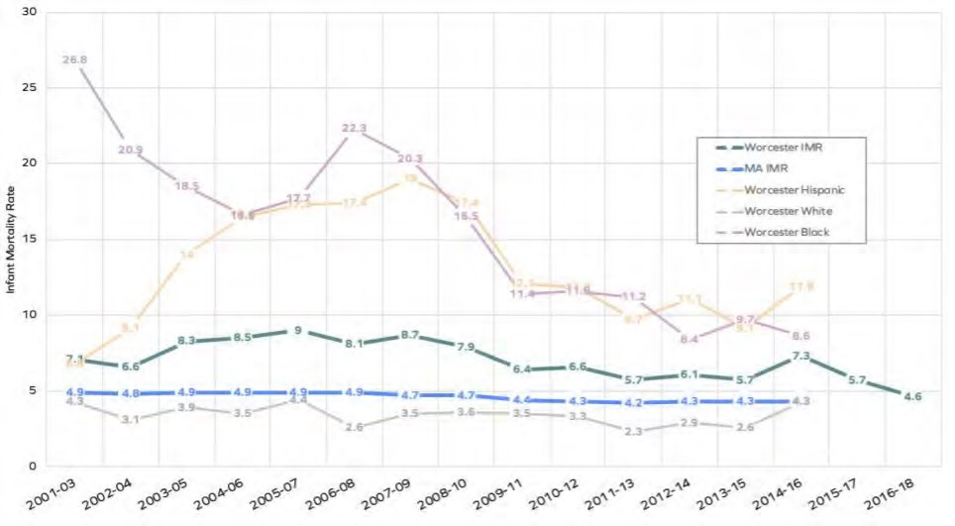
Source: Worcester Division of Public Health, Massachusetts Birth Reports

Low birth weight and premature birth are two causes of infant mortality; in Worcester, 69% of infants who died in 2016-2018 were low birth weight, and 60% were premature. A growing body of research indicates that racism and discrimination, and the health impacts of high stress, play a significant role in preterm births and low birth rates.

Infectious Disease & Sexual Health
Though great strides have been made to control the spread of infectious diseases in the U.S., they remain a major cause of illness, disability, and even death - as evidenced by the COVID-19 pandemic. Sexually transmitted infections, diseases transmitted through drug use, vector-borne illnesses, tuberculosis, pneumonia, and influenza are among the infectious diseases that have the greatest impact on modern American populations. Older adults, immunocompromised individuals, injection drug users, and individuals who have unprotected sex are often at the greatest risk for contracting infectious diseases.

TABLE 45: INFLUENZA AND PNEUMONIA DEATHS
 | Five Year Total Deaths, 2015‐  2019 Total | Age‐Adjusted Death Rate  (Per 100,000  Population)
Worcester | 204 | 17.6
Worcester County | 898 | 17.6
Massachusetts | 6,854 | 15.2
United States | 273,174 | 14.0
Data Source: Centers for Disease Control and Prevention, National Vital Statistics System. Accessed via CDC WONDER. 2015‐2019. Source geography: County

Over the past several years, the Worcester Department of Health and Human Services has focused on a campaign to provide comprehensive sexuality education in schools. Comprehensive sexuality education teaches that, while abstinence is the best method for avoiding sexually transmitted infections/diseases and unintended pregnancy, condoms and contraceptives reduce risk. It also focuses on teaching interpersonal and communication skills that encourage young people to explore their own values, goals, and options. According to the 2020 Worcester Regional Youth Health Survey, the percentage of middle school and high school students who reported having used a condom the last time they had sexual intercourse decreased between 2017 and 2019, as did the percentage who reported having talked to parents or adults about HIV, STIs, and pregnancy. Further, there were 223 pregnant or parenting young women in Worcester schools in 2019, including 55 in the 7th or 8th grade.
FIGURE 18: "HAVE YOU EVER TALKED ABOUT WAYS TO PREVENT HIV INFECTION,
OTHER STIS, OR PREGNANCY WITH YOUR PARENTS OR OTHER ADULTS IN YOUR
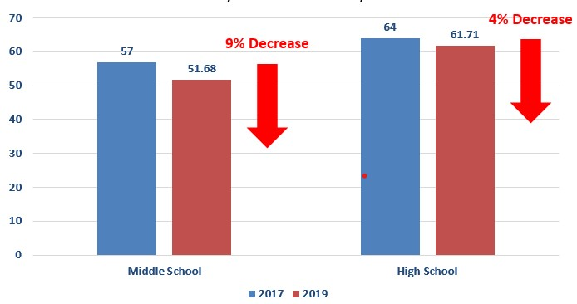

Source: UMass Memorial Health & WDPH. 2020. Worcester Regional Youth Health Survey

FIGURE 19: “THE LAST TIME YOU HAD SEXUAL INTERCOURSE, DID YOU OR YOUR PARTNER USE A CONDOM?”
Middle School, 2017: 62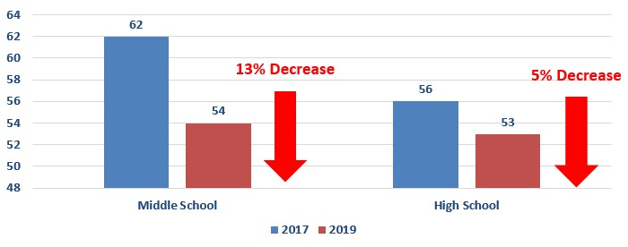
Source: UMass Memorial Health & WDPH. 2020. Worcester Regional Youth Health Survey

TABLE 46: STIS IN WORCESTER
 | Chlamydia  Infections, Rate per 100,000 Pop. | Gonorrhea  Infections, Rate per  100,000 Pop. | HIV / AIDS  Infections, Rate per  100,000 Pop.
Worcester | 337.6 | 92 | 7.19
Massachusetts | 444.0 | 117.7 | 10.9
United States | 539.9 | 179.1 | 13.6
Source: Centers for Disease Control and Prevention, National Center for HIV/AIDS, Viral Hepatitis, STD, and TB Prevention. 2018

COVID-19
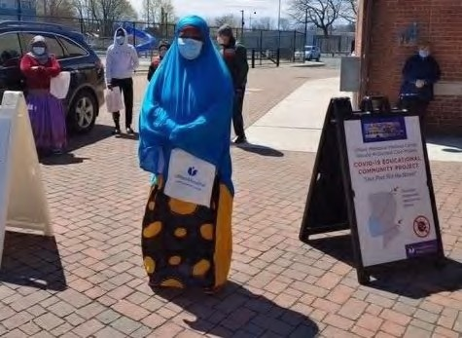On March 11, 2020, the World Health Organization (WHO) declared the novel coronavirus (COVID-19) a global pandemic and advised the public to reduce activities and practice social distancing. Since then, the world has continued to adapt to new research, procedures, and policies. Over the course of the assessment, stakeholders and focus group participants emphasized the many multi-faceted impacts of COVID-19, as discussed throughout this report.
UMASS MEMORIAL HEALTH RONALD MCDONALD CARE MOBILE “FEET ON THE
STREET” COVID-19 COMMUNITY OUTREACH AND EDUCATION
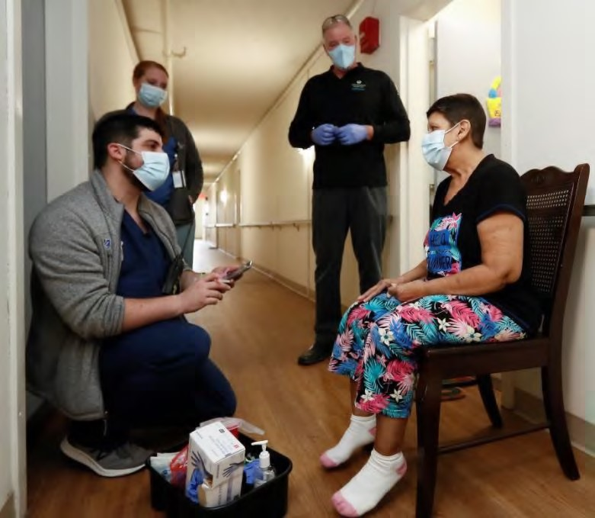COVID-19 presented monumental challenges for individuals, communities, local public health systems, health care providers, and society. The Centers for Disease Control and Prevention (CDC) reports that risk of severe illness and death from COVID-19 increases with age; more than 80% of COVID-19 related deaths have been in people over the age of 65. People with chronic and complex medical conditions - including those with cancer, respiratory diseases, neurological conditions (e.g., dementia and Alzheimer’s), diabetes, and those who are immunocompromised - are also at
UMASS MEMORIAL HEALTH INSTITUTED A MOBILE VACCINE EQUITY ENHANCEMENT an increased risk of illness and
PROGRAM THAT PROVIDES ONSITE VACCINATIONS AT LOW-_{INCOME HOUSING} death. COVID-19 also illuminated
COMPLEXES, SENIOR CENTERS, CHURCHES, AND OTHER COMMUNITY SITES long-standing health and social inequities; research has shown that many of those in racial and ethnic minority groups are at an increased risk of illness and death from COVID-19. People with disabilities have also been disproportionately affected, as they are more likely than those without disabilities to have a chronic health condition, live in congregate settings, and face barriers to healthcare. These populations continue to face systemic barriers to care, which often center around the social determinants of health - defined as the conditions in which individuals live, learn, work, play, and worship.
One of the few positives that arose from the pandemic was the way in which organizations - working across sectors, missions, and target populations - came together in rapid response. In mid-March of 2020, individuals representing approximately 25 local entities came together to start Worcester Together, and met weekly to plan citywide response and relief efforts. Worcester Together continues to meet; membership has increased to over 230 members, and several focused workgroups have been formed (e.g., Logistics, Housing, Youth, Older Adults, etc.). Later, the group started the Worcester Together Fund, which has raised and distributed over $11 million dollars in relief funding.
"I think the sustainability of the collaboration [Worcester Together] has been strong because we came together in service, and not for dollars. Prior to [the
pandemic], there was a lot of conflict between folks since we didn’t understand fully what each other were doing. The pandemic necessitated better coalition building and allowed for relationships to build." –CHA Focus Group participant
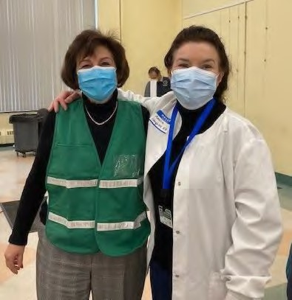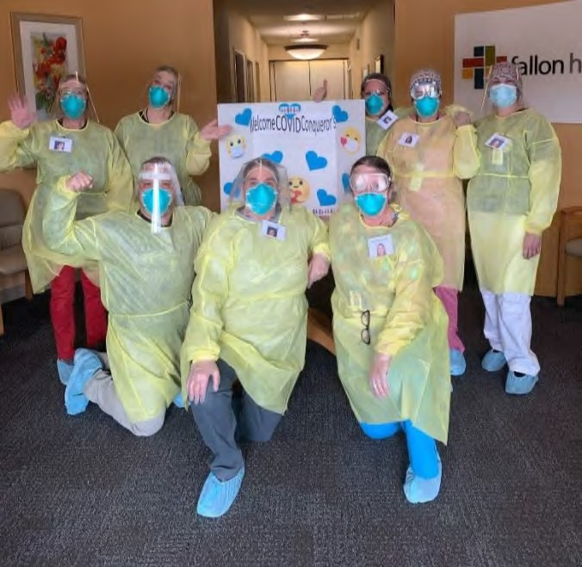
Follow the links below f
or data in CHA service area
communities:

City of Worcester COVID
-
19
Status Dashboard

City of Worcester COVID
-
19
Vaccination Dashboard

Impact of COVID
-
19
on Black People in Worcester

and Access to Vaccines

Grafton Coronavirus Information

Millbury Coronavirus Information

Shrewsbury Coronavirus Information

West Boylston Coronavirus Information

O
PENING
D
AY AT
W
ORCESTER
S
ENIOR
C
ENTER
E
MERGENCY
D
ISPENSING
S
ITE
-

D
R
M
ATILDE
C
ASTIEL
,

H
EALTH
C
OMMISSIONER AND
A
MELIA
H
OUGH
TON
,

P
UBLIC
H
EALTH
N
URSE

SUMMIT ELDERCARE ON GROVE STREET, AS IT WAS BEING USED AS AN INFIRMARY FOR MEMBERS WITH COVID-19
FIGURE 20: SOCIAL VULNERABILITY INDEX IN WORCESTER (LEFT) AND POSITIVE COVID-19 CASES IN AUGUST 2020
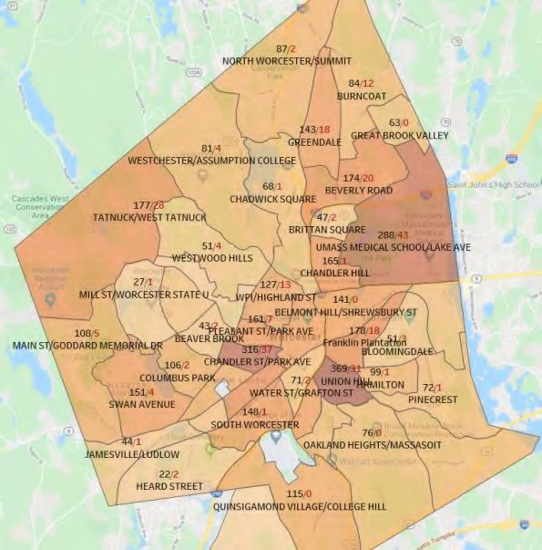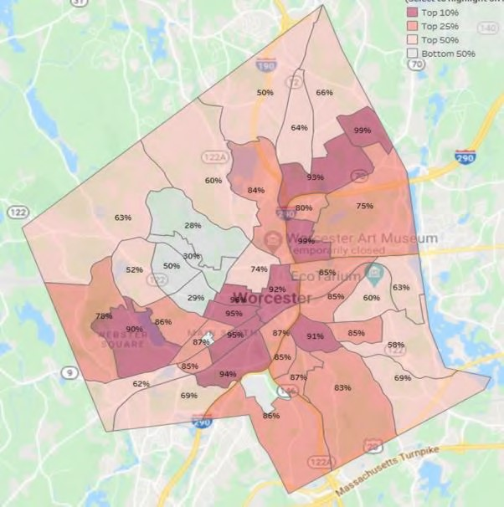
(
RIGHT
)

Source: UMass Memorial Medical Center, Office of Clinical Integration

In Figure 20, above, notice the overlap between the city’s most vulnerable neighborhoods, and the highest COVID-19 case counts.

FIGURE 21: TOTAL POSITIVE COVID-19 CASES BY RACE/ETHNICITY IN WORCESTER (AS OF AUGUST 2020)
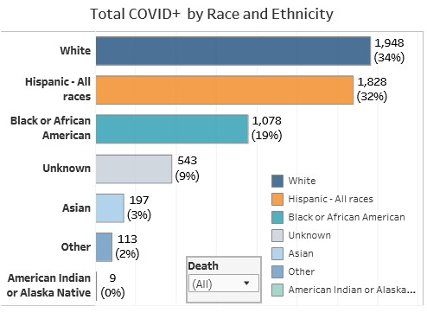

Oral Health
Poor oral health not only causes pain and discomfort, but also contributes to various diseases and conditions—including cardiovascular disease, diabetes, infectious disease and Alzheimer’s disease. Maintaining good oral health is especially important for children, as untreated dental conditions may lead to issues with development related to speech, eating and learning.
According to a 2016 University of Massachusetts Medical School report on oral health in Worcester, the city has fewer oral health providers who accept MassHealth than Worcester children who need services. Key informants corroborated this information, especially the need for a more effective safety net to provide oral health care for low-income children and families. Community water fluoridation, in which a fluoride compound is added to the public water supply, is not mandated in Massachusetts, though many cities and towns have chosen to participate. However, Worcester is one of the few municipalities in the state that remains unfluoridated.
TABLE 47: ROUTINE DENTAL CARE, 2018
 | Percentage of Adults with Recent Dental Visit
Grafton | 79.00%
Millbury | 75.80%
Shrewsbury | 78.90%
West Boylston | 73.30%
Worcester | 65.70%
01545 | 78.90%
01583 | 73.30%
01602 | 73.90%
01603 | 62.20%
01604 | 67.40%
01605 | 62.40%
01606 | 72.00%
01607 | 65.70%
01608 | 54.71%
01609 | 66.80%
01610 | 56.80%
Worcester County | 73.1%
Massachusetts | 72.7%
United States | 64.4%
Source: Centers for Disease Control and Prevention, Behavioral Risk Factor Surveillance System. Accessed via the 500 Cities Data
Portal. 2018.

CHIP & CHA PRIORITIES

The following is a summary of the population segments and community health issues that were prioritized by interviewees, focus group participants, and survey respondents. This prioritization also draws heavily on the quantitative data collected for this assessment, and the strength and momentum of existing community health efforts.
Priority Populations
The CHA Sponsors, working in collaboration with other health and social service stakeholders throughout the region, are committed to improving the health status and well-being of all residents in the service area. This report includes findings that are relevant to all residents, however, there was broad consensus on which segments of the population face significant barriers to care and experience adverse social determinants of health. that can put them at greater risk. The assessment identified the following groups as priority populations:
People of color | Immigrants, refugees, and  non-English  speakers | Youth and adolescents
Individuals with disabilities and  chronic/complex conditions | Individuals and families with  limited economic  means | Older adults
Priority Areas and Cross Cutting Issues
The CHA aims to identify the full range of community health issues affecting the region, across all its demographic and socioeconomic segments. The assessment is framed broadly to ensure that the breadth of unmet needs and community health issues are recognized. However, it is critical that the CHA identify leading community health issues based on the full range of data collected throughout the CHA process.

With this in mind, the CHA Sponsors framed the leading community health issues into five priority areas:
- Social determinants of health, including: food insecurity, housing, transportation/accessibility, cultural and linguistic barriers, socioeconomics
- Mental health, including: depression, stress, trauma, social isolation, serious mental illness
- Substance use, including: alcohol, tobacco, e-cigarettes, opioids and other prescription drugs, marijuana
- Chronic/complex conditions and their risk factors, including: obesity, physical activity, nutrition, asthma, diabetes, cardiovascular disease, neurological conditions, cancer, disabilities
- Racism, discrimination, and health equity: a cross-cutting priority that affects barriers to care, health outcomes, and health disparities in each of the other priority areas

Mental
health
Chronic/complex
conditions and
risk factors
Substance
use
Social
determinants
of health
Racism, discrimination, and health equity

ATTACHMENT A: COMMUNITY HEALTH SURVEY

Dear Community Partners,

The Central Massachusetts Regional Public Health Alliance, Fallon Health, The Hanover
Insurance Group and UMass Memorial Health invite you to participate in the 2021 Greater Worcester Community Health Needs Assessment (CHA) Survey. A CHA is conducted every three years to help us understand key problems that impact health and to assess the strengths of our community. The last CHA was completed in 2018.

In this process, your voice and input is vital. If you live in Worcester or the surrounding towns of Grafton, Millbury, Shrewsbury and West Boylston please participate by completing this short, voluntary and anonymous survey that will take just a few minutes. Our goal is to collect a large number of responses, which represent the diversity of our community. Findings of this survey will be documented in the 2021 Community Health Needs Assessment to be published in the Fall of this year and will be available in print and online on our respective websites.

Thank you for your participation in this important process.

- In your view, what makes a community healthy? Choose all that apply. No options were selected

Access to good healthcare

Recreation

Safety

Walk/Bike-ability

Access to jobs

Livable wages / Workforce development opportunities

Access to healthy food

Education (good schools/equity in schools)

Healthy housing/ Stabilized Housing

Transportation

Affordable Childcare / Afterschool Programs/Summer Programs

Access to WiFi and Devices for All

Services and Support for Elders/Seniors

House of Faith/Churches

Social Support for Seniors and those living alone

Arts

Culture

Public Parks /Green Spaces Other (please specify)
- What does a healthy community look like to you?
Consider- Good place to raise children; low crime rate/safe neighborhoods; good schools; access to healthy foods; access to healthcare; low adult death and disease rates; low infant deaths; clean parks; clean streets and sidewalks; affordable housing; communities prepared for emergencies; community support groups; availability of good jobs; activities for youth, etc.

- How would you rate the overall health of the community that you live in?

Very unhealthy

Unhealthy

Somewhat healthy
Healthy (this option has been selected)

Very healthy
Other (please specify)

- Please respond to the following statements using the scale provided.
Agree Neither agree nor disagree Disagree

You are satisfied with the quality of life in your community. (Consider your sense of safety, well-being, participation in community life and associations, etc.)
You are satisfied with the health care system in the community. (Consider accessibility, cost, availability, quality, and options in health care)
This community is a good place to grow old. (Consider elder-friendly housing, transportation to medical services, churches, shopping, elder day-care, social support for the elderly living alone, meals on wheels, etc.)
This community is a safe place to live. (Consider residents' perceptions of safety in the home, the workplace, schools, playgrounds, parks, and the mall. Do neighbors know and trust one another? Do they look out for each other?)
There are networks of support for individuals and families during times of stress. (consider neighbors, support groups, faith community, outreach agencies, etc.)
Comments?

- Are the following economic opportunities available in the community? (Choose all that apply) No options selected

Locally owned and operated businesses

Jobs with career growth

Job training/higher education opportunities

Affordable housing

Reasonable commute to work

- Please select yes or no for each of the following
No Yes
Do you feel safe in your community?
Do you feel safe at home?

- What makes Greater Worcester a healthy region?
Q7. Answer 1

Q7. Answer 2

Q7. Answer 3

- In your view, what do you think are the greatest community health challenges?
Q8. Answer 1
Q8. Answer 2
Q8. Answer 3

- How did the COVID-19 pandemic affect or exacerbate these community health issues?

- What challenges will exist after the pandemic?

- In what ZIP code is your home located? (enter 5-digit ZIP code; for example, 00544 or 94305)

- What is your age?
  - 16-29 years old o 30-49 years old o 50-64 years old o 65-74 years old o 75 years old or older
- What is your gender? No options selected

Girl/Woman

Boy/Man

Non-Binary

Genderqueer

Two-spirit
Transgender girl/woman

Transgender boy/man

Unsure

Prefer not to answer

Other (please specify)

- What racial ethnic group do you most identify with? No options selected
African
-
American / Black

American Indian, Alaska Native, Indigenous or First Nations

Arab or Middle Eastern

Asian or Asian American

Hispanic, Latina or Latino

Native Hawaiian or Pacific Islander

White, Caucasian or European American

Other (please specify)

- What is the highest level of education you have completed?
  - Still In high school o Less than high school graduate o High school diploma or GED o Associate's degree / some college o Bachelor's degree o Graduate or professional degree o Still in college
Thank you for participating in the 2021 Greater Worcester Community Health Assessment Survey!
ATTACHMENT B: COMMUNITY ASSET LISTING

Community Resource |  | Town | Food | Housing | Goods | Transit | Health | Care | Education | Work | Legal
Gardner
Community
Action
Committee,
 | Inc.  Community | Worcester |  |  | X | X | X
 | Servings  Urban Missionaries of Our Lady of Hope – The | Worcester | X |  |  | X
 | LittleStore | Worcester | x
 | CENTRO  Elder Services of Worcester | Worcester |  |  |  |  | X | X |  |  | X
 | Area (ESWA) Net of | Worcester |  |  |  |  | X | X
 | Compassion  Training  Resources of | Worcester | x |  |  |  |  |  |  | X | X
 | America Inc Worcester | Worcester |  |  |  |  |  |  |  | X | X
 | Public Library  Massachusetts Association for the Blind and Visually Impaired | Worcester |  |  |  |  |  |  | X
 | (MAB)  Guild of St. | Worcester |  |  |  |  | X | X
 | Agnes | Worcester |  |  |  |  |  | X | X
 | CENTRO  City of  Worcester  Office of | Worcester |  |  |  |  |  | X | X |  | X
 | Human Rights | Worcester |  |  |  |  |  |  | X |  | X

Seven Hills
Foundation Guild of St. | Worcester |  |  |  |  |  | X
Agnes  New Hope, | Worcester |  |  |  |  |  | X | X
Inc.  City of  Worcester  Department of  Health &  Human | Worcester |  | X
Services Elder Services of Worcester | Worcester | x | x |  |  | x |  | x
Area (ESWA) Boston Bar | Worcester |  |  |  |  |  | X | X
Association Seven Hills | Worcester |  |  |  |  |  |  |  |  | X
Foundation  Central  Massachusetts | Worcester |  |  |  |  | X |  | X
Collaborative  Jewish Family  & Children's  Service | Worcester |  |  |  |  |  |  | X
(JF&CS) | Worcester
CENTRO  Central  Massachusetts  Agency on | Worcester |  |  |  |  |  | X
Aging  Guild of St. | Worcester |  |  |  |  |  | X
Agnes  Jewish Family  & Children's  Service | Worcester |  |  |  |  |  |  | X
(JF&CS)  HealthAlliance  Home Health  & Hospice | Worcester |  |  |  |  |  | X |  | X
(HAHHH) | Worcester |  |  |  |  |  | X
CENTRO  Massachusetts Association for the Blind | Worcester |  |  |  |  | X | X
and Visually | Worcester |  |  |  |  | X | X
Impaired (MAB)
Greendale Peoples
Church  Jewish Family  & Children's  Service | Worcester | X
(JF&CS)  Family Health Center of | Worcester |  | X |  |  | X | X |  | X | X
Worcester  Community  Healthlink -  Worcester | Worcester |  |  |  |  |  | X
Team  Elder Services of Worcester | Worcester |  |  |  |  | X
Area (ESWA) Christopher | Worcester |  |  |  |  | X | X | X
Heights | Worcester |  | X
CENTRO  Jewish Family  & Children's  Service | Worcester |  |  |  |  |  | X | X
(JF&CS) Elder Services of Worcester | Worcester |  |  |  |  |  | X
Area (ESWA) | Worcester |  |  |  |  | X | X | X
Tri-Valley, Inc. Seven Hills | Worcester |  |  |  |  | X | X
Foundation  Massachusetts  Society for the  Prevention of  Cruelty to  Children | Worcester |  |  |  |  |  | X | X
(MSPCC) | Worcester |  |  |  |  |  | X | X
CENTRO  Easterseals | Worcester |  |  |  |  |  | X | X
Massachusetts CareOne - | Worcester |  |  |  |  |  | X
Millbury  Ace Medical | Worcester |  |  |  |  | X | X
Services | Worcester |  |  |  |  |  | X

CENTRO  Pernet Family | Worcester |  |  |  |  |  | X | X
Health Service | Worcester | X |  | X |  | X | X |  |  | X
Jeremiah's Inn | Worcester | X
Mission E4  Elder Services | Worcester |  |  |  |  |  | X
of Worcester Area (ESWA)  Notre Dame | West  Boylston | x |  |  |  | X | X | X
Health Care  Center Inc  HealthAlliance  Home Health | West  Boylston |  |  | X |  | X | X | X
& Hospice  (HAHHH)  Community  Healthlink - | West  Boylston |  |  |  |  |  | X
Worcester  Team  Elder Services | West  Boylston |  |  |  |  | X
of Worcester Area (ESWA) | West  Boylston |  |  |  |  | X | X | X
Ace Medical  Services  Ace Medical | West  Boylston |  |  |  |  |  | X
Services CareOne - | Shrewsbury |  |  |  |  |  | X
Millbury Elder Services of Worcester | Shrewsbury |  |  |  |  | X
Area (ESWA)  Notre Dame  Health Care | Shrewsbury | x |  |  |  | X | X |  | x | x
Center Inc  Shrewsbury  Council on | Shrewsbury |  |  | X |  | X | X
Aging (SCOA)  Shrewsbury  Youth &  Family | Shrewsbury | X | X | X | X | X | X | X | X | X
Services, Inc. Elder Services of Worcester | Shrewsbury |  |  |  |  |  |  | X | X | X
Area (ESWA) | Millbury |  |  |  |  |  | X | X | X
Elder Services of Worcester
Area (ESWA)  Notre Dame  Health Care | Millbury | x |  |  |  | X | X | X
Center Inc  Central  Massachusetts  Agency on | Millbury |  |  | X |  | X | X | X
Aging  Youth Mobile  Crisis  Intervention | Millbury |  |  |  |  |  | X
(YMCI) | Millbury |  |  |  |  | X
Tri-Valley, Inc.  CareOne - | Millbury |  |  |  |  | X | X
Millbury  Ace Medical | Millbury |  |  |  |  | X | X
Services Elder Services of Worcester | Millbury |  |  |  |  |  | X
Area (ESWA)  Notre Dame  Health Care | Grafton | X |  |  | X | X | X
Center Inc  Central  Massachusetts  Agency on | Grafton |  |  | X |  | X | X | X
Aging  Community | Grafton |  |  |  |  |  | X
Healthlink Elder Services of Worcester | Grafton |  |  |  |  | X
Area (ESWA) | Grafton |  |  |  |  | X | X | X
CareOne | Grafton |  |  |  |  | X | X

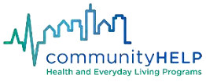
*Resource listing compiled utilizing the CommunityHELP IT Platform, created in partnership by UMass
Memorial Health and Reliant Health. Visit the platform at: https://www.communityhelp.net/

2021 Greater Worcester Community Health Needs Assessment || Page 85

Summary of Community Benefits Impact Activities
2018-2021

UMass Memorial Medical Center

Evaluation of Impact, 2018-2021
UMass Memorial Medical Center developed and approved an Implementation Strategy to address significant health needs identified in the 2018-2021 Community Health Needs Assessment (CHA). These programs support the Greater Worcester Community Health Improvement Plan (CHIP) which was developed collaboratively with the Worcester Division of Public Health, Fallon Health, The Hanover Insurance Group, the Coalition for a Healthy Greater Worcester and the community at large. The Implementation Strategy closely aligns with the CHIP and addresses the following health needs through a commitment of Community Benefit programs and resources:

- Domain 1: Increase Access to Health Care
- Domain 2: Promote Healthy Weight
- Domain 3: Promote Health Equity by Addressing Health Disparities (Cross cutting across all Domain Areas)
- Domain 4: Promote Positive Youth Development
- Other: Enhance the Public Health Infrastructure of the Community

To accomplish the Implementation Strategy, goals were established to address the health needs. Strategies to address the priority health needs/Domains were identified and impact measures tracked. The following tables outline the impact made on the selected significant health needs since the completion of the 2018 CHA. UMass Memorial has a dedicated Community Benefits Department that works closely with community organizations and reports activities to the UMass Memorial Health Care Board of Trustees and their Community Benefits Committees.

Domain 1: Increase Access to Health Care

Goal | Programs/Strategies to Address Health Need | Outcomes/Impact
Support programs and develop collaborative efforts that will improve access to care for the medically underserved/uninsured in Worcester. | Remove the stigma and barriers often associated with youth accessing mental health services. | Healthy Options for Prevention and Education (HOPE) Coalition Peer Leaders developed a Youth Mental Health Model that integrates counselors into the staff milieu at youth organizations.  Through this partnership with UMass Memorial, the Massachusetts Society for the Prevention of Cruelty to Children (MSPCC) and You, Inc. counselors are on staff at:  - The Worcester Youth Center • Boys & Girls Club  - Girls, Inc.  - Friendly House  A total of 1,525 youth were served during the period by this program through one-on-one counseling, therapeutic groups and crisis intervention.  Since its launch, the Model has served over 6,500 youth who otherwise would not have had access to mental health support. During the period, over 400 youth group meetings and 1,214 one-on-one counseling sessions were held.
 | Reach medically-underserved populations including those who are uninsured, underinsured, or not connected to primary care medical services or dental providers. | UMass Memorial Ronald McDonald® Care Mobile program:  Served a total of over 10,000 patients.  Provided preventive dental services (fluoride varnish treatments, screenings, sealants) at 20 schools and preventive dental and medical services at 11 neighborhoods across the City of Worcester.  Screenings and educational sessions were held at special community events and schools.  The Care Mobile manager co-lead the Worcester Free Clinics Coalition which conducted an on-going survey to identify more information about the patient population utilizing these services.

UMass Memorial coordinates and supports the Central Massachusetts Oral Health Task Force, a group comprised of diverse dental health stakeholders to ensure Worcester Public School students receive preventive dental services.
UMass Memorial Medical Center and its affiliates — HealthAlliance, Clinton and Marlborough hospitals — provide enrollment assistance for health insurance, to improve access to health care and nutritious food for uninsured/low income populations. An average of approximately 12,000 total people receive health insurance enrollment assistance each year.
The Care Mobile was not operational in FY2021 due the COVID-19 pandemic. Care Mobile staff were redeployed to COVID-19 community testing and vaccination.

UMass Memorial Care Mobile Staff; Public Health Emergency COVID-19 Pandemic Redeployment UMass Memorial Care Mobile “Feet on the Street” Community COVID Education and Outreach:
Beginning in March 2020, the UMass Memorial Ronald McDonald Care Mobile program staff were redeployed for critical COVID-19 community outreach, education and testing efforts to reach vulnerable populations and address disparities among high risk and highly impacted populations including Black and Hispanic in the City of Worcester and surrounding area. These multi-pronged, community-based approaches were developed and implemented to combat COVID-19 within neighborhoods targeting populations most at-risk. Beginning with the COVID-19 Feet on the Street outreach, the hospital’s Care Mobile staff were redeployed to provide onsite education and demonstration on handwashing, proper masking, answers to COVID-19 questions in Spanish and English and written materials in six languages. The intervention distributed nearly 10,000 tool kits with face masks, sanitizers and information on basic needs including food, housing and evictions. Specially-trained, bilingual Community Health Workers in the Community Relations Department also played a key role in staffing these COVID-19 efforts and in connecting to hard to reach, vulnerable populations. The scope of communitybased interventions in which UMass Memorial Care Mobile staff were deployed included: COVID-19 Feet on the Street Education and Outreach, COVID-19 Stop the Spread Testing site at the Mercantile Center in downtown Worcester, the only free COVID-19 testing site in the area.
Stop the Spread COVID-19 Testing initiative:
With the onset of the COVID-19 During the pandemic, the UMass Memorial Ronald McDonald Care Mobile could no longer see patients in the vehicle clinic due to infection control restrictions was taken off the road because of its close working environment. As such, the dedicated Care Mobile team quickly pivoted to conduct outreach to high-risk populations, educate, test and vaccinate community members at neighborhood-based popup sites in Worcester, Leominster and Clinton. A total of over 120,000 facial masks were distributed.
Testing sites were held throughout Worcester serving 150–600 people per day. Moving indoors as the weather turned colder, capacity increased to 800–1,000 daily with the help of new hires, temporary employees, public school nurses and volunteers. During testing events were held three days per week at
Worcester’s Mercantile Center reaching 1,100–1,500 people per week from November 2020 to January 2021.

Mobile Vaccine Equity Enhancement Program (MVEEP)
In February 2021, UMass Memorial initiated the Mobile Vaccine Equity Enhancement Program (MVEEP) for vulnerable populations. Statewide, the elderly were the first priority. We visited low-income housing complexes, senior centers, churches, and other community partners, to assist those who had difficulty getting to mass-vaccination sites and vaccinated over 4,500 community members. As of September 10, 2021 a total of 5,533 vaccines have been given at MVEEP sites.

City of Worcester COVID-19 Health Equity Task Force:
To address disparities in COVID-19 positivity rates, the Worcester City Manager and the CEO of UMass Memorial Health organized the City of Worcester COVID-19 Health Equity Task Force which is comprised of several committees including: Access to Care, Data, Education and Outreach and Testing. Each of these groups were active, provided valuable feedback had a diverse community and clinical system representation.

 | Strategy 3.2.5: Improve connections between clinical and community providers for residents with poor health outcomes such as asthma, hypertension, oral ill-health, sexual ill-health and those at risk for injuries such as falls, especially for underserved and vulnerable populations. | 12,000 screenings for Social Determinants of Health were completed by the UMass Memorial Clinical Medical Group in 33 primary care practices  UMass Memorial provided support for Medical Interpretation at four free clinics (Epworth, Saint Peter’s Church, Saint Anne’s Church and the Akwaaba Clinic)  CommunityHELP (Aunt Bertha), a collaborative effort with UMass Memorial Medical Center and Reliant Health. The CommunityHELP IT platform links community resources and social determinants with patients’ needs and allows patients, providers and community members to seek information on services. CommunityHELP was developed as a result of an extensive community engagement process. Work to link the platform to the Medical Record in EPIC was conducted during the period. During the period, CommunityHELP was integrated within the Epic EHR and the MyChart patient portal. To improve community awareness and knowledge of use of the system. a CommunityHELP introductory video was also created in collaboration with the City of Worcester, distributed to community organizations, and CommunityHELP YouTube channel launched.  Community Relations staff partnered with the UMass Memorial Legal Department, the University of  Massachusetts Medical School and Community Legal Aid to secure funding to increase capacity of private sector lawyers to provide pro-bono services to our patients in several practices who are in need of legal support to address social barriers impacting their healthcare. A total of 449 referrals were made to the program during the period. 640 referrals (from Hahnemann, Benedict Family Medicine and Benedict Pediatrics) since the program’s start.  Infant Mortality, Supported the Worcester Healthy Baby Collaborative: Worcester has a higher infant mortality rate (IMR) than similar cities in the state. Approximately 75 percent of infant deaths are neonatal and due to extreme prematurity and low birth weight. The rate for Hispanics surpassed the Black IMR for the first time from 2012 to 2014, and is more than double the state average. In partnership with the March of Dimes, the Worcester Division of Public Health and local agencies, the Worcester Healthy Baby Collaborative (WHBC), chaired by Sara Shields, MD, at Family Health Center, is working to reduce the rate of premature birth and infant death in the city. Cathy Violette, NP, UMass Memorial Maternal Fetal Medicine Department serves as vice chair of the collaborative.
 |  | UMass Memorial Child & Maternal Health developed and implemented a pilot utilizing a Community Health Worker *CHW) to work with high-risk mothers to help ensure health of the mother and baby pre-and post-pregnancy to improve health outcomes and prevent infant mortality among at-risk Latino and other populations within the nine census tracks of the City of Worcester. The hospital developed and formalized the relationship with the City of Worcester Division of Public Health (WDPH) to successfully establish the CHW pilot OB-Gyn intervention in 2019. The intervention includes a focus on identifying social determinants of health including food insecurity and access to healthy nutrition. The pilot was established as part of a REACH (Racial and Ethnic Approaches to Community Health) grant from the Centers for Disease Control and Prevention (CDC) grant received by the City of Worcester Division of Public Health in 2018. The project goal is to reduce health disparities among racial and ethnic populations with the highest burden of chronic disease (i.e., hypertension, heart disease, Type 2 diabetes, and obesity) through culturally-tailored systematic interventions that address community conditions and impact access to care, poor nutrition, and physical inactivity. During the period, A specially-trained, multi-lingual and culturally competent Community Health Worker provided the home visiting program (Virtual Visiting Program due to COVID-19 beginning in March 2020), serving Latina/x, (English, Spanish and Portuguesespeaking) patients enrolled in the program, including assessment of breastfeeding support and education needs and providing appropriate referrals for patients, social determinant of health needs. A minimum of 100 patients were enrolled in the program. Due to the COVID-19 pandemic beginning in March 2020, in person home visits and group sessions were discontinued however the Community Health Worker conducted virtual home visits and follow up contacts with program participants via Zoom and Facetime. A total of approximately 80 referrals were made by the CHW to a range of community resources addressing social determinants of health. (A number of participants were referred to more than one resource).
Chronic conditions -asthma | Pediatric Asthma to reduce rates of pediatric asthmarelated ED visits in Worcester are double that of the state. | Worcester City-wide Pediatric Asthma Home Visiting Intervention: Asthma is a serious and chronic condition that is far more prevalent in Hispanic, Black and low-income populations, especially those living in public housing and older housing. A comprehensive, multi-sectoral strategy is necessary to addressing pediatric asthma. As such, UMass Memorial Medical Center spearheaded, and co-chaired throughout this period, the city-wide Worcester Pediatric Asthma Task Force that incorporates reduction of environmental exposures in the home and school settings that trigger asthma. The  community/clinical linkage program utilizes trained, culturally-competent Community Health Workers (CHW) incorporated as part of the clinical team, to assess and address asthma triggers in the home. CHWs additionally provided basic education to improve medication understanding and adherence for children with poorly-controlled asthma. The CHWs also provide participant families with supplies to help rectify asthma triggers (i.e. mold, pest and rodent infestation) including asthma-friendly cleaners. The intervention aims to reduce school absenteeism, hospitalizations and unnecessary ED use among high risk asthmatic children. In 2014, Worcester was selected as one of nine communities in the state to receive Massachusetts Prevention and Wellness Trust Fund (PWTF) funding, under the coordination of the Worcester Division of Public Health. Through PWTF, a UMMMC pilot was expanded to the city-wide intervention including all 44 Worcester Public Schools (WPS), the Worcester Head Start program and multiple partners including: two community health centers, UMMMC Pediatrics and Pulmonology departments, The City of Worcester’s Division of Public Health and Healthy Homes Office, and Community Legal Aid. UMMMC’s Pediatric Pulmonology department also works with the WPS and Head Start providing training programs to school nurses and clinical providers. To date since the program start, UMass Memorial clinical sites have completed a total of over 700 home visits. Including all partner sites (Edward M. Kennedy  Community Health Center and Family Health Center of Worcester) over 1,375 home visits have been completed. Due to the COVID-19 pandemic beginning in March 2020, in person home visits were discontinued however  Community Health Workers conducted virtual home visits via Zoom and Facetime. UMass Memorial  Community Health Workers working in the Pediatric Asthma Intervention also played a key role in providing
Substance Abuse: | Strategy 2.3.2. Support research about innovative treatment approaches for opioid addiction treatment and monitoring | critical health and COVID-19 information and social determinant of health/community resource information to high risk households and asthmatic students enrolled in the AsthmaLink program during the pandemic.  The AsthmaLink Program (formerly called Meds-In-School) enrolls approximately 80 students with persistent asthma yearly. With this school-based Medication Adherence program, UMass Memorial Pedi-Pulmonology NP provides medical advice and coordinating control medications given by school nurses for high risk patients and connects families with high risk asthmatic children to the home visiting Intervention. UMMMC Pediatric Pulmonology also works closely with the WPS/Head Start providing training programs to school nurses, clinical providers at each clinical site as well as parents/guardians and students. During the school closures beginning in March 2020 due to COVID-19, the Pedi-  Pulmonology Clinic established a new text messaging communication intervention utilizing the CHW for enrolled high-risk patients, providing reminders for medication adherence and a check in on asthma status and needs.  UMass Memorial In-Patient/ED-Intervention: Operated by the UMass Memorial Pediatric Pulmonology, this effort connects pediatric asthma patients admitted to the hospital to the Community Health Worker (CHW)/Home Visiting Intervention. This linkage triggers a CHW visit to the home upon patient discharge. Since the program start in 2016, over 100 referrals to the home visiting program have been made through this intervention.  Pediatric Asthma Intervention: Policy Task Force: An established sub-committee of the city-wide Pediatric Asthma Intervention, the Policy Task Force works to improve environmental asthma triggers in the Worcester Public Schools (WPS) through environmental policy reform efforts such as standardization of duct work, the use of asthma friendly cleaners, and the removal of throw rugs and other asthma triggers in school buildings. A pilot intervention/environmental assessment conducted at WPS schools with the highest rates of absenteeism and high rates of asthmatic students to assess and address identified environmental triggers resulted in the WPS’s first time hiring of an Indoor Air Quality  Specialist/Environmental Officer to address this work going forward as a priority throughout the WPS school system and Head Start Programs.  UMass Memorial supports the Medical Director position at Hector Reyes House, a residential substance abuse treatment program for Latino men. In addition to on-site medical care and cognitive behavioral therapy to reduce relapse and ease the transition to independent living, the program offers job training and skill development at the Café Reyes, featuring Cuban food and coffee. The Hector Reyes House serves 20-25 Latino men annually.

Domain 2: Promote Healthy Weight
Access to Healthy Food/Address Food Insecurity
Goal | Programs/Strategies to Address Health Need | Outcomes/Impact
Reduce overweight/obesity among youth and adults and support efforts that promote Healthy Weight. | Increase knowledge of growing fresh produce and access to healthy food in food insecure | The Grant Square Community Garden in Bell Hill was developed in 2010 in partnership with the Regional Environmental Council (REC) with support from UMass Memorial and the City of Worcester, which provided land use at a public park for the garden. The garden includes a total of 34 raised beds maintained by youth gardeners and residents. Produce from the garden is made available to the Bell Hill neighborhood and at 15 stops in food insecure areas across the city through the

 | areas through Community Garden efforts. | REC “Veggie Mobile” mobile Farmers’ market. Three of the Veggie Mobile stops are in the Bell Hill neighborhood and average between 60-90 customers per week.  Sustained an urban agriculture, YouthGROW youth leadership program for youth working at the Grant Square garden.  YouthGROW was established by REC with support from UMass Memorial as part of the launch of the Grant Square Community Garden effort in 2010). Approximately 2,000 pounds of fresh produce was contributed to the Veggie Mobile from the garden during the period.  During the period, the program included over 100 total youth from the Bell Hill neighborhood (approximately 34 annually)
Reduce food insecurity and improve access to healthy food and nutrition among vulnerable populations | Promote policy change to increase access to healthy food and nutrition for medicallyunderserved populations by participating in the Worcester Food Policy Council. | Since 2010, UMass Memorial Medical Center has served as an active member of the Steering Committee for the Worcester Food Policy Council (WFPC). The WFPC Steering Committee convenes the CHIP Access to Healthy Foods work group to promote healthy weight and nutrition. The Council works on a range of issues to improve access in underserved, food insecure areas, including healthy food retail, SNAP (food stamp), increasing minimum wage and expanding urban agriculture opportunities.  WFPC accomplishments and on-going efforts during the period have included:  Successful advocacy for Massachusetts Food Trust Legislation that will increase healthy food access and spur economic development by providing loans, grants, and technical assistance to support healthy food retailers and local food enterprises in low- and moderate-income communities.  Successful advocacy for refunding of the Massachusetts Healthy Incentives anti-hunger Program (HIP) which provides monthly incentives to SNAP households when they purchase fresh, locally-grown produce at farmers markets, farm stands, Community Supported Agriculture Farms (CSAs), and mobile markets.  Advocacy to pass Urban Agriculture Legislation that would update Worcester’s zoning code to promote farming and farm stands in the city to improve access to healthy food.  Advocacy for free school meals and breakfast in the classroom for all students as a strategy to reduce hunger.  Collaboration with the Worcester Public Schools (WPS) to improve the health content of food served.  Advocacy for policies that improve access to healthy nutrition such as:  - Implementation of the “Breakfast After the Bell” program that removes stigma for students qualifying for free meals by providing for all students to eat breakfast in their classrooms at the start of the school day statewide.  - The federal Child Nutrition bill that supports healthy foods in schools and in Summer Feeding programs.  Continued advocacy for SNAP and the anti-hunger Massachusetts Healthy Incentives Program (HIP) that provides monthly incentives to SNAP households when they purchase fresh, locally grown produce at farmers markets and stands, community supported agriculture farms and mobile markets.  Support of emergency COVID-19 food insecurity efforts including dissemination of information on SNAP, WIC, accessing Cash Benefits through the Massachusetts Department of Transitional Assistance and Community Legal Aid and connectivity to the Worcester Family Resource Center.  Support and advocacy for a range of related efforts including livable wage, Farm to Table and Hunger Free Communities.  Other Food Insecurity/Access to Healthy Nutrition Efforts:  Community Relations staff served as an active member of the UMass Memorial Health Anchor Mission planning team to establish a pilot Food Pharmacy Pantry working initially with the hospital's Cancer Center. Planning and development efforts were ongoing during 2020 in anticipation of the launch of the initial Food Pharmacy Pantry in the fall of 2021.
 | Promote Food as Medicine | Addressing Food Insecurity in Worcester’s African Population: Provided planning assistance and skills building training in anticipation of the development of a food pantry pilot effort tailored to address cultural and linguistic barriers among Worcester's large African population which identified food insecurity as a critical issue.  UMass Memorial Medical Center and the WFPC are also part of the Food is Medicine Massachusetts State Planning effort being led by the Harvard University Center for Health Law and Policy Innovation and Community Servings that will seek to find ways to increase access to medically-tailored foods and improve the availability of prepared nutritious food for economically-disadvantaged patients being discharged. testified at two hearings at the Massachusetts State House (Joint Committee on Public Health and Joint Committee on Health Care Financing) in advocacy of legislation to establish a Food and Health Piot program that would require the Executive Office of Health and Human Services (EOHHS) to establish a Food and Health Pilot Program that equips health care systems to connect MassHealth enrollees with diet-related health conditions to one of the three appropriate nutrition services, with the expectation that health outcomes will improve and cost of care will decrease. A determination if the legislation will be implemented is expected in the Fall of 2021.

Domain 4: Promote Positive Youth Development
Goal | Programs/Strategies to Address Health Need | Outcomes/Impact
Support at-risk youth programs that promote positive youth development (e.g., substance use, tobacco, mental health and violence prevention). | Support youth leadership development programming aimed at reducing violence, Alcohol, Tobacco and other Drug (ATOD) use. | Provided coordination and on-going support of the Healthy Options for Prevention and Education (HOPE) Coalition/ Youth Substance Abuse Prevention Task Force: HOPE is a youth-adult partnership created to reduce youth violence, substance use and promote adolescent mental health.  HOPE Peer Leaders co-chair the Youth Substance Abuse Prevention Task Force along with the Worcester Division of Public Health to reduce alcohol, tobacco and other drug (ATOD) use among young people.  HOPE Peer Leaders conducted a Social Norms Campaign reaching 750 students at North High School to communicate accurate information about the prevalence of healthy behavior in order to reinforce healthy behaviors among youth and to reduce smoking, underage drinking and prescription drug abuse. In total during the period, HOPE reached approximately 3,000 people with its “I’m About this Life” Social Norms Campaign.  190 youth from eight different youth organizations participated in HOPE dialogues as part of the Social Norms Campaign.  HOPE held two Youth Education Success (YES!) Summits to inspire dialogue among youth and between youth and adults to foster communication between student body, adults, leadership and policy makers. Over 100 people including 80 youth and city decision-makers including the Worcester City Manager, other key legislators, Worcester Public Schools (WPS) Committee and over 10 WPS teachers attended.  HOPE also launched a social media campaign to prevent underage drinking and driving in partnership with the Worcester Police Department and developed a new youth leadership curriculum based on social justice principles.  In 2018, HOPE established a Health Ambassador program at the Worcester Public Schools which is led by students that is focused on social norms which will start function in the 2018-2019 academic year.  In 2020, HOPE Peer Leaders continued to work to reduce youth violence and substance use, and promote adolescent mental health, through a youth-adult partnership. COVID-19 forced HOPE Peer Leaders to move to a completely virtual program. Peer Leaders meetings and trainings were held in an online format. Attention was focused on remaining connected to the HOPE Peer Leaders, ensuring their social-emotional wellbeing during this unprecedented time of significant disconnection and disruption.
 | Strategy: 9.2.5. Implement an intervention for young children who witness violence, to support positive social and emotional development.  8.1.3. Identify access and programming gaps to public and private indoor and outdoor physical activity facilities for specific vulnerable populations. | The HOPE Coalition Youth Working Training Institute (YWTI) provides professional education for front-line youth workers from community organizations in the Greater Worcester area to better prepare them to serve vulnerable young people. HOPE partners with Clark University to offer college credit to youth workers who take YWTI courses. During the period, over 100 youth workers enrolled in the Professional Certificate in Youth Work Practice program and an additional 66 core members enrolled in the Worcester Youth Worker Alliance. A larger network of over 400 area youth workers also benefited through shared resources and attending YWTI events. HOPE also partners with Worcester Public Schools (WPS) to certify youth workers in First Aid Youth Mental Health. Additional YWTI collaborating partners include: Girls Inc., Boys & Girls Club, Friendly House, Worcester Youth Center, Recreation Worcester, Ascentria Care Alliance, Christian Brotherhood, Worcester Community Action Council and YOU Inc.  In 2017, Dr. Laurie Ross (UMass Memorial Community Relations staff) in partnership with the Worcester Youth Violence Prevention Coalition established an Early Childhood Trauma Task Force that developed a plan with multiple stakeholders to establish an effective response to young children who experience and witness violence in their homes and/or communities as a means of reducing behavioral effects and future violence. The Task Force assembled a robust group of project partners representing multiple sectors including law enforcement, social services, education, families, and health care. In 2018, the intervention hired and trained two Community Health Resilience Workers and launched the Worcester ACTS home visiting program. The Task Force additionally participated in a citywide strategic planning for early childhood health and wellbeing and was Included in a federal grant application with the Worcester Division of Public Health to expand the model to include young children affected by the opioid epidemic. During the period a total of 165 families were served by the program.  Building Brighter Futures With Youth (BBWF): UMass Memorial provides summer employment at many medical center departments. The program served approximately 70 total students during the period. Students work 24 hours per week. While most BBWF students are placed in departments across the hospital system, three-five youth are employed annually at Grant Square Community Garden in Bell Hill though YouthGROW, a food justice program of the Regional Environmental Council.  UMass Memorial has invested in the City of Worcester’s “Recreation Worcester” program (formerly Wheels to Water) since its inception in 2008. This neighborhood-based summer initiative provides access to free, safe, supervised physical activity and educational programming promoting positive youth development for approximately 1,600 inner-city children (ages 7 to 13) annually for a total of 4,800 during the period. The program incorporates healthy nutrition by providing three meals and a snack daily. In partnership with the Worcester Public Schools, educational activities are included using a curriculum developed by the Worcester Education Collaborative to minimize summer learning loss. UMass Memorial investment leverages Massachusetts YouthWorks funding to employ a minimum of 100 youth each summer. Since 2008, the hospital has provided a total of $880,000 in funding for this program. Since 2012, UMass Memorial’s support has leveraged over $1.5 Million in YouthWorks funding.

Other: Enhance the Public Health Infrastructure of the Community
Goal | Programs/Strategies to Address Health Need | Outcomes/Impact
 | Develop and support strategies and systems that enhance the public health infrastructure of the Greater Worcester community.  Academic Health Collaborative  Coalition for a Healthy Greater  Worcester | Supported opportunities and partnerships that aimed to improve the public health in the community through the development of the 2015-2018 Community Health Needs Assessment (CHA) and the Community Health Improvement Plan (CHIP) which is reviewed annually.  Provided funding to support the Worcester Division of Public Health Infrastructure including the Academic Health Collaborative, Recreation Worcester and other city-lead initiatives.  In partnership with stakeholders, reactivated the CHNA-8 Healthy Communities Coalition as a strategy to support the 2018-2021 CHIP strategies.  A total of 129 Academic Health Collaborative interns worked on a variety of public health efforts in support of the  Greater Worcester Community Health Improvement Plan including: the YouthConnect Social Norms campaign, City of Worcester Recreation Program efforts including tracking curriculum development and registration and retention data, efforts supporting the development of for the 2015 and 2018 Community Health Needs Assessments (CHA) including compilation of community surveys at public events and festivals and data compilation for the completion of the 2018 CHA, healthy Eating Corner Store Initiative, Safe Routes to School, GIS mapping, substance abuse: research effectiveness of recovery coaches, observe programs that incorporate recovery coaches and wrap around services for incarcerated individuals and others. A total of eight academic institutions are involved in this effort. They include: Clark University, University of Massachusetts Medical School, Worcester State University, The College of the Holy Cross, Worcester Polytechnic Institute, Becker College, Assumption College and the Massachusetts College of Pharmacy.  UMass Memorial Medical Center was one of the founding partners that spearheaded the reactivation of the CHNA-8 Healthy Communities Coalition to launch the Coalition for a Healthy Greater Worcester and is its primary funder. In 2017 and in 2018, the hospital continued to serve as a member of the Coalition’s Steering Committee and a Community Relations staff member holds the position of Treasurer. UMass Memorial additionally helped to secure the fiscal conduit for the Coalition which is comprised of public, non-profit, and private sector stakeholders. The Coalition convenes partners including the Massachusetts Department of Public Health, service providers, local health departments, consumers and residents of the general public in Worcester and six contiguous towns to implement the Community Health Improvement Plan (CHIP) and promote the continuous improvement of health status for all residents in the greater Worcester region. The Coalition oversees Working Groups for the CHIP Work Groups. In 2017, working with the Coalition, UMass Memorial and its partners, the Worcester Division of Public Health (WDPH), Fallon Health embarked on the completion of the 2018 Community Health Needs Assessment (CHA) including review of primary and secondary data to identify priorities. Findings of the CHA will be used to update the CHIP. The Coalition served as the Advisory Group in the development of the 2018 Community Health Assessment. A Resource & Development Subcommittee was also established for the purpose of securing funding for the Coalition’s long-term sustainability and distribution of UMass Memorial Determination of Need (DoN) Funding. The goal of DoN funding is to improve the health and well-being of medically-underserved populations in alignment with the CHIP. UMass Memorial funds the coalition director position and in 2018 provided DoN funding to nine organizations.

Other
Goal | Programs/Strategies to Address Health Need | Outcomes/Impact
Ensure that all residents regardless of age, race, ethnicity, class, gender identity, sexual |  | Goods for Guns: UMass Memorial’s Injury Prevention Department collaborates with the Worcester Police Department, the Worcester Department of Public Health and the Worcester office of the District Attorney and other Community
orientation, housing situation, family status, or religion will feel safe, secure, respected, and live a life free from violence.  UMass Memorial Anchor Institution Mission |  | Partners to purchase grocery store gift cards in exchange for local residents turning in unwanted firearms. Participants are educated about safe gun storage and are offered trigger locks free of charge. Worcester has become the city in MA with the lowest per capita occurrence rate of firearm injury in the State. The program works in collaboration with police departments in 17 surrounding communities and collected 516 guns during the period. Since the inception of the program in 2002, over 3,313 guns have been returned to law enforcement officials in Central Massachusetts.  UMass Memorial Health recently adopted a system-wide Anchor Mission to leverage the breadth and depth of the assets of the organization in a more concerted way to address poverty and social determinants of health. The concept, developed by the Democracy Collaborative, a national research institute, encourages and challenges large institutions, with strong roots in a specific locale, to expand their traditional business practices to more broadly improve and develop the economy of the distressed neighborhoods which surround them. For hospitals, this means moving from a clinical focus to a wider, upstream perspective on non-clinical factors that adversely impact a person's health. Examples include, but are not limited to, housing, education, poverty, nutrition, economic stability and physical environment. UMass Memorial's Anchor Mission focuses on the pillars of: Investment, Local Procurement. Hiring and Employee Volunteerism. During the period, the system sustained the Anchor Mission infrastructure to support activities addressing social determinants of through broad participation in each of the pillars. Community Relations staff additionally served as a member of the Anchor Mission planning committee for the development of a UMass Memorial Food Pharmacy pilot initiative. Over $2 Million have been distributed as investments for neighborhood revitalization and housing for first time homeowners.  The concept of a establishing an Anchor District in one of Worcester’s most vulnerable neighborhoods was explored utilizing indicators and data at the Census tract level. The program has started to gather input from neighborhood stakeholders.

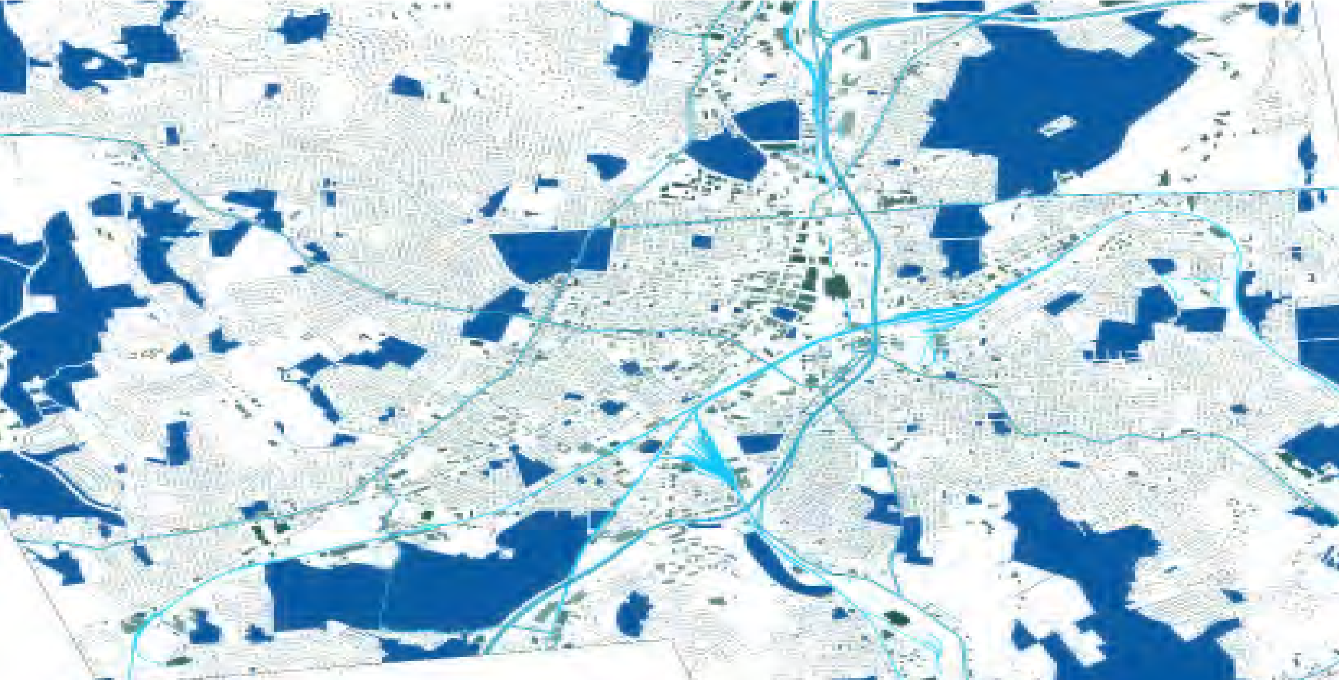
UMMHC-21120810-RE - 149

APPENDIX 4
AFFILIATED PARTIES FORM

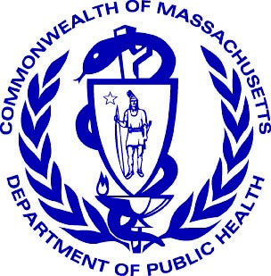
Massachusetts Department of Public Health
Determination of Need
Affiliated Parties
Version:

DRAFT
3-15-17
DRAFT
Application Date:
2
/
01
5
/2022
UMMHC-21120810-RE
Application Number:
Applicant Information
UMass Memorial Health Care, Inc.
Applicant Name:
David Bierschied
Contact Person:
Title: Sr. Director of Strategic Financial Planning
Phone:
5083340463
Ext:
E-mail:
david.bierschied@umassmemorial.org
Affiliated Parties
1.9 Affiliated Parties:
List all officers, members of the board of directors, trustees, stockholders, partners, and other Persons who have an equity or otherwise controlling interest in the application.
Add/  Del  Rows | Name  (Last) | Name  (First) | Mailing Address | City | State | Affiliation | Position with affiliated entity  (or with Applicant) | Stock, shares, or partnership | Percent  Equity  (numbers only) | Convictions or  violations | List other health care facilities affiliated with | Business relationship with  Applicant
 | Siegrist | Richard | 97 Worcester Street | Boston | MA | Applicant | Applicant Officer & Trustee |  |  | No | UMass Memorial Medical Center, Inc. | No
 | Pawlicki | Raymond | 23 Marlborough Street | Boston | MA | Applicant | Applicant Officer & Trustee |  |  | No | UMass Memorial Medical Center, Inc. | No
 | Dickson, MD | Eric | 93 Mirick Way | Princeton | MA | Applicant | Applicant Officer & Trustee |  |  | No | UMass Memorial Medical Center, Inc. | Yes
 | Melgar | Sergio | 71 Clubhouse Way | Sutton | MA | Applicant | Applicant Officer |  |  | No | UMass Memorial Medical  Center, Inc. , HealthAlliance  Home Health and Hospice,  Inc ., Marlborough Hospital ,  Community Healthlink, Inc.,  UMass Memorial HealthAlliance -Clinton Hospital, Inc. | Yes
 | Brown | Douglas | 92 Bullard Street | Sherborn | MA | Applicant | Applicant Officer |  |  | No | UMass Memorial Medical  Center, Inc., Community  Healthlink , Inc. UMass Memorial HealthAlliance- Clinton Hospital, Inc. | Yes
 | Eshghi | Katherine | 16 Oak Meadow Road | Lincoln | MA | Applicant | Applicant Officer |  |  | No | UMass Memorial Medical Center, Inc. | Yes

Add/  Del  Rows | Name  (Last) | Name  (First) | Mailing Address | City | State | Affiliation | Position with affiliated entity  (or with Applicant) | Stock, shares, or partnership | Percent  Equity  (numbers only) | Convictions or  violations | List other health care facilities affiliated with | Business relationship with  Applicant
 | D'Alelio | Edward | 88 Black Rock Drive | Hingham | MA | Applicant | Applicant Trustee |  |  | No | UMass Memorial Medical Center, Inc. | No
 | Finberg | Robert | 259 Crawford Street | Northborough | MA | Applicant | Applicant Trustee |  |  | No | UMass Memorial Medical Center, Inc. | Yes
 | Benjamin, MD | Evan | 10B Chandler Street, Unit #2 | Boston | MA | Applicant | Applicant Trustee |  |  | No | UMass Memorial Medical Center, Inc. | No
 | Guardiola | Elvira | 122 Sterling Street, #1 | Worcester | MA | Applicant | Applicant Trustee |  |  | No | UMass Memorial Medical Center, Inc. | No
 | Bovenzi | Leslie | 560 Goodrich Street | Lunenburg | MA | Applicant | Applicant Trustee |  |  | No | HealthAlliance Home Health and Hospice, Inc., UMass  Memorial Medical Center, Inc. | No
 | Johnson, MD | Mark | 29 Peakham Road | Sudbury | MA | Applicant | Applicant Trustee |  |  | No | UMass Memorial Medical Center, Inc. | Yes
 | Kane | Nancy | 109 Wilderness Drive | Naples | FL | Applicant | Applicant Trustee |  |  | No | UMass Memorial Medical Center, Inc. | No
 | Bennett | Richard | 19 Mark Avenue | Webster | MA | Applicant | Applicant Trustee |  |  | No | UMass Memorial Medical Center, Inc. | No
 | Knox | Peter | 3157 Seafarer Way | Suamico | WI | Applicant | Applicant Trustee |  |  | No | UMass Memorial Medical Center, Inc. | No
 | Mailman | Susan | 24 Holden Street | Worcester | MA | Applicant | Applicant Trustee |  |  | No | UMass Memorial Medical Center, Inc. | No
 | Bennett | David | 7 Mt. View Drive | Paxton | MA | Applicant | Applicant Trustee |  |  | No | UMass Memorial Medical Center, Inc. | No
 | Thomsen | Rosemary | 118 Kirkstail Road | Newton | MA | Applicant | Applicant Trustee |  |  | No | UMass Memorial Medical Center, Inc. | No
 | Young, MD | Linda | 10 Otsego Roag | Worcester | MA | Applicant | Applicant Trustee |  |  | No | UMass Memorial Medical Center, Inc., UMass Memorial Medical Group , Inc. | No
 | Collins, MD | Michael | 72 Flagg Street | Worcester | MA | Applicant | Applicant Trustee |  |  | No | UMass Memorial Medical Center, Inc. | No
 | Flotte, MD | Terence | 122 Paxton Road | Holden | MA | Applicant | Applicant Trustee |  |  | No | UMass Medical School, UMass  Memorial Medical Center, Inc., UMass Memorial Medical Group, Inc. | No
 | Paulhus | Robert | 10 Larcridge Lane | Ashland | MA | Applicant | Applicant Trustee |  |  | No | UMass Memorial Medical Center, Inc. | No
 | Murphy | Micharl | 72 Fox Run Road | Bolton | MA | Applicant | Applicant Trustee |  |  | No | Marlborough Hospital, UMass Memorial Medical Center, Inc. | No
 | Shea | John | 39 Coventry Road | Worcester | MA | Applicant | Applicant Trustee |  |  | No | Community Healthlink, Inc.,  UMass Memorial Medical Center, Inc. | No
 |  |  |  |  | MA
+ - |  |  |  |  | MA
Page 2 of 3
UMMHC-21120810-RE - 152
age 3 of 3
Document Ready for Filing
When document is complete click on "document is ready to file". This will lock in the responses and date and time stamp the form. To make changes to the document un-check the "document is ready to file" box.
Edit document then lock file and submit Keep a copy for your records. Click on the "Save" button at the bottom of the page.

To submit the application electronically, click on the "E-mail submission to Determination of Need" button.
This document is ready to file:
Date/time Stamp:

APPENDIX 5
CHANGE IN SERVICE FORM

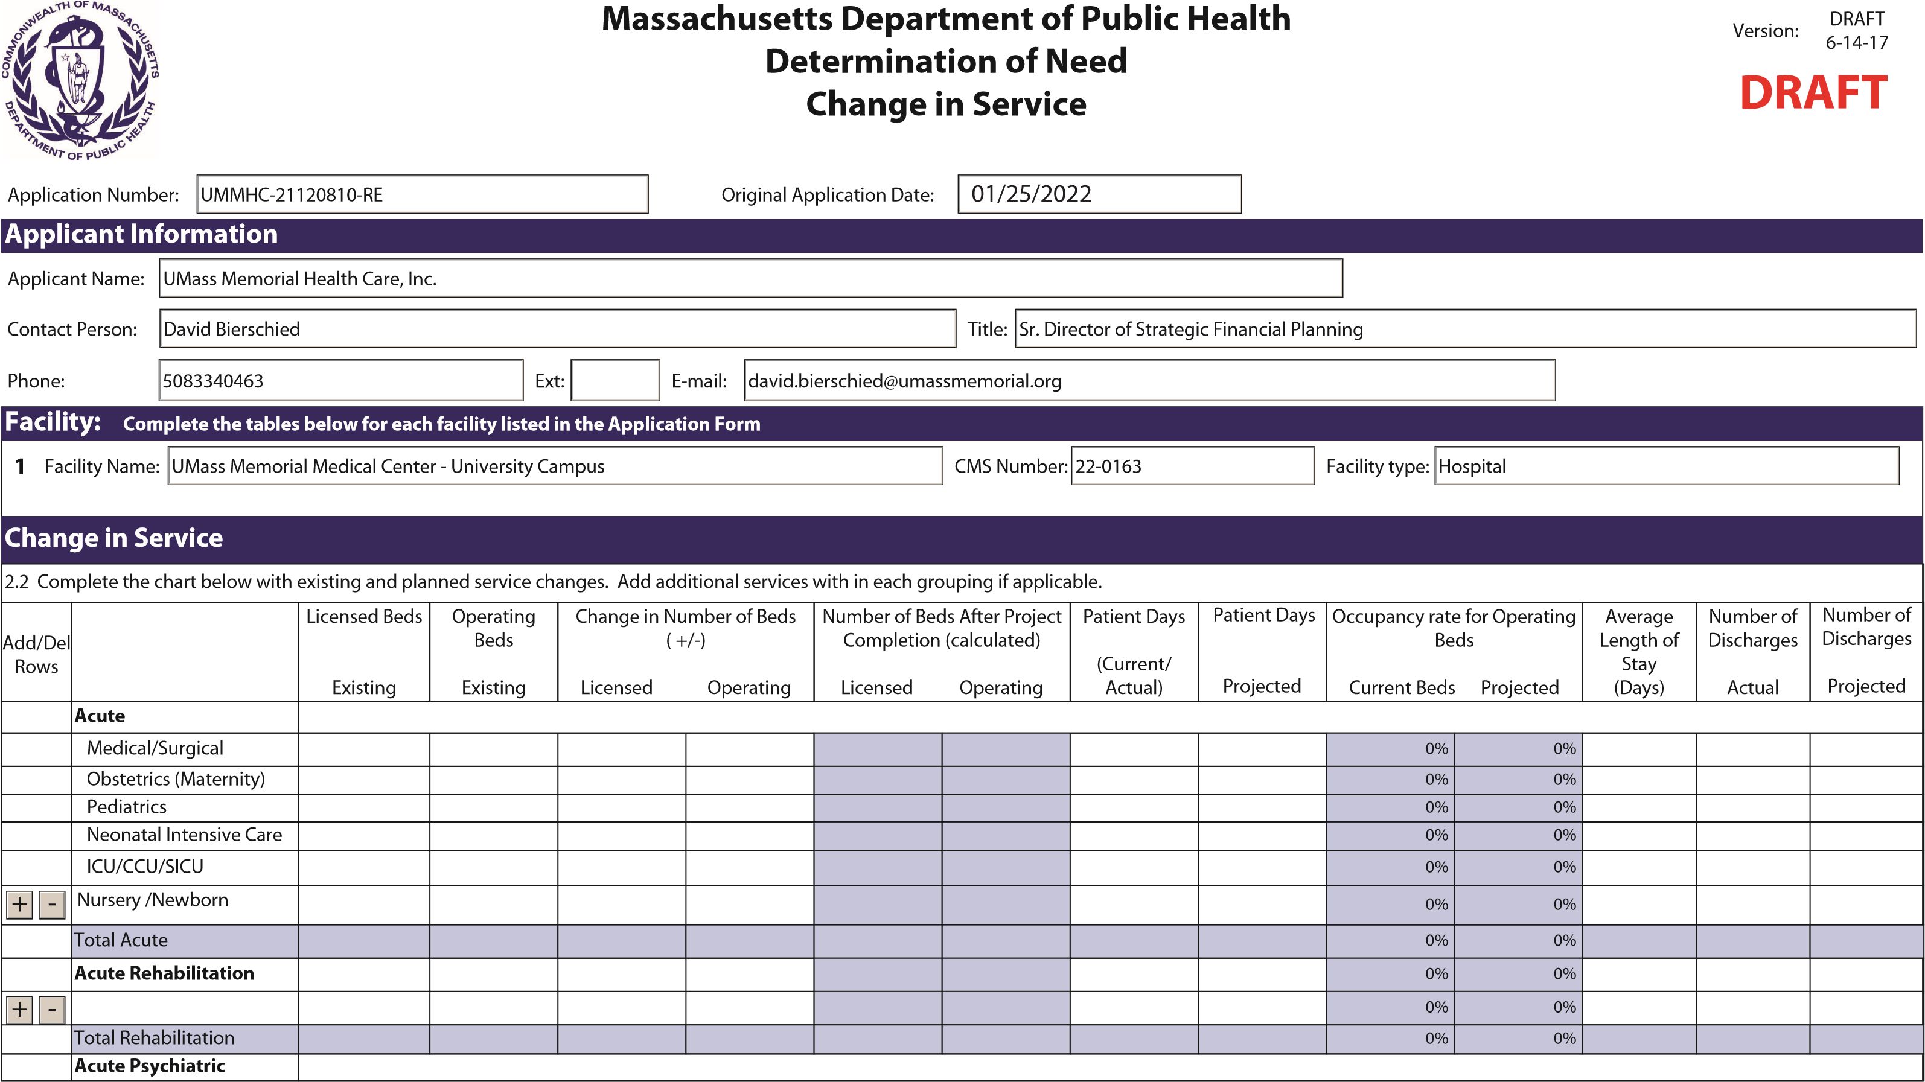
Page 1 of 3
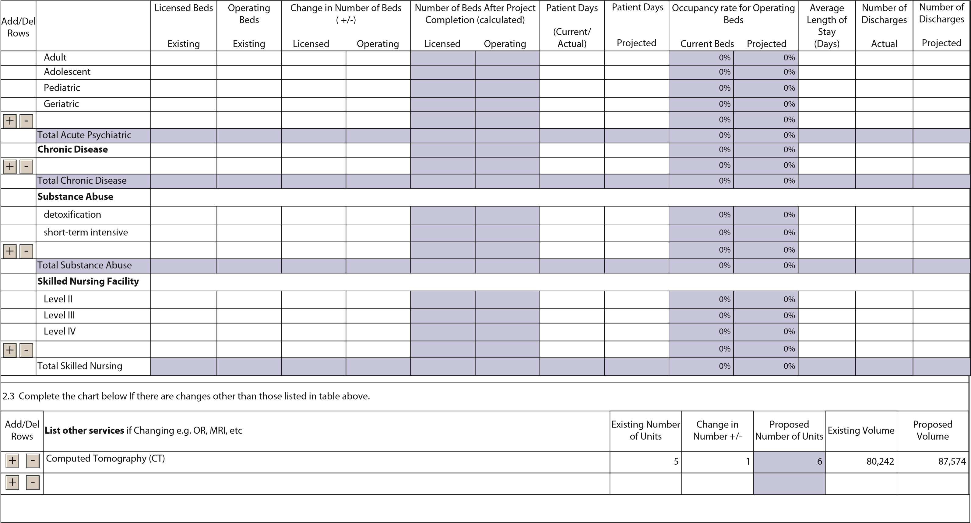
Document Ready for Filing
When document is complete click on "document is ready to file". This will lock in the responses and date and time stamp the form. To make changes to the document un-check the "document is ready to file" box. Edit document then lock file and submit Keep a copy for your records. Click on the "Save" button at the bottom of the page.
To submit the application electronically, click on the"E-mail submission to Determination of Need" button.
This document is ready to file: Date/time Stamp:

APPENDIX 6
NOTICE OF INTENT

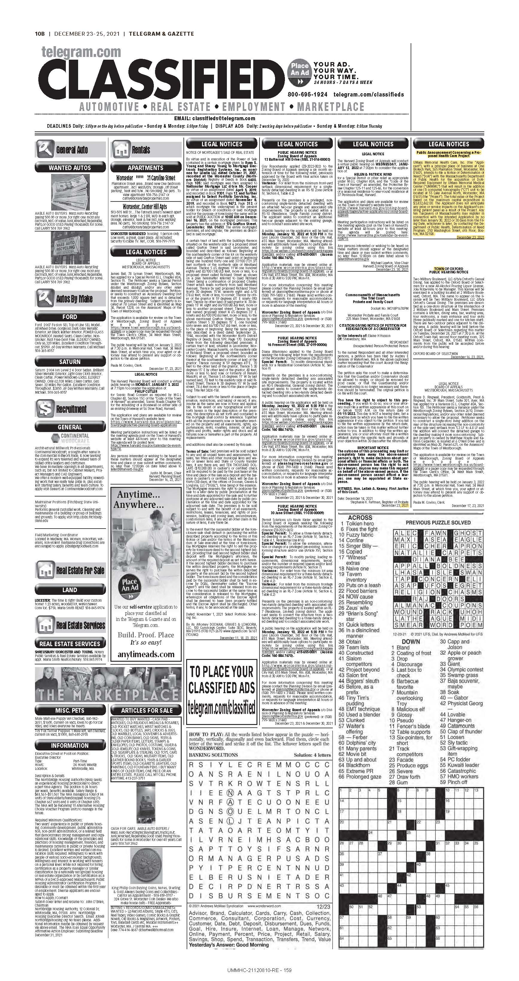

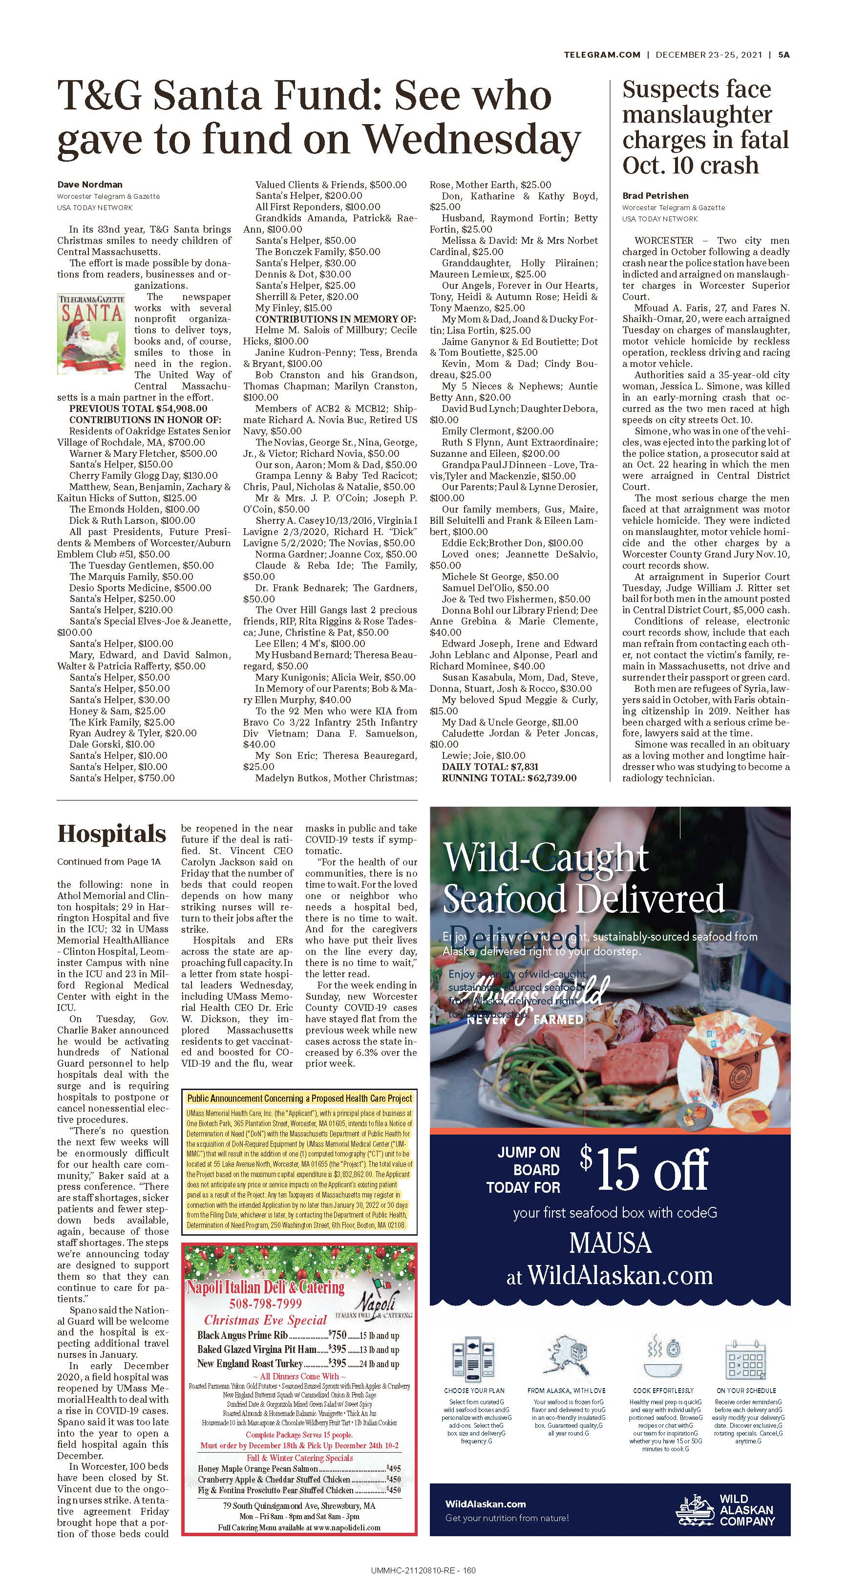

APPENDIX 7
ARTICLES OF INCORPORATION

The Commonwealth of Massachusetts
William Francis Galvin
Secretary of the Commonwealth
One Ashburton Place, Boston; Massachusetts 02108-1512

ARTICLES OF ORGANIZATION
(General Laws, Chapter 180)

ARTICLE I
The exact name of the corporation is:
UMass Memorial Health Care, Inc.

ARTICLED
The purpose of the corporation is to engage in the following activities:

See page 2a attached hereto and made a part hereof.

Note: If the space provided under any article or item on this form is insufficient, additions shall be set forth on one side only of separate 8 1/2 x 11 sheets of paper with a left margin of at least 1 inch. Additions to more than one article may be made on a single sheet so long as each article requiring each addition is clearly indicated.

ARTICLE III
A corporation may have one or more classes of members. If it does, the designation of such classes, the manner of election or appointments, the duration of membership-and the qualification and rights, including voting rights, of the members of each class, may be set forth in the by-laws of the corporation or may be set forth below:

The corporation shall have no members.
ARTICLE IV
"'Other lawful provisions, if any, for the conduct and regulation of the business and affairs of the corporation, for its voluntary dissolution, or for limiting, defining, or regulating the powers of the corporation, or of its directors or members, or of any class of members, are as foUows:

See pages 4a-4d attached hereto and made a part hereof.
ARTICLEV
The by-laws of the corporation have been duly" adopted and the initial directors, president, treasurer and clerk or other presiding, financial or recording officers, whose names are set out on the following page, have been duly elected.

**If there are no provisions, state "None”.
Note: The preceding four (4) articles are considered to be permanent and may only be changed by filing appropriate Articles of Amendment.

CONTINUATION PAGES
ARTICLES OF ORGANIZATION OF UMASS :MEMORIAL HEALTH CARE, INC.

2. The purpose of the corporation is to engage in the following activities:

- To develop and coordinate an integrated health care delivery system that includes multiple health care providers and provides opportunities for and supports medical education and training; to support the advancement of the knowledge and practice of, and education and research in, medicine, surgery, nursing and all other subjects relating to the care, treatment and healing of humans and in that connection to support promote and enhance the academic medical programs and activities of the University of Massachusetts Medical School; to improve the health and welfare of all persons; to develop, sponsor and promote services and programs that are charitable, scientific or educational and that address the physical and mental needs of the community at large, provided that the corporation shall operate exclusively for the benefit of UMass Memorial Medical Center, Inc. and other charitable organizations or hospitals that are controlled by or under common control with the corporation in the conduct of their charitable, educational and scientific functions, and provided further, that the corporation shall not engage in the practice of medicine.
- To receive in trust or otherwise and from whatever source, and administer, gifts, legacies and devises, grants and grants-in-aid, whether unrestricted or for specific purposes; to cooperate with, contribute to and support other organizations in promoting the purposes of this corporation, including all corporations affiliated with this corporation that are determined to be exempt from federal income taxation under Section 501(c)(3) of the Internal Revenue Code of 1986 (the "Code"); and to do all things incidental to the foregoing;
- To conduct any business that may lawfully be carried on by a corporation formed under Chapter 180 of the General Laws of Massachusetts and that is not inconsistent with this corporation's qualification as an organization described in Section 501(c)(3) of the Code.

- Other Lawful Provisions for Conduct and Regulation of the Business and Affairs of the
. Corporation, for its Voluntary Dissolution, and for Limiting, Defining and Regulating the Powers of the Corporation and of its Trustees and Members (if any) or any class of Members.
4.1 The corporation shall have in furtherance of its corporate purposes all of the powers specified in Section 6 of Chapter 180 and in Sections 9 and 9A of Chapter 156B of the Massachusetts General Laws (except those provided in paragraph (m) of said Section 9) as now in force or as hereafter amended, and may carry on any operation or activity referred to in Article 2 to the same extent as might an individual, either alone or in a joint venture or other arrangement with others, or through a wholly or partly owned or controlled corporation; provided, however, that no such power shall be exercised in a manner inconsistent with said Chapter 180 or any other chapter of the Massachusetts General Laws or inconsistent with the exemption from federal income tax to which the corporation shall be entitled under Section 501(c)(3) of the Internal Revenue Code.
4.2 The trustees may make, amend or repeal the by-laws in whole or in part.
4.3 The Corporation shall have no members. Any action or vote required or permitted to be taken by members may be taken by the same percentage of the trustees.
4.4 No trustee or officer of the corporation shall be personally liable to the corporation for monetary damages for breach of fiduciary duty as such trustee or officer notwithstanding any provision of law imposing such liability, except to the extent that such exemption from liability is not permitted under Chapter 180 of the Massachusetts General Laws.
4.5.(a) The corporation shall, to the extent lega11y permissible, indemnify each person
·who serves as one of its trustees or officers, or who serves at its request as a member, trustee or officer of another organization or in a capacity with respect to any employee benefit plan (each such person being called in this Section 4.5 a "Person") against all liabilities and expenses, including amounts paid in satisfaction of judgments, in compromise or as fines and penalties, and counsel fees, reasonably incurred by such Person in connection with the defense or disposition of any action, suit or other proceeding, whether civil or criminal, in which such Person may be involved or with which such Person may be threatened, while in office or thereafter, by reason of being or having been such a Person, except with respect to any matter as to which such Person shall have been adjudicated in any proceeding not to have acted in good faith in the reasonable belief that his or her action was in the best interests of the corporation or, to the extent that such matter relates .to service at the request of the corporation for another organization or an employee benefit plan, in the best interests of such organization or of the participants or beneficiaries of such employee benefit plan. Such best interests shall be deemed to be the best interests of the corporation for the purposes of this Section 4.5.

- Notwithstanding the foregoing, as to any matter disposed of by a compromise payment by any Person, pursuant to a consent decree or otherwise, no indemnification either for said payment or for any other expenses shall be provided unless such compromise shall be approved as in the best interests of the corporation, after notice that it involves such indemnification, (a) by a disinterested majority of the trustees then in office; or (b) by a majority of the disinterested trustees theii in office, provided that there has been obtained an opinion in writing of independent legal counsel to the effect that such Person appears to have acted in good faith in the reasonable belief that his or her action was in the best interests of the corporation.

- Expenses, including counsel fees, reasonably incurred by any Person in connection. with the defense or disposition of any such action, suit or other proceeding may be paid from time to time by the corporation in advance of the final disposition thereof upon receipt of an undertaking by such Person to repay the amounts so paid if such Person ultimately shall be adjudicated to be not entitled to indemnification under this Section 4.5. Such an undertaking may be accepted without reference to the financial ability of such Person to make repayment.

- The right of indemnification hereby provided shall not be exclusive. Nothing contained in this Section shall affect any other rights to indemnification to which any Person or other corporate personnel may be entitled by contract or otherwise under law.

. (e) As used in this Section 4.5, the term "Person" includes such Person's respective heirs, executors and administrators, and a "disinterested" trustee is one against whom in such capacity the proceeding in question, or another proceeding on the same or similar grounds, is not then pending.
4.6.(a) No person shall be disqualified from holding any office by reason of any interest. In the absence of fraud, any trustee or officer of this _corporation, or any concern in which any such trustee or officer has any interest, may be a party to, or may be pecuniarily or otherwise interested in, any contract, act or other transaction (collectively called a "transaction") of this corporation, and
  - such transaction shall not be in any way invalidated or otherwise affected by that fact; and

  - no such trustee or officer or concern shall be liable to account to this corporation for any profit or benefit realized through any such transaction;

provided, however, that such transaction either was fair at the time it was entered into or is authorized or ratified by a majority of the trustees who are not so interested and to whom the nature of such interest has been disclosed. No interested trustee of this corporation may vote or may be counted in determining the existence of a quorum at any meeting at which such transaction shall be authorized, but may participate in discussion thereof.
1134349.03 -4b-

- For purposes of this Section 4.6, the term "interest" shall include personal 4i,terest and also interest as a trustee, officer, stockholder, shareholder, director, member or beneficiary of any concern; and the term “concern” shall mean any corporation, association, trust, partnership, firm, person or other entity other than this corporation.

- No transaction shall be avoided by reason of any provisions of this paragraph 4.6 which would be valid but for such provisions.

  - No part of the assets or net earnings of the corporation shall inure to the benefit of any officer or trustee of the corporation or any individual; no substantial part of the activities of the corporation shall be the carrying on of propaganda, or otherwise attempting, to influence legislation except to the extent permitted by Section 501(h) of the Internal Revenue Code; and the corporation shall not participate in, or intervene in (including the publishing or distributing of statements), any political campaign on behalf of (or in opposition to) any candidate for public office. It is intended that the corporation shall be entitled to exemption from federal income tax under Section 50l(c)(3) of the Internal Revenue Code and shall not be a private foundation under Section 509(a) of the Internal Revenue Code.

  - If and so long as the corporation is a private foundation (as that tennis defined in Section 509 of the Internal Revenue Code), then notwithstanding any other provisions of the articles of organization or the by-laws of the corporation, the following provisions shall apply:

- the income of the corporation for each taxable year sha11 be distributed at such time and in such manner as not to subject the corporation to the tax on undistributed income imposed by Section 4942 of the Internal Revenue Code, and

- the corporation shall not engage in any act of self dealing (as defined in Section 494l(d) of the Internal Revenue Code), nor retain any excess business holdings (as defined in Section 4943(c) of the Internal Revenue Code), nor make any investments in such manner as to subject the corporation to tax under Section 4944 of the Internal Revenue Code, nor make any taxable expenditures (as defined in Section 4945(d) of the Internal Revenue Code).

  - Upon the liquidation or dissolution of the corporation, after payment of all of the liabilities of the corporation or due provision therefor I all of the assets of the corporation shall be disposed of pursuant to Massachusetts General Laws, Chapter 180, Section 11A, to UMass Memorial Medical Center, Inc. so long as it is then exempt from Federal income tax under Section 50l(c)(3) of the Code and otherwise 50% to the University of Massachusetts and 50% to one or more corporations exempt from Federal income tax under Section 501(c)(3) of the Code or an instrumentality of The Commonwealth of Massachusetts selected by a majority of the Trustees then in office.

1134349.03 -4c-

  - The corporation shall not discriminate in administering its policies and programs or in the employment of its personnel on the basis of race, color, religion, national or ethnic origin, sex, handicap or otherwise.

  - All references herein: (i) to the Internal Revenue Code shall be deemed to refer to the Internal Revenue Code of 1986, as now in force or hereafter amended; (ii) to the General Laws of The Commonwealth of Massachusetts, or any chapter thereof, shall be deemed to refer to said General Laws or chapter as now in force or hereafter' amended; and
(iii) to particular sections of the Internal Revenue Code or said General Laws shall be deemed to refer to similar or successor provisions hereafter adopted.

1134349.03 -4d-
The Commonwealth of Massachusetts William Francis Galvin  Secretary of the Commonwealth, Corporations Division  One Ashburton Place, 17th floor  Boston, MA 02108-1512  Telephone: (617) 727-9640 | Minimum Fee: $15.00
Articles of Amendment
(General Laws, Chapter 180, Section 7)
Identification Number: 043358566
We, ERIC DICKSON, MD X President Vice President,
and KATHARINE ESHGHI Clerk X Assistant Clerk ,
of UMASS MEMORIAL HEALTH CARE, INC.
located at: ONE BIOTECH PARK 365 PLANTATION ST. WORCESTER , MA 01605 USA
do hereby certify that these Articles of Amendment affecting articles numbered:
Article 1 X Article 2 Article 3 X Article 4
(Select those articles 1, 2, 3, and/or 4 that are being amended)
of the Articles of Organization were duly adopted at a meeting held on 12/11/2019 , by vote of: 0 members, X directors, or 0 shareholders,
being at least two-thirds of its members/directors legally qualified to vote in meetings of the corporation (or, in the case of a corporation having capital stock, by the holders of at least two thirds of the capital stock having the right to vote therein):
ARTICLE I
The exact name of the corporation, as amended, is:
(Do not state Article I if it has not been amended.)
ARTICLE II

The purpose of the corporation, as amended, is to engage in the following business activities: (Do not state Article II if it has not been amended.)

THE CORPORATION IS ORGANIZED AND SHALL BE OPERATED EXCLUSIVELY FOR CHARITA
BLE, SCIENTIFIC AND EDUCATIONAL PURPOSES WITHIN THE MEANING OF SECTION 501(C)
(3) OF THE INTERNAL REVENUE CODE (THE “CODE”), AND IS ORGANIZED AND SHALL BE OP
ERATED EXCLUSIVELY FOR THE BENEFIT OF, TO PERFORM THE FUNCTIONS OF OR TO CAR
RY OUT THE PURPOSES OF UMASS MEMORIAL MEDICAL CENTER, INC., MARLBOROUGH H
OSPITAL, UMASS MEMORIAL HEALTH ALLIANCE-CLINTON HOSPITAL, INC., UMASS MEMO
RIAL MEDICAL GROUP, INC., UMASS MEMORIAL BEHAVIORAL HEALTH SYSTEM, INC., UMA SS MEMORIAL COMMUNITY HOSPITALS, INC., UMASS MEMORIAL HEALTH VENTURES, IN
C., UMASS MEMORIAL REALTY, INC., COMMUNITY HEALTHLINK, INC., CENTRAL NEW ENG
LAND HEALTHALLIANCE, INC., HEALTHALLIANCE HOME HEALTH AND HOSPICE, INC. AND
SUCH OTHER AFFILIATED CHARITABLE ORGANIZATIONS OR HOSPITALS THAT (I) ARE EXE MPT FROM TAXATION UNDER SECTION 501(C)(3) OF THE CODE AND (II) ARE CLASSIFIED AS OTHER THAN PRIVATE FOUNDATIONS UNDER SECTION 509(A)(1) OR 509(A)(2) OF THE CO

MA SOC Filing Number: 201945425600 Date: 12/12/2019 3:50:00 PM
DE (COLLECTIVELY, THE “SUPPORTED ORGANIZATIONS”). IN THIS CAPACITY, THE CORPORATION WILL ENGAGE IN THE FOLLOWING ACTIVITIES: (1) TO DEVELOP AND COORDINATE AN INTEGRATED HEALTH CARE DELIVERY SYSTEM THAT INCLUDES MULTIPLE HEALTH CARE PROVIDERS AND PROVIDES OPPORTUNITIES FOR AND SUPPORTS MEDICAL EDUCATIOAND TRAINING; TO SUPPORT THE ADVANCEMENT OF THE KNOWLEDGE AND PRACTICE OF, AND EDUCATION AND RESEARCH IN, MEDICINE, SURGERY, NURSING AND ALL OTHER SUBJECTS RELATING TO THE CARE, TREATMENT AND HEALING OF HUMANS AND IN THAT CONNECTION TO SUPPORT, PROMOTE AND ENHANCE THE ACADEMIC MEDICAL PROGRAMS AND ACTIVITIES OF THE UNIVERSITY OF MASSACHUSETTS MEDICAL SCHOOL; TO IMPROVE THE HEALTH AND WELFARE OF ALL PERSONS; TO DEVELOP, SPONSOR AND PROMOTE SERVICES AND PROGRAMS THAT ARE CHARITABLE, SCIENTIFIC OR EDUCATIONAL AND THAT ADDRESS THE PHYSICAL AND MENTAL NEEDS OF THE COMMUNITY AT LARGE, PROVIDED THAT THE CORPORATION SHALL NOT ENGAGE IN THE PRACTICE OF MEDICINE; (2) TO RECEIVE IN TRUST OR OTHERWISE AND FROM WHATEVER SOURCE, AND ADMINISTER, GIFTS, LEGACIES AND DEVISES, GRANTS AND GRANTS-IN-AID, WHETHER UNRESTRICTED O
R FOR SPECIFIC PURPOSES; TO COOPERATE WITH, CONTRIBUTE TO AND SUPPORT THE SUPPORTED ORGANIZATIONS IN PROMOTING THE PURPOSES OF THIS CORPORATION, AND TO DO ALL THINGS INCIDENTAL TO THE FOREGOING; AND (3) TO CONDUCT ANY BUSINESS THAT MAY LAWFULLY BE CARRIED ON BY A CORPORATION FORMED UNDER CHAPTER 180 OF THE GENERAL LAWS OF MASSACHUSETTS AND THAT IS NOT INCONSISTENT WITH THIS CORPORATION’S QUALIFICATION AS AN ORGANIZATION DESCRIBED IN SECTION 501(C)(3) OF THE CODE.
ARTICLE III

A corporation may have one or more classes of members. As amended, the designation of such classes, the manner of election or appointments, the duration of membership and the qualifications and rights, including voting rights, of the members of each class, may be set forth in the by-laws of the corporation or may be set forth below:
ARTICLE IV

As amended, other lawful provisions, if any, for the conduct and regulation of the business and affairs of the
corporation, for its voluntary dissolution, or for limiting, defining, or regulating the powers of the business entity, or of its directors or members, or of any class of members, are as follows: (If there are no provisions state "NONE")

ARTICLE 4 OF THE CORPORATION'S ARTICLES REMAIN UNCHANGED EXCEPT ARTICLE 4.9
OF THE CORPORATION'S ARTICLES IS AMENDED AS FOLLOWS: 4.9 UPON THE LIQUIDATIO
N OR DISSOLUTION OF THE CORPORATION, AFTER PAYMENT OF ALL OF THE LIABILITIES
OF THE CORPORATION OR DUE PROVISION THEREFOR, ALL OF THE ASSETS OF THE CORPO
RATION SHALL BE DISPOSED OF PURSUANT TO MASSACHUSETTS GENERAL LAWS, CHAPT
ER 180, SECTION 11A, TO UMASS MEMORIAL MEDICAL CENTER, INC. SO LONG AS IT IS THE
N EXEMPT FROM FEDERAL INCOME TAX UNDER SECTION 501(C)(3) OF THE CODE AND OTH
ERWISE 50% TO THE UNIVERSITY OF MASSACHUSETTS AND 50% TO ONE OR MORE SUPPO
RTED ORGANIZATIONS THAT ARE THEN EXEMPT FROM FEDERAL INCOME TAX UNDER SEC
TION 501(C)(3) OF THE CODE AND ARE SELECTED BY A MAJORITY OF THE TRUSTEES THEN I
N OFFICE OR, IF NONE OF SUCH ENTITIES ARE THEN EXEMPT FROM FEDERAL INCOME TA
X UNDER SECTION 501(C)(3) OF THE CODE, TO SUCH ONE OR MORE OTHER ENTITIES EXEM
PT FROM FEDERAL INCOME TAX UNDER SECTION 501(C)(3) OF THE CODE OR AN INSTRUM ENTALITY OF THE COMMONWEALTH OF MASSACHUSETTS SELECTED BY A MAJORITY OF THE TRUSTEES THEN IN OFFICE.
The foregoing amendment(s) will become effective when these Articles of Amendment are filed in accordance with
UMMHC-21120810-RE - 180
General Laws, Chapter 180, Section 7 unless these articles specify, in accordance with the vote adopting the
amendment, a later effective date not more than thirty days after such filing, in which event the amendment will become effective on such later date.

Later Effective Date:
Signed under the penalties of perjury, this 12 Day of December, 2019, ERIC DICKSON, MD , its , President / Vice President,
KATHARINE ESHGHI , Clerk / Assistant Clerk.

© 2001 - 2019 Commonwealth of Massachusetts
All Rights Reserved
UMMHC-21120810-RE - 181
MA SOC Filing Number: 201945425600 Date: 12/12/2019 3:50:00 PM

THE COMMONWEALTH OF MASSACHUSETTS

I hereby certify that, upon examination of this document, duly submitted to me, it appears that the provisions of the General Laws relative to corporations have been complied with, and I hereby approve said articles; and the filing fee having been paid, said articles are
deemed to have been filed with me on:
December 12, 2019 03:50 PM

<signature on file>

WILLIAM FRANCIS GALVIN
Secretary of the Commonwealth UMMHC-21120810-RE - 182

 | The Commonwealth of Massachusetts William Francis Galvin  Secretary of the Commonwealth, Corporations Division  One Ashburton Place, 17th floor  Boston, MA 02108-1512  Telephone: (617) 727-9640 | Minimum Fee: $15.00
Articles of Amendment
(General Laws, Chapter 180, Section 7)
 | Identification Number: 043358566
 | We, ERIC DICKSON, MD X President Vice President,
 | and KATHARINE ESHGHI Clerk X Assistant Clerk ,
of UMASS MEMORIAL HEALTH CARE, INC.
located at: ONE BIOTECH PARK 365 PLANTATION ST. WORCESTER , MA 01605 USA
do hereby certify that these Articles of Amendment affecting articles numbered:

Article 1 X Article 2 Article 3 Article 4

(Select those articles 1, 2, 3, and/or 4 that are being amended)
of the Articles of Organization were duly adopted at a meeting held on 6/10/2020 , by vote of: 0 members, x directors, or 0 shareholders,
being at least two-thirds of its members/directors legally qualified to vote in meetings of the corporation (or, in the case of a corporation having capital stock, by the holders of at least two thirds of the capital stock having the right to vote therein):
ARTICLE I

The exact name of the corporation, as amended, is:
(Do not state Article I if it has not been amended.)

ARTICLE II

The purpose of the corporation, as amended, is to engage in the following business activities: (Do not state Article II if it has not been amended.)

THE CORPORATION IS ORGANIZED AND SHALL BE OPERATED EXCLUSIVELY FOR CHARITA
BLE, SCIENTIFIC AND EDUCATIONAL PURPOSES WITHIN THE MEANING OF SECTION 501(C)
(3) OF THE INTERNAL REVENUE CODE (THE “CODE”), AND IS ORGANIZED AND SHALL BE OP
ERATED EXCLUSIVELY FOR THE BENEFIT OF, TO PERFORM THE FUNCTIONS OF OR TO CAR
RY OUT THE PURPOSES OF UMASS MEMORIAL MEDICAL CENTER, INC., MARLBOROUGH H
OSPITAL, UMASS MEMORIAL HEALTH ALLIANCE-CLINTON HOSPITAL, INC., UMASS MEMO
RIAL MEDICAL GROUP, INC., COMMUNITY HEALTHLINK, INC., CENTRAL NEW ENGLAND H
EALTHALLIANCE, INC., HEALTHALLIANCE HOME HEALTH AND HOSPICE, INC. AND SUCH O
THER AFFILIATED CHARITABLE ORGANIZATIONS OR HOSPITALS THAT (I) ARE EXEMPT FRO
TAXATION UNDER SECTION 501(C)(3) OF THE CODE AND (II) ARE CLASSIFIED AS OTHER
THAN PRIVATE FOUNDATIONS UNDER SECTION 509(A)(1) OR 509(A)(2) OF THE CODE (COLL ECTIVELY, THE “SUPPORTED ORGANIZATIONS”). IN THIS CAPACITY, THE CORPORATION WILL ENGAGE IN THE FOLLOWING ACTIVITIES: (1) TO DEVELOP AND COORDINATE AN INTEG

MA SOC Filing Number: 202093556910 Date: 6/11/2020 1:52:00 PM
RATED HEALTH CARE DELIVERY SYSTEM THAT INCLUDES MULTIPLE HEALTH CARE PROVI DERS AND PROVIDES OPPORTUNITIES FOR AND SUPPORTS MEDICAL EDUCATION AND TR
AINING; TO SUPPORT THE ADVANCEMENT OF THE KNOWLEDGE AND PRACTICE OF, AND E DUCATION AND RESEARCH IN, MEDICINE, SURGERY, NURSING AND ALL OTHER SUBJECTS RELATING TO THE CARE, TREATMENT AND HEALING OF HUMANS AND IN THAT CONNECTI
ON TO SUPPORT, PROMOTE AND ENHANCE THE ACADEMIC MEDICAL PROGRAMS AND AC
TIVITIES OF THE UNIVERSITY OF MASSACHUSETTS MEDICAL SCHOOL; TO IMPROVE THE H
EALTH AND WELFARE OF ALL PERSONS; TO DEVELOP, SPONSOR AND PROMOTE SERVICES
AND PROGRAMS THAT ARE CHARITABLE, SCIENTIFIC OR EDUCATIONAL AND THAT ADDRE
SS THE PHYSICAL AND MENTAL NEEDS OF THE COMMUNITY AT LARGE, PROVIDED THAT T
HE CORPORATION SHALL NOT ENGAGE IN THE PRACTICE OF MEDICINE; (2) TO RECEIVE IN
TRUST OR OTHERWISE AND FROM WHATEVER SOURCE, AND ADMINISTER, GIFTS, LEGACIE
S AND DEVISES, GRANTS AND GRANTS-IN-AID, WHETHER UNRESTRICTED OR FOR SPECIFI C PURPOSES; TO COOPERATE WITH, CONTRIBUTE TO AND SUPPORT THE SUPPORTED ORG
ANIZATIONS IN PROMOTING THE PURPOSES OF THIS CORPORATION, AND TO DO ALL THI
NGS INCIDENTAL TO THE FOREGOING; AND (3) TO CONDUCT ANY BUSINESS THAT MAY L
AWFULLY BE CARRIED ON BY A CORPORATION FORMED UNDER CHAPTER 180 OF THE GE
NERAL LAWS OF MASSACHUSETTS AND THAT IS NOT INCONSISTENT WITH THIS CORPOR ATION’S QUALIFICATION AS AN ORGANIZATION DESCRIBED IN SECTION 501(C)(3) OF THE CODE.
ARTICLE III

A corporation may have one or more classes of members. As amended, the designation of such classes, the manner of election or appointments, the duration of membership and the qualifications and rights, including voting rights, of the members of each class, may be set forth in the by-laws of the corporation or may be set forth below:

ARTICLE IV

As amended, other lawful provisions, if any, for the conduct and regulation of the business and affairs of the
corporation, for its voluntary dissolution, or for limiting, defining, or regulating the powers of the business entity, or of its directors or members, or of any class of members, are as follows: (If there are no provisions state "NONE")

The foregoing amendment(s) will become effective when these Articles of Amendment are filed in accordance with General Laws, Chapter 180, Section 7 unless these articles specify, in accordance with the vote adopting the amendment, a later effective date not more than thirty days after such filing, in which event the amendment will become effective on such later date.

Later Effective Date:
Signed under the penalties of perjury, this 11 Day of June, 2020, ERIC DICKSON, MD , its , President / Vice President,
KATHARINE ESHGHI , Clerk / Assistant Clerk.

© 2001 - 2020 Commonwealth of Massachusetts
All Rights Reserved
UMMHC-21120810-RE - 184

MA SOC Filing Number: 202093556910 Date: 6/11/2020 1:52:00 PM

THE COMMONWEALTH OF MASSACHUSETTS

I hereby certify that, upon examination of this document, duly submitted to me, it appears that the provisions of the General Laws relative to corporations have been complied with, and I hereby approve said articles; and the filing fee having been paid, said articles are
deemed to have been filed with me on:
June 11, 2020 01:52 PM

<signature on file>

WILLIAM FRANCIS GALVIN
Secretary of the Commonwealth

APPENDIX 8
AFFIDAVIT
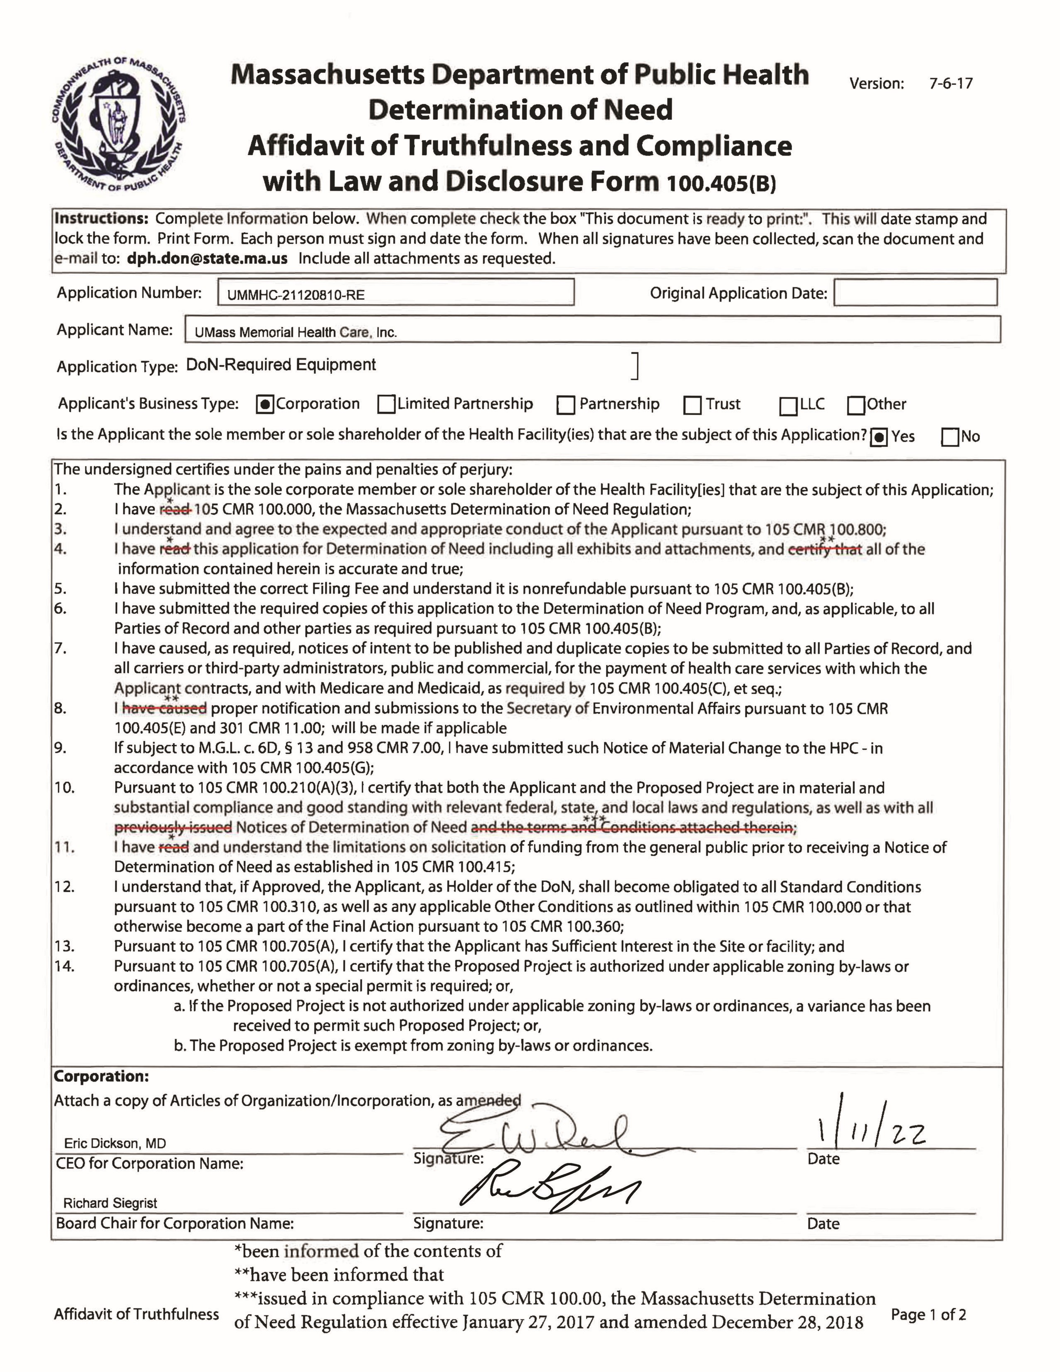
1
/11/
22
01/25/2022
This document is ready to print:
Date/time Stamp:
Affidavit of Truthfulness Page 2 of 2
APPENDIX 9
FILING FEE

Capital Planning & Management

MEMO
To:  From:  Date:  RE: | Lara Szent-Gyorgyi, DoN Program Director  Scott Reynolds, Director of Design and Construction  1/21/2022  DoN Filing

Lara,

Attached is a check for the Determination of Need filing for UMass Memorial Health Care, Inc. The DoN Application number is UMMHC-21120810-RE. Please let me know if you have any questions.

Thank you,

Scott Reynolds
Director of Design and Construction
Capital Planning and Management
508-334-5216

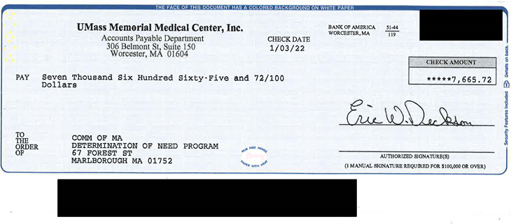

Please note UMMHC’s Patient Panel data does not include Harrington Health Care System, which was acquired by UMMHC effective July 1, 2021.
Includes: HealthAlliance Hospital – Clinton; UMass Memorial Medical Center; Marlborough Hospital; and Harrington Hospital.
https://www.mass.gov/doc/pss-time-target-recommendations-0/download; Get With the Guidelines – Stroke Fact Sheet. https://www.heart.org/-/media/files/professional/quality-improvement/get-with-the-guidelines/get-with-the-guidelines-stroke/strokefact-sheet_-final_ucm_501842.pdf?la=en&hash=7FA33C71D753DF7AB1D4850451C95BBE25BEA622
https://www.mass.gov/service-details/trauma-hospital-destinations
https://www.medicalnewstoday.com/articles/153201#uses
https://www.nibib.nih.gov/science-education/science-topics/computed-tomography-ct
https://www.nibib.nih.gov/science-education/science-topics/computed-tomography-ct
https://www.medicalnewstoday.com/articles/153201#uses ; https://www.envrad.com/how-ct-scans-mris-used-to-diagnose-strokes/ ⁹ https://pubmed.ncbi.nlm.nih.gov/20924012/
Diagnostic imaging trends in the emergency department: an extensive single-center experience. Gunnar Juliusson , Birna Thorvaldsdottir, Jon Magnus Kristjansson and Petur Hannesson. https://www.ncbi.nlm.nih.gov/pmc/articles/PMC6669846/ ¹¹ Pandharipande PV, Reisner AT, Binder WD, et al. CT in the Emergency Department: a real-time study of changes in physician decision making. Radiology 2016;278:812–821. https://pubmed.ncbi.nlm.nih.gov/26402399/
Evaluation of early abdominopelvic computed tomography in patients with acute abdominal pain of unknown cause: prospective randomised study; https://jamanetwork.com/journals/jama/fullarticle/1697967
https://my.clevelandclinic.org/health/diagnostics/16899-coronary-computed-tomography-angiogram
Dang, W, Kielar AZ, Fu, AYN et al. Does distance matter? Effect of having a dedicated CT scanner in the emergency department on completion of CT imaging and final patient disposition times. JACR 2015; 12 (3): 277-283.
https://lowninstitute.org/projects/lown-institute-hospitals-index/
https://www.communityhelp.net/
The Proposed Project is for the acquisition of a computed tomography (“CT”) unit to be to be located in the Emergency Department at UMass Memorial Medical Center - University Campus (the “Hospital”).

