BAYSTATE NEW ENGLAND ORTHOPEDIC SURGEONS ALLIANCE, LLC

APPLICATION FOR DETERMINATION OF NEED APPLICATION # BNEOS-21122916-AS AMBULATORY SURGERY CENTER

FEBRUARY 28, 2022

BY

BAYSTATE NEW ENGLAND ORTHOPEDIC SURGEONS ALLIANCE, LLC
759 CHESTNUT STREET
SPRINGFIELD, MA 01199

BAYSTATE NEW ENGLAND ORTHOPEDIC SURGEONS ALLIANCE, LLC DON FOR AMBULATORY SURGERY CENTER
APPLICATION # BNEOS-21122916-AS

TABLE OF CONTENTS

Appendix 1 Application Form Appendix 2 Narrative
Appendix 3 Factor 1 Exhibits (Community Engagement Presentations) Appendix 4 Factor 4 Exhibit (CPA Report)
Appendix 5 Factor 6 Exhibits (Community Health Initiative)

  - CHI Narrative
  - Community Health Needs Assessment and Implementation Plan

Appendix 6 Change in Service Form Appendix 7 Affiliated Parties Form Appendix 8 Affidavit
Appendix 9 Certificate of Organization Appendix 10 Notice of Intent
Appendix 11 ACO Letter

Appendix 12 Notices of Material Change
  - Baystate Medical Center, Inc.
  - NEOS SurgCo, LLC

Appendix 13 Filing Fee

APPENDIX 1 APPLICATION FORM

Massachusetts Department of Public Health Determination of Need
Application Form

Version: 11-8-17

Application Type:
Ambulatory Surgery

Application Date:

02/28/2022

Applicant Name:
Baystate New England Orthopedic Surgeons Alliance, LLC
759 Chestnut Street

Mailing Address: City:
Springfield
Massachusetts
01199
Bill Kern
Senior Director, Finance, Baystate Health, Inc.

State:

Zip Code:

Contact Person: Title:
280 Chestnut Street, 3rd Floor

Mailing Address: City:
Springfield

State:

Zip Code:

Phone: Ext: E-mail:
Massachusetts
01199
4137945556
william.kernii@baystatehealth.org

1 Facility Name:
Facility Address: 50 Wason Avenue City: Springfield
State: Massachusetts
Zip Code: 01107
Facility type:
Freestanding Ambulatory Surgery Facility
CMS Number:
Facility Information
List each facility affected and or included in Proposed Project
- About the Applicant
  - Type of organization (of the Applicant):
for profit

  - Applicant's Business Type: LLC

  - What is the acronym used by the Applicant's Organization?
BNEOS
  - Is Applicant a registered provider organization as the term is used in the HPC/CHIA RPO program? Yes

  - Is Applicant or any affiliated entity an HPC-certified ACO?
Yes

    - If yes, what is the legal name of that entity?
Baycare Health Partners, Inc.
  - Is Applicant or any affiliate thereof subject to M.G.L. c. 6D, § 13 and 958 CMR 7.00 (filing of Notice of Material Change to the Health Policy Commission)? Yes

  - Does the Proposed Project also require the filing of a MCN with the HPC? Yes

    - If Yes, has Material Change Notice been filed? Yes
    - If yes, provide the date of filing.
10/26/2021

  - Has the Applicant or any subsidiary thereof been notified pursuant to M.G.L. c. 12C, § 16 that it is exceeding the health care cost growth benchmark established under M.G.L. c. 6D, § 9 and is thus, pursuant to M.G.L. c. 6D, §10 required to file a performance improvement plan with CHIA? No

1.9 Complete the Affiliated Parties Form
- Project Description
  - Provide a brief description of the scope of the project.
See attached Narrative.

2.2 and 2.3 Complete the Change in Service Form
- Delegated Review
  - Do you assert that this Application is eligible for Delegated Review? No

- Conservation Project
  - Are you submitting this Application as a Conservation Project? No

- DoN-Required Services and DoN-Required Equipment
  - Is this an application filed pursuant to 105 CMR 100.725: DoN-Required Equipment and DoN-Required Service? No

- Transfer of Ownership
  - Is this an application filed pursuant to 105 CMR 100.735? No

- Ambulatory Surgery
  - Is this an application filed pursuant to 105 CMR 100.740(A) for Ambulatory Surgery? Yes

  - If yes, is Applicant or any affiliate thereof a HPC-certified ACO OR in the process of becoming a Certified ACO? Yes

7.2.a If yes, Please provide the date of approval and attach the approval letter:
12/30/2021

7.4 See section on Ambulatory Surgery in the Application Instructions
7.3 Does the Proposed Project constitute: (Check all that apply)
Ambulatory Surgery capacity located on the main campus of an existing Hospital 105 CMR 100.740(A)(1)(a)(i);
An Expansion, Conversion, Transfer of Ownership, transfer of Site, or change of designated Location for Ambulatory Surgery capacity located on a satellite campus of an existing Hospital 105 CMR 100.740(A)(1)(a)(ii);
A Freestanding Ambulatory Surgery Center within the Primary Service Area of an independent community hospital (Refer to a list that we update regularly with support from HPC) 105 CMR 100.740(A)(1)(a)(iii); or
An Expansion, Conversion, Transfer of Ownership, transfer of Site, or change of designated Location for a Freestanding Ambulatory Surgery Center that received an Original License as a Clinic on or before January 1, 2017 105 CMR 100.740(A)(1)(a)(iv).
- Transfer of Site
  - Is this an application filed pursuant to 105 CMR 100.745? No

- Research Exemption
  - Is this an application for a Research Exemption? No

- Amendment
  - Is this an application for a Amendment? No

- Emergency Application
  - Is this an application filed pursuant to 105 CMR 100.740(B)? No

- Total Value and Filing Fee
Enter all currency in numbers only. No dollar signs or commas. Grayed fields will auto calculate depending upon answers above.
Your project application is for: Ambulatory Surgery
12.1 Total Value of this project:
$14,844,635.00
12.4 Maximum Incremental Operating Expense resulting from the Proposed Project:
$19,334,161.00
$29,689.27
12.3 Filing Fee: (calculated)
$742,231.75
12.2 Total CHI commitment expressed in dollars: (calculated)
12.5 Total proposed Construction costs, specifically related to the Proposed Project, If any, which will be contracted out to local or minority, women, or veteran-owned businesses expressed in estimated total dollars.

13. Factors
Required Information and supporting documentation consistent with 105 CMR 100.210
Some Factors will not appear depending upon the type of license you are applying for. Text fields will expand to fit your response.
Factor 1: Applicant Patient Panel Need, Public Health Values and Operational Objectives
F1.a.i Patient Panel:
Describe your existing Patient Panel, including incidence or prevalence of disease or behavioral risk factors, acuity mix, noted health disparities, geographic breakdown expressed in zip codes or other appropriate measure, demographics including age, gender and sexual identity, race, ethnicity, socioeconomic status and other priority populations relevant to the Applicant's existing patient panel and payer mix.
See attached Narrative.

F1.a.ii Need by Patient Panel:
Provide supporting data to demonstrate the need for the Proposed Project. Such data should demonstrate the disease burden, behavioral risk factors, acuity mix, health disparities, or other objective Patient Panel measures as noted in your response to Question F1.a.i that demonstrates the need that the Proposed Project is attempting to address. If an inequity or disparity is not identified as relating to the Proposed Project, provide information justifying the need. In your description of Need, consider the principles underlying Public Health Value (see instructions) and ensure that Need is addressed in that context as well.
See attached Narrative.

F1.a.iii Competition:
Provide evidence that the Proposed Project will compete on the basis of price, total medical expenses, provider costs, and other recognized measures of health care spending. When responding to this question, please consider Factor 4, Financial Feasibility and Reasonableness of Costs.
See attached Narrative.
F1.b.i Public Health Value /Evidence-Based:
Provide information on the evidence-base for the Proposed Project. That is, how does the Proposed Project address the Need that Applicant has identified.
See attached Narrative.
F1.b.ii Public Health Value /Outcome-Oriented:
Describe the impact of the Proposed Project and how the Applicant will assess such impact. Provide projections demonstrating how the Proposed Project will improve health outcomes, quality of life, or health equity. Only measures that can be tracked and reported over time should be utilized.
See attached Narrative.

F1.b.iii Public Health Value /Health Equity-Focused:
For Proposed Projects addressing health inequities identified within the Applicant's description of the Proposed Project's need- base, please justify how the Proposed Project will reduce the health inequity, including the operational components (e.g. culturally competent staffing). For Proposed Projects not specifically addressing a health disparity or inequity, please provide information about specific actions the Applicant is and will take to ensure equal access to the health benefits created by the Proposed Project and how these actions will promote health equity.
See attached Narrative.

F1.b.iv Provide additional information to demonstrate that the Proposed Project will result in improved health outcomes and quality of life of the Applicant's existing Patient Panel, while providing reasonable assurances of health equity.
See attached Narrative.

F1.c Provide evidence that the Proposed Project will operate efficiently and effectively by furthering and improving continuity and coordination of care for the Applicant's Patient Panel, including, how the Proposed Project will create or ensure appropriate linkages to patients' primary care services.
See attached Narrative.
F1.d Provide evidence of consultation, both prior to and after the Filing Date, with all Government Agencies with relevant licensure, certification, or other regulatory oversight of the Applicant or the Proposed Project.
See attached Narrative.
F1.e.i Process for Determining Need/Evidence of Community Engagement: For assistance in responding to this portion of the Application, Applicant is encouraged to review Community Engagement Standards for Community Health Planning Guideline. With respect to the existing Patient Panel, please describe the process through which Applicant determined the need for the Proposed Project.
See attached Narrative.

F1.e.ii Please provide evidence of sound Community Engagement and consultation throughout the development of the Proposed Project. A successful Applicant will, at a minimum, describe the process whereby the “Public Health Value” of the Proposed Project was considered, and will describe the Community Engagement process as it occurred and is occurring currently in, at least, the following contexts: Identification of Patient Panel Need; Design/selection of DoN Project in response to “Patient Panel” need; and Linking the Proposed Project to “Public Health Value”.
See attached Narrative.

Factor 2: Health Priorities

F2.a Cost Containment:
Addresses the impact of the Proposed Project on health more broadly (that is, beyond the Patient Panel) requiring that the Applicant
demonstrate that the Proposed Project will meaningfully contribute to the Commonwealth's goals for cost containment, improved public health outcomes, and delivery system transformation.
Using objective data, please describe, for each new or expanded service, how the Proposed Project will meaningfully contribute to the Commonwealth's goals for cost containment.
See attached Narrative.

F2.b Public Health Outcomes:
Describe, as relevant, for each new or expanded service, how the Proposed Project will improve public health outcomes.
See attached Narrative.
F2.c Delivery System Transformation:
Because the integration of social services and community-based expertise is central to goal of delivery system transformation, discuss how the needs of their patient panel have been assessed and linkages to social services organizations have been created and how the social determinants of health have been incorporated into care planning.
See attached Narrative.

Factor 3: Compliance
Applicant certifies, by virtue of submitting this Application that it is in compliance and good standing with federal, state, and local laws
and regulations, including, but not limited to M.G.L. c. 30, §§ 61 through 62H and the applicable regulations thereunder, and in compliance with all previously issued notices of Determination of Need and the terms and conditions attached therein .
F3.a Please list all previously issued Notices of Determination of Need
Add/Del Rows | Project Number | Date Approved | Type of Notification | Facility Name

Applicant has provided (as an attachment) a certification, by an independent certified public accountant (CPA) as to the availability of sufficient funds for capital and ongoing operating costs necessary to support the Proposed Project without negative impacts or consequences to the Applicant's existing Patient Panel.

Factor 4: Financial Feasibility and Reasonableness of Expenditures and Costs

F4.a.i Capital Costs Chart:
For each Functional Area document the square footage and costs for New Construction and/or Renovations.
 |  | Present Square  Footage |  | Square Footage Involved in Project |  |  |  | Resulting Square  Footage |  | Total Cost |  | Cost/Square Footage
 |  |  |  | New Construction |  | Renovation
Add/Del Rows | Functional Areas | Net | Gross | Net | Gross | Net | Gross | Net | Gross | New Construction | Renovation | New Construction | Renovation
 | Central Sterile Processing |  |  |  | 2,076 |  |  |  |  | $52,880.00 |  | $25.47
 | HVAC in Decontamination Room |  |  |  | 508 |  |  |  |  | $78,100.00 |  | $153.74
 | Building Acquisition |  |  |  | 40,833 |  |  |  |  | $14,635,428.00 |  | $358.42
 | Total: (calculated) |  |  |  | 43,417 |  |  |  |  | $14,766,408.00 |  | $537.63

F4.a.ii For each Category of Expenditure document New Construction and/or Renovation Costs.
 | Category of Expenditure | New Construction | Renovation | Total  (calculated)
 | Land Costs
 | Land Acquisition Cost
 | Site Survey and Soil Investigation
 | Other Non-Depreciable Land Development
 | Total Land Costs
 | Construction Contract (including bonding cost)
 | Depreciable Land Development Cost
 | Building Acquisition Cost | $14635428. |  | $14635428.
 | Construction Contract (including bonding cost) | $130980. |  | $130980.
 | Fixed Equipment Not in Contract
 | Architectural Cost (Including fee, Printing, supervision etc.) and Engineering Cost | $31900. |  | $31900.
 | Pre-filing Planning and Development Costs | $1081. |  | $1081.
 | Post-filing Planning and Development Costs
Add/Del  Rows | Other (specify)
 | Net Interest Expensed During Construction
 | Major Movable Equipment
 | Total Construction Costs | $14799389. |  | $14799389.
 | Financing Costs:
 | Cost of Securing Financing (legal, administrative, feasibility studies, mortgage insurance, printing, etc | $45245. |  | $45245.
 | Bond Discount
Add/Del  Rows | Other (specify
 | Total Financing Costs | $45245. |  | $45245.
 | Estimated Total Capital Expenditure | $14844634. |  | $14844634.

Factor 5: Relative Merit
F5.a.i Describe the process of analysis and the conclusion that the Proposed Project, on balance, is superior to alternative and substitute methods for meeting the existing Patient Panel needs as those have been identified by the Applicant pursuant to 105 CMR 100.210(A)(1). When conducting this evaluation and articulating the relative merit determination, Applicant shall take into account, at a minimum, the quality, efficiency, and capital and operating costs of the Proposed Project relative to potential alternatives or substitutes, including alternative evidence-based strategies and public health interventions.
Proposal:
See attached Narrative.
Quality:
See attached Narrative.
Efficiency:
See attached Narrative.
Capital Expense:
See attached Narrative.
Operating Costs:
See attached Narrative.
List alternative options for the Proposed Project:
Alternative Proposal:
See attached Narrative.
Alternative Quality:
See attached Narrative.
Alternative Efficiency:
See attached Narrative.
Alternative Capital Expense:
See attached Narrative.
Alternative Operating Costs:
See attached Narrative.
Add additional Alternative Project
Delete this Alternative Project
F5.a.ii Describe the process of analysis and the conclusion that the Proposed Project, on balance, is superior to alternative and substitute methods for meeting the existing Patient Panel needs as those have been identified by the Applicant pursuant to 105 CMR 100.210(A)(1). When conducting this evaluation and articulating the relative merit determination, Applicant shall take into account, at a minimum, the quality, efficiency, and capital and operating costs of the Proposed Project relative to potential alternatives or substitutes, including alternative evidence-based strategies and public health interventions.
See attached Narrative.

Factor 6: Community Based Health Initiatives

F6 Does your existing CHNA/CHIP meet the minimum standards outlined in the Community Engagement Standards for Community health Planning Guideline? Yes

Documentation Check List

Copy of Notice of Intent Affidavit of Truthfulness Form
The Check List below will assist you in keeping track of additional documentation needed for your application.
Once you have completed this Application Form the additional documents needed for your application will be on this list. E-mail the documents as an attachment to: DPH.DON@state.ma.us
Scanned copy of Application Fee Check Affiliated Parties Table Question 1.9
Change in Service Tables Questions 2.2 and 2.3
Certification from an independent Certified Public Accountant Notification of Material Change
Current IRS Form, 990 Schedule H CHNA/CHIP and/or Current CHNA/CHIP submitted to Massachusetts AGO's Office Community Engagement Stakeholder Assessment form
Community Engagement-Self Assessment form

Document Ready for Filing

This document is ready to file:
When document is complete click on "document is ready to file". This will lock in the responses and date and time stamp the form.
To make changes to the document un-check the "document is ready to file" box. Edit document then lock file and submit Keep a copy for your records. Click on the "Save" button at the bottom of the page.
To submit the application electronically, click on the"E-mail submission to Determination of Need" button.
Date/time Stamp:

E-mail submission to Determination of Need
Application Number: BNEOS-21122916-AS

Use this number on all communications regarding this application.

Community Engagement-Self Assessment form

APPENDIX 2 NARRATIVE

2. Project Description
Baystate New England Orthopedic Surgeons Alliance, LLC (the “Applicant”), located at 759 Chestnut Street, Springfield, MA 01999, is filing a Notice of Determination of Need (“Application”) with the Massachusetts Department of Public Health (“Department”) for the creation of a freestanding ambulatory surgery center (“ASC”) to be located at 50 Wason Avenue, Springfield, MA 01107 (the “Proposed Project”). Currently, the proposed ASC is a licensed outpatient ambulatory surgery satellite of Baystate Medical Center (“Baystate” or “the Hospital”). The Proposed Project will convert the service to a freestanding ASC operated by the Applicant and will not result in an expansion of operating rooms. The Applicant is a newly formed joint venture created for the purpose of establishing the ASC. Its members are Baystate (60%), NEOS SurgCo, LLC (“NEOS”, 35%), and Compass Surgical Partners Holdings of Springfield, LLC (“Compass”, 5%), a third-party management services provider
Baystate, an affiliate of Baystate Health, Inc., located in Springfield, Massachusetts, is a teaching hospital and the region’s only Level 1 trauma center. Baystate operates Baystate Orthopedic Surgery Center (“BOSC”), located at 50 Wason Avenue, Springfield, Massachusetts, as a satellite on Baystate’s hospital license. BOSC is a comprehensive outpatient orthopedic surgery center that provides access to highly skilled orthopedic specialists to patients in Baystate’s service area. NEOS is a limited liability company formed for the purpose of participating in a joint venture with Baystate in furtherance of the Proposed Project. The members of NEOS are orthopedic surgeons who will perform surgical procedures at the ASC. Through the Proposed Project, the Applicant seeks to leverage the clinical excellence of Baystate and NEOS and the management experience of Compass in order to provide high-quality care while reducing overall health care costs.
The Proposed Project is in response to the need to provide existing and future patients with outpatient orthopedic surgery in the most cost-effective setting. Specifically, the ASC will allow Baycare Health Partners, Inc., inclusive of Pioneer Valley Accountable Care, LLC; and Baystate Health Care Alliance, LLC, which is affiliated with Baystate Health, to provide the same quality services at lower costs in furtherance of the ACO. To that end, the Applicant seeks to operate BOSC as a freestanding ASC. As a result, BOSC will no longer be operated as a hospital-based satellite of Baystate. The Applicant anticipates minimal construction will be required to meet current architectural standards and as a result, patients will experience minimal disruption from this conversion from a hospital satellite to a freestanding ASC. Existing and future patients will continue to have access to ambulatory orthopedic surgery in their community at lower cost.
With respect to quality, the Applicant asserts that the Proposed Project will advance the provision of high- quality ambulatory orthopedic surgery and improve quality of life for patients seeking treatment for joint- related pain and conditions. Compared with hospital-based outpatient departments (“HOPD”), ASCs are able to provide patients with equivalent or better clinical outcomes, as well as a more convenient experience. Moreover, the ASC will maximize operational efficiencies through the utilization of an experienced management company.
Finally, the Proposed Project will meaningfully contribute to Massachusetts’ goals for cost containment by providing cost-effective, high-quality same-day orthopedic surgery and creating care efficiencies for patients. As a freestanding ASC, the Applicant anticipates the Proposed Project will be reimbursed at a lower rate than the existing hospital service at the same location, and therefore will positively impact the cost growth benchmark set for the Commonwealth in furtherance of its goals of containing the rate of growth of total medical expenses (“TME”) and total healthcare expenditures (“THCE”).
In sum, the Proposed Project will facilitate the continued provision of high-quality ambulatory surgery in a more cost-effective setting. This shift from providing care as a service of the Hospital to a freestanding ASC will reduce the cost of care for payers and patients, in furtherance of the Commonwealth’s goals for cost containment, and while continuing to provide access in a convenient setting, leading to increased patient satisfaction and improved public health outcomes. Accordingly, the Proposed Project meets the factors of review for Determination of Need approval.

Factor 1: Applicant Patient Panel Need, Public Health Values and Operational Objectives F1.a.i Patient Panel:
Describe your existing Patient Panel, including incidence or prevalence of disease or behavioral risk factors, acuity mix, noted health disparities, geographic breakdown expressed in zip codes or other appropriate measure, demographics including age, gender and sexual identity, race, ethnicity, socioeconomic status and other priority populations relevant to the Applicant's existing patient panel and payer mix.
- Overview of Patient Panel Selection
As discussed in the Project Description, the Applicant is a newly formed joint venture between Baystate and NEOS. Accordingly, the Applicant does not have a Patient Panel and instead relies on the Patient Panel of BOSC as the Applicant anticipates BOSC’s historical patients will be consistent with those patients which the Applicant intends to serve through the Proposed Project as the same surgeons will refer patients for surgery at the proposed ASC.
- Baystate Orthopedic Surgery Center
The majority of BOSC’s patients are aged 46-64 (46.5%), followed by ages 19-45 (27.5%), ages 65+ (20.8%) and ages 0-18 (5.2%). Additionally, most BOSC patients self-identified as White (76.8%). Patients also self-identified as Hispanic (14.8%), Black/African American (5.3%), and Asian (0.7%). Only 2.2% of patients identified as a different ethnicity or declined to provide their preferred race/ethnicity.
TABLE 1: BOSC PATIENT PANEL DEMOGRAPHICS

 | FY19 |  | FY20 |  | FY21
 | Count | % | Count | % | Count | %
Gender
Female | 2,514 | 51.5% | 2,516 | 50.2% | 2,657 | 51.7%
Male | 2,365 | 48.5% | 2,495 | 49.8% | 2,486 | 48.3%
Total | 4,879 | 100% | 5,011 | 100% | 5,143 | 100%
Race/Ethnicity
Asian | 43 | 0.9% | 40 | 0.8% | 38 | 0.7%
Black or African American | 271 | 5.6% | 259 | 5.2% | 275 | 5.3%
Hispanic | 745 | 15.3% | 730 | 14.6% | 763 | 14.8%
Other/Unknown¹ | 108 | 2.2% | 126 | 2.5% | 118 | 2.2%
White | 3,712 | 76.1% | 3,856 | 77.0% | 3,949 | 76.8%
Total | 4,879 | 100% | 5,011 | 100% | 5,143 | 100%
Age
0-18 | 352 | 7.2% | 267 | 5.3% | 265 | 5.2%
19-45 | 1,285 | 26.3% | 1,388 | 27.7% | 1,412 | 27.5%
46-64 | 2,314 | 47.4% | 2,374 | 47.4% | 2,394 | 46.5%
65+ | 928 | 19.0% | 982 | 19.6% | 1,072 | 20.8%
Total | 4,879 | 100% | 5,011 | 100% | 5,143 | 100%

- Other includes American Indian or Alaska Native, Native Hawaiian or Other Pacific Islander, and Refuse to Answer.

The majority of BOSC’s patients (64%) reside in and around Springfield, including Westfield, Agawam, Chicopee, West Springfield, and Ludlow.
TABLE 2: BOSC PATIENT PANEL GEOGRAPHICS

FY19 |  | FY20 |  | FY21
Zip Code | Encounters | Zip Code | Encounters | Zip Code | Encounters
Springfield | 785 | Springfield | 743 | Springfield | 739
Westfield | 330 | Westfield | 321 | Westfield | 360
Agawam | 288 | Agawam | 271 | Agawam | 313
Chicopee | 255 | Chicopee | 255 | Chicopee | 280
West Springfield | 227 | West Springfield | 249 | West Springfield | 263
Ludlow | 210 | Ludlow | 215 | Ludlow | 218
East Longmeadow | 181 | East Longmeadow | 204 | East Longmeadow | 179
Holyoke | 171 | Wilbraham | 177 | Longmeadow | 167
Longmeadow | 159 | Longmeadow | 170 | Chicopee | 156
Chicopee | 154 | Holyoke | 169 | Holyoke | 155
Wilbraham | 140 | Chicopee | 143 | Wilbraham | 136
Belchertown | 108 | South Hadley | 109 | South Hadley | 130
South Hadley | 102 | Belchertown | 105 | Belchertown | 114
Southwick | 89 | Southwick | 93 | Ware | 90

Lastly, BOSC patients are primarily commercially insured (48%), followed by Medicare (15%), Managed Medicaid (12%), and Managed Medicare (8%). Additionally, a significant percent of patients received coverage through Worker’s Comp (7%).

TABLE 3: BOSC PATIENT PANEL PAYER MIX

 | FY19 |  | FY20 |  | FY21²
 | Cases | Percent | Cases | Percent | Cases | Percent
Managed Medicare | 377 | 7% | 374 | 7% | 484 | 8%
Original Medicare | 818 | 15% | 812 | 15% | 828 | 15%
Managed Medicaid³ | 599 | 11% | 558 | 10% | 691 | 12%
Medicaid | 239 | 4% | 242 | 4% | 260 | 5%
Worker’s Comp. | 455 | 9% | 462 | 8% | 412 | 7%
Other Government Payers⁴ | 114 | 2% | 147 | 3% | 179 | 3%
Commercial | 2,622 | 49% | 2,735 | 50% | 2,823 | 48%
Non-Managed Care⁵ | 94 | 2% | 123 | 2% | 99 | 2%
Other⁶ | 15 | 0% | 15 | 0% | 8 | 0%
Total | 5,333 | 100% | 5,465 | 100% | 5,784 | 100%

- FY21 is 9-months annualized (Oct. 2020 – June 2021)
³ Includes ACO patients.
⁴ Includes out-of-state Medicaid, Veteran’s Affairs, and incarcerated patients.
⁵ Includes automobile insurance coverage.
⁶ Includes self-pay, Health Safety Net, and Commonwealth Care.

F1.a.ii Need by Patient Panel:
Provide supporting data to demonstrate the need for the Proposed Project. Such data should demonstrate the disease burden, behavioral risk factors, acuity mix, health disparities, or other objective Patient Panel measures as noted in your response to Question F1.a.i that demonstrates the need that the Proposed Project is attempting to address. If an inequity or disparity is not identified as relating to the Proposed Project, provide information justifying the need. In your description of Need, consider the principles underlying Public Health Value (see instructions) and ensure that Need is addressed in that context as well.
The Applicant seeks DoN approval to operate a freestanding, single-specialty ASC to provide orthopedic surgery. The goal of the Proposed Project is to meet the existing and future needs of BOSC’s Patient Panel and Baycare Health Partners’ members in a clinically appropriate and cost-effective setting. To that end, the Proposed Project will transition an existing orthopedic HOPD to a freestanding ASC.
HISTORIC UTILIZATION
As discussed in the previous section, BOSC has experienced growth in the number of unique patients in serves, including two percent growth in the number of patients aged 65 and older. This increased demand for surgical services among older adults is consistent with national trends which indicate that adults aged 55 plus have experienced the greatest increase in surgical procedures in ASCs since 1990.7 Additionally, surgical case volume has increased at BOSC year over year, including periods of time impacted by the COVID-19 pandemic. Procedure volume increased approximately 8% in FY21 compared to pre-pandemic utilization. Given the extent to which care has been disrupted both locally and nationally by the pandemic, the increase in utilization at BOSC demonstrates the continued need for access to orthopedic surgery in the community.
The most common procedures performed at BOSC are Shoulder Arthroscopy, Knee Arthroscopy, Rotator Cuff Repair, and Carpal Tunnel Release Surgery, representing approximately 44% of all procedures.
TABLE 4: HISTORICAL BOSC VOLUME8

 | FY19 | FY20 | FY21⁹
Total Cases | 5,333 | 5,465 | 5,784
Total Procedures | 8,341 | 8,818 | 9,049

PROJECTED GROWTH AND FUTURE DEMAND
Similar to other regions in The Commonwealth, the Applicant anticipates modest growth among its patient panel in the Pioneer Valley.10 Moreover, the 65+ age cohort in the region is expected to increase from 14% in 2010 to 23% in 2035. The Applicant anticipates more adults will require orthopedic surgery to improve quality of life, treat co-occurring diseases, and extend life expectancy.11 Specifically, arthritis and obesity are more prevalent among older adults, and increase the likelihood of requiring surgical intervention. As a result, the Applicant anticipates that the need for orthopedic surgery will increase as the population ages, driving projected growth at the Proposed ASC.

⁷ 1. Hall MJ, Schwartzman A, Zhang J, et al. Ambulatory surgery data from hospitals and ambulatory surgery centers: United States, 2010. Nat Health Stat Rep 2017;102:1-14.
⁸ Cases represent the number of single-day operative encounters, which may consist of one or more surgical procedures.
9 FY21 is 9-months annualized (Oct. 2020 – June 2021)
¹⁰ UMDI Long Term Population Projections, “Our model anticipates that this growth will continue at a slightly increased level through 2030, with the region adding about 8,000 to 9,000 in each five-year period before falling off to about 5,000 in the 2030 to2035 period. During the 2000s, the annualized population growth rate was 0.21%. This rate will increase through 2025 to as much as to 0.31%, and then start to decline again. Our model predicts that by 2035 the region will be home to 644,975 residents, about 32,000 more than counted in the 2010 Census”.
¹¹ https://pubmed.ncbi.nlm.nih.gov/23569671/

TABLE 5: PROJECTED ASC VOLUME

 | Year 1 | Year 2 | Year 3 | Year 4 | Year 5
Projected Cases | 5,841 | 5,957 | 6,077 | 6,198 | 6,322
In addition to a growing aging population and joint-related disease prevalence, the Applicant anticipates that demand for orthopedic surgery will increase as a result of the improved affordability that will be available through the Proposed Project. As further discussed in section F1.b.i, ASCs provide significant cost savings to payers and patients, which may make surgical intervention more accessible if cost is a barrier to care. Moreover, Medicare continues to expand access to outpatient orthopedic surgery. In 2020, Medicare removed total joint replacements from the inpatient only list. Medicare has announced plans to expand the ASC Covered Procedure List for 2023 through a nomination process.12 Through the Proposed Project, the Applicant will provide access to outpatient orthopedic surgical services in a lower cost setting than the existing services, further contributing to improved outcomes, quality of life, and life expectancy for those impacted by joint-related conditions.

F1.a.iii Competition:
Provide evidence that the Proposed Project will compete on the basis of price, total medical expenses, provider costs, and other recognized measures of health care spending. When responding to this question, please consider Factor 4, Financial Feasibility and Reasonableness of Costs.
The Proposed Project will compete on the basis of price, total medical expenses, provider costs, and other recognized measures of health care spending by reducing the cost of care for ambulatory orthopedic surgery. Through the Proposed Project, the Applicant will provide high-quality ambulatory orthopedic surgery in a lower-cost setting by converting an existing hospital outpatient department to a freestanding ASC. By providing ambulatory orthopedic surgery in a freestanding ASC, both patients and payers will realize cost savings. As a result, the Proposed Project will have a positive impact on price, total medical expenses (“TME”), provider costs or other recognized measures of health care spending.
On average, Medicare reimbursement rates for ASCs are 58% of the rate allowed for the same procedures when they are performed in a HOPD.13 Annually, this translates into more than $2.3 billion in savings for the Medicare program and its beneficiaries.14 Studies demonstrate that if the ASC share of procedures increased by 2% annually, the savings to the Medicare program could be as high as $5.2 billion.15 Similarly, the Medicaid program, commercial payers and other insurers realize significant savings by shifting eligible patients and procedures to ASCs.16 Specific to ACOs, access to lower-cost care settings, such as freestanding ASCs, promote care coordination and management of the patients covered by the ACO.
The growing availability of high-quality orthopedic ASCs has led to more insurers, including Medicare, incentivizing the provision of additional types of surgeries in the outpatient setting by approving new cases for reimbursement in an ASC. As a result, more care will shift from the inpatient to outpatient setting.
To that end, it is expected that the majority of orthopedic surgeries will be performed in ASC by within five years.17 This trend will continue to create savings for payors, patients, and providers, directly impacting TME. Therefore, the Proposed Project will compete on the basis of price, TME and provider costs.

¹² ASC Covered Procedures List (CPL) Nomination Process for CY 2023
¹³ Ambulatory Surgical Centers Association. (2013). Medicare Cost Savings Tied to Ambulatory Surgery Centers, available at https://www.ascaconnect.org/HigherLogic/System/DownloadDocumentFile.ashx?DocumentFileKey=7b33b916-f3f1-42e5-a646- 35cc2f38fe4d&forceDialog=0
¹⁴ Id. Based on a review of Medicare claims from 2008-2011, the utilization of ASCs resulted in savings of $2.3 billion in 2011 alone.
¹⁵ Id.
¹⁶ Id. See also Commercial Insurance Cost Savings in Ambulatory Surgery Centers (2016), available at https://www.ascassociation.org/HigherLogic/System/DownloadDocumentFile.ashx?DocumentFileKey=829b1dd6-0b5d-9686-e57c- 3e2ed4ab42ca&forceDialog=0.
¹⁷ https://www.beckersasc.com/orthopedics-tjr/ascs-projected-to-take-68-of-orthopedic-surgeries-by-mid-decade-5-insights.html

F1.b.i Public Health Value /Evidence-Based:
Provide information on the evidence-base for the Proposed Project. That is, how does the Proposed Project address the Need that Applicant has identified.
The Proposed Project will provide the BOSC Patient Panel with access to ambulatory orthopedic surgery in a more cost-effective setting without compromising quality, in turn improving health outcomes and promoting patient satisfaction. This shift to an ASC model is supported by extensive literature as described below.
SURGICAL UTILIZATION BY OLDER ADULTS
According to recent ASC utilization data, older adults are the primary age cohort utilizing ASC services.18 Data shows that 33% of all procedures performed in ASC were on patients aged 65 and older.19 An additional 39% of patients were in the 45-64 age group.20 In total, adults over the age of 45 comprise 72% of all ASCs patients. With respect to orthopedic surgical services, the increased demand by older adults is driven in part by the prevalence of diseases in older adults which result in joint damage. One such disease is arthritis, which is most prevalent in older adults as a result of certain risk factors, including age, obesity, repetitive movements (e.g., repetitive knee bending), joint injury, and smoking.21 Nearly one in four adults in the US have arthritis.22 Moreover, approximately 9.8% of all adults in the US reported arthritis-attributable activity limitation in 2012, and the portion of adults with such limitation is expected to grow 52% to 34.6 million (11.4% of all adults) by 2040.23
Obesity is also linked to soft tissue damage and osteoarthritis, as well as non-orthopedic-related conditions. In Massachusetts, more than half of adults are overweight or obese, including 24.4 of adults who are obese.24 Due to the increased pressure placed on the body’s joints, overweight and obese individuals are 20 times more likely to need knee replacement surgery than individuals who are not overweight.25 Because of increasing obesity rates in the US, the number of total knee arthroplasty (“TKA”) procedures for overweight individuals doubled between 2002 and 2009. Current and projected incidence rates of arthritis and obesity suggest that demand will continue to increase for orthopedic surgical services necessary to treat joint-related issues. Furthermore, demand for these services in the ASC setting are likely to increase since total joint replacement were approved for reimbursement by Medicare beginning in January 2021.
COST-EFFECTIVENESS AND ACCESS TO CARE
ASCs provide a lower cost alternative to procedures performed in HOPDs. On average, ASCs are approximately 40% to 60% less expensive than hospitals as a result of savings attributed to more efficient use of time and resources.26 By focusing on low acuity procedures, ASCs do not require the same level of overhead, such as staffing, laboratory, medication, and imaging costs, compared to hospital departments.27 Further, ASCs do not need to maintain equipment or supplies outside of what is required for the procedure offered, adding to the cost-saving efforts of ASCs. Overall, the ASC setting creates efficiencies that benefit patients and providers alike.

¹⁸ https://www.reliasmedia.com/articles/140663-latest-asc-data-highlight-ambulatory-surgical-trends
¹⁹ Id.
²⁰ Id.
²¹ https://www.cdc.gov/arthritis/basics/risk-factors.htm
²² Id.
²³ Updated Projected Prevalence of Self-Reported Doctor-Diagnosed Arthritis and Arthritis-Attributable Activity Limitation Among US Adults, 2015-2040. Available at https://pubmed.ncbi.nlm.nih.gov/27015600/#:~:text=By%202040%2C%20the%20number%20of,11.4%25%20of%20all%20adults). ²⁴ https://www.mass.gov/service-details/massachusetts-obesity-statistics; https://www.americashealthrankings.org/explore/annual/measure/Obesity/state/MA
²⁵ The Impact of Obesity on Bone and Joint Health, AAOS Position Statement, March 2015. Available at https://www.aaos.org/contentassets/1cd7f41417ec4dd4b5c4c48532183b96/1184-the-impact-of-obesity-on-bone- and-joint- health1.pdf
²⁶ Louis Levitt. The Benefits of Outpatient Surgical Centers. The Centers for Advanced Orthopedics. June 2017; available at https://www.cfaortho.com/media/news/2017/06/the-benefits-of-outpatient-surgical-centers.; https://www.odtmag.com/issues/2017- 03-01/view_columns/the-abcs-of-asc-cost-savings/
²⁷ Dennis C. Crawford et al., Clinical and Cost Implications of Inpatient Versus Outpatient Orthopedic Surgeries: A Systematic Review of the Published Literature, 7 ORTHOPEDIC REVIEW 116 (2015), available at https://www.ncbi.nlm.nih.gov/pmc/articles/PMC4703913/pdf/or-2015-4-6177.pdf; David Cook et al., From ‘Solution Shop’ Model to ‘Focused Factor’ In Hospital Surgery: Increasing Care Value and Predictability, 33 HEALTH AFFAIRS 746 (2014), available at https://www.healthaffairs.org/doi/pdf/10.1377/hlthaff.2013.1266

With respect to patients, lower procedure costs provide significant savings for patients who self-pay or who have cost-sharing. Due to the ability to perform services at a lower cost, patients will experience lower out- of-pocket costs for procedures performed in an ASC than if the same procedure is performed in an HOPD.28 Savings are also realized by the Medicaid and Medicare programs for each procedure performed in an ASC as compared to a HOPD.29 Specifically, Medicare reimbursement rates for ASCs are, on average, 58% of the amount paid to HOPDs.30 As a result, ASCs reduced Medicare costs by $28.7 billion from 2011 through 2018 and are projected to reduce Medicare costs by an additional $73.4 billion from 2019 to 2028.31 Likewise, commercial payors could save as much as $55 billion annually by shifting eligible procedures to ASCs.32 The cost savings derived from shifting procedures from HOPDs to ASCs are especially important for ACOs that are responsible for the total cost of care for the ACO’s patients. Access to lower-cost services provided by ASCs reduces the ACO’s shared risk, contributing to their overall success and ability to provide patients high-quality coordinated care. As a result, ASCs provide significant financial benefits to patients and the health care system.
Lastly, the cost of care has been shown to have a direct impact on access to care. Approximately one in ten adults (10.5%) have delayed or not received care due to cost.33 Moreover, of adults who reported delaying or going without care, twice as many reported being in worse health compared to those in better health.34 This data demonstrates that the cost of care plays a significant role on access to care and health outcomes.

F.1.b.ii Public Health Value /Outcome-Oriented:
Describe the impact of the Proposed Project and how the Applicant will assess such impact. Provide projections demonstrating how the Proposed Project will improve health outcomes, quality of life, or health equity. Only measures that can be tracked and reported over time should be utilized.
- Improving Health Outcomes and Quality of Life
The Applicant anticipates that the Proposed Project will improve health outcomes and quality of life by creating access to high quality outpatient orthopedic surgery in a lower cost setting. As more fully discussed in Factor F.1.b.i., shifting patients to an ASC setting allows for high-quality care at a reduced cost when compared to procedures provided in an HOPD. By providing treatment for joint-related conditions, including osteoarthritis, repetitive movement damage, and injury, the Proposed Project will improve quality of life.
- Assessing the Impact of the Proposed Project
To assess the impact of the Proposed Project, the Applicant developed the following quality metric projections for indicators that will measure patient satisfaction and quality of care.
  - Patient Satisfaction: Patients that are satisfied with their care are more likely to seek additional treatment when necessary. ASC staff will review patient satisfaction scores around patient recommendations to determine the impact of the Proposed Project on patient experience.
    - Measure: “Likely to Recommend" – Response options include Numerical Scoring “0” (“Not Likely”) – “10” (“Extremely Likely”)
    - Projections: As the Proposed Project is to establish a new ASC, the Applicant will provide baseline measures and three years of projections following the first full fiscal year following implementation of the Proposed Project.

²⁸ Id.
²⁹ Id.
³⁰ http://www.ascaconnect.org/HigherLogic/System/DownloadDocumentFile.ashx?DocumentFileKey=7b33b916-f3f1-42e5-a646- 35cc2f38fe4d&forceDialog=0
³¹ As determined by KNG Health Consulting, LLC through a review of actual Medicare claims data from 2011 through 2018. https://www.ascassociation.org/advancingsurgicalcare/reducinghealthcarecosts/costsavings
³² Id. See also Commercial Insurance Cost Savings in Ambulatory Surgery Centers, available at https://www.ascassociation.org/HigherLogic/System/DownloadDocumentFile.ashx?DocumentFileKey=829b1dd6-0b5d-9686-e57c- 3e2ed4ab42ca&forceDialog=0.
³³ https://www.healthsystemtracker.org/chart-collection/cost-affect-access-care/
³⁴ Id.

    - Monitoring: Quarterly.
  - Surgical Site Infection: This measure will monitor the rate at which the ASC’s patients develop surgical site infections and aims to reduce or eliminate such incidences.
    - Measure: The number of all patients who develop a surgical-site infection within 30 days of surgery; or, within 90 days of surgery for arthroplasty (implant) procedures.
    - Projections: As the Proposed Project is to establish a new ASC, the Applicant will provide baseline measures and three years of projections following the first full fiscal year following implementation of the Proposed Project.
    - Monitoring: Results will be reviewed monthly by the Infection Control Nurse.
  - Fall Prevention: This measure will monitor the number of patients who report a fall within 24 hours after the completion of surgery and aims to reduce or eliminate such incidences.
    - Measure: The number of patients with a documented fall at home.
    - Projections: As the Proposed Project is to establish a new ASC, the Applicant will provide baseline measures and three years of projections following the first full fiscal year following implementation of the Proposed Project.
    - Monitoring: Patients who experience a fall on the day of service are reported through the internal Risk Management program. Patients receive a follow-up contact the day after surgery and can report any fall that has occurred between the time they were discharged and the time of the contact. Patients who experience a fall which results in a physician intervention, are reported to the center by the physician monthly.
All falls will require an incident report be completed which will be reviewed by the internal Risk Manager upon receipt. Falls will be tracked monthly on the ACS’s incident reporting log. They will be reported as part of the ASC’s Quality Assurance and Performance Improvement Program (“QAPI”) and the Medical Executive Committee (“MEC”) on a quarterly basis.

F1.b.iii Public Health Value /Health Equity-Focused:
For Proposed Projects addressing health inequities identified within the Applicant's description of the Proposed Project's needbase, please justify how the Proposed Project will reduce the health inequity, including the operational components (e.g. culturally competent staffing). For Proposed Projects not specifically addressing a health disparity or inequity, please provide information about specific actions the Applicant is and will take to ensure equal access to the health benefits created by the Proposed Project and how these actions will promote health equity.
As detailed throughout this Narrative, the Proposed Project will increase access to high quality and cost- effective care for all clinically appropriate patients in BOSC’s service area. The Applicant values diversity, equity, and inclusion, and is committed to establishing systems, behaviors and an organizational culture that will create a positive environment for everyone that passes through the doors of its facilities – this includes patients, their families and visitors, vendors, and employees.
The ASC will not discriminate based on ability to pay or payer source, physical ability, sensory or speech limitations, or religious, spiritual and cultural beliefs. Through the Proposed Project, the Applicant seeks to further access to cost-effective, convenient services for all patients including ACO patients. The following measures will be implemented to facilitate equitable access to the ASC’s services.
The Proposed Project will ensure equal access to its services and the resulting health benefits provided by a freestanding ASC. Two ways in which the ASC will provide equal access to its services are through free translation services and culturally competent staffing. The ASC anticipates employing staff members that are bilingual, including, but not limited to, English/Spanish speaking employment candidates. Patients will be assessed for the need for interpreter services at the time the request for services is made. If a translator is needed, one will be scheduled in advance in order to ensure that the patient can move seamlessly through the system. If a translator is not available in person, video interpreter technology through Stratus

will be available for ASC patients via iPad. Interpreter services will be available for all pre- and post-op visits and phone calls.
Additionally, to facilitate patient safety following a surgical procedure patients will be asked about their plans for safe transportation to and from the facility at the time the surgery is scheduled. Patients will be counseled regarding the importance of safe transportation. When needed, patients will be provided referrals to potential community resources that may be able to assist with transportation, such as senior centers or their house of worship.

F1.b.iv Provide additional information to demonstrate that the Proposed Project will result in improved health outcomes and quality of life of the Applicant's existing Patient Panel, while providing reasonable assurances of health equity.
The Proposed Project will improve public health outcomes by reducing costs and in turn, expanding access to ambulatory orthopedic surgery. As discussed in Section F1.b, approximately one in ten adults (10.5%) have delayed or not received care due to cost.35 Moreover, of adults who reported delaying or going without care, twice as many reported being in worse health compared to those in better health.36 This demonstrates that the cost of care plays a significant role on access to care. Access to care is fundamental to preventing disease and illness, receiving timely diagnoses and treatment, and increasing life expectancy. As a result, access to care leads to improved outcomes and quality of life. To that end, the Proposed Project seeks to improve health outcomes and quality of life through access to ambulatory orthopedic surgery in the ASC setting.

F1.c Provide evidence that the Proposed Project will operate efficiently and effectively by furthering and improving continuity and coordination of care for the Applicant's Patient Panel, including, how the Proposed Project will create or ensure appropriate linkages to patients' primary care services.
Because the Proposed Project is focused on outpatient orthopedic surgery services, many of the activities related to needs assessment and care linkages will continue to occur during pre-surgical office visits that take place in the physician office setting of the surgeons who perform procedures at the ASC. To ensure continuity of care, improved health outcomes, and enhanced quality of life for the ASC’s patients, all patients will be required to complete a questionnaire on topics that could affect the patient’s outcome following surgery. The questionnaire will be reviewed by the nurse and the anesthesia provider prior to surgery, and any questions will be addressed with the patient before the actual surgery date. Questions will include the clinical state of the patient, including experience with previous surgeries (e.g., reactions from anesthesia), history of bleeding disorders, and DVT/pulmonary embolisms, as well as a health history with questions requesting details on previous illnesses and treatments. Other information requested may include identification of the person escorting the patient home, who will be with the patient once the patient arrives at home, questions around abuse (prompting need for interventions), and requests for health care proxy documents and primary language if not English. The form will also ask for information on the patient's primary care physician as well as any other specialists who provide care to the patient on an ongoing basis. Generally, the surgeon’s office will contact the patient’s primary care physician regarding the surgery, and to discuss the results of the questionnaire if follow-up is determined to be required by the pre-operative nurse). Moreover, the Applicant asserts that a high majority of patients have a primary care provider and will receive copies of the operating notes and results of office visits pre-and post-surgery. All patients will require clinical clearance and a history and physical (“H&P”) prior to surgery; some H&Ps are completed at the surgeon’s office and others at the primary care provider’s office. For each patient, the staff nurse identifies and addresses patient social needs (e.g., a patient living in a walk-up who will require additional assistance, patients who will need transport to and from appointments), at times coordinating with the surgeon's office.
In addition, the ASC will ensure each patient is called at home by a nurse the day after surgery. Translators are utilized if needed for this post-op phone call. Inquiries will be made about pain, mobility, medication, diet, nausea and vomiting, problems with ambulation or dressing, and whether the patient has fallen; and

³⁵ Supra note 33.
³⁶ Id.

patient questions and concerns are addressed. All patients will have access to follow-up calls with the physician on an as-needed basis.

F1.d Provide evidence of consultation, both prior to and after the Filing Date, with all Government Agencies with relevant licensure, certification, or other regulatory oversight of the Applicant or the Proposed Project.
As a broad range of input is valuable in the planning of a project, the Applicant consulted with individuals at various regulatory agencies regarding the Proposed Project. The following individuals were those consulted regarding this Project:
- Lara Szent-Gyorgyi, Director, Determination of Need Program, Department of Public Health
- Jennica Allen, Office of Community Health Planning and Engagement, Department of Public Health
- Elizabeth Maffei, Office of Community Health Planning and Engagement, Department of Public Health
- MassHealth
- Health Policy Commission
- Center for Health Information and Analysis
- The Centers for Medicare & Medicaid Services

F1.e.i Process for Determining Need/Evidence of Community Engagement:
For assistance in responding to this portion of the Application, Applicant is encouraged to review Community Engagement Standards for Community Health Planning Guideline. With respect to the existing Patient Panel, please describe the process through which Applicant determined the need for the Proposed Project.
As more thoroughly described throughout this Narrative, the Applicant determined the need for the Proposed Project based on historical and projected orthopedic surgical procedure volumes, disease prevalence warranting orthopedic surgical intervention, as well as the cost savings that will be realized by patients and insurers as a result of shifting to an ASC model.

F1.e.ii Please provide evidence of sound Community Engagement and consultation throughout the development of the Proposed Project. A successful Applicant will, at a minimum, describe the process whereby the "Public Health Value" of the Proposed Project was considered, and will describe the Community Engagement process as it occurred and is occurring currently in, at least, the following contexts: Identification of Patient Panel Need; Design/selection of DoN Project in response to "Patient Panel" need; and Linking the Proposed Project to "Public Health Value".
To ensure sound community engagement throughout the development of the Proposed Project, Baystate took the following actions to inform interested parties of the proposed conversion of BOSC to a freestanding ASC:
- Presented to Baystate’s Community Benefits Advisory Committee on January 13, 2022.
- Presented to North End Stakeholder’s on February 9, 2022
- Presented to Baystate’s Patient and Family Advisory Council on February 16, 2022. For detailed information on these activities, see Appendix 3.
Factor 2: Health Priorities
Addresses the impact of the Proposed Project on health more broadly (that is, beyond the Patient Panel) requiring that the Applicant demonstrate that the Proposed Project will meaningfully contribute to the Commonwealth's goals for cost containment, improved public health outcomes, and delivery system transformation.

F2.a. Cost Containment:
Using objective data, please describe, for each new or expanded service, how the Proposed Project will meaningfully contribute to the Commonwealth's goals for cost containment.
The Proposed Project will meaningfully contribute to The Commonwealth’s goals for cost containment by providing care in a lower cost setting without compromising health outcomes and quality. The Proposed Project will meet these goals by transitioning an existing hospital-licensed outpatient surgery center to a freestanding ASC. As previously discussed in F1.b.1, reimbursement rates for procedures performed in ASCs are approximately 60% of the rate for the same procedures performed in HOPD.37 Through the Proposed Project, patients will have access to the same offering of high-quality surgical services in a lower cost setting. Accordingly, the Proposed Project will reduce overall health care expenditures in The Commonwealth.

F2.b. Public Health Outcomes:
Describe, as relevant, for each new or expanded service, how the Proposed Project will improve public health outcomes.
The Proposed Project will improve public health outcomes by reducing costs and in turn, expanding access to ambulatory orthopedic surgery. As discussed in Section F1.b, approximately one in ten adults (10.5%) have delayed or not received care due to cost.38 Moreover, of adults who reported delaying or going without care, twice as many reported being in worse health compared to those in better health.39 This demonstrates that the cost of care plays a significant role on access to care. By reducing potential financial barriers to care, the Proposed Project will improve health outcomes and quality of life by providing timely, affordable access to orthopedic surgery for joint-related conditions.

F2.c. Delivery System Transformation:
Because the integration of social services and community-based expertise is central to goal of delivery system transformation, discuss how the needs of their patient panel have been assessed and linkages to social services organizations have been created and how the social determinants of health have been incorporated into care planning.
The Applicant will work with patients and primary care providers to ensure patients are referred for services as needed. If concerns around social determinants of health are identified or suspected during pre- procedure screenings and appointments, staff will provide the patient with referral resources and notify the patient’s primary care provider as appropriate to encourage necessary follow-up.

F5.a.i Describe the process of analysis and the conclusion that the Proposed Project, on balance, is superior to alternative and substitute methods for meeting the existing Patient Panel needs as those have been identified by the Applicant pursuant to 105 CMR 100.210(A)(1). When conducting this evaluation and articulating the relative merit determination, Applicant shall take into account, at a minimum, the quality, efficiency, and capital and operating costs of the Proposed Project relative to potential alternatives or substitutes, including alternative evidence-based strategies and public health interventions.
Proposal: The Proposed Project seeks to create a freestanding ASC in Springfield, Massachusetts with eight (8) operating rooms and 28 pre/post-operation care rooms. It is a superior method for meeting the Patient Panel’s needs because of the cost-savings achieved for patients and payers.

37 Louis Levitt. The Benefits of Outpatient Surgical Centers. The Centers for Advanced Orthopedics. June 2017; available at https://www.cfaortho.com/media/news/2017/06/the-benefits-of-outpatient-surgical-centers.
³⁸ Supra note 33.
³⁹ Id.

Quality: Orthopedic surgical procedures and care have demonstrated high quality and health outcomes equal to or better than HOPDs for the same procedures.
Efficiency: The operation of a freestanding ASC will maximize clinical and operational efficiencies through the use of dedicated staff as well as through the use of an experienced management company.
Capital Expense: $14,844,635
Operating Costs: Operating costs for the first Fiscal Year of implementation of the Proposed Project $16,581,106.
Alternative Proposal: An alternative to the Proposed Project would be for Baystate to continue to operate BOSC as a HOPD.
Alternative Quality: Quality of care will not be diminished under this alternative.
Alternative Efficiency: The alternative does not allow for the efficiency that can be achieved through the Proposed Project.
Alternative Capital Expenses: Baystate recently purchased the building in which BOSC is located and as such the capital expense for this proposal is $14,635,428.
Alternative Operating Costs: Under this proposal, operating costs are projected to exceed those projected under the Proposed Project.

APPENDIX 3

FACTOR 1 EXHIBITS (COMMUNITY ENGAGEMENT PRESENTATIONS)

North End Stakeholder Meeting Wednesday, February 9, 2022

1
Topic | Presenter/Facilitator
Welcome / Introductions | Annamarie Golden
COVID-19 Update | Denise Schoen  Vice President Patient Experience
Determination of Need (DoN) Application  for a Joint-Venture Ambulatory Surgery Center (ASC)  Baystate New England Orthopedic Surgeons Alliance, LLC (50 Wason Ave, 2nd floor) | Bill Kern Tony Rino  Annamarie Golden
BMC Hospital of the Future Construction Update | Kirsten Waltz
Q&A | All
Next Steps | Annamarie Golden

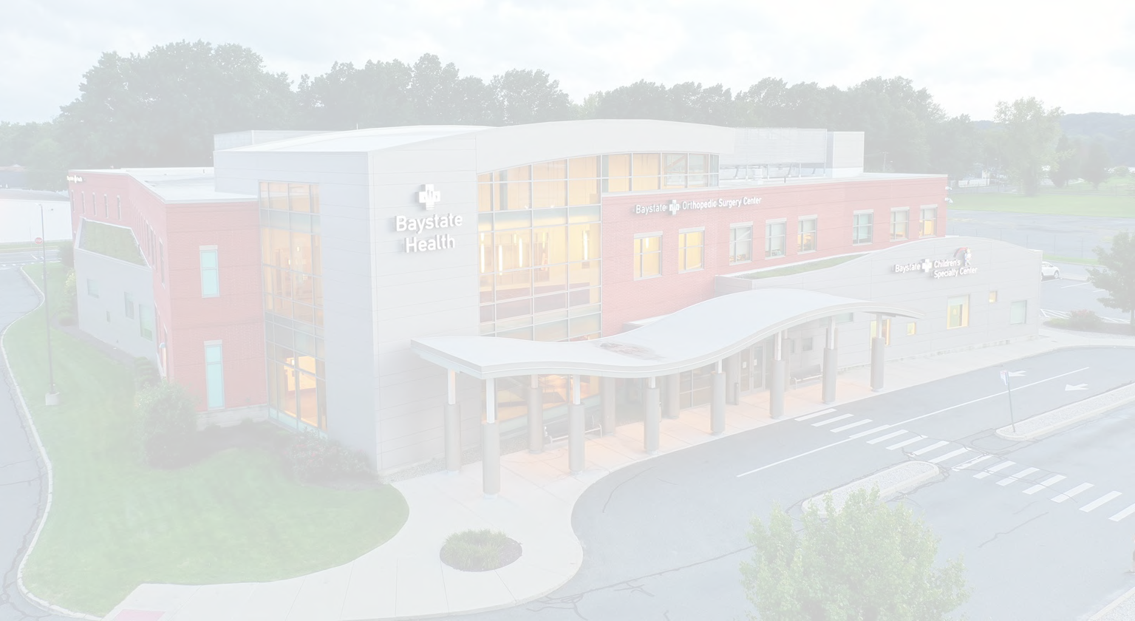
Welcome

Baystate New England Orthopedic Surgeons Alliance, LLC

North End Stakeholder Meeting Wednesday, February 9, 2022
Determination of Need (DoN) Application
for a Joint-Venture Ambulatory Surgery Center (ASC)

Desired Outcomes of Presentation | Annamarie Golden  Director, Community Relations
Strategic Objective and Project Timeline | Bill Kern, MPH, MBA Senior Director, Finance Business Development Baystate Health
Ambulatory Surgery Center (ASC) Project | Tony Rino, MT (ASCP), MHA  Executive Director  New England Orthopedic Surgeons (NEOS)
Community Health Initiative (CHI) Requirement & Investment Plan | Annamarie Golden
Q&A | All

- Overview of Determination of Need (DoN) Program and why the MA Department of Public Health requires a DoN application for this project

- Shared understanding of Baystate Medical Center (BMC) and New England Orthopedic Surgeons (NEOS) decision to partner, converting Baystate Orthopedic Surgery Center to a jointly-owned, freestanding ambulatory surgery center (ASC)
- Overview of DoN application and conversion timeline
- Overview of DoN Community Health Initiative (CHI) requirement and how BMC plans to invest the required CHI funding related to this project

- BMC fulfillment of community engagement as prescribed by DoN requirements

NEOS providers (as “NEOS SurgCo, LLC”) and BMC seek to expand their relationship and partnership by converting Baystate Orthopedic Surgery Center, at 50 Wason Avenue, to a jointly-owned, freestanding ambulatory surgery center (ASC). The joint venture partnership proposes to operate as “Baystate New England Orthopedic Surgeons Alliance, LLC”.

- Alignment: NEOS is the regional leader in the diagnosis and treatment of musculoskeletal injuries and disorders, and are the only sub-specialized comprehensive orthopedic surgical practice in western Massachusetts; BMC and NEOS have enjoyed a two decade-plus relationship, and are excited for this opportunity for greater alignment
- Quality & Convenience: ASC’s have demonstrated an exceptional ability to improve quality and patient experience in a highly specialized, convenient, same-day setting – removing the larger scale “hospital” from the experience
- Lower-Cost Setting: The Proposed Project is in response to the need to provide existing and future patients with outpatient orthopedic surgery in the most cost- effective setting. Patients will continue to have access to ambulatory orthopedic surgery in their community at lower cost

PROJECT SCHEDULE

PROJECT KICKOFF
DoN
Documentation & Approval
DPH Plan Approval &
Licensure
2022

Go-Live

DoN Documentation, Review, and Approval  (5-7 Months) | February thru July-September  2022
DPH Plan Approval & Licensure | September – October 2022
Go Live (Target) | October 2022

- The location for the ASC will be 50 Wason Avenue (2nd floor), with state-of-the-art facilities and technology

- Located 1-mile from Baystate Medical Center, with convenient on-premise parking

- Specializing in hips, knees, shoulders, ankles, and sports related injuries

- Now performing same-day “total joint” replacements

- Performing over 5,000 surgical procedures per year
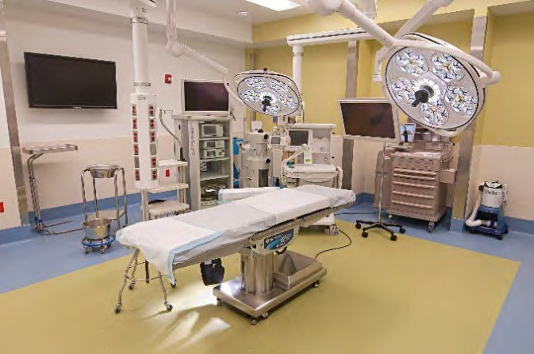
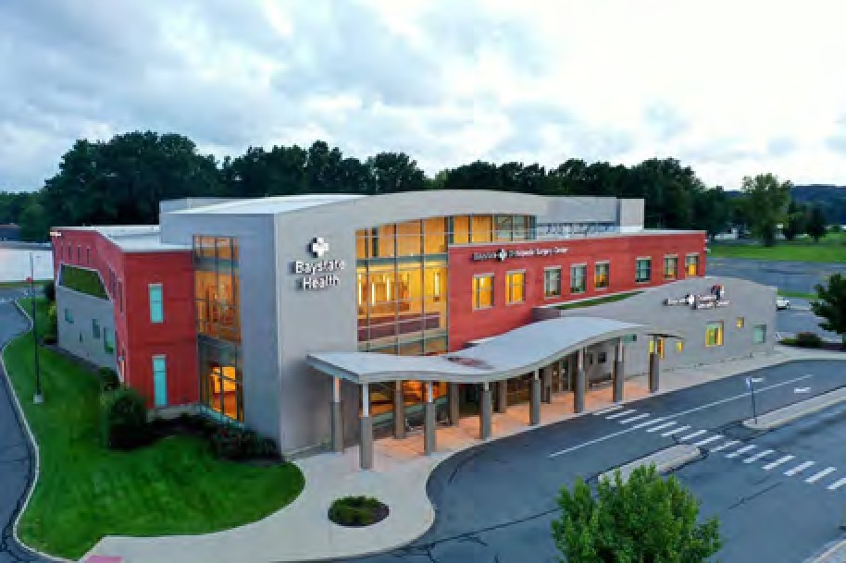
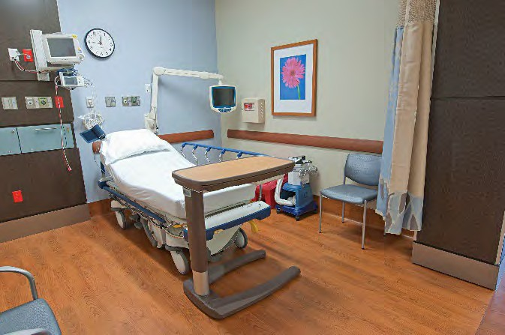

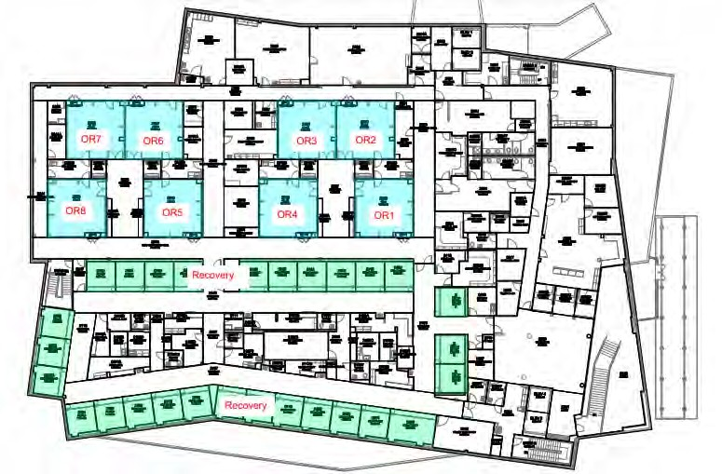
- Integrated design for surgery and post-operative care

- Eight (8) multi-use operating rooms with

- Twenty-eight (28) post-operative recovery rooms

- On-site pharmacy

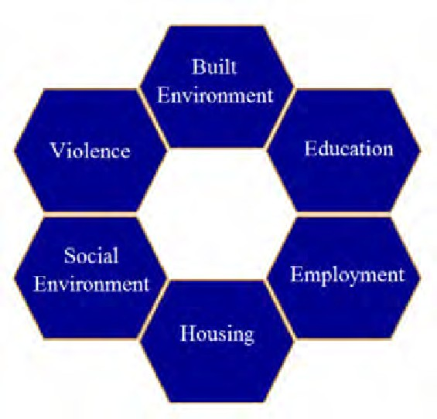
Determination of Need (DoN)
Community Health Initiatives (CHI) Funding
Project: Ambulatory Surgery Center Joint Venture

Approval: MA DPH Public Health Council (Delegated Review) – Month 2022 TBD
Maximum Capital Expenditure (MCE): $14.8 Million
Community Health Initiatives (CHI) / 5% of MCE: $742,231 (Tier 2) [funded by ]
  - Administrative: $22,266 (not to exceed 3%; retained by Baystate)
  - 25% to DPH for Statewide CHI Fund: $179,991 (due within 30 days of approval)
  - Evaluation: $53,997 (not to exceed 10%, retained by Baystate)
  - CHI for local investment: $485,976

1/13 BMC Community Benefits Advisory Council (CBAC)

2/9 North End Stakeholder Group

2/16 BMC Patient Family Advisory Council(s) (PFAC)

2/23 BMC Community Advisory Council (CAC)

JAN/ FEB

Elected Officials

FEB/ MAR

Virtual Community Meeting

11
March
New North (3/8) and Atwater Park Neighborhood Association (TBD)

1 Await MDPH decision/approval to keep/invest CHI locally
2022 Community Health Needs Assessment
2
In Progress (Anticipated completion by September 2022)

3 BMC Community Benefits Advisory Council (CBAC)

Baystate rwi Health I ADVANCING cARE.
ENHANCING LIVES.

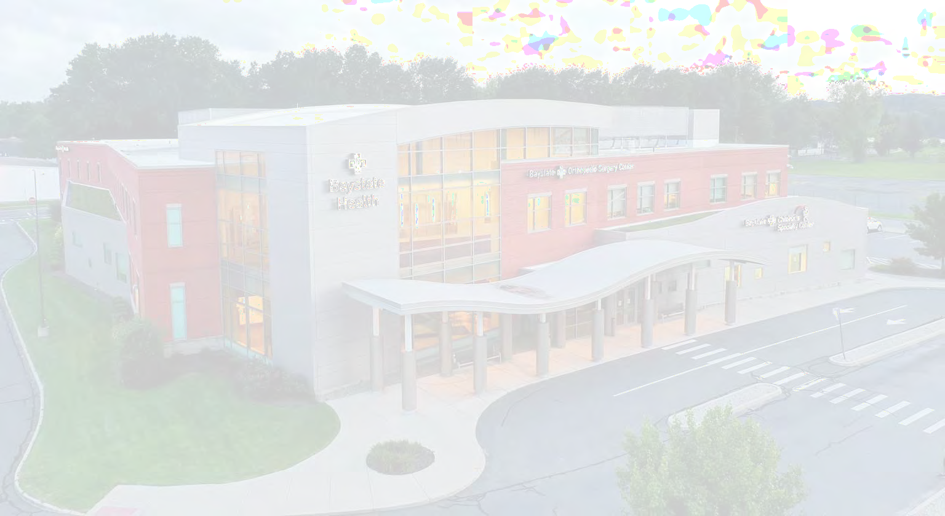
Welcome

Baystate New England Orthopedic Surgeons Alliance, LLC

BMC Community Benefits Advisory Council Thursday, January 13, 2022
Determination of Need (DoN) Application
for a Joint-Venture Ambulatory Surgery Center (ASC)

Overview | Annamarie Golden  Director, Community Relations
Strategic Objective and Project Timeline | Bill Kern, MPH, MBA Senior Director, Finance Business Development Baystate Health
Ambulatory Surgery Center (ASC) Project | Tony Rino, MT (ASCP), MHA  Executive Director  New England Orthopedic Surgeons (NEOS)
Community Health Initiative (CHI) Requirement & Investment Plan | Annamarie Golden
Q&A | All

- Overview of Determination of Need (DoN) Program and why the MA Department of Public Health requires a DoN application for this project

- Shared understanding of Baystate Medical Center (BMC) and New England Orthopedic Surgeons (NEOS) decision to partner, converting Baystate Orthopedic Surgery Center to a jointly-owned, freestanding ambulatory surgery center (ASC)
- Overview of DoN application and conversion timeline
- Overview of DoN Community Health Initiative (CHI) requirement and how BMC plans to invest the required CHI funding related to this project
- BMC fulfillment of community engagement as prescribed by DoN
requirements

STRATEGIC OBJECTIVE

NEOS providers (as “NEOS SurgCo, LLC”) and BMC seek to expand their relationship and partnership by converting Baystate Orthopedic Surgery Center, at 50 Wason Avenue, to a jointly-owned, freestanding ambulatory surgery center (ASC). The joint venture partnership proposes to operate as “Baystate New England Orthopedic Surgeons Alliance, LLC”.

- Alignment: NEOS is the regional leader in the diagnosis and treatment of musculoskeletal injuries and disorders, and are the only sub-specialized comprehensive orthopedic surgical practice in western Massachusetts; BMC and NEOS have enjoyed a two decade-plus relationship, and are excited for this opportunity for greater alignment
- Quality & Convenience: ASC’s have demonstrated an exceptional ability to improve quality and patient experience in a highly specialized, convenient, same-day setting – removing the larger scale “hospital” from the experience
- Lower-Cost Setting: The Proposed Project is in response to the need to provide existing and future patients with outpatient orthopedic surgery in the most cost- effective setting. Patients will continue to have access to ambulatory orthopedic surgery in their community at lower cost

PROJECT SCHEDULE

PROJECT KICKOFF
DoN
Documentation &
Approval
DPH Plan Approval &
Licensure
2022

Go-Live

DoN Documentation, Review, and Approval  (5-7 Months) | January 2022 thru June –  August 2022
DPH Plan Approval & Licensure | August – September 2022
Go Live (Target) | October 2022

- The location for the ASC will be 50 Wason Avenue (2nd floor), with state-of-the-art
facilities and technology

- Located 1-mile from Baystate Medical Center, with convenient on-premise parking

- Specializing in hips, knees, shoulders, ankles, and sports related injuries

- Now performing same-day “total joint” replacements

- Performing over 5,000 surgical procedures per year
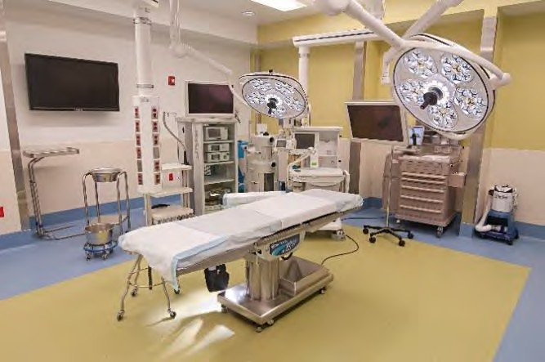
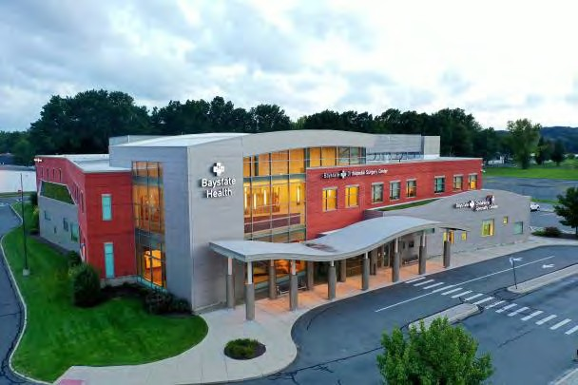
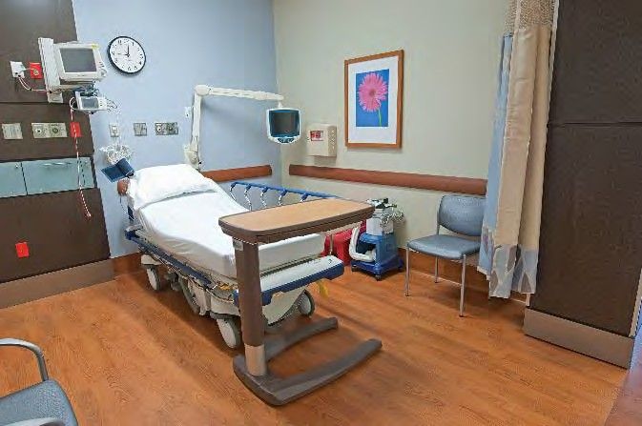

- Integrated design for surgery and post-operative care

- Eight (8) multi-use operating rooms with

- Twenty-eight (28) post-operative recovery rooms

- On-site pharmacy

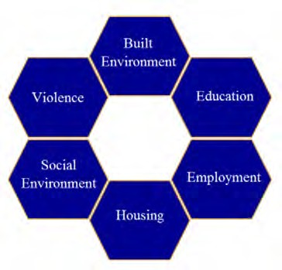
Determination of Need (DoN)
Community Health Initiatives (CHI) Funding
Project: Ambulatory Surgery Center Joint Venture

Approval: MA DPH Public Health Council (Delegated Review) – Month 2022 TBD
Maximum Capital Expenditure (MCE): $14.8 Million
Community Health Initiatives (CHI) / 5% of MCE: $742,231 (Tier 2) [funded by ]
  - Administrative: $22,266 (not to exceed 3%; retained by Baystate)
  - 25% to DPH for Statewide CHI Fund: $179,991 (due within 30 days of approval)
  - Evaluation: $53,997 (not to exceed 10%, retained by Baystate)
  - CHI for local investment: $485,976

1/13 BMC Community Benefits Advisory Council (CBAC)

2/9 North End Stakeholder Group

2/16 BMC Patient Family Advisory Council(s) (PFAC)

2/23 BMC Community Advisory Council (CAC)

JAN/
FEB

Elected Officials

FEB/ MAR

Virtual Community Meeting

10
March
New North (3/8) and Atwater Park Neighborhood Association (TBD)

1 Awaiting MDPH approval to keep/invest CHI locally
2022 Community Health Needs Assessment
2
In Progress (Anticipated completion by September 2022)

3 BMC Community Benefits Advisory Council (CBAC)

Baystate r.wi HealthI AovANc1NG cARE.
ENHANCING LIVES.

APPENDIX 4

FACTOR 4 EXHIBITS (CPA REPORT)

BAYSTATE NE-W- ENGLAND ORTHOPEDIC SURGEONS ALLJ.ANCE, LLC
Analysis oCthe R.easonableness of Assumptions Used For and the
Feasibility of"Project:ed Financial InCon:nation associated with the creation of"a Creestandin.g ambulatory surgical center to be operated byBaystate NewEngland Orthopedic Surgeons Alliance, LLC

For Years One through Five of Operations

BAYSTATE NEW ENGLAND ORTHOPEDIC SURGEONS ALLIANCE,, LLC

TABLE OF CONTENTS
I. Executive Summary 1
IL Relevant Background Information 1
IlL Scope or Report 2
- P.rimary Sources or lnrormation Utilized 2-3
- Review ot~tbe Projections 3-7
- Feasibility 7

MeyersBrotherst<alicka ,P.C.
CERTIFIED PUBLIC ACCOUNTANTS AND BUSINESS STRATEGISTS

February 25, 2022

Mr. Raymond McCarthy
SVP, Chief Financial O:f-ficer and Treasurer Baystate Health, Inc.
280 Chestnut Street Springfield, MA 01199

DearMr. McCarthy:

We have pertormed an analysis of the financial projections prepared by Baystate Medical Center, Inc. ("'Baystate" or "the Hospital") detailing the projected operations of Baystate New England Orthopedic Surgeons Alliance, LLC ("Applicant''), including projected operations of Baystate Orthopedic Surgery Center ("BOSC"). The Applicant is a nevvly formed joint venture between NEOS Su.rgCO, LLC ("'NE.OS") (35%) and Baystate (60%) and a third-party management services provider, Compass Surgical Partners Holdings of Springfield, LLC ("Compass") (5%), founded for thepurpose.of creating a freestanding ambulatory surgery center C'ASC"). The Applicant is filing a Determination of Need ("DON") for thispurpose. This reportdetails our analysis and findings vvithregards to thereasonableness of
assumptions used in the preparation and feasibility of the projected financial information of the proposed project as

Mr. Raymond McCarthy Baystate1-Iealth, Inc.
February 25, 2022

m.Scope of"Report
The scope of this report js limited to an analysis of the five-year financial projections prepared by Management and the supporting documentation in order to assess thereasonableness of assumptions used in the preparation and f'easibility of theprojecti.ons with regards to the proposed project. Our analysis of the projections and conclusions contained within thisreport are based upo.n our detailed review of allrelevant information (see section JV of this report). Wehavegained an understanding through our reviev,1of the information provided by Management, including results of the existing BOSC, as well as a review of the internal rmancialstatements of BOSC for the fiscal year endedSepte1nber 30, 2020, as well as the projected/pro-formaresults fortbefiscal year endedSep1.e1nber 30, 2021, and the DON application.

Reasonableness is defined within the context of this report as supportable and proper, given the underlying inforrnation. Feasibility is defined as based onthe assumptions used; the plan is not likely to result in insui'ficient funds available f'or capital and ongoing operating costs necessary tosupport the proposed project without negative ianpacts or consequences to the Applicant, or its parties.

This report is based upon historical and prospectivermancial infonnation providedto usby Managem.ent. If'M:eyers Brothers Kalicka, P.C. had audited the underlying data, matters n1ay have come to our attention that would have resulted in our using ru:nounts that differ from those provided. Accordingly, we do not express an opinion or any otl-ier assurances on the underlying data presented orrelied upon in tl'.lisreport. Wedonotprovide assurance on die achievability of theresults forecasted by Management because events and circumstances frequently do not occur as expected, and the achievement of the :forecastedresults is dependent on the actions,plans, and assumptions of
Management. We reserve the ri.ght to update our analysis, ifvve are provided vith additi.onal i:nfonnation.

Mr. Raymond McCarthy Baystate Health, Inc.
February 25, 2022

:rv. Primary Sources of J.nformation Utilized (cont:inued)

- Letter orlntent (LOI) foe- managementservices terms bet.--ween Baystate New England Orthopedic Surgeons Alliance, LLC and Con,pass SurgjcaJPartners Holdings ofSpringfield, LLC.

- Detail listing ot-BOSC full time employees ("FTE's") for the fiscal year ended September 30, 2020 and the projected/pro-.fonna FTE's fortl'le fiscalyear ended September 30, 2021.

- Capital expenditure assUJnptions of $950,000 Forthe projected/profonna Year One and $800 000 for the projected/pro.fon:na Years Two through YearFive.

- TheVMGHealth Fair Market Value Analysis Schedules report dated March 202).

V. Review 0£the Projections

Tb.is section of the reportsummarizes our review oftbe reasonablenessofthe assun'lptions used and feasibility ofthe projections. The tables that followsummarize the historical results ofBOSC and projected results o-fBaystate New England Orthopedic Surgeons Alliance, LLC, following the creation o'f the ASC by the Applicant. Based on discussions ,,vith Management and a review of the inforrnation, net earnings vvHl continue to :in'lprove after the creation of the ASC by the Applicant.
Revenues

M:r. Ray1nond McCarthy Baystate Health. Inc.
February 25,2022

V. Revie-w of".-be Proiections (continued)

We analyzed the projected/pro-forma revenue for the fiscalyears beginning with the first full fiscal year of"the ASC's operation ("Year One") through Year Five o:roperations inrelation to thehistoricalresults. Management provided the historical actual for the fiscal year ended September 30, 2020, and the projected/pro-forma for the fiscal year ended September 30, 202.l, in order to assess thereasonableness of the pro-formastate1nents or the Proposed Project. The projected/pro-tonna foe-the fiscal year ended Septero ber 30,2021 isbased on the nine 1nonths tor the period ended June 30,2021.

Based on our analysis, the pro-fonna operatingrevenues arereasonable. Perdiscussions withanagement, total cases are expected to increase approximately 2.0% each yeai:-vvith the creation of the freestanding ambulatory surgical center. Gross charge per case vvill align wjth the 2.0% increase in number of cases in the projected years. Historically, BOSC received provider-basedreimbursement rates as a departm.ent of the Hospital, but the five year projections illustrate what the :freestanding ASC would receive on a freestanding basis. These adjustments are projected to be 64% of gross charges each year. The net charge per case in the projected/profonna for the fiscal year ended September 30,2021 was $4,762, which decreased to $3,350per case io theprojected/pro-rorma fiscal Vear One. The approximate decrease of $1,400 co1Telates t.o the approx.i1nate 30% reimbursement reduction for procedures in an ambulatory surgical center set-ting versus a hospital outpatient depart,nen.t (HOPD) payment system; net revenue decreased approximateJy $8 m.illion :from the projected/p·roforma for tbe fiscal year ended September 30, 2021 to the projected/profo:nna Year One.

Expenses

M_r. Ray1nond McCa1-th.y Baystate Health, Inc.
February 25, 2022

- Review o:Cthe Proiections (continued)

  - Projections ofsaJaries, wages and benefits are made under the assUJnption that changes to the staffing structure vvill be made to operate on a freestanding basis. The average salary, excludingbenefits, per full-ti1ne employee for the projected years range between $82,000 and $91,000. Benefits are expected to be approximately J 8.5% of thetotal salaries, wages and benefits fbrYears Onethrough Year Five. TotalsaJaries, wages andbenefits are expected to increase 4.2% ea.ch year.

  - Occupancy costs includes the building at 50 Wason Avenue, common area maintenance, u6Hties and janitorial expenses. The Wason Avenue building is approximately 41,000square f'eet, and the projected costs, including utilities and janitorial, for the projected/pc-ofon:nafor the fiscal year ended September 30, 2021 is approxunately
$50 persquare foot. The costs 'for the projected/proforma Year One is expected to be $42.41 persquare foot, inclusive of co1nn'lon area1naintenance an_d utilities, aod is projected 'to increase by 2.5% each year. Janitorial services areto be excluded from the scope of the new lease and will be contracted for with a third-party service provider moving forward.

  - Drugs and 1nedical supplies increased app.roxi.nlately $850,000 froxn. the historical actual for the fiscal year ended September 30, 2020 to the projected/pro-forma .for the fiscal year ended September 30,2021. TheYear One projection is approximately $330,000 less thanthe projected/proforma :for the fiscal year ended Septe1nber 30, 2021 dueto Management's assertion or opportuni6es to consojjdate and strea.tnline productselection and procure1nent strategies. The cost of drugs and medicalsupplies is projected to increase ,,vith inflation by approximately 2.5% each year, therefore costs per case are expected to range from approxitnately $1,030 to

.Mr. Raymond McCarthy Baystate I-:LeaJth, Inc .
February 25, 2022

- Review of'the Proiections (continued)

- Equip1nent expense, repairs and 1naintenance for the projected/pro-form.a for the fiscal year ended September 30, 2021 vvas approxi1nately $830,000 more than the projected/pro-forrna Year One expense. ·rhe projections for Years Onethrough Year Five include equipment contracts and1naintenance, equipmentrepairs, andsurgical instTuments repairs, as -well as any non-capitalized instrument purchases. A portion. of the historical equipment expenses, approxi.Jnately $797,000, included the 1najor moveable depreciation expense, ,,vhich vvas removed from the projections as they are associated with purchases that vvere o.iginally expensed but vvill be capitalized goingforward (seeCa.pit.al ExpendituJ'es)- Any expenses related to maintenance materials, plu1nbing, carpentry, or electrical work will beabsorbed by the Lessor under the nevv lease terms.

- A letter of intent has been executed with Compass for 1nru,agement services. The finalized tenns for the management reeexpense isexpected to bewithin 5-10% ofthe rnarket projections expressed iothe VMG Health report, as reflected above. In addition, there will be a one-tin,e development tee of $?50,000 during the projected/proformaYear One, to be paid over the itnplementation period in projection Year One.

- Projected depreciation has been revie,,ved and is expected to be sb-aight-lined for the five projected years, leasehold i1T1provements are depreciated over 5 years, and furniture and fixtures are deprecjated over 1Oyears. Additions -for the projected/proforma Year One.are expected to be approximately $950,000, and additions are expected to beapproxunately $800,000 each of the follow.ing years. The estimate of1-uture capital expendjtures includes the acquisitions of equipment such as frtstruments, sterilization, waste1nanagement, aod othersurgical. equipment.

Mr_Rayxnond McCarthy Baystate Health, Inc_ February 25, 2022

v_Review of the Projections (continued)

Cash Flows
Thetablebelow provides asununru:y of cash flovv by year:

Projected/ pro-fonna
£or U1enscal
year ended September
Projected/ pro-fonna with creatioq o-t· lheASC
Projected/ pro"fonna with creation 0£ the ASC
Projected/ Projected/
pro-forn1a pro-fonna
vvirh ""it.b
creation of' creation o:f
the ASC 1-heASC
Prqjcctcd/ pro-forTna
-with creation 01 the ASC

30, 2021
Year 1 Year2
Ycw:-3 Year_4_
Years

Netearnings.
Oeprec.intion | -811,644 | 1,025,979 | 1.105.979 | l.185,979 | 1,265,979 | 1,345.979
Capjtal c.xpeadilurcs | (1.330,547) | (950.000) | (800,000) | (800,000) | (800.000) | (800,000)

Financing
$ 7.547,752 $

-
2;987.1.00

475,000
$ 3,276.962
$ 3,319.708 $ 3,364,061

-
$ 3,410.536

Principalpay-,nents -
(89,037)
(90.524)
(93,277) (96,J 15)
(106.04-7)

Net cash
$ -- 7_,028_._849 $
3,449,042 $ 3.492.417
$ 3.612.410 733,925
--
$
$ 3,850.468

Capital Expenditures
The projected capital expenditures after the facility is operational a.re expected to be $950,000 in Year One and
$800,000 in each of the following four years, which may include equipment such as instruments,steriliza.tion.,. video, vvaste management, and other surgical equipment, which Ma.n.age1-nentprovided based on historical asset records. The additional $150,000 in the Year One projection isrelated to the conversion of the facility to a ti-eestanding
ru.nbulatorysurgical center. Per discussion vvith Management, it is anticipated that 50% of capital expendjtures will.

FACTOR 6 EXHIBITS

CHI NARRATIVE

Baystate New England Orthopedic Surgeons Alliance, LLC Community Health Initiative Narrative

  - Community Health Initiative Monies

The breakdown of Community Health Initiative (“CHI”) monies for the Proposed Project is as follows. Please note, all totals are presented in the order calculated, beginning with the Maximum Capital Expenditure (“MCE”).

 | Total | Description
MCE | $14,844,635.00
CHI Monies | $742,231.75 | (5% of Maximum Capital Expenditure)
Administrative Fee | $22,266.95 | (3% of the CHI Monies, retained by Baystate)
Remaining Monies | $719,964.80 | (CHI Monies minus the Administrative fee)
Statewide Initiative | $179,991.20 | (25% of remaining monies, paid to State-wide fund)
Local Initiative | $539,973.60 | (75% of remaining monies)
Evaluation Monies | $53,997.36 | (10% of Local Initiative Monies, retained by Baystate)
CHI Monies for Local Disbursement | $485,976.24

  - Basis of the Proposed CHI

The CHI processes and community engagement for the proposed Determination of Need (“DoN”) Project1 will be overseen by Baystate Medical Center (“Baystate” or the “Hospital”) and its existing Community Benefits program.

Baystate is a member of the Coalition of Western Massachusetts Hospitals/Insurer (the “Coalition”) a partnership between eight non-profit hospitals, clinics, and insurers in the region. The Coalition formed in 2012 to bring hospitals in western Massachusetts together to share resources and work in partnership to conduct their triennial community health needs assessments (“CHNAs”) and address regional needs. Baystate worked with the Coalition to conduct its current CHNA (2019) and is currently working with the Coalition to conduct the upcoming, 2022 CHNA. The goals of each CHNA include:

- improving the Hospital’s understanding of the health needs of the communities it serves
- meeting its fiduciary requirement as a tax-exempt Hospital
- serving as a resource for community organizations for data that is not readily available in other ways
- guiding Baystate Medical Center’s Community Benefits Strategic Implementation Plan (“SIP”) development efforts

The CHNA will use a participatory, collaborative approach and examined health in its broadest context. As part of the upcoming assessment, the Coalition is seeking input and will be guided by a Regional Advisory Committee (“RAC”) to inform the methodology, including recommendation of secondary data sources, and identification of key informants and focus group segments. The assessment will utilize the following information inputs: 1) social, economic, and health quantitative data from the MDPH, the U.S Census Bureau, the County Health Ranking Reports, the Massachusetts Healthy Aging Collaborative, Social Explorer, and a variety of other data sources; 2) findings from focus groups, interviews with key informants (including with local and regional public health officials), Community Listening Sessions, and Community

1 This Application requests approval for the creation of a freestanding orthopedic ambulatory surgery center in Springfield, Massachusetts.

Chats; and 3) existing assessment reports published since 2019 that were completed by community and regional agencies serving Hampden County. As with past assessments, the 2022 CHNA will focus on county-level data and select community-level data as available.

Based on reflection and feedback from the 2019 CHNA, the following changes are being made to the upcoming CHNA:

- Revised and expanded representation of community members on the RAC.
- Implemented a co-chair structure for the RAC – one community and one hospital coalition representative
- Added two community RAC members to join the monthly Steering Committee meeting, previously limited to hospital representatives and consultants.
- Allocated stipend funding for RAC members who are residents/are not compensated by their employer to participate on the RAC
- Hired two research assistants and engaged three interns from local colleges to assist with note taking, data tasks, and other administrative duties.
- Switched the monthly RAC meeting to Zoom which has driven strong attendance due to the ability of members to join virtually and avoid commuting.

  - Oversight of the CHI Process

The CHI will be overseen by Baystate Medical Center’s Community Benefits Advisory Council (“CBAC”). Given that this is a Tier 2 CHI, the scope of work that the CBAC will carry out includes:

- Ensuring appropriate engagement with residents from targeted communities and community partners around the CHI.
- Determining the Health Priorities for CHI funding based upon the needs identified in the 2022 CHNA/CHIP. The CBAC will ensure that all Health Priorities are aligned with the Department of Public Health’s Health Priorities and the Executive Office of Health and Human Services’ Focus Areas.
- Providing oversight to the evaluator that is carrying out the evaluation of CHI-funded projects.
- Conducting a conflict of interest disclosure process to determine which members also will comprise the Allocation Committee.
- Reporting to the Department of Public Health on the DoN – CHI.

  - Allocation Committee Duties

The Allocation Committee is comprised of individuals from the CBAC who do not have a conflict of interest in regard to funding. The scope of work that the Allocation Committee will carry out includes:

- Selecting Strategies for the noted Health Priorities.
- Completing and submitting the Health Priorities and Strategies Selection Form for approval by the Department of Public Health.
- Determining the process by which CHI funds will be awarded.
- Engaging resources that can support and assist applicants with their responses to the RFP.
- Disbursement of CHI funding.
- Providing oversight to a third-party vendor that is selected to carry out the evaluation of CHI- funded projects.

  - Timeline for CHI Activities

Upon a Notice of Determination of Need being issued by the Public Health Council, the CBAC will commence meeting and begin the CHI Process. However, as Baystate will be relying on the results of its 2022 CHNA to serve as the basis of this CHI, activities may be pushed back to ensure the CHNA is sufficiently complete in order for the CBAC to review its findings. The timeline for CHI activities is as follows:

- Six weeks post-approval: The CBAC will begin meeting and reviewing the 2022 CHNA/CHIP to commence the process of selecting Health Priorities.
- Three – four months post-approval: The CBAC has determined Health Priorities for funding.
- Four – five months post-approval: The Allocation Committee is selecting strategies for the Health Priorities and will submit the Health Priorities and Strategies Form to the Department.
- Five – six months post-approval: The Allocation Committee is developing the RFP process and determining how this process will work in tandem with Baystate’s current grant efforts.
- Five – six months post-approval: Baystate will commence working with the evaluator that will serve as a technical resource to grantees.
- Nine months post-approval: The RFP for funding is released.
- Ten months post-approval: Bidders conferences are held on the RFP.
- Twelve months post-approval: Responses are due for the RFP.
- Fifteen months post-approval: Funding decisions are made, and the disbursement of funds begins.
- Eighteen months to five years post-approval: Evaluator will begin evaluation work.

The aforementioned process is longer than the process outlined in the DoN Guidelines for Tier 2 projects. However, given the Applicant’s previous experience with RFP processes, staff feel strongly that it will take nine months to develop an RFP process that is transparent, fair and appropriate.

  - Request for Additional Years of Funding

Baystate is seeking additional time to carry out the disbursement of funds for CHI. In order to best facilitate sustainability through CHI funding, Baystate anticipates distributing funds through multi-year awards and accordingly is seeking to disburse these monies over a three-to-five year period to ensure the greatest impact for the largest number of individuals.

  - Administrative and Evaluation Funds

Baystate is requesting $22,266.95 to be used towards administrative costs. These monies are critical in developing a sound CHI process that complies with the Department of Public Health’s expectations as administrative funding will be used to hire additional support staff. These monies will also pay for reporting and dissemination of promising practices and lessons learned, facilitation support for the CBAC and Allocation Committee, costs associated with the development of communication materials and placement of procurement information in community newspapers. Finally, these monies will help to offset the costs of the development and implementation of the RFP process. Additionally, Baystate is seeking to use 10% of local CHI funding ($53,997.36) for evaluation efforts. These monies will allow Applicant to engage a third- party evaluator to carry out technical assistance and ensure appropriate evaluation of the CHI-funded projects.

