Expert physicians. Quality hospitals. Superior care.

Cape Cod Hospital Cancer and Cardiology Expansion

Patient Family Advisory Council
February 10, 2022
©2015 Cape Cod Healthcare Inc.

2

Caring for our Community

Strategic goal: To provide a full array of comprehensive medical services to the community.
- Patients receive quality medical care close to home without incurring higher costs and the inconvenience of travel to Boston.

Existing Constraints Include:
- The current cardiovascular, oncology and some of the medical/surgical units need to be updated, improved and expanded.
- Patient rooms, space for diagnostic equipment, storage, physician and nurse workspace are currently limited.
- Over the past decade the hospital has renovated areas where possible to ensure compliance with current standards and address growth in patient volumes.
- However, the cardiovascular, oncology and surgical suites are essentially “landlocked” in the current configuration.

The creation of the proposed new patient floors and the new cancer center will address our current and future needs. Further, it will allow us to redefine the care we deliver at Cape Cod Hospital.

Expert physicians. Quality hospitals. Superior care.

3

Caring for Community – Cancer & Cardiology

New Oncology / Cancer Center
- Demand for oncology services is increasing, but existing oncology space has constrained program development.
- New center has a patient-centered design to increase capacity from 19 to 36 patient bays with potential to expand.
- Proper space for practitioners, pharmacy, laboratory, patient education & family support areas.
- Radiation therapy upgraded with new linear accelerator, updated CT simulation equipment & dedicated brachytherapy equipment.

Cardiovascular Medical / Surgical Unit
- Proposed 32-bed CV Medical/Surgical unit to replace existing 12-bed and 24-bed units housed in 1950’s portion of hospital.
- New unit will transform delivery of care at CCH and recognizes role of the family to support a patient’s well-being.
- New units exceed minimum guidelines, enable better clinical team collaboration, provide space for new technologies, and provide amenities to families.

Expert physicians. Quality hospitals. Superior care.

4

Caring for our Community – Medical Surgical

The 32-bed proposed CV Medical/Surgical Unit for the new addition will replace the existing 12-bed and 24-bed CV med/surg units housed in a 1950’s building on the Cape Cod Hospital campus.
The new unit will transform the way medical care is delivered at Cape Cod Hospital and will recognize the role of the family as a partnership to support patient well-being. Focus on patient and family experience and staff efficiency are the key drivers in the design. The new units will exceed the minimum 2018 FGI Guidelines, enable clinical teams to collaborate more effectively, and provide space for emerging technologies, as well as amenities for families on the units and within the patient room.

Expert physicians. Quality hospitals. Superior care.

5

Project Overview

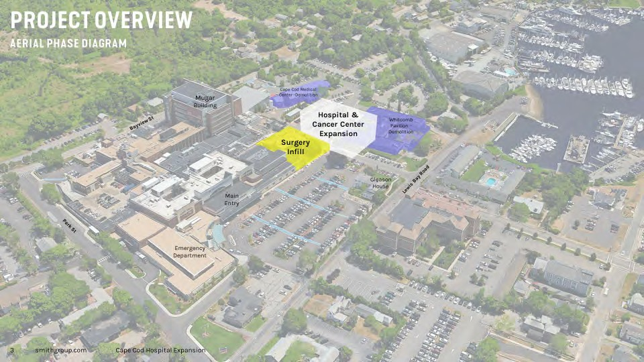

Expert physicians. Quality hospitals. Superior care.

6

Where we are now -Southwest View

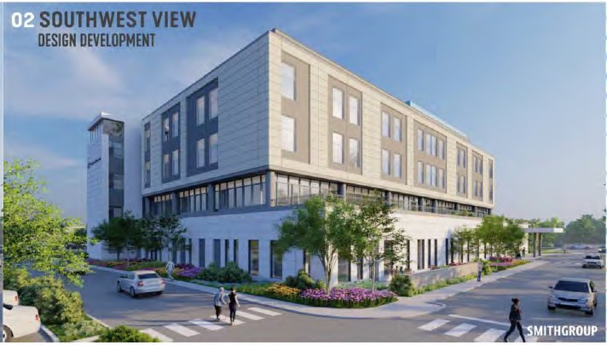

©2015 Cape Cod Healthcare Inc.

Expert physicians. Quality hospitals. Superior care.

7

Where we are now - Northwest View

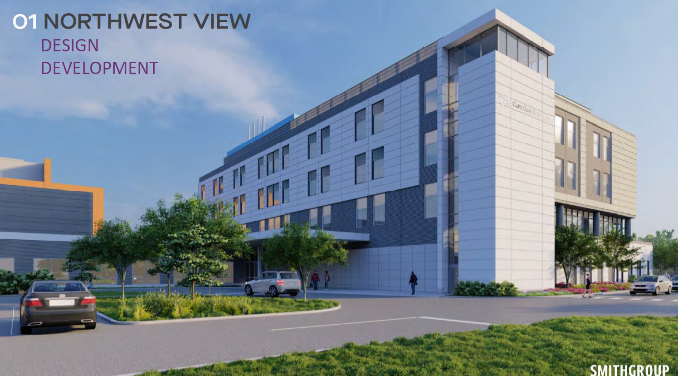

©2015 Cape Cod Healthcare Inc.

Expert physicians. Quality hospitals. Superior care.

8

Side by Side Statistics

CAPE COD HOSPITAL
PREVIOUS TOWER PROJECT COMPARISON TO CURRENT NEW EXPANSION DESIGN

DESIGN | DESIGN
60,988 SFAREA OF GROSS FOOTPRINT | 50,926 | SF AREA OF GROSS FOOTPRINT
122,542 SF AREA OF NEW BUILDING CONSTRUCTION | 60,298 | SF AREA OF NEW BUILDING CONSTRUCTION
76,753 SFOF BUILDINGSDEMOLISHED | 76,753 | SFOF BUILDINGS DEMOLISHED
22 NEW PARKING SPACES ADDED | 59 | NEW PARKING SPACES ADDED
107.9' BUILOING HElGHT (MEAN GRADE TO TOP OF PENTHOUSE) | 91.3' | BUILDING HEIGHT (MEANGRADETOTOPOFPEI\JTHOUSE)
199,295 SF 6 STORY TOWER  - 1sT FLOOR-LOBBY, RADIATION ONCOLOGY 38,745SF  - 1st Floor-MUGAR CONNECTOR 8,465 SF  - 2NDFLOOR-MEDICAL ONCOLOGY 26,797 SF  - 3Ro_FLOORICU/CV-ICU 28 BEDS 28,008 SF  - 4TH-FLOOR-36 BED MEDSURGE BEDS 28,008 SF  - 5m - FLOOR-SHELL SPACE 28,008 SF  - 6THFLOOR-EDUCATION CENTER& 22,648 SF MECHANICALPENTHOUSE  - SURGICAL EXPANSION ADD 2 OR'S 18,616 SF | 137,051 SF 4 STORIES PLUS MECHANICAL PENTHOUSE  - 1STFLOOR -LOBBY, RADIATION ONCOLOGY 30,986 SF  - 2N° FLOOR-MEDICAL ONCOLOGY 24,919 SF  - 3RD-FLOOR-32 BED MEDSURGE BEDS 26,303 SF  - 4TH- FLOOR-SHELL SPACE 26,303 SF  - PH MECHANICAL PENTHOUSE 8,600 SF  - SURGICAL EXPANSION GROUND FLOOR 19,940 SF ADD 2 OR'S

EXISTING INFORMATION

Existing parking Spaces prior to parking lot expansion 1396 spaces.

Existing Mugar Tower Building Height is 98.8' (MEAN GRADE TO TOP OF DECORATIVE ROOF WALL)

Expert physicians. Quality hospitals. Superior care.

9
Design Driver

EXPERIENTIAL QUALITY

'We are beginning to learn that our brains are hardwired to react positively to water and that being near it can calm and connect us, increase innovation and insight, and even heal what's broken."

\ltAl.1 ,Ii.LI:. I, NICHOU
BLUE
MIND
n,,;...., "'"""•T"- -.-·
l,.,_,._ .. ,1,d+<-l'-,f"II.Ml,.lf • .-VI

--
23 srnithgrobp._£

\
Cap" Codospital lcxpansiQn

Expert physicians. Quality hospitals. Superior care.

10

Context- campus arrival experience

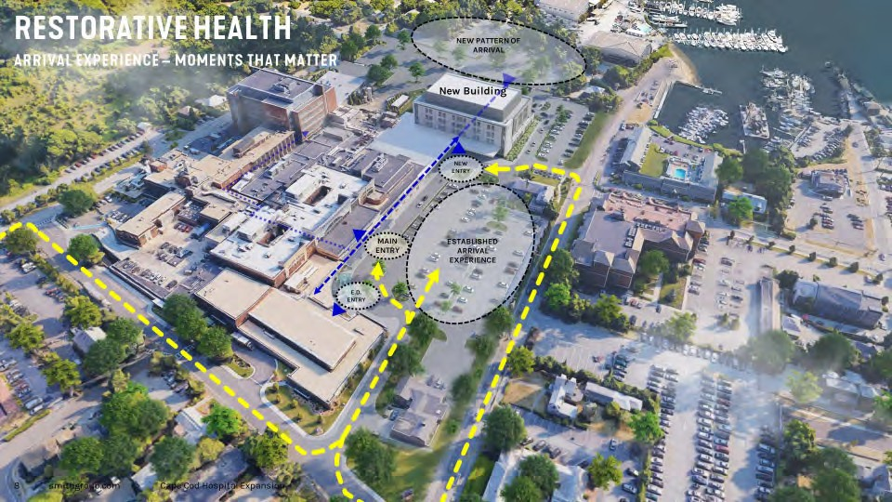

Expert physicians. Quality hospitals. Superior care.

11

Site Plan

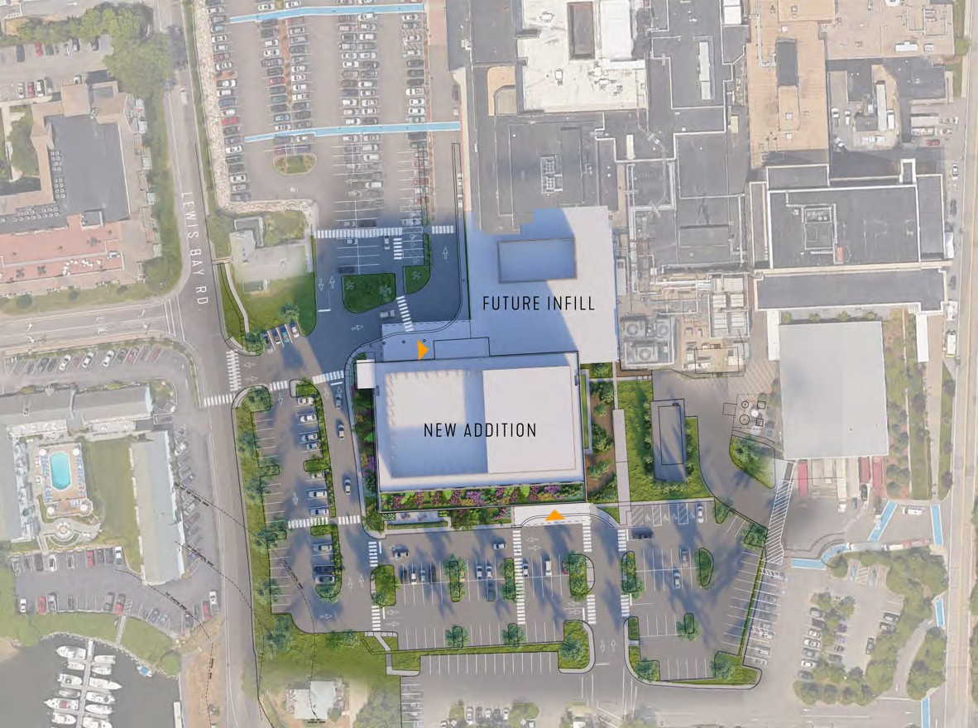

©2015 Cape Cod Healthcare Inc.

Expert physicians. Quality hospitals. Superior care.

12
Context- Cape beacons

BEACON TO THE COMMUNITY -
A
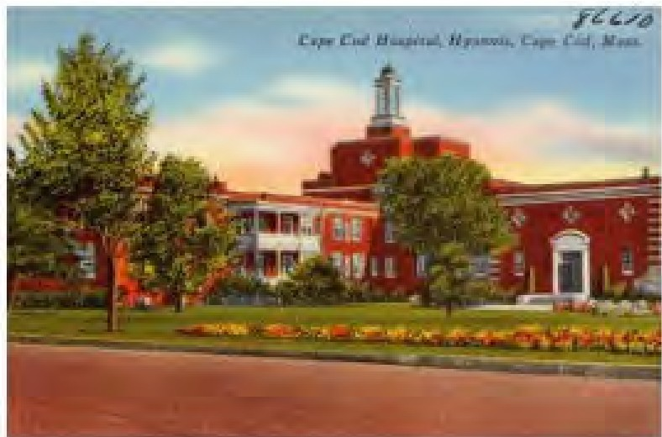
B1RANDEXPRESS ION
-

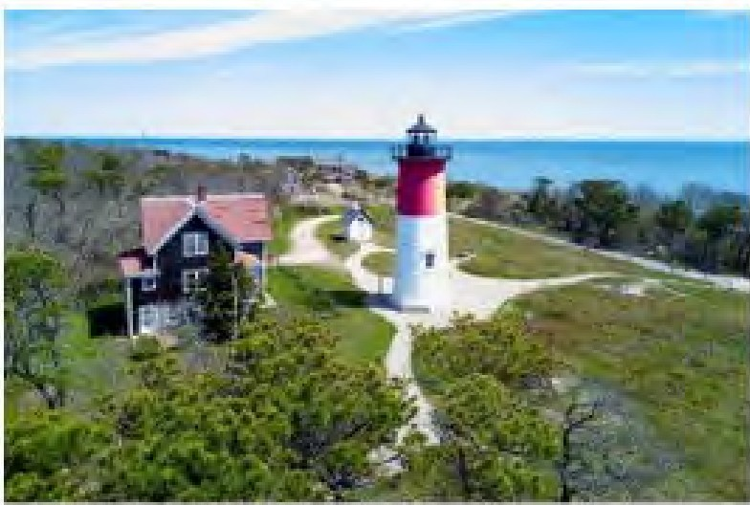
3S ;; mltt;,group.wrn C fl"J Cod ll'O:!opltal E. pan$k>'1

Expert physicians. Quality hospitals. Superior care.

13

Connection to the hospital

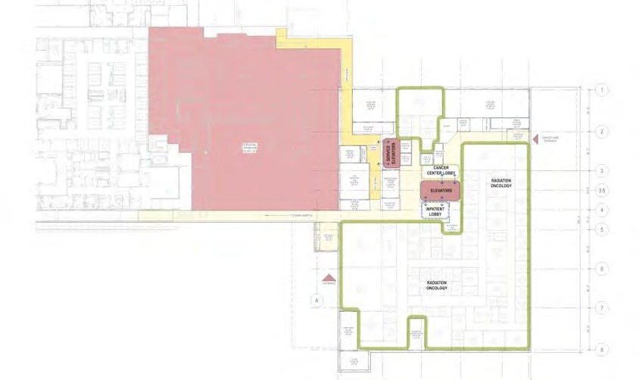
Future OR
Expansion Area

Expert physicians. Quality hospitals. Superior care.

14

First Floor Radiation Therapy

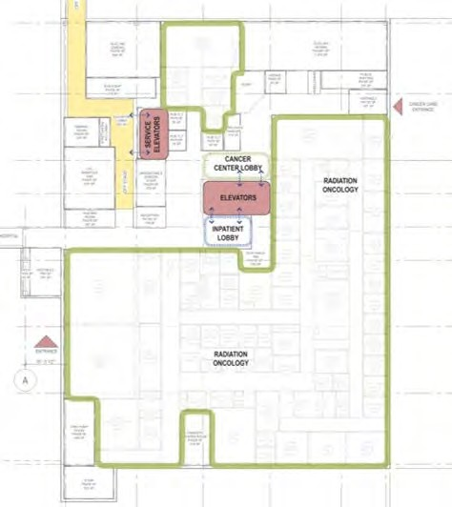

Expert physicians. Quality hospitals. Superior care.

L1 RADIATION + IMAGING

REFLECTED CEILING PLAN FLOOR PLAN
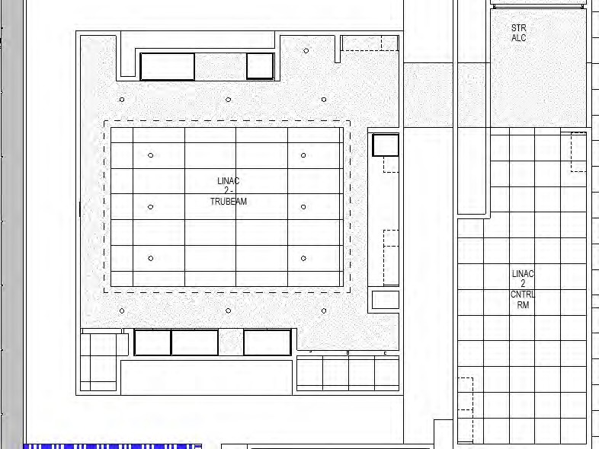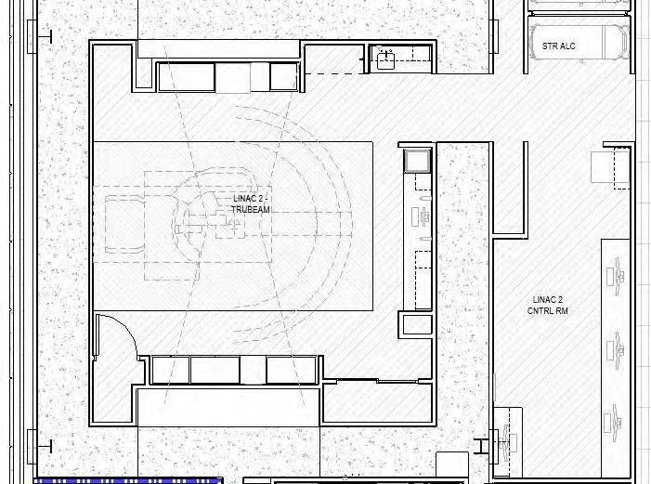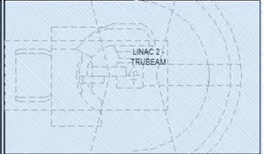

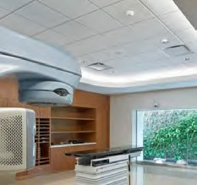
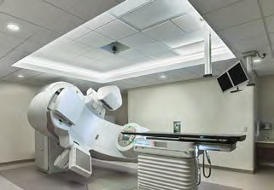
LIGHTING DESIGN INTENT:
WALL FINISH: MILLWORK FINISH: FLOOR FINISH:

als. Superior care.

15
smithgroup.com
CAPE COD HOSPITAL CANCER & CARDIOVASCULAR ADDITION
Expert physicians. Quality hospit

16

Radiation Therapy Check in

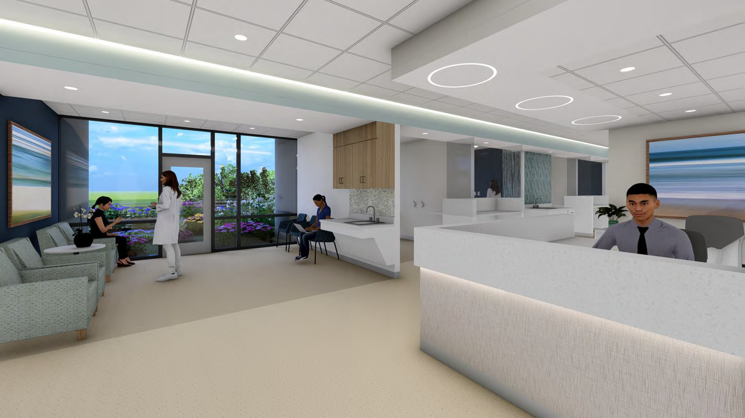
©2015 Cape Cod Healthcare Inc.

Expert physicians. Quality hospitals. Superior care.

17

Cancer Care Reception

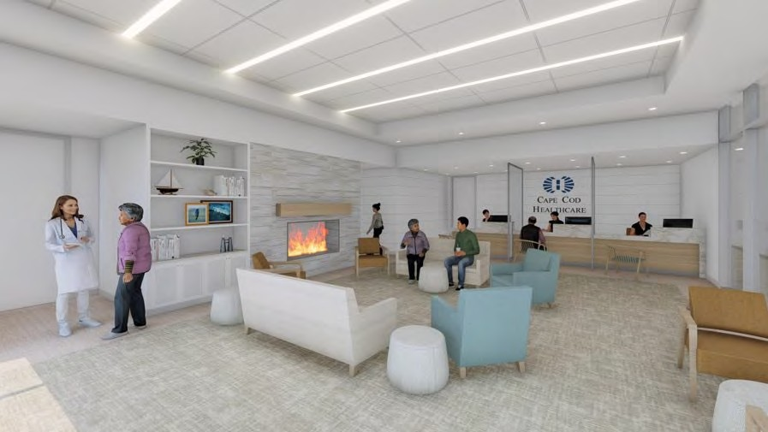

Expert physicians. Quality hospitals. Superior care.

L1 RAD/ONC NURSE STATION

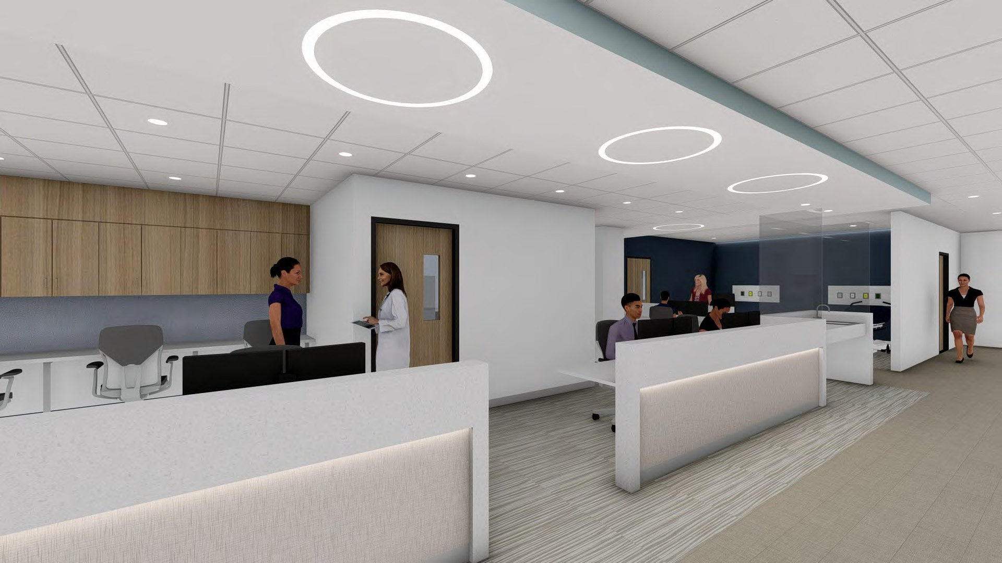

18
smithgroup.com
CAPE COD HOSPITAL CANCER & CARDIOVASCULAR ADDITION
Expert physicians. Quality hospitals. Superior care.

PATIENT JOURNEY

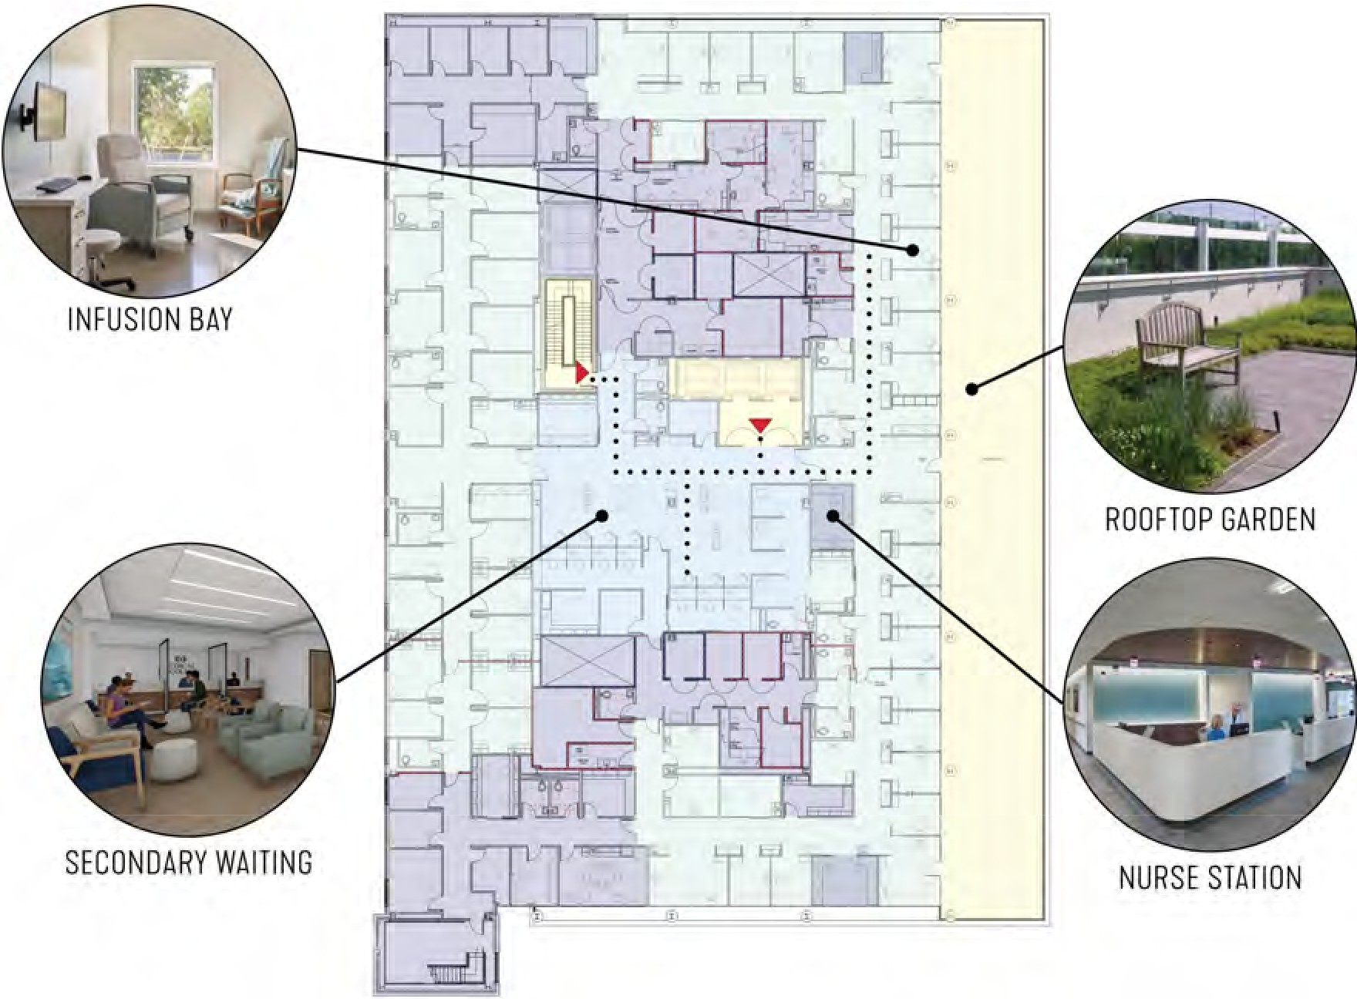
MOMENTS THAT MATTER
PUBLIC CIRCULATION PUBLIC WAITING CLINICAL ZONE STAFF ZONE

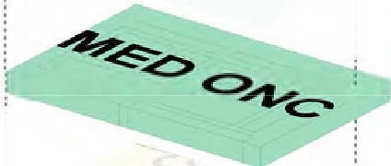

19
smithgroup.com
CAPE COD HOSPITAL CANCER & CARDIOVASCULAR ADDITION
Expert physicians. Quality hospitals. Superior care.

L2 LIVING ROOM

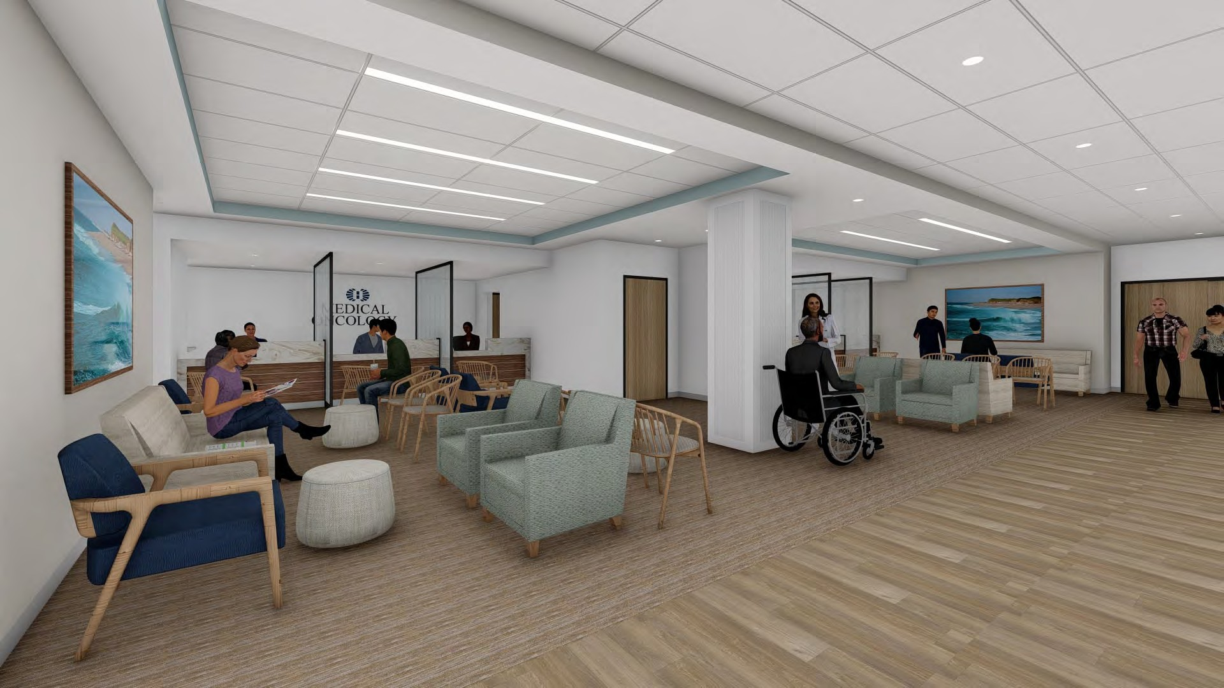

20
smithgroup.com
CAPE COD HOSPITAL CANCER & CARDIOVASCULAR ADDITION
Expert physicians. Quality hospitals. Superior care.

21

Infusion bay

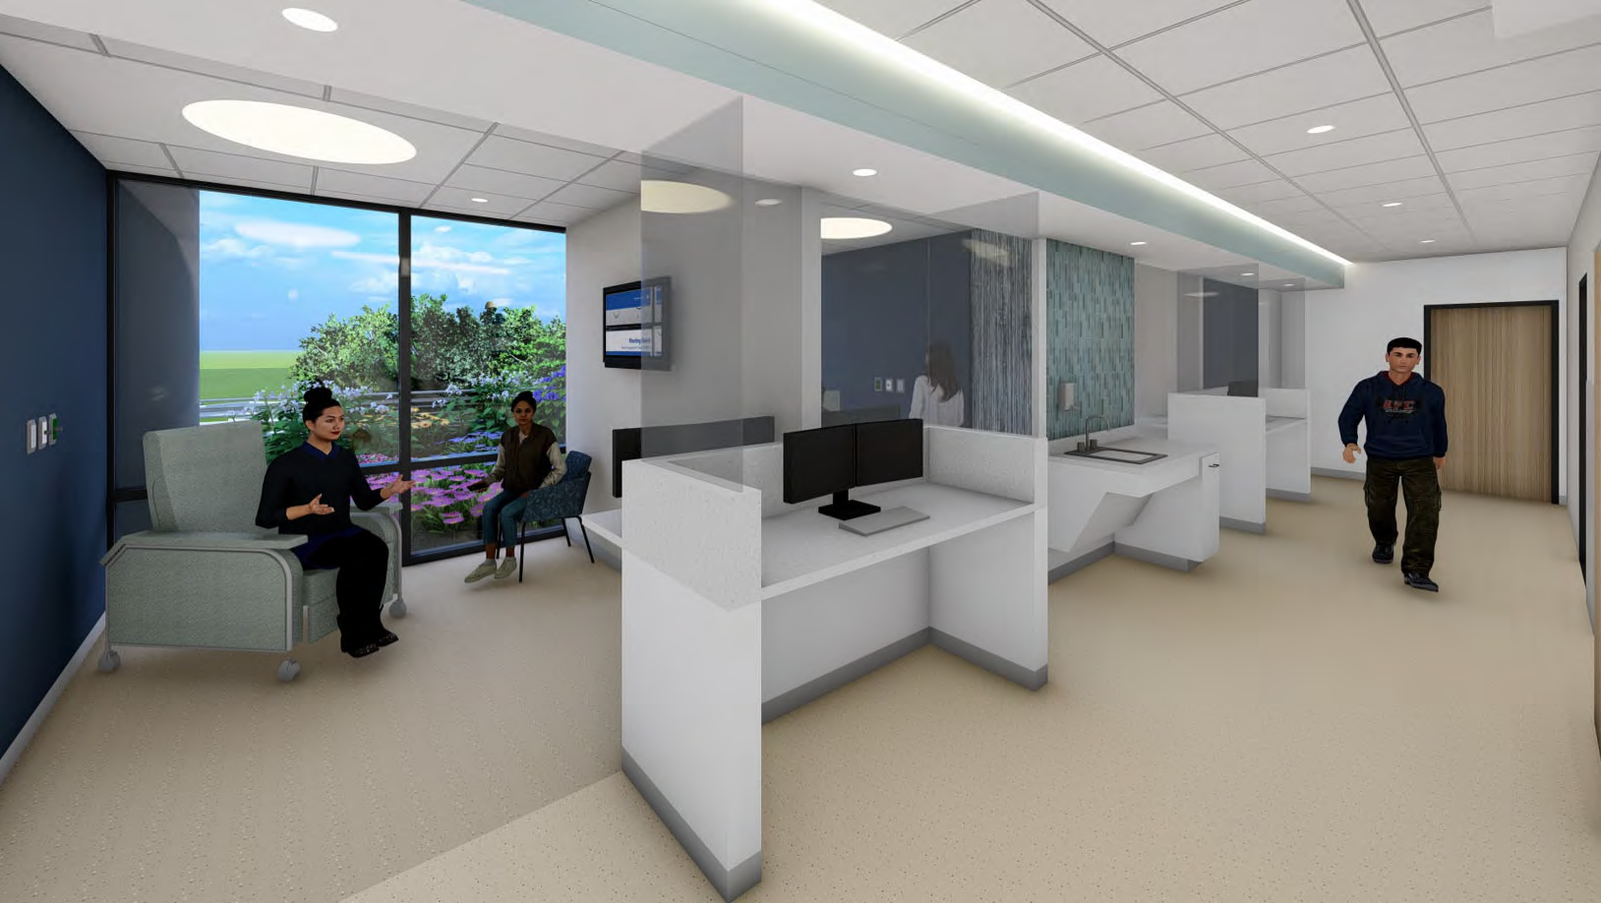
©2015 Cape Cod Healthcare Inc.

Expert physicians. Quality hospitals. Superior care.

