22

Oncology nurse station

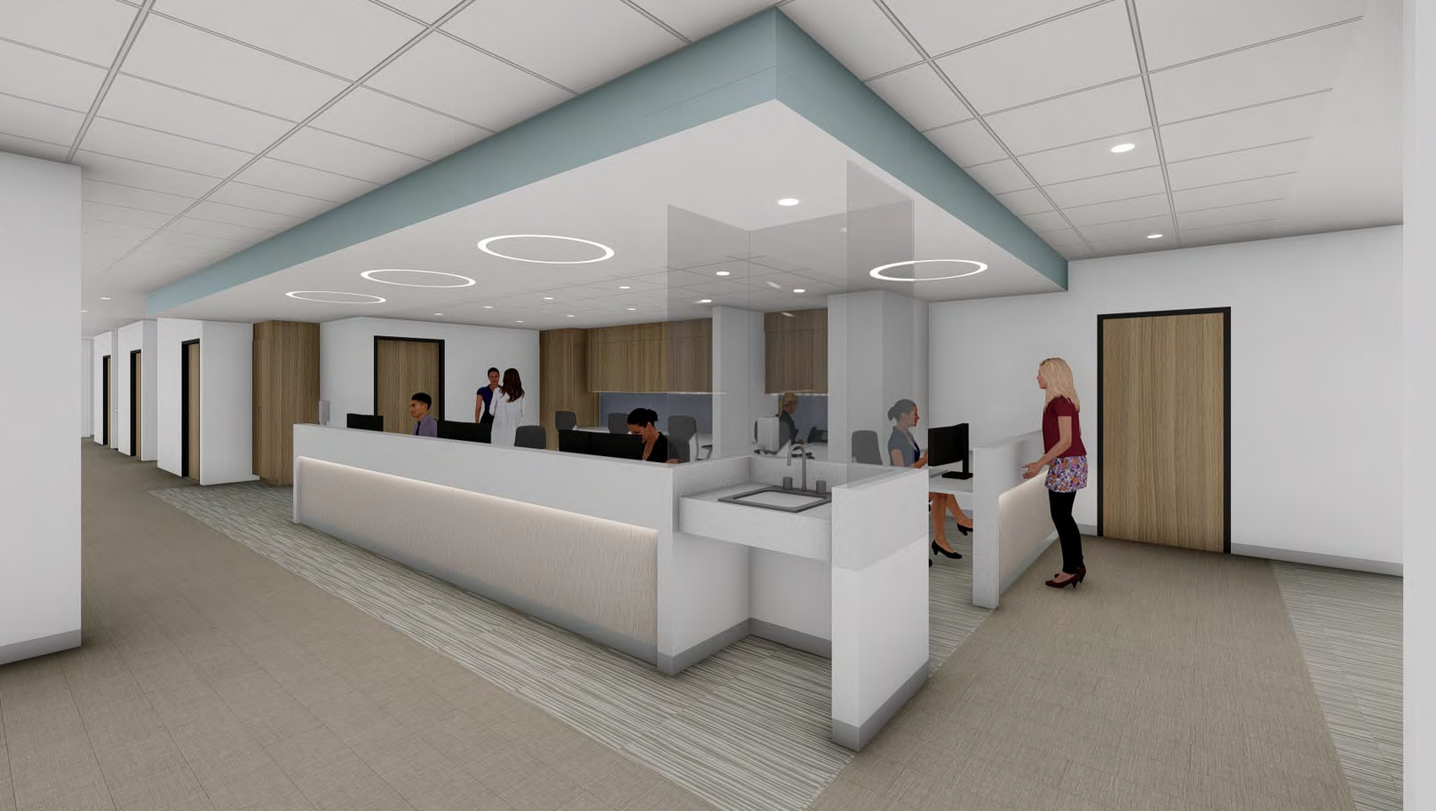
©2015 Cape Cod Healthcare Inc.

Expert physicians. Quality hospitals. Superior care.

23

3rd Floor Med Surg

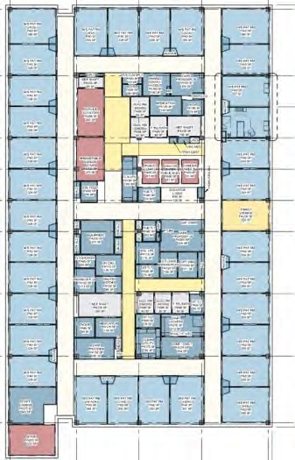
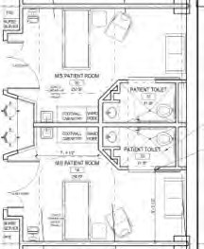

Expert physicians. Quality hospitals. Superior care.

24

3rd Floor Med Surg – Patient Room

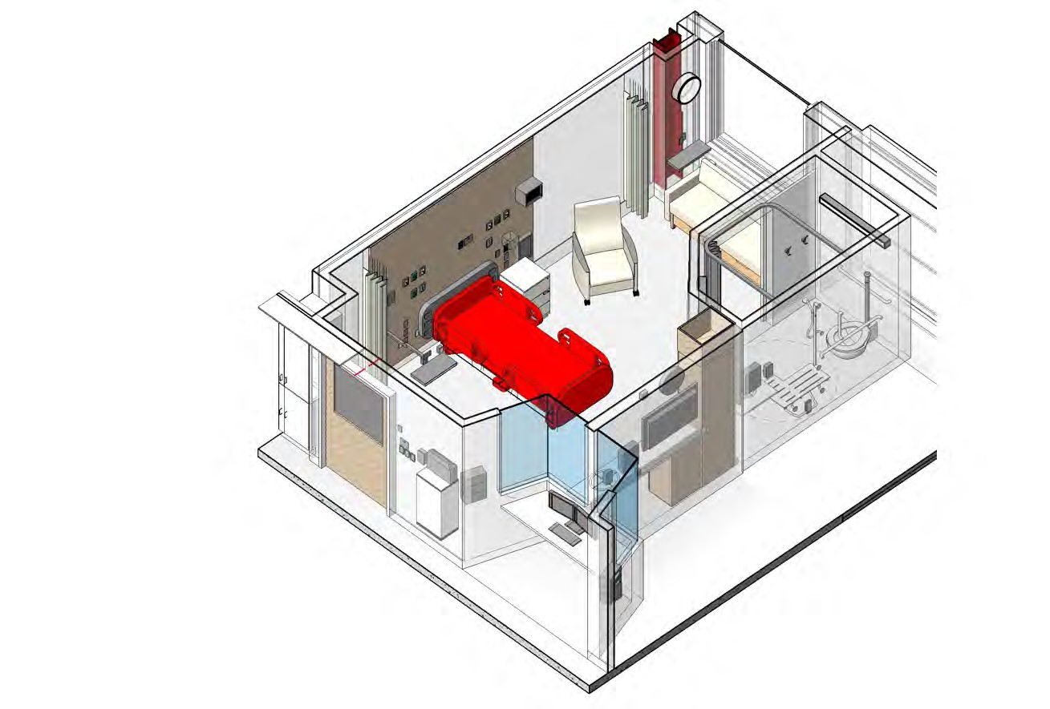

Expert physicians. Quality hospitals. Superior care.

M/S HEADWALL + FOOTWALL

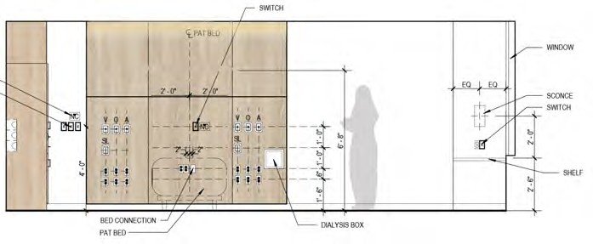
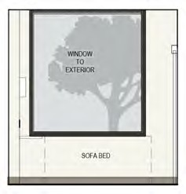
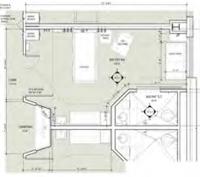
LOCATION
PLAN
4
1
2
3

1 HEADWALL ELEVATION
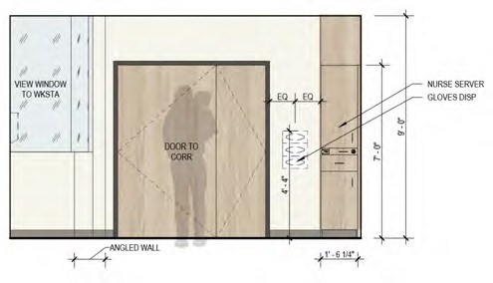
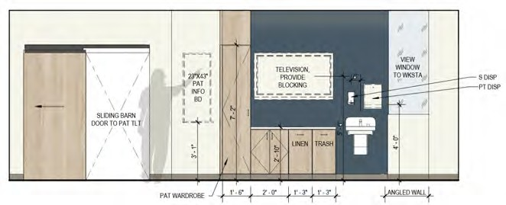

4 PATIENT ROOM
3 PATIENT ROOM – FOOTWALL
2 PATIENT ROOM

als. Superior care.

25
smithgroup.com
CAPE COD HOSPITAL CANCER & CARDIOVASCULAR ADDITION
Expert physicians. Quality hospit

M/S NURSE STATION

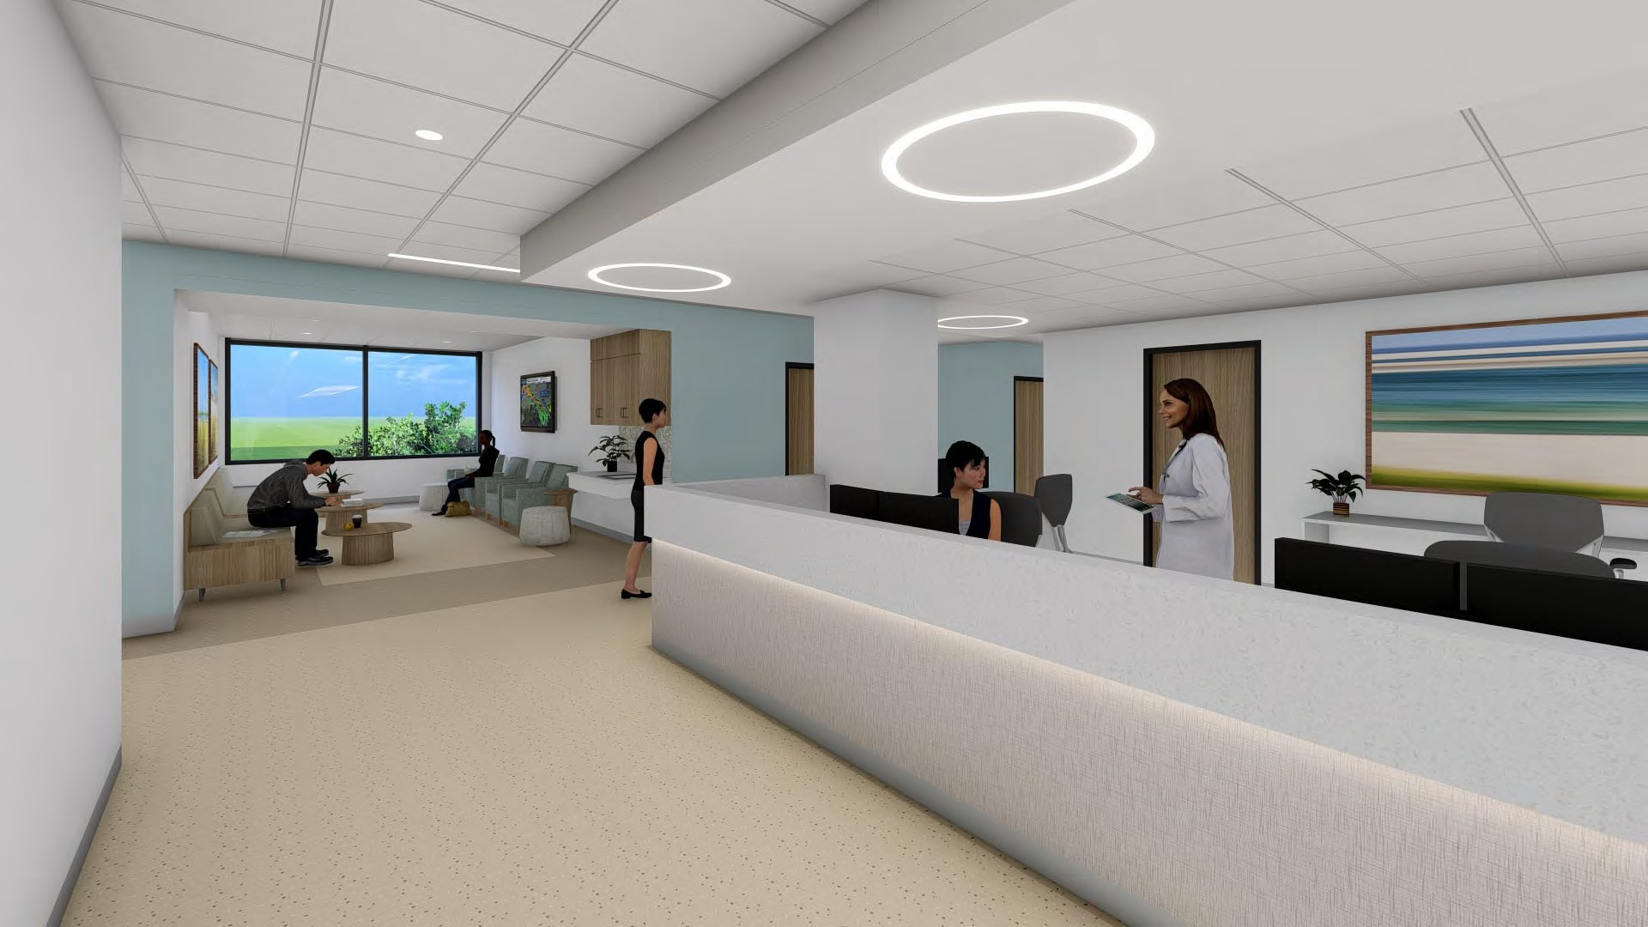

26
smithgroup.com
CAPE COD HOSPITAL CANCER & CARDIOVASCULAR ADDITION
Expert physicians. Quality hospitals. Superior care.

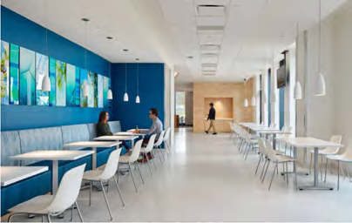
TYPICAL STAFF LOUNGE
als. Superior care.

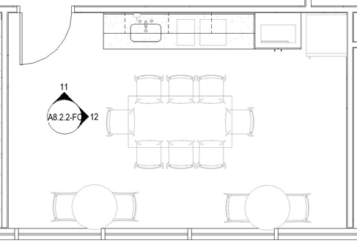
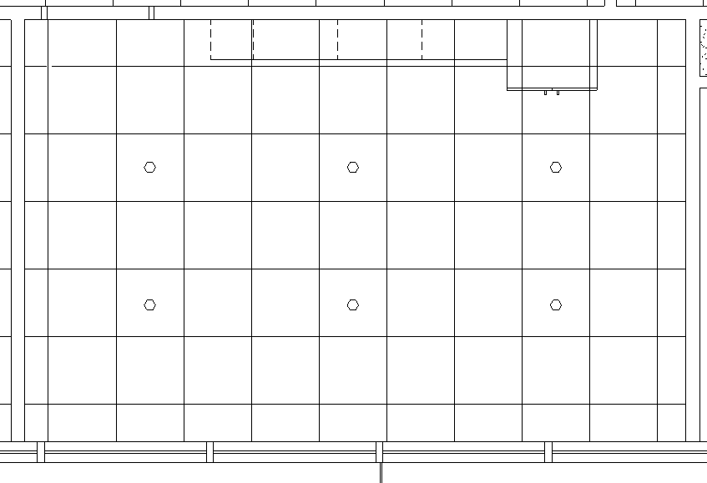
REFLECTED CEILING PLAN: FLOOR PLAN: MATERIALITY:

PLAM CABINETS

SSM COUNTERS

BACKSPLASH
ACCENT
PAINT

RESILIENT TILE FLOORING
MILLIKIN, QUIETLIFE LONGSTRAW 5MM

27
smithgroup.com
CAPE COD HOSPITAL CANCER & CARDIOVASCULAR ADDITION
Expert physicians. Quality hospit

28

Northwest View

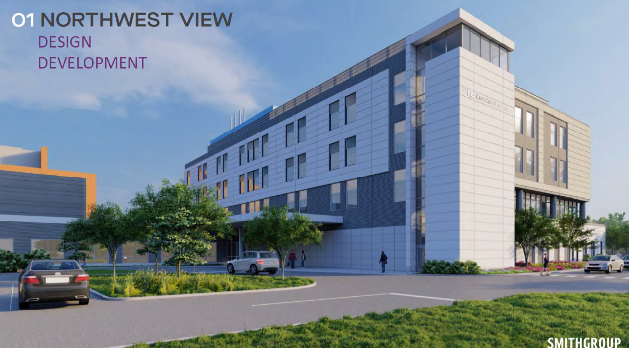

©2015 Cape Cod Healthcare Inc.

Expert physicians. Quality hospitals. Superior care.

29

Southwest View

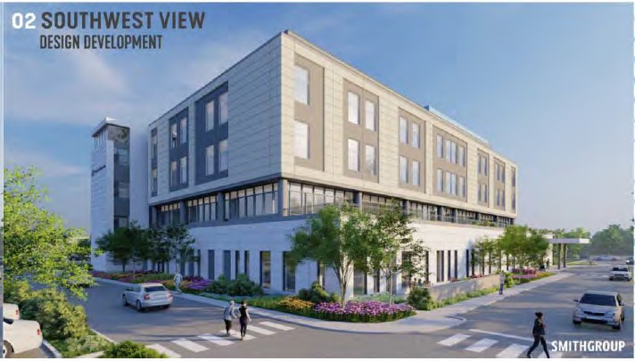

©2015 Cape Cod Healthcare Inc.

Expert physicians. Quality hospitals. Superior care.

30
Southeast view

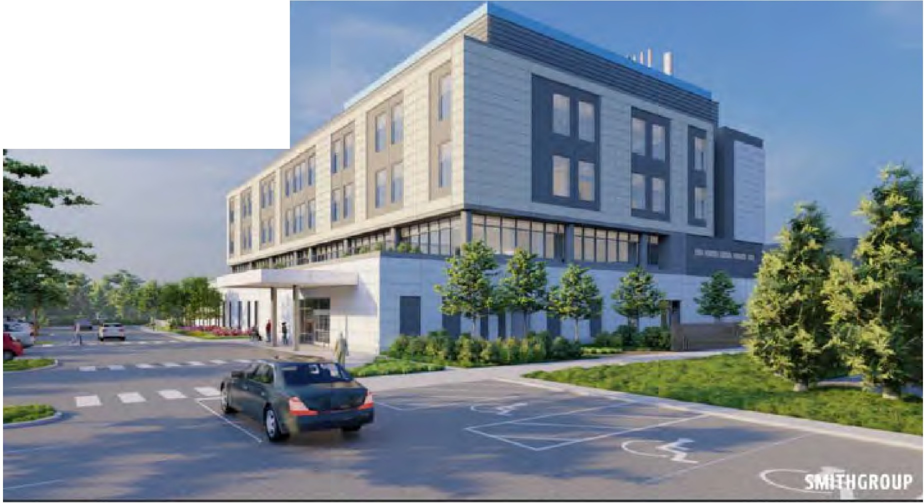
SOUTHEAST VIEW
DESlGN DEVELOPMENT

©2015 Cape Cod Healthcare Inc.

Expert physicians. Quality hospitals. Superior care.

31

Cross section

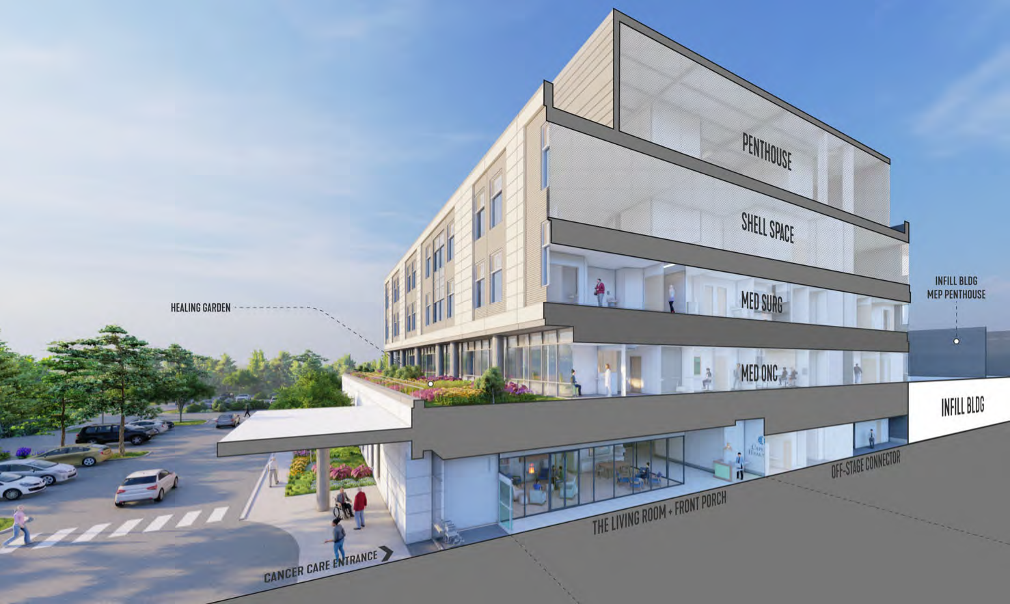
©2015 Cape Cod Healthcare Inc.

Expert physicians. Quality hospitals. Superior care.

PATIENT JOURNEY
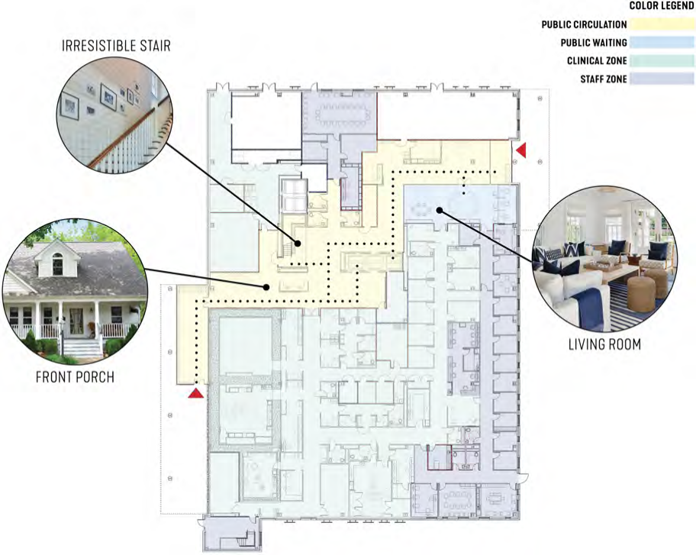

MOMENTS THAT MATTER

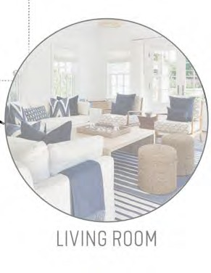

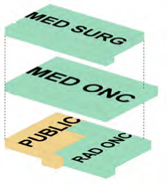
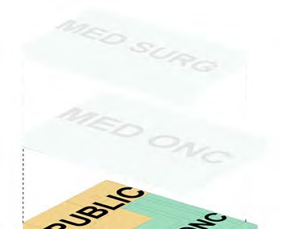

32
smithgroup.com
CAPE COD HOSPITAL CANCER & CARDIOVASCULAR ADDITION
Expert physicians. Quality hospitals. Superior care.

LOOK AND FEEL

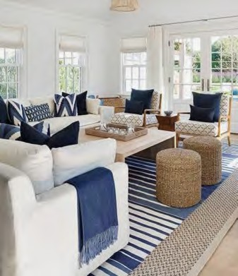
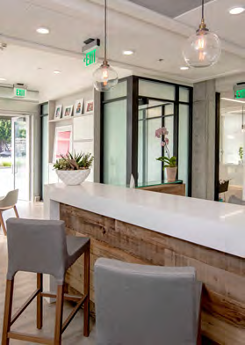
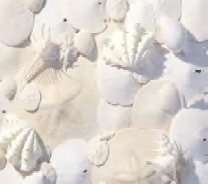
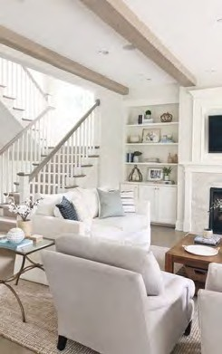
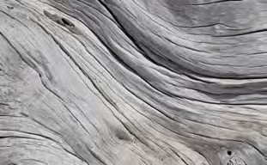
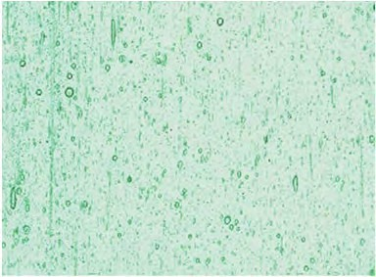
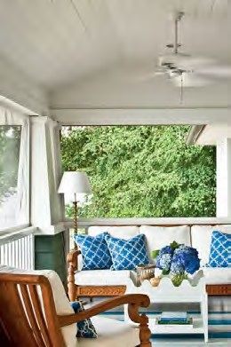
RESIDENTIAL, SOPHISTICATED, COMFORTING, TAILORED

33
smithgroup.com
CAPE COD HOSPITAL CANCER & CARDIOVASCULAR ADDITION
Expert physicians. Quality hospitals. Superior care.

MATERIAL PALETTE, PUBLIC LOBBY

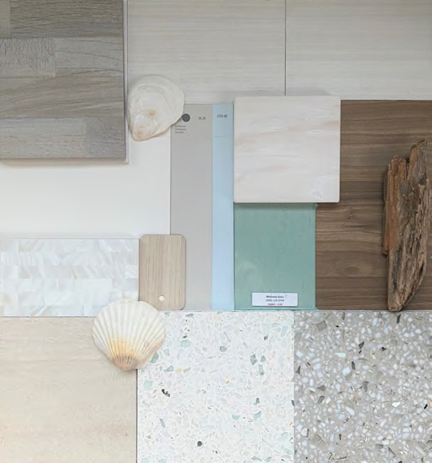

USG PLANK CEILING
SARANTE, S‐11 CRÈME OVANG

PUBLIC RECEPTION LIGHT PENDANT
SECTO DESIGN

ELEVATOR WALL TILE + FIREPLACE TILE,
BEST TILE, RESERVOIR TIMBERWOLFE
GENERAL WHITE PAINT,
BENJAMIN MOORE SIMPLY WHITE
WOOD LOOK PLASTIC LAMINATE ACCENT
NEVAMAR, MACCHIATO WF0011T
PUBLIC SOLID SURFACE
CORAIN, SAND STORMS

GENERAL NEUTRAL ACCENT PAINT,
BENJAMIN MOORE COLLINGWOOD

GENERAL ACCENT PAINT,
BENJAMIN MOORE SUMMER SHOWER
GENERAL PLASTIC LAMINATE
LAMINART, AMERICAN CHESTNUT

PUBLIC BATHROOM WALL TILE
ARTISTIC TILE WHITE RIVER RIDE

PUBLIC BATHROOM FLOOR TILE
BEST TILE, RUN SALT

SEEDED COLORED GLASS
MCGORY GLASS

PUBLIC TERRAZZO FLOORING
TM SUPPLY, CUSTOM COLORS
PUBLIC TERRAZZO ACCENT FLOORING
TM SUPPLY, CUSTOM COLORS

als. Superior care.

34
smithgroup.com
CAPE COD HOSPITAL CANCER & CARDIOVASCULAR ADDITION
Expert physicians. Quality hospit

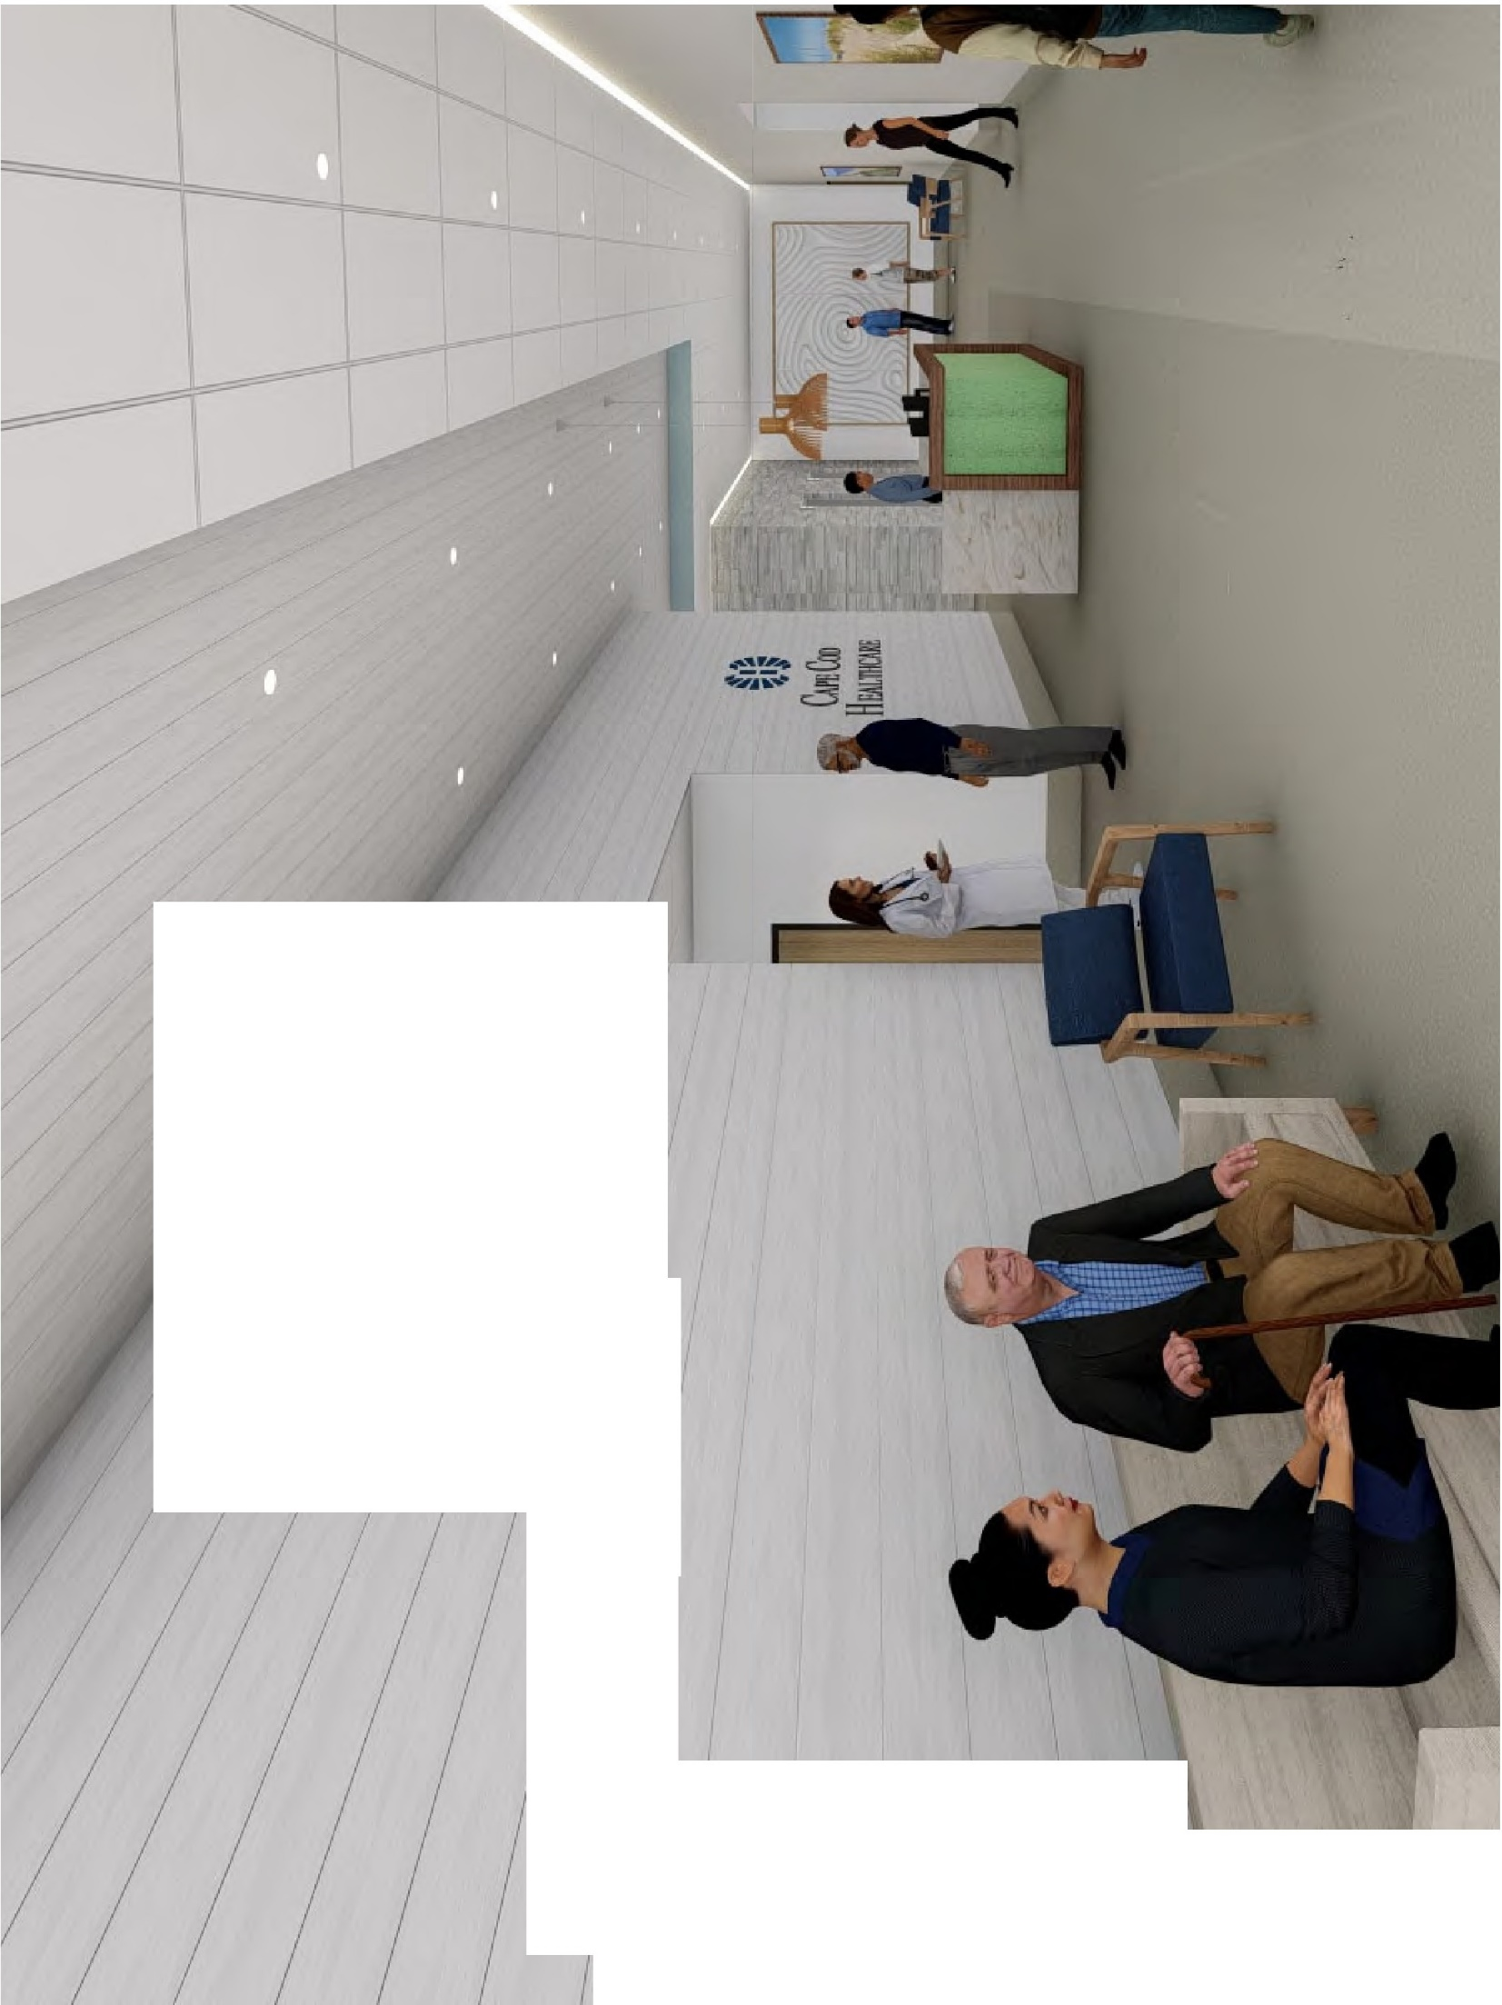

I I I
I '
I I ' I
I ,
I I
/ / / J

I /1'1/ //
I I I;! J I I
I
I

I
/

r
I
I \
\
\
\

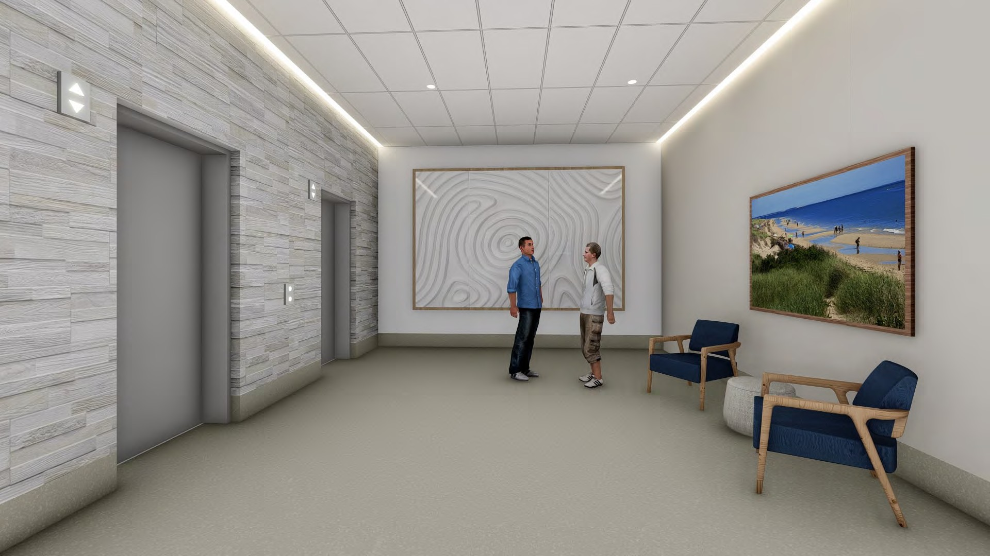

FRONT PORCH
36
smithgroup.com
CAPE COD HOSPITAL CANCER & CARDIOVASCULAR ADDITION
Expert physicians. Quality hospitals. Superior care.

37

Community Benefits and Patient Family Advisors

Cape Cod Healthcare is currently undertaking its Community Health Initiative update to be completed by summer 2022. We would expect approximately $4.5 mm of new community dollars will be awarded over a 5-year period with local, state, and DON approval of the project.

Cape Cod Healthcare is committed to providing the highest level of care in the most state of the art facilities. We believe this project will enhance our existing services and provide a place of restorative health for our patients, community and staff.

Expert physicians. Quality hospitals. Superior care.

