APPENDIX 4

FACTOR 4 EXHIBITS (FINANCIAL FEASIBILITY)

APPENDIX 4.01

F4.a.i CAPITAL COSTS CHART

Factor 4: Financial Feasibility and Reasonableness of Expenditures and Costs
Applicant has provided (as an attachment) a certification, by an independent certified public accountant (CPA) as to the availability of sufficient funds for capital and ongoing operating costs necessary to support the Proposed Projects without negative impacts or consequences to the Applicant's existing Patient Panel.
F4a.i Capital Costs Charts:
For each Functional Area document the square footage and costs for New Construction and/or Renovations
 |  | Present Square Footage |  | Square Footage Involved in Project |  |  | Resulting Square Footage |  | Total Cost |  | Cost/Square Footage
 |  |  |  | New Construction |  | Renovation
Add/Del  Rows | Functional Areas | Net | Gross | Net | Gross | Gross | Net | Gross | New Construction | Renovation | New  Construction | Renovation
Shared | Stairs/Elevators |  |  | 1023 | 1376 |  |  |  | 1,238,400 |  | 900.00
Shared | Shafts |  |  | 465 | 521 |  |  |  | 442,850 |  | 850.00
FL-1 | General Building |  |  | 5843 | 6519 |  |  |  | 5,867,100 |  | 900.00
FL-1 | MEP/IT/Building Support |  |  | 4912 | 5500
FL-1 | Off-Stage Circulation |  |  | 931 | 1019
FL 1 | Lobby |  |  | 4717 | 5049 |  |  |  | 3,281,850 |  | 650.00
FL 1 | Cancer Center |  |  | 1499 | 1648 |  |  |  | 947,600 |  | 575.00
 | Cancer Center Patient Care |  |  | 153 | 163
 | Cancer Center Conf |  |  | 724 | 764
 | Cancer Center Staff/Administrative |  |  | 497 | 585
 | Cancer Center Circulation |  |  | 125 | 136
FL 1 | Infill Shell |  |  | 16573 | 16861 | 2500 |  |  | 9,273,550 | 2,625,000 | 550.00 | 1050.00
FL 1 | Connector Circulation |  |  | 2363 | 2746 |  |  |  | 2,402,750 |  | 875.00
 | On-stage connector |  |  | 1012 | 1204
 | Off-stage connector |  |  | 1351 | 1542
FL 1 | Radiation Oncology |  |  | 14155 | 16787 |  |  |  | 14,773,903 |  | 880.08
 | Radiation Oncology Patient Care |  |  | 4862 | 6562
 | Radiation Oncology Clinical Support |  |  | 2668 | 3062
 | Radiation Oncology Staff/Administrative |  |  | 1632 | 1914
 | Radiation Oncology Waiting |  |  | 1016 | 1065
 | Radiation Oncology Circulation |  |  | 3977 | 4184
FL 2 | Medical Oncology |  |  | 19445 | 21561 |  |  |  | 16,711,284 |  | 775.07
 | Medical Oncology Patient Care |  |  | 6720 | 7752
 | Medical Oncology Clinical Support |  |  | 2380 | 2636
 | Medical Oncology Staff/Administrative |  |  | 2286 | 2554
 | Medical Oncology Circulation |  |  | 5934 | 6343
 | Medical Oncology Lab |  |  | 507 | 563
 | Medical Oncology Waiting |  |  | 1618 | 1713
FL-3 | MEP/IT/Building Support |  |  | 489 | 545 |  |  |  | 479,600 |  | 880
FL 2 | Pharmacy |  |  | 928 | 1018 |  |  |  | 2,239,600 |  | 2200
FL 2 | Infill Penthouse |  |  | 2761 | 2985 |  |  |  | 4,477,500 |  | 1500
FL 3 | Med-Surg Unit |  |  | 20618 | 24235 |  |  |  | 17,984,794 |  | 742
 | Med-Surg Patient Care |  |  | 10117 | 11992
 | Med-Surg Clinical Support |  |  | 3360 | 3762
 | Med-Surg Staff/Administrative |  |  | 1010 | 1123
 | Med-Surg Circulation |  |  | 5701 | 6849
 | Med-Surg Waiting |  |  | 430 | 509
FL-3 | MEP/IT/Building Support |  |  | 489 | 548 |  |  |  | 482,240 |  | 880
FL 4 | Shell Space |  |  | 22890 | 23815 |  |  |  | 13,098,250 |  | 550
FL-4 | MEP/IT/Building Support |  |  | 494 | 544 |  |  |  | 231,200 |  | 425
FL-4 | Shell Space Circulation |  |  | 488 | 537 |  |  |  | 295,441 |  | 550.17
FL 5 | Penthouse |  |  | 7440 | 7643 |  |  |  | 34,393,500 |  | 4500.00
 | Total: (calculated) | 0 | 0 | 123169 | 134938 | 2500 | 0 | 0 | 128,621,412 | 2,625,000 | 953.19 | 1050.00

APPENDIX 4.02 CPA REPORT

Analysis of the Reasonableness of Assumptions Used For and Feasibility of Projected Financials of:

Cape Cod Healthcare, Inc.
For the Years Ending September 30, 2022 Through September 30, 2027

The report accompanying these financial statements was issued by
BDO USA, LLP, a Delaware limited liability partnership and the U.S. member of BDO International Limited, a UK company limited by guarantee.



March 17, 2022 Richard Silveria
Chief Financial Officer Cape Cod Healthcare, Inc. 88 Lewis Bay Road Hyannis, MA 02601
Tel: 617-422-0700 One International Place
Fax: 617-422-0909 Boston, MA 02110-1745
www.bdo.com

RE: Analysis of the Reasonableness of Assumptions and Projections Used to Support the Financial Feasibility and Sustainability of the Proposed Project

Dear Mr. Silveria:

Enclosed is a copy of our report on the reasonableness of assumptions used for and feasibility of the financial projections for Cape Cod Healthcare, Inc. Please contact me to discuss this report once you have had an opportunity to review.

Sincerely,
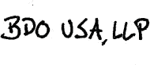

BDO USA, LLP, a Delaware limited liability partnership, is the U.S. member of BDO International Limited, a UK company limited by guarantee, and forms part of the international BDO network of independent member firms.
BDO is the brand name for the BDO network and for each of the BDO Member Firms.

TABLE OF CONTENTS

Page I. EXECUTIVE SUMMARY 1
- RELEVANT BACKGROUND INFORMATION 2
- SCOPE OF REPORT 4
- SOURCES OF INFORMATION UTILIZED 5
- REVIEW OF THE PROJECTIONS 7
- FEASIBILITY 14

March 17, 2022 Richard Silveria
Chief Financial Officer Cape Cod Healthcare, Inc. 88 Lewis Bay Road Hyannis, MA 02601
Tel: 617-422-0700 One International Place
Fax: 617-422-0909 Boston, MA 02110-1745
www.bdo.com

RE: Analysis of the Reasonableness of Assumptions and Projections Used to Support the Financial Feasibility and Sustainability of the Proposed Project

Dear Mr. Silveria:

We have performed an analysis related to the reasonableness and feasibility of the financial projections (the “Projections”) of Cape Cod Healthcare, Inc. (“CCHC” or “the Applicant”) related to its Determination of Need (“DON”) filing in connection with a planned expansion of Cape Cod Hospital located in Hyannis, Massachusetts (the “Proposed Project”), described further below. This report details our analysis and findings with regards to the reasonableness of assumptions used in the preparation of the Projections and feasibility of the projected financial results prepared by the management of CCHC (“Management”). This report is to be used by CCHC in connection with its DON Application – Factor 4 and should not be distributed or relied upon for any other purpose.

- EXECUTIVE SUMMARY

The scope of our review was limited to an analysis of the six-year financial projections for the Applicant for the fiscal years ending 2022 through 2027 prepared by Management and the supporting documentation in order to render an opinion as to the reasonableness of assumptions used in the preparation and feasibility of the Projections.


Mr. Silveria Cape Cod Healthcare, Inc.
March 17, 2022
Page 2

The Projections exhibit a cumulative operating EBITDA surplus of approximately 5.4 percent of cumulative projected revenue for CCHC for the six years from fiscal year (“FY”) 2022 through 2027. Based upon our review of the relevant documents and analysis of the Projections, we determined the anticipated operating EBITDA surplus is a reasonable expectation and based upon feasible financial assumptions. Accordingly, we determined that the Projections are reasonable and feasible, and not likely to have a negative impact on the Applicant’s patient panel or result in a liquidation of CCHC’s assets. A detailed explanation of the basis for our determination of reasonableness and feasibility is contained within this report.

- RELEVANT BACKGROUND INFORMATION

CCHC is a not-for-profit corporation that serves as the parent company of various entities providing health care services to the residents and visitors of Cape Cod, Massachusetts. The Applicant has more than 450 physicians, 5,300 employees, and 790 volunteers across two acute care hospitals, a skilled nursing and rehabilitation facility, an assisted living facility, an ambulatory surgery center, and numerous primary and specialty care physician practices along with other health programs.

Cape Cod Hospital (“CCH”), one of two CCHC hospitals (the other being Falmouth Hospital Association, Inc. (“Falmouth Hospital”)), was opened in 1920 and its main campus is comprised of several buildings built throughout the 20th century. Due to advancements in patient care techniques and utilization of diagnostic equipment in patient rooms, larger and better equipped rooms are required to serve patients both efficiently and cost effectively and remain competitive. Additionally, patient expectations for privacy and family space has led to new

Mr. Silveria Cape Cod Healthcare, Inc.
March 17, 2022
Page 3

market standards for private rooms. As such, the Applicant proposes to build a new building on the existing CCH campus. The new facility will include: (1) relocated and expanded medical oncology department; (2) relocated radiation oncology department; (3) relocated medical/surgical unit consisting of 32 beds; and (4) shell space for future projects. The Proposed Project is anticipated to be completed and in place for occupancy in October 2024.

The first and second floors of the new building will include radiation and medical oncology. The new cancer center will increase capacity as the existing space has constrained program development. The Proposed Project will increase capacity for medical oncology treatment from 19 patient bays to 36 patient bays and from 12 exam rooms to 16 exam rooms. This increased capacity for medical appointments and chemotherapy will reduce delays to beginning and receiving treatment. Additionally, the Proposed Project will centralize medical oncology services by co-locating exam rooms, infusion therapy, pharmacy services, and the oncology laboratory in one location in the new building.

The third floor will house a 32-bed cardiovascular medical/surgical unit. These beds will replace the existing 12-bed and 24-bed cardiovascular medical/surgical units housed in a 1950’s building. The Proposed Project will combine the existing smaller units into one unit, which will enable better clinical team collaboration. The patient rooms will include required bed clearance, non-slip flooring, and space for family visitation and necessary equipment.

The fourth floor will be shelled and unfinished and reserved for future use.

Mr. Silveria Cape Cod Healthcare, Inc.
March 17, 2022
Page 4

- SCOPE OF REPORT

The scope of this report is limited to an analysis of the six-year financial projections for CCHC, the Applicant, for the fiscal years ending 2022 through 2027, prepared by Management, and the supporting documentation in order to render an opinion as to the reasonableness of assumptions used in the preparation and feasibility of the Projections. Reasonableness is defined within the context of this report as supportable and proper, given the underlying information. Feasibility is defined as based on the assumptions used the Proposed Project is not likely to result in a liquidation of the underlying assets or the need for reorganization.

This report is based on prospective financial information provided to us by Management. BDO understands the prospective financial information was developed as of March 11, 2022 and is still representative of Management’s expectations as of the drafting of this report. BDO has not audited or performed any other form of attestation services on the projected financial information related to the operations of CCHC.

If BDO had audited the underlying data, matters may have come to our attention that would have resulted in our using amounts that differ from those provided. Accordingly, we do not express an opinion or any other assurances on the underlying data presented or relied upon in this report. We do not provide assurance on the achievability of the results forecasted by the Applicant because events and circumstances frequently do not occur as expected, and the achievement of the forecasted results are dependent on the actions, plans, and assumptions of Management. We reserve the right to update our analysis in the event that we are provided with additional information.

Mr. Silveria Cape Cod Healthcare, Inc.
March 17, 2022
Page 5

- SOURCES OF INFORMATION UTILIZED

In formulating our opinions and conclusions contained in this report, we reviewed documents produced by Management as well as third party industry data sources. The documents and information upon which we relied are identified below or are otherwise referenced in this report:

  - Financial Model for CCHC for the periods ending September 30, 2019 through September 30, 2027, including three-year historical and six-year income statement, balance sheet, and cash flow;
  - Key Ratios for the periods ending September 30, 2019 through September 30, 2027;

  - Global Baseline Model Assumptions for CCHC;

  - Assumptions for 6 Year Planning for CCHC;

  - Key Operating Statistics for Baseline, Trauma, and Tower;

  - Budget Fiscal Year 2022 Board Presentation dated September 13, 2021;

  - Summary Visits and Discharges for Year-to-Date December 31, 2020 and December 31, 2021;
  - Cape Cod Hospital Cancer and Cardiology Expansion Project Overview Presentation;

  - CCHC DON Long Range Plan Draft Presentation dated January 14, 2022;

  - Tower Project Spend Budget Summary;

  - Draft CCH Tower Narrative for DON Application;

  - Draft Capital Expenditure Tables for DON Application;

  - PP&E Rollforward for FY21 through FY27;

  - Design Build Proposal from SmithGroup dated July 22, 2021;

Mr. Silveria Cape Cod Healthcare, Inc.
March 17, 2022
Page 6

  - Owners Project Manager Services Proposal from MEDCOM Architectural Group, LLC dated August 12, 2021;
  - Commissioning Fee Proposal from CMTA dated January 11, 2022;

  - Suffolk Construction Company, Inc. Conceptual Estimate dated September 7, 2021;

  - Telemetry Budget Proposal from Nihon Kohden dated January 27, 2022;

  - Preconstruction Services Agreement between CCHC and Suffolk Construction Company, Inc. and Associated Amendments;
  - Equipment Item Summary related to the Proposed Project provided by Shen Milsom & Wilke LLC;
  - Unaudited Combined Financial Report for Cape Cod Healthcare for the Period Ended November 30, 2021, including an actual-to-budget comparison of operating performance;
  - Unaudited Statement of Operations and Change in Unrestricted Net Assets for Cape Cod Healthcare for the Period Ended December 31, 2021, including an actual-to-budget and an actual-to-prior year comparison of operating performance;
  - Audited Consolidated Financial Statements and Supplemental Consolidating Information for CCHC and Affiliates for Fiscal Year Ending September 30, 2021 and 2020;
  - Audited Consolidated Financial Statements and Supplemental Consolidating Information for CCHC and Affiliates for Fiscal Year Ending September 30, 2020 and 2019;
  - Integra Reports, published by MicroBilt Corporation;

  - Definitive Healthcare data;

  - IBISWorld Industry Report, Hospitals in the US, dated November 2021; and

  - Determination of Need Application Instructions dated March 2017.

Mr. Silveria Cape Cod Healthcare, Inc.
March 17, 2022
Page 7

- REVIEW OF THE PROJECTIONS

This section of our report summarizes our review of the reasonableness of the assumptions used and feasibility of the Projections.

The following tables present the Key Metrics, as defined below, which compare the operating results of the Projections to market information from Integra Reports (“Integra”), IBISWorld, and Definitive Healthcare as well as the Applicant’s historical performance, to assess the reasonableness of the projections.

Key Financial Metrics and Ratios Projected
Cape Cod Healthcare, Inc. |  | 2022 |  | 2023 |  | 2024 | 2025 | 2026 | 2027
Profitability
Operating Margin (%) |  | 0.7% |  | 1.3% |  | 1.6% | 1.5% | 1.6% | 1.6%
Excess Margin (%) |  | 1.9% |  | 2.4% |  | 2.6% | 2.4% | 2.6% | 2.5%
Debt Service Coverage Ratio (x) |  | 3.5x |  | 4.9x |  | 6.0x | 6.6x | 7.0x | 7.0x
Liquidity
Days Available Cash and Investments on Hand (#) |  | 227.5 |  | 220.3 |  | 201.0 | 204.7 | 210.4 | 214.5
Operating Cash Flow (%) |  | 4.5% |  | 4.9% |  | 5.4% | 5.5% | 5.6% | 5.4%
Solvency
Current Ratio (x) |  | 1.5x |  | 1.5x |  | 1.5x | 1.5x | 1.5x | 1.5x
Ratio of Long Term Debt to Total Capitalization (%) |  | 10.1% |  | 8.7% |  | 7.5% | 6.4% | 5.2% | 4.3%
Ratio of Cash Flow to Long Term Debt (%) |  | 48.1% |  | 61.3% |  | 77.8% | 94.3% | 115.8% | 139.4%
Unrestricted Net Assets ($ in thousands) | $ | 840,887 | $ | 874,278 | $ | 913,078 | $ 951,867 | $ 993,284 | $ 1,032,511
Total Net Assets ($ in thousands) | $ | 919,458 | $ | 953,663 | $ | 991,733 | $ 1,026,308 | $ 1,063,035 | $ 1,100,156

Mr. Silveria Cape Cod Healthcare, Inc.
March 17, 2022
Page 8

Key Financial Metrics and Ratios Actual Industry Data (1) Integra - General
Medical and IBIS - Hospitals Definitive
Cape Cod Healthcare, Inc. 2019 2020 2021 Surgical Hospitals in the US Healthcare
Profitability
Operating Margin (%) 2.3% -1.2% -1.2% 3.5% 7.0% -9.2%
Excess Margin (%)  Debt Service Coverage Ratio (x) |  | 4.3%  5.2x |  | 0.5%  3.9x |  | 3.3%  4.8x |  | 1.4%  1.4x | NA  14.3x | -1.5%  NA
Liquidity  Days Available Cash and Investments on Hand (#) |  | 205.4 |  | 298.2 |  | 285.5 |  | NA | NA | 31.0
Operating Cash Flow (%) |  | 6.6% |  | 4.9% |  | 3.4% |  | 7.0% | 55.7% | NA
Solvency
Current Ratio (x) |  | 1.7x |  | 1.2x |  | 1.3x |  | 2.5x | 1.1x | 0.6x
Ratio of Long Term Debt to Total Capitalization (%) |  | 15.2% |  | 13.7% |  | 11.6% |  | 43.1% | NA | NA
Ratio of Cash Flow to Long Term Debt (%) |  | 47.9% |  | 37.4% |  | 30.2% |  | 25.8% | NA | NA
Unrestricted Net Assets ($ in thousands) | $ | 751,514 | $ | 772,039 | $ | 808,869 |  | NA | NA | NA
Total Net Assets ($ in thousands) | $ | 817,179 | $ | 844,466 | $ | 892,989 | $ | 1,935,790 | NA | NA

(2)

Footnotes:
- Industry data ratios based on each data source's respective definitions and may differ from the ratio definitions listed below.
- Net income margin from Integra and Definitive Healthcare data treated as an equivalent to excess margin.

The Key Metrics fall into three primary categories: profitability, liquidity, and solvency. Profitability metrics are used to assist in the evaluation of management performance in how efficiently resources are utilized. Liquidity metrics, including common ratios such as “days of available cash and investments on hand”, measure the quality and adequacy of assets to meet current obligations as they come due. Solvency metrics measure the company’s ability to take on and service debt obligations. Additionally, certain metrics can be applicable to multiple categories. The table below shows how each of the Key Metrics are calculated.

Mr. Silveria Cape Cod Healthcare, Inc.
March 17, 2022
Page 9

Key Financial Metrics and Ratios
Ratio Definitions | Calculation
Profitability
Operating Margin (%) | Excess of Revenue over Expenses from Operations Divided by Total Operating Revenue

Excess Margin (%) | Excess of Revenue over Expenses Divided by (Total Operating Revenue + Net Non-Operating Revenue)
Debt Service Coverage Ratio (x) | (Excess of Revenue over Expenses + Depreciation and Amortization + Interest) Divided by (Principal
 | Payments and Interest)
Liquidity
Days Available Cash and Investments on Hand (#) | (Cash and Board Designated Investments) Divided by [(Total Operating Expenses Less Depreciation and  Amortization) / 365]
Operating Cash Flow (%) | (Excess of Revenue over Expenses from Operations Plus Depreciation and Amortization) Divided by
 | Total Operating Revenue
Solvency
Current Ratio (x) | Current Assets Divided by Current Liabilities
Ratio of Long Term Debt to Total Capitalization (%) Long Term Debt Divided by Total Capitalization (Long Term Debt and Unrestricted Net Assets)

Ratio of Cash Flow to Long Term Debt (%) (Excess of Revenue over Expenses from Operations Plus Depreciation and Amortization) Divided by
Long Term Debt Unrestricted Net Assets ($ in thousands) Total Unrestricted Net Assets

Total Net Assets ($ in thousands) Total Fund Balance

- Revenue

We analyzed the projected revenue within the Projections. Revenue for the Applicant includes net patient service revenue (“NPSR”) and other operating revenue. Historically, approximately
63.5 percent of revenue is derived from CCH and 17.5 percent from Falmouth Hospital. The remainder of revenue is derived from the Applicant’s other entities, including revenue recorded by the parent company itself, the Cape Cod Healthcare Foundation, Inc., Medical Affiliates of Cape Cod, Inc., Visiting Nurse Association of Cape Cod, JML Care Center, Inc., Cape and Islands Health Services II, Inc., Falmouth Assisted Living, Inc., Cape Cod Human Services, Inc., Cape Health Insurance Company, and Cape Cod Research Institute. Approximately 93.0 percent of revenue is derived from net patient service revenue.

Mr. Silveria Cape Cod Healthcare, Inc.
March 17, 2022
Page 10

NPSR is projected to grow between 2.9 percent and 4.0 percent annually between FY 2023 and FY 2027 which is below actual growth of 6.8 percent in FY 2021. NPSR in FY 2022 is projected to grow 8.2 percent. We understand FY 2022 is based on the Applicant’s Board-approved budget, adjusted following the Applicant’s performance in the first quarter of 2022. BDO reviewed the Applicant’s year-to-date results as of December 31, 2021 and compared the results to the first quarter budget as well as the prior year actuals for the same period. We understand growth in FY 2022 relates to patients who had put off care due to the coronavirus pandemic (“COVID-19”) as well as increases in laboratory volumes related to testing and vaccinations.

Based upon our discussions with Management and the documents provided, the projected net patient service revenue was estimated based upon Management’s anticipated changes in the following categories:

Inpatient Discharges Growth

Inpatient discharges for FY 2022 are estimated at 6.0 percent for CCH and 4.0 percent for Falmouth Hospital. Thereafter, inpatient discharges at CCH and Falmouth Hospital are projected to grow 1.0 percent annually between FY 2023 and FY 2027. Management also included an estimated 95 inpatient discharges in FY 2023 and 379 inpatient discharges annually from FY 2024 through FY 2027 related to trauma as CCH is developing a trauma program and expected to be certified as a Level III Trauma Center in January of FY 2023. No additional inpatient discharges were included within the Projections related to the Proposed Project.

Mr. Silveria Cape Cod Healthcare, Inc.
March 17, 2022
Page 11

Outpatient Visits Growth

Outpatient visits are expected to grow 8.3 percent in FY 2022, between 3.0 percent and 3.2 percent for FY 2023 through FY 2025, and 1.6 percent for FY 2026 and FY 2027. Projected growth in outpatient visits is below historical growth of 16.3 percent in 2022. Outpatient visits related to the Applicant’s trauma program were estimated at 44 visits in FY 2023 and 175 outpatient visits annually from FY 2024 through FY 20327 These outpatient visits related to trauma are included within the noted growth rates. No additional outpatient visits were included within the Projections related to the Proposed Project.

Reimbursement Inflation Rates by Payor

Projected payor increases were provided by the physician hospital organization for non- government payor and any non-negotiated years were projected to increase at an annual rate of 2.0 percent. Medicare and Mass Health are projected to increase 1.0 percent and 0.5 percent annually, respectively. The Applicant’s payor mix is based on the actual payor mix in FY 2021, adjusted in FY 2023 and FY 2024 by a 0.5 percent increase from Medicare to commercial.

The Proposed Project has been designed to meet the healthcare needs of the Cape Cod community. As a result, the Projections do not include incremental revenue related to the Proposed Project.

In order to determine the reasonableness of the projected revenue, we reviewed the underlying assumptions upon which Management relied. Based upon our review, Management relied upon the historical operations and anticipated market movements. Based upon the foregoing, it is

Mr. Silveria Cape Cod Healthcare, Inc.
March 17, 2022
Page 12

our opinion that the revenue growth projected by Management is based on a reasonable estimation of future revenue of CCHC.

- Operating Expenses

We analyzed each of the categorized operating expenses for reasonableness and feasibility as it related to the Projections.

The operating expenses in the analysis include salaries and wages, employee benefits, professional fees, supplies, purchased services, depreciation and amortization, interest, and other expense. Salaries and wages account for approximately 47.0 percent of total operating expenses and supplies account for approximately 20.0 percent of total operating expenses.

Salaries and wages were projected to increase 7.5 percent in FY 2022 and between 2.8 percent and 3.6 percent between FY 2023 and FY 2027. Growth in salaries and wages includes an increase in full time equivalents (“FTEs”) and an inflationary increase in salaries/wages. Salary increases for CCH and Falmouth Hospital are based on negotiated contracts, where available. For non-negotiated years, an annual salary increase of 3.0 percent was assumed for union employees and 2.0 percent for non-union employees. A net change of 331 FTEs is expected over the projection period, with 13 of these (FTEs) relating to the Proposed Project. The remaining increase in FTEs relates to growth in discharges and visits and the trauma program.

Supplies were projected to increase 9.3 percent in FY 2022, 0.2 percent in FY 2023, and between 3.0 percent and 3.5 percent annually for FY 2024 through FY 2027. Projected growth

Mr. Silveria Cape Cod Healthcare, Inc.
March 17, 2022
Page 13

in supplies, with the exception of FY 2022, falls within the historical range of growth from -3.6 percent to 7.4 percent.

Based upon the foregoing, it is our opinion that the operating expenses projected by Management are based on a reasonable estimation of future expenses of the Applicant.

- Capital Expenditures and Proposed Project Financing

We reviewed the project costs within the Projections related to the Proposed Project which totaled $172.6M, of which $137.0 million are classified as maximum capital expenditures per Management under the DON regulations. The total project costs related to the Proposed Project are included within the Projections between FY 2022 and FY 2026, with the majority incurred in FY 2023 and FY 2024. The Projections also include routine capital expenditures of $14.4 million annually. The total project cost budget for the Proposed Project was based primarily on the following, which were obtained and reviewed by BDO: (1) a construction estimate by the construction manager, Suffolk Construction Company, Inc. and (2) an equipment listing estimate provided by Shen Milsom & Wilke LLC. We note that construction cost of $137.8M is approximately 80.0 percent of the total project cost for the Proposed Project.

In addition to capital expenditures, we also reviewed the proposed financing of the Proposed Project. It is our understanding that the expenditures related to the Proposed Project are expected to be funded through the Applicant’s net assets and cash flows and that the Applicant liquidated some of the investment pool for use in funding the Proposed Project. The capital expenditures are included within the Applicant’s cash flows with no additional debt financing

Mr. Silveria Cape Cod Healthcare, Inc.
March 17, 2022
Page 14

anticipated. We note that the Projections include cumulative capital expenditures of $336.5M, of which the Proposed Project will represent approximately 51.3 percent. We note the model indicates a decline in the total cash balance in FY 2022 through FY 2024, while maintaining a healthy days available cash and investments on hand ratio, before increasing again in FY 2025 through FY 2027. Therefore, there appears to be sufficient room to accommodate the financing for the Proposed Project within the Application’s normal capital expenditures without the need for debt financing.

- FEASIBILITY

We analyzed the Projections and Key Metrics for the Proposed Project. In preparing our analysis we considered multiple sources of information including industry metrics, historical results, and Management expectations. It is important to note that the Projections do not account for any anticipated changes in accounting standards. These standards, which may have a material impact on individual future years, are not anticipated to have a material impact on the aggregate Projections.

Within the projected financial information, the Projections exhibit a cumulative operating EBITDA surplus of approximately 5.4 percent of cumulative projected operating revenue for the six years from 2022 through 2027. Based upon our review of the relevant documents and analysis of the Projections, we determined the anticipated operating surplus is a reasonable expectation and based upon feasible financial assumptions. Accordingly, we determined that the Projections are reasonable and feasible, and not likely to have a negative impact on the patient panel or result in a liquidation of assets of CCHC.

Mr. Silveria Cape Cod Healthcare, Inc.
March 17, 2022
Page 15

Respectively submitted,
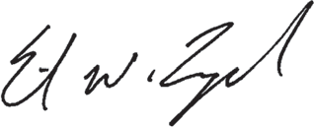

Erik Lynch
Partner, BDO USA LLP

APPENDIX 5

FACTOR 6 EXHIBITS

(COMMUNITY HEALTH INITIATIVE)

APPENDIX 5.01 CHI NARRATIVE

CAPE COD HEALTHCARE
DoN Community Health Initiative Narrative

- Community Health Initiative Monies

The breakdown of Community Health Initiative (“CHI”) monies for the Proposed Project is as follows. Please note, all totals are presented in the order calculated, beginning with the Maximum Capital Expenditure (“MCE”).

 | Total | Description
MCE | $137,048,632.00
CHI Monies | $6,852,431.60 | (5% of Maximum Capital Expenditure)
Administrative Fee | $137,048.63 | (2% of the CHI Monies, retained by CCHC)
Remaining Monies | $6,715,382.97 | (CHI Monies minus the Administrative fee)
Statewide Initiative | $1,678,845,74 | (25% of remaining monies, paid to State-wide fund)
Local Initiative | $5,036,537.23 | (75% of remaining monies)
Evaluation Monies | $503,653.72 | (10% of Local Initiative Monies, retained by CCHC)
CHI Monies for Local Disbursement | $4,532,883,51

- Overview and Discussion of CHNA/DoN Processes

The Community Health Initiative (“CHI”) processes and community engagement for the proposed Determination of Need (“DoN”) Project1 will be conducted by Cape Cod Healthcare (“CCHC” or the “Applicant”). Cape Cod Healthcare is the predominant provider of healthcare services for residents and visitors of Cape Cod. With more than 450 physicians, 5,300 employees and 790 volunteers, Cape Cod Healthcare includes two acute care hospitals, homecare and hospice services, a skilled nursing and rehabilitation facility, an assisted living facility, an ambulatory surgery center, and numerous primary and specialty care physician practices along with many other health programs.

CCHC is currently conducting its triennial community health needs assessment (“CHNA”) which will serve as the basis for its 2023-2025 implementation plan. The purpose of the CHNA is to undertake a data- driven and community-led process that identifies and prioritizes the health needs of residents of the region based on the frequency, size, scope, and magnitude of the issues. To accomplish this, the CHNA will include two phases:
- a community health needs assessment (CHNA) to identify the health-related needs and strengths of the region; and
- a strategic implementation plan to identify major health priorities, develop goals, select strategies and identify partners to address these priority issues across the region.

As with prior CHNAs, the CHNA will use a participatory, collaborative approach and examine health in its broadest context. Many sources and data collection methodologies are used to obtain a comprehensive view of the health and health care needs of the region and the people served by CCH and FH. Input on the design of data collection instruments is solicited from public health experts, health care consumers, and persons representing vulnerable and medically underserved populations and minorities. Conscientious efforts will be made to reach a wide-ranging population of residents during data collection to ensure

1 This Application requests approval for the construction of a new facility at Cape Cod Hospital that will include (1) the relocation and expansion of the medical oncology service, (2) the relocation of the radiation therapy service, and (3) the relocation of one (1) medical-surgical inpatient unit. The new facility will also include shell space for future projects as demand dictates.

broad representation of community interests and perspectives. Data sources include secondary data, community stakeholder conversations, interviews, focus groups, and a community survey.

As a result of these efforts, the CHNA will provide valuable information to:
- Identify vulnerable, disadvantaged, and medically underserved target population
- Identify key areas of significant community need and vulnerable populations
- Examine the impact and role of social determinants of health in the community
- Monitor regional health data and maintain an inventory of available resources
- Facilitate the development of multi-year implementation strategies to guide hospital community health initiatives and community investments to improve health; and
- Promote partnership and dialogue between the hospitals and community organizations

- Oversight of the CHI Process

CCHC’s Community Health Committee will serve as the CHI’s Advisory Board (“CAB”). The CAB is comprised of individuals from across the Cape and Islands as well as a variety of public and private agencies that enable the CAB to meaningfully represent the community throughout the CHI process.

- Advisory Committee Duties

The scope of work that the Committee will carry out includes:

- Ensuring appropriate engagement with residents from targeted communities and community partners around the CHI.
- Determining the Health Priorities for CHI funding based upon the needs identified in the 2023 CHNA/CHIP. Further, the CAB will ensure that all Health Priorities are aligned with the Department of Public Health’s Health Priorities and the Executive Office of Health and Human Services’ Focus Areas.
- Providing oversight to the evaluator that is carrying out the evaluation of CHI-funded projects.
- Participating in a conflict-of-interest disclosure process to determine which members also will comprise the Allocation Committee (see below).

- Allocation Committee Duties

The Allocation Committee will be comprised of individuals from the CAB who do not have a conflict of interest in regard to funding. The scope of work that the Allocation Committee will carry out includes:

- Selecting Strategies for the noted Health Priorities.
- Completing and submitting the Health Priorities and Strategies Selection Form for approval by the Department of Public Health.
- Carrying out a formal request for proposal (“RFP”) process (or an equivalent, transparent process) for the disbursement of CHI funds.
- Engaging resources that can support and assist applicants with their responses to the RFP.
- Disbursement of CHI funding.
- Providing oversight to a third-party vendor that is selected to carry out the evaluation of CHI- funded projects.

2
664236.1

- Timeline for CHI Activities

Upon a Notice of Determination of Need being issued by the Public Health Council, the CAB will commence meeting and begin the CHI Process. The timeline for CHI activities is as follows:

- Six weeks post-approval: The CAB will begin meeting and reviewing the 2023 CHNA/CHIP to commence the process of selecting Health Priorities.
- Three – four months post-approval: The CAB has determined Health Priorities for funding.
- Four – five months post-approval: The Allocation Committee is selecting strategies for the Health Priorities and will submit the Health Priorities and Strategies Form to the Department.
- Five – six months post-approval: The Allocation Committee is developing the RFP process and determining how this process will work in tandem with CCHC’s current grant efforts.
- Five – six months post-approval: CCHC will commence working with the evaluator that will serve as a technical resource to grantees.
- Nine months post-approval: The RFP for funding is released.
- Ten months post-approval: Bidders conferences are held on the RFP.
- Twelve months post-approval: Responses are due for the RFP.
- Fifteen months post-approval: Funding decisions are made, and the disbursement of funds begins.
- Eighteen months to six years post-approval: Evaluation efforts and reporting is ongoing.

- Request for Additional Years of Funding

CCHC is seeking additional time to carry out the disbursement of funds for CHI. Based on CCHC’s previous experience with providing grant funding, CCHC is seeking to distribute funds over five years. As a result of the longer time frame, CCHC intends to fund several multi-year grants with CHI funding.
Therefore, CCHC is seeking to disburse these monies over a five-year period to ensure the greatest impact for the largest number of individuals.

- Evaluation Overview

CCHC is seeking to use 10% of local CHI funding ($503,653.72) for evaluation efforts. These monies will allow Applicant to engage a third-party evaluator to carry out technical assistance and ensure appropriate evaluation of the CHI-funded projects.

- Administrative Monies

Applicants submitting a Tier 3 CHI are eligible for a two percent (2%) administrative fee. Accordingly, Applicant is requesting $137,048.63 in administrative funding. These monies are critical in developing a sound CHI process that complies with the Department of Public Health’s expectations as administrative funding will be used to hire additional support staff. These monies will also pay for reporting and dissemination of promising practices and lessons learned, facilitation support for the CAB and Allocation Committee, costs associated with the development of communication materials and placement of procurement information in community newspapers. Finally, these monies will help to offset the costs of the development and implementation of the RFP process.

APPENDIX 5.02 CHNA/CHIP SELF-ASSESSMENT FORM

CCH & FH CHNA & IP 2020 - 2022

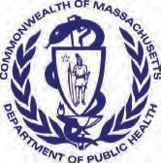
Massachusetts Department of Public Health Determination of Need
Community Health Initiative CHNA / CHIP Self Assessment

Version: 8-1-17

This self-assessment form is to understand the Community Engagement process that has led/ will lead to the identification of priorities for community health planning processes. It is being used to demonstrate to DPH that an existing community health planning process adequately meets DPH standards for community engagement specific to Determination of Need, Community Health Initiative purposes.

This form will provide the basic elements that the Department will use to determine if additional community engagement activities will be required. When submitting this form to DPH, please also submit your IRS Form 990 and Schedule H CHNA/CHIP and/or current CHNA/ CHIP that was submitted to the Massachusetts Attorney General's Office. Additionally, the Applicant is responsible for ensuring that the Department receives Stakeholder-Assessments from the stakeholders involved in the CHNA / CHIP process.
All questions in the form, unless otherwise stated, must be completed.

Approximate DoN Application Date: DoN Application Type:
03/01/2022
Hospital/Clinic Substantial Capital Expenditure
What CHI Tier is the project? Tier 1 Tier 2 Tier 3

DoN Applicant Information
Applicant Name:
Cape Cod Healthcare
27 Park Street

Mailing Address: City:
Hyannis

State:

Zip Code:

Community Engagement Contact Person
Massachusetts
02601
Associate Director of Development & Community Benefits

Contact Person:
Jennifer Cummings

Mailing Address: PO Box 370
Title:

City: Hyannis State: Massachusetts Zip Code: 02601

Phone: Ext: E-mail:
5088627849
jrcummings@capecodhealth.org

About the Community Engagement Process
Please indicate what community engagement process (e.g. the name of the CHNA/CHIP) the following form relates to. This will be use as a point of reference for the following questions and does not need to be a fully completed CHNA or implemented CHIP.
(please limit the name to the following field length as this will be used throughout this form):
CCH & FH CHNA & IP 2020 - 2022

CCH & FH CHNA & IP 2020 - 2022
4. Associated Community Health Needs Assessments
In addition to the above engagement process, please list Community Health Needs Assessments and/or Community Health Improvement Planning Processes, if any that the Applicant been involved with in the past 5 years (i.e. CHNA/ CHIP processes not led by the Applicant bur where the Applicant was involved?
(Please see page 22 of the Community-Based Health Initiative Guidelines for reference http://www.mass.gov/eohhs/docs/dph/quality/don/guidelines-community-engagement.pdf)
Add/ Del Rows | Lead Organization Name / CHNA/CHIP Name | Years of Collaboration | Name of Lead Organizer | Phone Number | Email Address of Lead Organizer
+ - | Cape Cod Covid 19 Response Task Force: see description in attached Narrative | 2 | Senator Julian Cyr | 6177221570 | julian.cyr@masenate.gov

Factor 6 Self Assessment Cape Cod Healthcare Page 2 of 13

CCH & FH CHNA & IP 2020 - 2022

CHNA Analysis Coverage

Within the CCH & FH CHNA & IP 2020 - 2022

, please describe how the following DPH Focus Issues were analyzed DoN Health

Priorities and Focus Issues (please provide summary information including types of data used and references to where in the submitted CHNA/CHIP documents these issues are discussed):

  - Built Environment
Several strategies were employed to engage and gain perspectives from different population groups during data collection for the CCH & FH CHNA & IP 2020-2022. This process included integrating existing quantitative, secondary data on social, economic, and health issues in the region with qualitative methods to get an understanding of individual thoughts and opinions. The specific data sources and methodologies utilized in the CHNA process included secondary data review, a community health survey, focus groups, community stakeholder dialogs, and key informant interviews.
In analyzing the Built Environment, two sub categories emerged for Barnstable County: Transportation and Environment and Safety. These are discussed in detail on pages 26-27 of the CCH & FH CHNA & IP 2020-2022.
Given the impact that social factors have on health, community survey respondents were asked to identify the social issues most affecting the community. Transportation was cited as the social issue most affecting the community by 39% of respondents.
Through thoughtful consideration of the data presented, the prioritization criteria and knowledge of the existing and planned programs already in place, the group decided on the five priority areas, one of which is transportation
  - Education
Focus group participants and key informant interviewees reported that schools in the community are strong. Education was cited as the social issue most affecting the community by only 18.4% of survey respondents. This is discussed in detail on pages 25-27 of the CCH & FH CHNA & IP 2020-2022.
In Barnstable County, 4.6% of residents have less than a high school diploma, compared to 10% at the state level. However, 70.2% or residents have completed at least some amount of college or obtained a college degree, compared to 65.0% at the state level. The four- year high school graduation rate for Barnstable County is slightly lower than the rate for Massachusetts in 2017 (86.0% vs. 88.3%, respectively), which reflects the current population of youth residing year-round in the County.
5.3 Employment
‘Employment’ was the third most frequently selected social concern by survey respondents as impacting the community in which they live (44.5% of respondents). Community participants in focus groups and dialogues expressed substantial concern about the seasonal job cycle (i.e., high employment in the summer and low employment in the winter) and the impact it has on the overall economy and poverty. Quantitative data confirm that unemployment rates in Barnstable County are highly variable, swinging from highs of 6% to 7% in the winter months to lows of 3% to 4% in the summer months. Employment is discussed in detail on pages 5, 18, and 23-25 of the CCH & FH CHNA & IP 2020-2022.
Through thoughtful consideration of the data presented, the prioritization criteria and knowledge of the existing and planned programs already in place, five priority areas were identified, one of which is Workforce Development.
During the Strategic Implementation planning, it was concluded that CCHC is best positioned to support and collaborate on initiatives that aim to develop the regional healthcare workforce.

  - Housing
Housing was the most frequently specified need across all forms of data collection, and is discussed in detail on pages 18-22 of the CCH & FH CHNA & IP 2020-2022.
All stakeholders described the cost and availability of housing as a major concern in Barnstable County. Housing or homelessness was most highly selected as the top social concern for the community (65.5% of survey respondents). The cost of housing also affects the ability to retain healthcare professionals with year-round employment, which interviewees described as potentially having a long-term impact on the availability of health care.
When survey respondents were asked to rate their level of concern for specific housing and economic issues impacting their community, the issues of ‘affordable housing for older adults’, ‘housing costs and issues associated with renting’, and ‘housing costs and issues associated with home ownership’ were rated as a ‘high concern’ by the largest proportions of survey respondents. Among survey respondents living on the lower or outer cape, each of these issues was rated as a ‘high concern’ by an even larger proportion of respondents (69.0%, 66.6%, and 65.6%, respectively).
Further, quantitative data consistently show that the housing stock located in Barnstable County is unique within the state. Half of all the seasonal units that exist in Massachusetts are located in Barnstable County. Furthermore, the number of seasonal units is growing twice as fast as year-round units with implications for the availability of housing to year-round residents. The cost and availability of housing in Barnstable County was mentioned as an area of concern in almost every focus group and interview, as well as in stakeholder dialogues, and was seen as a fundamental challenge affecting overall well-being and health.

CCH & FH CHNA & IP 2020 - 2022
Through thoughtful consideration of the data presented, the prioritization criteria and knowledge of the existing and planned programs already in place, five priority areas were identified, one of which is Housing.
  - Social Environment
Barnstable County was described by key informant interviewees as a “very collaborative region” and a caring, cooperative community with the ability to respond to issues with strong connectivity. Awareness and collaboration were considered major factors in addressing community issues.
Despite these perceptions, 28.8% of community survey respondents identified ‘community engagement/social connections’ as a top social concern for the community and 37.1% identified this as a concern for themselves individually and/or their families. Additionally, ‘social isolation or loneliness’ was rated as a ‘high concern’ for the community by 21.6% of survey respondents. Several focus group participants noted, for example, that there are few things for younger adults to do, especially in the winter months. Participants in both key informant interviews and stakeholder dialogues discussed the impact of social isolation/loneliness on residents of the Cape.
Social Environment is discussed in detail on pages 28-29 of the CCH & FH CHNA & IP 2020-2022.
We expect to see these levels of social isolation and loneliness increase in our next CHNA as a result of Covid and social distancing.
  - Violence and Trauma
The majority of towns in Barnstable County have property crime rates that are on par or below the state rate of 1,437.0 crimes per 100,000 residents. However, the property crime rate is markedly higher in Provincetown (4,243.2 per 100,000). The majority of towns in Barnstable County also have violent crime rates that are on par or below the state rate of 358.0 crimes per 100,000. However, the violent crime rate is higher in Provincetown, Truro, and Yarmouth. Twenty-one percent of community survey respondents identified violence and crime as a community social concern. The specific issues of ‘property crime’, ‘interpersonal violence (e.g., domestic violence, sexual violence, bullying)’, and ‘community violence (e.g., gangs, guns, street crime)’ were each rated as a ‘high concern’ for the community by about 15% of survey respondents. The issue of domestic violence came up consistently in focus groups and stakeholder dialogues.
Focus group participants in particular noted that domestic violence is a concern for the Hispanic community and that access to services is limited by availability and fear in seeking help. (pgs. 18, 29-30)
Violence & Trauma is discussed in detail on pages 18, 29-30 of the CCH & FH CHNA & IP 2020-2022.
  - The following specific focus issues
a. Substance Use Disorder
Substance use was identified as the second top health concern among community survey respondents, with over half (57.7%) of respondents identifying this as a top health concern. Substance use disorder is discussed in detail on pages 42-46 of the CCH & FH CHNA & IP 2020-2022.
When survey respondents were asked to rate their level of concern for specific substance use issues impacting their community, the issues of ‘opioid misuse,’ ‘alcohol or binge drinking’, and ‘other illicit drugs’ were rated as a ‘high concern’ by the largest proportion of survey respondents. Survey respondents of minority race/ethnicity were more likely to rate ‘other illicit drugs’ (47.5%) and ‘vaping or e-cigarettes’ as a ‘high concern’ for the community (33.8%) compared to the overall survey sample.
Existing data on the prevalence of substances use is sparse. Available self-reported data indicate similar proportions of adults who binge drink (approximately 20%) or smoke cigarettes (approximately 14%) in Barnstable County and the state overall. Vaping in particular is emerging as a serious issue for adolescents nationally, in Massachusetts, and in Barnstable County.
Substance abuse-related inpatient discharge rates are lower in Barnstable County than the state. One town, Falmouth, has a rate that exceeds the state rate. Data from the Massachusetts Bureau of Substance Abuse Services (BSAS) demonstrates that the overall substance abuse treatment admission rate is higher in Barnstable County than the state. Over half of all BSAS admissions in Barnstable County were for alcohol, which is a higher proportion than the state, at 34.5%.
The overall opioid mortality rate in 2015 was higher in Barnstable County than the state (41.0 per 100,000 vs. 24.6 per 100,000, respectively).37 The rates in Mashpee (80.8 per 100,000), Falmouth (65.0 per 100,000), and Yarmouth (58.9 per 100,000) were also higher, although in most towns, deaths due to opioids are low and rates are not reportable from the MA DPH. More recent preliminary data on opioid-related overdose deaths for 2016 and 2017 suggest slight downward trends both statewide (from 31.9 to 30.6 per 100,000) and in Barnstable County (from 37.7 to 31.2 per 100,000).
Key informant interviewees discussed, and existing data show, the impact of the opioid crisis on family structures, specifically the higher number of grandparents raising grandchildren. When asked about substance use treatment facilities in the community, interviewees and stakeholder dialogue participants reported that current facilities were insufficient and at capacity and as a result, residents are transported out of the county to receive treatment. Over 20% of community survey respondents rated alcohol or drug treatment services for adults (22.3%) and youth (21.9%) as ‘hard’ or ‘very hard’ to access. Interviewees and stakeholder dialogue participants cited a need for more treatment beds, sober houses, and community-based services.
Through thoughtful consideration of the data presented, the prioritization criteria and knowledge of the existing and planned programs already in place, five priority areas were identified, one of which is Mental Health including Substance

CCH & FH CHNA & IP 2020 - 2022
Use.
We look forward to updating this data for our next CHNA, as much of the existing data is from 2015. We know that in 2020 overall the opioid overdose death rates for Massachusetts have risen 5%, which is consistent with national trends, and is among the smallest increase seen by a State. However, rates among Black non-Hispanic males have risen a startling 69% in the same time period. We look forward to exploring how this is playing out for Barnstable County and implementing intervention efforts to support individuals with substance use disorder and combat the opioid crisis in our community.
c. Housing Stability / Homelessness
All stakeholders described the cost and availability of housing as a major concern in Barnstable County. Housing or homelessness was most highly selected as the top social concern for the community (65.5% of survey respondents). As of 2018, an estimated 358 homeless individuals reside in the Cape Cod region, including 102 dependent children. This annual count has remained consistent over the past three years.
Please see section 5.4 Housing above for more information on Housing Stability / Homelessness. This issue is also discussed in detail on pages 18-22 of the CCH & FH CHNA & IP 2020-2022.
Since our last CHNA was published, Cape Cod Healthcare has built strong relationships with housing and homeless advocates across the region, and participate in regional coalitions to address homelessness on Cape Cod. For our next CHNA, we plan to solicit feedback from a greater number of people currently experiencing homelessness.
d. Chronic Disease with a focus on Cancer, Heart Disease, and Diabetes
Top health concerns for the community cited by survey respondents included chronic health conditions (43.8%) and cancer (36.4%).
Through thoughtful consideration of the data presented, the prioritization criteria and knowledge of the existing and planned programs already in place, five priority areas were identified, one of which is Physical Health with a focus on Chronic Disease.
Cancer: Over one third (36.4%) of community survey respondents identified cancer as a top health concern in the community, and over one quarter (28.0%) of community survey respondents rated cancer as a ‘high concern’ for the community.
The overall cancer mortality rate is similar in Barnstable County and the state (163.2 per 100,000 vs. 152.8 per 100,000, respectively). However, the mortality rates for breast and prostate cancers are over twice that for the state (breast cancer:
23.5 per 100,000 vs. 9.8 per 100,000; prostate cancer: 21.0 per 100,000 vs. 7.0 per 100,000, respectively). Key informant interviewees identified both skin and breast cancer as important and emerging concerns for the community.
Heart Disease: The rate of Cardiovascular-related Emergency visits among Barnstable County residents is notably higher than for the state (729.2 per 100,000 vs. 379.0 per 100,000). More than half of the Medicare population in Barnstable County currently has a diagnosis of hypertension or hyperlipidemia (61.9% and 55.5%, respectively), which is slightly higher than for the state.
Diabetes: It is estimated that 8% of Barnstable County adults aged 20 and older have been diagnosed with diabetes
b. Mental Illness and Mental Health
Behavioral health was identified as a top health concern across key informant interviewees, focus group participants, and stakeholder dialogue participants. They mentioned anxiety and depression as well as trauma, including both adverse childhood experiences and post-traumatic stress disorder.
Almost half (46.4%) of survey respondents said mental health issues were a top health concern for the community and 29.5% said it was a top concern for themselves. While stakeholders agreed that risk for mental and behavioral health problems transcend age groups, transitional-aged youth were perceived as having the highest risk. A number of underlying causes of mental health issues were discussed in focus groups, including economic instability, lack of things for young adults to do, and isolation in the off-season.
Existing data related to the prevalence of mental health conditions or experiences of poor mental health are limited. Self- reported data suggest similar proportions of adults in Barnstable County and the state overall report 14 or more days of poor mental health in the prior month (11% vs. 12%). Data on diagnoses of depression indicate rates are slightly higher among residents in Barnstable County than for the state overall, at 6.2% compared to 5.5%, respectively.
The overall inpatient discharge rate for mental health conditions is higher in Barnstable County than the state. The overall suicide mortality rate in Barnstable County is notably higher than the state (16.7 per 100,000 vs. 9.0 per 100,000). The rate in Bourne (20.6 per 100,000) and Barnstable (20.4 per 100,000) are higher than the county rate. However, in most towns, deaths due to suicide are low and rates are not reportable.
Mental health and substance use were also identified as two of the top three health concerns (by 46.4% and 57.7% of community survey respondents, respectively). Mental health and substance use were seen as both deeply intertwined and pervasive concerns in Barnstable County. Through thoughtful consideration of the data presented, the prioritization criteria and knowledge of the existing and planned programs already in place, five priority areas were identified, one of which is Mental Health including Substance Use.
Mental Illness and Mental Health is discussed in detail on pages 39-42 of the CCH & FH CHNA & IP 2020-2022.

CCH & FH CHNA & IP 2020 - 2022
compared to 9% in MA overall. More recent data based on the patient populations served by three Federally Qualified Health Centers located within Barnstable County suggest that between 6 to 10% of adults age 18-75 have a current diabetes diagnosis. The rate of diabetes-related emergency department visits among Barnstable County residents is higher than for the state.
Chronic disease is discussed in detail on pages 18-22 of the CCH & FH CHNA & IP 2020-2022.

Community Definition
Specify the community(ies) identified in the Applicant's CCH & FH CHNA & IP 2020 - 2022

Add/Del Rows |  | Municipality | If engagement occurs in specific neighborhoods, please list those specific neighborhoods:
+ | - | Barnstable
+ | - | Bourne
+ | - | Brewster
+ | - | Chatham
+ | - | Dennis
+ | - | Eastham
+ | - | Falmouth
+ | - | Harwich
+ | - | Mashpee
+ | - | Orleans
+ | - | Provincetown
+ | - | Sandwich
+ | - | Truro
+ | - | Wellfleet
+ | - | Yarmouth

CCH & FH CHNA & IP 2020 - 2022
- Local Health Departments

Please identify the local health departments that were included in your CCH & FH CHNA & IP 2020 - 2022 . Indicate which of these local health departments were engaged in
this CCH & FH CHNA & IP 2020 - 2022 . For example, this could mean participation on an advisory committee, included in key informant interviewing, etc. (Please see page 24 in the Communit
further description of this requirement http://www.mass.gov/eohhs/docs/dph/quality/don/guidelines-community-engagement.pdf.)

Add/ Del Rows | Municipality | Name of Local Health Dept | Name of Primary Contact | Email address | Describe how the health department was involved
+ - | Barnstable | Barnstable County Department of Health and Environment | Deidre Arvidson, RN | darvidson@barnstablecounty.org | Stakeholder Dialogue, Community Forum, and Key Informant Interviews
+ - | Bourne | Town of Bourne Board of Health | Terri Guarino | tguarino@townofbourne.com | Participation on Advisory Committee
+ - | Yarmouth | Town of Yarmouth Health Department | Bruce Murphy | BMurphy@yarmouth.ma.us | Key Informant Interview
- CHNA / CHIP Advisory Committee
Please list the community partners involved in the CHNA/CHIP Advisory Committee that guided the CCH & FH CHNA & IP 2020 - 2022 . (please see the
required list of sectorial representation in the Community Engagement Standards for Community Health Planning Guidelines http://www.mass.gov/eohhs/docs/dph/ quality/don/guidelines-community-engagement.pdf) Please note that these individuals are those who should complete the Stakeholder Engagement Assessment form. It is the responsibility of the Applicant to ensure that DPH receives the completed Stakeholder Engagement Assessment form:

Add/Del Rows | Sector Type | Organization Name | Name of Primary  Contact | Title in Organization | Email Address | Phone Number
 | Municipal Staff | Barnstable County Department of Human Services | Beth Albert | Director | balbert@barnstablecounty.org | 6176486665
 | Education | Cape Cod Coop. Extension | Michael Maguire | Extension Director | mmaguire@barnstablecounty.org | 5083756701
 | Housing | Housing Assistance Corp. | Alisa Magnotta | CEO | alisa@haconcapecod.org | 5087715400
 | Social Services | Community Action Committee of Cape Cod & Islands, Inc | Kristina Dower | Executive Director | kdower@jteccorp.com | 5088626160
 | Planning + Transportation | Cape Cod Regional Transit Authority | Chris Kennedy | Mobility Manager | ckennedy@capecodrta.org | 5087758504
 | Private Sector/ Business | Cape Cod Healthcare Board of Trustees | Sharon Kennedy | Trustee | sharon@eastwingpr.com | 6176486665
 | Community Health Center | Outer Cape Health Services | Leo Blandford | Director of Community Based Coordinated Care | lblandford@outercape.org | 5083493131

Factor 6 Self Assessment Cape Cod Healthcare Page 7 of 13

CCH & FH CHNA & IP 2020 - 2022
Add/Del Rows | Sector Type | Organization Name | Name of Primary  Contact | Title in Organization | Email Address | Phone Number
 | Community Based Organizations | The Cape Cod Foundation | Dara Gannon | Director of Programs & Donor Services | DGannon@capecodfoundation.org | 508-790-3040 x 113
+ - | Private Sector | Kinlin Grover | Ellie Claus | Agent | eclaus@kinlingrover.com | 5082210961
+ - | Social Services | Cape Cod US Veterans Center | Jocelyn Howard | Vet Center Director | jocelyn.howard@va.gov | 5087780124
+ - | Local Public Health Departments/Boards of Health | Town of Bourne - Board of Health | Terri Guarino | Health Agent | tguarino@townofbourne.com | 508-759-0600 x 1513
+ - | Social Services | AIDS Support Group of Cape Cod | Tanya Kohli | Director Prevention & Screening | tkohli@asgcc.org | 5087370197
+ - | Private Sector | Thirwood Place | Larry Lyford | Executive Director of Sales & Marketing | llyford@thirwoodplace.com | 5087606520
+ - | Additional municipal staff (such as elected officials, planning, etc.) | Barnstable School Board | Barbara Dunn | Board Member | barbdunn71@gmail.com
+ - | Additional municipal staff (such as elected officials, planning, etc.) | Town of Barnstable | Madeline Noonan | Director of Community Services | madeline.noonan@town.barnstable. ma.org | 5088624768
+ - | Community-based organizations | B Free Wellness | Ayanna Parrent | Founder & Owner | bfreewellnessayanna@gmail.com | 5086872664
+ - | Community-based organizations | YMCA Cape Cod | Stacie Peugh | President & CEO | speugh@ymcacapecod.org | 7742515101
+ - | Social Services | Cape Cod Healthcare Interpreter Services | Cecilia Phelan-Stiles | Sr. Manger HR Communications | cpstiles@capecodhealth.org | 5088627822
+ - | Regional Planning and Transportation agencies | Cape Cod Comission | Kristy Senatori | Executive Director | ksenatori@capecodcommission.org | 5087741216
+ - | Housing | Homeless Prevention Council | Hadley Luddy | CEO | hadley@hpccapecod.org | 5082559667
+ - | Regional Planning and Transportation agencies | Cape Cod Regional Transit Authority | Leah LaCross | Director of Planning & Grants | llacross@capecodrta.org | 5087758504
+ - | Social Services | Falmouth Service Center | Elyse DeGroot | Deputy Director | elysed@falmouthservicecenter.org | 5085482794
+ - | Additional municipal staff (such as elected officials, planning, etc.) | Town of Falmouth | Suzie Hauptmann | Director Falmouth Human Services | suzie.hauptmann@falmouthma.gov | 5085480533
+ - | Private Sector | Cape Cod Healthcare, Inc | Kate Michaud | Executive Director, Oncology | Katie.Michaud@CapeCodHealth.org | 5088625711
8a. Community Health Initiative

For Tier 2 and Tier 3 CHI Projects, is the the Applicant's CHNA / CHIP Advisory Board the same body that will serve as the CHI advisory committee as outlined in the Table 1 of the Determination of Need Community-Based Health Initiative Guideline (http://www.mass.gov/eohhs/docs/dph/quality/don/guidelines-chi-planning.pdf)?

Yes No

Factor 6 Self Assessment Cape Cod Healthcare Page 8 of 13

CCH & FH CHNA & IP 2020 - 2022

Engaging the Community At Large

Thinking about the extent to which the community has been or currently is involved in the CCH & FH CHNA & IP 2020 - 2022 ,
please choose one response for each engagement activity below. Please also check the box to the left to indicate whether that step is complete or not. (For definitions of each step, please see pages 12-14 in the Community Engagement Standards for Community Health Planning Guidelines http://www.mass.gov/eohhs/docs/dph/quality/don/guidelines-community-engagement.pdf).

 | Inform | Consult | Involve | Collaborate | Delegate | Community - Driven / -Led
Assess Needs and Resources
Please describe the engagement process employed during the  “Assess Needs and Resources” phase. | please see attached narrative
Focus on What's Important
Please describe the engagement process employed during  the “Focus on What's Important” phase. | please see attached narrative
Choose Effective Policies and Programs
Please describe the engagement process employed during  the “Choose Effective Policies and Programs” phase. | please see attached narrative
Act on What's Important
Please describe the engagement process employed during  the “Act on What's Important” phase. | please see attached narrative
Evaluate Actions
Please describe the engagement process employed during  the “Evaluate Actions” phase. | please see attached narrative

Representativeness

Approximately, how many community agencies are currently involved in of the community at large?
CCH & FH CHNA & IP 2020 - 2022
within the engagement

50 Agencies

Approximately, how many people were engaged in the process (please include team members from all relevant agencies and independent community members from the community at large)?

2,500 Individuals

CCH & FH CHNA & IP 2020 - 2022

Please describe the diversity of the people who have been engaged in the process both within the CHNA/CHIP Advisory Committee and the community at large. Explicitly describe how the process included diverse representation from different groups/individuals with varied gender, sexual orientation, race/ethnicity, disability status, international status and age. Please see page 10 and Appendix A of the Community Engagement Standards for Community Health Planning Guideline (http:// www.mass.gov/eohhs/docs/dph/quality/don/guidelines-community-engagement.pdf) for further explanation of this.
Many sources and data collection methodologies were used to obtain a comprehensive view of the health and health care needs of the region and the people served by CCH and FH. Input on the design of data collection instruments was solicited from public health experts, health care consumers, and persons representing vulnerable and medically underserved populations and minorities. Conscientious efforts were made to reach a wide-ranging population of residents during data collection to ensure broad representation of community interests and perspectives.
CCHC considered gender, sexual orientation, age, disability status, socioeconomic status, and geographic location in addition to race and ethnicity when soliciting participation in focus groups and the community survey. Deliberate outreach to members of medically underserved and low income and minority populations was conducted, and participants were represented in the stakeholder dialogues and key informant interviews. Organizations were chosen to represent those that serve a variety of residents and addressing various needs, including public health, housing and homelessness, public safety, and other human services.
Please describe the type of representation that was/is employed in the community engagement process and the rationale for that type of representation. For more information on types of representation and representativeness, please see Appendix A from the Community Engagement Standards for Community Health Planning Guidelines (http://www.mass.gov/eohhs/docs/dph/ quality/don/guidelines-community-engagement.pdf). Please include descriptions of both the Advisory Board and the Community at large.
Both grass tops and grassroots approaches were employed in CCH & FH CHNA & IP 2020-2022.
To build our Advisory Board (the CCHC Community Health Committee) and ensure that it is a representative group, we used mainly a grass tops approach. Members of the current committee and CCHC staff worked together to analyze the current composition of the committee and identify gaps in service area, target population, geography, etc. We identified names and used existing relationships to bring new members on to the committee who would increase sectorial diversity and provide sufficient representation. This is an ongoing process and we continue to add members as appropriate.
Beyond the Advisory Board, the community at large was engaged at the grassroots level through focus groups and a community survey. When inviting participants to the focus groups and distributing the survey, we ensured that participants were representative of our community based on race, primary language, ethnicity, disability status and sexual orientation. The community at large was also engaged on a grass tops level through stakeholder dialogues, which are structured, in depth interviews with experts in our community who are strategically selected to be representative of our community.
As a result of this work, many individuals from diverse groups were included in our overall strategy and data collection that informed CCH & FH CHNA & IP 2020-2022. This approach allowed us to have many diverse voices at the table and encouraged innovation, improved existing work and ensured we heard from the many diverse voices in our community as possible. We plan to build on and refine this process as we move into our next CHNA.

To your best estimate, of the people engaged in CCH & FH CHNA & IP 2020 - 2022
number of individuals.
approximately how many: Please indicate the

Number of people who reside in rural area 500

Number of people who reside in urban area

Number of people who reside in suburban area 2,000

Resource and Power Sharing

CCH & FH CHNA & IP 2020 - 2022
For more information on Power Sharing, please see Appendix A from the Community Engagement Standards for Community Health Planning Guidelines (http://www.mass.gov/eohhs/docs/dph/quality/don/guidelines-community-engagement.pdf).
By community partners, we mean agencies, organizations, tribal community, health departments, or other entities representing communities.
By Applicant partners, we mean the hospital / health care system applying for the approval of a DoN project

 | Community Partners | Applicant Partners | Both | Don't Know | Not Applicable
Which partner hires personnel to support the community engagement
activities?
Who decides the strategic direction of the engagement process?
Who decides how the financial resources to facilitate the engagement
process are shared?
Who decides which health outcomes will be measured to inform the
process?

Transparency
Please describe the efforts being made to ensure that the engagement process is transparent. For more information on transparency, please see Appendix A from the Community Engagement Standards for Community Health Planning Guidelines.
As we approach the community engagement process for our next CHNA, we are putting transparency front and center in our outreach. We reiterate that our goal of community engagement is to have a transparent process that brings as many diverse voices to the table as possible. Our goal is to keep an open relationship with the community as we move through this process. Some of the ways we have ensured transparency include distributing meeting minutes, hosting an open meetings to the public, publicizing widely the opportunities the community has to make their voice heard in this process, public speaking at community-based organizations meetings and events, and keeping a line of communication open with the community through the Community Benefits office. We make sure that everyone who was engaged in the process is updated with the results of our work.
Going forward, we will make sure that meetings have a virtual option, and these meetings are recorded and shared as appropriate.

Formal Agreements

Does / did the
CCH & FH CHNA & IP 2020 - 2022
have written formal agreements such as a Memorandum of Agreement/

Understanding (MOU) or Agency Resolution?
Yes, there are written formal agreements No, there are no written formal agreements

Did decision making through the engagement process involve a verbal agreement between partners? Yes, there are verbal agreements No, there are no verbal agreements

CCH & FH CHNA & IP 2020 - 2022

Formal Agreement Specifics
Thinking about your MOU or other formal agreement(s), does it include any provisions or language about:

 | Yes | No | Don't Know | Doesn't Apply
Distribution of funds
Written Objectives
Clear Expectations for
Partners' Roles
Clear Decision Making Process (e.g. Consensus vs. Voting
Conflict resolution
Conflict of Interest Paperwork

CCH & FH CHNA & IP 2020 - 2022

Document Ready for Filing
When the document is complete click on "document is ready to file". This will lock in the responses and date and time stamp the form. To make changes to the document un-check the "document is ready to file" box. Edit document then lock file and submit
Keep a copy for your records. Click on the "Save" button at the bottom of the page.
To submit the application electronically, click on the"E-mail submission to DPH" button.
This document is ready to file: Date/time Stamp:

When providing the Stakeholder Assessment Forms to the community advisory board members(individuals identified in Section 8 of this form), please include the following information in your correspondence with them. This will aid in their ability to complete the form:

- Community Engagement Process:

CCH & FH CHNA & IP 2020 - 2022

- Applicant:
Cape Cod Healthcare

- A link to the DoN CHI Stakeholder Assessment

APPENDIX 5.02(a)

CHNA/CHIP SELF-ASSESSMENT SUPPLEMENT

- Engaging the Community At Large
As stated, at the time of submission, Cape Cod Hospital (CCH) is in the final year of the current CHNA and are collecting data and engaging the community at large for the next CHNA, which will cover years 2023-2025. Our goal going forward is to move up the continuum through to the Community-Driven-Led level.
One of the most significant ways that Cape Cod Healthcare (CCHC) has engaged the community at large is through our response to Covid-19. As the community health safety net, CCHC has immersed itself in the many different ways our community is responding to the pandemic. We look to community leaders, as well as our own internal expertise, to strategize and act upon the ways we can care for our community during this crisis. We continue to work with many different community-based organizations and our local government to develop collaborative strategies to care for and protect Cape Codders. In our response to the Covid-19 crisis on Cape Cod, CCHC has engaged with the community and jumped in to help fight this pandemic whenever and wherever needed.
  - CCHC is an active member of the Cape Cod Covid-19 Response Task Force, led by the Cape & Islands Legislative Delegation, the Cape Cod Chamber of Commerce and Barnstable County, with participation from municipal officials, first responders, community leaders and others to ensure economic recovery while protecting the health and safety of residents and visitors.
  - CCHC has set up Covid testing, treatment and vaccine services with a health equity lens. For example, we responded to a local outbreak in our Brazilian community by ramping up our public health messaging around prevention and vaccine through partnership with a local leader in the Brazilian community on Cape Cod (Health Ministry) and producing targeted materials in Brazilian Portuguese. Overall, the vaccine effort resulted in 58,000 vaccines administered to our community through CCHC.
  - CCH hosts a robust Monoclonal antibodies (mAbs) treatment clinic and was the first in the State to offer this service to the community. CCHC engaged in a comprehensive public awareness campaign around mAbs treatment that focused on traditionally underserved members of our community.
Assess Needs and Resources:
Needs and Resources were assessed by working with the community in a number of ways.
- Secondary Data Review: A comprehensive review of existing data drawn from national, state, and local sources included, but were not limited to, the U.S. Census Bureau, the Centers for Disease Control and Prevention, the Massachusetts Department of Public Health, and others. Types of data included demographics, vital statistics, public health surveillance, as well as self-reported health behaviors from large, population-based surveys such as the Massachusetts Behavioral Risk Factor Surveillance Survey (BRFSS). The selection of secondary data points was generally based on the prior CHNAs to allow for examination of trends over time. However, additional secondary data sources were explored when major themes or issues arose from qualitative data collection. When available, data were stratified by age group or by income/poverty level to identify areas of disparity. Going forward, we will seek out specific COVID-related secondary data sources that examine how the pandemic has impacted our community.
  - Community Health Survey: A community survey asking about community and individual health and health care needs was developed and made available on-line and on paper to residents of Barnstable County. Both formats were available in English, Spanish, and Portuguese. The survey included questions that focused on residents’ perceptions of their own health, the health of their community, health care utilization, and social needs in the community. Community interest and participation went beyond our expectations and led to a total of 2,011 people completing the survey.

  - Focus Groups: Two focus groups, one conducted in Spanish and one in Portuguese, were held with residents to gather information about the community, health challenges and needs, existing services, and suggestions for the future. These specific language groups were targeted based upon data collection gaps identified in the prior CHNA process. A total of 20 residents participated in the focus groups. Stipends and meals were made available.
  - Community Stakeholder Dialogs: Two stakeholder dialogues were held with staff from a broad array of agencies and organizations actively working in the health and human services sectors of Barnstable County. These facilitated small- and large-group discussions focused on health in the community and services in the community. Approximately 70 people attended these sessions.
  - Key Informant Interviews: Phone interviews with community stakeholders, were conducted with 25 community leaders from organizations across all of Barnstable County, representing health centers, public safety organizations, housing organizations, tribal leaders, and other human service groups. Key informants were identified for participation based on their in-depth knowledge of the health needs and resources of the region. Discussions focused on health strengths and needs in the community and opportunities and challenges to addressing community needs. Participants were also asked to describe organizational partnerships within Barnstable County, perceptions of community services, and perceptions of CCHC.
Focus on What’s Important
In early February 2019 the consulting group HRiA led a facilitated process with leadership from Cape Cod Healthcare and community stakeholders including Barnstable County Human Services and behavioral health and infectious disease representatives from CCHC, to identify the priorities, goals and objectives for the Strategic Implementation Plan (SIP). HRiA presented the key health issues identified in the CCH & FH CHNA & IP 2020-2022 project, including the magnitude and severity of these issues and their impact on priority populations.
Choose Effective Policies and Programs
HRiA also facilitated a discussion with CCHC leadership and community stakeholders to evaluate possible priorities based on key criteria outlined in Figure 1.
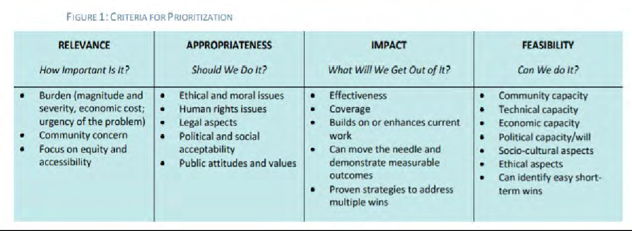
Through thoughtful consideration of the data presented, the prioritization criteria and knowledge of the existing and planned programs already in place, the group decided on the five priority areas listed below. The level of feedback and data from the assessment led the group to also include the aging population and healthcare access as cross-cutting themes to be included in objectives and/or strategies in each of the priority areas chosen.
Priorities Areas:
- Physical Health Conditions
- Behavioral Health

- Transportation
- Housing
- Workforce Development – This priority emerged during the planning process
Cross-cutting themes to be represented in each of the above priority areas:
    - Aging Population
    - Healthcare Access Act on What’s important
Later in February 2019, HRiA led a Strategic Implementation Plan planning session that included mapping current and emerging programs and initiatives against these needs, as well as decision-making regarding which existing programs and initiatives would be continued and what new programs or initiatives would be developed.
Evaluate Actions
The resulting plan is included in the CCH & FH CHNA & IP 2020-2022 and is reviewed annually and adjusted to accommodate revisions that merit attention. This evaluation process is led by CCHC leadership and the Community Health Committee.

APPENDIX 5.03 COMMUNITY ENGAGEMENT PLAN

Massachusetts Department of Public Health Determination of Need
Community Health Initiative Community Engagement Plan

Version: 8-1-2017

The Community Engagement Plan is intended for those Applicants with CHIs that require further engagement above and beyond the regular and routine CHNA/CHIP processes. For further guidance, please see the Community Engagement Standards for Community Health Planning Guidelines and its appendices for clarification around any of the following terms and questions.
All questions in the form, unless otherwise stated, must be completed.

Approximate DoN Application Date: 03/01/2022 DoN Application Type: Hospital/Clinic Substantial Capital Expenditure

Applicant Name: Cape Cod Healthcare
What CHI Tier is the project? Tier 1 Tier 2 Tier 3

Community Engagement Contact Person

Contact Person: Jennifer Cummings Title: Associate Director of Development & Community Benefits
27 Park Street

Mailing Address: City: Hyannis

State:

Zip Code:

Phone: Ext: E-mail: jrcummings@capecodhealth.org
Massachusetts
02601
5088627849

Name of CHI Engagement Process
Please indicate what community engagement process (e.g. the name DoN CHI Initiative associated with the CHI amount) the following form relates to. This will be use as a point of reference for the following questions.
(please limit the name to the following field length as this will be used throughout this form):
CCHC DoN CHI 2022

CHI Engagement Process Overview and Synergies with Broader CHNA /CHIP
Please briefly describe your overall plans for the CHI engagement process and specific how this effort that will build off of the CHNA / CHIP community engagement process as is stated in the DoN Community-Based Health Initiative Planning Guideline.
Our CHI engagement process is occurring in tandem with our work on the next CCH & FH CHNA. We are enhancing the community engagement strategy used for our tri-annual CHNA to include the CHI regulations. There are four main ways we are engaging the community, and all of the work is done through a diversity, equity and inclusion (DEI) lens.

- Community Health Committee - CCHC is utilizing an advisory committee to oversee the community engagement process. The same committee that will direct the CHI process and is made up of community members who are diverse along the lines of ethnicity, service area and geography. We have recently done extensive recruitment to ensure we have representatives across all the stakeholders that are required for the CHI process.

- Key Stakeholder Interviews – Srategically chosen, in-depth interviews with community experts working on specific issues facing our area.

- Focus groups, listening sessions and other group settings – We will hold numerous focus groups to get the perspective of certain specific groups in our community. Here we employ incentives to compensate participants for their valuable information they are providing. We will conduct at least one group in Spanish, and one in Portuguese.

- Community Health Survey - CCHC will conduct a community health survey which will be distributed online and paper, as well as in three languages.

Through these efforts, and with the help of the advisory committee, we are committed to engaging every sector of our community.

CHI Advisory Committee
In the CHNA/CHIP Self Assessment, you listed (or will list) the community partners that will be involved in the CHI Advisory Committee to
guide the CCHC DoN CHI 2022 . As a reminder:

For Tier 2 DON CHI Applicants: The CHI Advisory Committee is tasked with helping select DoN Health Priorities based on the CHNA / CHIP unless the Applicant is directed by DPH to conduct additional community engagement. If so, the advisory committee's role is to guide that additional work.

For Tier 3 DON CHI Applicants: The CHI Advisory Committee is to select DoN Health Priorities based on, but not exclusive to, the CHNA / CHIP. This includes the additional community engagement that must occur to develop the issue priorities.

Focus Communities for CHI Engagement

Within the
CCHC DoN CHI 2022
, please specify the target community(ies), please consider the community(ies)

represented in the CHNA / CHIP processes where the Applicant is involved.

Add/Del Rows |  | Municipality | If engagement occurs in specific neighborhoods, please list those specific neighborhoods:
+ | - | Barnstable
+ | - | Bourne
+ | - | Brewster
+ | - | Chatham
+ | - | Dennis
+ | - | Eastham
+ | - | Falmouth
+ | - | Harwich
+ | - | Mashpee
+ | - | Orleans
+ | - | Provincetown
+ | - | Sandwich
+ | - | Truro
+ | - | Wellfleet
+ | - | Yarmouth

Reducing Barriers
Identify the resources needed to reduce participation barriers (e.g., translation, interpreters, child care, transportation, stipend). For more information on participation barriers that could exist, please see Appendix A from the Community Engagement Standards for Community Health Planning Guidelines http://www.mass.gov/eohhs/docs/dph/quality/don/guidelines-community-engagement.pdf
We have identified potential barriers to engagement for our community members, and will continue to work with our advisory committee and participants to identify barriers and address them as they arise to ensure sufficient representation from all groups in our community. Barriers we have identified include:

- Trust – An issue identified for our immigrant community was distrust of sharing information with others, particularly healthcare and governmental organizations. We acknowledge this is a hard barrier to overcome and will utilize trusted community leaders to recruit participants and make sure we are providing as much information as possible about data collection and how we plan to use the information we gather. Groups and interviews will be facilitated by an independent consultant and/or a trusted member of the particular community.

- Capacity – Our participants are dealing with a myriad of issues that may leave them with little to no capacity to participate. We are committed to acknowledging the value of each participant's time by providing compensation (i.e., monetary, food) as well as information sharing/education and virtual opportunities for engagement. Events will be held in central community locations that are familiar and trusted to particular groups in our community.

- Rural isolation – Barnstable County is large, with many diverse towns. Part of the County is rural, and virtual options for participation will help engagement in these areas.

- Non-English speaking participants – We have a strong team of interpreter services ready to serve this population. Survey materials, focus groups and interviews will be offered in the three main languages spoken in our community: English, Portuguese and Spanish.

Communication
Identify the communication channels that will be used to increase awareness of this project or activity:
We have worked with the CCHC marketing department, as well as an outside consultant, to develop a culturally competent, comprehensive marketing and communication plan to create awareness of this project. Communication channels include social media, word of mouth via trusted community leaders, print ads, media stories, radio, website and utilizing relationships across our community to spread the word.
Materials will be designed in “plain talk,” so they are easily understood, and interpreters (including ASL) will be available and utilized throughout the process. We are continually refining our communication to be culturally competent, and constantly work on identifying how unconscious bias, equity and social justice are impacting our engagement process.

Build Leadership Capacity

Are there opportunities with this project or activity to build community leadership capacity?

If yes, please describe how.
Yes No

Throughout the CHI process, and in our day-to-day work, CCHC staff look to the leaders in our community to help drive initiatives. Throughout every aspect of the CHI and Community Engagement process, we strategize with our advisory committee to identify additional potential community leaders and partners to determine how these individuals can be an integral part of our work. We consider networks and community partners to determine how we can bolster community leadership capacity. Examples include:
- Community leaders organizing a listening session with a professionally trained facilitator. These community leaders are empowered to make engagement decisions based on their expertise of the population and issue, and are offered financial assistance / stipends to provide a tangible recognition of value for their work and knowledge sharing.
- Community members serving on an allocation committee and being part of a group decision making process regarding funding.
These activities build decision-making capacity, foster involvement and innovation, and engage community members as equal and valued partners.

Evaluation
Identify the mechanisms that will be used to evaluate the planning process, engagement outcome, and partner perception and experience:
It is necessary to continuously evaluate our community engagement process to ensure quality improvement. CCHC staff uses the Community Health Planning Guideline to ensure we are meeting the engagement requirements of the CHI process and employs the recommended best practices. We plan to utilize the tools laid out on page 15 of the Community Health Planning Guideline, particularly "Process and outcome constructs for evaluation community-based participatory research projects: A matrix of existing measures" to evaluate our activities.

CCHC also works with a consultant (Health Resources in Action, HRiA) on our community engagement. HRiA will facilitate focus groups and interviews, and will measure participant experience.

At this point we have engaged, or have plans on how we will engage, all of the required stakeholders as outlined in the Community Health Planning Guideline. All of the minimum organization types are represented on our advisory committee. We work closely with the advisory committee to solicit feedback about the community engagement outcomes as well as the community’s perception of our work.

Reporting

Identify the mechanisms that will be used for reporting the outcomes of this project or activity to different groups within the community:
Residents of Color
CCHC will target press releases to media outlets that reach residents of color. We will also post information to social media sites, coalition websites and community pages utilized by residents of color. We will recruit and work with trusted community leaders to serve as ambassadors to this population. Key partnerships include: Barnstable No Place For Hate, The MLK Action Committee, NAACP Cape Cod, Amplify POC Cape Cod, B Free Wellness, members of the faith community.
Residents who speak a primary language other than English
CCHC will target press releases to media outlets that reach residents who speak a primary language other than English. We will also post information to social media sites, coalition websites and community pages utilized by residents who speak a primary language other than English. We have a robust interpreter and translation services program to utilize. Press releases, communications and materials will be translated and available in the three main languages spoken in our region: English, Spanish and Portuguese. We will recruit and work with trusted community leaders to serve as ambassadors to this population. Key existing partnerships include: Health Ministries, CCHC Interpreter Services, Barnstable County Food Access Community Leadership Team, members of the faith community.
Aging population
As Barnstable County is the third oldest county in the country in terms of age, we have a large community focused on issues for the aging population. CCHC will target press releases to media outlets that reach the aging population. We will also post information to social media sites, coalition websites and community pages utilized by the aging population. We will recruit and work with trusted community leaders to serve as ambassadors to this population. Key existing partnerships include: Senior Centers, Samaritans of the Cape & Islands, Alzheimer’s Family Caregiver Support Center, Barnstable County.
Youth
CCHC will target press releases to media outlets that reach youth and those who work with youth. We will also post information to social media sites, coalition websites and community pages utilized by youth and those who work with youth. We will recruit and work with trusted community leaders to serve as ambassadors to this population. Key existing partnerships include: Barnstable School Department, Barnstable No Place For Hate, Cape Cod YMCA, Cape Cod Children’s Place, Cape Cod Voices.

Residents Living with Disabilities
CCHC will target press releases to media outlets that reach residents with disabilities. We will also post information to social media sites, coalition websites and community pages utilized by residents with disabilities. We will recruit and work with trusted community leaders to serve as ambassadors to this population. We will ensure materials are created in "plain talk" to be easily understandable and materials will be accessible on our website. Key partnerships include local libraries, Cape Abilities, Latham Center, Cape Cod CORD, Riverview School.
GLBTQ Community
CCHC will target press releases to media outlets that reach our LGBTQI+ community. We will also post information to social media sites, coalition websites and community pages utilized by the LGBTQI+ community. We will recruit and work with trusted community leaders to serve as ambassadors to this population. Key partnerships include: Duffy Health Center, Helping Our Women, PFLAG Cape Cod, Barnstable No Place for Hate.

Residents with Low Incomes
CCHC will target press releases to media outlets that reach residents with low incomes. We will also post information to social media sites, coalition websites and community pages utilized by residents with low incomes. We will recruit and work with trusted community leaders to serve as ambassadors to this population. Key existing partnerships include: Falmouth Service Center, Homeless Prevention Council, Federally Qualified Health Centers, Cape Cod Community Action Committee, The Family Pantry of Cape Cod, Health Imperatives.
Other Residents
CCHC will target press releases to media outlets that broadly reach the Cape Cod community. We will also post information to social media sites, coalition websites and community pages utilized by the majority of our community. We will recruit and work with trusted community leaders to serve as ambassadors. As new target groups emerge, we will work on a targeted communication plan with the goal of reaching as many diverse community members as possible.

Engaging the Community At Large
Which of the stages of a CHNA/CHIP process will the CCHC DoN CHI 2022 focus on? Please describe specific

activities within each stage and what level the community will be engaged during the CCHC DoN CHI 2022
. While

the step(s) you focus on are dependent upon your specific community engagement needs as a result of your previous CHNA/CHIP work, for tier 3 applicants the CHI community engagement process must at a minimum include the “Focus on What's Important,” “Choose Effective Policies and Programs” and “Act on What's Important” stages. (For definitions of each step, please see pages 12-14 in the Community Engagement Standards for Community Health Planning Guidelines http://www.mass.gov/eohhs/docs/dph/quality/don/ guidelines-community-engagement.pdf).
 | Inform | Consult | Involve | Collaborate | Delegate | Community - Driven / -Led
Assess Needs and Resources
Please describe the engagement process employed during the  “Assess Needs and Resources” phase. | CCHC conducted a comprehensive needs assessment to publish the 2020-2022 CCH & FH CHNA. This process is outlined in the Community Engagement Self-Assessment Form.
Focus on What's Important
Please describe the engagement process employed during  the “Focus on What's Important” phase. | Trained facilitators led a process with leadership from CCHC, the CHC Advisory Board and community stakeholders to identify the priorities, goals and objectives for a Strategic Implementation Plan. Key issues identified were presented to the community, including information on the magnitude and severity of these issues and their impact on priority populations. Community feedback, advice and recommendations were discussed.
Choose Effective Policies and Programs
Please describe the engagement process employed during  the “Choose Effective Policies and Programs” phase. | Trained facilitators led a discussion with CCHC leadership, the CHC Advisory Board and community stakeholders to evaluate possible priorities based on relevance, appropriateness, impact and feasibility. Through thoughtful consideration of the data presented, the prioritization criteria and the knowledge of the existing and planned programs already in place, the group decided on priorities for effective policies and programs.
Act on What's Important
Please describe the engagement process employed during  the “Act on What's Important” phase. | CCHC leadership, the advisory committee and community stakeholders engaged in a Strategic Implementation Planning session that mapped current and emerging programs and initiatives against identified community needs. This led to collaborative decision making on which programs and initiatives to act on.
Evaluate Actions

Document Ready for Filing
When the document is complete, click on "document is ready to file". This will lock in the responses, and Date/Time stamp the form. To make changes to the document, un-check the "document is ready to file" box. Edit the document, then lock file and submit.
Keep a copy for your records. Click on the "Save" button at the bottom of the page.
To submit the application electronically, click on the"E-mail submission to DPH" button.
This document is ready to file: Date/Time Stamp:

APPENDIX 5.04
Community Health Needs Assessment and Implementation Plan


Community Health Needs Assessment Report
and Implementation Plan 2020-2022
Cape Cod Hospital & Falmouth Hospital

Contents
INTRODUCTION . - 1 -
About Cape Cod Healthcare .................................................................................................................... - 1 -
Mission Statement...................................................................................................................... - 1 -
Vision Statement ........................................................................................................................ - 1 -
Values Statement ....................................................................................................................... - 1 - Cape Cod Healthcare Community Benefits ................................................................................ - 1 -
Community Health Needs Assessment and Strategic Implementation Plan Summary ........................... - 2 - Methods ..................................................................................................................................... - 2 -
CHNA Key Findings...................................................................................................................... - 2 -
Priority Health Issues for the Strategic Implementation Plan .................................................... - 4 - Vulnerable Populations Addressed by this Strategic Implementation Plan ............................... - 5 - Social Determinants of Health Issues Addressed by this Strategic Implementation Plan .......... - 5 - Rationale for Priority Community Needs Not Addressed ........................................................... - 5 -
Community Health Needs Assessment (CHNA) Introduction and Background ....................................... - 5 - Purpose of the Community Health Needs Assessment .............................................................. - 5 - Project Collaborators.................................................................................................................. - 7 -
Role and Review of Previous Community Health Needs Assessments....................................... - 7 - Methodology and Community Profile ........................................................................................ - 9 -
Community Profile.................................................................................................................... - 10 -
Social Determinants of Health and Health Findings .............................................................................. - 17 -
Housing and Homelessness ...................................................................................................... - 18 -
Income and Poverty.................................................................................................................. - 22 -
Employment ............................................................................................................................. - 23 -
Education.................................................................................................................................. - 25 -
Transportation .......................................................................................................................... - 26 -
Food Access .............................................................................................................................. - 27 -
Social Environments ................................................................................................................. - 28 -
Environment and Safety ........................................................................................................... - 29 -
I

Crime and Violence . - 30 -
Community Health Issues ...................................................................................................................... - 30 -
Overall Health and Mortality .................................................................................................... - 30 -
Chronic Disease ........................................................................................................................ - 34 -
Alzheimer’s Disease .................................................................................................................. - 39 -
Behavioral Health ..................................................................................................................... - 39 -
Maternal and Child Health........................................................................................................ - 46 -
Infectious Disease ..................................................................................................................... - 47 -
Health Care Access ................................................................................................................... - 50 -
Cape Cod Healthcare Strategic Implementation Plan (SIP) Overview ................................................... - 55 - Priority 1: Physical Health Conditions....................................................................................... - 56 -
Priority 2: Behavioral Health..................................................................................................... - 58 -
Priority 3: Transportation ......................................................................................................... - 59 -
Priority 4: Housing .................................................................................................................... - 60 -
Priority 5: Workforce Development ......................................................................................... - 61 -
APPENDIX A: LIST OF PARTICIPATING ORGANIZATIONS 62
APPENDIX B: TIMELINE FOR CHNA ACTIVITIES 64
APPENDIX C: DATA SOURCES AND METHODOLOGIES 65
APPENDIX D: LIST OF SECONDARY DATA SOURCES 67
APPENDIX E: COMMUNITY SURVEY RESPONDENT CHARACTERISTICS 69
APPPENDIX F: INVENTORY OF AVAILABLE RESOURCES ADDRESSING SIGNIFICANT HEALTH NEEDS 72
APPENDIX G: CAPE COD HEALTHCARE CHNA AND SIP WORK GROUP 75

II

Introduction

About Cape Cod Healthcare
Cape Cod Healthcare is the leading provider of healthcare services for residents and visitors of Cape Cod, Massachusetts. With more than 450 physicians, 5,300 employees and 790 volunteers, Cape Cod Healthcare (CCHC) includes two acute care hospitals, the Cape’s leading provider of homecare and hospice services (VNA), a skilled nursing and rehabilitation facility (JML Care Center), an assisted living facility (Heritage at Falmouth), an ambulatory surgery center, and numerous primary and specialty care physician practices along with many other health programs. To fulfill its mission of coordinating and delivering the highest quality, accessible health services, which enhance the health of all Cape Cod residents and visitors, Cape Cod Healthcare annually contributes over $27 million in uncompensated care, community health improvement, community benefits, health professions education, subsidized health services, research, and community education and awareness.

Mission Statement
To coordinate and deliver the highest quality, accessible health services, which enhance the health of all Cape Cod residents and visitors.

Vision Statement
We will be the health service provider of choice for Cape Cod residents by achieving and maintaining the highest standards in healthcare delivery and service quality. To do so, we will partner with other health and human service providers as well as invest in needed medical technologies, human resources and clinical services. Above all, we will help identify and respond to the needs of our community.

Values Statement
To be compassionate, respectful and professional in the way we deliver care. To be relentless in pursuing the highest standard of quality through continuous improvement, emphasizing the power of teamwork. To be honest, ethical and open in all our relationships. To be responsible stewards of the community`s resources by working efficiently and cost effectively. To serve all without regard to sex, race, creed, residence, national origin, sexual orientation or ability to pay

Cape Cod Healthcare Community Benefits
Cape Cod Healthcare, Inc., through its Community Benefits initiative, is committed to enhancing the quality of and access to comprehensive healthcare services for all Cape Cod residents. Through continuous assessment of community needs, coordinated planning and the allocation of resources, this commitment includes a special focus on the unmet needs of the financially disadvantaged and underserved populations. We will assume a leadership role in collaborative efforts joining our resources, talent, and commitment with that of other providers, organizations and community members.

Community Health Needs Assessment and Strategic Implementation Plan Summary
Improving the health of a community is essential to enhancing the quality of life for residents in the region and supporting future social and economic well-being. To fulfill the federal IRS requirements and the Massachusetts Attorney General Community Benefits Guidelines and as a continuing best practice in community health, Cape Cod Healthcare (CCHC) engaged in a community health planning process to improve the health of residents in Barnstable County, Massachusetts. This effort included two phases:
  - a community health needs assessment (CHNA) to identify the health-related needs and strengths of the region and (2) a strategic implementation plan to identify major health priorities, develop goals, select strategies and identify partners to address these priority issues across the region.

Methods
The community health needs assessment was guided by a participatory, collaborative approach, which examined health in its broadest sense. Qualitative and quantitative methods were implemented throughout this assessment. This process included integrating existing quantitative, secondary data on social, economic, and health issues in the region with qualitative methods to get an understanding of individual thoughts and opinions from the following methods:
    - 1 community health survey which was administered online and disseminated through multiple channels to individuals who live or work in Barnstable County. The survey was translated and distributed in English, Portuguese and Spanish. Community interest and participation went beyond our expectations and led to a total of 2,011 people completing the survey.
    - 2 focus groups; one in Portuguese and one in Spanish, with residents in service-related occupations, and residents in the healthcare field.
    - 2 community stakeholder dialogs, which were conducted with stakeholders and human/social service providers in the community.
    - 25 interviews with community stakeholders, including health centers, public safety, housing and tribal organizations and human service groups.

CHNA Key Findings
The following key health issues emerged most frequently from a review of the available data and community input and were considered in the selection of the Strategic Implementation Plan (SIP) health priorities:
    - Housing: All stakeholders described the cost and availability of housing as a major concern in Barnstable County. Housing or homelessness was most highly selected as the top social concern for the community (65.5% of survey respondents). This concern impacts residents’ ability to afford child care, food, and other necessities. The populations perceived as at-risk include: seasonal employees, families with children, senior citizens, and veterans. It also impacts the retention of healthcare professionals, some of whom also struggle to afford housing. Other housing related concerns include: housing quality (e.g., mold), lack of year-round housing, and lack of home ownership.
    - Transportation: Private and public transportation were cited as concerns, with 29% of survey respondents saying that the availability of public transportation was high concern. Bridges and roads struggle to support the population influx in the summer. There was discussion about the number of routes and lines available through the public transit system; mostly centered on sufficiency. Transportation is particularly challenging when discussing healthcare access for residents. The majority

(81.5% of survey respondents) of working population drives alone to and from work, while few utilize public transportation (1.4%), however access to a vehicle is not universal among Barnstable County residents.
    - Seasonal Economy and Employment Variation: There is high employment in the summer and low employment during in the winter. Many residents must earn the majority of their annual income in a few months leading to financial insecurity. The lack of year-round professional jobs deters young professionals from remaining in the area. ‘Employment’ was the third most frequently selected social concern by survey respondents as impacting the community in which they live (44.5% of respondents).
    - Behavioral Health (including Substance Use and Mental Health): Depression, anxiety, and substance use disorder were named as primary concerns. Substance use was 2nd most selected top health concern for the community (57.7% of survey respondents). 46.4% of survey respondents said mental health issues was a top health concern for the community and 29.5% said it was for themselves. Many said poor access is not due to lack of resources, but a need for more resources (i.e., there are many treatment facilities, but they are constantly at capacity). While stakeholders agreed that risk for mental and behavioral health problems transcend age groups, transitional-aged youth were perceived as having the highest risk.
    - Aging Population: ‘Aging health concerns’ was most frequently selected as a top health concern impacting the community (72.6% of survey respondents). The age distribution of the Barnstable County population skews older than for the state (Population aged 65 years and older is 15.1% for MA and 27.8% for Barnstable County). Further exploration of the population age 65 years and older show that several towns have sizeable proportions of their population who are considerably older than 65, with rates that are three times that of the state overall. Primary aging concerns were dementia, Alzheimer's, and social isolation, with higher isolation risk for residents living alone and/or without a regular caregiver. Other aging concerns include elder abuse, fall-related injuries, and susceptibility to communicable diseases (e.g., influenza). Availability of affordable housing for older adults and availability of transportation for older adults were also cited as issues of “high concern”.
    - Physical Health Conditions: Top health concerns for the community cited by respondents included chronic health conditions (43.8% of respondents) and cancer (36.4% of respondents). Cancer incidence is higher than the state for most types. Mortality is higher than the state for breast, prostate, and skin cancers. The rate of Cardiovascular-related Emergency visits among Barnstable County residents is notably higher than for the state (729.2 per 100,000 vs. 379.0 per 100,000) and the rate of Diabetes- related Emergency visits among Barnstable County residents is slightly higher than for the state (159.9 per 100,000 v 129.8 per 100,000).
    - Healthcare Access: 60% percent of survey respondents stated barriers while 40% said no barriers. For those who cited barriers, they included long waits (28.9%), cost of care (21.3%), and difficulty with scheduling appointments (18.3%). 22.2% said transportation to medical appointments was of high concern.
Access to Providers (specialists and primary care providers); 45.2% said access to primary care provider (PCP) is a top health concern for the community and 31.8% said for themselves. The population to provider ratios for primary care physicians, mental health providers, and dentists is similar in Barnstable County and the state.

Priority Health Issues for the Strategic Implementation Plan
In early February 2019, HRiA led a facilitated process with leadership from Cape Cod Healthcare and community stakeholders including Barnstable County Human Services and behavioral health and infectious disease representatives from CCHC, to identify the priorities, goals and objectives for the Strategic Implementation Plan (SIP). HRiA presented the key health issues identified in the FY2020- FY2022 community health needs assessment (CHNA) project, including the magnitude and severity of these issues and their impact on priority populations. HRiA facilitated a discussion with CCHC leadership and community stakeholders to evaluate possible priorities based on key criteria outlined in Figure 1.

FIGURE 1: CRITERIA FOR PRIORITIZATION

RELEVANCE  How Important Is It? | APPROPRIATENESS  Should We Do It? | IMPACT  What Will We Get Out of It? | FEASIBILITY  Can We do It?
- Burden (magnitude and severity, economic cost; urgency of the problem)  - Community concern  - Focus on equity and accessibility | - Ethical and moral issues  - Human rights issues  - Legal aspects  - Political and social acceptability  - Public attitudes and values | - Effectiveness  - Coverage  - Builds on or enhances current work  - Can move the needle and demonstrate measurable outcomes  - Proven strategies to address multiple wins | - Community capacity  - Technical capacity  - Economic capacity  - Political capacity/will  - Socio-cultural aspects  - Ethical aspects  - Can identify easy short- term wins

Through thoughtful consideration of the data presented, the prioritization criteria and knowledge of the existing and planned programs already in place, the group decided on the five priority areas listed below. The level of feedback and data from the assessment led the group to also include the aging population and healthcare access as cross-cutting themes to be included in objectives and/or strategies in each of the priority areas chosen.
Priorities Areas for the 2019-2021 Strategic Implementation Plan (SIP):
- Physical Health Conditions
- Behavioral Health
- Transportation
- Housing
- Workforce Development – This priority emerged during the planning process

Cross-cutting themes to be represented in each of the above priority areas:
    - Aging Population
    - Healthcare Access

Later in February 2019, HRiA led a SIP planning session that included mapping current and emerging programs and initiatives against these needs, as well as decision-making regarding which existing

programs and initiatives would be continued and what new programs or initiatives would be developed. The resulting plan is meant to be reviewed annually and adjusted to accommodate revisions that merit attention.

Vulnerable Populations Addressed by this Strategic Implementation Plan
- Residents across Barnstable County with focus on specific regions of the Cape most acutely impacted by geographic isolation, access to services, transportation barriers, and economic opportunity)
- Residents over the age of 65
- Transitional-aged youth (18-24 yrs. old)
- Low-income individuals and families
- Populations managing mental health and/or behavioral health disorders
- Non-English speaking individuals

Social Determinants of Health Issues Addressed by this Strategic Implementation Plan
- Employment, education and economic opportunities
- Housing
- Transportation
- Access to Healthy Food, Nutrition

Rationale for Priority Community Needs Not Addressed
Seasonal Economy & Employment Variation: CCHC is best positioned to support and collaborate on initiatives that aim to develop the regional healthcare workforce as part of this SIP. In this way, we are hoping to have a positive influence on the economy and employment opportunities in Barnstable County. Addressing the complex challenges created by a seasonal economy and employment variation in the region in industries outside of healthcare is beyond the core competencies of CCHC and our mission.

Community Health Needs Assessment (CHNA) Introduction and Background

Purpose of the Community Health Needs Assessment
Cape Cod Healthcare (CCHC) is the leading provider of health care services for residents and visitors of Cape Cod. With more than 450 physicians, 5,300 employees, and 790 volunteers, CCHC is the parent company of Cape Cod Hospital and Falmouth Hospital, the two acute care hospitals serving year-round residents and visitors to the region. CCHC is also the Cape’s principal provider of homecare and hospice services (Visiting Nurse Association of Cape Cod). CCHC operates a skilled nursing and rehabilitation facility (JML Care Center), an assisted living facility (Heritage at Falmouth), and numerous health programs.

CCHC collaborates with community partners across the region to assess community needs, identify promising programs, and implement strategies to improve people’s health. Through an open and competitive Annual Strategic Grants program, CCHC funds projects addressing a variety of health needs, prioritizing efforts that focus on chronic and infectious disease, behavioral health, access to care, and disease prevention and wellness. Additionally, CCHC has invested in new and expanded hospital programs in areas such as cancer support, chronic disease self-management, case management for individuals living with HIV/AIDS, suicide prevention, and support for new families, among others. CCHC community benefits’ funding also supports medical interpreter services for limited English-speaking patients, hospital social workers and case managers, and financial counselors. Finally, CCHC plays a leadership role through participation in, among others, the Barnstable County Economic Development Council, the Barnstable County Human Services Advisory Council, the Barnstable County Regional Substance Use Council, the Cape Cod Chamber of Commerce, and the Cape and Islands Community Health Area Network (CHNA 27) Steering Committee.
Cape Cod Hospital (CCH) and Falmouth Hospital (FH) share the service area of Barnstable County, also known as Cape Cod, and jointly conduct a community health needs assessment (CHNA) every three years. CCH and FH have released two prior joint Community Health Needs Assessment Reports and Implementation Plans (in 2014 and 2017).
The purpose of the CHNA is to undertake a data-driven and community-led process that identifies and prioritizes the health needs of residents of the region based on the frequency, size, scope, and magnitude of the issues. In addition, the CHNA process provides CCH and FH the opportunity to:
  - Identify vulnerable, disadvantaged, and medically underserved target populations
  - Identify key areas of significant community need and vulnerable populations
  - Examine the impact and role of social determinants of health in the community
  - Monitor regional health data and maintain an inventory of available resources
  - Facilitate the development of multi-year implementation strategies to guide hospital community health initiatives and community investments to improve health
  - Promote partnership and dialogue between the hospitals and community organizations
In 2014, the Internal Revenue Service (IRS) established requirements for non-profit hospitals to conduct health needs assessments and develop approaches to address identified needs. These requirements provide specific guidance for how hospitals assess and prioritize health needs in their service area and identify specific implementation strategies to address those needs.
In February 2018, the Massachusetts (MA) Attorney General released updated Community Benefits Guidelines for Non-Profit Hospitals. These new guidelines include recommendations to ensure that CHNAs align with the IRS requirements. In response to these new guidelines, CCHC collected and examined data related to the social determinants of health as part of the 2019 CHNA process. The inclusion of such data encourages communities to define health needs broadly including the social, behavioral, and environmental factors that impact health in the community.
CCHC’s CHNA work has also informed the prior CHNA processes conducted by Spaulding Rehabilitation Hospital Cape Cod, a sub-acute hospital operating in Barnstable County. In both 2013 and 2016, CCHC shared its preliminary CHNA report and data with Spaulding and involved Spaulding in data collection efforts. Spaulding leveraged these resources to develop its implementation strategies in prior years.
CCHC and Spaulding have also identified opportunities to collaborate beyond the CHNA process. For example, CCHC and Spaulding are collaborative partners with the steering committee for Healthy Aging

Cape Cod under the leadership of Barnstable County Health and Human Services where assessment and planning for the region include municipal governmental organizations.

Project Collaborators
CCHC extends a special thanks to the Barnstable County Department of Human Services, the Cape Cod Commission, the Cape Cod Regional Transit Authority, and the Housing Assistance Corporation on Cape Cod for their contributions of data and research for this CHNA. The Visiting Nurse Association of Cape Cod’s Public Health and Wellness Division provided a part-time project staff member to assist the CCHC Community Benefits Director with organizing assessment activities and synthesizing and disseminating information throughout the project.
More than 30 health, human, and public service agencies from across Barnstable County contributed to the assessment including organizations representing low-income, vulnerable, and medically underserved residents. Through various engagement activities, these organizations validated data findings, identified information gaps, identified specific target populations and populations experiencing health inequities, and offered input for health improvement strategies. For a complete list of participating organizations and the resident populations they represent, please see Appendix A.
Truven Health Analytics, a subsidiary of IBM Watson Health, served as a consultant on the project to collect and analyze publicly available data on the physical health, social conditions, behavioral risk factors, and environmental factors that influence the health of residents of Barnstable County.
Health Resources in Action (HRiA), a Boston-based public health research firm, provided valuable contributions to this project through the facilitation of community engagement activities such as stakeholder forums and key informant interviews, administration of the community health survey, analysis and synthesis of data, and summary of the findings shared in this report.

Role and Review of Previous Community Health Needs Assessments
Previously released CCH and FH CHNA Reports and Implementation Plans spanning FY2014-FY2016 and FY2017-FY2019 serve as the foundation for this FY2020-FY2022 CHNA project(feedback from community residents was encouraged after the release of each report, to-date CCHC has not received any written comments on the information distributed.)
Chronic and infectious disease, access to care, and behavioral health remained consistent concerns for Barnstable County in the previous assessments. These issues are longstanding and complex. Solutions addressing these issues require significant resources and community-wide collaboration and support.
Inclusion of disease prevention and wellness as a priority in the FY2017-FY2019 CHNA report represented a shift in focus and a commitment to support upstream prevention of disease through education and improving risk factors that influence health. The FY2020-FY2022 CHNA will continue to evolve the assessment process by identifying and analyzing social determinants of health as critical drivers of health outcomes.
The CHNA process and report ultimately inform the development of multi-year implementation strategies to guide hospital community health initiatives and investments to improve health. Since the

release of the FY2017-FY2019 CHNA in September of 2016, CCHC has invested more than $50 million in community health initiatives including over $2 million in grants to local non-profit organizations.
In addition to grants, other CCHC community investments have included charity care for vulnerable populations, new and expanded hospital-based programs, support and strategic collaboration with Federally Qualified Health Centers (FQHCs), leadership participation in regional health and human service initiatives, and workforce development partnerships that addressed workforce gaps in the regional health care sector.
Examples of hospital-based initiatives at CCH and FH:
  - Expanded oncology programs including support groups and counseling services, nutrition and dietary support, physical conditioning and wellness programs, and screening initiatives for the uninsured
  - Launched a Congestive Heart Failure Clinic providing individuals with support to self-manage chronic diseases
  - Implemented a Recovery Specialists program in CCH and FH emergency departments assisting patients with substance use disorders
  - Increased behavioral health services through providing support and peer groups, creating a Community Crisis Line, and establishing partnerships in the community through the Zero Suicide initiative to reduce suicides in the region
  - Created local Moms Do Care program; an integrated system of medical and behavioral health care including access to medication assisted treatment (MAT) and recovery support throughout the pregnancy and postpartum period through the use of peer recovery coaches
Examples of new and expanded community programs supported through CCHC community benefits grants included:
  - Expanded MAT and Office-Based Addiction Treatment (OBAT) programs at FQHCs across the region
  - Launched new education and awareness campaigns and programs to address tick borne illness, HPV, Hepatitis C, and suicide
  - Developed new models expanding access to healthy and locally sourced food to low-income seniors, families, and individuals
  - Increased support and counseling services for caregivers of individuals with Alzheimer’s disease and with mental health and substance use disorders
Although progress has been made in each health priority area, challenges exist to fully address some issues or achieve anticipated outcomes. Areas in need of continued focus include:
  - Recruitment of health care providers to the region
  - Development of information systems for direct electronic referrals between health care providers and community-based programs that support health (e.g., CCH, FH, and Physician Practices are implementing Epic in 2020)
  - Created local Moms Do Care program that uses an integrated system of medical and behavioral health care including access to medication assisted treatment (MAT) and recovery support throughout the pregnancy and postpartum period through the use of peer recovery coaches
  - Surveillance and reporting of regional disease information
  - Implementation of evidence-based practices for prevention and disease management
  - Engagement of patients to self-manage chronic diseases and reduce risky health behaviors
The successes and challenges of implementing strategies to address health priorities identified in previous CHNAs are recognized and woven into the assessment, analysis, and planning phases of the FY2020-FY2022 CHNA process.

Methodology and Community Profile

Project Approach
The following sections detail how the CHNA process was conducted including the engagement of stakeholders and community members, methods for data collection and analyses, and the broader lens that was used to guide this process. The detailed timetable for CHNA activities is shared in Appendix B. The CHNA process was conducted in three phases:
  - Collection of health indicator data, social determinants of health data, and community input
  - Prioritization of health needs and community resource analysis
  - Development of CHNA report and implementation strategies
Data Sources and Methodologies
Many sources and data collection methodologies were used to obtain a comprehensive view of the health and health care needs of the region and the people served by CCH and FH. Input on the design of data collection instruments was solicited from public health experts, health care consumers, and persons representing vulnerable and medically underserved populations and minorities. Conscientious efforts were made to reach a wide-ranging population of residents during data collection to ensure broad representation of community interests and perspectives. Detailed descriptions of these methodologies are provided in Appendix C. Briefly, the data sources and methodologies included:
  - Secondary Data. Existing data from national, state, and local sources were reviewed. The types of data collected included demographics, vital statistics, and public health surveillance, as well as self-reported health behaviors from large, population-based surveys such as the Massachusetts Behavioral Risk Factor Surveillance Survey (BRFSS).
  - Community Stakeholder Dialogues. Two facilitated “stakeholder dialogues” were held with staff from a broad array of agencies and organizations actively working in the health and human services sectors of Barnstable County. Approximately 70 people attended these sessions.
  - Interviews. Twenty-five telephone interviews were conducted with leaders from a variety of organizations serving Barnstable County including health centers, public safety organizations, housing organizations, and other human service groups.
  - Focus Groups. Two focus groups, one conducted in Spanish and one in Portuguese, were held with residents to gather information about the community, health challenges and needs, and existing and needed services. These specific language groups were targeted based upon data collection gaps identified in the prior the prior CHNA process. A total of 20 residents participated in the focus groups.
  - Community Survey. A community survey asking about community and individual health and health care needs was developed and made available on-line and on paper to residents of Barnstable County. The survey was conducted in English, Spanish, and Portuguese and was completed by 2,011 total residents. The demographic characteristics of the survey respondents are detailed in Appendix E.
Data Limitations and Information Gaps
As with all data collection efforts, there are several limitations that should be acknowledged. A number of secondary data sources were drawn upon in creating this report. Although all are considered highly credible, each source may use different methods, assumptions, or time periods and may not be directly comparable to one another. For the Community Health Survey, convenience sampling was used and data were collected from those who were readily available and willing to participate. Thus, findings may not be generalizable to the larger population or to specific sub-populations of Barnstable County residents. Finally, while key informant interviews, stakeholder dialogues, and focus groups provide

valuable insights, results are not statistically representative of a larger population due to non-random recruiting techniques and a small sample size.

Community Profile
Definition of Community Served
CCHC’s primary service area is Barnstable County. Barnstable County is a geographically isolated region located on the eastern seaboard of Massachusetts. The narrow peninsula spans over 70 miles in length and hosts a year-round population of 214,703 residents.¹ Barnstable County consists of 15 towns that vary in population size from about 45,000 residents (Barnstable) to slightly more than 1,500 residents (Truro).² In addition to serving year-round residents, the regional community infrastructure, including CCH and FH, must meet the demands of a significant influx of seasonal residents and visitors each year which, by one estimate, is equivalent to about seven million visitors and residents on Cape Cod in a given summer season.³
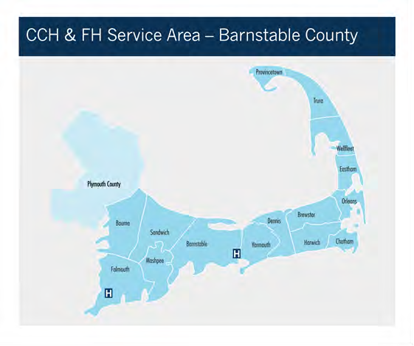

1 U.S. Census Bureau. American Community Survey 5-year estimates, 2012-2016.
2 U.S. Census Bureau. American Community Survey 5-year estimates, 2012-2016.
3 UMASS Donahue Institute. (2015). Long-term Population Projections for Massachusetts Regions and Municipalities. Retrieved from http://pep.donahue-institute.org.

Population Demographic Trends
Nearly half of the total population of Barnstable County reside in the three largest towns (Barnstable, Falmouth, and Yarmouth) and population size becomes increasingly smaller in towns of the lower (Harwich, Brewster, Chatham, and Orleans) and outer cape (Eastham, Wellfleet, Truro, and Provincetown), many of which are considered rural.
Between 2011 and 2016, the overall population of Barnstable County remained stable with a slight decrease of -0.9%.⁴ In comparison, the state population grew by 3.5% during that time period. The overall population of Barnstable County and the islands of Nantucket and Martha’s Vineyard is projected to decline in coming decades (an estimated -13.0% between 2010 and 2035), attributed to out- migration of younger residents and to the fact that deaths currently outnumber births.⁵
Consistent with the previous CHNA, the population of Barnstable County is older than for the state overall. The median age in Barnstable County is 51.8 years compared to 39.4 years for the state overall (Table 1). Proportionally, residents age 65 years and older comprise 27.8% of the population in Barnstable County, compared to the state at 15.1%. In contrast, the proportion of residents under 18 years is lower in Barnstable County than in the state at 15.9% vs. 20.6%, respectively. Similarly, the proportion of residents between 18 and 24 years is lower in Barnstable County than in the state at 7.3% vs. 10.4%, respectively. Several towns on the lower and outer cape have a notably higher proportions of residents age 65 years and older, including Chatham (38.9%), Orleans (38.7%), and Wellfleet (38.0%), compared to the County average.
TABLE 1: AGE DISTRIBUTION OF POPULATION, 2016
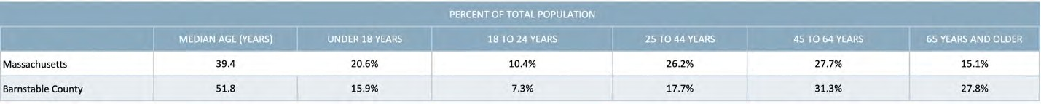
DATA SOURCE: U.S. Census Bureau, American Community Survey 5-Year Estimates, 2012-2016

More detailed data on the age of residents reveal that Barnstable County also has a higher proportion of residents who are within the ‘oldest’ age categories compared to Massachusetts overall, including those age 75 to 84 (8.8% vs. 4.4%, respectively) and those age 85 years and older (3.9% vs. 2.3%, respectively)
(Figure 1).

4 U.S. Census Bureau, American Community Survey 5-Year Estimates, 2007-2011 and 2012-2016
5 UMASS Donohue Institute. Long-term Population Projects for Massachusetts Regions and Municipalities, 2015.

FIGURE 1: DETAILED AGE DISTRIBUTION FOR POPULATION AGE 65 YEARS AND OLDER, 2016
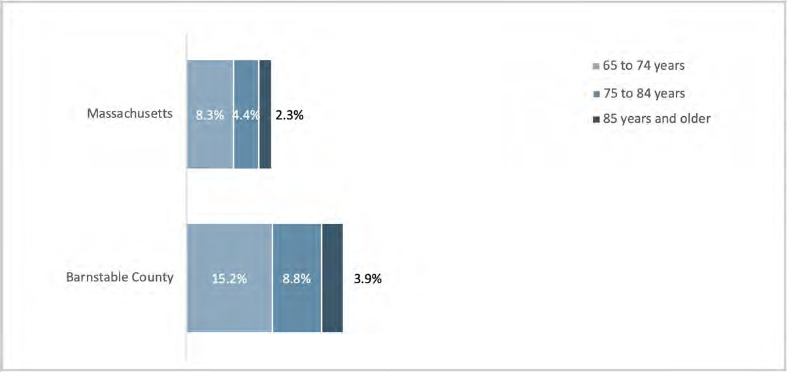
DATA SOURCE: U.S. Census Bureau, American Community Survey 5-Year Estimates, 2012-2016

Concern about meeting the needs of an aging population was a prominent theme in key informant interviews, stakeholder dialogues, and the community survey. ‘Aging health concerns’ was the most frequently identified health concern for the community by survey respondents (72.6%) (Figure 22) with ‘health care services focused on seniors’ and ‘support to older adults to maintain independent living’ ranking among the most frequently selected health and social service priorities by survey respondents (Figure 43 and Figure 18).

FIGURE 22: PERCENT OF SURVEY RESPONDENTS IDENTIFYING ISSUE AS A TOP HEALTH CONCERN FOR COMMUNITY
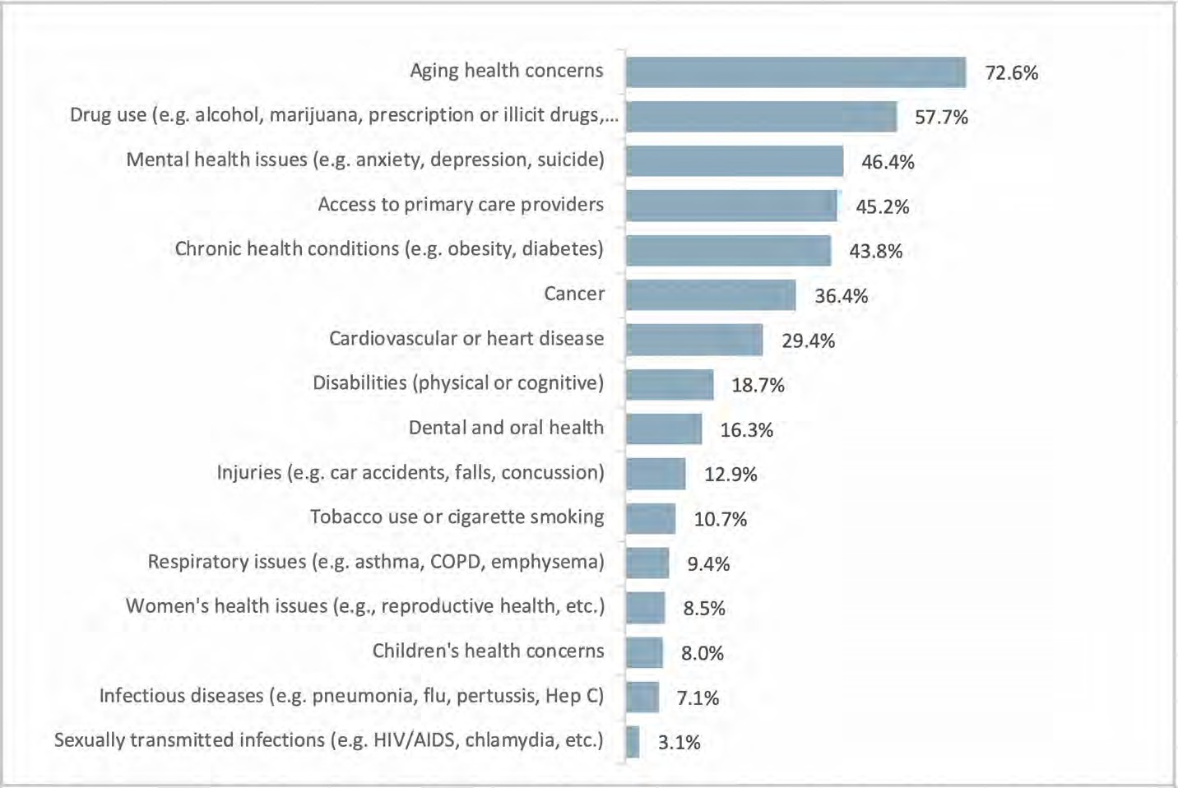
DATA SOURCE: CCHC Community Health Survey, 2018
NOTES: Percentages were based on sample size of n=1,727; respondents were asked to select up to five responses; percentages may not sum to 100%

FIGURE 43. PERCENT OF SURVEY RESPONDENTS IDENTIFYING HEALTH CARE SERVICE AS A TOP PRIORITY
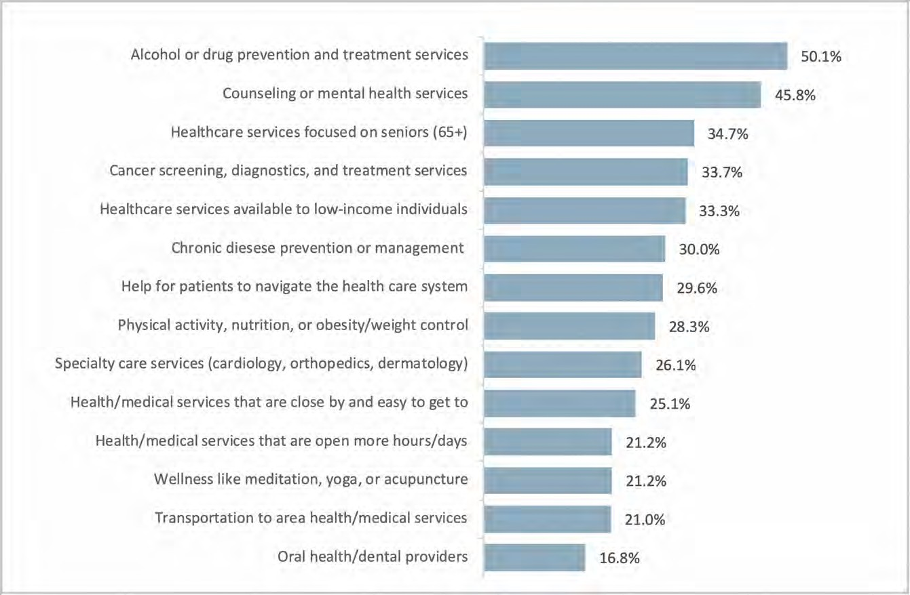
DATA SOURCE: CCHC Community Health Survey, 2018
NOTE: Respondents were asked to select up to five responses; percentages may not sum to 100%; percentages are based upon sample size of n=1,503
FIGURE 18. PERCENT OF SURVEY RESPONDENTS IDENTIFYING SOCIAL SERVICE AS A TOP PRIORITY
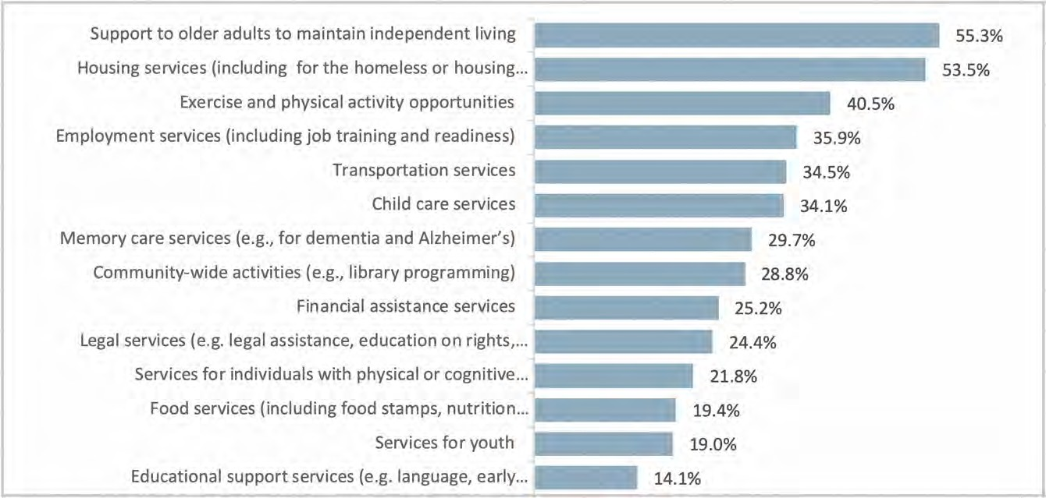
DATA SOURCE: CCHC Community Health Survey, 2018
NOTE: Respondents were asked to select up to five responses; percentages may not sum to 100%; percentages are based upon sample size of n=1,466

Key informant interviewees also noted that the population in the region is older and aging, which affects and will continue to affect the health and social service infrastructure.
One phenomenon discussed by key informant interviewees and substantiated by existing data is the large and growing number of seniors who are caring for grandchildren. Between 2011 and 2016, the proportion of grandchildren residing with their grandparents, who are responsible for them, declined in Massachusetts from 29.8% to 28.0%, while it increased substantially in Barnstable County from 27.0% to 42.8% (Figure 2). This increase occurred in parallel timing with the inception of the opioid epidemic in 2012, which has disproportionally impacted Barnstable County. While grandparents’ homes can provide stability and support when parents are unable to care for their children, caring for grandchildren can be physically and emotionally demanding for seniors, create financial challenges, and strain social and family relationships. These all contribute to poorer mental and physical health among grandparents.⁶
FIGURE 2: PERCENT OF GRANDCHILDREN RESIDING WITH THEIR GRANDPARENTS WHO ARE RESPONSIBLE FOR THEM, 2011 VS. 2016
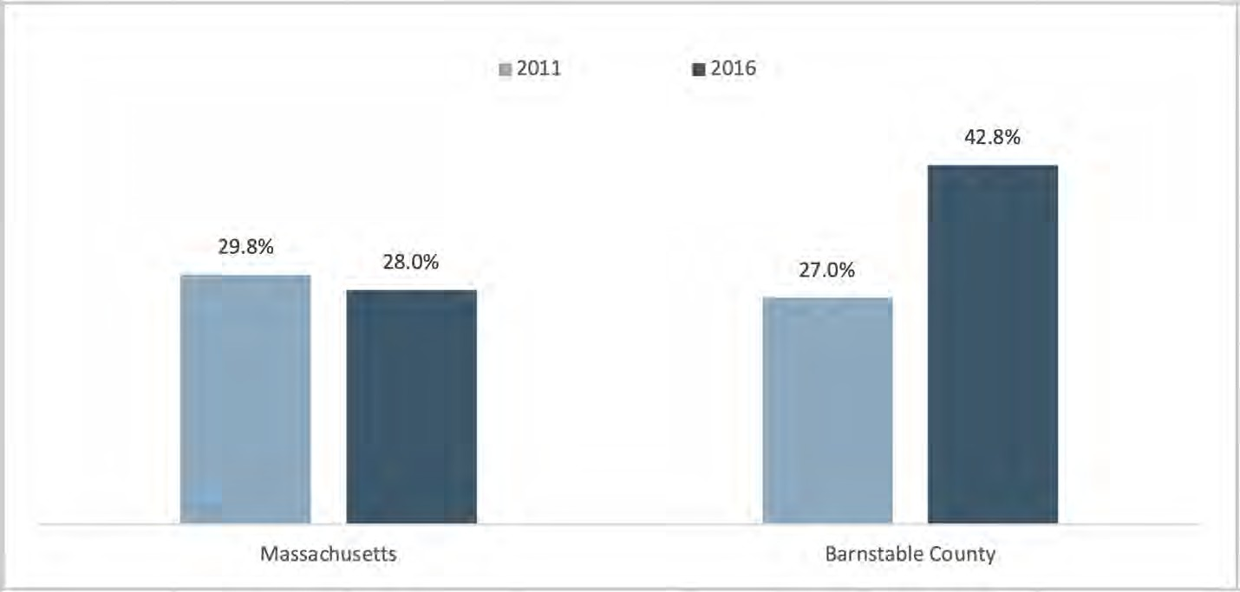
DATA SOURCE: U.S. Census Bureau, American Community Survey 5-Year Estimates, 2007-2011 & 2012-2016
Related in part to the older age of the population, Barnstable County has a larger proportion of veterans and residents with disabilities than the state overall. Eleven percent (11.0%) of county residents identified as veterans compared to 6.4% for the state overall.⁷ The largest proportion of veterans residing in Barnstable County is of the Vietnam era (36.2%). Approximately 14% of residents in Barnstable have a disability, compared to 11.6% for the state.
Between about 5% to 7% of Barnstable County residents have a hearing, cognitive, ambulatory, or independent living disability (Figure 3).

6https://www.asaging.org/blog/grandparents-grandchildren-and-caregiving-impacts-americas-substance-use-crisi 6https://www.asaging.org/blog/grandparents-grandchildren-and-caregiving-impacts-americas-substance-use-crisi
7 U.S. Census Bureau, American Community Survey 5-Year Estimates, 2012-2016; NOTE: Rates are based upon the civilian population aged 18 years or older.

Figure 3: Percent of Population with a Disability, By Type, 2016
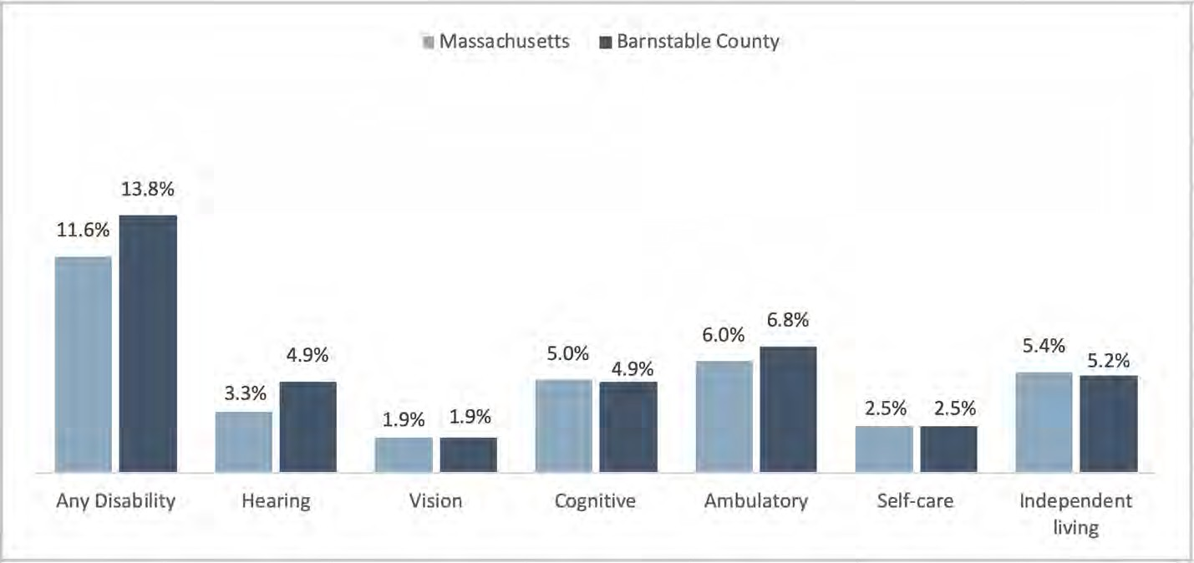
DATA SOURCE: U.S. Census Bureau, American Community Survey 5-Year Estimates, 2012-2016
In terms of race and ethnicity, the population of Barnstable County is less diverse than the state overall. Ninety percent (90.6%) of Barnstable County residents identify as White, non-Hispanic compared to 73.7% in the state overall (Figure 4). Though comprising a small proportion of the overall population, approximately 20,000 Barnstable County residents identify as a racial or ethnic minority.

FIGURE 4. RACIAL/ETHNIC DISTRIBUTION OF POPULATION, 2016
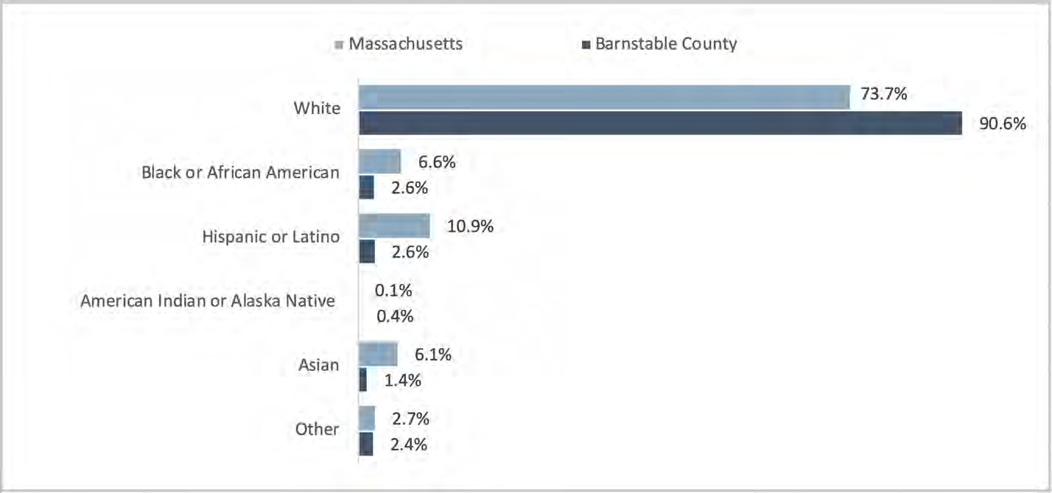
DATA SOURCE: U.S. Census Bureau, American Community Survey 5-Year Estimates, 2012-2016

Similarly, smaller proportions (7.8%) of Barnstable County residents speak a language other than English compared to the state overall (22.7%).⁸ While language minorities comprise a small portion of the county’s population, Spanish and Portuguese-speaking focus group participants shared those language barriers are a substantial barrier to economic advancement and the ability to access some health and social services. Focus group participants further reported that limited spaces in English as a Second Language (ESL) classes make it difficult for immigrants to learn English.

Social Determinants of Health and Health Findings

Social Determinants of Health Framework
The review of secondary data was undertaken with a broad definition of health that recognized numerous factors, beyond individual behaviors, that impact individual, community, and regional health. It is important to recognize that these multiple factors have an impact on health and that there is a dynamic relationship between real people and their lived environments. Figure 5 provides a visual representation of this relationship.

FIGURE 5: SOCIAL DETERMINANTS OF HEALTH FRAMEWORK
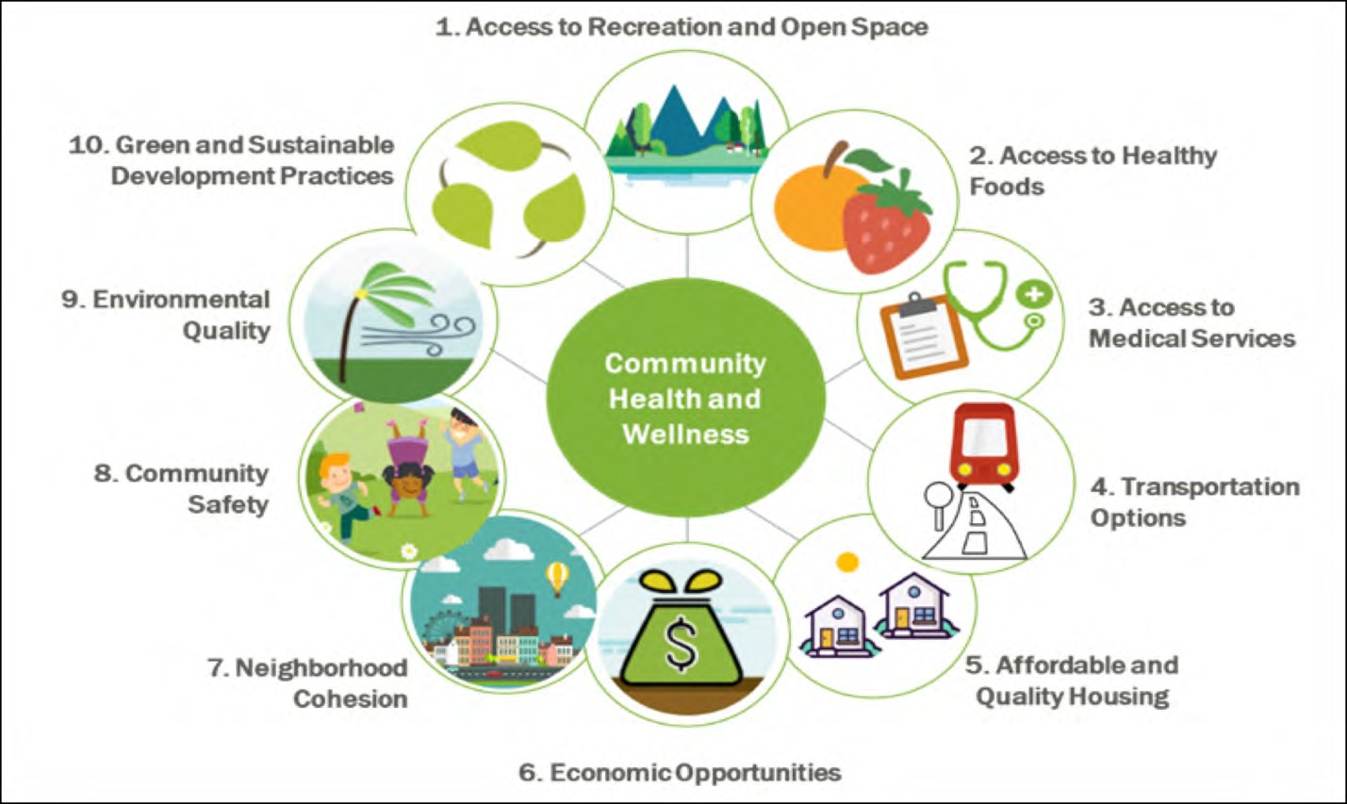
DATA SOURCE: Health Resources in Action, 2018

8 U.S. Census Bureau, American Community Survey 5-Year Estimates, 2012-2016; NOTE: Rates are based upon the population aged 5 years or older.

Given the impact that social factors have on health, community survey respondents were asked to identify the social issues most affecting the community. Housing or homelessness was identified as the top concern affecting the community by 65.5% of respondents, followed by access to health care services, identified by 53.7% of respondents (Figure 6). Other pressing issues identified by respondents included employment (44.5%), access to affordable and healthy food (40.3%), and transportation (39.0%).

FIGURE 6: PERCENT OF SURVEY RESPONDENTS IDENTIFYING ISSUE AS A TOP SOCIAL CONCERN FOR THE COMMUNITY
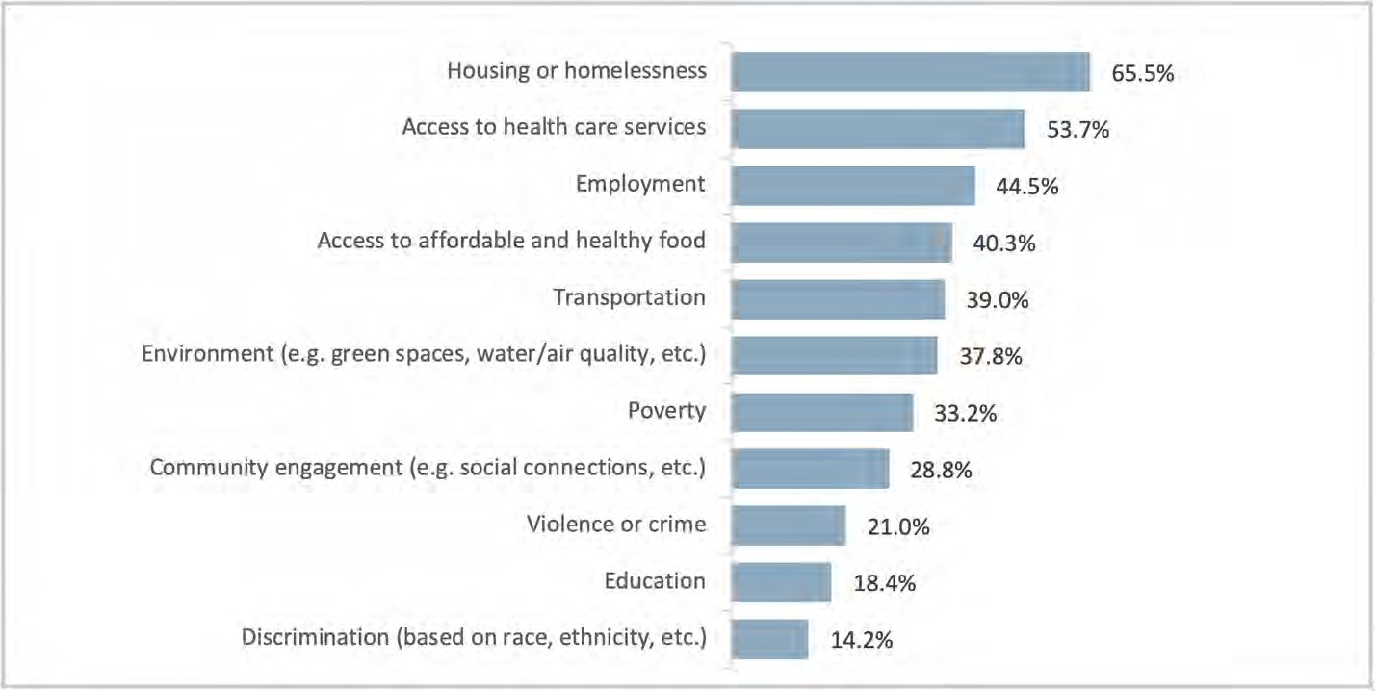
DATA SOURCE: CCHC Community Health Survey, 2018
NOTES: Percentages were based on sample size of n=1,469; respondents were asked to select up to five responses; percentages may not sum to 100%

Poverty as a social concern ranked more highly among survey respondents with household incomes less than $35,000 (42.6%) while the environment ranked more highly among survey respondents age 65 years or older (42.3%). The leading social concerns identified in the survey were echoed by key informant interviewees, focus group participants, and those participating in stakeholder dialogues and are discussed in subsequent sections by topic area.

Housing and Homelessness
“[Residents’] ability to earn wages doesn’t match the cost of housing.” (Key Informant Interviewee)
“Every day we hear about somebody who has to leave the Cape because the prices of housing are going up more and more.” (Key Informant Interviewee)
Quantitative data consistently show that the housing stock located in Barnstable County is unique within the state. Based on a 2017 real estate and housing report, 49% of all the seasonal units that exist in

Massachusetts are located in Barnstable County.⁹ Furthermore, the number of seasonal units is growing twice as fast as year-round units with implications for the availability of housing to year-round residents.
The cost and availability of housing in Barnstable County was mentioned as an area of concern in almost every focus group and interview, as well as in stakeholder dialogues, and was seen as a fundamental challenge affecting overall well-being and health. Housing—both ownership and renting—was described by participants as very expensive and increasing in cost as demand for seasonal housing increases. The high cost of housing contributes to an overall high cost of living in the community, which creates substantial pressure for year-round families, especially those who are low-income. Demand for vacation rental properties likewise means that less housing is available for those who need it all year long with implications for employment and the workforce.
The cost of housing also affects the ability to retain healthcare professionals with year-round employment, including nurses, medical assistants, physician assistants, and nurse practitioners, which interviewees described as potentially having a long-term impact on the availability of health care.
Regarding the housing that is available, some focus group participants further expressed dismay with the quality of the housing (e.g., mold).
As of 2018, an estimated 358 homeless individuals reside in the Cape Cod region, including 102 dependent children.¹⁰ The annual count has remained consistent over the past 3 years.
As noted above, 65.5% of community survey respondents identified housing and homelessness as the top social concern in the community (Figure 6). When asked to rate their level of concern for specific housing and economic issues impacting their community, the issues of ‘affordable housing for older adults’, ‘housing costs and issues associated with renting’, and ‘housing costs and issues associated with home ownership’ were rated as a ‘high concern’ by the largest proportions of survey respondents (57.6%, 54.6%, and 54.4%, respectively) (Figure 7). Among survey respondents living on the lower or outer cape, each of these issues was rated as a ‘high concern’ by an even larger proportion of respondents (69.0%, 66.6%, and 65.6%, respectively).

9 Cape Cod Commission, Cape Cod Regional Housing Market Analysis Report, 2017.
10 Cape and Islands Regional Network on Homelessness, Annual Point in Time Count for Barnstable, Dukes, and Nantucket Counties, 2016, 2017, 2018.

FIGURE 7: PERCENT OF SURVEY RESPONDENTS REPORTING “HIGH CONCERN”, BY HOUSING/ECONOMIC ISSUE
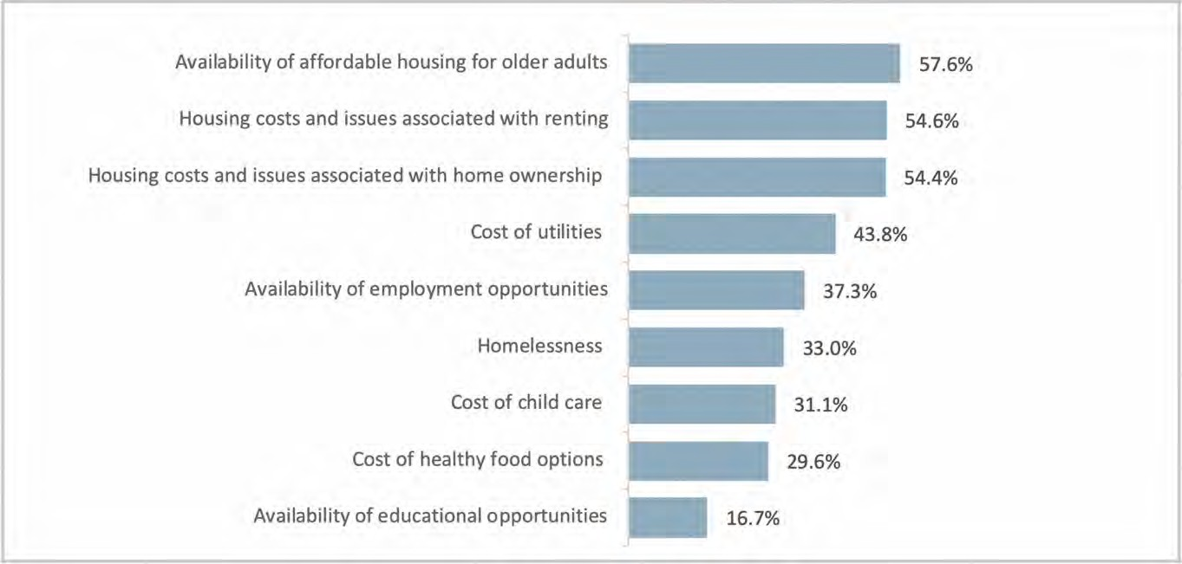
DATA SOURCE: CCHC Community Health Survey, 2018 NOTES: Percentages were based on sample size of n=1,648
Households in Barnstable County are predominately owner-occupied with less than one quarter (20.8%) being renter-occupied (Figure 8). However, some towns have larger proportions of renter-occupied households than the county, specifically Provincetown (33.2%), Barnstable (25.4%), and Bourne (24.6%).
FIGURE 8: PERCENT OF HOUSEHOLDS THAT ARE RENTER VS. OWNER OCCUPIED, 2016
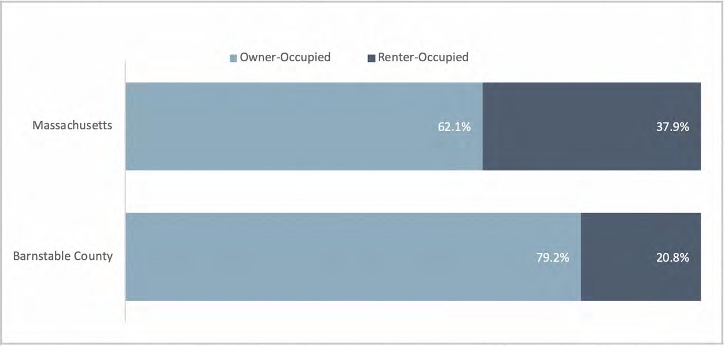
DATA SOURCE: U.S. Census Bureau, American Community Survey 5-Year Estimates, 2012-2016

Median monthly housing costs for residents of Barnstable County are similar to the state regardless of housing type (owners with a mortgage: $2,067 in MA vs. $1,826 in Barnstable County; owners without a mortgage: $730 in MA vs. $656 in Barnstable County; renters: $1,129 in MA vs. $1,137 in Barnstable County) (Figure 9). However, these estimates may not reflect shorter-term seasonal pressure on housing

costs as the U.S. Census American Community Survey captures data using a 2-month residency rule (i.e., those residing in a place for less than 2 months are not included in the survey).
FIGURE 9: MEDIAN MONTHLY HOUSING COSTS BY OWNERSHIP STATUS, BY STATE AND COUNTY, 2016
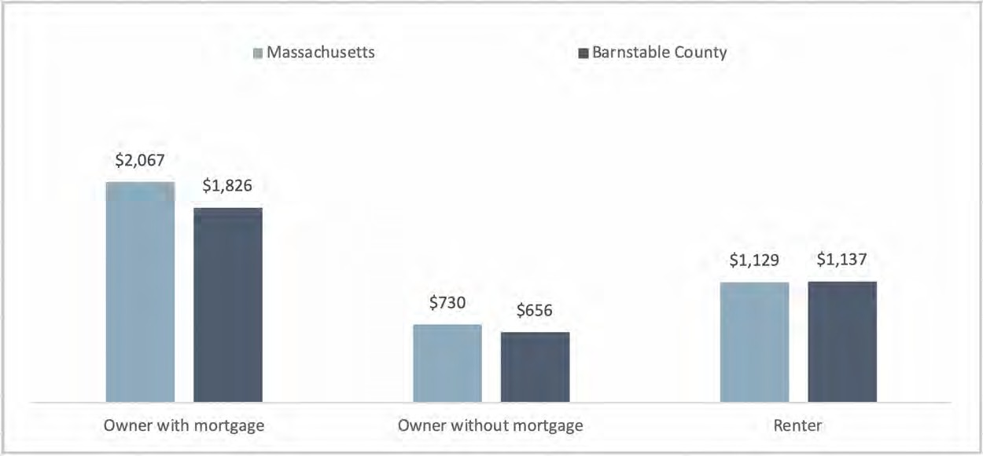
DATA SOURCE: U.S. Census Bureau, American Community Survey 5-Year Estimates, 2012-2016

In Barnstable County, over one third (39.1%) of renters and nearly one third (32.8%) of owners with a mortgage are identified as ‘housing cost burdened’ (i.e., the household devotes 35% or more of household income to housing costs) (Figure 10). These rates exceed those for the state overall, at 37.9% and 24.5% for renters and owners with a mortgage, respectively.

FIGURE 10: PERCENT OF HOUSING UNITS THAT ARE COST BURDENED, BY OWNERSHIP STATUS, 2016
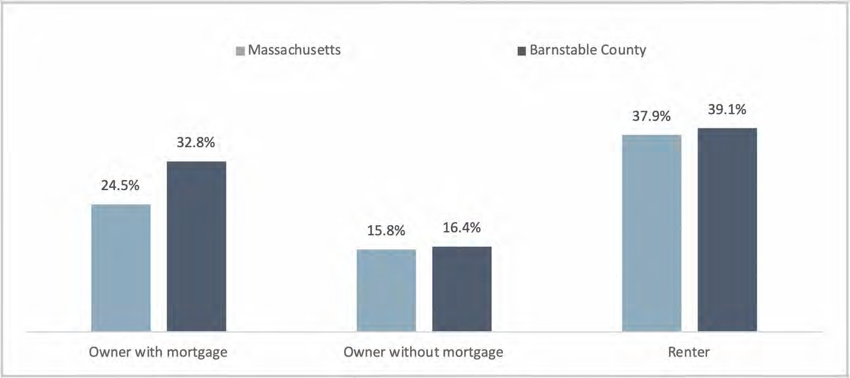
DATA SOURCE: U.S. Census Bureau, American Community Survey 5-Year Estimates, 2012-2016 NOTE: Cost burdened is defined as housing costs that equal 35% or more of household income

In thinking about the future, focus group and stakeholder dialogue participants as well as interviewees stressed the importance of improving housing quality, availability, and affordability for year-round residents and seasonal workers. The market rate cost of renting, for example, is tremendous – it’s more than Boston.” Implications for the aging population looking to downsize were also brought up by key informant interviewees. Participants identified improvements to the wastewater system and updated zoning regulations for spaces that can support housing as possible solutions to improving housing.
Participants stressed that updates to city/town zoning regulations could also be a feasible way to meet the increasing needs regarding affordable housing availability and the growing aging population.
Overall, participants emphasized the importance of improving housing with a thoughtful approach and smart design of neighborhoods. Along those same lines, participants supported a comprehensive community approach to homelessness, as many homeless individuals must also manage physical and/or mental health concerns. Participants also identified access to residential and public spaces as a community need. Some participants highlighted the fact that many elderly residents and individuals with disabilities find buildings to be inaccessible due to a lack of accommodations. These challenges can increase the risk for social isolation for some residents.

Income and Poverty
“Most people here have to have two jobs because the salaries are low, the income is low. There is no social life because when people leave work, they have to go to their second job.” (Focus Group Participant)
“I think that there is a perception that everyone that lives on the Cape is wealthy, which of course is not true. The people that live here year-round that are in the service industry, it’s common practice for so many folks to move out of their homes in the summer…to rent their homes because they can get so much money through the summer to take them through the winter.” (Key Informant Interviewee)
Although the prevailing view is that residents of Barnstable are primarily wealthy, key informant interviewees shared that this is a misperception as there are many residents in the county who are low- income and face financial instability. One third (33.2%) of community survey respondents identified poverty as one of their top social concerns (Figure 6).
The overall median household income for Barnstable County is slightly below the state ($65,382 vs.
$70,954), and generally much lower in non-family and renter-occupied households than in owner- occupied and family households ($37,140, $36,077, $73,364, and $82,945, respectively, in Barnstable County) (Table 2). Median household incomes were noted as particularly low for non-family households in Wellfleet ($25,667), Orleans ($29,881), and Provincetown ($31,958) and for renter-occupied households in Orleans ($15,662), Wellfleet ($21,458), and Dennis ($23,425).¹¹

11 U.S. Census Bureau, American Community Survey 5-Year Estimates, 2012-2016.

TABLE 2: MEDIAN HOUSEHOLD INCOMES BY HOUSEHOLD TYPE, 2016
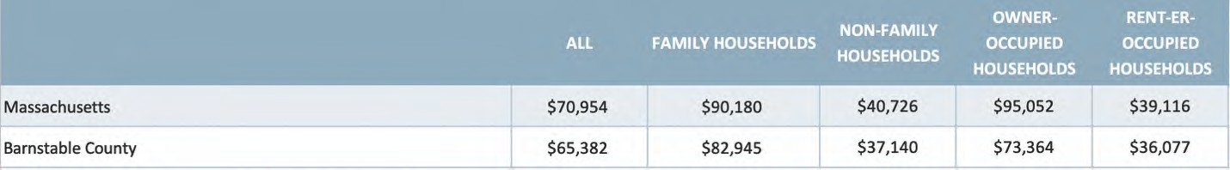
DATA SOURCE: U.S. Census Bureau, American Community Survey 5-Year Estimates, 2012-2016

The individual poverty rate for Barnstable County is lower than for the state, at 8.2% vs. 11.4%, respectively (Figure 11). However, there is variability between towns, with Provincetown (13.2%) and Chatham (12.7%) having higher rates of poverty than the state.¹² Similarly, the poverty rate for individuals age 65 and older is lower for Barnstable County than for the state (5.4% vs. 9.0%, respectively), whereas Provincetown has a higher rate of poverty for individuals age 65 and older than the state (15.0%).¹³

FIGURE 11: PERCENT OF INDIVIDUALS WITH INCOME BELOW 100% OF FEDERAL POVERTY LINE, 2016
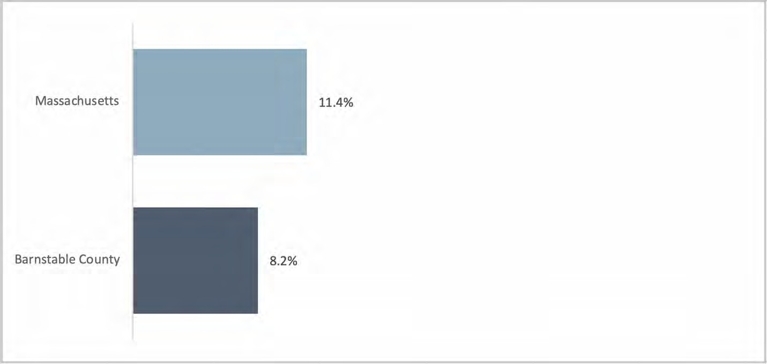
DATA SOURCE: U.S. Census Bureau, American Community Survey 5-Year Estimates, 2012-2016

Employment
“We’re primarily a service industry, meaning the hospitality, restaurants – things that support the tourism business, which is our prime economic driver. So, we have plenty of service-related jobs, but they’re not jobs that can support a family and can support the higher cost of housing here.” (Key Informant Interviewee)

12 U.S. Census Bureau, American Community Survey 5-Year Estimates, 2012-2016.
13 U.S. Census Bureau, American Community Survey 5-Year Estimates, 2012-2016.

“It is a problem, not just for the lower income people, but the children of the middle-income people, the upper middle class even. If they go away to college, they often don’t come back because the good, entry-level professional jobs are not here.” (Key Informant Interviewee)
Community participants expressed substantial concern about the seasonal job cycle (i.e., high employment in the summer and low employment in the winter) and the impact it has on the overall economy and poverty. The prevalence of seasonal service-based jobs and the lack of year-round professional jobs leads to reduced opportunities for upward job mobility, which – in addition the high cost of housing – deters young professionals from living and working in Barnstable County.
Quantitative data confirm that unemployment rates in Barnstable County are highly variable, swinging from highs of 6% to 7% in the winter months to lows of 3% to 4% in the summer months (Figure 12). In 2018, the seasonal swing in unemployment rates was particularly pronounced for towns of the Outer Cape. Between January and August 2018, Provincetown swung from a low of 2.5% to a high of 22.1%, Truro swung from a low of 1.8% to a high of 14.4%, and Wellfleet swung from a low of 2.5% to a high of 12.4%.¹⁴

FIGURE 12: TREND IN UNEMPLOYMENT RATE, JANUARY 2017 THROUGH MARCH 2019
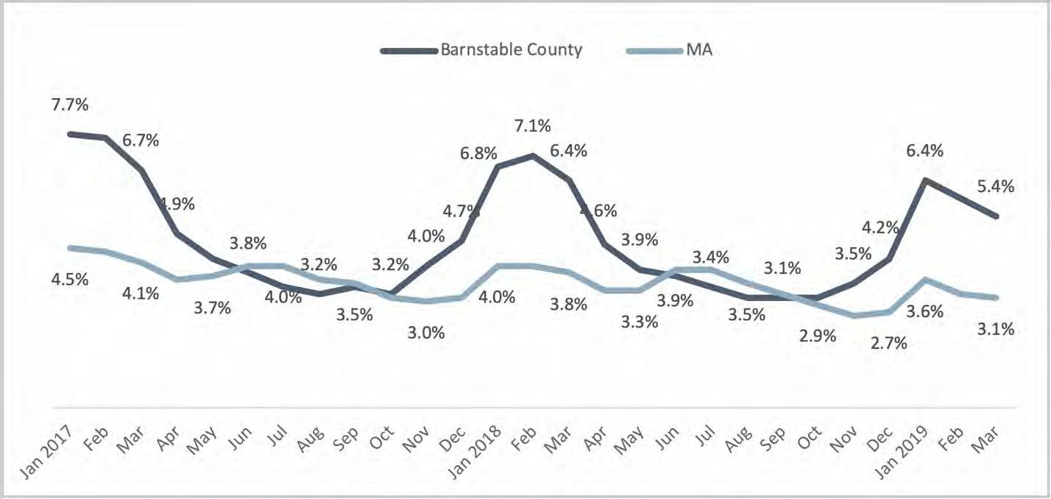
DATA SOURCE: U.S. Bureau of Labor Statistics, Local Area Unemployment Statistics, 2017, 2018, 2019
NOTE: Rates shown are not seasonally adjusted; represents the number unemployed as a percent of the labor force; unemployed is defined as persons aged 16 years and older who had no employment during the reference week, were available for work, except for temporary illness, and had made specific efforts to find employment sometime during the 4-week period ending with the reference week

A seasonal economy forces many residents to earn much of their income for an entire year over the course of five months. This leads to many residents experiencing financial insecurity during the

14 U.S. Bureau of Labor Statistics, Local Area Unemployment Statistics, 2018.

remainder of the year. Concerns were expressed that there is a lack of support for the working poor (individuals working more than one job, but still falling under the federal poverty line).
There was also a primary concern for young adults (persons aged approximately 18 to 26 years old). This cohort was described as being vulnerable to the effects of the seasonal economy and the overall lack of professional jobs in Barnstable County. Immigrants, who tend to be lower skilled, likewise face challenges in the economy. Focus group participants reported that the experience of economic instability during winter time brings with it stress, anxiety, and depression.
Generally, participants expressed desire for more overall funding and investments in economic development in the county. Additionally, participants would like to see improvements in the creation of incentives to hire older adults. Many of these residents want to continue working, but preferred part- time work, making them less competitive applicants.

Education
Barnstable County residents are well educated. Focus group participants and key informant interviewees reported that schools in the community are strong.
In Barnstable County, 4.6% of residents have less than a high school diploma, compared to 10% at the state level. However, 70.2% or residents have completed at least some amount of college or obtained a college degree, compared to 65.0% at the state level (Figure 13). The four-year high school graduation rate for Barnstable County is slightly lower than the rate for Massachusetts in 2017 (86.0% vs. 88.3%, respectively)¹⁵ , which reflects the current population of youth residing year-round in the County.
FIGURE 13: EDUCATIONAL ATTAINMENT FOR POPULATION AGE 25 YEARS AND OVER, 2016
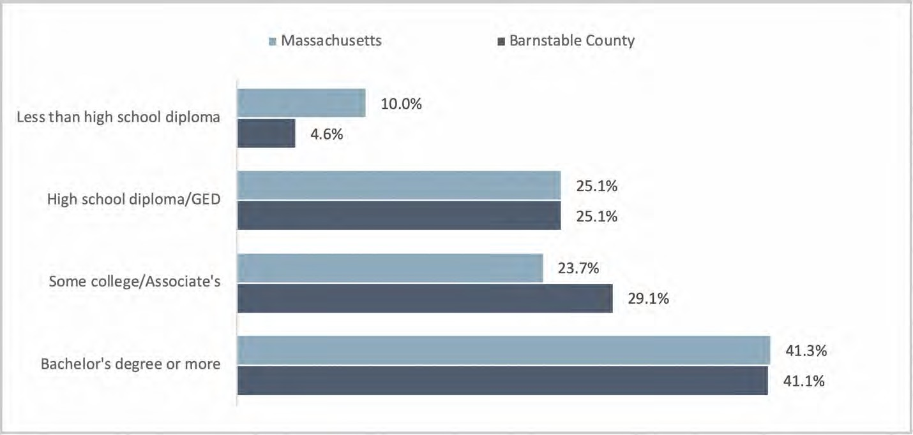
DATA SOURCE: U.S. Census Bureau, American Community Survey 5-Year Estimates, 2012-2016 NOTE: Rates shown are based upon the population aged 25 years or older

15 Massachusetts Department of Elementary and Secondary Education, School/District Profiles, 2017.

Transportation
“If you have a car, you’re fine. But if you do not and you live in Provincetown and you need get over to the next town or two towns over, you might as well be going to Boston because it’s that difficult to navigate around the Cape without a car.” (Key Informant Interviewee)
Both public and private transportation access and availability were a top concern in the community. Interviewees acknowledged that the Regional Transit Authority (RTA) makes a significant effort to meet the needs of residents who require public transportation, but rural geography and insufficient infrastructure creates challenges. As one key informant interviewee said, “If you don’t own car it’s nearly impossible to live on Cape Cod.”
Existing data suggest that access to a vehicle is not universal in Barnstable County. A fairly small proportion of owner-occupied households (2.7%) do not have access to a vehicle. However, the rate is over five times higher (16.5%) among renter-occupied households (Figure 14).

FIGURE 14: PERCENT OF HOUSEHOLDS WITH NO VEHICLE AVAILABLE, 2016
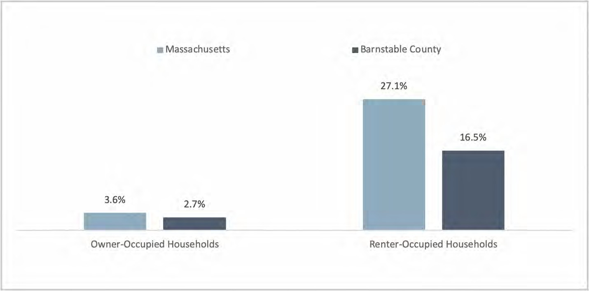
DATA SOURCE: U.S. Census Bureau, American Community Survey 5-Year Estimates, 2012-2016

Reduced public transit service in the winter months was noted as particularly difficult for year-round residents. While Cape Cod Healthcare has endeavored to reduce the number of residents who need to travel to Boston for health care, there are still transportation challenges for residents who do not have a vehicle. Some participants mentioned that existing transportation services are not well marketed to those who need them.
Thirty-nine percent (39.0%) of community survey respondents identified transportation as a top social concern in the community (Figure 6). When asked to rate their level of concern for specific transportation issues impacting their community, the issues of ‘summer traffic congestion’ and ‘availability of transportation for older adults’ were rated as ‘high concern’ by the largest proportion of

survey respondents at 51.0% and 32.9%, respectively; 29.2% identified ‘availability of public transportation’ as an issue (Figure 15).

FIGURE 15: PERCENT OF SURVEY RESPONDENTS REPORTING “HIGH CONCERN”, BY TRANSPORTATION ISSUE
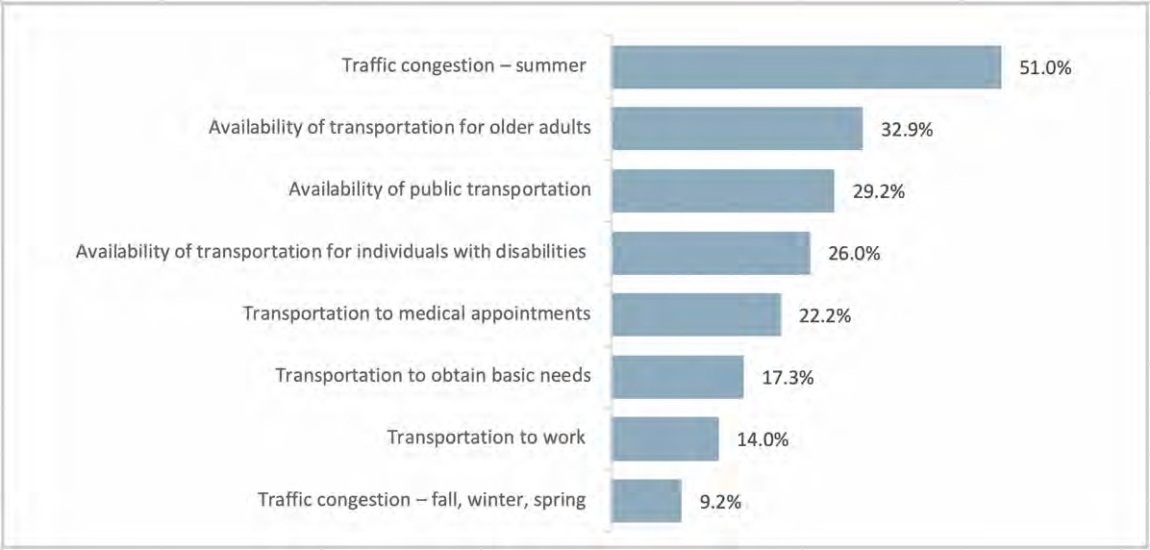
DATA SOURCE: CCHC Community Health Survey, 2018 NOTES: Percentages were based on sample size of n=1,648

When asked about what needs to change, participants envisioned improvements to the both the roadways and the public transportation system, so that the community can better handle the population influx during warmer months and residents without personal vehicles can better travel throughout the county.

Food Access
Geographic access to food is more limited in Barnstable County where 9.7% of low-income households are estimated to have limited access to healthy food compared to 4.1% low-income households in the state overall.¹⁶
Forty percent (40.3%) of community survey respondents identified ‘access to affordable and healthy food’ as a top social concern in the community (Figure 6) and 29.6% of survey respondent rated the ‘cost of healthy food options’ as a ‘high concern’ for the community (Figure 7).
Overall, the proportion of the population estimated to be food insecure is slightly lower in Barnstable County than the state overall (8.2% vs. 9.6%, respectively). However, the proportion of children estimated to be food insecure is slightly higher in Barnstable County than the state overall (12.9% vs. 12.1%, respectively) (Figure 16). Furthermore, among the 8.2% who are food insecure in Barnstable County, an estimated 36% of these individuals have incomes above the income threshold of less than

16 U.S. Department of Agriculture Food Environment Atlas, 2015.

200% of the federal poverty line and are therefore not eligible for Supplemental Nutrition Assistance Program (SNAP) benefits.¹⁷
FIGURE 16: PERCENT OF POPULATION THAT IS FOOD INSECURE, 2016
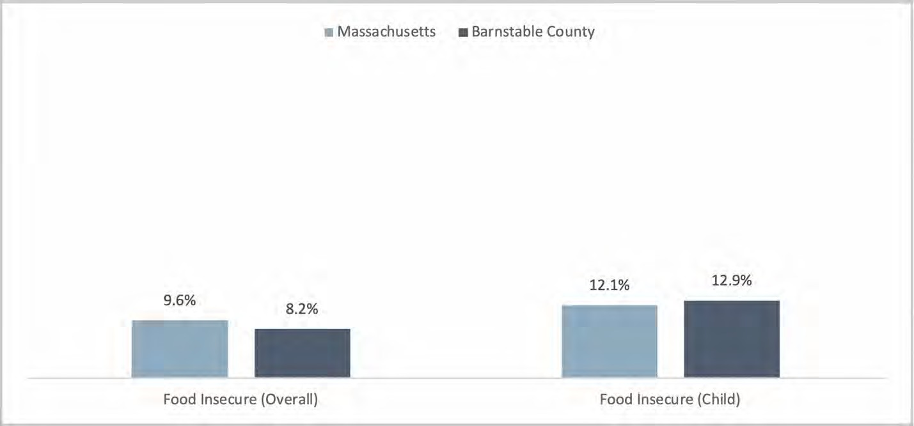
DATA SOURCE: Feeding America, Map the Meal Gap, Food Insecurity Estimates at the County Level, 2016

The percent of households that received SNAP benefits in the prior year is lower in Barnstable County than the state (7.8% vs. 12.5%, respectively).

Social Environments
“I think the community has a wonderful ability to come together and solve problems.” (Key Informant Interviewee)
“Because we’re an older community and there is wealth on the Cape, it’s a very generous community. There are a lot of public and charitable resources on the Cape for folks who are struggling. A lot of partnerships exist, both private and public.” (Key Informant Interviewee)
Barnstable County was described by key informant interviewees as a “very collaborative region” and a caring, cooperative community with the ability to respond to issues with strong connectivity. Awareness and collaboration were considered major factors in addressing community issues. Some noted that the collaboration is unavoidable due to the location of Barnstable County relative to the rest of the state. Regarding community cohesion, one key informant? Interviewee explained, “There’s a resiliency here that you don’t necessarily see in other areas.” Focus group participants likewise praised their communities and reported that they enjoyed living on Cape Cod. As one focus group participant stated, “People are kind and polite.”

17 U.S. Bureau of Labor Statistics, Local Area Unemployment Statistics, 2018.
18 Federal Bureau of Investigation, Criminal Justice Information Services (CJIS), Uniform Crime Reporting (UCR), Offenses Known to Law Enforcement, by State and by City, 2017; NOTE: Data not available for county; property crime includes burglary, larceny- theft, and arson.

Despite these perceptions, 28.8% of community survey respondents identified ‘community engagement/social connections’ as a top social concern for the community (Figure 6) and 37.1% identified this as a concern for themselves individually and/or their families. Additionally, ‘social isolation or loneliness’ was rated as a ‘high concern’ for the community by 21.6% of survey respondents. Several focus group participants noted, for example, that there are few things for younger adults to do, especially in the winter months.
Participants in both key informant interviews and stakeholder dialogues discussed the impact of social isolation/loneliness on residents of the Cape. Social isolation/loneliness is particularly felt when the tourism season ends, as seasonal occupations end and there are fewer social events in the community. Participants acknowledged that all residents can be affected by social isolation and loneliness, most expressed concern for older adults and young adults. For older adults, the risk for isolation was made worse for residents who live alone and those who do not have a regular/local caregiver. The perceived impact for both groups included declines in mental health (e.g., increased anxiety, depression), and substance use/misuse. Young adults were viewed as having the highest risk for substance use disorder because the shift in the job market could lead to boredom, depression, and financial insecurity.

Environment and Safety
About 38% (37.8%) of community survey respondents identified environmental issues as a top concern for the community (Figure 6). When asked to rate their level of concern for specific issues, the issues of ‘pedestrian or bicycle safety’, ‘air or water quality’ were rated as a ‘high concern’ by the largest proportion of survey respondents at 27.9% and 26.9%, respectively (Figure 17).
FIGURE 17: PERCENT OF SURVEY RESPONDENTS REPORTING “HIGH CONCERN”, BY ENVIRONMENT AND SAFETY ISSUE
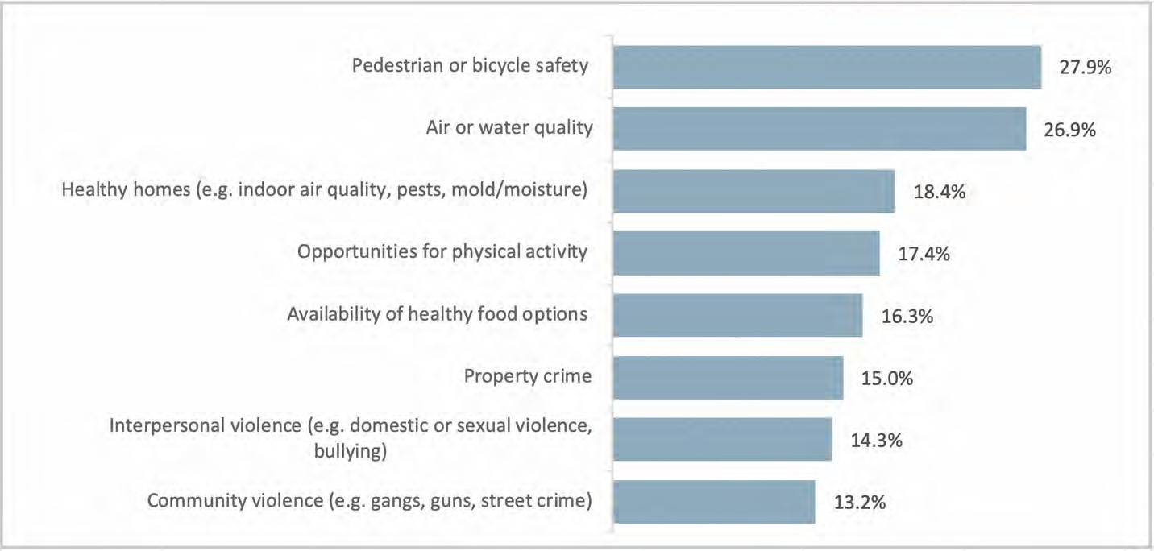
DATA SOURCE: CCHC Community Health Survey, 2018 NOTES: Percentages were based on sample size of n=1,648

Environment-related health issues were identified by a few focus group participants who shared concerns about public water and bacteria in produce. A handful of key informant interviewees

expressed concern with rising sea levels, problems with water filtration, wastewater leeching into the groundwater supply, as well as tick and mosquito borne illness.

Crime and Violence
The majority of towns in Barnstable County have property crime rates that are on par or below the state rate of 1,437.0 crimes per 100,000 residents. However, the property crime rate is markedly higher in Provincetown (4,243.2 per 100,000).¹⁸ The majority of towns in Barnstable County also have violent crime rates that are on par or below the state rate of 358.0 crimes per 100,000. However, the violent crime rate is higher in Provincetown (768.5 per 100,000), Truro (693.8 per 100,000), and Yarmouth (680.4 per 100,000).¹⁹
Twenty-one percent (21.0%) of community survey respondents identified violence and crime as a community social concern (Figure 6). The specific issues of ‘property crime’, ‘interpersonal violence (e.g., domestic violence, sexual violence, bullying)’, and ‘community violence (e.g., gangs, guns, street crime)’ were each rated as a ‘high concern’ for the community by about 15% of survey respondents. The issue of domestic violence came up consistently in focus groups and stakeholder dialogues. Focus group participants in particular noted that domestic violence is a concern for the Hispanic community and that access to services is limited by availability and fear in seeking help.

Community Health Issues

Overall Health and Mortality
Survey respondents generally rated their own/family’s health higher than the health of the community (Figure 19). Overall, 18.1% of all survey respondents rated community health as ‘Fair’ or ‘Poor’, while 9.5% of all survey respondents rated their own/family’s health as ‘Fair’ or ‘Poor.’ Survey respondents with low household incomes (<$35,000) were more likely to self-report their own/family’s health as ‘Fair’ or ‘Poor’ (22.7%) compared to the overall survey sample, though their rating of the community’s health was similar to the overall population (data not shown).

18 Federal Bureau of Investigation, Criminal Justice Information Services (CJIS), Uniform Crime Reporting (UCR), Offenses Known to Law Enforcement, by State and by City, 2017; NOTE: Data not available for county; property crime includes burglary, larceny- theft, and arson.
19 Federal Bureau of Investigation, Criminal Justice Information Services (CJIS), Uniform Crime Reporting (UCR), Offenses Known to Law Enforcement, by State and by City, 2017; NOTE: Data not available for county; violent crime includes murder and non- negligent manslaughter, forcible rape, robbery, and aggravated assault.

FIGURE 19: SELF-RATED HEALTH STATUS, OVERALL COMMUNITY AND SELF/FAMILY
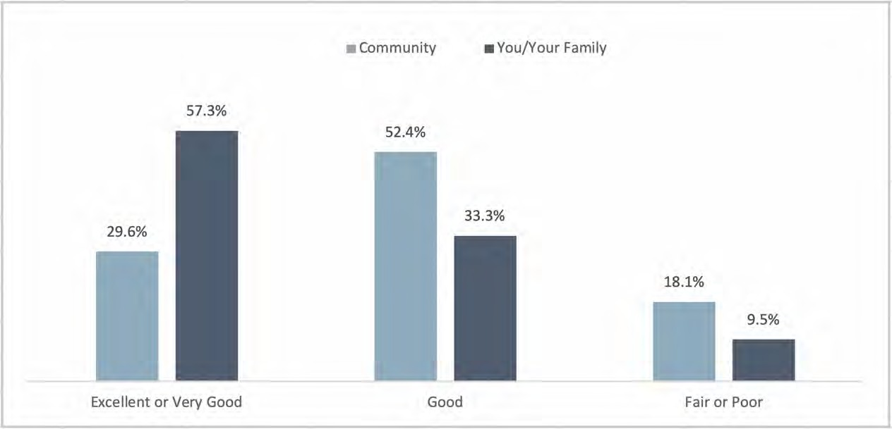
DATA SOURCE: CCHC Community Health Survey, 2018
NOTES: Percentages were based on sample size of n=1,791 (community) and n=1,999 (you/your family)

Overall, mortality rates for Barnstable County are on par with that of the state (Figure 20). Premature mortality rate (defined as deaths that occur before the age of 75) is slightly higher for Barnstable County than in the state, at 703.8 per 100,000 vs. 684.5 per 100,000 respectively. Several towns had premature mortality rates that were higher than the county, specifically Yarmouth (401.5 per 100,000) and Bourne (401.2 per 100,000).
FIGURE 20: OVERALL AND PREMATURE MORTALITY RATES PER 100,000 POPULATION, 2015
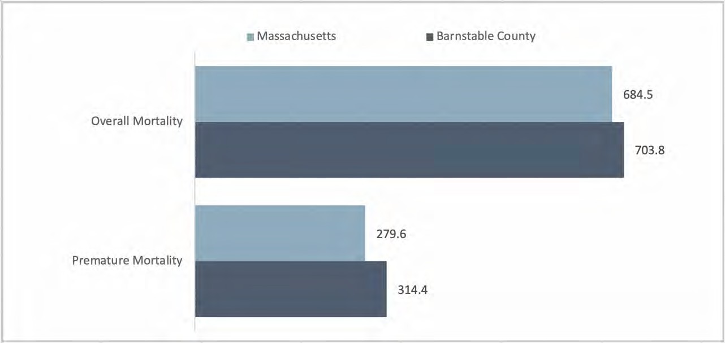
DATA SOURCE: Massachusetts Department of Public Health, Registry of Vital Records and Statistics, 2015 NOTE: Rates shown are age adjusted; premature mortality is defined as deaths that occur before age 75

Existing data show that cancer and heart disease are the top two leading causes of death in Barnstable County and in Massachusetts (Figure 21). Injuries and poisonings ranks third for Barnstable County residents (compared to ranking fourth for the state overall) due, in part, to the higher rate of opioid- related deaths in Barnstable County. Alzheimer’s disease ranks fourth for Barnstable County residents (compared to ranking sixth for the state overall), likely due to the older population in the County.

FIGURE 21: LEADING CAUSES OF MORTALITY, AGE-ADJUSTED RATES PER 100,000 POPULATION, 2015
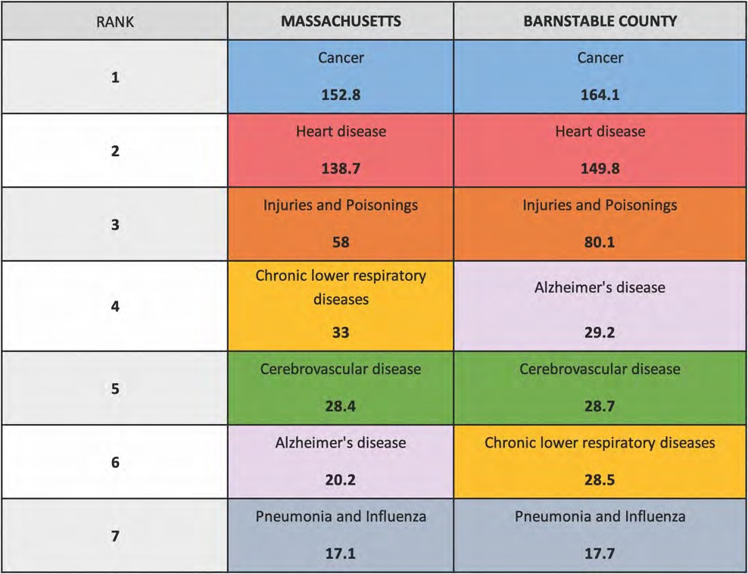
DATA SOURCE: Massachusetts Department of Public Health, Registry of Vital Records and Statistics, 2015

Among community survey respondents, the most frequently selected health issues impacting the community were ‘aging health concerns’ (72.6%), ‘drug use’ (57.7%), ‘mental health issues’ (46.4%), ‘access to primary care’ (45.2%), and ‘chronic health conditions’ (43.8%) (Figure 22).

FIGURE 22: PERCENT OF SURVEY RESPONDENTS IDENTIFYING ISSUE AS A TOP HEALTH CONCERN FOR COMMUNITY
DATA SOURCE: CCHC Community Health Survey, 2018
NOTES: Percentages were based on sample size of n=1,727; respondents were asked to select up to five responses; percentages may not sum to 100%

Survey respondents age 65 and older were more likely to select ‘aging health concerns’ as a top health concern for the community (81.7%) compared to the overall survey sample. Respondents that live on the lower or outer cape were more likely to select ‘access to primary care providers’ as a top health concern (57.6%) compared to the overall survey sample. Additionally, respondents of minority race/ethnicity and respondents with household incomes <$35,000 were more likely to select ‘dental and oral health’ as a top health concern (32.9% and 30.6%, respectively) compared to the overall survey sample.
Expanding health care services for seniors was consistently suggested by key informant interviewees and stakeholder dialogue participants. Participants saw a need for more geriatric providers, as well as enhanced capacity to address issues of dementia and Alzheimer’s, including caregivers, caregiver support, and education. Key informant interviewees suggested expanded use of telemedicine to reach home-bound seniors. Several participants mentioned a need for more education and services related to falls prevention. In addition to general comments about increasing care quality and access for seniors, some participants felt that all Barnstable Councils on Aging should expand their current obligations in the community. Specifically, participants suggested that councils adopt a more active role in chronic disease management for seniors and intergenerational programming.

Chronic Disease
Chronic health conditions were consistently identified as a community concern by community survey respondents, focus group participants, stakeholder dialogue participants, and key informant interviewees. Of community survey respondents, 43.8% identified chronic disease as a top health concern for the community (Figure 22). When survey respondents were asked to rate their level of concern for specific physical health conditions impacting their community, the issues of ‘cancer’ (28.0%), ‘heart disease or heart attack’ (22.5%), and ‘overweight/obesity’ (20.5%) were rated as a ‘high concern’ by the largest proportion of survey respondents (Figure 23).

FIGURE 23: PERCENT OF SURVEY RESPONDENTS REPORTING “HIGH CONCERN” FOR COMMUNITY, BY CONDITION
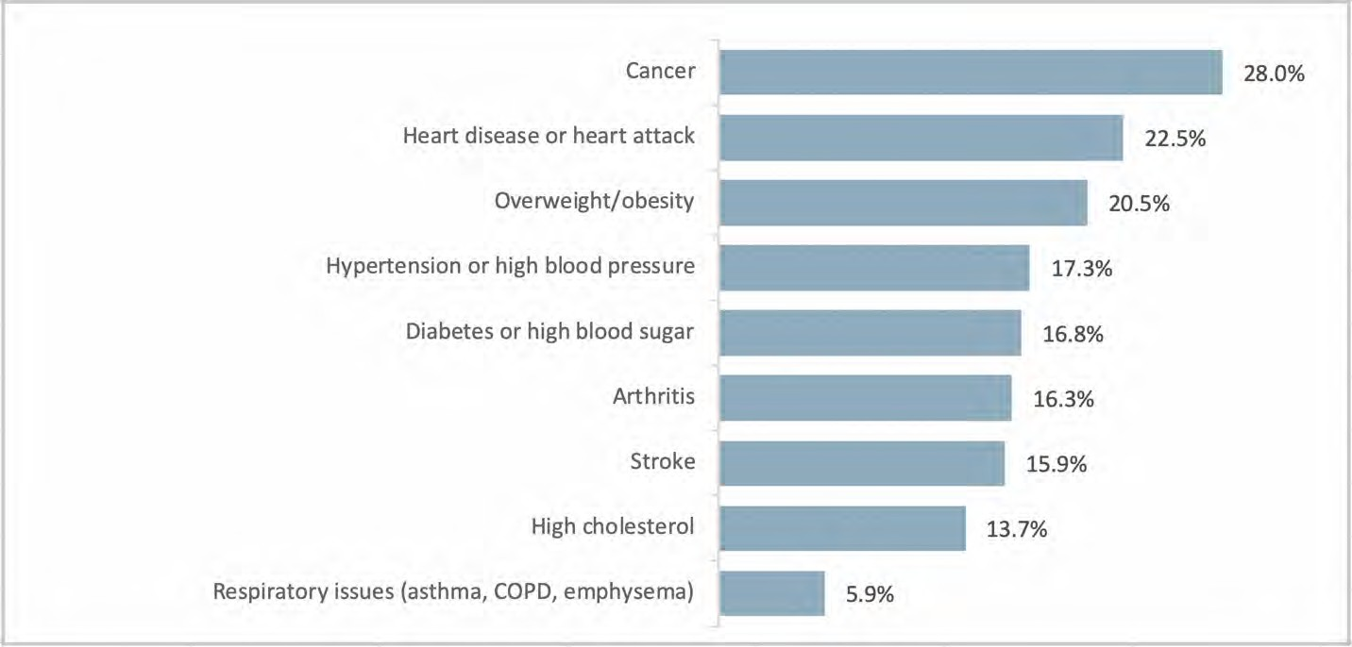
DATA SOURCE: CCHC Community Health Survey, 2018 NOTES: Percentages were based on sample size of n=1,808

Cardiovascular Disease and Related Conditions
More than half of the Medicare population in Barnstable County currently has a diagnosis of hypertension or hyperlipidemia (61.9% and 55.5%, respectively), which is slightly higher than for the state (59.5% and 48.4%, respectively. About one quarter (25.8%) of the Medicare population in Barnstable County has a diagnosis of Ischemic Heart Disease, on par with the state (26.2%) (Table 3).

TABLE 3: PERCENT OF MEDICARE POPULATION DIAGNOSED WITH CARDIOVASCULAR-RELATED CONDITIONS, 2015
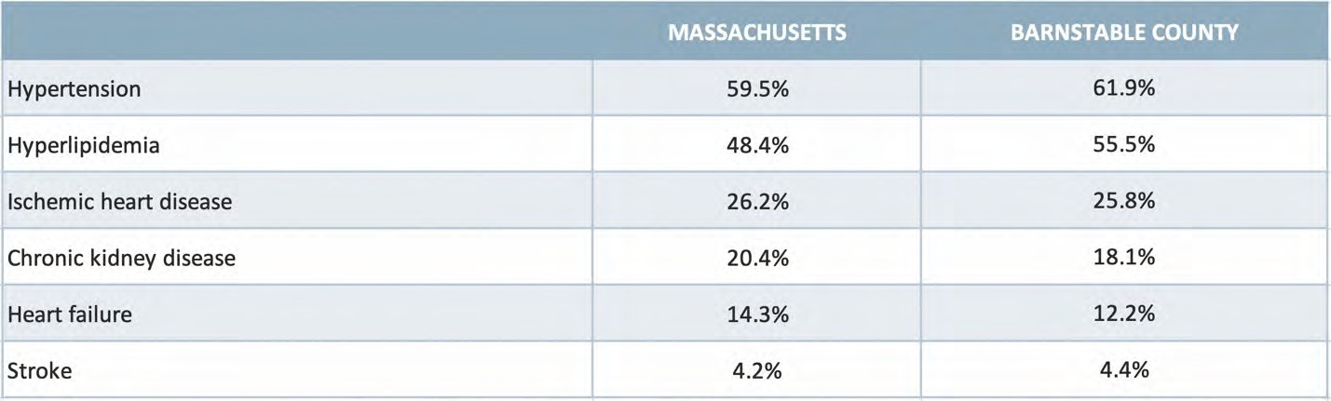
DATA SOURCE: Center for Disease Control and Prevention, 2015
NOTE: Rates show are based on Medicare beneficiaries age 65 and older

The rate of cardiovascular disease emergency room discharges among Barnstable County residents is notably higher than for the state (729.2 per 100,000 vs. 379.0 per 100,000, respectively) (Figure 24). Cardiovascular disease inpatient discharge rates are similar between Barnstable County and the state (1,018.6 per 100,000 vs. 934.65 per 100,000, respectively). However, the rate is notably higher in some towns. Bourne, Falmouth, Dennis, Yarmouth, Barnstable, and Sandwich all have cardiovascular disease inpatient discharge rates that exceed 1,500.0 per 100,000.
FIGURE 24: CARDIOVASCULAR DISEASE EMERGENCY AND INPATIENT DISCHARGE RATES PER 100,000 POPULATION
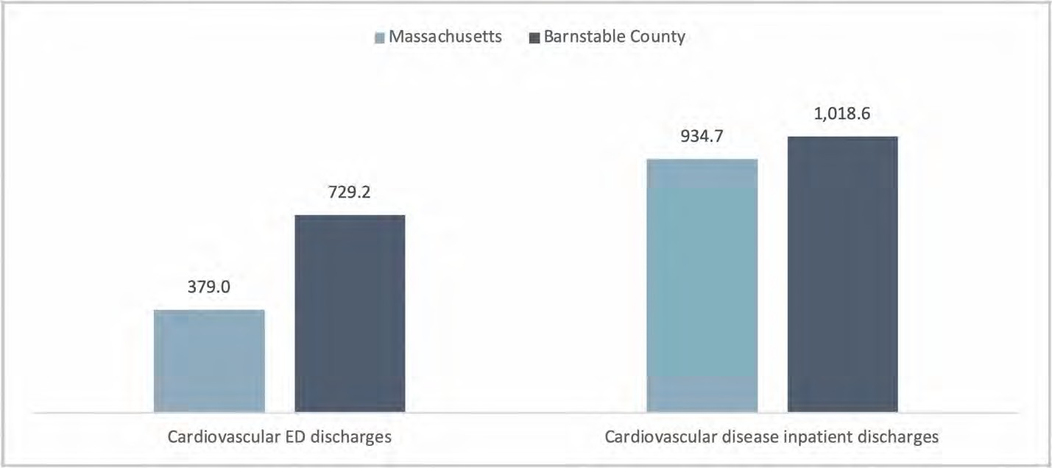
DATA SOURCE: Inpatient Discharges - Fiscal Year 2017 Massachusetts Health Data Consortium; ED Discharges – Fiscal Year 2015 Massachusetts Health Data Consortium; based on Cape Cod hospital discharge data and using state weights for age adjustment.

Heart disease mortality rates are similar in Barnstable County and the state (149.0 per 100,000 vs. 138.7 per 100,000).²⁰

Diabetes
It is estimated that 8% of Barnstable County adults aged 20 and older have been diagnosed with diabetes compared to 9% in MA overall.²¹ More recent data based on the patient populations served by three Federally Qualified Health Centers located within Barnstable County suggest that between 6 to 10% of adults’ age 18-75 have a current diabetes diagnosis.²²
The rate of diabetes-related emergency department visits among Barnstable County residents is higher than for the state (219.8 per 100,000 vs. 159.9 per 100,000) (Figure 25). The overall diabetes inpatient discharge rate is slightly lower in Barnstable County than the state (127.0 per 100,000 vs. 143.0 per 100,000). However, several towns have higher rates than the county, specifically Bourne (206.8 per 100,000), Dennis (194.5 per 100,000), Mashpee (194.4 per 100,000), and Orleans (187.5 per 100,000).

FIGURE 25: DIABETES EMERGENCY DEPARTMENT AND INPATIENT DISCHARGE RATE PER 100,000 POPULATION
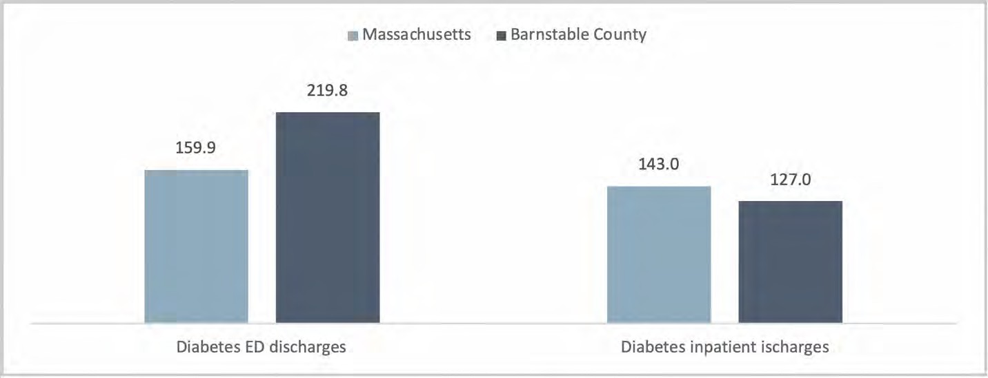
DATA SOURCE: Inpatient Discharges - Fiscal Year 2017 Massachusetts Health Data Consortium; ED Discharges – Fiscal Year 2015 Massachusetts Health Data Consortium; based on Cape Cod hospital discharge data and using state weights for age adjustment.

Cancer
Over one third (36.4%) of community survey respondents identified cancer as a top health concern in the community (Figure 22), and over one quarter (28.0%) of community survey respondents rated cancer as a ‘high concern’ for the community (Figure 23). The overall cancer incidence rate is slightly higher among Barnstable County residents than for the state, at 539.0 per 100,000 vs. 508.5 per

20 Massachusetts Department of Public Health, Registry of Vital Records and Statistics, 2015.
21 CDC Diabetes Interactive Atlas, based on 3-years of aggregated BRFSS data, 2014.
22 Health Resources & Services Administration (HRSA), Health Center Program Grantee Data, Uniform Data System (UDS), 2017; NOTE: Rates shown are based upon adult patients age 18 to 75.

100,000, respectively. The incidence rates for several specific cancer types are also slightly higher for Barnstable County residents including breast cancer, prostate cancer, and melanoma, compared to the state (breast cancer: 202.2 per 100,000 vs. 178.9 per 100,000; prostate cancer: 118.6 per 100,000 vs.
107.6 per 100,000; melanoma: 49.7 per 100,000 vs. 32.8 per 100,000 respectively) (Figure 26).

FIGURE 26: CANCER INCIDENCE RATE PER 100,000 POPULATION BY TYPE, 2011-2015
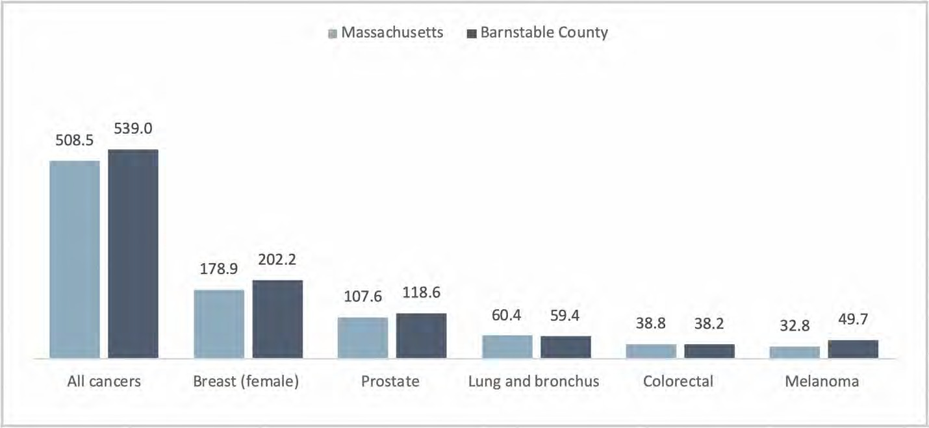
DATA SOURCE: Massachusetts Cancer Registry, 5-year Profile 2011-2015. NOTE: Rates shown are age adjusted

The overall cancer mortality rate is similar in Barnstable County and the state (163.2 per 100,000 vs.
152.8 per 100,000, respectively).²³ However, the mortality rates for breast and prostate cancers are over twice that for the state (breast cancer: 23.5 per 100,000 vs. 9.8 per 100,000; prostate cancer: 21.0 per 100,000 vs. 7.0 per 100,000, respectively) (Figure 27). Key informant interviewees identified both skin and breast cancer as important and emerging concerns for the community.

23 Massachusetts Department of Public Health, Registry of Vital Records and Statistics, 2015.

FIGURE 27: CANCER MORTALITY RATE PER 100,000 POPULATION BY TYPE, 2015
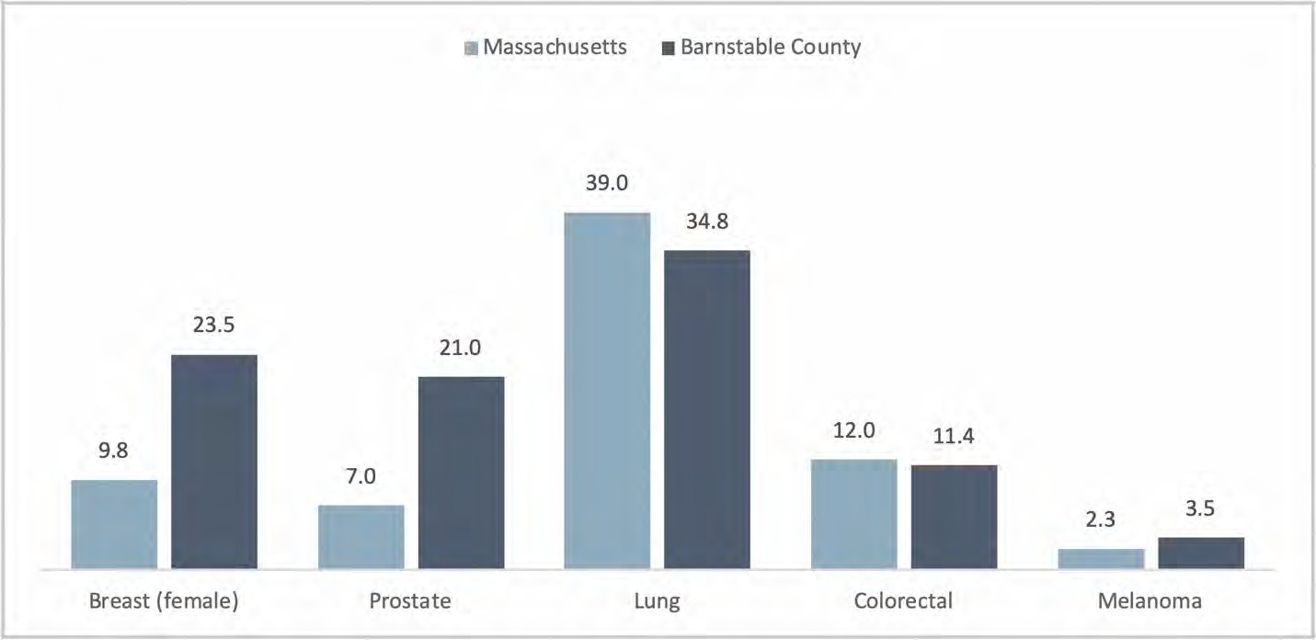
DATA SOURCE: Massachusetts Department of Public Health, Registry of Vital Records and Statistics, 2015 NOTE: Rates shown are age adjusted

Respiratory Health
Respiratory conditions, such as asthma, Chronic Obstructive Pulmonary Disorder (COPD), and emphysema were not identified as a leading health issue in the community by community survey respondents (Figure 22). However, these conditions impact individual well-being and may be related or exacerbated by environmental factors, such as exposure to tobacco smoke or unhealthy homes (e.g., mold, pests, etc.).
The asthma inpatient discharge rate is lower in Barnstable County than the state (34.3 per 100,000 vs.
62.1 per 100,000) respectively data for the patient populations served by three FQHCs located within Barnstable County suggest that between 5% and 10% of patients have a current asthma diagnosis.²⁴ Within the public school population, 9.8% of students in Barnstable County have a current asthma diagnosis which is the same as the state (9.8%). However, several school districts have higher proportions of students with asthma than the county overall, specifically Falmouth (15.8%) and Mashpee (14.9%).²⁵
The overall rate of COPD inpatient discharges is much lower for Barnstable County than for the state (119.0 per 100,000 vs. 246.8 per 100,000).

24 Health Resources & Services Administration (HRSA), Health Center Program Grantee Data, Uniform Data System (UDS), 2017 25 Massachusetts Department of Public Health, Bureau of Environmental Health, 2016-2017; Rates are based on public school students in K through 8th grade.

Alzheimer’s Disease
“We’re an older population to start with and as more and more of our seniors are not able to care for themselves, it is creating some stresses on our nursing homes, our assisted living facilities.” (Key Informant Interviewee)
The population of Barnstable County is older than the state overall and has a higher proportion of residents over age 75. Key informant interviewees and stakeholder dialogue participants shared concerns about the growing prevalence of Alzheimer’s disease and dementia in the community, and the ability of the health and social systems to address them. They reported that the community does not have a sufficient number of physicians and other health professionals skilled in geriatric issues. Noting that many seniors prefer to “age in place,” respondents also shared that one of the biggest current challenges is finding enough in-home workers to effectively care for Alzheimer’s patients and residents over age 70. The demand for these types of services is expected to increase in the coming years, yet Barnstable County’s younger population of potential caregivers is declining.
The 2018 Massachusetts Healthy Aging Community Data profile cites Center for Medicare data indicating that the rate of Alzheimer’s disease or related dementias among those age 65 or older ranges from a low of 6.0% in Wellfleet to a high of 11.7% in Bourne, with all of Barnstable County having a lower rate compared to the state (13.6%).²⁶ Alzheimer’s disease inpatient discharge rates are the same in Barnstable County and the state, with both rates at 20.9 per 100,000.²⁷ Alzheimer’s disease mortality rates are higher in Barnstable County compared to the state (29.2 per 100,000 vs. 20.2 per 100,000, respectively).²⁸

Behavioral Health
“It’s addiction and it’s mental health. And they are often connected, and they often end up in our correctional facility or our offices are dealing with them on the street as part of the homeless population or the drug trade.” (Key Informant Interviewee)
“The lack of resources is a problem. The lack of ability to find care and find treatment causes constant, perpetual calls for service from the police department.” (Key Informant Interviewee)
Mental health and substance use were seen as both deeply intertwined and pervasive concerns in Barnstable County. Behavioral health was identified as a top health concern across key informant interviewees, focus group participants, and stakeholder dialogue participants. Mental health and substance use were also identified as two of the top three health concerns (by 46.4% and 57.7% of community survey respondents, respectively) (Figure 22). Several focus group participants named the opioid crisis specifically, but many named depression, anxiety, and substance use disorder as overarching issues.

26 Massachusetts Healthy Aging Community Data Profile, 2018, Tufts Health Plan Foundation, https://mahealthyagingcollaborative.org/data-report/explore-the-profiles/.
27 Fiscal Year 2017 Massachusetts Health Data Consortium; Based on Cape Cod hospital discharge data and using state weights for age adjustment.
28 Massachusetts Department of Public Health, Registry of Vital Records and Statistics, 2015; Rates shown are age adjusted.

While participants agreed that the risk for behavioral health problems transcends age groups, young adults (approximately age 18 to 26 years) were perceived to be at high risk.
Mental Health
Forty-six percent (46.4%) of community survey respondents identified mental health as a community concern, ranking it third among all concerns (Figure 22). Among key informant interviewees, focus group participants, and stakeholder dialogue participants, mental health concerns were also named a top issue. They mentioned anxiety and depression as well as trauma, including both adverse childhood experiences and post-traumatic stress disorder. A number of underlying causes of mental health issues were discussed, including economic instability, lack of things for young adults to do, and isolation in the off-season.
The issues of ‘social isolation or loneliness’, ‘depression or bipolar disorder’, and ‘the general stress of day-to-day life’ were rated as mental health issues of ‘high concern’ for the community by the largest proportions of survey respondents (21.6%, 19.7%, and 19.2%, respectively) (Figure 28). Survey respondents of minority race/ethnicity were more likely to rate ‘depression or bipolar disorder’ (31.3%) and ‘suicidal behaviors’ (23.8%) as a ‘high concern’ for the community compared to the overall survey sample.
FIGURE 28: PERCENT OF SURVEY RESPONDENTS REPORTING “HIGH CONCERN” FOR THE COMMUNITY, BY MENTAL HEALTH CONDITION
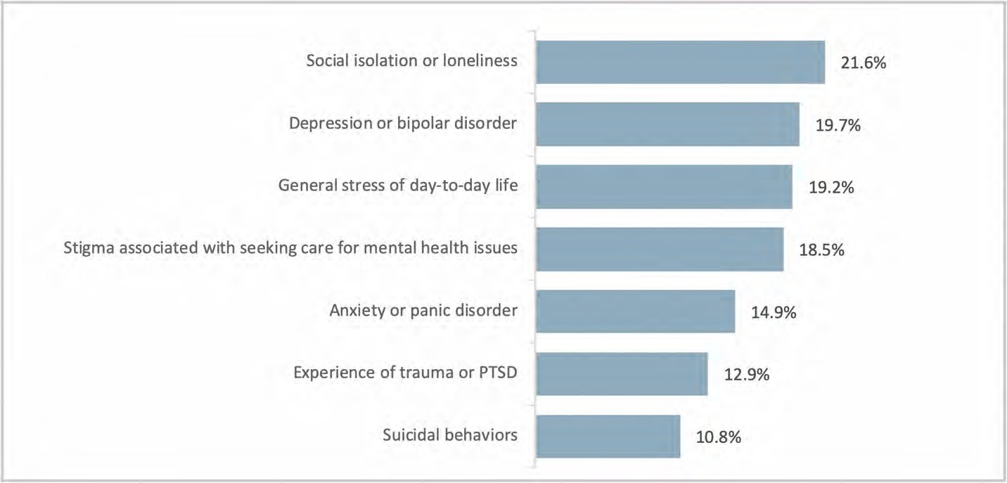
DATA SOURCE: CCHC Community Health Survey, 2018 NOTES: Percentages were based on sample size of n=1,808

Existing data related to the prevalence of mental health conditions or experiences of poor mental health are limited. Self-reported data suggest similar proportions of adults in Barnstable County and the state overall report 14 or more days of poor mental health in the prior month (11% vs. 12%).²⁹

29 Centers for Disease Control and Prevention, Behavioral Risk Factor Surveillance System, as reported by County Health Rankings, 2016.

Data on diagnoses of depression indicate rates are slightly higher among residents in Barnstable County than for the state overall, at 6.2% compared to 5.5%, respectively. Within Barnstable County, depression diagnoses rates were higher among women compared to men (7.7% vs 4.7%) and among residents age 18 to 34 years compared to residents aged 12 to 17 (6.1% vs. 3.5%) (Figure 29).
FIGURE 29: DEPRESSION DIAGNOSIS RATES, 2016
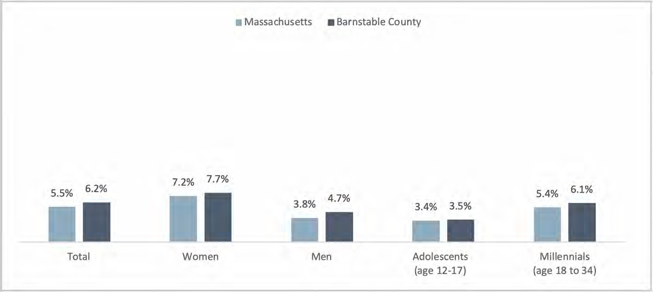
DATA SOURCE: 2016 Depression Diagnosis Rates by MSA, Blue Cross Blue Shield Foundation Report: Major Depression-The Impact on Overall Health, 2018

The overall inpatient discharge rate for mental health conditions is higher in Barnstable County than the state (507.4 per 100,000 vs. 424.3 per 100,000, respectively). Several towns had higher rates compared to the county, specifically Provincetown (755.8 per 100,000), Chatham (751.3 per 100,000), Dennis
(673.5 per 100,000), Yarmouth (641.3 per 100,000), and Barnstable (637.8 per 100,000).³⁰
The overall suicide mortality rate in Barnstable County is notably higher than the state (16.7 per 100,000 vs. 9.0 per 100,000). The rate in Bourne (20.6 per 100,000) and Barnstable (20.4 per 100,000) are higher than the county rate. However, in most towns, deaths due to suicide are low and rates are not reportable.³¹
Throughout the interviews, key informant interviewees identified younger residents as vulnerable to mental and behavioral health issues due to the lack of economic mobility and lack of targeted community programming. Interviewees saw a need for enhanced services for this group. Additionally, while Barnstable County was seen as “veteran-friendly,” a handful of interviewees recognized that there are still barriers and health concerns related to this population.
Access to mental health services was described as a substantial barrier in Barnstable County. Twenty- nine (28.9 %) percent of community survey respondents rated counseling or mental health care for

30 Fiscal Year 2017 Massachusetts Health Data Consortium; Based on Cape Cod hospital discharge data and using state weights for age adjustment.
31 Massachusetts Department of Public Health, Registry of Vital Records and Statistics, 2015.

adults as ‘hard’ or ‘very hard’ to access and 25.4% of respondents rated mental health services for children/adolescents similarly. Participants in interviews and stakeholder dialogues stated that there is a shortage of mental and behavioral health services in the community, particularly psychiatrists, nurse practitioner psychiatrists, and in-patient services for children and adolescents. Interviewees also noted a lack of “wraparound” services when patients leave mental/behavioral health treatment.
When asked what was needed to address mental health issues in Barnstable County, key informant interviewees, focus group participants, and stakeholder dialogue participants stated that the region needs more services to address mental health issues. One key informant interviewee suggested that one way to address this would be for primary care clinics to provide care for less complicated psychiatric conditions, so that psychiatrists could focus on people with more complicated conditions. Participants also reported that more prevention of mental health problems was needed as well as efforts that reduce the stigma surrounding behavioral health.
Substance Use
“The largest concern facing the Cape…is the opioid-fentanyl drug problem. It’s literally impacted every community – rural, urban, and suburban. There are no demographic lines, there are no town lines, there’s no socioeconomic lines. It has affected the wealthy, the educated, the poor and we have a higher number of, not only overdoses, but people in treatment. It has been the issue for at least five years affecting virtually every part of the Cape.” (Key Informant Interviewee)
“Addiction is another problem in our community. Access to services related to addiction is difficult.”
(Focus Group Participant)
Substance use was noted as a primary concern for Barnstable County. The opioid epidemic was mentioned most frequently, and participants stated that it has impacted all age groups and communities, as well as the criminal justice system, employment, and homelessness. Tobacco use and alcohol use disorder were mentioned as concerns as well. Participants also expressed concern about the growth in the use of marijuana since legalization and the popularity of vaping among young people.
Substance use was identified as the second top health concern among community survey respondents, with over half (57.7%) of respondents identifying this as a top health concern (Figure 22). When survey respondents were asked to rate their level of concern for specific substance use issues impacting their community, the issues of ‘opioid misuse, ‘alcohol or binge drinking’, and ‘other illicit drugs’ were rated as a ‘high concern’ by the largest proportion of survey respondents (45.6%, 36.7%, and 34.4% respectively) (Figure 31). Survey respondents of minority race/ethnicity were more likely to rate ‘other illicit drugs’ (47.5%) and ‘vaping or e-cigarettes’ as a ‘high concern’ for the community (33.8%) compared to the overall survey sample.

FIGURE 31: PERCENT OF SURVEY RESPONDENTS REPORTING “HIGH CONCERN” FOR THE COMMUNITY, BY SUBSTANCE ABUSE ISSUE
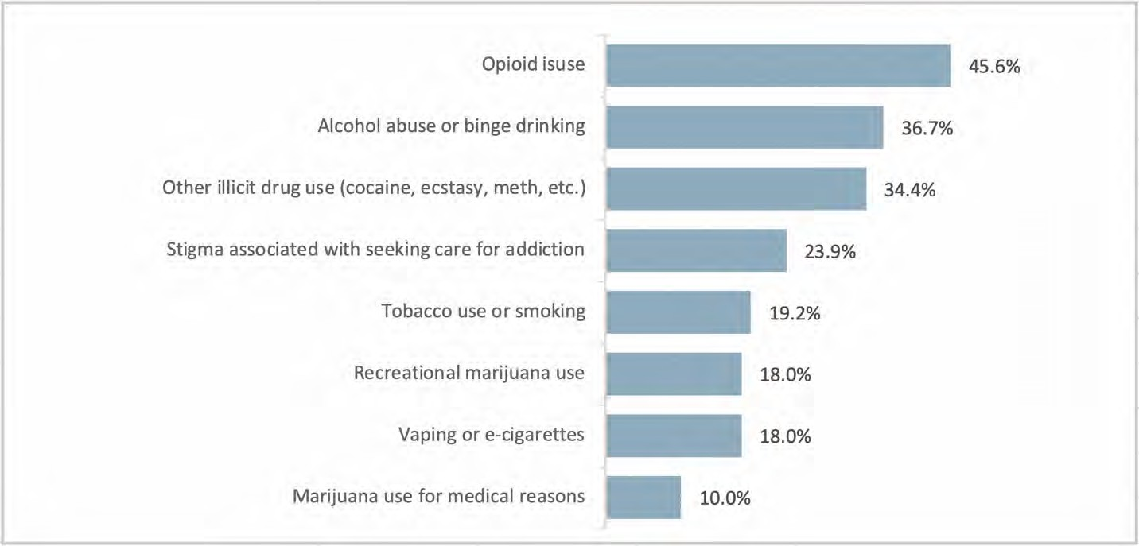
DATA SOURCE: CCHC Community Health Survey, 2018 NOTES: Percentages were based on sample size of n=1,808

FIGURE 32. PERCENT OF 12TH GRADERS REPORTING SUBSTANCE USE IN PRIOR 30 DAYS, 2016-2017
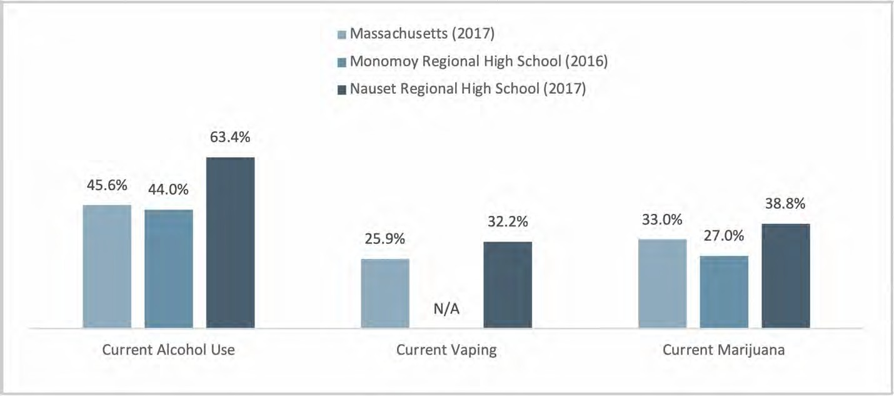
DATA SOURCE: Youth Health Survey, MA Department of Health (2017), Monomoy Regional High School (2016), and Nauset Regional High School (2017). NOTE: Rates shown reflect students in grade 12 only

Existing data on the prevalence of substances use is sparse. Available self-reported data indicate similar proportions of adults who binge drink (approximately 20%) or smoke cigarettes (approximately 14%) in Barnstable County and the state overall.³²
Vaping in particular is emerging as a serious issue for adolescents nationally, in Massachusetts, and in Barnstable County. Self-reported vaping among high school seniors, for example, has increased by ten percentage points (from 27.8% to 37.3%) nationwide between 2017 and 2018.³³ In Massachusetts in 2015, almost half of high school students reported that they have ever used an electronic vapor product.³⁴ (Figure 32)
Substance abuse-related inpatient discharge rates are lower in Barnstable County than the state (158.3 per 100,000 vs. 264.5 per 100,000). One town, Falmouth, has a rate that exceeds the state rate (273.8 per 100,000).³⁵
Data from the Massachusetts Bureau of Substance Abuse Services (BSAS) demonstrates that the overall substance abuse treatment admission rate is higher in Barnstable County than the state (1,979.9 per 100,000 vs. 1,564.5 per 100,000).³⁶ Over half (52.8%) of all BSAS admissions in Barnstable County were for alcohol, which is a higher proportion than the state, at 34.5% (Figure 33).
FIGURE 33: PERCENT OF BSAS TREATMENT ADMISSIONS LISTING ALCOHOL AND HEROIN AS PRIMARY SUBSTANCE, FISCAL YEAR 2018
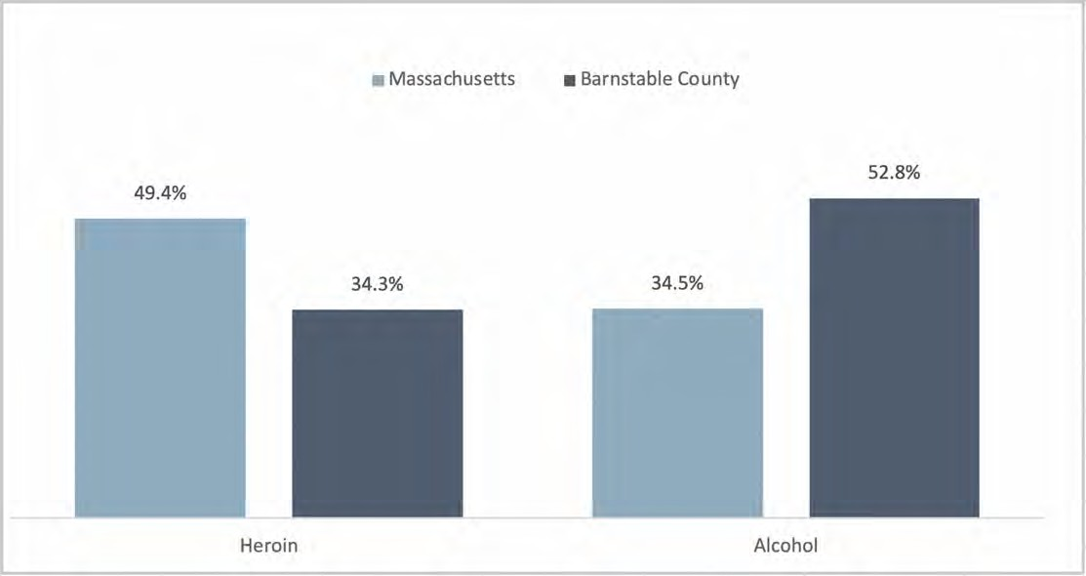
DATA SOURCE: Massachusetts Department of Public Health, Bureau of Substance Abuse Services, Office of Statistics and Evaluation, Fiscal Year 2018

32 Centers for Disease Control and Prevention, Behavioral Risk Factor Surveillance System, as reported by County Health Rankings, 2016.
33 https://www.drugabuse.gov/news-events/news-releases/2018/12/teens-using-vaping-devices-in-record-numbers
34 https://www.mass.gov/files/documents/2016/09/vp/youth-health-risk-report-2015.pdf
35 Fiscal Year 2017 Massachusetts Health Data Consortium; Based on Cape Cod hospital discharge data and using state weights for age.
36 Massachusetts Department of Public Health, Bureau of Substance Abuse Services, Office of Statistics and Evaluation, Fiscal Year 2018. NOTE: Rates are crude rates, calculated using the total population counts cited in US Census. American Community Survey 5-Year Estimates, 2012-2016.

The overall opioid mortality rate in 2015 was higher in Barnstable County than the state (41.0 per 100,000 vs. 24.6 per 100,000, respectively).³⁷ The rates in Mashpee (80.8 per 100,000), Falmouth (65.0 per 100,000), and Yarmouth (58.9 per 100,000) were also higher, although in most towns, deaths due to opioids are low and rates are not reportable from the MA DPH.
More recent preliminary data on opioid-related overdose deaths for 2016 and 2017 suggest slight downward trends both statewide (from 31.9 to 30.6 per 100,000) and in Barnstable County (from 37.7 to 31.2 per 100,000) (Figure 34). However, these data should be considered only preliminary rates that are likely to change as final mortality data are not yet available from MA DPH after 2015.
FIGURE 34: ESTIMATED RATE OF OPIOID-RELATED OVERDOSE DEATHS PER 100,000 POPULATION, 2015-2017
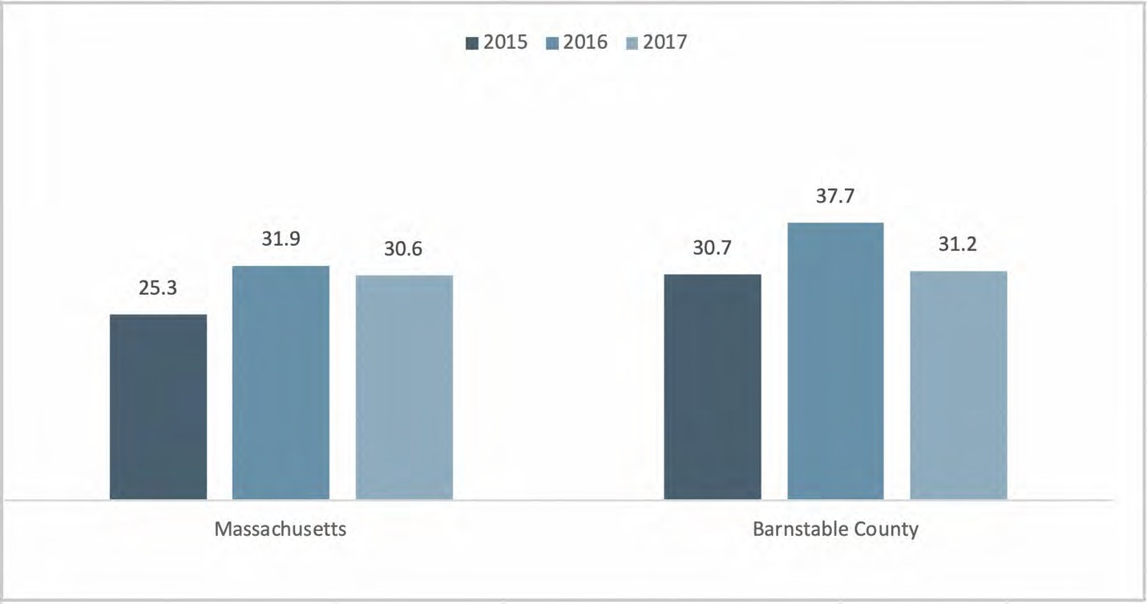
DATA SOURCE: Massachusetts Department of Public Health, Registry of Vital Records, Current Opioid Statistics NOTE: Data only includes confirmed cases – 2016 and 2017 data are preliminary and subject to updates (data current as of 10/25/2018)

As described earlier, key informant interviewees discussed, and existing data show the impact of the opioid crisis on family structures, specifically the higher number of grandparents raising grandchildren. Responsibility for grandchildren can be a source of emotional and financial stress for grandparents, having negative consequences for their physical and mental health. This has substantial implications for the health and social services supporting seniors in the community.
When asked about substance use treatment facilities in the community, interviewees and stakeholder dialogue participants reported that current facilities were insufficient and at capacity and as a result, residents are transported out of the county to receive treatment. Over 20% of community survey respondents rated alcohol or drug treatment services for adults (22.3%) and youth (21.9%) as ‘hard’ or ‘very hard’ to access. Interviewees and stakeholder dialogue participants cited a need for more treatment beds, sober houses, and community-based services.

37 Massachusetts Department of Public Health, Registry of Vital Records and Statistics, 2015. NOTE: Rates are age adjusted.

Overall, participants agreed that there is a need for more availability of regionalized care so that residents can live and work in their own community while receiving treatment for drug and alcohol use disorders. Participants also saw a need for better care coordination including through hospital social workers and patient navigators, follow-up visits to homes after overdose, and re-entry supports for those being released from prison. Finally, participants suggested more education, both relative to substance use prevention (and beginning with children) and relative to addressing the stigma associated with behavioral health and seeking care.

Maternal and Child Health
Maternal and child health were not prominent topics identified by key informant interviewees, focus group participants, stakeholder dialogue participants, or community survey respondents. However, existing data highlight some potentially important issues related to the current health of mothers and children in Barnstable County. A total of 1,601 births occurred in 2016 to residents of Barnstable County.³⁸ Over half of these were to women in the towns of Barnstable (424 births), Falmouth (241 births), and Yarmouth (170 births). Teen birth rates (births to mothers aged 15 to 19 years) were slightly lower in Barnstable County than the state (7.4 per 1,000 vs. 8.5 per 1,000) in 2016.³⁹
Over one quarter (28.1%) of women who gave birth in Barnstable County were identified as having inadequate prenatal care, a proportion that is higher than the state (17.7%) (Figure 35).
FIGURE 35: PERCENT OF BIRTHS WITH INADEQUATE PRENATAL CARE, 2016
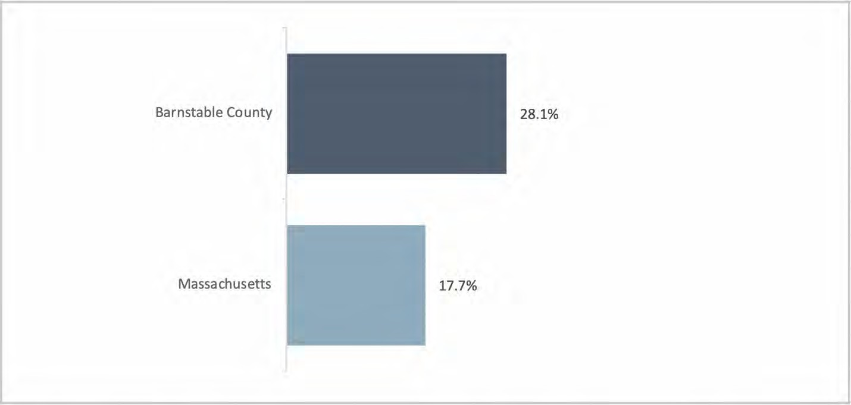
DATA SOURCE: Massachusetts Department of Public Health, Registry of Vital Records and Statistics, 2016
NOTE: Inadequate prenatal care defined as care that began month 5 or later and/or less than 50% of expected prenatal care received.

38 Massachusetts Department of Public Health, Registry of Vital Records and Statistics, 2016.
39 Massachusetts Department of Public Health, Registry of Vital Records and Statistics, 2016.

The proportion of births that are pre-term (<37 weeks gestation) is similar for Barnstable County and the state overall (9.1% vs. 8.7%, respectively) (Figure 36).
FIGURE 36: PERCENT OF BIRTHS THAT ARE PRE-TERM OR LOW BIRTH WEIGHT, 2016
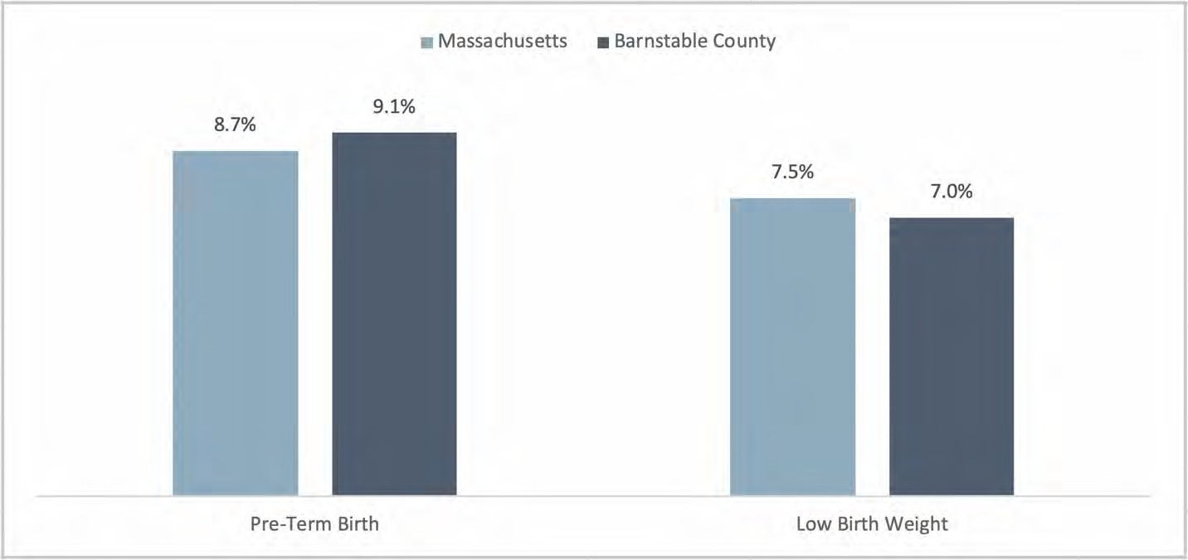
DATA SOURCE: Massachusetts Department of Public Health, Registry of Vital Records and Statistics, 2016

The proportion of births that are low birth weight is also similar for Barnstable County and the state (7.0% vs. 7.5%, respectively). However, the infant mortality rate for Barnstable County is twice as high as the state rate (8.8 per 1,000 vs. 4.3 per 1,000, respectively).⁴⁰

Infectious Disease
Sexually Transmitted Infections
Sexually transmitted infections (STI) and infectious disease in general, were not identified as prominent topics by community survey respondents (Figure 22). However, several key informant interviewees and stakeholder dialogue participants identified STIs as problematic in Barnstable County, particularly the stigma associated with HIV/AIDS. As one stakeholder dialogue participant said, “People will avoid care to avoid that stigma.”
Barnstable County has the third highest HIV prevalence rate of all counties in Massachusetts (385 per 100,000) behind Suffolk County (846 per 100,000) and Hamden County (481 per 100,000) and is slightly above the state rate (338 per 100,000).⁴¹ The annual incidence rate for HIV in Barnstable County was on par with the state (8.2 per 100,000 vs. 9.7 per 100,000) between the years of 2014 and 2016.⁴²

40 Massachusetts Department of Public Health, Registry of Vital Records and Statistics, 2015.
41 National Center for HIV/AIDS, Viral Hepatitis, STD, and TB Prevention as reported by County Health Rankings, 2015; NOTE: Rates are based on population age 13 years and older.
42 Massachusetts Department of Public Health, Bureau of Infectious Disease and Laboratory Sciences. 2018 Massachusetts HIV/AIDS Epidemiologic Profile: Regional HIV/AIDS Epidemiologic Profile of Barnstable County.

The rate of reported chlamydia cases is lower in Barnstable County than the state (271.9 per 100,000 vs.
446.0 per 100,000, respectively) (Figure 37). Likewise, the overall rate of reported gonorrhea cases is lower in Barnstable County than the state (50.5 per 100,000 vs. 111.6 per 100,000, respectively). The rate of reported syphilis cases in Barnstable County is on par with the state (14.8 per 100,000 vs. 16.7 per 100,000). While most towns’ rates are similarly low, Provincetown has markedly high rates of chlamydia (1,156.1 per 100,000), gonorrhea (1,054.1 per 100,000), and syphilis (544.1 per 100,000).
FIGURE 37: CHLAMYDIA, GONORRHEA AND SYPHILIS CASE RATES PER 100,000 POPULATION, 2017
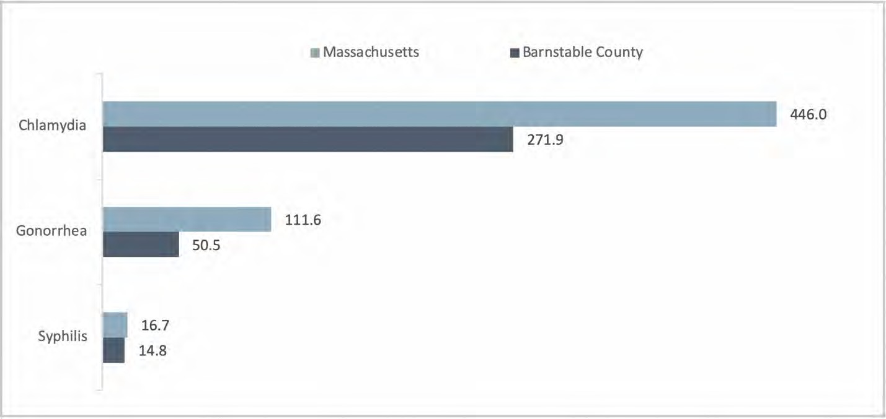
DATA SOURCE: Massachusetts Department of Public Health, Bureau of Infectious Disease and Laboratory Sciences, Office of Integrated Surveillance and Informatics Services, 2017. NOTE: Rates shown are based on confirmed and probable cases

The Hepatitis C rate in Barnstable County is on par with the state (113.4 per 100,000 vs. 116.4 per 100,000, respectively). However, the rate is higher in several towns, including Falmouth (174.4 per 100,000), Bourne (141.7 per 100,000), and Yarmouth (130.3 per 100,000).⁴³ The number and rate of new Hepatitis C cases among persons 15-29 years of age increased dramatically between 2009 and 2015 in both the state (from 140.2 to 190.2 per 100,000) and in Barnstable County (from 163.3 to 461.3 per 100,000), followed by a sharp decline between 2016 and 2017 in both the state (172.7 to 153.2 per 100,000) and in Barnstable County (441.3 to 212.0 per 100,000) (Figure 38). Rates in Barnstable County for this age group have been higher than the state since 2009. Although the reasons for the recent decline are unclear, the state report suggests the increase from 2009 to 2015 was most likely linked to the injectable opioid use epidemic.

43 Massachusetts Department of Public Health, Bureau of Infectious Disease and Laboratory Sciences, Office of Integrated Surveillance and Informatics Services, 2017. NOTE: Rates are based on confirmed and probable cases.

FIGURE 38: HEPATITIS C CASE RATE PER 100,000 POPULATION, AGE 15 TO 29 YEARS, 2007 TO 2017
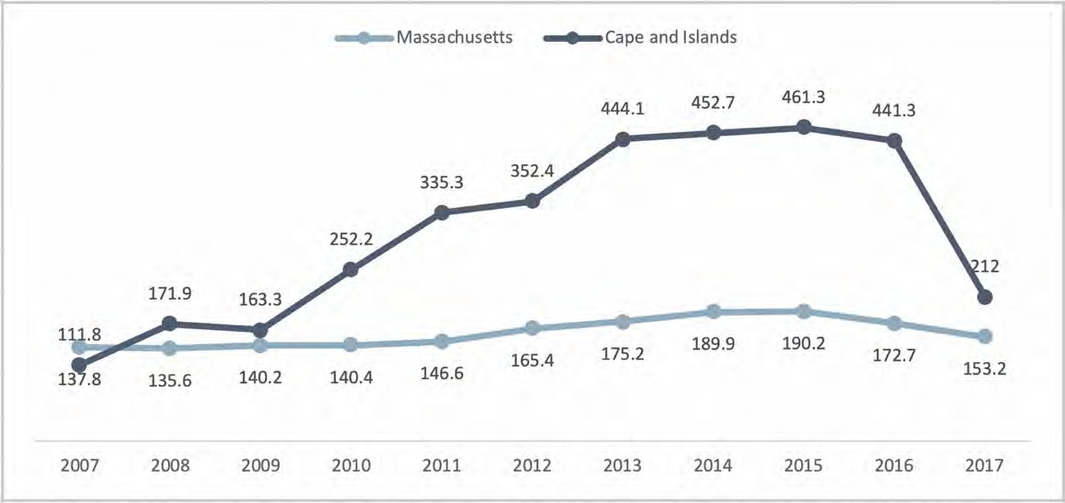
DATA SOURCE: Bureau of Infectious Disease and Laboratory Sciences, Office of Integrated Surveillance & Informatics Services, Disease Status Report
NOTE: ‘Cape and Islands’ includes data for Barnstable, Dukes, and Nantucket Counties; data are current as of 11/15/2016 for the 2007-2015 data and as of 2/28/19 for the 2016 and 2017 data

Tick Borne Diseases
The prevalence of tick-related diseases was mentioned as a major health concern in Barnstable County by several key informant interviewees. Incidence rates for tick borne diseases are higher for Barnstable County than the state (Lyme disease: 122.0 per 100,000 vs. 86.0 per 100,000; human granulocytic anaplasmosis: 25.5 per 100,000 vs. 11.7 per 100,000; Babesiosis: 48.6 per 100,000 vs. 7.8 per 100,000, respectively) (Figure 39). Of tick-borne illnesses, Lyme disease is most common, followed by Babesiosis, and human granulocytic anaplasmosis.

FIGURE 39: TICK BORNE DISEASE INCIDENCE RATES PER 100,000 POPULATION, 2014-2016
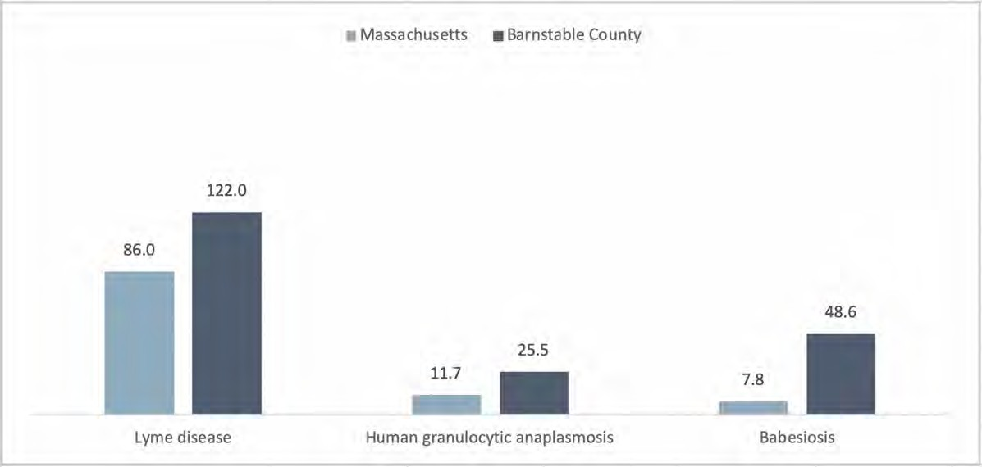
DATA SOURCE: Massachusetts Department of Public Health, 2014 (Lyme), 2015 (HGA), and 2016 (Babesiosis). NOTE: Rates shown are based on confirmed and probably cases

Health Care Access
Insurance Status
Massachusetts and Barnstable County experience lower uninsured rates than the nation overall. For the adult population, age 18 to 64 years of age, 3.5% are uninsured in Barnstable County, compared to 3.2% in the state and 16.4% in the U.S. (Figure 40). Among residents under 18 years of age, the uninsured rate is slightly higher in Barnstable County than the state (3.5% vs. 3.2%, respectively). Several towns have higher uninsured rates than the county, including Dennis (7.0%), Chatham (3.9%), and Mashpee (3.5%). However, many towns have virtually fully insured populations of children.

FIGURE 40: PERCENT OF POPULATION THAT IS UNINSURED, BY AGE GROUP 2016
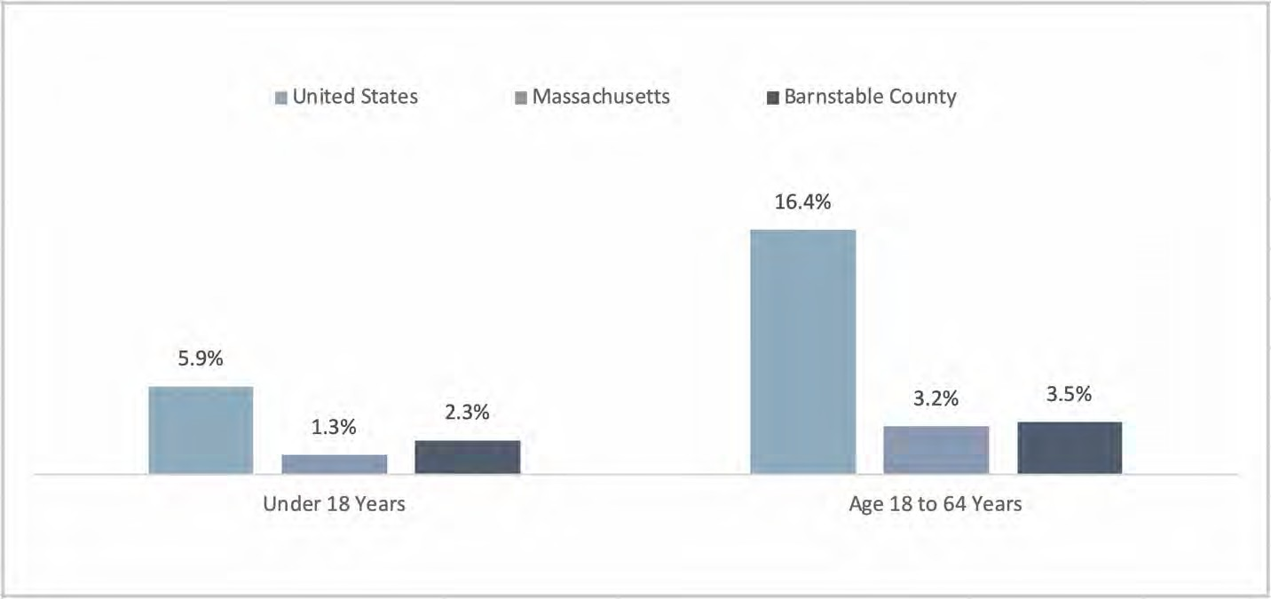
DATA SOURCE: U.S. Census Bureau, American Community Survey 5-Year Estimates, 2012-2016

The previously-described seasonal variation in employment impacts many Barnstable County residents’ insurance coverage. As stakeholder dialogue participants shared, for seasonal employees, access to insurance can be cyclical with employees having insurance in summer months but not in the off-season. Thus, access to health care services may be limited and inconsistent for many families.
Health Care Resources
“For the most part, I feel like the access to health care is one of the strengths of this area. We hear way more positives about health care from people here than negative.” (Key Informant Interviewee)
“I think our health care system here in the county is very good. I think the care that we get from our providers excellent. Whether it be a Cape Cod Healthcare person, or an Outer Cape Healthcare Services person, or even in some cases with some of these offices, folks from Beth Israel. But I think all in all, I like to think of us as a Cape Cod Healthcare region and I think that the services that they’ve been providing are really good.” (Key Informant Interviewee)

“...I think we have great service, but I also think it [the health care system] may be at capacity as well.” (Key Informant Interviewee)
Many key informant interviewees indicated that Barnstable County has abundant health care resources for those in need, including for aging adults. The increasing availability of urgent care clinics and the broad efforts of Cape Cod Healthcare itself were mentioned as essential elements of meeting the health care needs of residents. Interviewees also emphasized the importance of the health services offered by Barnstable County Human Service Department, the Barnstable County Department of Health and Environment, and by law enforcement for incarcerated individuals. Some of these services included infectious disease surveillance and referrals to substance use treatment.
Services by community health centers were emphasized by interviewees for their extended hours, language services, and navigator and counseling staff. Stakeholder dialogue participants praised the integrated approach taken by community health centers, which allows patients to receive most of their care in one location and thereby reduce emergency department use. Likewise, the collaboration of hospitals and emergency departments with community organizations as well as first responders was seen as important to reducing hospital readmissions. Community wellness programs and school programs for truancy prevention and drug education were also cited as successful efforts.
Despite these very clear strengths and essential assets in the region related to health care, key informant interviewees and stakeholder dialogue participants consistently expressed that more health care resources and a greater capacity at the system level were needed, as described in the following sections.
Challenges to Accessing Health Care Services
Community survey respondents were asked to identify how easy or hard it was to access different types of health care services. The health care services that were most frequently rated as “very easy” or “easy” to access included outpatient services (69.7%), immunizations (66.8%), urgent care services (64.5%), emergency department services (61.9%), hospital services (56.4%), and vision services (55.9%). In contrast, the types of services that were most frequently rated ‘hard’ or ‘very hard’ to access were specialty care (34.5%), primary care physicians (31.4%), counseling or mental health for adults (28.9%) and for children/adolescents (25.4%), and alcohol or drug treatment services for adults (22.3%) and for youth (21.9%) (Figure 41).

FIGURE 41: HEALTH CARE SERVICES PERCEIVED AS “HARD” OR “VERY HARD” TO ACCESS
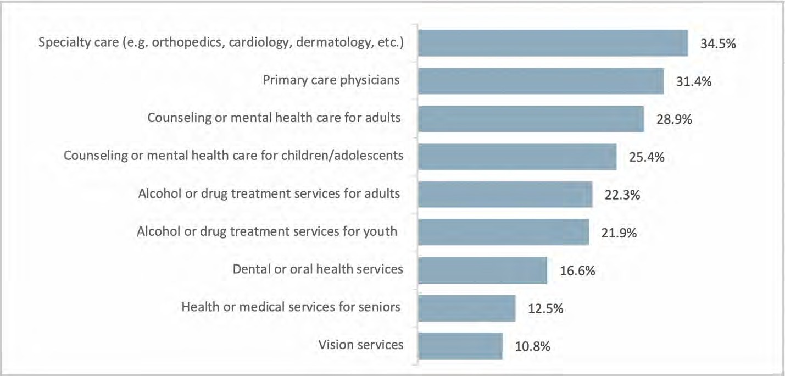
DATA SOURCE: CCHC Community Health Survey, 2018 NOTES: Percentages were based on sample size of n=1,568

Community survey respondents who lived on the lower or outer cape were more likely to rate specialty care and primary care as ‘hard’ or ‘very hard’ to access (44.2% and 41.9%, respectively) compared to the overall survey sample. Survey respondents with household incomes <$35,000 were more likely to rate dental or oral health services as ‘hard’ or ‘very hard’ to access (28.9%) compared to the overall survey sample.
Key informant interviewees, focus group participants, and stakeholder dialogue participants shared several barriers to accessing health care services. These included a lack of primary care providers and specialists, cost, and lack of information about services. The most frequently-identified barriers experienced by community survey respondents were ‘long waits for appointments’ (28.9%), ‘cost of care’ (21.3%), ‘difficulty scheduling appointments’ (18.3%), and ‘lack of evening and weekend hours’ 16.7%) (Figure 42).

FIGURE 42: COMMUNITY SURVEY RESPONDENTS’ TOP BARRIERS TO HEALTH CARE IN PRIOR 12 MONTHS
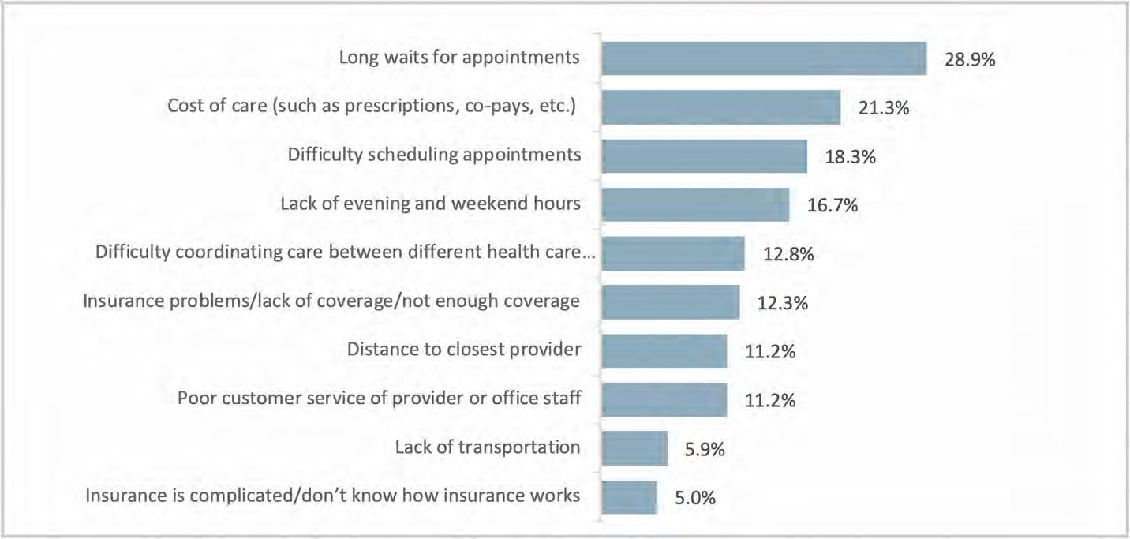
DATA SOURCE: CCHC Community Health Survey, 2018 NOTES: Percentages were based on sample size of n=1,600

“We may not have as many positions [for health care providers] as what the area may need. There’s always a waiting list.” (Key Informant Interviewee)
“Primary care is very hard to come by.” (Key Informant Interviewee)
This perspective was echoed by 45.2% of community survey respondents who identified ‘access to primary care providers’ as one of the top health concerns impacting the community (Figure 22). Slightly over one third (34.5%) of community survey respondents rated specialty care services as ‘hard’ or ‘very hard’ to access in Barnstable County and 31.4% of respondents rated primary care services similarly.
Interviewees and stakeholder dialogue participants specifically noted that dermatologists, ophthalmologists, gerontologists, and oral health providers are in limited supply. Further constraining access, according to focus group participants, is the fact that some specialists do not accept MassHealth, the state’s Medicaid and Children’s Health Insurance Program (CHIP).
Over one quarter (22.2%) of all community survey respondents noted ‘high concern’ for the issue of ‘transportation to medical appointments’ (Figure 15). These findings suggest geography and distance play an important role in the access to care. Concerns about the geographic distribution of health care services were specifically mentioned during stakeholder dialogues, with the observation that those who live on the outer and upper Cape often must travel far or even leave the Cape to receive necessary services. Key informant interviewees and stakeholder dialogue participants suggested that a Level 1 trauma center would improve care access in Barnstable County, particularly for emergencies and in the summer months when the roads are very crowded.
Health care costs were also mentioned as a barrier to accessing health care. Key informant interviewees, for example, noted that the increasing cost of insurance coverage makes it difficult for small business owners to fund insurance.

Focus group participants, who were all Spanish or Portuguese-speaking residents, reported that lack of interpreters and bilingual providers creates challenges to accessing health care. Interpretation services are especially difficult to access in specialty practices according to focus group participants.
Lack of access to information about existing services was mentioned by a few key informant interviewees, focus group participants, and stakeholder dialogue participants. Some participants attributed this access barrier to a lack of communication among organizations that can contribute to a “siloed” approach to addressing residents’ needs. Participants discussed that the lack of information or incorrect information can lead to incorrect referrals and underutilization of needed services.
Closely related to the issue of increasing access to information is care coordination. Participants in stakeholder dialogues suggested that care coordination could be improved by hiring health care navigators/liaisons that understand the health care system and can advocate for patients and connect them to community-based services. Participants also recommended enhancing discharge planning to ensure that patients and families are connected to needed community resources and are able to ask questions.

Cape Cod Healthcare Strategic Implementation Plan (SIP) Overview

Priority Areas |  | Goals | Objectives
1 | Physical Health Conditions | Reduce and prevent the occurrence and severity of chronic and infectious disease in Barnstable County through collaborative approaches. | 1.1 | Expand hospital-based initiatives and support regional efforts to prevent, screen, detect and treat chronic and infectious diseases. (Chronic Obj 1)
 |  |  | 1.2 | Strengthen strategic collaborations between hospitals and community health centers to improve regional health safety net of care. (Access 2)
 |  |  | 1.3 | Support initiatives that increase access to care through provider availability, interpreter services, and insurance coverage. (Access 4)
 |  |  | 1.4 | Support local and regional initiatives to promote health and wellness across the lifespan. (Prevention and Wellness)
2 | Behavioral Health | CCHC will be a leading partner in providing comprehensive regional health services and community resources for individuals with mental health conditions and substance use disorders. | 2.1 | Expand hospital-based services and collaborations to assess and address mental health, substance use disorders and co- occurring disorders in various care settings.
 |  |  | 2.2 | Strengthen the regional network of care for individuals with mental health and substance use disorders.
 |  |  | 2.3 | Support efforts to build a recovery-friendly community.
3 | Transportation | Regional transportation systems support increased access to health care services in Barnstable County. | 3.1 | Increase transportation options to primary care, specialty care, urgent care, hospital system, and allied health services in our region.
 |  |  | 3.2 | Increase transportation options to access services in the community that support health (e.g., food pantries, open spaces).
4 | Housing | Vulnerable populations in our community show improved health indicators through access to stable and quality housing. | 4.1 | Develop partnerships with regional organizations that address issues of housing and homelessness.
 |  |  | 4.2 | Improve regional capacity to support transitions between health care settings and home.
5 | Workforce Development | Our community is served by a strong, adequate health care workforce. | 5.1 | Foster existing and new partnerships with educational institutions and academic medical centers.
 |  |  | 5.2 | Invest in recruitment and retention of health care providers in the community to meet growth demands for health care services.

Priority 1: Physical Health Conditions

Goal 1: Reduce and prevent the occurrence and severity of chronic and infectious disease in Barnstable County through collaborative approaches.
Objective 1.1: Expand hospital-based initiatives and support regional efforts to prevent, screen, detect and treat chronic and infectious diseases. (Chronic Obj 1)
Monitoring/Evaluation Approach
- Evaluation of cancer screening results and activities
- Annual community benefits reporting for hospital programs
- Annual Community Benefits Grant Outcomes and Summary Reports by grantees
Potential Partners
- Specialty Network for the Uninsured
- Federally-Qualified Health Centers
- Cape Wellness Collaborative
- Councils on Aging across Cape Cod
- YMCA Weny Diabetes Education Center
- American Diabetes Association
- American Cancer Society
- AIDS Support Group of Cape Cod
- Health Imperatives Cape Cod
- MA Department of Public Health
- Health Resources and Services Administration (HRSA) HIV/AIDS Bureau
- Cape Cod Cooperative Extension
- UMASS Laboratory of Medical Zoology
- Local health departments
Objective 1.2: Strengthen strategic collaborations between hospitals and community health centers to improve regional health safety net of care. (Access 2)
Monitoring/Evaluation Approach
- Annual community benefits reporting for hospital programs
- Annual Community Benefits Grant Outcomes and Summary Reports by grantees
- Monitoring of ACO social determinants of health projects
Potential Partners
- Community Health Center of Cape Cod
- Duffy Health Center
- Harbor Community Health Center
- Outer Cape Health Services
- Island Health Care
Objective 1.3: Support initiatives that increase access to care through provider availability, interpreter services, and insurance coverage. (Access 4)
Monitoring/Evaluation Approach
- Annual community benefits reporting for hospital programs
- Annual Community Benefits Grant Outcomes and Summary Reports by grantees
Potential Partners
- Community based physician offices
- Federally Qualified Health Centers

- The Specialty Network for the Uninsured
- Serving the Health Insurance Needs of Everyone (SHINE) program at Barnstable County Human Services
- Cape Cod Hospital and Falmouth Hospital financial counselors
Objective 1.4: Support local and regional initiatives to promote health and wellness across the lifespan. (Prevention and Wellness)
Monitoring/Evaluation Approach
- Annual community benefits reporting for hospital programs
- Annual Community Benefits Grant Outcomes and Summary Reports by grantees
Potential Partners
- Health Imperatives Cape Cod
- National Park Services- Cape Cod National Seashore
- Honoring Choices Massachusetts

Priority 2: Behavioral Health
Goal 2: CCHC will be a leading partner in providing comprehensive regional health services and community resources for individuals with mental health conditions and substance use disorders.
Objective 2.1: Expand hospital-based services and collaborations to assess and address mental health, substance use disorders and co-occurring disorders in various care settings.
Monitoring/Evaluation Approach
- Annual community benefits reporting for hospital programs
- Annual Community Benefits Grant Outcomes and Summary Reports by grantees
Potential Partners
- National Alliance for Mental Illness (NAMI) Cape Cod
- Various community based program providing adolescent, adult and geriatric psychiatric care
- Various peer-based community programs
- Gosnold on Cape Cod
- Federally Qualified Health Centers
- Various treatment facilities in MA
- Community based recovery support programs
- Cape & Islands Police and Fire Departments
Objective 2.2: Strengthen the regional network of care for individuals with mental health and substance use disorders.
Monitoring/Evaluation Approach
- Annual community benefits reporting for hospital programs
- Annual Community Benefits Grant Outcomes and Summary Reports by grantees
- Zero suicide program outcome reports
- Event evaluation forms from trainings and the Behavioral Health Coalition Summit event
Potential Partners
- Behavioral Health Provider Coalition of Cape Cod & the Islands
- Barnstable County Human Services Department
- MA Department of Mental Health (DMH)
- MA Department of Public Health (DPH)
- Samaritans on Cape Cod and the Islands
- Duffy Health Center
- Bay Cove
- Veterans Administration
Objective 2.3: Support efforts to build a recovery-friendly community. Monitoring/Evaluation Approach
- Annual community benefits reporting for hospital programs
- Annual Community Benefits Grant Outcomes and Summary Reports by grantees
Potential Partners
- Barnstable County Regional Substance Use Council
- WellStrong
- Gosnold, Inc.
- PIER Recovery Center – Gandara Center
- Duffy Health Center
- Cape Cod Children’s Place, Vinfen

Priority 3: Transportation

Goal 3: Regional transportation systems support increased access to health care services in Barnstable County.
(Cross-cutting: elderly, lower income, mom’s with kids)
Objective 3.1: Increase transportation options to primary care, specialty care, urgent care, the hospital system, and allied health services in our region.
Monitoring/Evaluation Approach
- Transportation utilization data from partner organizations
- Annual Community Benefits Grant Outcomes and Summary Reports by grantees
- Calculation of employee hours committed to participation in partnership engagement
Potential Partners
- Cape Cod Regional Transportation Authority
- Council’s on Aging
- Federally Qualified Health Centers
- Cape Cod Commission
- Spaulding Rehabilitation Hospital Cape Cod
Objective 3.2: Increase transportation options to access services in the community that support health (e.g., food pantries, open spaces).
Monitoring/Evaluation Approach
- Annual Community Benefits reporting for hospital programs
- Annual Community Benefits grant outcomes and summary reports by grantees
- Assess the impact of environmental changes, emerging factors
Potential Partners
- Cape Cod Regional Transportation Authority
- Town recreational departments
- National Park Service
- Food pantries across region
- CCHC Retail Pharmacies
- Cape Cod Commission
- Chambers of Commerce

Priority 4: Housing
Goal 4: Vulnerable populations in our community show improved health indicators through access to stable and quality housing. (Cross-cutting: Aging, HC Access, primary/secondary/tertiary prevention)
Objective 4.1: Develop partnerships with regional organizations that address issues of housing and homelessness.
Monitoring/Evaluation Approach
- Annual AG self-assessment
- Calculation of employee hours committed to participation in partnership engagement
- Assess the impact of environmental changes, emerging factors
Potential Partners
- Housing Assistance Corporation on Cape Cod
- Community Development Partnership
- Town Housing Authorities
- Barnstable County Regional Network on Homelessness
Objective 4.2: Improve regional capacity to support transitions between health care settings and home.
Monitoring/Evaluation Approach
- Annual community benefits reporting for housing-related hospital programs
- Annual Community Benefits Grant Outcomes and Summary Reports by grantees
- Calculation of employee hours committed to participation in partnership engagement
- Assessment of the impact of environmental changes, emerging factors
Potential Partners
- Cape Cod Chamber of Commerce
- Cape Cod Commission
- Cape Cod Health News
- Cape Cod Cooperative Extension
- Visiting Nurse Association of Cape Cod
- Barnstable County Department of Health and Environment
- Cape Cod Hoarding Task Force
- Housing Assistance Corporation on Cape Cod
- Community Development Partnership
- Town Housing Authorities

Priority 5: Workforce Development
Goal 5: Our community is served by a strong, adequate health care workforce.
(cross-cutting: Aging, HC Access, primary/secondary/tertiary prevention)
Objective 5.1: Foster existing and new partnerships with educational institutions and academic medical centers.
Monitoring/Evaluation Approach
- Annual community benefits reporting for workforce development hospital programs
- Calculation of employee hours committed to participation in partnership engagement
- Annual Community Benefits Grant Outcomes and Summary Reports by grantees
Potential Partners
- University of Massachusetts
- Cape Cod Community College
- Bridgewater State
- Community Colleges
- Local vocational and technical schools
- Local public school systems
- Riverview School
Objective 5.2: Invest in recruitment and retention of health care providers in the community to meet growth demands for health care services.
Monitoring/Evaluation Approach
- Annual community benefits reporting for physician recruitment, loan forgiveness, and tuition reimbursement activities
- Annual provider recruitment goals and objectives
Potential Partners
- Chambers of Commerce
- Cape Cod Community College
- Cape and Islands Workforce Investment Board
- Federally Qualified Health Centers

APPENDIX A: List of Participating Organizations

Organization | Type of Organization | Populations Served/Represented by Organization
 |  | Seniors | Children | Low- Income | Minority | Medically Underserved*
AIDS Support Group of Cape Cod and the Islands | Health | • |  | • | • | •
Alzheimer's Family Support Center | Human Services | • |  | • | • | •
Barnstable Council on Aging | Municipal | • |  | • | • | •
Barnstable County Department of Health and Environment | County Public Health | • | • | • | • | •
Barnstable County Department of Health and Environment Public Nurse | County Public Health | • | • | • | • | •
Barnstable County Department of Human Services | Human Services | • | • | • | • | •
Bourne Council on Aging | Municipal | • |  | • | • | •
Bourne Human Services Committee | Municipal | • | • | • | • | •
Cape and Islands Emergency Medical Services System | Health | • | • | • | • | •
Cape Abilities | Human Services | • | • | • | • | •
Cape Cod Children's Place | Human Services |  | • | • | • | •
Cape Cod Healthcare Accountable Care Organization | Health | • | • | • | • | •
Cape Organization for the Rights of the Disabled | Human Services | • | • | • | • | •
Community Action Committee of Cape Cod and Islands, Inc. | Community Action Agency | • | • | • | • | •
Council of Churches | Faith Based | • | • | • | • | •
Duffy Health Center | Federally Qualified Health Center | • | • | • | • | •
Elder Services of Cape Cod and the Islands | Area Agency on  Aging (AAA) | • |  | • | • | •

62

Organization | Type of Organization | Populations Served/Represented by Organization
 |  | Seniors | Children | Low- Income | Minority | Medically Underserved*
Falmouth Service Center | Human Services | • | • | • | • | •
Health Imperatives Cape Cod | Health | • | • | • | • | •
Healthy Aging Project Cape Cod | Regional coalition | • |  | • | • | •
Mashpee Council on Aging | Municipal | • |  | • | • | •
Mashpee Human Services | Municipal | • | • | • | • | •
Mashpee Wampanoag Tribe | Tribal | • | • | • | • | •
Orleans Council on Aging | Municipal | • |  | • | • | •
Outer Cape Health Services | Federally Qualified Health Center | • | • | • | • | •
Relief Home Health Services, Inc. | Health | • | • | • | • | •
Spaulding Rehabilitation Hospital Cape Cod | Health | • | • | • | • | •
The Family Pantry of Cape Cod | Human Services | • | • | • | • | •
Town of Yarmouth Health Department | Local Health Agent/Municipal | • | • | • | • | •
Visiting Nurse Association of Cape Cod | Health | • | • | • | • | •
Town of Yarmouth Senior Services | Municipal | • |  | • | • | •
YMCA Cape Cod | Human Services | • | • | • | • | •
*Per IRS Definition: Medically underserved populations include populations experiencing health disparities or that are at risk of not receiving adequate medical care because of being uninsured or underinsured, due to geographic, language, financial, or other barriers, or those living within a hospital facility’s service area but not receiving adequate medical care from the facility because of cost, transportation difficulties, stigma, or other barriers.

63

APPENDIX B: Timeline for CHNA Activities

Activity | Timeframe
Collected and analyzed local, state, and national health indicator data | October 2018 – January 2019
Interviewed public health experts and organizations serving low-income, vulnerable, disadvantaged, and medically underserved residents (Key Informant Interviews) | October 31, 2018 –January 4, 2019
Launched/distributed/conducted Community Health  Survey | November 12, 2018 – December 31, 2018
Conducted Community Focus Groups | December 2018 – January 2019
Conducted Cape-wide Health and Human Services Provider Forums (Stakeholder Dialogues) | October 2019 – November 2019
Analyzed data and community input | January – February 2019
Cataloged health care facilities and resources within the community | February 2019
Developed health priorities and implementation  strategies | February 8, 2019 – March 25, 2019
CCHC Board of Trustees approved report findings and implementation strategies | June 11, 2019 – June 30, 2019
Finalized publication of CHNA report and  implementation plan | September 1, 2019
Publicly distributed CHNA report and implementation plan | September 2019

APPENDIX C: Data Sources and Methodologies
Several strategies were employed to engage and gain perspectives from different population groups during data collection. CCHC considered gender, sexual orientation, age, disability status, socioeconomic status, and geographic location in addition to race and ethnicity when soliciting participation in focus groups and the community survey. Deliberate outreach to members of medically underserved and low- income and minority populations was conducted, and participants were represented in the stakeholder dialogues and key informant interviews. Organizations were chosen to represent those that serve a variety of residents and addressing various needs, including public health, housing and homelessness, public safety, and other human services. A complete list of participating organizations is provided in Appendix A.
The specific data sources and methodologies utilized in the CHNA process include:
Secondary Data Review. A comprehensive review of existing data drawn from national, state, and local sources was conducted. Data sources included, but were not limited to, the U.S. Census Bureau, the Centers for Disease Control and Prevention, the Massachusetts Department of Public Health, among others. Types of data included demographics, vital statistics, public health surveillance, as well as self-report of select health behaviors from large, population-based surveys such as the Massachusetts Behavioral Risk Factor Surveillance Survey (BRFSS). The selection of secondary data points was generally based on the prior CHNAs to allow for examination of trends over time. However, additional secondary data sources were explored when major themes or issues arose from qualitative data collection. When available, data were stratified by age group or by income/poverty level to identify areas of disparity. A complete list of secondary data sources is provided in Appendix D.
Community Stakeholder Dialogues. Two “stakeholder dialogues” were held with staff from a broad array of agencies and organizations actively working in the health and human services sectors of Barnstable County. These facilitated small- and large-group discussions focused on health in the community and services in the community. A total of approximately 70 individuals attended these sessions.
Key Informant Interviews. Key informant interviews were conducted via phone with 25 community leaders from organizations across all of Barnstable County, representing health centers, public safety organizations, housing organizations, and other human service groups. Key informants were identified for participation based on their in-depth knowledge of the health needs and resources of the region. Discussions focused on health strengths and needs in the community and opportunities and challenges to addressing community needs. They were also asked to describe organizational partnerships within Barnstable County, perceptions of community services, and perceptions of CCHC.
Focus Groups. Two focus groups, one conducted in Spanish and one in Portuguese, were held with residents to gather information about the community, health challenges and needs, existing services, and suggestions for the future. One focus group of Portuguese-speaking residents was conducted at IPR Cape Cod Church and involved 14 participants. The other involved six Spanish- speaking participants and was held at the Immigration Resource Center at Community Action Committee of Cape Cod.

Community Survey. A community survey was made available to all residents of Barnstable County. Respondents were able to access the survey either on-line (via Survey Monkey) or as a hard copy, and both formats were available in English, Spanish, and Portuguese. The survey included questions that focused on residents’ perceptions of their own health, the health of their community, health care utilization, and social needs in the community. The survey was completed by 2,011 Barnstable County residents. The demographic characteristics of the survey respondents are detailed in Appendix E.
As with all data collection efforts, there are several limitations that should be acknowledged. A number of secondary data sources were drawn upon in creating this report. Although all are considered highly credible, each source may use different methods and assumptions when tabulating data. Due to the collection of data from multiple sources, the data presented in this report may cover multiple time periods and indicators may not be directly comparable to one another. Additionally, secondary data pertaining to health indicators are obtained from the MA DPH via its mandated health reporting programs. However, for many indicators MA DPH data are simply not available for recent years or not available at the local level.
For the Community Health Survey convenience sampling was used, and data were collected from those who were readily available and willing to participate. Thus, findings may not be generalizable to the larger population or to specific sub-populations of Barnstable County. Additionally, the survey relies on self-reported information; respondents may have over- or under-reported perceptions based on biases or misunderstanding of the question asked. Furthermore, this survey may be prone to selection bias – individuals who had more positive or negative experiences or perceptions may have been more likely than other individuals to complete the survey.
Finally, key informant interviews, stakeholder dialogues, and focus groups were conducted for this study. While these provide valuable insights, results are not statistically representative of a larger population due to non-random recruiting techniques and a small sample size. Recruitment for interviews, dialogues, and focus groups was conducted by the CCHC Community Benefits Department and collaborating agencies and organizations. Because of this, it is possible that the responses received only provide one perspective of the issues discussed. It is also important to note that these data were collected at one point in time, so findings, while directional and descriptive, should not be interpreted as definitive.

APPENDIX D: List of Secondary Data Sources

U.S. Census Bureau, American Community Survey 5-Year Estimates, 2011-2015
U.S. Census Bureau, American Community Survey 5-Year Estimates, 2012-2016
U.S. Census Bureau, American Community Survey 5-Year Estimates, 2007-2011 and 2012-2016
Massachusetts Department of Elementary and Secondary Education, School/District Profiles, 2017
U.S. Bureau of Labor Statistics, Local Area Unemployment Statistics, 2017 and 2018
Feeding America, Map the Meal Gap, Food Insecurity Estimates at the County Level, 2016
U.S. Department of Agriculture Food Environment Atlas, 2015
Business Analyst, Delorme map data, ESRI, & U.S. Census Tigerline Files, as reported by County Health Rankings, 2016; Centers for Disease Control and Prevention, Diabetes Interactive Atlas, as reported by County Health Rankings, 2014
Cape and Islands Regional Network on Homelessness, Annual Point in Time Count for Barnstable, Dukes, and Nantucket Counties, 2016, 2017, 2018
Health Resources & Services Administration, Health Center Program Grantee Data, Uniform Data System, 2017
Massachusetts Behavioral Risk Factor Surveillance System, 2016; as cited by County Health Rankings
Massachusetts Department of Public Health, Registry of Vital Records and Statistics, 2015
Massachusetts Department of Public Health, Registry of Vital Records and Statistics, 2016
Center for Disease Control and Prevention, 2015
Fiscal Year 2017 Massachusetts Health Data Consortium Inpatient Discharge Rate; Based on Cape Cod hospital discharge data and using state weights for age adjustment
FY 2015 Massachusetts Health Data Consortium
Massachusetts Cancer Registry, 5-year Profile 2011-2015
Massachusetts Department of Public Health, Bureau of Environmental Health, 2016-2017
Centers for Disease Control and Prevention, Behavioral Risk Factor Surveillance System, as reported by County Health Rankings, 2016
Youth Health Survey, Massachusetts Department of Health (2017), Monomoy Regional High School (2016), and Nauset Regional High School (2017); NOTE: Rates shown reflect students in grades 9-12
2016 Depression Diagnosis Rates by MSA, Blue Cross Blue Shield Foundation Report: Major Depression – The Impact on Overall Health, 2018
Massachusetts Department of Public Health, Bureau of Substance Abuse Services, Office of Statistics and Evaluation, Fiscal Year 2018
Federal Bureau of Investigation, Criminal Justice Information Services, Uniform Crime Reporting, Offenses Known to Law Enforcement, by State and by City, 2017
Massachusetts Department of Public Health, Bureau of Infectious Disease and Laboratory Sciences, Office of Integrated Surveillance and Informatics Services, 2017
National Center for HIV/AIDS, Viral Hepatitis, STD, and TB Prevention as reported by County Health Rankings, 2015
Massachusetts Department of Public Health, 2014 (Lyme), 2015 (HGA), and 2016 (Babesiosis)
National Provider Identification file, Centers for Medicare and Medicaid Services, Area Health Resource File, as reported by County Health Rankings, 2016

University of Massachusetts Donahue Institute. (2015). Long Term Population Projections for Massachusetts Regions and Municipalities. Retrieved from http://pep.donahue-institute.org
Massachusetts Attorney General Guidelines for Non-Profit Hospitals: https://www.mass.gov/files/documents/2016/08/qy/hospital-guidelines.pdf
A comprehensive description of the Massachusetts Department of Public Health social determinant of health priorities is available on their website: http://www.mass.gov/files/documents/2017/01/tr/guidelines-health-priority.pdf
Final Internal Revenue Service Regulations-(IRS Notice 2011-52 as outlined in section 501(r) (3) of the Internal Revenue Code): https://www.federalregister.gov/documents/2014/12/31/2014- 30525/additional-requirements-for-charitable-hospitals-community-health-needs-assessments-for-
charitable

APPENDIX E: Community Survey Respondent Characteristics
A total of 2,011 Barnstable County residents completed the survey. Of this total, 1,979 respondents completed the survey on-line (98.4%) and 32 respondents completed hard copy surveys (1.6%).
Additionally, the survey was distributed in three languages: 1,971 respondents completed the survey in English (98.0%), 31 in Portuguese (1.5%), and 9 in Spanish (0.4%).
Demographic Characteristics of Survey Respondents
 | Count | Percent
Town of Residence (N=2,011)
Barnstable | 399 | 19.8%
Bourne | 72 | 3.6%
Brewster | 105 | 5.2%
Chatham | 70 | 3.5%
Dennis | 132 | 6.6%
Eastham | 48 | 2.4%
Falmouth | 253 | 12.6%
Harwich | 138 | 6.9%
Mashpee | 124 | 6.2%
Orleans | 51 | 2.5%
Provincetown | 53 | 2.6%
Sandwich | 144 | 7.2%
Truro | 25 | 1.2%
Wellfleet | 23 | 1.1%
Yarmouth | 374 | 18.6%
Age (N=1,530)
Under 18 years old | 0 | 0.0%
18-24 years old | 14 | 0.9%
25-34 years old | 75 | 4.9%
35-44 years old | 136 | 8.9%
45-54 years old | 184 | 12.0%
55-64 years old | 321 | 21.0%
65-74 years old | 477 | 31.2%
75-84 years old | 253 | 16.5%
85+ years old | 50 | 3.3%
Prefer not to say | 20 | 1.3%
Gender (N=1,525)
Male | 358 | 23.5%
Female | 1,129 | 74.0%
Non-binary | 4 | 0.3%
Prefer not to say | 34 | 2.2%
Race/Ethnicity (N=1,502)
American Indian or Alaskan Native, non-Hispanic | 3 | 0.2%
Asian, non-Hispanic | 3 | 0.2%

Black or African American, non-Hispanic | 4 | 0.3%
Hispanic/Latino(a), any race | 28 | 1.8%
Middle Eastern or North African, non-Hispanic | 1 | 0.1%
Native Hawaiian or Other Pacific Islander, non-Hispanic | 1 | 0.1%
White, non-Hispanic | 1,385 | 91.1%
Multiple races | 21 | 1.4%
Some other race, ethnicity or origin | 19 | 1.3%
Prefer not to say | 55 | 3.6%
Educational Attainment (N=1,529)
Less than high school | 7 | 0.5%
High school graduate or GED | 56 | 3.7%
Vocational or trade school | 27 | 1.8%
Some college | 205 | 13.4%
Associate or technical degree/certification | 159 | 10.4%
College graduate | 489 | 32.0%
Graduate or professional degree | 568 | 37.1%
Prefer not to say | 18 | 1.2%
Annual Household Income (N=1,524)
Less than $25,000 | 66 | 4.3%
$25,000 to $34,999 | 117 | 7.7%
$35,000 to $49,999 | 124 | 8.1%
$50,000 to $74,999 | 236 | 15.5%
$75,000 to $99,999 | 223 | 14.6%
$100,000 to $ 150,999 | 253 | 16.6%
$151,000 to $ 199,999 | 102 | 6.7%
$200,000 or more | 88 | 5.8%
I don’t know or don’t want to say | 315 | 20.7%
Language Spoken Most Often at Home (N=1,526)
English | 1,483 | 97.2%
Portuguese | 28 | 1.8%
Spanish | 8 | 0.5%
Mandarin | 0 | 0.0%
French | 0 | 0.0%
Haitian Creole | 0 | 0.0%
Other | 7 | 0.5%
Current Living Situation (N=1,999)
Live in an apartment/condo/house that I own | 1,654 | 82.7%
Live in an apartment/condo/house that I rent | 210 | 10.5%
Live in a seasonal rental | 5 | 0.3%
Live in a family member’s home | 109 | 5.5%
Live in a shelter | 1 | 0.1%
Homeless | 1 | 0.1%
Other | 19 | 1.0%

Current Employment Status* (N=2,005)
Employed for wages year-round | 818 | 40.8%
Self-employed year-round | 140 | 7.0%
Seasonally employed (not year-round) | 53 | 2.6%
Unemployed | 36 | 1.8%
Homemaker/Stay-at-home parent | 29 | 1.4%
Student | 26 | 1.3%
Caregiver | 32 | 1.6%
Retired | 911 | 45.4%
Unable to work | 33 | 1.6%
Prefer not to answer | 4 | 0.2%
Other | 66 | 3.3%
Caregiver Status of Survey Respondents**
Current parent/legal guardian for children under 18 (N=2,002)
Yes | 277 | 13.8%
No | 1,725 | 86.2%
Caregiver for person with physical/cognitive disability (N=1,994)
Yes | 269 | 13.5%
No | 1,725 | 86.5%
Caregiver for person over 50 (N=2,000)
Yes | 326 | 16.3%
No | 1,674 | 83.7%
*Respondents were allowed to select more than one response; percentages may not sum up to 100%. ** Caregiver categories are not mutually exclusive

APPPENDIX F: Inventory of available resources addressing significant health needs

Priority 1: Physical Health
Cape Cod Healthcare (CCHC) Services:
Bourne Health Center Cape Cod Hospital
Cape Cod Hospital OB/GYN Clinic Cape Cod Hospital Pain Center CCHC Diabetes Education Services CCHC Family Birthplace
CCHC Financial Counseling
CCHC Heart and Vascular Institute
CCHC Infectious Disease Clinical Services CCHC Laboratory Services
CCHC Neurosciences and Pain Services CCHC Orthopedic Services
CCHC Pharmacies in Falmouth, Harwich, Hyannis and Sandwich
CCHC Regional Cancer Network CCHC Rehabilitation Services
CCHC Urgent Care Centers in Falmouth, Harwich, Hyannis and Sandwich
CCHC Wound Care Center Clark Cancer Center
Davenport-Mugar Cancer Center Emerald Physicians
Falmouth Hospital
Falmouth Hospital Imaging at Community Health Center of Cape Cod
Falmouth Hospital Outpatient Services Falmouth Hospital Outpatient Surgery Center Fontaine Medical Center
Heritage at Falmouth JML Care Center
Medical Affiliates of Cape Cod (MACC) Oppenheim Medical Building
Primary Care Internists Rogers Outpatient Center Stoneman Outpatient Center
Visiting Nurse Association of Cape Cod Wilkens Medical Complex
Federally Qualified Health Centers:
Community Health Center of Cape Cod Duffy Health Center
Harbor Community Health Center- Hyannis Outer Cape Health Services
Community-Based Services:
AIDS Support Group of Cape Cod
Alzheimer’s Family Support Center of Cape Cod American Cancer Society
American Heart Association American Lung Association
Barnstable County Department of Health and Environment
Barnstable County Department of Human Services
Barnstable County Public Health Nurse
Cape and Islands Emergency Medical Services System, Inc.
Cape Abilities
Cape and Islands Veterans Outreach Center Cape Cod Cooperative Extension
Cape Cod Council of Churches Cape Cod Hunger Network
Cape Cod Medical Reserve Corps
Cape Cod Regional Tobacco Control Program Cape Cod WIC
Cape Disability Network
Cape Organization for the Rights of the Disabled Cape Wellness Collaborative
COAST (Council's on Aging Serving Together) Community Action Committee of Cape Cod and Islands
Elder Services of Cape Cod and the Islands Falmouth Human Services
Falmouth Service Center Glenna Kohl Fund for Hope Health Imperatives Cape Cod Healthy Aging Cape Cod Helping Our Women Independence House
Lower Cape Outreach Council Lyme Awareness of Cape Cod MA Department of Public Health
MA Department of Veterans Services Mashpee Wampanoag Health Service Unit– Indian Health Services
National Multiple Sclerosis Society Outer Cape WIC
Parish Nurse Ministries of Cape Cod

Parkinson's Support Network of Cape Cod Relief Home Health Services
Serving the Health Needs of Everyone (SHINE) Sight Loss Services
Spaulding Rehabilitation Hospital Cape Cod Specialty Network for the Uninsured
Team Maureen The Family Pantry
Town of Sandwich Public Health Nurse
U.S. Department of Veterans Affairs Medical Center – Hyannis
WE CAN
YMCA Cape Cod
YMCA Diabetes Resource Center

Priority 2: Behavioral Health
Cape Cod Healthcare (CCHC) Services:
CCHC Centers for Behavioral Health Outpatient Counseling and Therapy
CCHC Inpatient and Partial Hospital Psychiatric Services
Cape Cod Hospital Emergency Department Falmouth Hospital Emergency Department Community-Based Services:
AIDS Support Group of Cape Cod Al-Anon/Alateen
Barnstable County Regional Substance Use Council
Baybridge Clubhouse
Baycove Cape & Islands Crisis Intervention Team
Behavioral Health Innovators
Behavioral Health Provider Coalition of Cape Cod & the Islands
Cape and Islands Suicide Prevention Coalition Cape Behavioral Health Center
Cape Cod Family Resource Center Cape Cod Hoarding Task Force Child and Family Services Children’s Cove
Community Health Center of Cape Cod Cove Clubhouse
Dance in the Rain Peer Center Duffy Health Center
Duffy Health Center – Moms Do Care Program Falmouth Prevention Partnership
Family Continuity Fellowship Health Services Gandara Center
Gosnold, Inc.
Habit OPCO Yarmouth Treatment Center Harbor Community Health Center
High Point Treatment Center Justice Resource Institute Learn to Cope
MA Department of Children and Families MA Department of Mental Health
MA Department of Public Health (MADPH) MADPH Bureau of Substance Addiction Services Massachusetts Organization for Addiction Recovery
Massachusetts Substance Abuse Info and Education Helpline
Cape & Islands Maternal Depression Task Force Nar-Anon
National Alliance on Mental Illness (NAMI) Cape Cod and the Islands
Nauset Together We Can
New England Region Narcotics Anonymous Outer Cape Health Services
Parent Supporting Parents PIER Recovery Center Recovering Champions Recovering Youth Coalition
Community-Based Services continued:
Recovery Without Walls
South Bay Community Services
Stanley Street Treatment and Resources (SSTAR)
Cape Cod Intergroup of Alcoholics Anonymous The Open Doorway of Cape Cod
Vinfen WellStrong

Priority 3: Transportation
Community-Based Services: Bay to Sound Neighbors Cape Cod Ambulance Service Cape Cod Collaborative
Cape Cod Commission
Cape Cod Regional Transit Authority Cape Cod Wheelchair Transit

Cape Organization for Rights of the Disabled CORD)
Councils on Aging Serving Together (COAST) Elder Services of Cape Cod and the Islands Helping Our Women
Massachusetts Department of Transportation Nauset Neighbors
Neighborhood Falmouth

Priority 4: Housing
Community-Based Services:
Barnstable County Department of Human Services
Barnstable County HOME Investment Partnership Program
Barnstable Housing Authority Bourne Housing Authority Brewster Housing Authority
Cape and Islands Regional Network to Address Homelessness
Cape Cod Commission
Cape Cod Council of Churches Cape Cod Village
Cape Organization for Rights of the Disabled (CORD)
Catholic Charities – St. Joseph's House Shelter Champ Homes
Chatham Housing Authority
Community Action Committee of Cape Cod and the Islands
Community Development Partnership Dennis Housing Authority
Eastham Housing Authority Falmouth Housing Authority Falmouth Housing Corporation Falmouth Housing Trust F.O.R.W.A.R.D Cape Cod
Habitat for Humanity
Harwich Ecumenical Council for Housing
Harwich Housing Authority Homeless Not Hopeless Homeless Prevention Council Housing Assistance Corporation LIFE Cape Cod
Low Income Home Energy Assistance Program Lower Cape Outreach Council
MA Department of Housing and Community Development
Mashpee Housing Authority Mass Housing Partnership
Massachusetts Home Modification Loan Program
Orleans Housing Authority Provincetown Housing Authority Salvation Army
Sandwich Housing Authority Truro Housing Authority Wellfleet Housing Authority Yarmouth Housing Authority

Priority 5: Employment
Community-Based Services:
ARC of Cape Cod Cape Abilities
Cape Organization for Rights of the Disabled Community Connections
Department of Transitional Assistance – Employment Services Program
Elder Services of Cape Cod and the Islands Job Training and Employment Corporation (JTEC)
Mass Division of Unemployment Assistance MassHire Cape and Islands Career Center MassHire Cape and Islands Workforce Board Cape Cod Technology Council
Cape Cod Community College Cape Cod Chamber of Commerce
Cape Cod Young Professionals (CCYP)

APPENDIX G: CAPE COD HEALTHCARE CHNA AND SIP WORK GROUP
- Theresa Ahern, CCHC Senior Vice President Strategy and Government Affairs
- Lisa Guyon, CCHC Director of Community Benefits
- Tina Shaw, CCHC Director Strategy and Government Affairs
- Brenda Foley, CCHC Senior Manager Strategic Services
- Chaitanya Joshi, CCHC Manager Cost Accounting
- Susan Foley, Project Manager Strategy and Government Affairs
- Beth Albert, Barnstable County Human Services Director
- Vaira Harik, Barnstable County Human Services Deputy Director/Senior Project Manager
- Susan Harrington, CCHC ACO Clinical Director
- Elizabeth Lynch, CCHC Operations Manager Centers for Behavioral Health -- Outpatient
- Valerie Al-Hachem, CCHC Director and Grants Administrator Infectious Disease Clinical Services

The findings shared in this CHNA were used to develop the Strategic Implementation Plan (SIP) to guide CCHC’s work to address the priority community needs in the coming years. This plan will build on the two prior SIPs and is accessible at https://www.capecodhealth.org/about/caring-for-our-community/.

Page 75 of 77

Cape Cod Healthcare • 88 Lewis Bay Road • Hyannis, Massachusetts 02601

APPENDIX 6 AFFILIATED PARTIES

Application Date:
03/01/2022

Massachusetts Department of Public Health Determination of Need
Affiliated Parties

Application Number: CCHC-22021416-HE
Version: DRAFT

DRAFT
3-15-17

Applicant Information
Applicant Name: Cape Cod Healthcare, Inc.

Contact Person: Title: Vice President of Facilities
Michael Bachstein

Phone: Ext: E-mail: MBachstein@capecodhealth.org
5088625225
Affiliated Parties
1.9 Affiliated Parties:
List all officers, members of the board of directors, trustees, stockholders, partners, and other Persons who have an equity or otherwise controlling interest in the application.
Add/ Del Rows |  | Name (Last) | Name (First) | Mailing Address | City | State | Affiliation | Position with affiliated entity  (or with Applicant) | Stock, shares, or partnership | Percent Equity  (numbers only) | Convictions or violations | List other health care facilities affiliated with | Business relationship with Applicant
+ | - | Lauf | MIchael | 2 Meadow Spring Drive | E. Sandwich | MA | Cape Cod Healthcare, Inc. | President and CEO, CCHC CEO, Cape Cod Hospital |  |  | No | Cape Cod Hospital | Yes
+ | - | Johnston | Alastari Bruce | 2141 Oyster Harbors | Osterville | MA | Cape Cod Healthcare, Inc. | Chairman |  |  | No |  | No
+ | - | Ayer | Ramani | 22 Horseshoe Lane, North | South Orleans | MA | Cape Cod Healthcare, Inc. | Vice Chair and Treasurer |  |  | No |  | No
+ | - | Talerman | Robert A. | 34 Wild Goose Way | Centerville | MA | Cape Cod Healthcare, Inc. | Clerk |  |  | No |  | No
+ | - | Jones | Michael G. | 65 Shady Lane | Hatchville | MA | Cape Cod Healthcare, Inc. | Co-Clerk |  |  | No |  | Yes
+ | - | Calianos, M.D. | Theodore | 151 Whitmar Road | Cotuit | MA | Cape Cod Healthcare, Inc. | Trustee |  |  | No | Cape Cod Surgery Center | Yes
+ | - | Capodilupo | Lawrence | 77 Geranium Drive | Chatham | MA | Cape Cod Healthcare, Inc. | Trustee |  |  | No |  | No
+ | - | Devereux | Robin | 15 Peach Pipe Road | Falmouth | MA | Cape Cod Healthcare, Inc. | Trustee |  |  | No |  | No
+ | - | HInes, M.D. | Cynthia A. | 54 East Harbor Drive | East Falmouth | MA | Cape Cod Healthcare, Inc. | Trustee |  |  | No | Falmouth Hospital | Yes
+ | - | Kennedy | Sharon | 40 Fort Hill Road | East Sandwich | MA | Cape Cod Healthcare, Inc. | Trustee |  |  | No |  | No
+ | - | Mulchay, Jr. | Edward James | 2037 Oyster Harbors | Osterville | MA | Cape Cod Healthcare, Inc. | Trustee |  |  | No |  | No
+ | - | Rudman, M.D. | Nathan T. | 48 Waterman Farm Road | Centerville | MA | Cape Cod Healthcare, Inc. | Trustee |  |  | No | Cape Cod Hospital | Yes
+ | - | Sullivan, M.D. | Molly | 72 Scudder Bay Circle | Centerville | MA | Cape Cod Healthcare, Inc. | Trustee |  |  | No | Cape Cod Hospital | Yes
+ | - | Vilsaint, M.D. | Kevin | 103 Pine Tree Drive | Centerville | MA | Cape Cod Healthcare, Inc. | Trustee |  |  | No | Cape Cod Hospital | Yes

Affiliated Parties Cape Cod Healthcare, Inc. Page 1 of 2

Document Ready for Filing

This document is ready to file: Date/time Stamp:
When document is complete click on "document is ready to file". This will lock in the responses and date and time stamp the form. To make changes to the document un-check the "document is ready to file" box.
Edit document then lock file and submit Keep a copy for your records. Click on the "Save" button at the bottom of the page.
To submit the application electronically, click on the"E-mail submission to Determination of Need" button.

Affiliated Parties Cape Cod Healthcare, Inc. Page 2 of 2

APPENDIX 7 CHANGE IN SERVICE

Application Number:

Massachusetts Department of Public Health Determination of Need
Change in Service

Original Application Date: 03/01/2022
CCHC-220214160-HE
Version: DRAFT

DRAFT
6-14-17

Applicant Information
Applicant Name: Cape Cod Healthcare, Inc.

Contact Person: Title: Vice President of Facilities
Michael Bachstein

Phone: Ext: E-mail: MBachstein@capecodhealth.org
5088625225

Facility: Complete the tables below for each facility listed in the Application Form
1 | Facility Name: Cape Cod Hospital |  |  |  |  |  |  | CMS Number: | 220135 |  | Facility type: Hospital
Change in Service
2.2 Complete the chart below with existing and planned service changes. Add additional services with in each grouping if applicable.
Add/Del Rows |  |  | Licensed Beds  Existing | Operating Beds  Existing | Change in Number of Beds ( +/-)  Licensed Operating |  | Number of Beds After Project Completion (calculated)  Licensed Operating |  | Patient Days  (Current/ Actual) | Patient Days  Projected | Occupancy rate for Operating Beds  Current Beds Projected |  | Average Length of Stay (Days) | Number of Discharges  Actual | Number of Discharges  Projected
 |  | Acute
 |  | Medical/Surgical | 197 | 197 | 0 | 0 | 197 | 197 | 64,160 | 65,332 | 89% | 91% | 4.3 | 14,902 | 15,761
 |  | Obstetrics (Maternity) |  |  |  |  |  |  |  |  | 0% | 0%
 |  | Pediatrics |  |  |  |  |  |  |  |  | 0% | 0%
 |  | Neonatal Intensive Care |  |  |  |  |  |  |  |  | 0% | 0%
 |  | ICU/CCU/SICU |  |  |  |  |  |  |  |  | 0% | 0%
+ | - |  |  |  |  |  |  |  |  |  | 0% | 0%
 |  | Total Acute | 197 | 197 | 0 | 0 | 197 | 197 | 64,160 | 65,332 | 89% | 91% | 4.3 | 14,902 | 15,761
 |  | Acute Rehabilitation |  |  |  |  |  |  |  |  | 0% | 0%
+ | - |  |  |  |  |  |  |  |  |  | 0% | 0%
 |  | Total Rehabilitation |  |  |  |  |  |  |  |  | 0% | 0%
 |  | Acute Psychiatric

Add/Del Rows |  |  |  |  | Licensed Beds  Existing | Operating Beds  Existing | Change in Number of Beds ( +/-)  Licensed Operating |  | Number of Beds After Project Completion (calculated)  Licensed Operating |  | Patient Days  (Current/ Actual) | Patient Days  Projected |  | Occupancy rate for Operating Beds  Current Beds Projected |  |  |  | Average Length of Stay (Days) |  | Number of Discharges  Actual |  | Number of Discharges  Projected
 |  |  | Adult |  |  |  |  |  |  |  |  |  |  | 0% |  | 0%
 |  |  | Adolescent |  |  |  |  |  |  |  |  |  |  | 0% |  | 0%
 |  |  | Pediatric |  |  |  |  |  |  |  |  |  |  | 0% |  | 0%
 |  |  | Geriatric |  |  |  |  |  |  |  |  |  |  | 0% |  | 0%
+ - |  |  |  |  |  |  |  |  |  |  |  |  |  | 0% |  | 0%
 |  |  | Total Acute Psychiatric |  |  |  |  |  |  |  |  |  |  | 0% |  | 0%
 |  |  | Chronic Disease |  |  |  |  |  |  |  |  |  |  | 0% |  | 0%
+ - |  |  |  |  |  |  |  |  |  |  |  |  |  | 0% |  | 0%
 |  |  | Total Chronic Disease |  |  |  |  |  |  |  |  |  |  | 0% |  | 0%
 |  |  | Substance Abuse
 |  |  | detoxification |  |  |  |  |  |  |  |  |  |  | 0% |  | 0%
 |  |  | short-term intensive |  |  |  |  |  |  |  |  |  |  | 0% |  | 0%
+ - |  |  |  |  |  |  |  |  |  |  |  |  |  | 0% |  | 0%
 |  |  | Total Substance Abuse |  |  |  |  |  |  |  |  |  |  | 0% |  | 0%
 |  |  | Skilled Nursing Facility
 |  |  | Level II |  |  |  |  |  |  |  |  |  |  | 0% |  | 0%
 |  |  | Level III |  |  |  |  |  |  |  |  |  |  | 0% |  | 0%
 |  |  | Level IV |  |  |  |  |  |  |  |  |  |  | 0% |  | 0%
+ - |  |  |  |  |  |  |  |  |  |  |  |  |  | 0% |  | 0%
 |  |  | Total Skilled Nursing |  |  |  |  |  |  |  |  |  |  | 0% |  | 0%
2.3 Complete the chart below If there are changes other than those listed in table above.
Add/Del Rows |  |  |  | List other services if Changing e.g. OR, MRI, etc |  |  |  |  |  |  |  |  | Existing Number of Units |  | Change in Number +/- |  | Proposed Number of Units |  | Existing Volume |  | Proposed Volume
+ |  | - |  | Infusion Bays |  |  |  |  |  |  |  |  | 19 |  | 17 |  | 36 |  | 26,720 |  | 32,128
+ |  | - |  | Oncology Exam Rooms |  |  |  |  |  |  |  |  | 12 |  | 4 |  | 16 |  | 13,824 |  | 16,069
+ |  | - |  | Computed Tomography Simulator |  |  |  |  |  |  |  |  | 1 |  | 0 |  | 1 |  | 1,211 |  | 1,236
+ |  | - |  | Radiation Therapy -LINAC |  |  |  |  |  |  |  |  | 2 |  | 0 |  | 2 |  | 22,771 |  | 23,226

Document Ready for Filing

This document is ready to file: Date/time Stamp:
When document is complete click on "document is ready to file". This will lock in the responses and date and time stamp the form. To make changes to the document un-check the "document is ready to file" box.
Edit document then lock file and submit Keep a copy for your records. Click on the "Save" button at the bottom of the page.
To submit the application electronically, click on the"E-mail submission to Determination of Need" button.

APPENDIX 8 NOTICE OF INTENT

4A | MONDAY, FEBRUARY 14, 2022 | CAPE COD TIMES

Riley
Continued from Page 1A

As his disease progresses, Riley is losing his abil- ity to use his thumb to operate a switch that helps him work his computer.
He is seeking to replace the microlight switch with a breath-operated device called a sip-and-puff switch.
But there’s a problem.
“The company who manufactures it was unable to get components because of the supply chain issues,” Riley said in a Facebook message exchange.
Usually upbeat in his social media postings, Riley said on Facebook recently that he was deeply dis- tressed about the possibility of not being able to keep up with his online activity, including gaming and raising money for the Muscular Dystrophy Associa- tion.
“I’m starting to lose the use of my thumb, which is a big problem since I need it to actually be able to perform mouse clicks and it’s crucial in order to be able to play any games.”
Riley, who has a ventilator and a feeding tube, said he can still activate the microlight switch with a light touch of his thumb if he arranges his hands in a cer- tain way.
Working with a camera on the bottom of the com- puter screen that senses his eye movements, he is able to use the microlight switch as a mouse clicker.

Sip-puff switch enables mouse clicks

But as the disease he was diagnosed with when he was 2 years old advances, moving his thumb is get- ting harder and harder.
“I did find a solution … Or so I thought,” Riley said on Facebook.
“I found a sip-puff switch, which is a way to per- form mouse clicks with my mouth. I sent it to my OT (occupational therapist) who said it was a great idea and immediately put in for it.
“I figured everything was all set and I was likely to get it within a few months. Problem solved. Until I got the email today that the company who makes the device is having trouble getting the components and has no idea when or even if any new components will be coming in,” Riley wrote.

MDA Shaving Cream Challenge

This is a looming problem for Riley, who estimates he is in touch with 200 people on any given day.
His social contacts include his gaming partners. Riley’s favored video games include World of War- craft and Forza Horizon.
He also has a community of friends on Facebook and other social media, including people such as ac- tress Gabrielle Stone, whom he persuaded to partici- pate in a “shaving cream challenge” to raise money for the MDA.
Actress Gabrielle Stone doing my MD awareness shaving cream challenge!
The challenge involves plunging both feet into a bowl of shaving cream, filming the experience and posting the video online.
“I am constantly on Tiktok, Instagram, Twitter and YouTube,” Riley said in a Facebook message ex- change.
“I use my computer all day. It’s very important to me to be able to socialize and interact with the world, especially during Covid.”
Riley is asking participants in the challenge to dye the shaving cream red for Valentine’s Day. He planned to post himself participating in the chal- lenge on Sunday (Feb. 13).
The shaving cream challenge may not entail the same bragging rights as getting dosed with a bucket of ice water for the ALS challenge that went viral sev- eral years ago.
But Riley said it has the benefit of being accessible to people with Duchenne MDA who are in wheel- chairs and whose arms have become too weak to lift a bucket over their heads.

Shaving Cream Challenge ‘feels like a spa treatment’

Challenge taker Stephanie E. Boosahda, Riley’s former nurse, said the shaving cream feels like a spa treatment.
Riley “is just one of the most positive people I know. He’s just fun to talk with. He’s very thoughtful and thought-filled,” Boosahda said.
“We wouldn’t just watch TV we’d talk about the shows. I really looked forward to being in his compa- ny all the time.”
Boosahda said working with Riley helped her un- derstand the importance of assistive technology in the lives of people with severe disabilities.
“That’s how he connects with everyone.”

How a sip-and-puff switch works

The sip-and-puff switch, the Breeze, that Riley is seeking includes a headband and mouthpiece. It works by sensing sips and puffs of breath and con- verting them into mouse button clicks, joystick but- ton presses or keyboard characters.
“Users ‘take a sip’ or ‘blow a puff’ of air into a wand that resembles a straw to create air pressure. This air pressure sends a signal to the device and ignites cer- tain commands,” according to Accessibleweb.com.
Currently, the device is not in stock at Origin In- strument Corp., the company Riley usually deals with through an assistive technology expert at East-
er Seals.
And the company is not sure when it will be avail- able.

Semiconductors in short supply

The problem is the lack of semiconductor parts for the sip-and-puff switch, said Mel Dashner of Origin Instruments Lab, which manufactures the device.
“Normally these parts are in stock or several weeks out,” Dashner said in an email.
“We have some semiconductor parts on order with delivery dates into 2023. All of our products have been affected to some extent by supply chain issues, electronic components being the worst.”
“Every year there are fewer and fewer companies that actually fabricate the high-end semiconductors and they are all running at capacity,” Dashner said.
“Those companies have to triage which parts they will build and when. Like any business, they build the one that they have to under contract or that will make the most return.”

The problem is the lack of semiconductor parts for the
sip-and-puff switch, said Mel Dashner of Origin Instruments Lab, which manufactures the device.
“If your part isn’t on the high priority list, then it’s uncertain when your order will be filled,” he said.
Riley is not giving up, and neither is his mother, Virginia Riley.
During an interview at their ranch house in Yar- mouth Port, Virginia said she plans to reach out to area hospitals, including Cape Cod Hospital in Hyan- nis, to see if they have spare sip-and-puff switches. In the meantime, Riley’s contact at Easter Seals is exploring different possibilities and a friend of Ri- ley’s is trying to create a device on his own, Virginia
said.
“The sooner the better,” she said.

What is Duchenne muscular dystrophy?

There is no cure for Duchenne muscular dystro- phy, a genetic disease that causes progressive mus- cle wasting.
Boys are affected more than girls, and people with DMD usually need a wheelchair by the age of 12, ac- cording to the Muscular Dystrophy Association.
The association’s website said boys with Du- chenne “usually did not survive much beyond their teen years.”
But thanks to advances in cardiac and respiratory care, survival into the early 30s is becoming more common.
Riley has beat several major health challenges, al- though not without struggle.
He ended up at Cape Cod Hospital in intensive care for several days in the fall of 2018 after going into respiratory failure.

Social connections keep Riley active

“The doctors thought I would be brain damaged because my heart stopped for 45 minutes,” Riley said in a Facebook message exchange.
His personal nurse at the time, Sharon Sabbatino, saw him go into respiratory distress. She couldn’t find a pulse and immediately started CPR, Virginia said.
“Thank God she was here,” she said. “She was supposed to be off.”
“That saved me from brain damage,” Riley said by Facebook message. “The doctors told me I either get a trach or I would not survive.”
The tracheostomy tube is attached to a ventilator that helps Riley breathe by increasing the flow of ox- ygen to his lungs.
It was “the best thing that could have happened,” Riley said of his tracheotomy.
He said he feels better than he did when he wore an oxygen mask.
“Now you can see his beautiful face,” Virginia said.

Staying connected key to survival

On a recent winter day, Riley sipped chamomile tea through a straw and demonstrated a driving game to a visiting Times reporter. The pickup truck on the screen careered around tight corners at a fast speed under Riley’s gaze and light thumb strokes.
He has a feeding tube but is able to eat most foods: French onion soup and sushi are favorites. At night the tracheotomy setup prevents him from talking — a headband sensor allows him to call for assistance by raising an eyebrow — but during the day Riley can engage in conversation.
Online he searches for movies to attend, courtesy of an accessible wheelchair and plans road trips. In September, Riley and his mom plan to attend two weddings, one for a relative and one for Sabbatino’s daughter in New Hampshire.
“We try to have fun,” Riley said.
On Oct. 30, Riley celebrated his 40th birthday with about 30 friends and family members at his Yar- mouth Port home, including friends from his days at Dennis-Yarmouth Regional High School.
“If he was closed off from everything, he wouldn’t have survived for so long,” Virginia said.
Contact Cynthia McCormick at cmccormick@ca- pecodonline.com.

Gift
Continued from Page 3A

pends, her latest donation will help the community college’s nursing program expand beyond the 150 nursing students it serves each year to meet the com- munity’s growing need for nurses, college officials said.
“Her generosity continues,” Cox said. “Mrs. Wil- kens is among the single most influential donors across the country to community colleges.”

MacKenzie Scott also supports community colleges

Community colleges typically have drawn the short stick when it comes to philanthropic contributions to higher education.
But that may be changing.
This past June, MacKenzie Scott, a writer and for- mer wife of Jeff Bezos, announced she had given more than $2.73 billion to colleges and programs broaden- ing access to higher education for underrepresented students, including community colleges, regional col- leges and higher education nonprofits, according to Inside Higher Ed.
Cox said Wilkens and her late husband, Frank Wil- kens, who died in 2011, got to know Cape Cod Commu- nity College when Kathleen Schatzberg was presi- dent.

Why is supporting nursing education important?

In a statement released by Cape Cod Community College, Wilkens said she valued the work the college is doing to educate nurses for the community.
“This is a vitally important field, and I know hospi- tals and healthcare facilities all over the region, in- cluding Cape Cod Healthcare, rely deeply on the tal- ented healthcare professionals the college educates.” “The nursing faculty are at the center of that educa-
tion.”
Community college officials said they will name the first Wilkens Endowed Faculty Member in the fall se- mester beginning in September of 2022.

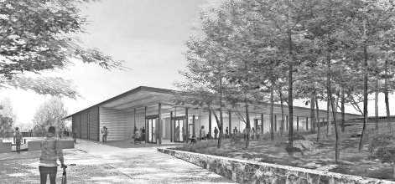
A schematic of the Frank and Maureen Wilkens Science and Engineering Center.
COURTESY OF CAPE COD COMMUNITY COLLEGE

Photo Shoot
Continued from Page 3A

Anyone who has had the motherboard go on a com- puter or the control chip in a car fail knows how quickly smart devices can become stupid and non-functional. I can’t solve most of the world’s problems with high- tech devices, but I have a simple work around for cam-
era enthusiasts that are fail safe — go manual.
Indeed turning off auto-exposure, autofocus and any other pre-programmed feature can be scary. Your photo can now be out of focus, poorly exposed but hopefully still wonderfully composed.
Because composition is the one thing your unique eye brings to a photograph. That is the starting point for going back to basics. Focusing the old-fashioned way can be cumbersome, but practice makes perfect. There was a time when getting a properly exposed photograph was an art form. Now with an instant read- out screen on the camera back, no more guesswork, right? But how does the camera know what I want to look good in the photo, put a person in front of a bright
window and see how it thinks.
I had a similar situation last week. The Cape Cod Lighthouse Charter School was working on a project for Holocaust Remembrance Day. Only one problem: The power was out.
No worries, I cranked up the sensor sensitivity on the camera and went to work. The wrong exposure was glowing at me from the screen back. The camera had exposed for the darkness and the room looked com- pletely bright, definitely not an accurate representa- tion of the power outage. Turning to manual mode and exposing for the light source, the exposure was cor- rected. Not a complex fix, I just had to be a bit smarter than the camera.

Briefs
Continued from Page 3A

phase. Southside fire coverage is now consigned to firefighter-paramedics responding from a trailer out- side the closed station in Monument Beach.
Selectmen have discussed combining a police- substation with a firehouse project. The last fire-sta- tion push was frustrated by the expensive cost of a possible Monument Beach property purchase along Route 28, and the realization that a favored tract at County Road, Pocasset, proved unsuitable in terms of reasonable emergency response times.
Paul Gately

CF-0001056979-01
Need Program, 250 Washington Street, 6th Floor, Boston, MA 02108.
later, by contacting the Department of Public Health, Determination of
than March 31, 2022 or 30 days from the Filing Date, whichever is
may register in connection with the intended Application by no later
result of the Proposed Project. Any ten Taxpayers of Massachusetts
price or service impacts on the Applicant’s existing patient panel as a
expenditure is $137,048,632. The Applicant does not anticipate any
total value of the Proposed Project based on the maximum capital
department will be relocated to accommodate the new facility. The
In addition, the Hospital’s outpatient obstetrics and gynecology
unit consisting of 32 beds (collectively, the “Proposed Project”).
radiation oncology department; and (3) relocated medical/surgical
and expanded medical oncology department; (2) relocated
Hospital’s main campus that will contain the following: (1) relocated
This Application includes the construction of a new facility on the
by Cape Cod Hospital (the “Hospital”) located at the same address.
Department of Public Health for a substantial capital expenditure
of Determination of Need (“Application”) with the Massachusetts
business at 27 Park Street, Hyannis, MA 02601, intends to ﬁle a Notice
Cape Cod Healthcare, Inc (the “Applicant”), with a principal place of
Concerning a Proposed Health Care Project
Public Announcement

CAPECODTIMES.COM | MONDAY, FEBRUARY 14, 2022 | 9B
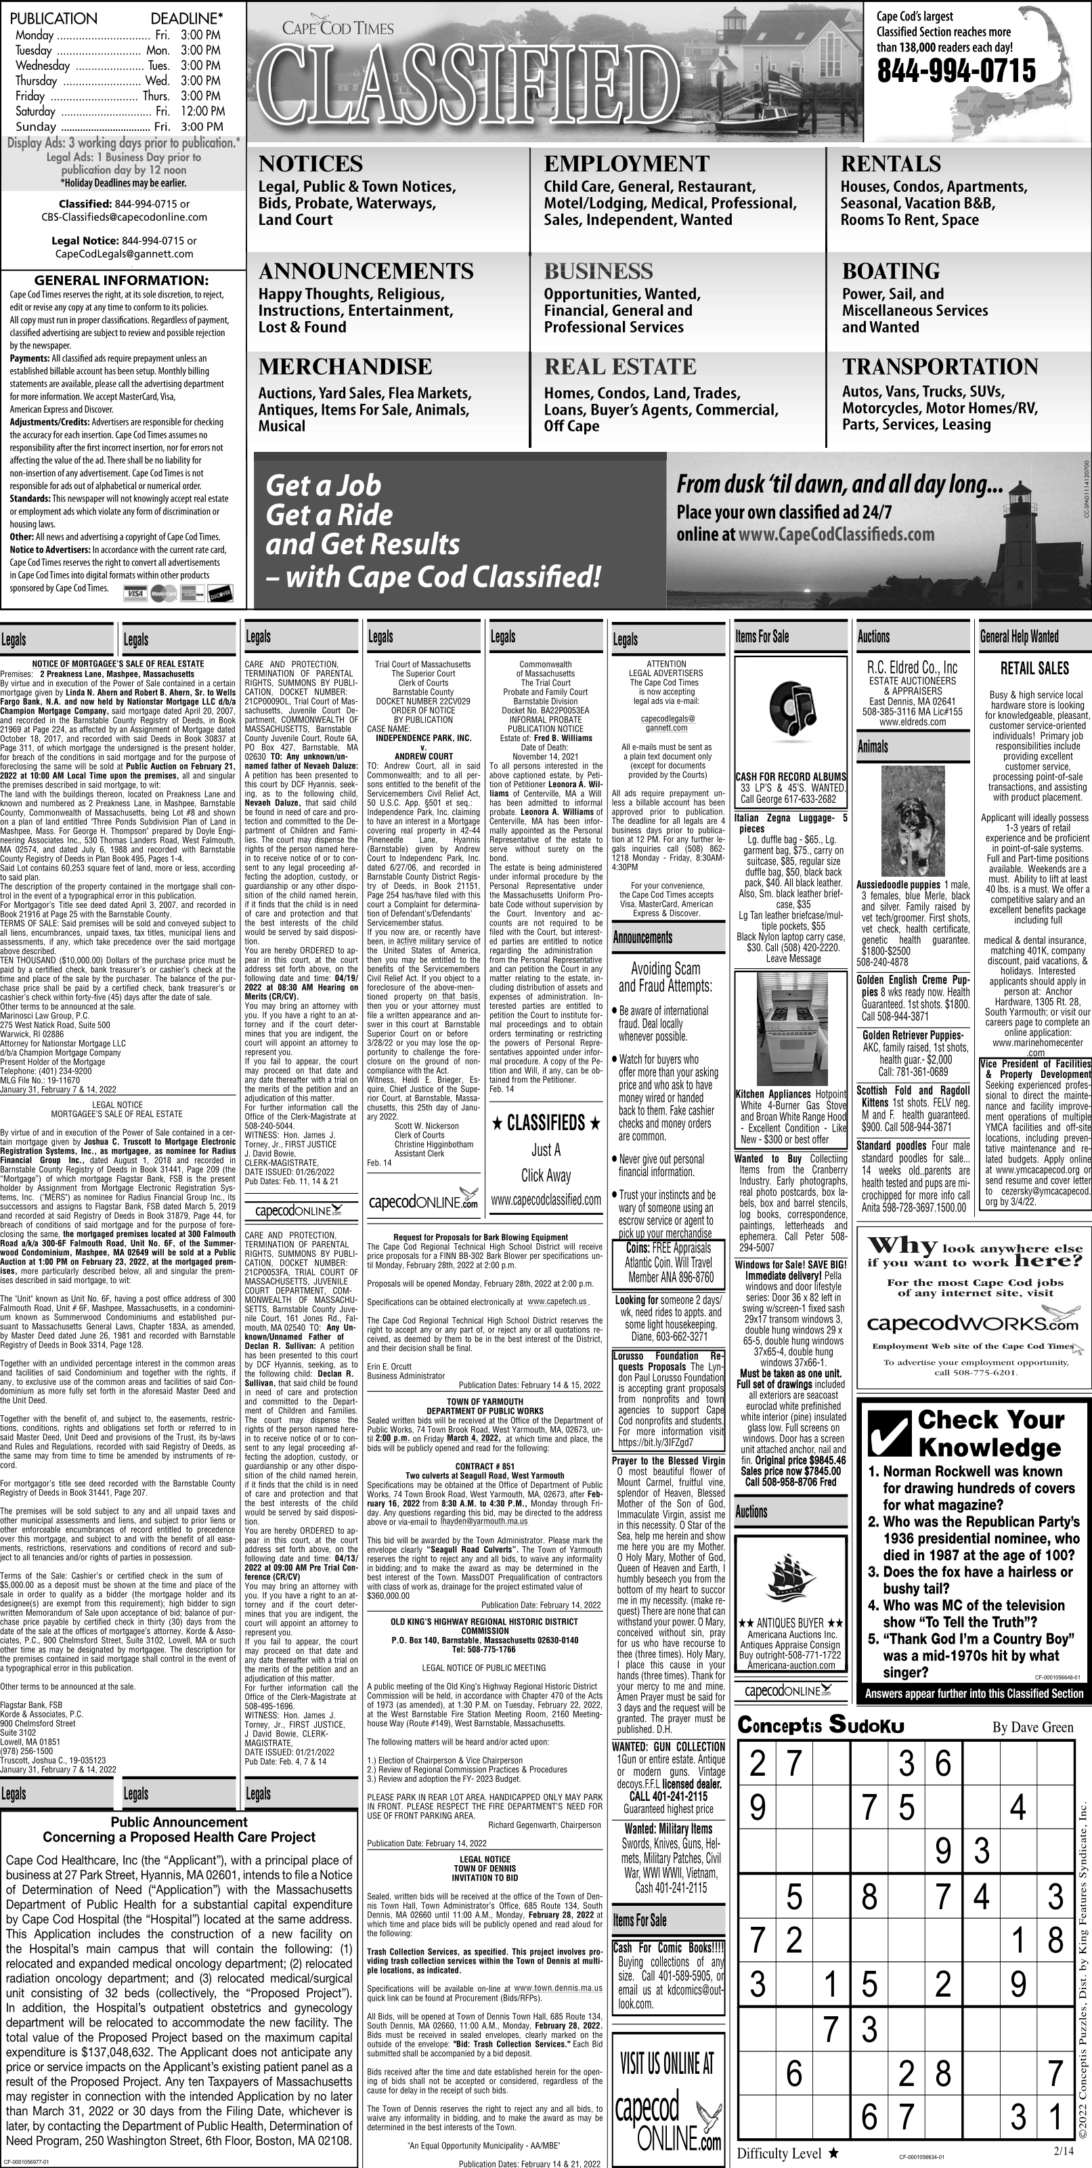

APPENDIX 9 ACO LETTER

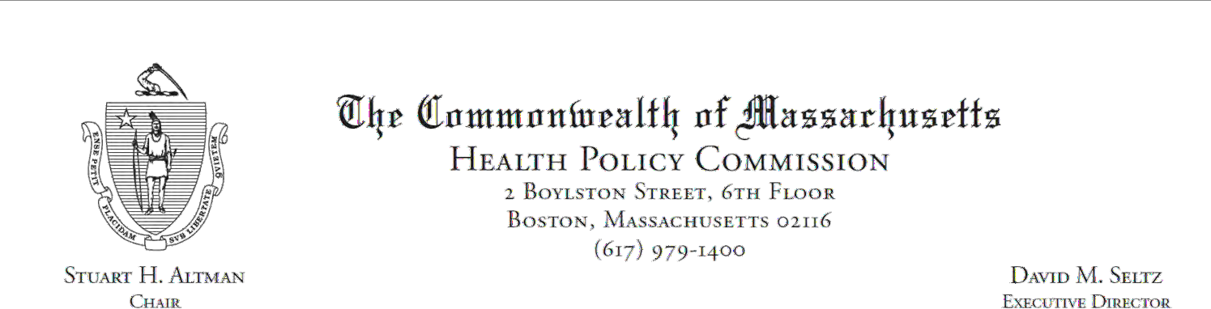
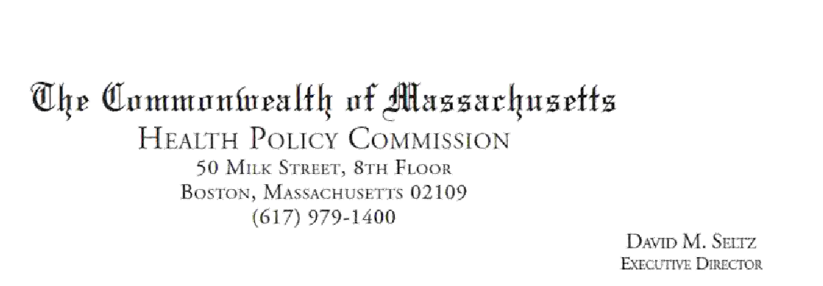

December 23, 2019 Gregory Watts
Steward Health Care Network, Inc.
89 A Street
Needham, MA 02494

RE: ACO Certification Dear Mr. Watts:
Congratulations! The Health Policy Commission (HPC) is pleased to inform you that Steward Health Care Network meets the requirements for ACO Certification. This certification is effective from the date of this letter through December 31, 2021.

The ACO Certification program, in alignment with other state agencies including MassHealth, is designed to accelerate care delivery transformation in Massachusetts and promote a high quality, efficient health system. ACOs participating in the program have met a set of objective criteria focused on core ACO capabilities including supporting patient-centered care and governance, using data to drive quality improvement, and investing in population health. Steward Health Care Network meets those criteria.

The HPC will promote Steward Health Care Network as a Certified ACO on our website and in our marketing and public materials. In addition, a logo is enclosed for your use in accordance with the attached Terms of Use. We hope you will use the logo to highlight the ACO Certification to your patients, payers, and others.

The HPC looks forward to your continued engagement in the ACO Certification program over the next two years.

Thank you for your dedication to providing accountable, coordinated health care to your patients. If you have any questions about this letter or the ACO Certification program, please do not hesitate to contact Mike Stanek, Manager, at HPC-Certification@mass.gov or (617) 757-1649.

Best wishes,

David Seltz Executive Director

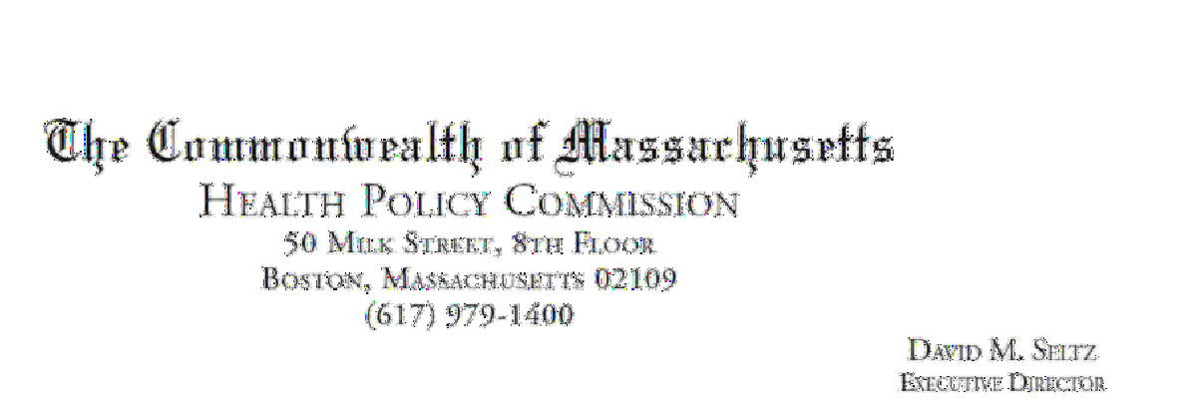

December 30, 2021 Joseph Weinstein
Steward Health Care Network, Inc.
30 Perwal Street
Westwood, MA, 02090

RE: Temporary Extension of ACO Certification Dear Dr. Weinstein:
In 2019 the Health Policy Commission (HPC) issued Steward Health Care Network, Inc. an ACO Certification effective through December 31, 2021. Due to continuing disruptions associated with the COVID-19 pandemic, this year the HPC extended both the application period and the review period for ACO Certification renewals. As of the date of this letter, Steward Health Care Network, Inc.’s application for certification under the Learning, Equity, and Patient-Centeredness (LEAP) 2022-2023 standards is under review.

The HPC is hereby temporarily extending Steward Health Care Network, Inc.’s current ACO Certification pending completion of review of its application for LEAP 2022-2023 certification and issuance of a final determination.

Thank you for your continued participation in this collaborative process and for your dedication to providing accountable, coordinated health care to your patients during this time of immense challenge for health care providers and organizations. If you have any questions about this letter or the ACO Certification program, please do not hesitate to contact Mike Stanek, Senior Manager, at HPC-Certification@mass.gov.

Best wishes,
David Seltz Executive Director

cc:

Elana Horwitz Contract Manager MassHealth

APPENDIX 10 ARTICLES OF INCORPORATION

xaminer
•
,,
FORM CD 18q Re\'. 3-79 20M-I 1 81-0907806

IDlp; Qln1nmnnwralttr·nf fflu.a.aurliu.artta
MICHAEL JOSEPH CONNOLLY
Secretary of State
ONE ASHBURTON PLACE, BOSTON, MASS. 02108

NAME
ARTICLES OF ORGANIZATION
(Under G.L. Ch. 180)
lncorporators

RESIDENCE

Include given name in full in case of nalural persons; in case of a corpora lion, give slale of incorporalion.

JAMES F. LYONS
520 Cotuit Bay Drive Cotuit, MA 02635



The above-named incorporator(s) do hereby associate (themselves) with the intention of forming a corporation under the provisions of General Laws, Chapter 180 and hereby state(s):

amc
,pprovcd

c.□
P D
M D
R.A. D

I. The name by which the corporation shall be known is:/

CAPE COD HEALTH SYSTEMS, JNC.

- The purposes for which the corporation is fanned is as follows:

See ":purposes for which the Corporation is Formed" on Continuation Sheets 2A-2C.

84 144043




.c.
JI)

Note: If the space provided under any article or item on this form is insufficient. addilions shall be set forth on separate 8 1/2 x 11 sheets of paper leaving a left hand margin of at least I inch for binding. Additions to more than one article may be continued on a single sheet so long as each article requiring each such addition is clearly indicated,

- If the corporation has more than one class of members. the designation of such classes. the manner of election or appointment, the duration of membership and the qualii.'1,;l}i9n_'l_nd rights, including voting rights, of the members of each class. arc as follows: -
See "Classes of Members'' on Continuation Sheet 2C. •

*4. Other lawful provisions, if any, for the conduct and regulation of the business and affairs of the c,,rporation, for its voluntary dissolution, or for limiting, defining. or regulating the powers of the corporation, or of its directors or members, or of any class of members, are as follows:-

See "Other Lawful Provisions" on Continuation Sheets 2C-2E.

*If there are no provisions state "None".

Continuation Sheet 2A
•

ARTICLES OF ORGANIZATION
of
CAPE COD HEALTH SYSTEMS, INC.
a Massachusetts Charitable Corporation
- Purposes for which the Corporation is For ed

  - The purposes for which CAPE COD HEA:TH SYSTEMS,
_INC. ( "the Corporation") is being formed are to promote and support by donation, loan or otherwise, the interests and purposes of Cape and Islands Health Resources, Inc., Cape Cod Hospital and Cape Cod Hospital Foundation in promoting the community's health and otherwise to operate for any charitable, scientific or educational purposes in any manner consistent with the requirements of Section 5Ol(c)(3) of the Internal Revenue Code of 1.954, as amended (or the corresponding provision of any future United States Internal Revenue law) (hereinafter referred to as "the Code"). The Corporation is organized exclusively for charitable, scientific or educational purposes, including, for such purposes, the making of distributions to organizations that qualify as exempt organizations under Section 5Ol(c)(3) of the Code.
  - The Corporation shall have the following powers in furtherance of its corporate purposes:

    - The Corporation shall have perpetual succession in its corporate name.
    - · The Corporation may sue and be sued.
    - The Corporation may have a corporate seal which it may alter at its pleasure.
    - The Corporation may elect or appoint directors, officers, empioyees and other agents, fix their compensation and define their duties and obligaticns.
    - The Corporation may purchase, receive or take by grant, gift, devise, bequest or otherwise, lease, or otherwise acquire, own, hold, improve, employ, use and otherwise deal in and with, real or personal property, or any interest therein, wherever situated, in an unlimited amou·nt.
    - The Corporation may sell, convey, lease, exchange, transfer or otherwise dispose of, or mortgage, pledge, encumber or create a security interest in, all or any of its property, or any interest therein, wherever situated.

Continuaticn Sheet 2B
•

    - The Corporation may purchase, take, receive, subscribe for, or otherwise acquire, own, hold, vote, employ, sell, lend, lease, exchange, transfer, or otherwise dispose of, mortgage, pledge, use and otherwise deal in ·and with, bonds and other obligations, shares, or other securities or interests issued by others, whether engaged in similar or different business, governmental, or other activities.

    - The Corporation may make contracts, give guarantees and incur liabilities, borrow money at such rates of interest as the Corporation may determine, issue its notes, bonds or other obligations, and secure any of its obligations by mortgage, pledge or encumbrance of, or security interest in, all or any of its property or any interest therein, wherever situated.

    - The Corporation may lend money, invest and reinvest its funds, and take and hold real and personal property as security for the payment of funds so lJaned or invested.

    - The Corporation may do business, carry on its operations, and have offices and exercise the ?Owers granted by Massachusetts General Laws, Chapter 180, in any jurisdiction within or without the United States, 3.lthough the Corporation shall not be operated for the prim3.ry purpose of carrying on for profit a trade or business unrelated to its tax exempt purposes.

    - The Corporation may pay pensions, establish and carry out pension, savings, thrift and other retirement and benefit plans, trusts and provisions for any or all of its directors, officers and employees.
      - The Corporation may make donations in such amounts as the Members or directors shall determine, irrespective of corporate benefit, for the public 1Jelfare or for community fund, hospital, charitable, religious, educational, scientific, civic or similar purposes, and in time of war or other national emergency in aid thereof; provided that, as long as the Corporation is entit:.ed to exemption from Federal income tax under Section SO:.(c)(3) of the Code, it shall make no contribution for other than religious,·charitable, scientific, testing for public safety, literary, or educational purposes or for the prevention of cruelty to children or animals.

- The Corporation may be an incorporator of other corporations of any type or kind.

Continuation Sheet 2C
•

- The Corporation may be a partner in any business enterprise which it would have power to conduct by itself.

Notwithstanding any other provision of these Articles, the Corporation shall not carry on any other activities not permitted to be carried on (a) by a corporation exempt from Federal income tax under Section 50l(c)(3) of the Code or
- by a corporation, contributions to which are eductible under Sections 170(c)(2), 2055(a)(2) or 2522(a)(2) of the Code.

Classes of Members
  - There shall be four classes of members of the Corporation:

- Initial voting members--The initial voting members of the Corporation shall consist of those persons who were voting members of Cape Cod Hospital at the time of incorporation of the Corporation. The initial voting members shall serve until the close of the first annual meeting of the members.

- Regular members--The Corporation shall have not more than one hundred (100) regular members who shall be elected at each annual meeting of the members from a slate submitted by the nominating committee. Regular members shall be voting members and shall serve for a term of one year.
- Ex-officio members--The directors and officers of the Corporation, the Chief of Staff and Vice Chief of Cape Cod Hospital, the President of the Cape Cod Hospital Aid Association and members of the legislature of the Commonwealth of Massachusetts elected from Mashpee, Sandwich, Barnstable, Yarmouth, Dennis, Harwich, Brewster, Chatham, Orleans, Eastham, Wellfleet, Truro and Provincetown shall be ex-officio and voting members of the Corporation.
- Associate members--Associate members shall be those person designated as such by the board of directors. Associate members shall be entitled to attend all meetings of the members and to express their views, but shall be without vote.
•

Other Lawful Provisions
1. Each person at any time a director, officer, employee or agent of the Corporation and any person who serves at its request as a director, officer, employee or other agent of another organization in which the Corporation directly or indirectly has an interest (including any person

-3-

Continuation Sheet 20
•

who is no longer a director, officer, employee or agent of the Corporation or of said other organization) shall, to the extent permitted by law and only to the extent that the status of the Corporation as an organization exempt under Section 50l(c)(3) of the Code, is not affected thereby and without prejudice to any other rights he might have, be entitled to be reimbursed by the Corporation for, and indemnified by the Corporation against, all costs and expenses reasonably incurred by him in connection with or "arising out of any claims made, or any action, sujt or proceeding threatened or brought against him or in which he may be involved as a party or otherwise by reason of any action alleged to have been taken or omitted by hjm as such director, officer, employee or agent, whether or not he continues to be such director, officer, employee or agent at the time of incurring such costs and expenses, including amounts paid or incurred by him in connection with reasonable settlements (other than amounts paid to the Corporation itself) of any claim, action, suit or proceeding, provided, that no person shall be so indemnified in relation to any matter which has been made the subject of a settlement, except with the approval of a court of competent jurisdiction or a vote of a majority of the voting members of the Corporation, or by a vote of a disinterested majority of directors then in office. Any rights to reimbursement and indemnification granted hereby to any such director, officer, employee or agent shall extend to his heirs, execLtors and administrators. No such reimbursement or indemnification shall be provided for any person with respect to any matter as to which he shall have been adjudicated in any proceeding not to have acted in good faith in the reasonable belief that his action was in the best interests of the Corporation.
Reimbursement or indemnification hereunder may, in the discretion of the Board of Directors, include payments by the Corporation of costs and expenses incurred in defending a civil or criminal action or proceeding in advance of the final disposition of such action or proceeding upon receipt of an undertaking by the person indemnified to repay such payment if he shall be adjudicated to be not entitled to indemnification hereunder. Nothing herein contained is intended to, or shall, prevent a settlement by the Corporation prior to final adjudication of any claim, including claims for reimbursement or indemnification hereunder, against the Corporation when such sett}ement appears to be in the interests of the Corporation. Each such person shall, by reason of his ontinuing such service or accepting such election or employment, have the right to be reimbursed and indemnified by the Corporation, as above set forth with the same force and effect as if the Corporation, to induce him to continue so to serve or to accept such election or employment, specifically agreed in writing to
•

I
i

Continuation Sheet 2E
- '
reimburbe and indemnify him in accordance with th:1 foregoing provisipns of this Section. No director or offic-;ir of the Corporation shall be liable to anyone for making any determihation as to the existence or absence of liability of the Corporation hereunder for making or refusing to make any paymentlhereunder in reliance upon advice of counsel.
j 2. Neither the Board of Directors, nor any member or officer, shall have power to bind the members or the individpal directors or officers of the Corporation, persona1lly. All persons or corporations extending credit to,
contrac ' ing with, or having claims against the Corporation,
shall lpok only to the funds and property of the Corporation for payment of any such contract or claim or for the payment of any debt, damage, judgment or decree, or of any money that may othbrwise become due and payable to them from the Corporaltion, so·that neither the Members, nor the directors, nor thej officers, present or future, shall be personally
.liable herefor.
I 3. The By-Laws of the Corporation may be amended by affi;rmati ve vote of a two-thirds majority of the Board of Directo rs then serving at the annual meeting or any regular or spec•1 ial meeting of the board, provided that a b'rief descri tion of such proposed amendment(s) shall have been publisHed in or with the notice of the meeting.
I 4. Dissolution shall be as follows:·
i
/ In the event of the dissolution of the Corporation, the Board of Directors, after paying or making provisilon for the payment of all the liabilities of the Corpor tion, shall distribute, in any proportions considered prudent, all the assets of the Corporation to Cape and Island Health Resources, Inc., if then in existence and if qualif ed under Section 501(c)(3) of the Code, otherwise in such m nner, or to such organization or organizations organized and operated exclusively for charitable,
educat onal or scientific purposes as shall at the time qualify as an exempt organization or organizations under Section 501(c)(3) of the Code, and as shall be affiliated with the Corporation, as the Board of Directors shall determfne. Any such assets not so disposed of shall be disposJd of by a court of competent jurisdiction of the county·f in which the principal office of the Corporation is then located, exclusively for such purposes or to such organiiation or organizations, as said court shall determine, which Jre organized and operated exclusively for such
•
purpos1I s.

-s-

Continuation Sheet 2F
- Directors
The name, residence, and post office address of each of the initial directors of the corporation are as follows:
NAME RESIDENCE P.O. ADDRESS

Daniel - Fern, Esq. MA
Kenneth. F. Eldredge II

P.O. Box 518
436 Main Street Hyannis, MA 02601
P.O. Box 640 Cape Cod Hospital 27 Park Street Hyannis, MA 02601

Milton Penn James H. Rice Mary Marble Forest Beam Joseph Daluz James F. Hall
William P. Luke, M.D.

John Lee Marchildon Joshua ,A. Nickerson Elisabeth W. Vaughn
•
II II
II II
II II
" "
II "
" II
" "
II II
II II
II "

- By-laws of the corporation ha"c been duly adopted and the initial directors, president, treasurer and clerk or other
presiding, financial or recording officers whose names are set out below, have been duly elected.
\
- The elTective date of organization oflhc corporation shall be the date of riling with the Secretary of the Commonwealth or if later date is desired, specify date. (not more than 30 days after date of filing).
•
- The following information shall not for any purpose be treated as a permanent part of the Articles of Organization of the
corporation.

  - The post office address of the initial principal office of the corporation in Massachusetts is:

c/o Cape Cod Hospital, P.O. Box 640, Hyannis, MA 02601

  - The name, residence, and post office address of each of the initial directors and following officers of the corporation are as follows:

NAME RESIDENCE POST OFFICE ADDRESS

President: James F. Lyons

Treasurer: Kenneth F. Eldredge

Clerk: /
Secretary Mary Marble
(MA)

(MA)

(MA)
520 Cotuit Bay Drive Cotuit, MA 02635

c/o Cap CodHospital
P.O. Box 640
27 Park Street Hyannis, MA 02601
"

Directors: (or officers having the powers of directors)

See "Directors" on Continuation Sheet 2F.

  - The date initially adopted on which the corporation's fiscal year ends is: September 30th of each year.

  - The date initially fixed in the by-laws for the annual meeting of members of the corporation is: the first Tuesday in December of each year.
  - The name and business address of the resident agent, if any. of the corporation is: N/A

IN WITNESS WHEREOF. and under the penalties of perjury the INCORPORA TOR(S) sign(s) these Articles of Organization this 1st day of May .19 84,
•

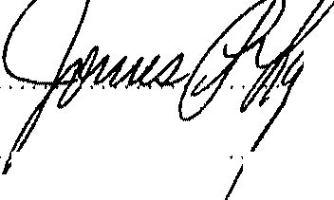
I/We-the below signed INCORPO ORS do hereby certify under the pains and penalties of perjury that I/ have not been convicted of any crimes relating t alcohol or gaming within the past ten years; I/We do hereby further certify that to the best of my/ k owledge the abo" na ed principal officers have not been similarly convicted. If so convicted, explain.

. ·····································································
...............' ................. '' ........ '.''........' ......... '' .................''' ....,'''..' ... ' ... ' ..

The signature of each incorporator which is not a natural person must be by an individual who shall show the capacity in which he acts and by signing shall represent under the penalties of perjury that he is duly authorized on its behalf to sign these Articles of Organization.



THE COMMONWEALTH OF MASSACHUSETTS

·-: : .J '">: •."
: ., .J I '- «• ,_

ARTfCLES OF ORGANIZATION
- . ,., 1-. ..
...... ;d ..;;,;\1 i\/!l lJf\liS Ud
GENERAL LAWS, CHAPTER 180

I hereby certify that, upon an examination of the within-written articles of organization, duly submitted to me, ii appears that the provisions of the General Laws relative to the organization of corporations have been complied with. and I hereby approve said articles: and the filing fee in the amount of$30.00 having been
7;!
paid, said articles are/deemed to have been filed with

me this ;f( .:3/4 day of
19 tf''f

Effective date
12: c1

Secretary of State

TO BE FILLED IN BY CORPORATION
PHOTO COPY OF ARTICLES OF ORGANIZATION TO BE SENT

TO:
..... _DC>nria_. aniElr?n. i .. .SCI:..........................
Herrick & Smith
''''' JO.O.. f.E;Jq(il:l;'?I,+, .?,1;.;t;(ilE;J:t;,.'''''' ''' ... ' '''''
......B.o..s..t.o..n..,...M.A.....0..2..1.1..0..............................
Telephone ....- - 7.--: .0.QO....................................

Filing Fee $30.00 Copy Mailed

JUNO 6 1984

- I . '
^{f} FEDERAL IDENTIFICATION.­
NO. 22-2600704 {;,/

Exaqdner

bt ·Qtommo
1
!l ! !! s- bu.s-ttt.s- ·O A\

Secretary of the Commonwealth I"\
One Ashburton Place, Boston, Massachusetts 02108-1512 0 ,:t--
Ii 043

RESTATED ARTICLES OF ORGANIZATION

)
Name
Approved

we,

(General Laws, Chapter 180, Section 7)

J_a_m_e_s_F;..•c......;Lc,Y...;O;.cnc:s
o7J 041-
o'fo
, 'President;

and
Secretary
......::G:.::ec=r.=a=l.=d_W:.:....:.....:H.=a:::z;.::a:..::r.=d.'"'....:..:M.:...D::. , 'Clerk/

of C;.ca e e C;.:o..cd-'CHCCe.=a.=1..ctcch_.c.SLyCC.s t em s ,_I n c=·
(Exact name of corporation)

locatedat 2:7 Park Street,. Hyannis, MA, 02601
(Street address of corporation In Massachusetts)

do hereby certify that the following Restatement of the Articles of Organization was duly adopted at a meeting

held on January 22, , 19 ..2.§ , by a vote of:

8 4 --- members, directors, or shareholders,

being at least two-thirds of its-members/directors legally qualified to vote in meetings of the corporation (or, in the case of a corporation having capital stock, by the holders of at least two thirds of the capital stock having the right to vote therein): ·'
ARTICLE I
The name of the corporation is: Cape Cod Healthcare, Inc.




C
p
M R.A.

J_
P.C.
ARTICLED
The purpose of the corporation is to engage in the following activities:

See Continuation Sheet 2A attached hereto and incorporated herein
by reference.

*Delete tbe fnappllcable words. ,
Note: Jftbe space provul.ed under any article or Item on tbts/onn ts insulfldent, addlttons shall be set/orlb on one side only of sept1rate 8 1/2 x I I sbeets of paper wttb a left ma n of at least 1 lncb. Additions to more tban one arltcle may be made on a single sbeel as long a., each article requiring each aadttt.on ts clearly Indicated.

.. I •
ARTICLE ID
A corporation may have one or ?re classes of members. If it does, the designation of such classes, the manner of election or appointments, the duration ot membership and the qualification and rights, including voting rights, of the members of each class, may be set forth in the by-laws of the corporation or may be set forth below:

The designation of members of the corporation, the manner of their election or appointment, the duration of membership and the qualification and rights, including voting rights, of the members are set forth in the By-laws.

ARTICLE IV
"Other lawful provisions, if any, for the conduct and regulation of the business and affairs of the corporation, for its voluntary dissolution, or for limiting, defining, or regulating the powers of the corporation, or of its directors or members,
or of any class of members, are as follows:

See Continuation Sheet 4A attach d hereto and incorporated herein by reference.

**If Ibero are no proutstons, state "None".
Note: Tbe preceding four (4) articles are considered to be permatU1111 and may ONLY be changed by flling approprlale Articles of Amendment.

CONTINUATION SHEET 2A

The Corporation is organized for the exclusively charitable and educational purposes of promoting and coordinating the provision of high quality health and related services and to ···. promote or support the general health of the residents of The Commonwealth of Massachusetts and, to that end, shall be operated exclusively for the benefit of Cape Cod Hospital, Inc. ("Cape Cod"), Falmouth Hospital Association, Inc. ("Falmouth") and any other corporations described in Section S0l(c)(3) of the Internal Revenue Code of 1986, as amended, (the "Code"} of which the Corporation, Cape Cod, Falmouth or any corporation controlled by any of them is the sole member, and may do all other things permitted or authorized by the laws of The Commonwealth of Massachusetts for corporations organized under G.L. ch. 180.

•
dsl/164489

CONTINUATION SHEET 4A
Subject to the limitations contained in paragraphs (a) through (e) below, the Corporation shall have the following powers: (1) the powers set forth in Massachusetts General Laws
c. 156B, §9 (a) through (k); (2) the power to pay pensions and to establish and carry out pension, savings, thrift and other retirement and benefit plans, trusts and provisions for any or all of its trustees, officers and employees; and (3) the power to be a partner with one or more other organizations exempt from Federal income taxation under §50l(c)(3) of the Internal Revenue Code of 1986 (or the corresponding provision of any future United States internal revenue law, hereinafter the "Internal Revenue Code") in any enterprise which carries out the purposes on which the Corporation's tax-exempt status is based.
- Notwithstanding any other provision of these Articles, the Corporation shall not carry on any activities not permitted to be carried on (i) by a corporation exempt from Federal income tax under §501(c)(3) of the Internal Revenue Code or (ii) by a corporation, contributions to which are deductible under §170(c)(2) of the Internal Revenue Code.
- No part of the net earnings of the Corporation shall inure to the benefit of any private member or individual, and no trustee, officer or employee of the Corporation shall receive or be lawfully entitled to receive any pecuniary profit of any kind therefrom except reasonable compensation for services in effecting one or more of its purposes.
- No substantial part of the activities of the Corporation shall be the carrying on of propaganda, or otherwise attempting, to influence legislation, and the Corporation shall not participate in, or intervene in (including the publishing or distributing of statements) any political campaign on behalf of any candidate for public office.
- Persons of any race and of either sex shall be entitled to all the rights, privileges, programs and activities generally accorded or made available to participants in the Corporation, its programs and activities, and the Corporation shall not discriminate on the basis of race or sex in administering its policies and programs.
- In the event of dissolution of the Corporation, the assets of the Corporation shall be distributed pursuant to Massachusetts General Laws c. 180, §llA to such organization or organizations with similar charitable, religious, scientific and educational purposes as at the date of dissolution are described in §50l(c)(3) of the Internal Revenue Code.
- Meetings of the trustees may be held anywhere in the United States.

(gf No trustee or officer of the Corporation shall be personally liable to the Corporation for monetary damages for breach of fiduciary duty as a trustee or officer; provided, however, that this paragraph shall not eliminate or limit the liability of a trustee or officer of the Corporation (i) for any breach of the trustee's or officer's duty of loyalty to the Corporation, (ii) for acts or omissions not in good faith or which involve intentional misconduct or a knowing violation of law, or (iii) for any transaction from which the trustee or officer derived an improper personal benefit. No amendment, modification or repeal of this paragraph, directly or by adoption of an inconsistent provision of these Articles, by the trustees of the Corporation shall apply to or have any effect on the liability or alleged liability of any trustee or officer of the Corporation for or with respect to any acts or omissions of such trustee or officer occurring prior to such amendment, modification or repeal.
DSl-118818

. . '
. '

Corisent to Use of Name

The undersigned Massachusetts corporation hereby consents to the use of the name "CAPE COD HEALTHCARE, INC." in connection with the name change of Cape Cod Health Systems, Inc., a Massachusetts corporation having its principal business office at 27 Park Street, Hyannis, Massachusetts 02601.

CAPE COD HEALTH CARE CORPORATION
By: I ',,f--, :t '-('.,._
.,_ -,.. g /J .
Mary J. WClair, Treasurer Date: January !.1_, 1996

1-235872

CONTINUATION SHEET 6B TRUSTEES

NAME
Robert V. Antonucci

Richard J. Bravman, D.M.D.
Edmund Fruean, III

Edward Gelsthorpe

Kenneth A. Heisler,M.D.

Peter Hickman
RESIDENTIAL ADDRESS
93 Ambleside Drive
West Falmouth, MA 02574
208 Scudder Bay Circle, Centerville, MA 02632
18 Crab Creek Lane, Yarmouthport, MA 02675
50 South Street
Dennis, MA 02641

78 Main Street Falmouth, MA 02540

Main Street Cotuit, MA 02635
POST OFFICE ADDRESS
P.O. Box 488, West Falmouth, MA 02574

P. 0. Box 857
East Dennis, MA 02641

P. 0. Box 528,
Cotuit, MA 02635

Michael T. Leahy, M.D. 68 Overlook Drive
Waquoit, MA 02536
Victoria H. Lowell 188 Sippewissett Road,
Falmouth, MA 02540

Barrett c. Nichols, Jr.
Thomas S. Olsen

David J. Penfield, M.D.
Willis B. Reals Charles N. Robinson Anne Q. Spaulding James F. Lyons
Roy A. Hitchings, Jr.
11 Stable Lane
Yarmouthport, MA 02675
31 Bumps River Road Osterville, MA 02655
38 Cahoon Road Harwich, MA 02645
73 Clowes Road Falmouth, MA 02540
39 Barrister's Walk Dennis, MA 02638
Blossom Lane
East Orleans, MA 02643
520 Cotuit Bay Drive Cotuit, MA 02635
18 Ridgeview Drive
West Falmouth, MA 02674
P. 0. Box 71 Yarmouthport, MA 02675

P. 0. Box 804
East Orleans, MA 02643

P. 0. Box 1236
West Falmouth, MA 02574

1-235630

ARTICLEV
The effective date of the Restat d Articles of Organization of the corporation shall be the date approved and filed by the Secretary of the Commonwealth. If a later effective date is desired, specify such date which shall not be more than thirty

days after the date of filing.
·
June 1, 1996

ARTICLE VI
The information contained in Article VI is not a permanent part of the Articles of Organization.

- The street address of the principal office of the corporation In Massachusetts is: (post office boxes are not acceptable)
27 Park Street, Hyannis, MA 02601
- The name, residential address and post office address of each director and officer of the corporation is:

President: Treasurer:
Clerk:
NAME RESIDENTIAL ADDRESS
James F. Lyons 520 Cotuit Bay Drive
Cotuit,·MA 02635 Willis B. Reals 73 Clowes Road
Falmouth, MA 02540
Edward Gelsthorpe 50 South Street
POST OFFICE ADDRESS
Sarne Sarne
P. 0, Box 857

Dennis, MA 02641
East Dennis, MA 02641

Directors: (or officers having the powers of directors)
See Continuation Sheet 6B attached hereto and incorporated herein by reference.

- The fiscal year of the corporation shall end on the last day of the month of: . September

- The name and business address of the resident agent of the corporation, if any, is: N/A

"We further certify that the foregoing Restated Articles of Organization affect no amendments to the Articles of Organization of the corporation as heretofore amended, except amendments to the following articles. Briefly describe amendments below:

Articles I, II, III and IV are amended as set forth herein.

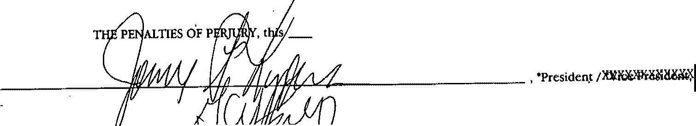
SIGNED UNDER
3 ls t day of .,,Ma"'-L..----- , 19 9'-'6'----
\
,,
1
.Jt- _.,,,.:....1.,,,L-=.-,Zi'-/11+./---+,,L; -----....!"..:'-·-:'...·_;
Secretary
, 'Clerk/


*Delete tbe tnappltcablc words, sucb amendments, state "Nune".

SECHET1\RY Or THE COMMONWEALTH
96MAY31 PM3:57
539085
TIIE COMMONWEALTII OF MASSACHUSETTS
•
RESTATED ARTICLES OF ORGANIZATION
(General Laws, Chapter 180, Section 7)

I hereby approve the within Restated Articles of Organization and, the filing fee in the amount of$ J67<llJ having been paid, said
14./ ,
articles are deemed to have been filed with me this day of
19 ..qt. -
I I Cl
I

Effective Date: J v I,) t I 19 q h


Secretary of the Commonwealth

TO BE FD.LED IN BY CORPORATION
Photocopy of document to be sent to:

Jeffrey L. Heidt. Esq. Choate, Hall & Stewart
Exchange Place 53 State Street
Boston, Massachusetts 02110

Telephone: ( 617) 248-5000

.-..:}::
-.._

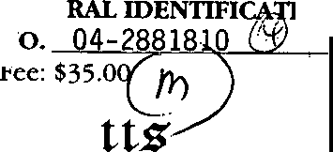
·,('

FEDERAL IDENTIFICAIJON NO. 22-2600 704
(,y
FEDERAL IDENTIFICATION FEDERALIDENTIFICATION
NO 04-2828094 NO. 04-2859578 •
v?'))
FEDE ON

bt rJ-monwtaltb f fflassacbust
William Francis Galvin
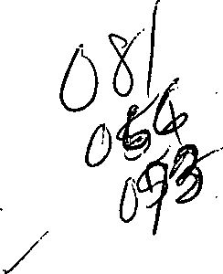
Secretary of the Commonwealth
One Ashburton Place, Boston, Massachusetts 02108-1512

ARTICLES OF *CON501,ffil,ffION / *MERGER
(General Laws, Chapter 180, Section 10)
Domestic and Domestic Corporations

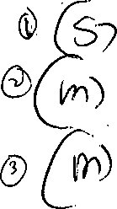
'l[)cm61!lllcaad!loc/ 'merger of Cape Cod Healthcare, Inc.
Falmouth.Hospital Foundation, Inc. Cape Cod Hospital Foundation, Inc. ,/

and


Visiting Nursing Association of ./
Cape Cod Foundation, Inc.

the constituent corporations, into

 Cape Cod Healthcare. Inc.
'one of the constituent corporations l! WZ<XZ'j(>i!ll<i!iXw.

The undersigned officers of each of the constituent corporatioris certify under the penalties of perjury as follows:

-'1
1
, · i

  - The agreement of ltXll1XG!Udru4111 / 'merger was duly adopted in accordance and compliance with the requirements of General Laws, Chapter 180, Section 10.

  - That if any of the constituent corporations constitutes a public charity, then the resulting or surviving corporation shall be a public charity.

  - The resulting or surviving corporation shall furnish a copy of the agreement ofl lc:r.100%/ 'merger to any of its members or to any person who was a stockholder or member of any constituent corporation upon
. written request and without charge.

  - The effective date of the 'z«asalildaOll!O: / 'merger determined pursuant to the agreement of 'z11111CJ!ldl)141!l11 / 'merger shall be the date approved and filed by the Secretary of the Commonwealth. If a later effective date is desired, specify such elate which shall not be more than thirty days after the date of filing:
July 1, 1999
  - (For a merger) .
(a) The following amendments to the Articles of Organization of the surviving corporation have been effecied pursuant to the agreement of merger: NOne

- I l


c:jiCp-\-.' 5.
-ncrhP
C
p
M
R.A.
□
□
I]
[J
P.C.

. *Delete the tnappltcable word.



(For a consolidation)
<l>X l!R llllii!'X ZllC' Jlll!OOX>»31(i<Xg-xax««IDIIPJwing»glfli g

'Z llllrJa$1J!lll!lgZ:llrptmllilOU! =xll"Jll?lu,(0:t$1!![11tlUtlllbazM<l!xlz>JCl[,)d)JIC Xli!OOZ11t IIIJlltlzOl!x'5ZOIZOimES(
tblf Zl'I.Z:klt\'iZ>JWt xlulcmmxl!l lillll!!lllilla:ijll ll2UOll>d!liltl(:illllZlml ,x afXl!IKZllWll!clOZXlfJaOCII x- timJG!itMl!IXl!O(!)l(IIJIISXlfxll«z: oozII[ IIEl)Jl:i!=illxllJo:el(z,ilc

'Zl)(l3JQIJQ:eoclnJRlill1:j!lmwst 1ilralo£xz,JOJ!11 111JOi>1t:.ofilla:Jol!lffll XlfXl!«I fflll>l>Qlclm lilKl!IXll'lll!.IIOZ3qxll96Z>.kRlclmZ>Xiooz]jmkln!lZJddlail1 Xl!lOC JIC;piOlNl:rk/llir.lilx:zOllfll)/lllmian(l>XDill;,:zjkrl®(211f
ll!IC0.loi:O!i JOI »t xayt£blxs<<ZOODJCIIUJIIIe< .l:ll>=xZ

  - TI1e information contained in Item 6 is not a pennanent part of the Articles of Organization of theZms»ll;ltllW •surviving
corporation.

- The street address of the Z lllt •surviving corporation in Massachusetts is: (Post office boxes are no't acceptable)
88 Lewis Bay Road Hyannis, MA 02601

*Delete the fnappitcable word. **If there are no provisions state "None".

...

Continuation Sheet 6B to the
Articles of Merger of
Cape Cod Healthcare, Inc.
Falmouth Hospital Foundation, Inc. Cape Cod Hospital Foundation, Inc.
Visiting Nursing Association of Cape Cod Foundation, Inc.

Officers

Name Residential Address

Stephen L. Abbott President and CEO

Joel Crowell Treasurer
88 Lewis Bay Road Hyannis, MA 02601

22 I Willow Street Yarmouthport, MA 02675

Richard Adams, M.D. Clerk
139 Lakeview Avenue
Falmouth, MA 02540

Directors

Stephen L. Abbott
88 Lewis Bay Road Hyannis, MA 02601

Richard Adams, M.D.

James Buckingham

Elliott Carr

Alexandra Maccallum Clark

Joel Crowell
139 Lakeview Avenue
Falmouth, MA 02540

19 Fish House Road
E. Sandwich, MA 02537

19 West Road-Box 10
Orleans, MA 02653
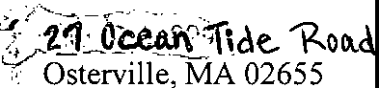

221 Willow Street
Yarmouthport, MA 02675

Directors

Name

Paul Dussault

Evangelos Geraniotis, M.D.

Leo F. Gildea

John Holland

Victoria Lowell

Peter McDermott

Robert McNutt, M.D.

Barrett C. Nichols, Jr.

Michael Oats, M.D.

Brian O'Malley, M.D.

Willis B. Reals

Jennifer Roberts, Esq.

David P. Sampson
Residential Address

295 Main Street
Falmouth, MA 02540

110 Main Street
Hyannis, MA 02601

83 Oyster Way
Osterville, MA 02655-2492

5 Madaket Place
Mashpee, MA 02649

188 Sippewissett Road
Falmouth, MA 02540

- Scotlin Way
Harwich, MA 02645

- West Road
Orleans, MA 02653

tr-s1:i\iii_J1...o..r.e.
Yarmouthport, MA 02675
( :;§;\!i.l Oe;hl.'c\<.. Ll>.r.t
- N. Falmouth, MA 02556

16 Shankpainter Road
Provincetown, MA 02657

73 Clowes Drive
Falmouth, MA 02540

184 Old County Road Sandwich, MA 02537

220 Sandwich Road
Bourne, MA 02532

Directors

Residential Address

Sheila Vanderhoef

Robert Yoo, M.D.
2500 State Highway
Eastham, MA 02642

26 Gleason Street
Hyannis, MA 02601

Exclrnnge.3011140.I

- co) Tlte name, re::al ad&ess anu post::=:::toranu ollicet 01:s::::E20,ro=ITT,···
President: ,,,,/

Treasurer:

Clerk:

Directors:

(c) The fl year (i.e. tax year) of the "resulting/ "JUCHYil!g<.Corporation shall end on the last day of the month of:

The undersigned officers of the several constituent corporations listed herein further state under 1the penalties of perjury as to their respective corporations that the agreement of /"merger has been duly executed on behalf of such corporations and duly approved by the members/ /lClit of such corporations in the manner required by General Laws, Chapter 180, Section 10.

TO BE EXECUJ'ED ON BEHALF OP EACH CONSTITUENT CORPORATION

-----f, -=-='=-=--,,;.(;:::....:.·.,,1';:;;.L.,;<,:::;,-,;·,.;:;;·,,_ :::..,;;;:....t.f,,--(!_,r_A_,_«_;.,,_"I_N. , •President/ •vice President
VJainesC . C ,'J7r.b.

-----....,,c=- ;{,Jldo.,,s..Je.Jp,"::J.,i,½..:f:...1..,fqfJ,?.,.,J.J.n.=,o;}-1,=f1:,./.saC7,f.111,.1.. ,_),,;/I....IL_"="== ,"Clerk/ "Assistant Clerk
of Cape Cod Hospital Foundation, Inc.
(Name of constituent corporation)

---,,a<-r/J==hz,:;:.l; :i:::<"-;,,l,J)r_.;e:;;: -e=,.:s;L,.e.::::===""'-,,---.::(2:::...:c;l:...,,_c.·:...:..,_R..PYl-=..:....:.c.'9.c.c.Nc...:.
>

- 4J}-<.++-,i« 'f..,-!Q-# "-"=:,;:;,,..c....
,, "President/ "Viee Presi<leat

, •clerk/ •AssisteRt GJ@rk

of z.::::iation of Cape Cod,Foundation, Inc.
(Name of constituent corporation)
*Delete /be tnappllcable words.

- The name, residential address and post office address of each director and officer of the '. Dl(ll11d1 'surviving corporation is:
'

President:

Treasurer:
NAME
RESIDENTIAL ADDRESS

See Continuation Sheet 6B
.'· . ( .'
. -. ·POST OFFICE ADDRESS

Clerk:

Directors:

See Continuation Sheet 6B

I
'

- The fiscal year (i.e. tax year) of the / 'surviving corporation shall end on the last day of the month of:
September
- The name and business address of the resident agent, if any, of thef !till!W 'surviving corporation is: N/A

. lThe undersigned .officers of the several listed herein further state the penalties of perjury as to their respective corporations that the agreement of JII/'merger has been duly executed on behalf of such corporations and duly approved by the members /}l>le1( g; /x!irmxoaxof such corporationsjin the manner required by General Laws, Chapter 180, Section 10.
constitUent·corporations under

TO BE EXECUTED ON BEHALF OF EACH CONSTITUENT CORPORATION

----- z:=:.A_·>,,,.,,L-":.-c.=L..s=..,_:....,t_--=:{2..1.. = ,;;...,,..,;;_;,;-.. , 'President/ '¥ice Ptcsidcnt
en L. Abbott
----------' ..e:.""-""'"=""-c)_,",·"--"'..""Z' "".".-", = ,.,'. '--,'Clerk/ 'Assistant-Gler.k
:.'>,

of _ _;;C.::a.1:.p=-e_C=-O=-d::....cH.:.:e:.:a:.:l..:t.:.:h..::c.=a.:..re=,--'I'"'n'"'c:.:·c.· -------- ----------
(Name of constituent corporation)

---- -IJ.ll·= =<-:·: ¥-1+-"-"' :c.-c:.·.::.,. 'II\--F" 'J,._,_1 _._(/4'4/Jl_"" "'\:.,c,:;;,c,,_,_= +I,'President/ 'Viee P,esiel-
argarbJtJ.Cllifurd '

-----'-"'-':::

=..,_,. ,t
, - (S)
,,_-'--' "" -
,'Clerk,' 'A,isis!llst Gl""1<

of
Paul E. Dussault
Fc.:a,,_lc,,me,Oc,,Uc,:t.:.:h..:Hce:o:c:se1:p'-'i-"t"'-a-'--l'F'-'o:.:u:.:;n:.::d.=a-=-t-"Oi :.:n.:.a•<-.::I.:.:n.::.c.:... _
(Name of constituent corporation)

1 *Delete the Inapplicable words.





C)
-
"••. . '"-
..
THli COMMONWEALTH OF MASSACHUSETTS
ARTICLES OF •a>N"S / *MERGER
(General Laws, Chapter 180, Section 10)
Domestic and Domestic Corporations

· I hereby approve the within Articles of •consolidation / 'Merger and,
the tiling fee in the amount of$ "°:3€;;. Q-a , having be 1hpaid,
... said articles are deemed.to have been flied with me this '""3-=-= -'---'-

.·•-::--
day of \_ j \.)\',....IL , 19 Cq\ .


Effeatve date: -- J=u lY l , 19 9=9 _

aH"• /
· WILLIAM FRAN
Secretary of tbe Commonwealth

TO BE FILLED IN BY CORPORATION
Photocopy of document to be sent to:

James P. Hawkins, Esq.
Choate, Hall & Stewart
Exchange Place
53 State Street
Boston, MA 02109

. Telephone: _
,6'--'1"'-7_-,._24.,_,8._-..,.5-"'0""00. _

APPENDIX 11 AFFIDAVIT


Massachusetts Department of Public Health Determination of Need
Affidavit of Truthfulness and Compliance with Law and Disclosure Form 100.40S(B)

Version: 7-6-17

Instructions: Complete Information below. When completecheck the box -rhls document Isready to print:". This wilt date stamp and ' lock the form. Print Form. Each person must sign and date the form. When all signatures have been collected, scan the document and
e-mail to: dph.don@state.ma,us Include allattachments as requested.
Application Number: [ CCH1?_-2_20_2_14_1_6-_H_E _,
Original Application Date: [ 03,u_1_12_02_2 I
Appllcant Name: ocl H_e-'-al.;...thca...c..:_r.;..:e,_tn_c_. _ ]
Application Type: Hospital/Clinic Substantial Capital Expenditure J
Applicant's Business Type: (!]Corporation OLlmlted Partnership O Partnership O Trust OLLC O0ther
Is the Applicant the sole member or soleshareholder of the Health Facility(ies) that arethe subject of this Applfcation?I!]Yes ONo

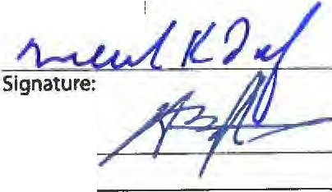
The undersigned certifies under the pains and penalties of perjury:
- The Ap llcant is the sole corporate member or soleshareholder of the Health Facillty[ies) that are the subject of this Application;
- I have r-ead-105 CMR 100.000, the Massachusetts Determination of Need Regulation;
- I understand and agree to the expected and appropriate conduct of the Applicant pursuant to 105 CMR 100.800;
- I have this appllcatlon for Determination of Need including all exhibits and attachments, and eertt(ytlrcrt all of the
Information contained herein isaccurate andtrue;
- I have submitted the correct FilingFee and understand It is nonrefundable pursuant to 105 CMR 100.405(6);
- I have submitted the required copies of this application to the Determination of Need Program, and, as applicable, to all Parties of Record andother parties as required pursuant to 105 CMR 100.405(8);
- I have caused,as required, notices of intent to be published and duplicate copies to be submitted to allParties of Record, and all carriers or thlrd party administrators,public andcommercial, for the payment of health careservices with which the Applicant contracts, and with Medicare and Medicaid, as required by 105 CMR 100.405(0, et seq.;
- I havec7'ti!ed proper notification and submissions to the Secretary of Environmental Affairs pursuant to 105 CMR
100.405(E) and 301 CMR 11.00; will be made if applicable
- If subject to M.G.L.c.6D, § 13 and 958CMR 7.00,I have submitted such Notice of MaterlaI Change to the HPC - in accordance with 105 CMR 100.40S(G);
- Pursuant to 105 CMR 100.210(A}(3),I certify that boththe Applicant andthe Proposed Project are in material and
substantial compliance and good standing withrelevant federal, statr,:ndl_ cal laws and.regulations, as welt as with all
pfeYlou y Issued Notices of Determination of Need aAd-tA ms-aR'4.<.oooitkms--attac:Red-thefei.R;
- I have l'ead and understand the limitations on solicltatlon of funding from the general public prior to receiving a Notice of Determination of Need as established in 105 CMR 100.415;
- I understand that,if Approved, the Applicant, as Holder of the DoN, shall become obligated to allStandard Conditions
pursuant to 105 CMR 100.310, as well as any appllcableOther Conditions as outlined within 105 CMR 100.000 or that otherwise become a part of the Final Action pursuant to 1OS CMR 100.360;
- Pursuant to 105 CMR 100.705(A), 1 certify that the Applicant has Sufficient Interest in the Site or facility; and
- Pursuant to 105 CMR 100.705(A),I certify that the Proposed Project Is authorized under applicable zoning by-laws or
ordinances, whether or not aspecial permit is required; or,
  - If the Proposed Project is not authorized under applicable zoning by-laws or ordinances, a variance has been
received to permit such Proposed Project; or,
  - The Proposed Project is exempt from zoning by-laws or ordinances.

Corporation:

Attach a copy of Articles of Organization/Incorporation, as amended Michael K.Lauf
CEO for Corporation Name:

Alastair Bruce Johnston

Board Chair for Corporation Name: Signature:
*been informed of the contents of
**have been informed that

Affidavit
••*issued in compliance with 105 CMR 100.00, the Massachusetts Determination
of Truthfulness nf'!I..Too...i 1>01n,l.. t.nT'I off'or+iuo T.. m ......, ')7 '}017 """ "'""'"""o" n .., h ?R ?01Q
Page 1 of2

This document Is ready to print O _{Date/time} _{Stamp:}I._ _,

Affidavit of Truthfulness Page2 of2

APPENDIX 12 FILING FEE



March 1, 2022

Lara Szent-Gyorgyi Determination of Need Program Department of Public Health
67 Forest Street
Marlborough, MA 01752

RE: Determination of Need Application #CCHC-22021416-HE

Dear Lara Szent-Gyorgyi:

Enclosed please find a check made payable to the Commonwealth of Massachusetts in the amount of $247,097.26 which is being provided as the required filing fee for the Determination of Need Application submitted on behalf of Cape Cod Healthcare, Inc. for a substantial capital expenditure by Cape Cod Hospital.

Please contact me with any questions regarding this fee, per my contact information included below.

Sincerely,


Michael Bachstein Vice President
27 Park Street
Hyannis, MA 02601 MBachstein@capecodhealth.org 508-862-5125

