 | Commonwealth of Massachusetts  City/Town of  Application for Industrial Wastewater Hauler Permit |  |  |  | $  Fee  Expires (close of year issued)
 | MassDEP has provided this form for use by local Boards of Health if they choose to do so. Before using the form, check with your local Board of Health to make sure that they will accept it.
 | In accordance with MGL c. 111, Section 31A, and 314 CMR 18.12, the undersigned makes application to the Board of Health or approving authority for permission to remove and transport industrial wastewater and the content of industrial wastewater holding tanks as set forth below:
Important: When filling out forms on the computer, use only the tab key to move your cursor - do not use the return key.
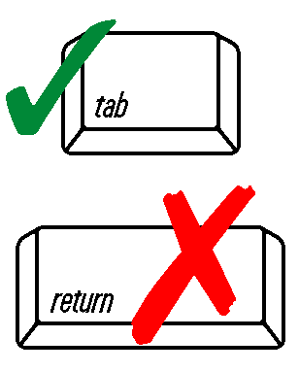
 | Applicant Information:
 | Name
 | Company Name
 | Address
 | City/Town |  | State |  |  | Zip Code
 |  |  | Telephone Number
 | Number and Types of Equipment and their gallon capacity:
 | Number | Type |  | Gallonage
 | Number | Type |  | Gallonage
 | Number | Type |  | Gallonage
 | Areas from which industrial wastewater will be accepted (append customer list):
 | List all locations where septage will be disposed of (include a copy of the contract or the approval for use of the disposal location):
 | Certification
 | I certify that the information I have provided above is true and accurate. I recognize that it is a violation of this permit to dispose of industrial wastewater anywhere other than the identified disposal locations or others approved by the Board in writing as an amendment to this permit.
 | Signature of Applicant |  | Date

