Massachusetts Department of Environmental Protection
Bureau of Water Resources – Groundwater Discharge, Reclaimed Water Use, and Surface Water Discharge (NPDES) Permits
WM 16 New/Modified Plan Approval for Surface Water Discharge (NPDES) Facilities, without Permit Modification

Application

 | A. General Information
Important: When filling out forms on the computer, use only the tab key to move your cursor - do not use the return key.  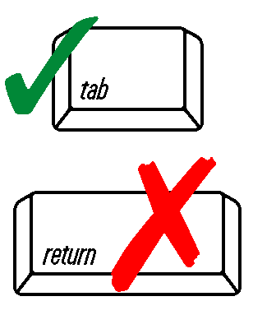 | 1. Applicant Information:
 | Contact Name
 | Street Address
 | City/Town | State | Zip Code
 | Telephone | Email
 | 2. Facility Information:
 | Name of Facility
 | Contact Name
 | Street Address
 | City/Town | State | Zip Code
 | Telephone | Email
 | Facility holding discharge permit:
 | Name of Facility |  | Permit Number
 | B. Certification
 | "I certify under penalty of law that this document and all attachments were prepared under my direction or supervision in accordance with a system designed to assure that qualified personnel properly gather and evaluate the information submitted. Based on my inquiry of the person or persons who manage the system, or those persons directly responsible for gathering the information, the information submitted is, to the best of my knowledge and belief, true, accurate, and complete. I am aware that there are significant penalties for submitting false information, including the possibility of fine and imprisonment for knowing violations."
 | Signature of applicant | Date Signed
 | Printed name of applicant | Title
 | Name of Preparer | Title
 | Telephone Number (including extension) | Email

