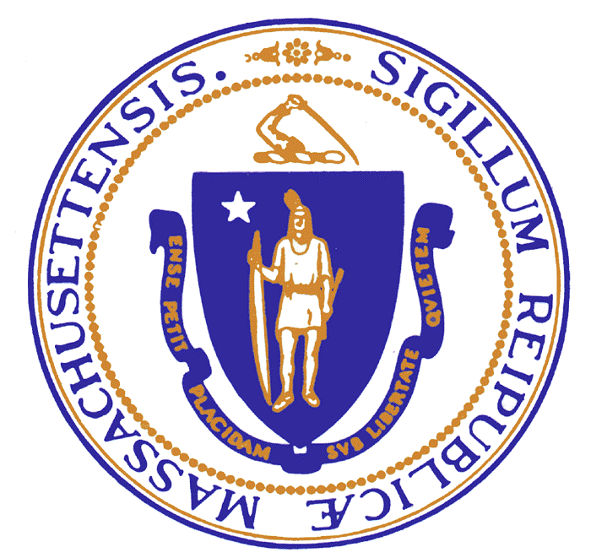  Charles D. Baker  Governor  Karyn E. Polito  Lieutenant Governor | The Commonwealth of Massachusetts  Executive Office of Public Safety and Security  Office of Grants & Research  Ten Park Plaza, Suite 3720  Boston, Massachusetts 02116  Tel: 617-725-3301  Fax: 617-725-0260  617-725-0267  www.mass.gov/eopss | Daniel Bennett  Secretary  Angela F.F. Davis  Executive Director

Application to Attend
September 2017 Governors Highway Safety Association (GHSA) Annual Meeting
on behalf of Massachusetts Highway Safety Division (HSD)

The Executive Office of Public Safety and Security, Office of Grants and Research, Highway Safety Division (EOPSS/OGR/HSD) has several initiatives underway to encourage greater support for traffic enforcement by state and local police. National research and the HSD’s recent statewide series of Law Enforcement Partnership Forums in early 2017 have revealed law enforcement personnel across the nation face a multitude of challenges to keep traffic enforcement as a top priority for their departments.

Through this application process, the HSD seeks to provide attendance-related support for up to two
members of Massachusetts local law enforcement in leadership roles to the 2017 GHSA Annual Meeting in Louisville, KY. It is anticipated the cost of this support will not exceed $6,300. The key meeting dates are September 18 - 20, 2017 (anticipated travel days September 17 and 20). More information is available at ghsa.org/events/Annual-Meetings/2017.
Attendance-related support will include reimbursement for up to three nights lodging not to exceed the conference rate and related taxes, up to four days of meals and related taxes at rates allowable by the state’s Red Book for managers, and qualified baggage handling/ground transportation/parking costs. If necessary, HSD may approve in advance a higher lodging rate and related taxes.
HSD will directly pay the GHSA Annual Meeting registration fee for the attendees. Also their air travel costs that will be paid for through a HSD vendor.

Attendees will need to complete a standard state contract packet with HSD before incurring any of the above-mentioned expenses. Reimbursement for the lodging, meals, and ground transportation/parking expenses will require submission to HSD of proper receipts and could take up to 45 days.

Personnel costs for attendees associated with travelling to and from or attending this meeting and any follow-up efforts are not reimbursable under this process.
An eligible applicant must either be associated with the Massachusetts Chiefs of Police Association’s (MCOPA) Traffic Safety Committee or be a senior law enforcement individual recommended by a committee member (he/she should have a lead role in department’s traffic enforcement/safety efforts).
Preference will be given to those who are on the committee, serve as an alternate for a member, or are a current candidate for membership.

Through this process, HSD will select up to two applicants to attend the meeting with assistance from the Chair of MCOPA’s Traffic Safety Committee who will attend the meeting, Chief Robert E. Meaney, Jr., and with final approval by EOPSS/OGR.
Those selected to attend will be required to do the following:
- Meet briefly in-person with HSD staff near the end of the GHSA Annual Meeting to discuss what we have all learned at the meeting and to ‘brain-storm’ on follow-ups possibilities.

- Within two months of returning, participate in a report-out to the Traffic Safety Committee with HSD participation.
- In the year following, assist the HSD with outreach efforts to local law enforcement on the importance of keeping traffic enforcement a top priority. This would include being featured in related MCOPA newsletter articles, HSD-generated on-line articles or social media posts, and/or speaking on this issue at the MCOPA Annual Conference or a similar public event. HSD would develop the articles, social media posts, events scripts, etc., so the law enforcement participants would only need to review/approve content/participate.
Applications are due to HSD by August 11, 2017.

Please e-mail a completed application to Mr. Brook Chipman at HSD at brook.chipman@state.ma.us. One may e-mail Brook questions or call him at 617-725-3355. Once HSD makes its selections, anticipated by August 16, 2017, it will make notifications and then enter into contracts with the individuals. Additional reimbursement requirements will be provided prior to contracting.

Application to Attend
September 2017 Governors Highway Safety Association (GHSA) Annual Meeting
on behalf of Massachusetts Highway Safety Division (HSD)

_________________________________________________________________________________
Name Title
_________________________________________________________________________________
Department
_________________________________________________________________________________
Signature/Date (hand-signed in blue ink)

1. Please identify your situation (check one):

___ Massachusetts Chiefs of Police Association’s (MCOPA) Traffic Safety Committee Member

___ Alternate Committee Member

___ Current Candidate for Committee Membership

___ Senior Law Enforcement Individual recommended by a Committee Member.
Provide recommending Committee Member’s name and title: __________________________________.

2. Briefly describe why you would be an ideal candidate to attend this meeting and to then assist the HSD efforts to support greater traffic enforcement by local law enforcement in Massachusetts?

3. Do you have any initial thoughts on how you could work with HSD to support greater traffic enforcement by local law enforcement in Massachusetts?

4. Do you have personal or professional accommodations that might impact your involvement in this initiative that HSD should be aware of or could assist you with?

Applications are due to HSD by August 11, 2017. Please e-mail a completed, hand-signed and dated in blue ink, application to Mr. Brook Chipman at HSD at brook.chipman@state.ma.us. Please e-mail questions or call 617-725-3355.

