Massachusetts Department of Environmental Protection
Bureau of Resource Protection – Drinking Water Program
WS Certification Form
For Drinking Water Program (Water Supply) Permits or Approvals

 | Certification
Important: When filling out forms on the computer, use only the tab key to move your cursor - do not use the return key.  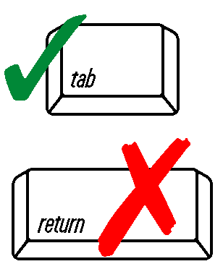 | “I certify, under penalty of law, that this application and all attachments were prepared under my supervision, in accordance with a system designed to ensure that qualified personnel properly gathered and evaluated the information submitted. Based on my inquiry of the person or persons who manage the system, or those persons directly responsible for gathering the information submitted in this application, the information submitted is, to the best of my knowledge and belief, true, accurate and complete.”
 | Authorized Signature | Date
 | Print Name | Position/Title
 | Professional Engineer (if applicable) | P.E. License Number

