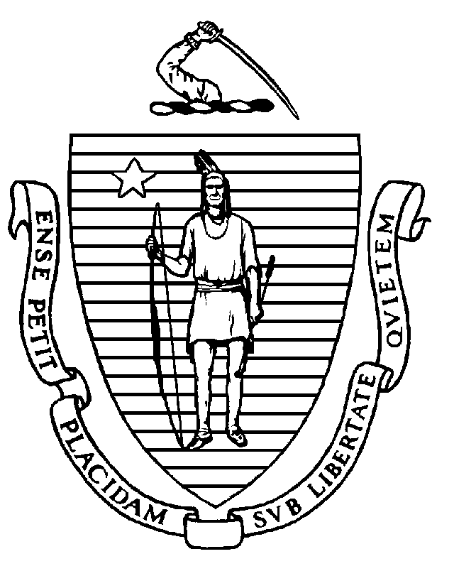 | The Commonwealth of Massachusetts  Department of Public Health  Board of Allied Mental Health and Human Services Professions  250 Washington Street  Boston, MA 02108  (617) 624-6199  amh.board@mass.gov
Applied Behavior Analyst Application Checklist

- How to Apply: You Must Apply Online

Applications are only accepted through the Massachusetts Department of Public Health
Health Professions Licensing System. Information on how to apply is available here.

- Before you apply online, you must have the following information or documents to upload:

- A head and shoulders photograph of yourself

- The date that you passed the Board Certified Behavior Analyst (BCBA) examination

- Your BCBA certification (wallet-sized card or wall certificate) from the Behavior Analyst Certification Board (BACB).

- A notarized Criminal Offender Record Information Form.

- You must use a credit card or checking account to pay the non-refundable application fee of $117.

- If you received your master’s degree or doctoral degree before January 1, 2015, you will be asked to complete and sign an attestation form regarding your education.

You will also need to arrange for the following to be emailed (to amh.board@mass.gov) or mailed (at the address above) to the Board:

- Your graduate school(s) must send an official transcript of the graduate education you are submitting to meet the licensing requirements.

- If you currently hold or have previously held a professional license in another jurisdiction, regardless of its status, please arrange for an official license verification to be sent to the Board by the issuing entity. Please contact the Board for further directions in the event the entity that licensed you does not issue verifications and only offers an online license lookup. A copy of your license is not an acceptable alternative.

If you are not certified by the BACB, please contact the Board for additional information about how to apply.

Please note that you must complete a board-approved training in domestic and sexual violence before you apply. Please see chapter260training.org to take the free online training.

After your application is reviewed, you will be notified by email of any deficiencies in your application or with instructions to pay the $155 license fee to get your license.

