Approving Reported Time
Introduction
There are currently two known issues related to time approvals for Time Collection Device employees. These are separate issues and are not related. ITD is actively researching the root cause of these errors. Until fixes are identified and implemented, please use the following steps to approve employees’ time.
- Some Time Approvers are currently receiving the following error message when they attempt to approve time from the employee’s timesheet:
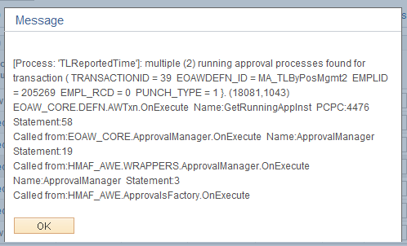
If you are receiving this error, please go back into the timesheet and check the boxes on every day EXCEPT 5/21/2015. Click Approve. The timesheet should save without a problem.
- Other Time Approvers are experiencing issues with approving time for Time Collection Device employees in which they are unable to approve time from the employee’s timesheet. When a time approver or core user selects the time and clicks on approve, the system attempts to save (spinning wheel icon in right corner) and eventually times out, closing the session.
Workaround
- Login to HR/CMS
- Navigate to Main Menu>Manager Self Service>Time Management>Approve Time and Exceptions>Reported Time
- On the Approve Reported Time Timesheet Summary page, click the Get Employees button. Your employees should appear below.
- To review your employee’s timesheet, click on the last name link. This will take you to the timesheet. Review the reported time and make any necessary adjustments. If you make adjustments, click Submit.
- Time cannot be approved from the Timesheet. At the bottom of the page, click on the Return to Select Employee link.
- Check the checkbox of the specific employee and click Approve. If you have reviewed all of your employees’ timesheets and are ready to approve all, click Select All and then Approve.
- An approve confirmation message will appear. Review this message carefully. Click OK to approve the employee’s reported time, or click CANCEL to return to the employee’s timesheet. By clicking OK you have electronically signed your employee’s timesheet. After you click OK, the Approve Confirmation page appears which informs you the approval was successful.
- On the Approve Confirmation page, click OK to return to the Approve Reported Time Timesheet Summary page.
If you are still experiencing difficulty approving your employees’ time, employees of ESC supported agencies should contact the ESC; employees of non-ESC supported agencies should contact your local Payroll office to report the issue so that the employee can be tracked.

