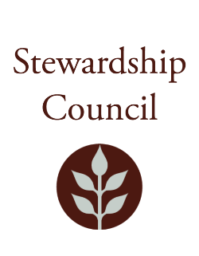

# Stewardship Council Meeting

**Thursday, April 10, 2025 |** 1:00 PM to 3:00 PM

Borderland State Park Visitor Center

259 Massapoag Ave

North Easton, MA 02356

## Agenda

|  |  |
| --- | --- |
| TOPIC | SEGMENT |
| **Welcome and Chair’s Update** – Dicken Crane, Chair | 1:00 – 1:10 PM |
| **DCR Report** – Brian Arrigo, Commissioner | 1:10 – 1:30 PM |
| **Regular Business I**   * Strategic Readiness Initiative Presentation – Fran Blanchard, Senior Director of Strategic Readiness * Approve Minutes: March 13, 2025 * Public Comment | 1:30 – 2:15 PM |
| **Regular Business II**   * Committee Updates * Councilor Comments | 2:15 – 3:00 PM |
| **Adjourn** | 3:00 PM |

## Zoom Meeting Information

**Meeting of the DCR Stewardship Council**

Join Zoom Meeting

<https://zoom.us/j/5296343609?pwd=dVI3NHdJUjlTeWlSVmtDTGRTUGU5Zz09&omn=93176112835>

Meeting ID: 529 634 3609

Passcode: 818194

One tap mobile

+13052241968,,5296343609#,,,,*818194# US

+13092053325,,5296343609#,,,,*818194# US

Please contact Matt Perry at [matthew.s.perry1@mass.gov](mailto:matthew.s.perry1@mass.gov%20) for accessibility information.

4/3/2025 10:42 AM