INDOOR AIR QUALITY ASSESSMENT

Arnone Community School
135 Belmont Street
Brockton, Massachusetts

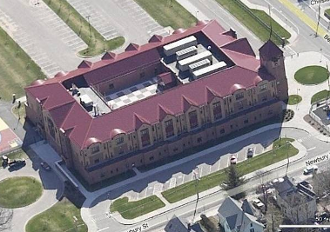

Prepared by:
Massachusetts Department of Public Health
Bureau of Environmental Health
Indoor Air Quality Program
June 2011

Background/Introduction
At the request Ms. Mary Jane Butler, Sanitary Inspector for the Brockton Health Department (BHD), the Massachusetts Department of Public Health (MDPH), Bureau of Environmental Health (BEH) conducted an indoor air quality (IAQ) assessment at the Arnone Community School (ACS) located at 135 Belmont Street, Brockton, Massachusetts. On May 23, 2011, an assessment of the ACS was made by Cory Holmes and Sharon Lee, Environmental Analyst/Inspectors within BEH’s IAQ Program. The assessment was prompted by concerns of water damage and potential mold growth in the building.
The ACS is a three-story, brick building with a peaked metal roof that was completed in 2002. The school contains general classrooms, science classrooms, computer rooms, a kitchen, cafeteria/auditorium, music rooms, art room, library, gymnasium and office space. Windows are openable throughout the building.

Methods
Air tests for carbon monoxide, carbon dioxide, temperature and relative humidity were conducted with the TSI, Q-Trak, IAQ Monitor, Model 7565. Air tests for airborne particle matter with a diameter less than 2.5 micrometers were taken with the TSI, DUSTTRAK™ Aerosol Monitor Model 8520. Moisture content of porous building materials (e.g., gypsum wallboard, wood, carpeting) was measured with a Delmhorst, BD-2000 Model, Moisture Detector equipped with a Delmhorst Standard Probe. MDPH staff also performed a visual inspection of building materials for water damage and/or microbial growth.

Results
The school houses approximately 820 kindergarten through fifth grade students and approximately 100 staff. Tests were taken during normal operations and results appear in Table 1.

Discussion

Ventilation
It can be seen from Table 1 that carbon dioxide levels were below 800 parts per million (ppm) in 54 of 57 areas, indicating adequate air exchange in the majority of areas surveyed at the time of the assessment. Mechanical ventilation is provided by a computer-controlled heating, ventilating and air conditioning (HVAC) system, which utilizes rooftop air-handling units (AHUs) (Picture 1). AHUs draw air in via fresh air intakes where it is heated/cooled and filtered before being distributed to occupied areas via ceiling-mounted supply diffusers (Picture 2). Exhaust air is drawn into ceiling or wall-mounted return vents (Picture 3) and ducted back to the AHUs.
To maximize air exchange, the MDPH recommends that both supply and exhaust ventilation operate continuously during periods of occupancy. In order to have proper ventilation with a mechanical supply and exhaust system, the systems must be balanced to provide an adequate amount of fresh air to the interior of a room while removing stale air from the room. It is recommended that HVAC systems be re-balanced every five years to ensure adequate air systems function (SMACNA, 1994). The date of the last balancing of these systems was not available at the time of the assessment.
The Massachusetts Building Code requires that each room have a minimum ventilation rate of 15 cubic feet per minute (cfm) per occupant of fresh outside air or openable windows (SBBRS, 1997; BOCA, 1993). The ventilation must be on at all times that the room is occupied. Providing adequate fresh air ventilation with open windows and maintaining the temperature in the comfort range during the cold weather season is impractical. Mechanical ventilation is usually required to provide adequate fresh air ventilation.
Carbon dioxide is not a problem in and of itself. It is used as an indicator of the adequacy of the fresh air ventilation. As carbon dioxide levels rise, it indicates that the ventilating system is malfunctioning or the design occupancy of the room is being exceeded. When this happens, a buildup of common indoor air pollutants can occur, leading to discomfort or health complaints. The Occupational Safety and Health Administration (OSHA) standard for carbon dioxide is 5,000 parts per million parts of air (ppm). Workers may be exposed to this level for 40 hours/week, based on a time-weighted average (OSHA, 1997).
The MDPH uses a guideline of 800 ppm for publicly occupied buildings. A guideline of 600 ppm or less is preferred in schools due to the fact that the majority of occupants are young and considered to be a more sensitive population in the evaluation of environmental health status. Inadequate ventilation and/or elevated temperatures are major causes of complaints such as respiratory, eye, nose and throat irritation, lethargy and headaches. For more information concerning carbon dioxide, consult Appendix A.
Indoor temperatures ranged from 64º F to 74º F, which were below the MDPH recommended comfort range in a few areas surveyed the day of the assessment (Table 1). The MDPH recommends that indoor air temperatures be maintained in a range of 70º F to 78º F in order to provide for the comfort of building occupants. In many cases concerning indoor air quality, fluctuations of temperature in occupied spaces are typically experienced, even in a building with an adequate fresh air supply.
Relative humidity measurements in the building ranged from 45 to 60 percent, which were within the MDPH recommended comfort range in all areas surveyed (Table 1). The MDPH recommends a comfort range of 40 to 60 percent for indoor air relative humidity. Relative humidity levels in the building would be expected to drop during the winter months due to heating. The sensation of dryness and irritation is common in a low relative humidity environment. Low relative humidity is a very common problem during the heating season in the northeast part of the United States.

Microbial/Moisture Concerns
In order for building materials to support mold growth, a source of water exposure is necessary. Identification and elimination of the source of water moistening building materials is necessary to control mold growth. Signs of roof leaks were observed in many areas throughout the school as evidenced by water-damaged ceiling tiles (Pictures 4 and 5/Table 1), peeling paint and stains on gypsum wallboard (GW) walls/ceilings (Pictures 6 through 8/Table 1). Routes of water penetration exist along multiple roof surfaces, primarily the junction of the 1st floor roof and 2nd floor exterior walls, as well as around architectural formations [e.g., the outcropped library window (Pictures 9 through 11)]. School maintenance staff reported that they are working with a roofing contractor to identify and repair leaks.
The US Environmental Protection Agency (US EPA) and the American Conference of Governmental Industrial Hygienists (ACGIH) recommend that porous materials (e.g., GW) be dried with fans and heating within 24 to 48 hours of becoming wet (US EPA, 2001; ACGIH, 1989). If not dried within this time frame, mold growth may occur. Once mold has colonized porous materials, they are difficult to clean and should be removed. Moisture testing of various porous materials throughout the building were all normal (i.e., dry) at the time of testing (Table 1). However, visible mold growth was observed at the base of GW beneath vinyl base coving in room 228 (Picture 8). Vinyl base coving can serve to trap moisture and preventing drying.
The school has a paneled rooftop courtyard that is used as a play area (Picture 1). Standing water was observed beneath the majority of the panels (Picture 12); indicating roof drains were likely obstructed. The freezing and thawing of water during winter months can lead to roof leaks and subsequent water penetration into the interior of the building. Pooling water can also become stagnant, which can serve as a breeding ground for mosquitoes. Other potential sources of water penetration were missing/failing window gaskets noted in room 107 and in the hallway outside room 304, and a space beneath the music room door in which light could be seen penetrating. These breaches can allow for uncontrolled air drafts as well as moisture to enter the building.
Open seams between sink countertops and backsplashes were observed in some rooms (Table 1). If not watertight, moisture can penetrate through seams, causing damage. Improper drainage or sink overflow can lead to water penetration into countertops, cabinet interiors and areas behind cabinets. Water penetration and chronic exposure of porous and wood-based materials can cause these materials to swell and show signs of water damage. Repeated moistening of porous materials can result in mold growth.

Other IAQ Evaluations
Indoor air quality can be negatively influenced by the presence of respiratory irritants, such as products of combustion. The process of combustion produces a number of pollutants. Common combustion emissions include carbon monoxide, carbon dioxide, water vapor and smoke (fine airborne particle material). Of these materials, exposure to carbon monoxide and particulate matter with a diameter of 2.5 micrometers (μm) or less (PM2.5) can produce immediate, acute health effects upon exposure. To determine whether combustion products were present in the indoor environment, BEH staff obtained measurements for carbon monoxide and PM2.5.

Carbon Monoxide
Carbon monoxide is a by-product of incomplete combustion of organic matter (e.g., gasoline, wood and tobacco). Exposure to carbon monoxide can produce immediate and acute health effects. Several air quality standards have been established to address carbon monoxide and prevent symptoms from exposure to these substances. The MDPH established a corrective action level concerning carbon monoxide in ice skating rinks that use fossil-fueled ice resurfacing equipment. If an operator of an indoor ice rink measures a carbon monoxide level over 30 ppm, taken 20 minutes after resurfacing within a rink, that operator must take actions to reduce carbon monoxide levels (MDPH, 1997).
The American Society of Heating Refrigeration and Air-Conditioning Engineers (ASHRAE) has adopted the National Ambient Air Quality Standards (NAAQS) as one set of criteria for assessing indoor air quality and monitoring of fresh air introduced by HVAC systems (ASHRAE, 1989). The NAAQS are standards established by the US EPA to protect the public health from six criteria pollutants, including carbon monoxide and particulate matter (US EPA, 2006). As recommended by ASHRAE, pollutant levels of fresh air introduced to a building should not exceed the NAAQS levels (ASHRAE, 1989). The NAAQS were adopted by reference in the Building Officials & Code Administrators (BOCA) National Mechanical Code of 1993 (BOCA, 1993), which is now an HVAC standard included in the Massachusetts State Building Code (SBBRS, 1997). According to the NAAQS, carbon monoxide levels in outdoor air should not exceed 9 ppm in an eight-hour average (US EPA, 2006).
Carbon monoxide should not be present in a typical, indoor environment. If it is present, indoor carbon monoxide levels should be less than or equal to outdoor levels. On the day of the assessment, outdoor carbon monoxide concentrations were non-detect (ND) (Table 1). No measurable levels of carbon monoxide were detected inside the building (Table 1).

Particulate Matter
The US EPA has established NAAQS limits for exposure to particulate matter. Particulate matter is airborne solids that can be irritating to the eyes, nose and throat. The NAAQS originally established exposure limits to particulate matter with a diameter of 10 μm or less (PM10). According to the NAAQS, PM10 levels should not exceed 150 micrograms per cubic meter (μg/m³) in a 24-hour average (US EPA, 2006). These standards were adopted by both ASHRAE and BOCA. Since the issuance of the ASHRAE standard and BOCA Code, US EPA established a more protective standard for fine airborne particles. This more stringent PM2.5 standard requires outdoor air particle levels be maintained below 35 μg/m³ over a 24-hour average (US EPA, 2006). Although both the ASHRAE standard and BOCA Code adopted the PM10 standard for evaluating air quality, MDPH uses the more protective PM2.5 standard for evaluating airborne particulate matter concentrations in the indoor environment.
Outdoor PM2.5 concentrations were measured at 7 μg/m³ (Table 1). PM2.5 levels measured indoors ranged from 2 to 15 μg/m³ (Table 1), which were below the NAAQS PM2.5 level of 35 μg/m³. Frequently, indoor air levels of particulates (including PM2.5) can be at higher levels than those measured outdoors. A number of activities that occur indoors and/or mechanical devices can generate particulate during normal operations. Sources of indoor airborne particulates may include but are not limited to particles generated during the operation of fan belts in the HVAC system, use of stoves and/or microwave ovens in kitchen areas; use of photocopiers, fax machines and computer printing devices; operation of an ordinary vacuum cleaner and heavy foot traffic indoors.

Volatile Organic Compounds
Indoor air quality can also be negatively influenced by the presence of materials containing volatile organic compounds (VOCs). VOCs are carbon-containing substances that have the ability to evaporate at room temperature. Frequently, exposure to low levels of total VOCs (TVOCs) may produce eye, nose, throat and/or respiratory irritation in some sensitive individuals. For example, chemicals evaporating from a paint can stored at room temperature would most likely contain VOCs. In an effort to identify materials that can potentially increase indoor VOC concentrations, BEH staff examined classrooms and common areas for products containing these respiratory irritants.
The majority of classrooms contained dry erase boards and related materials. Materials such as dry erase markers and dry erase board cleaners may contain VOCs, such as methyl isobutyl ketone, n-butyl acetate and butyl-cellusolve (Sanford, 1999), which can be irritating to the eyes, nose and throat. Cleaning products were also observed in several classrooms under sink cabinets and on countertops (Table 1). Like dry erase materials, cleaning products contain VOCs and other chemicals that can be irritating to the eyes, nose and throat and should be kept out of reach of students.
Plug-in air deodorizers were observed in use (Picture 13). Air deodorizers contain chemicals that can be irritating to the eyes, nose and throat of sensitive individuals. Many air fresheners contain 1,4-dichlorobenzene, a VOC which may cause reductions in lung function (NIH, 2006). Furthermore, deodorizing agents do not remove materials causing odors, but rather mask odors that may be present in the area.

Other Conditions
Other conditions that can affect indoor air quality were observed during the assessment. In many classrooms, items were observed on the floor, windowsills, tabletops, counters, bookcases and desks (Picture 14). The large number of items stored in classrooms provides a source for dusts to accumulate. These items (e.g., papers, folders, boxes) make it difficult for custodial staff to clean. Items should be relocated and/or be cleaned periodically to avoid excessive dust build up. In addition, these materials can accumulate on flat surfaces (e.g., desktops, shelving and carpets) in occupied areas and subsequently be re-aerosolized causing further irritation.
A number of air diffusers, exhaust/return vents and personal fans were observed to have accumulated dust/debris (Picture 2). If exhaust vents are not functioning, backdrafting can occur, which can re-aerosolize accumulated dust particles. Re-activated supply vents and fans can also aerosolize dust accumulated on vents/fan blades.
Stuffed animals, pillows, and cushions were noted in many classrooms (Picture 15). Old mattresses were observed in room 235 which appears to be used for physical therapy/occupational therapy (PT/OT) (Picture 16). Stuffed toys should be washed on a weekly basis to prevent disease (Hale and Polder, 1996). Furthermore, stuffed animals, pillows/cushions and mattresses can be a point for dust collection. Close contact with such items can leave oils, perspiration, hair and skin cells. Dust mites feed upon human skin cells and excrete waste products that contain allergens. As discussed, dust can be irritating to the eyes, nose and respiratory system.

Conclusions/Recommendations
In view of the findings at the time of the visit, the following additional recommendations are provided:
- Operate all ventilation systems throughout the building (e.g., gym, cafeteria, classrooms) continuously during periods of occupancy to maximize air exchange.
- Consider adopting a balancing schedule of every 5 years for all mechanical ventilation systems, as recommended by ventilation industrial standards (SMACNA, 1994).
- For buildings in New England, periods of low relative humidity during the winter are often unavoidable. Therefore, scrupulous cleaning practices should be adopted to minimize common indoor contaminants whose irritant effects can be enhanced when the relative humidity is low. To control dusts, a high efficiency particulate arrestance (HEPA) filter equipped vacuum cleaner in conjunction with wet wiping of all surfaces is recommended. Avoid the use of feather dusters. Drinking water during the day can help ease some symptoms associated with a dry environment (throat and sinus irritations).
- Remove water-damaged/mold colonized GW at base of wall beneath vinyl base coving in classroom 228 in a manner consistent with US EPA’s (2001) guidance. Consider leaving a ½ to 1-inch space along floor to prevent wicking moisture.
- Remove furniture placed against the exterior wall in 2nd floor classrooms susceptible to water penetration. Consider removing carpeting approximately 2-feet from exterior walls in these areas and replace with a non-porous material (e.g., tile) to prevent further moistening and potential mold growth on carpeting.
- In the event of further water penetration through exterior walls, remove vinyl coving along base of walls and carpeting. This should be done within 24 to 48 hours of water penetration.
- Continue to work with roofing contractor to repair roof leaks. Once repaired, replace any remaining water-stained ceiling tiles and make repairs to water-damaged GW and peeling paint.
- Refrain from storing porous items (boxes, papers, books, etc.) in areas prone to water leaks.
- Ensure roof drains for the rooftop courtyard are clear to prevent water pooling.
- Repair/replace missing/damaged window gaskets (e.g., room 107, hallway outside room 304).
- Install/replace weather-stripping around exterior doors (e.g., music room) to prevent drafts and water penetration. Ensure tightness of doors by monitoring for light penetration and drafts around doors/frames.
- Seal areas around sinks/backsplashes to prevent water damage to the interior of cabinets and adjacent wallboard.
- Store cleaning products properly and out of reach of students. All cleaning products used at the facility should be approved by the school department with MSDS’ available at a central location.
- Refrain from using strongly scented materials (e.g., air deodorizers) in classrooms.
- Relocate or consider reducing the amount of materials stored in classrooms to allow for more thorough cleaning of classrooms. Clean items regularly with a wet cloth or sponge to prevent excessive dust build-up.
- Clean accumulated dust and debris periodically from the surface of air diffusers, exhaust/return vents and blades of personal and ceiling fans.
- Clean pillows, cushions, and stuffed animals on a regular basis. If not possible/practical, consider removing from classrooms.
- Remove mattresses from PT/OT room 235.
- For more information on mold/remediation consult “Mold Remediation in Schools and Commercial Buildings” published by the US Environmental Protection Agency (US EPA, 2001) for more information on mold. This document can be downloaded from the US EPA website at: http://www.epa.gov/iaq/molds/mold_remediation.html.
- Consider adopting the US EPA (2000) document, “Tools for Schools”, as an instrument for maintaining a good indoor air quality environment in the building. This document is available at: http://www.epa.gov/iaq/schools/index.html.
- Refer to resource manual and other related indoor air quality documents located on the MDPH’s website for further building-wide evaluations and advice on maintaining public buildings. These documents are available at: http://mass.gov/dph/iaq.

References
ACGIH. 1989. Guidelines for the Assessment of Bioaerosols in the Indoor Environment. American Conference of Governmental Industrial Hygienists, Cincinnati, OH.
ASHRAE. 1989. Ventilation for Acceptable Indoor Air Quality. American Society of Heating, Refrigeration and Air Conditioning Engineers. ANSI/ASHRAE 62-1989.
BOCA. 1993. The BOCA National Mechanical Code/1993. 8th ed. Building Officials and Code Administrators International, Inc., Country Club Hill, IL.
Hale, C.M., Polder, J.A. 1996. The ABC’s of Safe and Healthy Child Care a Handbook for Child Care Providers, Department of Health and Human Services. United States Public Health Service, Centers for Disease Control.
MDPH. 1997. Requirements to Maintain Air Quality in Indoor Skating Rinks (State Sanitary Code, Chapter XI). 105 CMR 675.000. Massachusetts Department of Public Health, Boston, MA.
NIH. 2006. Chemical in Many Air Fresheners May Reduce Lung Function. NIH News. National Institute of Health. July 27, 2006. http://www.nih.gov/news/pr/jul2006/niehs-27.htm
OSHA. 1997. Limits for Air Contaminants. Occupational Safety and Health Administration. Code of Federal Regulations. 29 C.F.R 1910.1000 Table Z-1-A.
Sanford. 1999. Material Safety Data Sheet (MSDS No: 198-17). Expo® Dry Erase Markers Bullet, Chisel, and Ultra Fine Tip. Sanford Corporation. Bellwood, IL.
SBBRS. 1997. Mechanical Ventilation. State Board of Building Regulations and Standards. Code of Massachusetts Regulations. 780 CMR 1209.0
SMACNA. 1994. HVAC Systems Commissioning Manual. 1st ed. Sheet Metal and Air Conditioning Contractors’ National Association, Inc., Chantilly, VA.
US EPA. 2000. Tools for Schools. Office of Air and Radiation, Office of Radiation and Indoor Air, Indoor Environments Division (6609J). EPA 402-K-95-001, Second Edition. http://www.epa.gov/iaq/schools/tools4s2.html.
US EPA. 2001. “Mold Remediation in Schools and Commercial Buildings”. Office of Air and Radiation, Indoor Environments Division, Washington, DC. EPA 402-K-01-001. March 2001. Available at: http://www.epa.gov/iaq/molds/mold_remediation.html.
US EPA. 2006. National Ambient Air Quality Standards (NAAQS). US Environmental Protection Agency, Office of Air Quality Planning and Standards, Washington, DC. http://www.epa.gov/air/criteria.html.
Picture 1

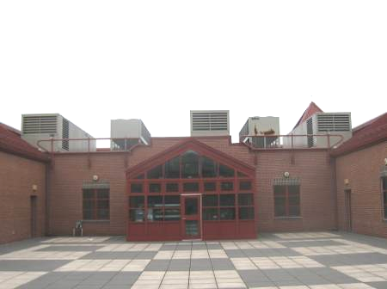

Rooftop Air Handling Units (AHUs), Also Note Rooftop Courtyard in Foreground

Picture 2

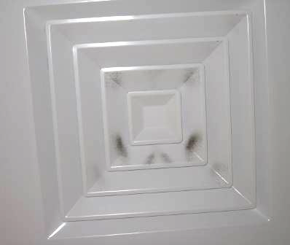

Ceiling-Mounted Supply Diffuser, Note Dust/Debris Accumulation on Louvers

Picture 3

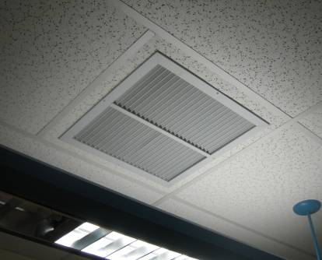

Ceiling-Mounted Return Vent

Picture 4

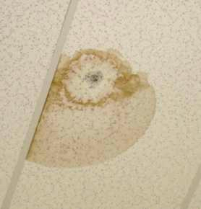

Water-Damaged Ceiling Tile, Dark Stain (Arrow) Indicates Mold Growth

Picture 5

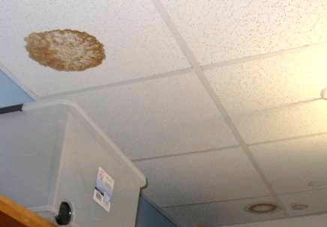

Water-Damaged Ceiling Tiles

Picture 6

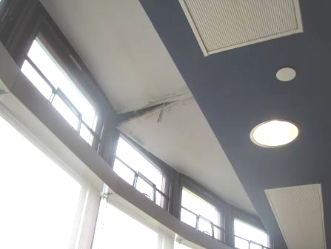

Water-Damaged Gypsum Wallboard Ceiling in Library

Picture 7

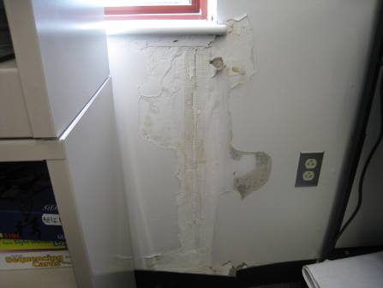

Peeling Paint and Water-Damaged Gypsum Wallboard in Room 228

Picture 8

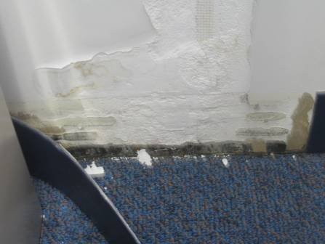

Mold Growth on Surface of Gypsum Wallboard beneath Vinyl Coving in Room 228

Picture 9

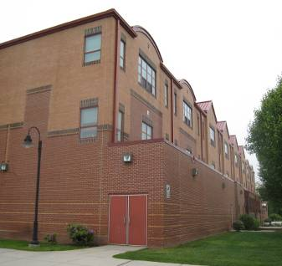

Junction Where 2nd Floor Exterior Walls Meet 1st Floor Roof Prone to
Water Penetration (Arrow)

Picture 10

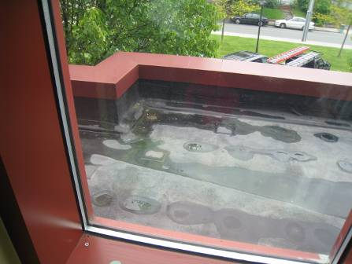

Interior View from 2nd Floor Classroom of 1st Floor Roofs Prone to Leakage

Picture 11



Multiple Roof Surfaces and Outcropped Library Window (Arrow)
Susceptible to Water Penetration

Picture 12

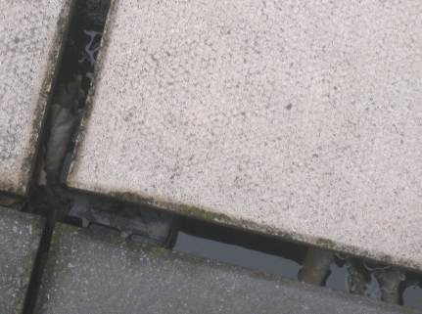

Standing Water beneath Rooftop Courtyard Panels

Picture 13

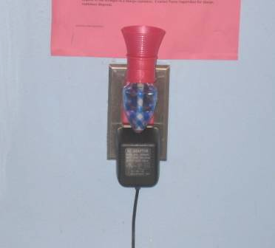

Plug-in Air Deodorizer

Picture 14



Accumulated Classroom Items

Picture 15

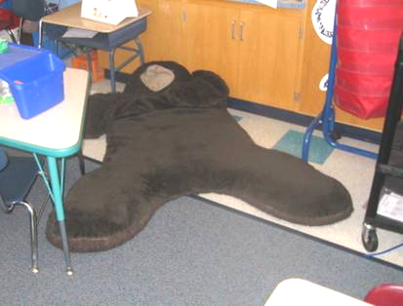

Large Pillow on Floor of Classroom

Picture 16

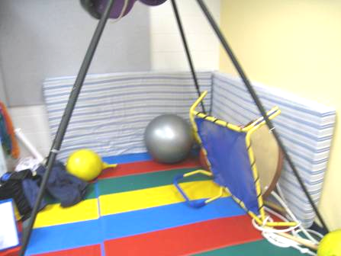

Mattresses in Room 235 PT/OT
Location | Carbon  Dioxide  (ppm) |  | Temp  (°F) |  |  | Relative  Humidity  (%) |  | Carbon Monoxide  (ppm) |  | PM2.5  (µg/m³) |  | Occupants  in Room |  | Windows Openable | Ventilation |  |  |  | Remarks
 |  |  |  |  |  |  |  |  |  |  |  |  |  |  | Supply |  | Exhaust
Background |  | 396 |  | 54 | 70 |  | ND |  | 7 |  |  |  |  |  |  |  |  |  |  | Cool, cloudy, light rain
Gym |  | 563 |  | 72 | 48 |  | ND |  | 5 |  | 0 |  | N |  |  | Y |  | Y
Cafetorium |  | 550 |  | 73 | 48 |  | ND |  | 5 |  | ~140 |  | Y |  |  | Y |  | Y |  | Dust/debris on vents
Guidance Suite |  | 603 |  | 72 | 49 |  | ND |  | 5 |  | 3 |  | N |  |  | Y |  | Y
102 |  | 698 |  | 70 | 54 |  | ND |  | 5 |  | 24 |  | Y |  |  | Y |  | Y |  | 1 WD CT (corner), 1 AT
103 |  | 683 |  | 70 | 52 |  | ND |  | 5 |  | 26 |  | Y |  |  | Y |  | Y
104 |  | 587 |  | 71 | 50 |  | ND |  | 5 |  | 1 |  | Y |  |  | Y |  | Y |  | DO, window open, 24 occupants gone ~ 30 minutes
105 |  | 1374 |  | 72 | 54 |  | ND |  | 15 |  | 25 |  | Y |  |  | Y |  | Y |  | CP-under sink, 1 WD CT (corner)
106 |  | 692 |  | 71 | 51 |  | ND |  | 5 |  | 23 |  | Y |  |  | Y |  | Y |  | UF, big pillows on floor, DO, 2 WD CT, WD walls, peeling paint, moisture testing –low/dry
107 |  | 538 |  | 71 | 49 |  | ND |  | 4 |  | 0 |  | Y |  |  | Y |  | Y |  | Loose window gasket, 1 WD CT (corner/painted)
108 |  | 560 |  | 72 | 49 |  | ND |  | 7 |  | 1 |  | Y |  |  | Y |  | Y |  | Space between sink/countertop, laminator, 2 PC (1 risograph)
109 |  | 551 |  | 72 | 49 |  | ND |  | 5 |  | 3 |  | N |  |  | Y |  | Y
111 |  | 568 |  | 72 | 49 |  | ND |  | 2 |  | 4 |  | Y |  |  | Y |  | Y |  | DO, 15 occupants gone ~ 5 minutes, 2 AT coat room, CP-sink/cabinet
158 Music Room |  | 465 |  | 74 | 45 |  | ND |  | 5 |  | 2 |  | N |  |  | Y |  | Y |  | Dust/debris on ceiling vents and surrounding tiles, space under exterior door
161 |  | 564 |  | 73 | 46 |  | ND |  | 6 |  | 3 |  | Y |  |  | Y |  | Y
174 |  | 611 |  | 71 | 51 |  | ND |  | 5 |  | 1 |  | N |  |  | Y |  | Y
185 |  | 557 |  | 73 | 47 |  | ND |  | 8 |  | 5 |  | N |  |  | Y |  | Y
208 A |  | 570 |  | 72 | 48 |  | ND |  | 6 |  | 0 |  | Y |  |  | Y |  | Y |  | CP-sink
208 B |  | 572 |  | 73 | 48 |  | ND |  | 6 |  | 1 |  | N |  |  | Y |  | Y |  | ~10 occupants gone~3 minutes
209 |  | 621 |  | 72 | 48 |  | ND |  | 6 |  | 26 |  | Y |  |  | Y |  | Y |  | Window open
211 |  | 838 |  | 74 | 49 |  | ND |  | 8 |  | 15 |  | Y |  |  | Y |  | Y |  | DO, CP-sink countertop
212 |  | 722 |  | 73 | 48 |  | ND |  | 7 |  | 25 |  | Y |  |  | Y |  | Y |  | Space between sink and countertop (right side)
213 |  | 543 |  | 72 | 48 |  | ND |  | 6 |  | 0 |  | Y |  |  | Y |  | Y |  | Moisture testing: carpet-dry/low, GW-dry/low, active leak through base of wall, flat roof outside
214 |  | 595 |  | 72 | 49 |  | ND |  | 6 |  | 26 |  | Y |  |  | Y |  | Y |  | DO, 2 WD CT
215 |  | 689 |  | 72 | 50 |  | ND |  | 7 |  | 27 |  | Y |  |  | Y |  | Y |  | DO, 1 WD CT, stuffed animals
217 |  | 499 |  | 72 | 48 |  | ND |  | 7 |  | 2 |  | N |  |  | Y |  | Y |  | DO
218 |  | 465 |  | 73 | 49 |  | ND |  | 6 |  | 2 |  | Y |  |  | Y |  | Y |  | CP-sink countertop
223 Music |  | 523 |  | 71 | 49 |  | ND |  | 6 |  | 16 |  | Y |  |  | Y |  | Y |  | Dust/debris on vents
224 |  | 550 |  | 72 | 50 |  | ND |  | 8 |  | 15 |  | Y |  |  | Y |  | Y |  | PF
225 |  | 583 |  | 72 | 49 |  | ND |  | 7 |  | 19 |  | Y |  |  | Y |  | Y |  | 1 WD CT-corner (roof drain), stuffed animals
226 |  | 641 |  | 71 | 50 |  | ND |  | 7 |  | 24 |  | Y |  |  | Y |  | Y |  | DO, CP-sink countertop
227 |  | 577 |  | 72 | 50 |  | ND |  | 7 |  | 25 |  | Y |  |  | Y |  | Y |  | DO, pillows on floor
228 |  | 712 |  | 72 | 50 |  | ND |  | 7 |  | 22 |  | Y |  |  | Y |  | Y |  | WD GW below window-dry/low moisture measurement, slight mold growth on GW beneath vinyl coving, carpet moisture testing-dry/low
229 |  | 590 |  | 72 | 50 |  | ND |  | 9 |  | 0 |  | Y |  |  | Y |  | Y |  | DO, CP, book cases against wall where former leaks reported
231 |  | 450 |  | 71 | 49 |  | ND |  | 8 |  | 1 |  | Y |  |  | Y |  | Y |  | WD GW windows-dry/low moisture testing, 1 AT, DO
232 |  | 420 |  | 72 | 50 |  | ND |  | 6 |  | 0 |  | Y |  |  | Y |  | Y |  | Pillows, WD CT-possible mold growth
233 |  | 397 |  | 72 | 49 |  | ND |  | 6 |  | 0 |  | Y |  |  | Y |  | Y |  | Pillows and stuffed animals
234 |  | 386 |  | 71 | 49 |  | ND |  | 6 |  | 0 |  | Y |  |  | Y |  | Y |  | Plants, 2 WD CT
235 PT/OT Room |  | 583 |  | 72 | 50 |  | ND |  | 6 |  | 4 |  | N |  |  | Y |  | Y |  | 2 WD CT, old mattresses (2)
236 |  | 662 |  | 72 | 49 |  | ND |  | 5 |  | 0 |  | Y |  |  | Y |  | Y |  | 3 WD CT, cushions on floor, plants missing fluorescent light cover
302 |  | 409 |  | 70 | 54 |  | ND |  | 7 |  | 1 |  | Y |  |  | Y |  | Y |  | DO, CP, 3 WD CT
303 |  | 453 |  | 71 | 53 |  | ND |  | 10 |  | 24 |  | Y |  |  | Y |  | Y |  | Window open, peeling paint GW near ceiling, WD CT
304 |  | 402 |  | 64 | 60 |  | ND |  | 11 |  | 1 |  | Y |  |  | Y |  | Y |  | CP-sink countertop, plants, peeling paint along exterior wall/ceiling
Hallway outside room 304 |  |  |  |  |  |  |  |  |  |  |  |  |  |  |  |  |  |  |  | Failing window gasket
305 |  | 403 |  | 67 | 59 |  | ND |  | 7 |  | 0 |  | Y |  |  | Y |  | Y |  | 4 WD CT, plug-in air freshener, pillows, CP-sink countertop
306 |  | 566 |  | 69 | 56 |  | ND |  | 7 |  | 22 |  | Y |  |  | Y |  | Y |  | Peeling paint on ceiling near windows, active leak reported
307 |  | 649 |  | 70 | 55 |  | ND |  | 7 |  | 22 |  | Y |  |  | Y |  | Y |  | 1 WD CT-near vent/corner, DO, 1 WD CT corner near window
308 |  | 605 |  | 70 | 55 |  | ND |  | 7 |  | 17 |  | Y |  |  | Y |  | Y |  | CP-sink countertop, 1 WD CT-corner near vent
315 Library |  | 503 |  | 71 | 52 |  | ND |  | 7 |  | 18 |  | Y |  |  | Y |  | Y |  | Leaks ceiling/window northeast wind/rain conditions, moisture testing of wooden bench/carpet-dry/low, GW near windows-dry/low
319 Computer Lab |  | 441 |  | 71 | 52 |  | ND |  | 8 |  | 2 |  | Y |  |  | Y |  | Y |  | DO, 32 computers
321 |  | 830 |  | 72 | 56 |  | ND |  | 9 |  | 18 |  | Y |  |  | Y |  | Y
323 |  | 589 |  | 71 | 55 |  | ND |  | 13 |  | 15 |  | Y |  |  | Y |  | Y |  | 3 WD CT, DO
325 |  | 700 |  | 70 | 56 |  | ND |  | 9 |  | 23 |  | Y |  |  | Y |  | Y |  | CP-sink countertop, 1 WD CT-mold growth, 3 WD CT near window
326 |  | 656 |  | 70 | 57 |  | ND |  | 10 |  | 22 |  | Y |  |  | Y |  | Y |  | Peeling paint near windows/ceiling, CP-sink countertop
327 |  | 666 |  | 69 | 59 |  | ND |  | 8 |  | 21 |  | Y |  |  | Y |  | Y |  | 1 WD CT
328 |  | 515 |  | 71 | 52 |  | ND |  | 8 |  | 17 |  | Y |  |  | Y |  | Y |  | 1 WD CT
332 Art |  | 363 |  | 67 | 55 |  | ND |  | 7 |  | 0 |  | Y |  |  | Y |  | Y |  | 1 WD CT, 1 AT
336 |  | 451 |  | 70 | 53 |  | ND |  | 6 |  | 0 |  | Y |  |  | Y |  | Y |  | Risograph, 1 WD CT, PC, laminator
337 |  | 394 |  | 72 | 53 |  | ND |  | 6 |  | 1 |  | Y |  |  | Y |  | Y |  | 6 WD CT, aquarium with standing water

